https://github.com/yassienE4/OS-VM/commit/6cb8e1e5887e13f7748f728cdeeb3f62c72b3c69
How to run
- First move to working directory
- cd chat
- Compile both server and client
- g++ server.cpp -o server -pthread
- g++ client.cpp -o client -pthread
- ./server
- Then instantiate as many clients as needed
- ./client

Server
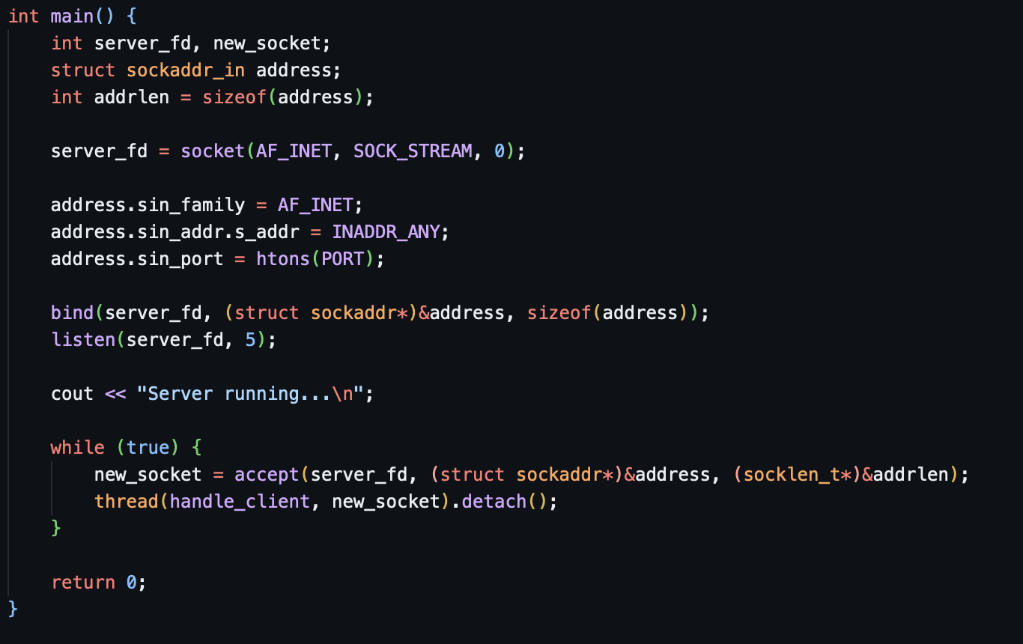
First we init a socket, and set the server to listening mode, while consistently receiving sockets from potential clients, then we handle the client in a separate thread so that messages are received asynchronously
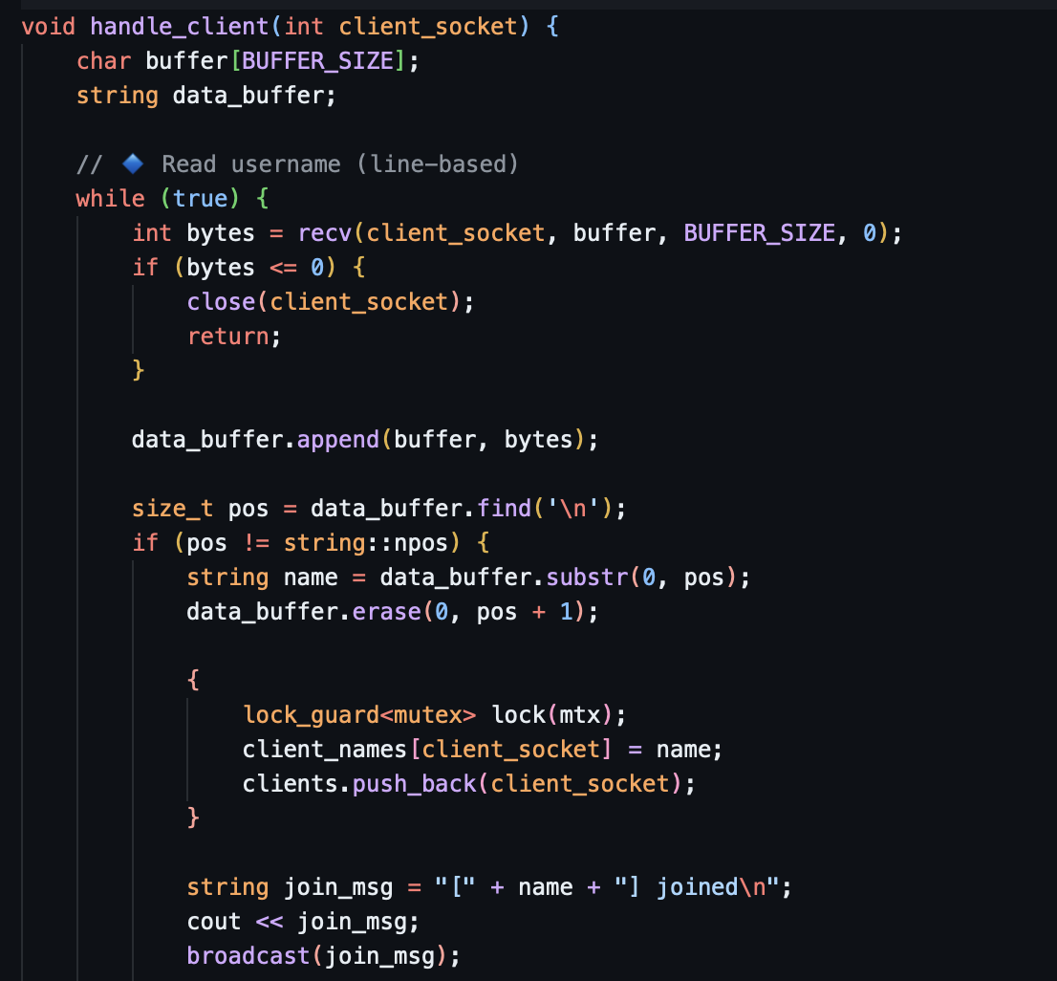
Here we just format the message and broadcast it
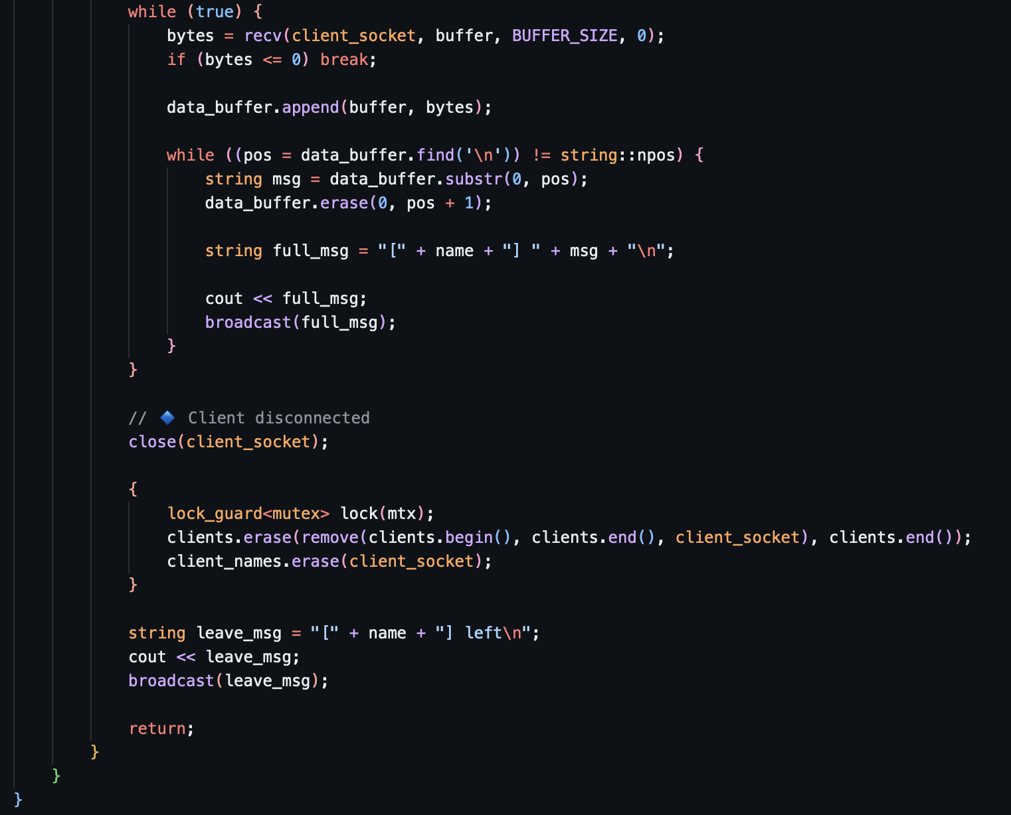
Here we disconnect the client
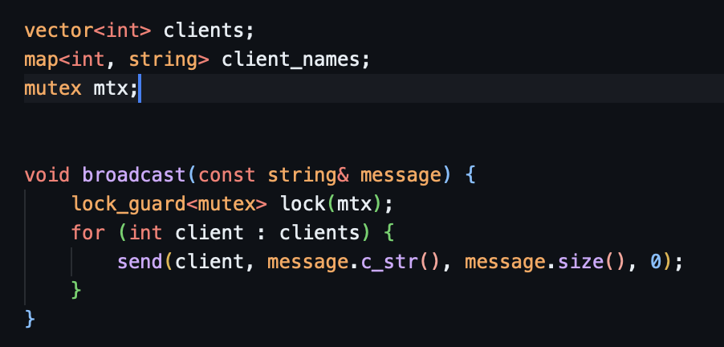
This broadcasts the messages to potential servers

Client
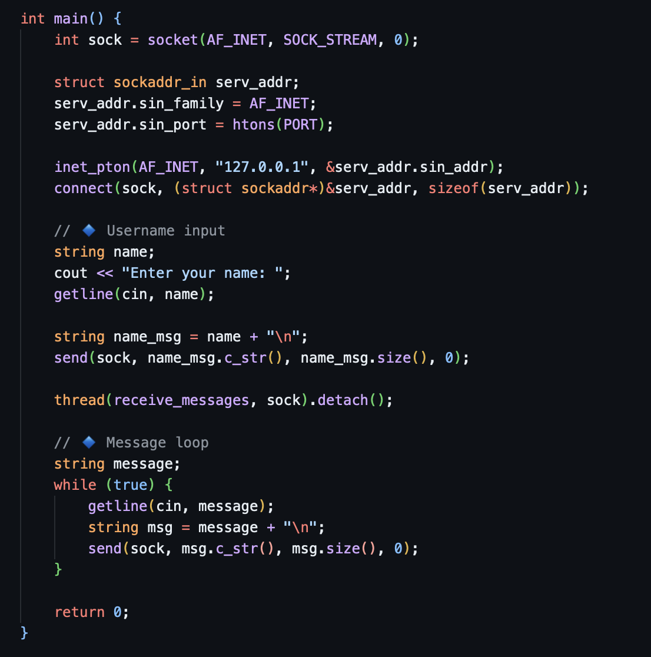
Similarly to the server we create a socket then set it to connect to the server
We then receive a username and create messages using it
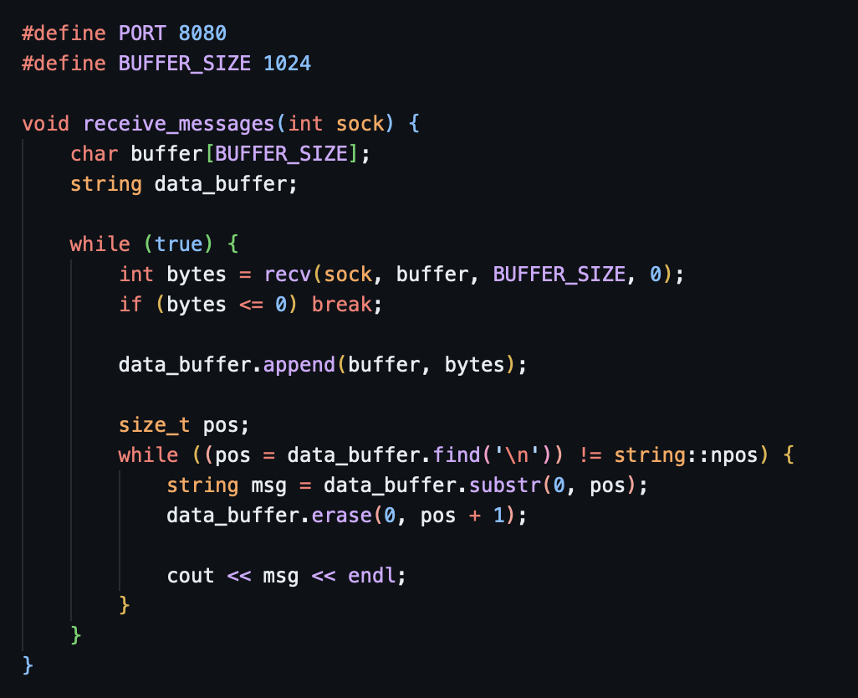
To receive messages as a client we just decode the buffer and format it

