https://github.com/yassienE4/OS-Portfoilio/commit/2472c7bcc4ca4e584a5f7c1c9ceb7fcce6b61607
How to run
- Verify openssl is installed, openssl version
- Go to working directory, cd passwords
- Compile, g++ main.cpp -o main -lssl -lcrypto
- Run, ./main
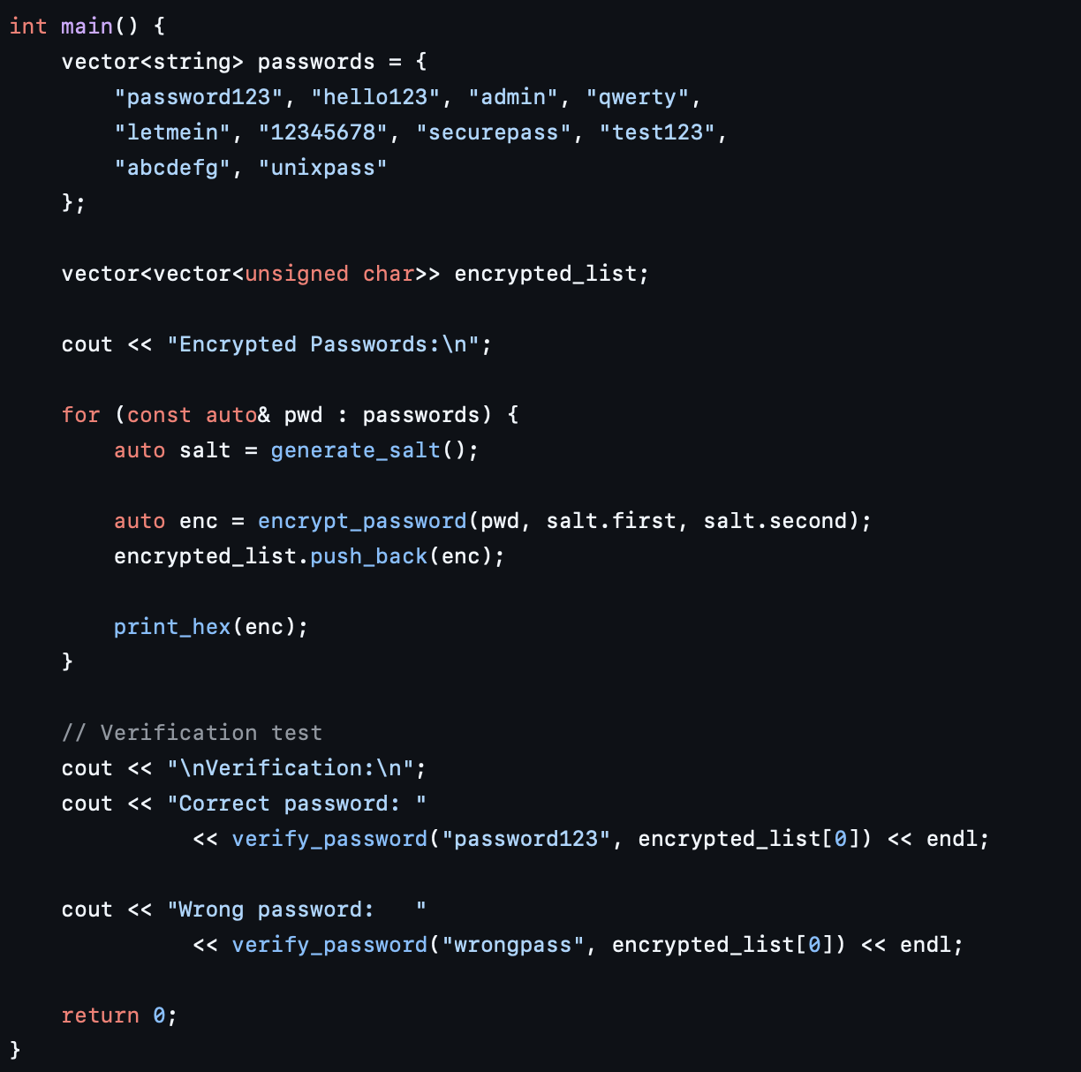
First I create a list of 10 passwords, and an empty list to store the encrypted passwords
For every password i create unique salt, and then encrypt the password using the salt, before adding it into the list,
To verify i pass the correct the password, and it reapplies the algorithm to get a new encrypted password which it checks against the stored password
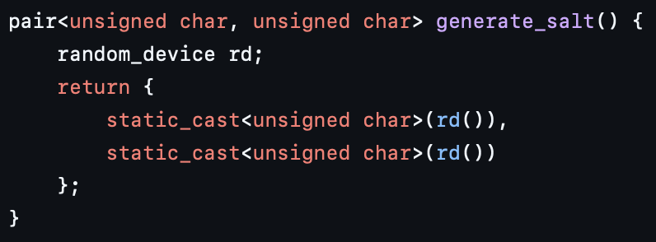
To generate a salt, i just create 2 random 8 bit strings, so that i can have a 16 bit string

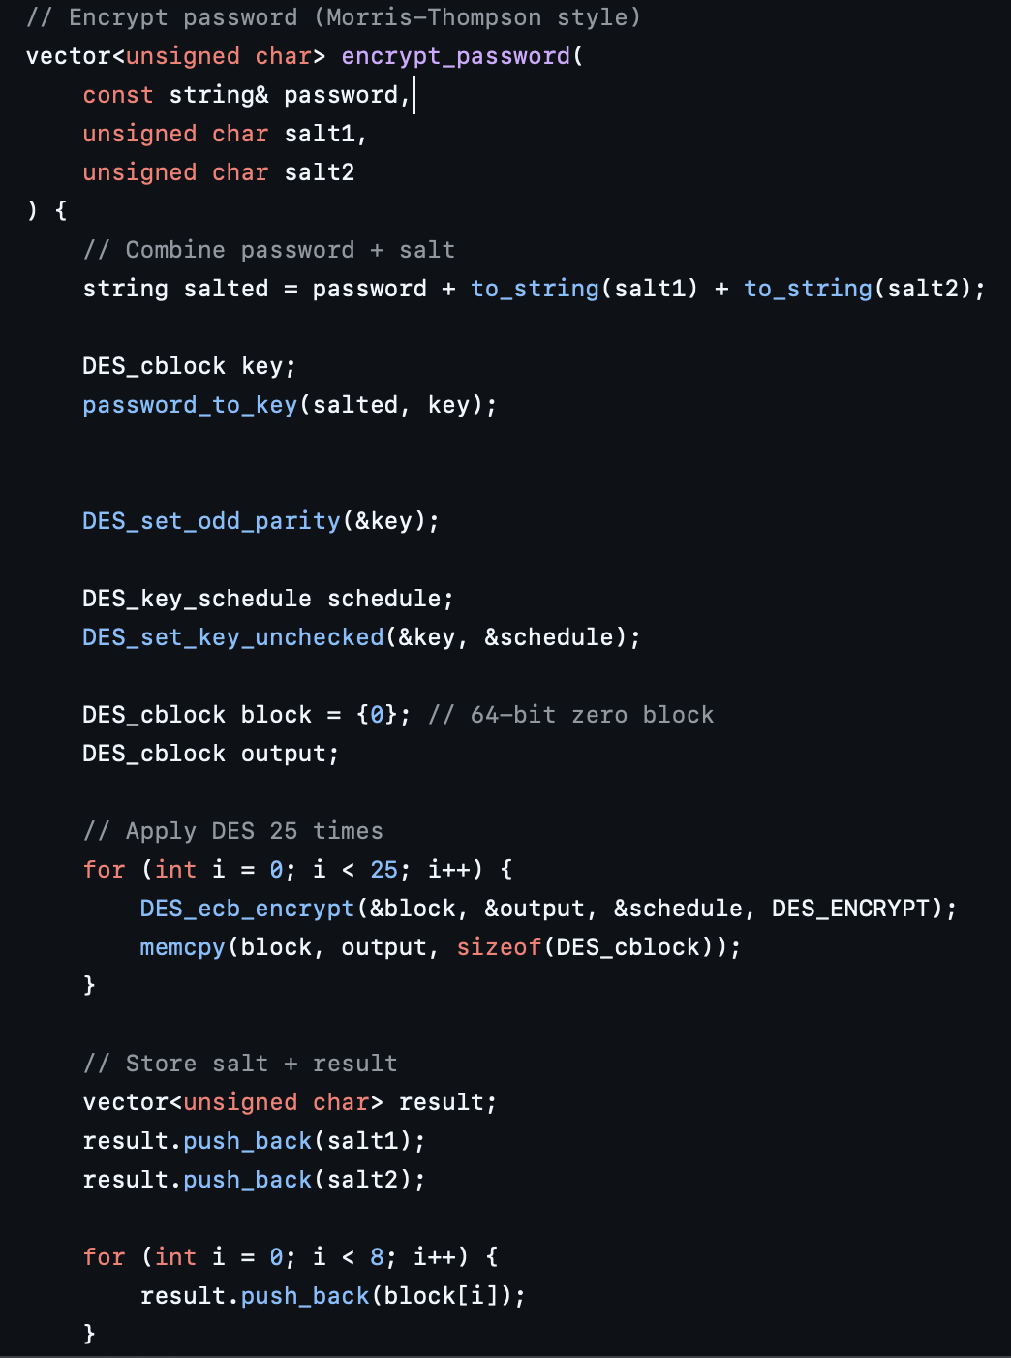
To encrypt the password first I add the salt to the password, then I convert the password to an 8 byte des key, which I use to apply the DES algorithm 25 times. I then store both the encrypted password and the salt in the final array.

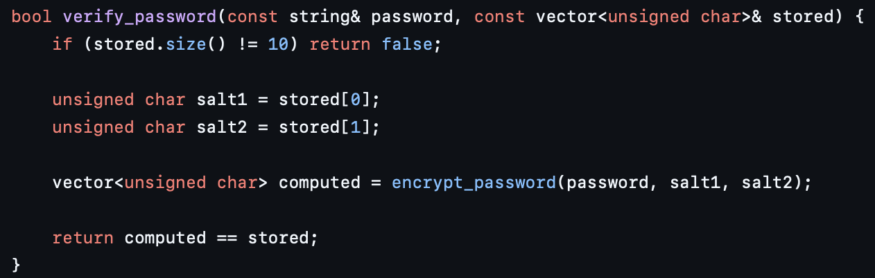

To verify a password, i first have to retrieve the salts stored, so that i can compute a new encrypted password using the same salts,
I then compare the computed password with the stored to verify.
And return the result.

