Debt without Broad US-EM EXR Index
Total Connectedness
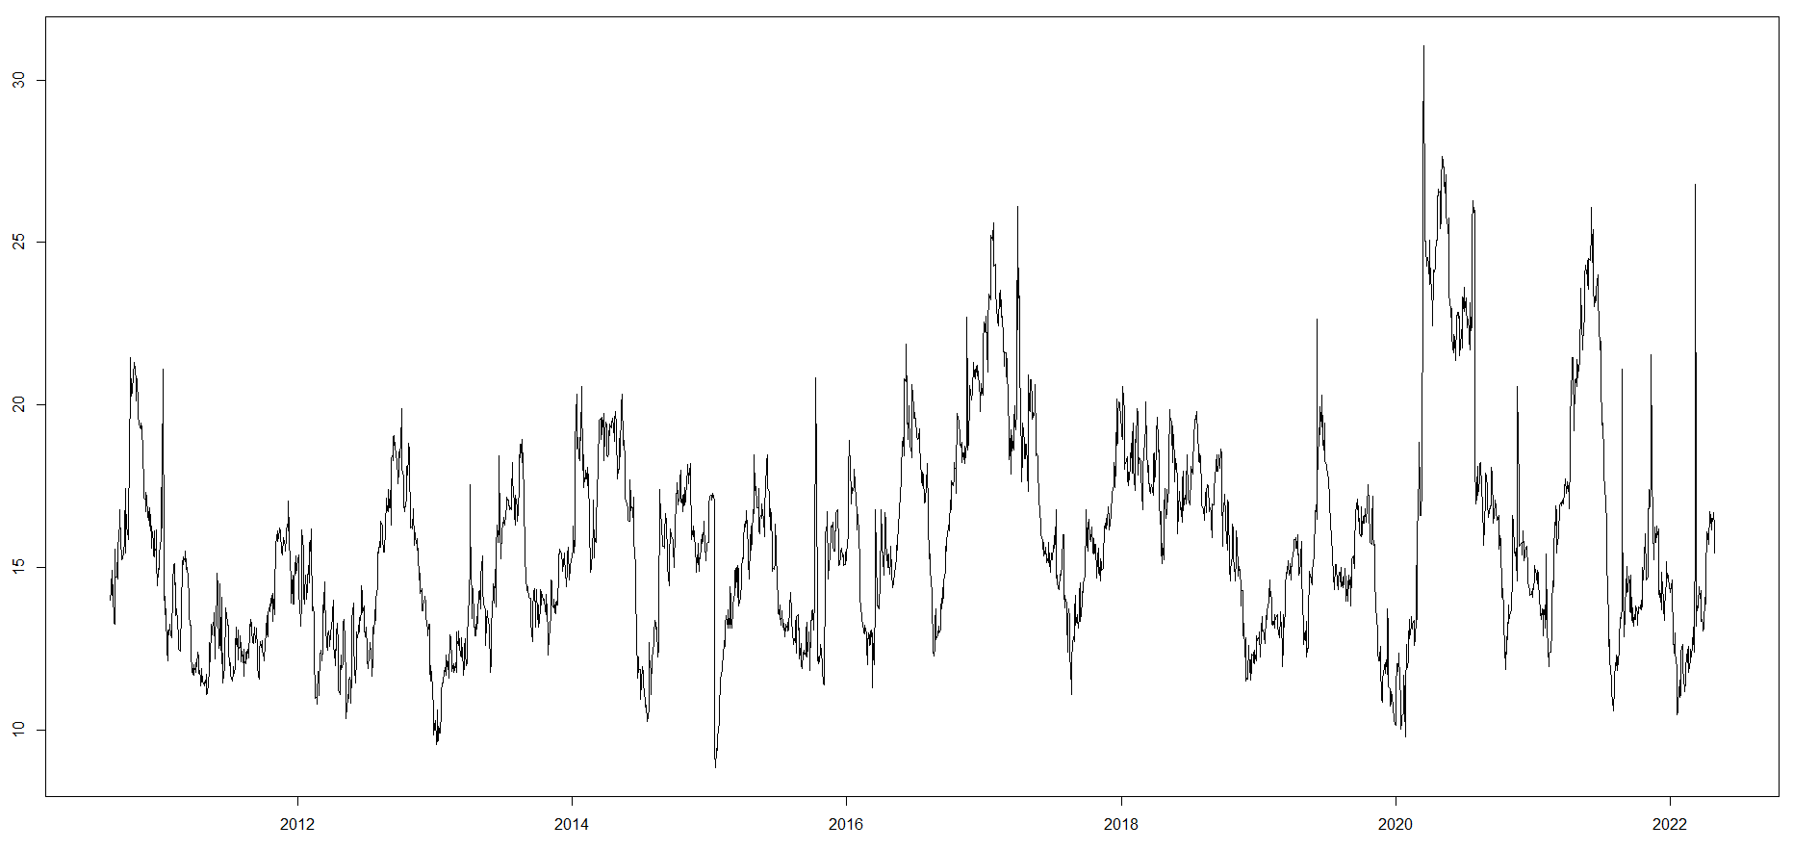
Frequency Decomposition
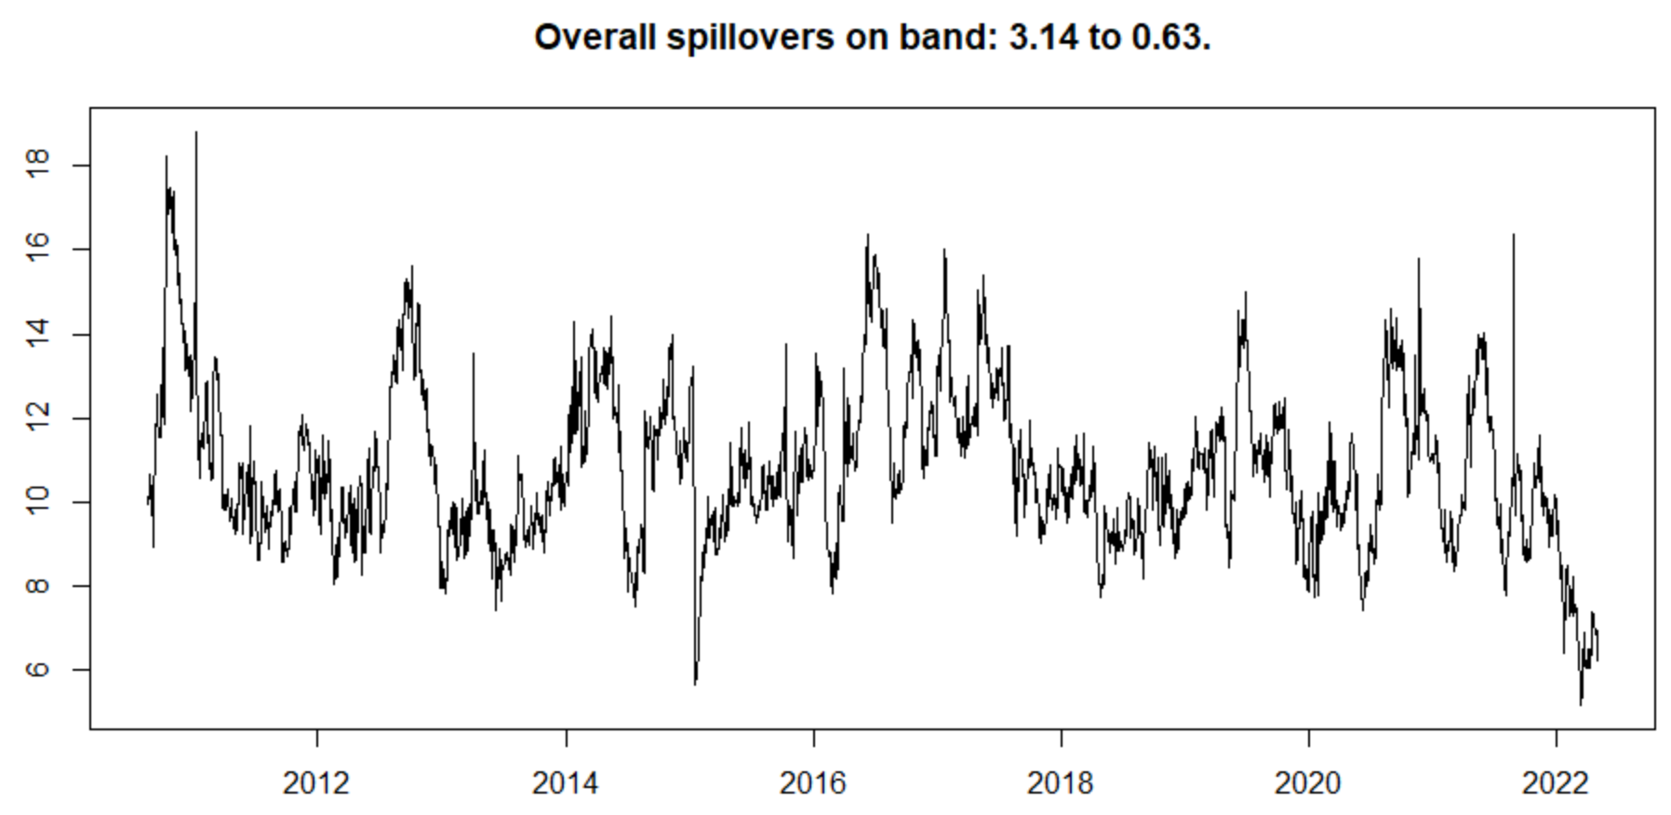
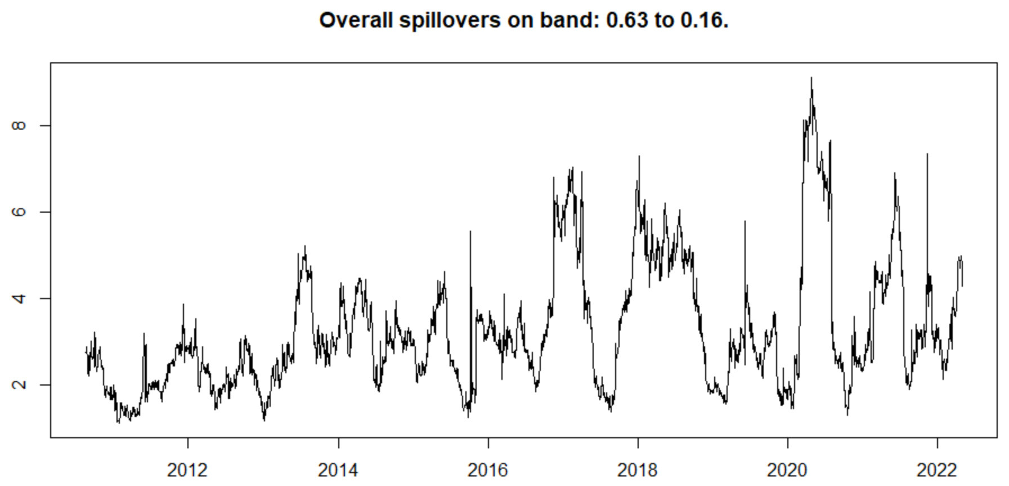
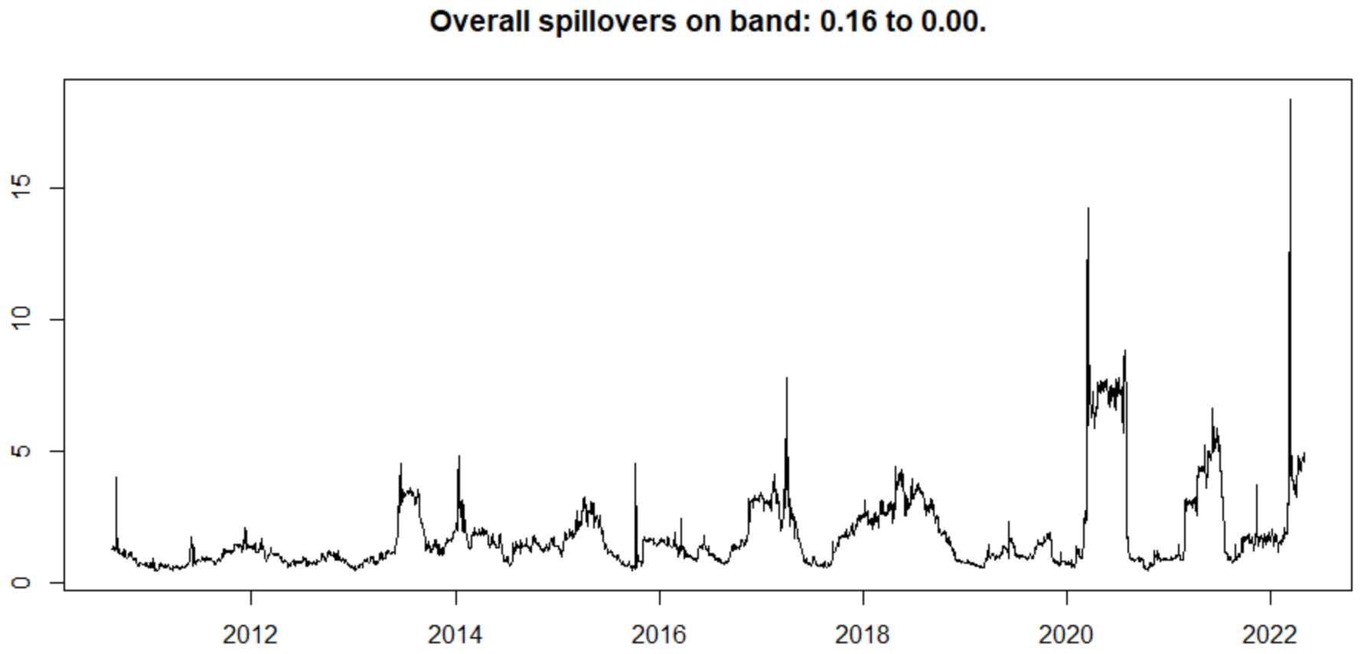

Debt with Broad US-EM EXR Index
Total Connectedness
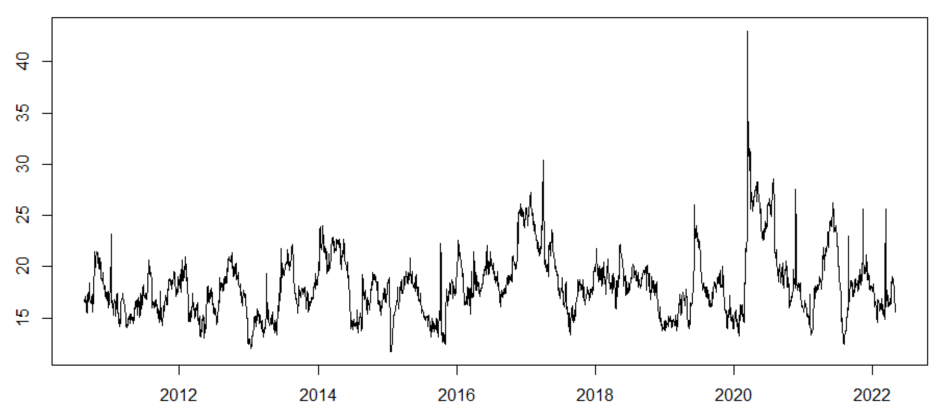
Frequency Decomposition
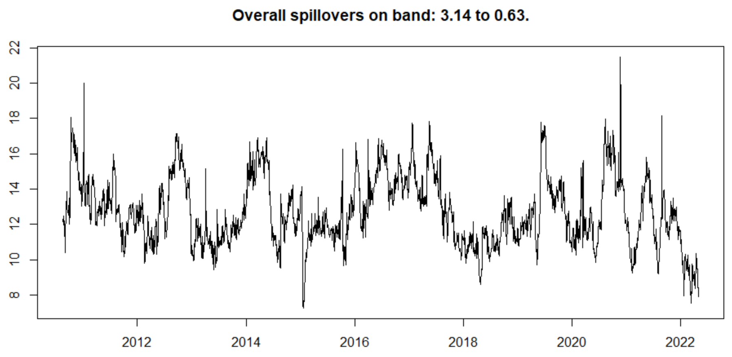
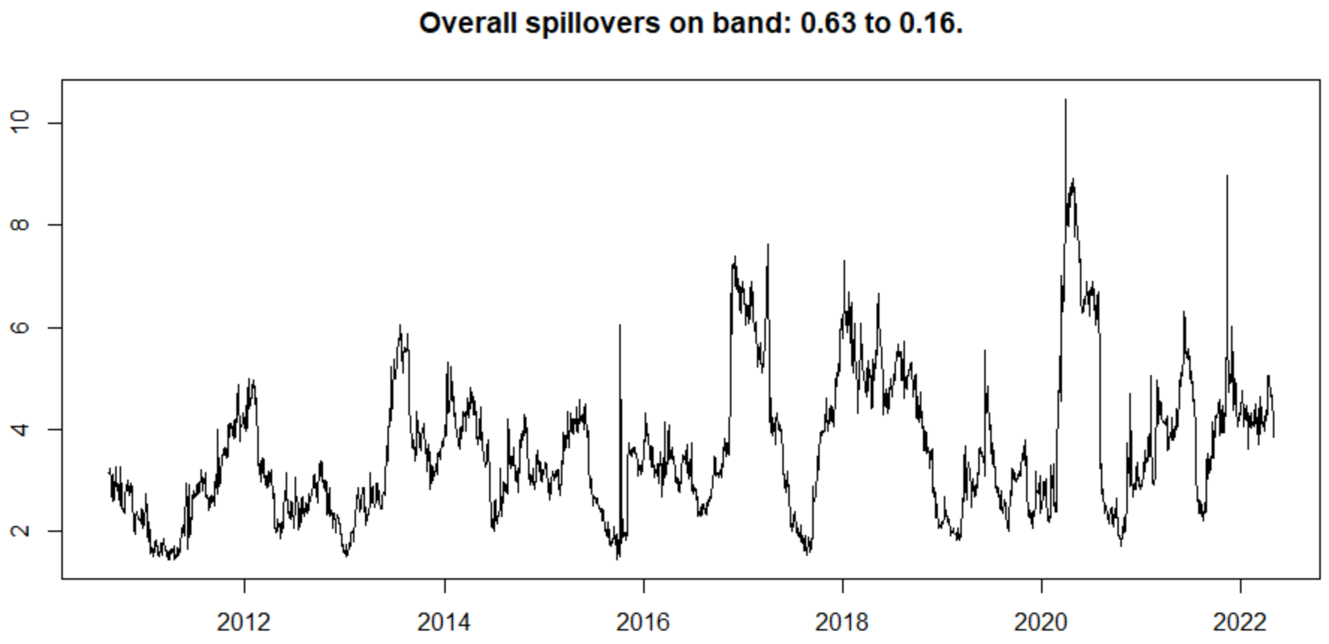
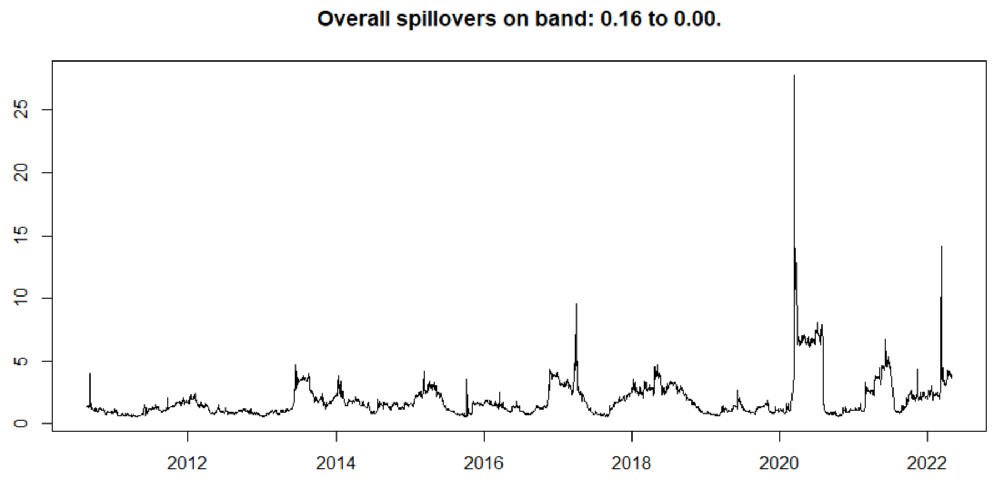

Net Spillover from Broad US-EM EXR Index
Net Spillovers on band: 0.14 to 0.63
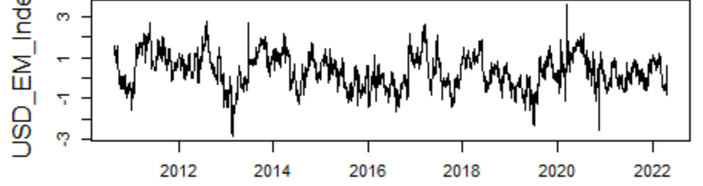
Net Spillovers on band: 0.63 to 0.16
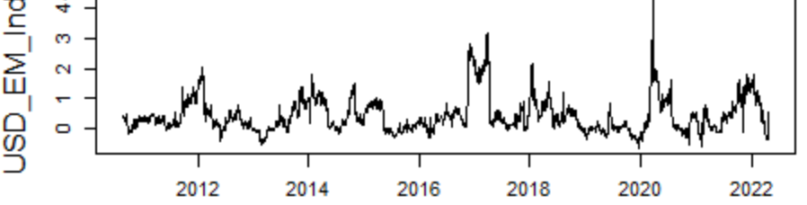
Net Spillovers on band: 0.16 to 0
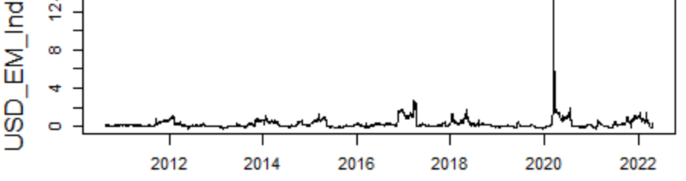

Equity without Broad US-EM EXR Index
Total Connectedness
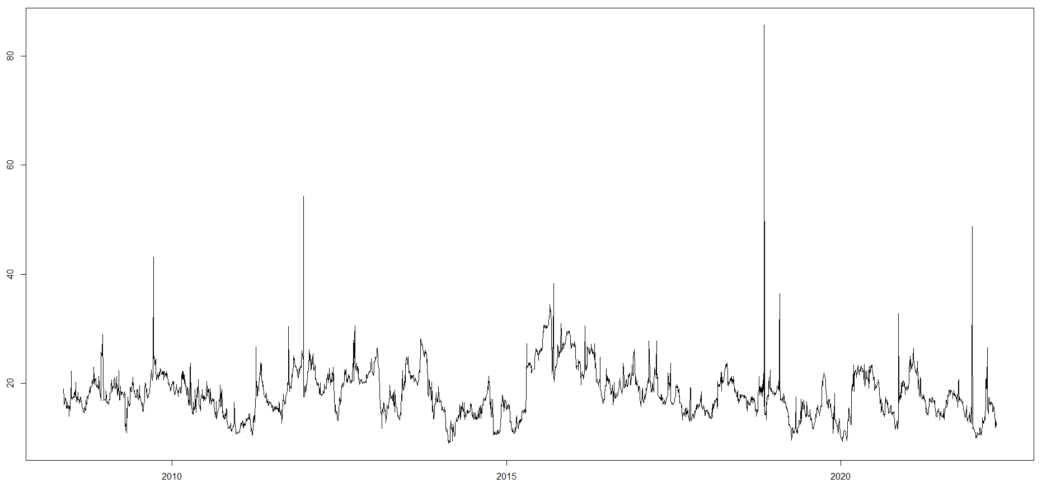
Frequency Decomposition
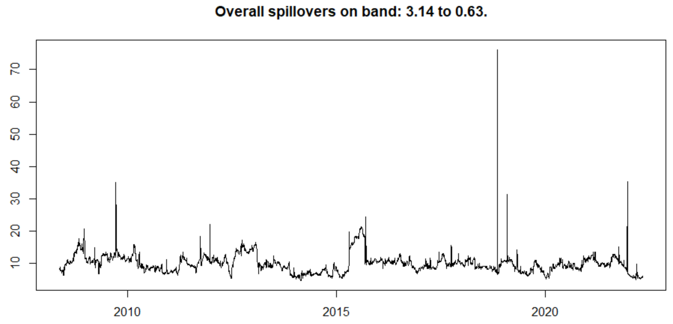
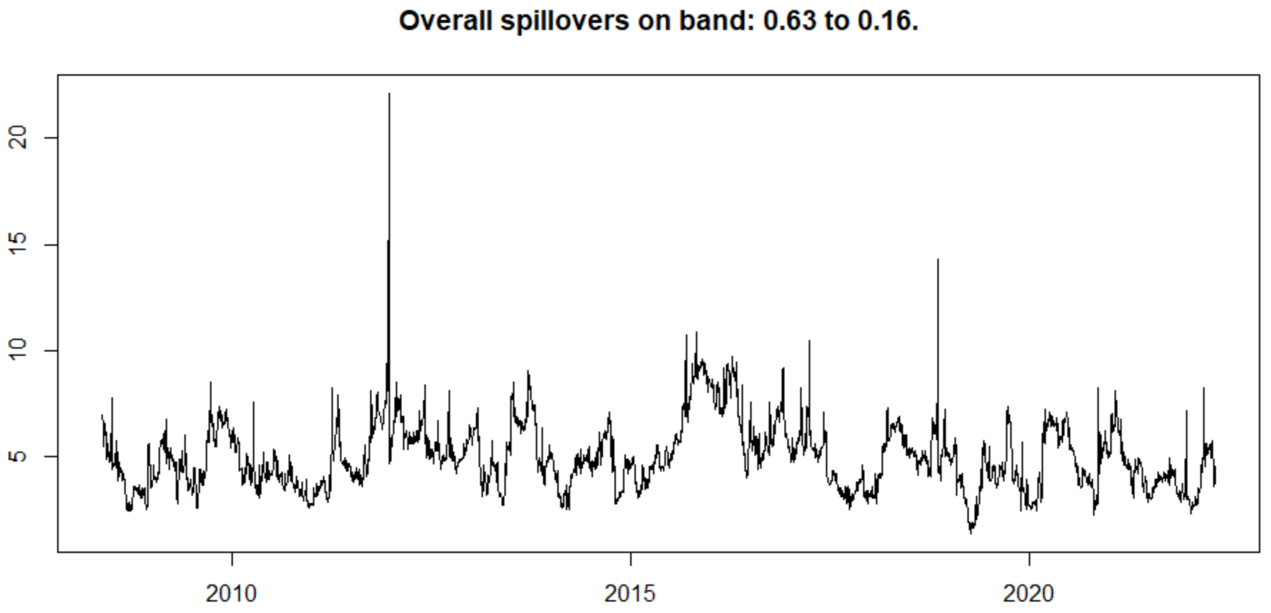
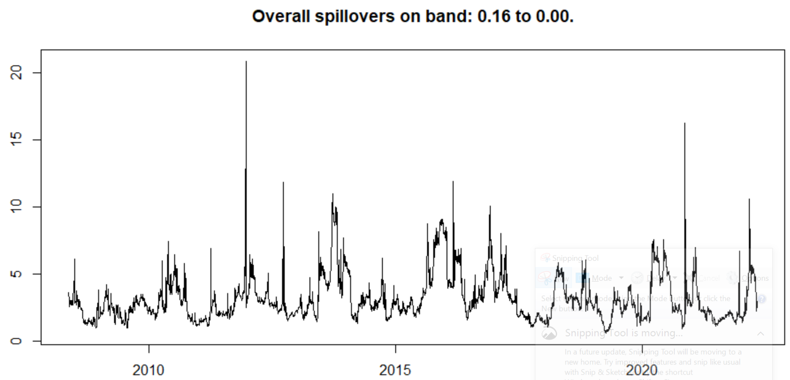
Equity with Broad US-EM EXR Index
Total Connectedness
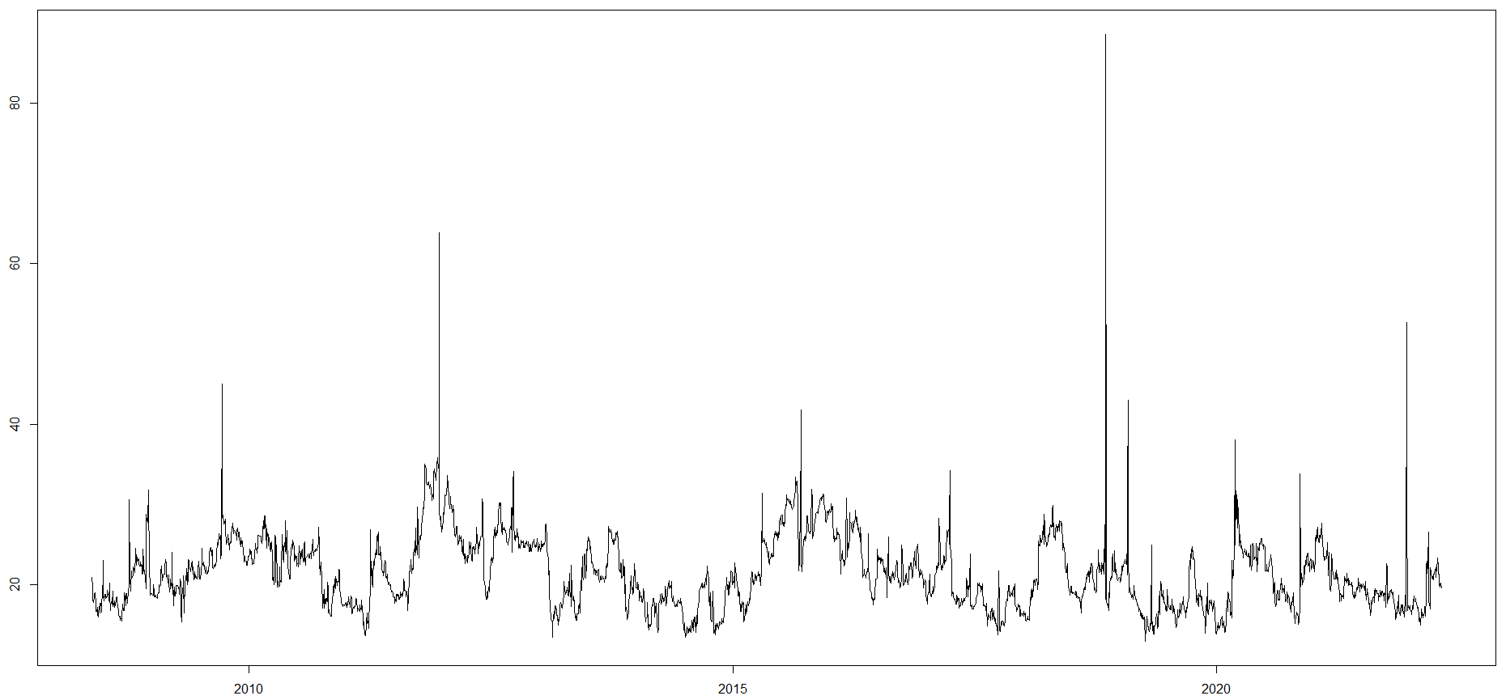
Frequency Decomposition
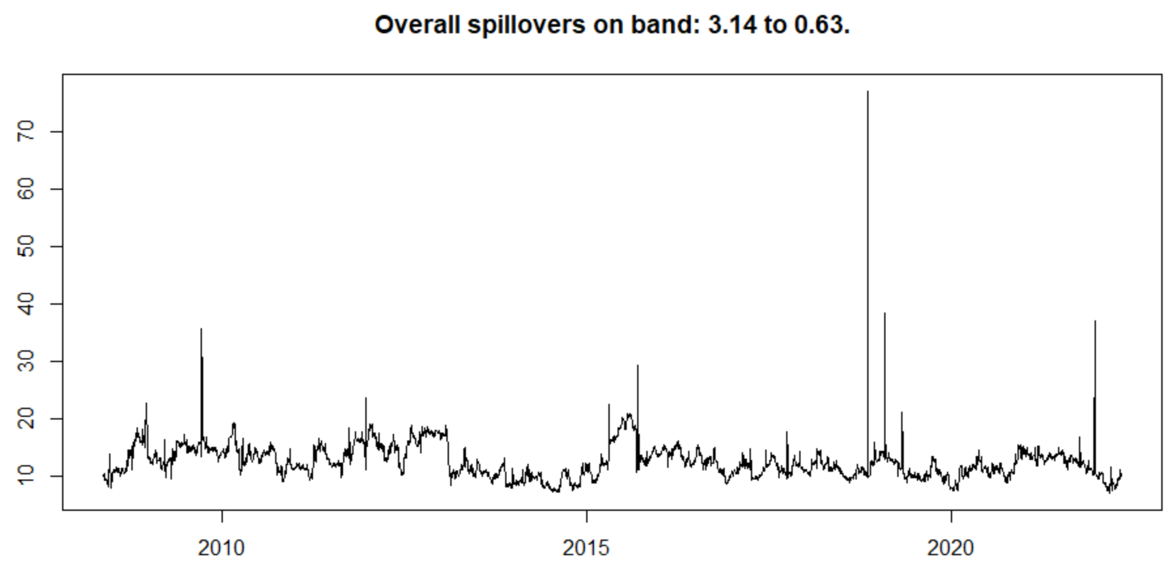
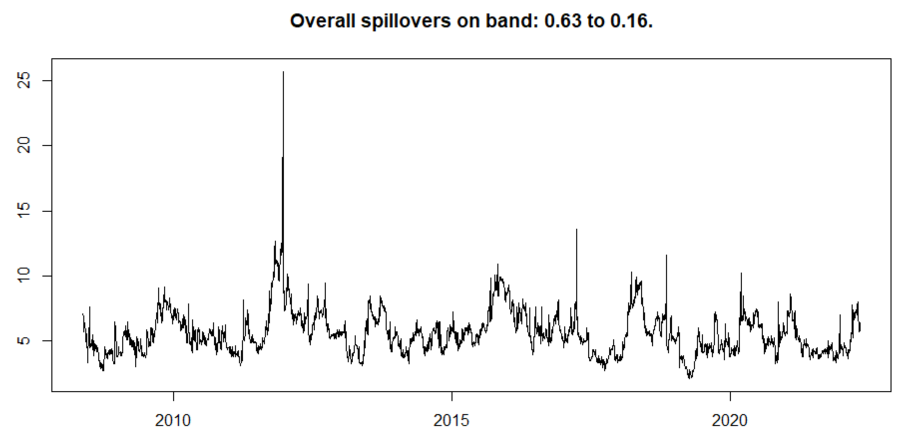
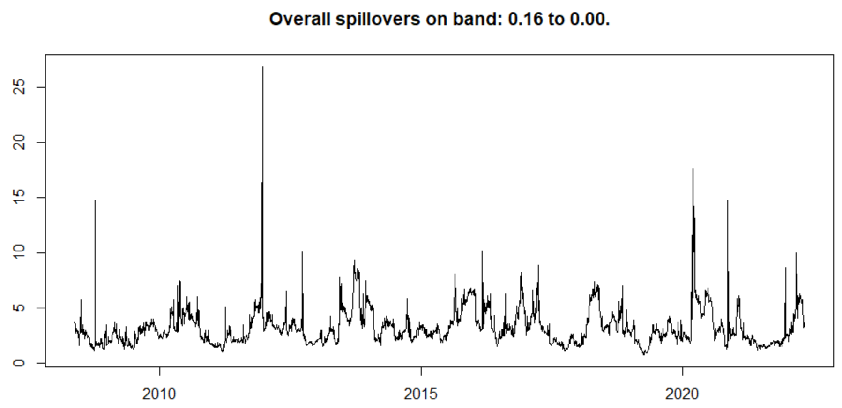
Net Spillovers on band: 0.14 to 0.63
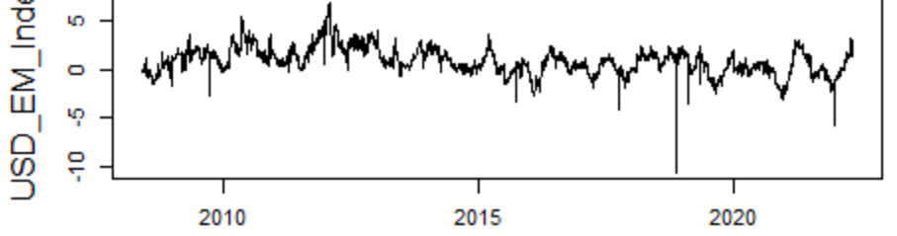
Net Spillovers on band: 0.63 to 0.16
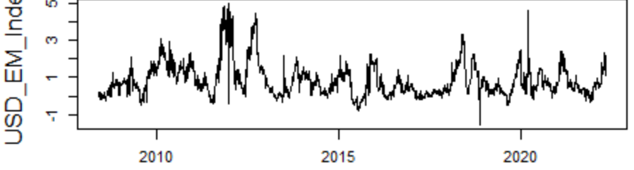
Net Spillovers on band: 0.16 to 0
