Teamwork

Task Distribution Table
Task | Team Member Responsible
Data Collection & Processing | Yassin
MATLAB Code & Analysis | Matthew
Presentation Design & Visuals | Viggo
Research & Report Writing | Tawsif
The workload was divided fairly based on each team member’s strengths. Yassin handled data processing, Matthew worked on MATLAB coding, Viggo designed the presentation, and Tawsif managed the research and documentation.

Details About Teamwork
Effective teamwork was essential for this project, allowing us to combine our individual strengths to achieve better results. Regular communication ensured that everyone stayed on track and could address challenges collaboratively. By dividing the tasks according to skillsets, we maximized efficiency while maintaining equal contributions. Everyone had a crucial role, and constructive feedback helped refine our work. Our approach promoted accountability and made the process smoother.

Team Interaction
We maintained consistent communication through weekly meetings and a shared group chat, where we discussed progress, challenges, and next steps. Meetings were structured to review completed tasks and plan upcoming work. We ensured engagement by actively listening to each other’s ideas and adjusting workloads when necessary. Viggo facilitated the presentation design sessions, while Yassin ensured data accuracy. Our teamwork was based on respect and inclusivity, allowing everyone to contribute equally and voice their opinions without hesitation.

Bystander Intervention Process
To facilitate bystander intervention within our team, we implemented a zero-tolerance approach to discrimination or exclusion. We encouraged open discussions about unconscious bias and created a supportive environment where concerns could be raised without fear. If any team member witnessed inappropriate behavior, they were expected to step in or report it. Additionally, we agreed to hold each other accountable, ensuring that everyone’s voice was valued and respected.

Protected Characteristics Considered
While working on this project, we considered various protected characteristics, including race, gender, and disability. Our discussions remained inclusive, ensuring all perspectives were acknowledged and respected. We used accessible materials, accommodated different working styles, and maintained a collaborative atmosphere. Additionally, we were mindful of unconscious biases, ensuring that contributions were judged based on merit rather than background. This approach fostered a positive and fair working environment for all team members.

Skill Matrix
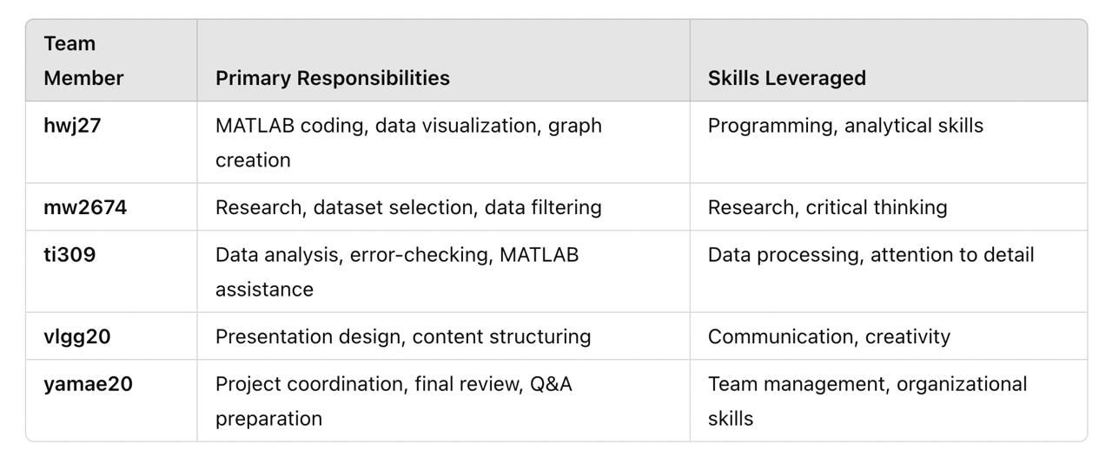

Critical Reflection
Throughout this project, I have gained a deeper understanding of the importance of collaboration and equitable workload distribution in team settings. Each team member brought a unique skillset, and our success was dependent on how well we utilized those strengths. Personally, I developed stronger communication and coordination skills, especially during group discussions and when resolving conflicts. Our efforts to create an inclusive and respectful environment significantly contributed to our productivity and overall experience. This project also emphasized the relevance of accountability and active participation, which I will carry forward into future group work, both academically and professionally.

