Life Cycle Energy Analysis (LCA)
The sustainable energy management approach in this project focuses on reducing energy consumption across the full life cycle of the energy-efficient LED lighting system. The life cycle stages include raw material extraction, material processing, manufacturing, product use, maintenance, and end-of-life recycling.

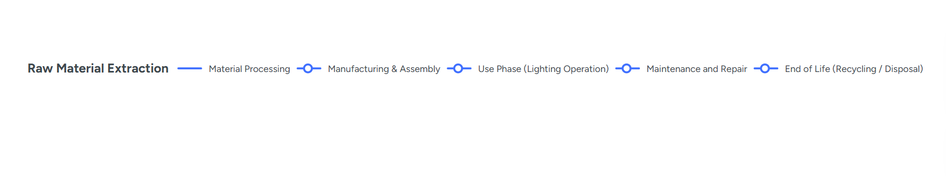

Energy Performance Improvements
Raw Material Extraction
Energy impact occurs during the mining of metals such as copper and aluminium used in the PCB and heat sink. Sustainable practices include sourcing recycled metals to reduce energy consumption during mining and refining.
Material Processing
Energy is used when manufacturing electronic components and printed circuit boards. Energy efficiency improvements can be achieved by selecting manufacturers that use renewable energy sources during component production.
Manufacturing
Energy is consumed during PCB production, soldering, and assembly. Efficient manufacturing processes and automated assembly can reduce electricity usage and improve production efficiency.

Use Phase
The largest energy improvement occurs during the operational stage. The LED lighting system uses a switch-mode driver with a buck converter, which significantly reduces energy consumption compared with traditional incandescent lighting systems.
Maintenance
Designing the system with replaceable components allows damaged parts to be repaired instead of replacing the entire lighting unit, reducing energy consumption associated with manufacturing new products.
End of Life
Electronic recycling processes allow valuable materials such as copper and aluminum to be recovered, reducing the energy required to extract new raw materials.

