
CAPSTONE PROJECT
Strategic Thinking - Semester II

Student name: YASSINE ZOHAIR
ID: 2025118

Credit Card Default Prediction Using Machine Learning


Assessment Cover Page

Student Full Name | Yassine Zohair
Student Number | 2025118
Module Title | Strategic thinking
Assessment Title | CA3 Final Submission
Assessment Due Date | 22/11/2025
Date of Submission | 22/11/2025

Declaration
By submitting this assessment, I confirm that I have read the CCT policy on academic misconduct and understand the implications of submitting work that is not my own or does not appropriately reference material taken from a third party or other source.
I declare it to be my own work and that all material from third parties has been appropriately referenced.
I further confirm that this work has not previously been submitted for assessment by myself or someone else in CCT College Dublin or any other higher education institution.

Contents
1 Introduction 5
2 Business Understanding 5
2.1 Business Description 5
2.2 Research Question 5
2.3 General Goal 6
2.4 Methodology 6
2.5 Machine Learning Models 6
2.6 Libraries 6
2.7 Data 6
2.8 Source 6
2.9 Attributes: 6
3 Exploratory Data Analysis (EDA) 7
3.1 Target variable analysis 8
3.2 LIMIT BILL variable Analysis 8
3.3 SEX variable analysis 10
3.4 EDUCATION variable analysis 10
3.5 MARRIAGE variable analysis 11
3.6 AGE variable analysis 12
4 Data Cleaning 13
4.1 Skewness 13
4.2 Handling Outlier 14
5 Statistical Hypothesis Tests 16
5.1 Hypothesis 1: Age of Non-Defaulting Male Customers 16
5.2 Hypothesis 2: Credit Limit of Defaulting Customers 17
6 Feature Engineering 17
7 Balancing the data 18
8 Building the Machine Learning Models 18
8.1 Splitting the Data 18
8.2 Data Scaling 19
8.3 Model Building Process 19
8.4 Cross-Validation Method 19
8.5 Hyperparameter Tuning 20
8.6 Building Logistic Regression Model 20
8.7 Building KNN Model 21
8.8 Building Random Forest Classifier Model 23
8.9 Comparison of Machine Learning Models Performance 24
9 Feature Importance 24
10 Model Interpretation with Shapash 25
11 Conclusion 25
12 References 26

Figure 1 Statistics of the numerical features in our dataset. 6
Figure 2 Bar plot target variable “defaulted” 7
Figure 3 Credit Limit (LIMIT_BAL) Distribution 7
Figure 4 Density plot of LIMIT_BAL by Default type 8
Figure 5 Boxplot of LIMIT_BAL by default 8
Figure 6 Gender Overview and Default Comparison 9
Figure 7 Education Levels and Default Payment Comparison 9
Figure 8 Marital status and Default Payment Comparison 10
Figure 9 Age Distribution by Default Status 11
Figure 10 Correlation Matrix of Numerical Features 11
Figure 11 Distribution of Numerical Features 12
Figure 12 Outlier Analysis of Numerical Features 13
Figure 13 Distribution of Numerical Variables After Removing Outliers 14
Figure 14 Z-Test Result for Mean Age of Non-Defaulting Male Customers 15
Figure 15 T-Test Result for Average Balance of Defaulting Customers 15
Figure 16 Comparison of Class Counts Before and After SMOTE 16
Figure 17 Train and Test Code 16
Figure 18 Scaling code 17
Figure 19 Confusion Matrix : Logistic regression Model 18
Figure 20 Confusion Matrix: KNN Model 20
Figure 21 Confusion Matrix: Random Forest Model 21
Figure 22 Comparison of Performance: Machine Learning Models 22
Figure 23 Feature Importances 23

Introduction

In the last few years, credit card usage has grown, and with that, the risk of default by individuals in paying their credit card dues on time. This creates big problems for bank and credit card companies (Zhou L., 2018). When a customer defaults on payment, the company loses money. That’s why it’s important to find a way to identify who might default before it happens.
In this project, we put into practice the development of machine learning models that can be used to solve this problem. My goal was to find out if we can use past data set about customers like their age, income, education and how they paid last month to predict if they are going to default on their next payment (Brown Iain, 2012).
Banks and credit card companies constantly seek ways to reduce the risk of losing money when customers fail to make payments. One of their biggest challenges is identifying in advance which customers are likely to miss their credit card payments. If a company can predict this accurately, it can take proactive steps such as lowering a customer's credit limit or offering financial advice to avoid potential losses (Henley, 1997).
With this report, we are trying to make predictions on which customers are likely to default using machine learning. Three different algorithms were used in this analysis. Methods such as cross validation, hyperparameters tuning and SHAPASH were added in this report to enhance its quality. (Yeh, 2009).

Business Understanding

Business Description
In this project, we build a Machine Learning model to predict if a customer will fail to pay their credit card bill. The dataset contains real information about clients, such as their payment history, credit limit, and past behavior. This prediction is very useful for banks because it helps them identify customers who might have problems paying back. By using this model, banks can make better decisions, reduce financial risk, and improve how they manage credit.

Research Question
Can we predict if a customer will default on their credit card payment based on their financial and personal information?

General Goal
The main goal of this analysis is to build a model that predicts whether a customer will pay their credit card bill or not. Banks and financial institutions can use these results to identify high-risk clients, reduce financial losses, and make better credit decisions. In this project, we focus on solving a classification problem where the target is to predict default or non-default.

Methodology
The methodology used to design the project was CRISP-DM. CRISP-DM stands for cross industry process for data mining. The CRISP-DM methodology provides a structured approach to planning a data mining project. It is a robust and well-proven methodology. It is flexible and useful when using analytics to solve tricky business problems. It has 6 stages like Business understanding, Data understanding, Data preparation, Modeling and Evaluation. (Shearer, 2000)

Machine Learning Models
In this project, three supervised Machine Learning models were used: Logistic Regression, K-Nearest Neighbors (KNN), and Random Forest Classifier, that are frequently employed for classification issues were used in this study. (Kubat, 2017)

Libraries
To carry out various jobs and model algorithms, numerous libraries have been employed. They might consist of Pandas, Numpy, Seaborn, Matplotlib, Statistics, SMOTE, StandardScaler, Metrics, FeatureImportances etc.

Data
The “Default of Credit Card Clients” dataset contains information about credit card users and whether they defaulted on their payments. It has 30,000 records and 24 features. Most variables are numerical, and the main target variable indicates if the client failed to pay their credit card bill (1 = default, 0 = no default).

Source
The data was obtained from the UCI Machine Learning Repository, which is a well-known source for publicly available datasets used in research and education.
You can access it through this link:
https://archive.ics.uci.edu/ml/datasets/default+of+credit+card+clients (UCI, 2008)

Attributes:
There are 23 independent variables (predictors) and 1 dependent variable (target).
The predictors include:
- LIMIT_BAL – the amount of the given credit limit
- SEX, EDUCATION, MARRIAGE, AGE – demographic information
- PAY_0 to PAY_6 – past monthly payment status
- BILL_AMT1 to BILL_AMT6 – bill statements over six months
- PAY_AMT1 to PAY_AMT6 – payment amounts over six months
The dependent variable “defaulted” shows whether the client defaulted (1) or not (0).

Exploratory Data Analysis (EDA)
First, we examined the dataset and reviewed basic descriptive statistics for the numerical variables. This helped us understand the data distribution before continuing with the analysis. (Tan, 2019)

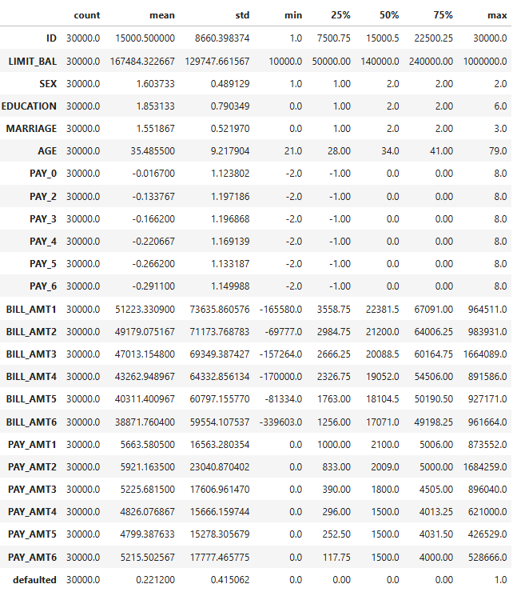
Figure 1 Statistics of the numerical features in our dataset.
We have a summary of the statistics of every variable showing the quartiles, mean, standard deviation, minimum and maximum values.
Now let’s analyze each group.

Target variable analysis
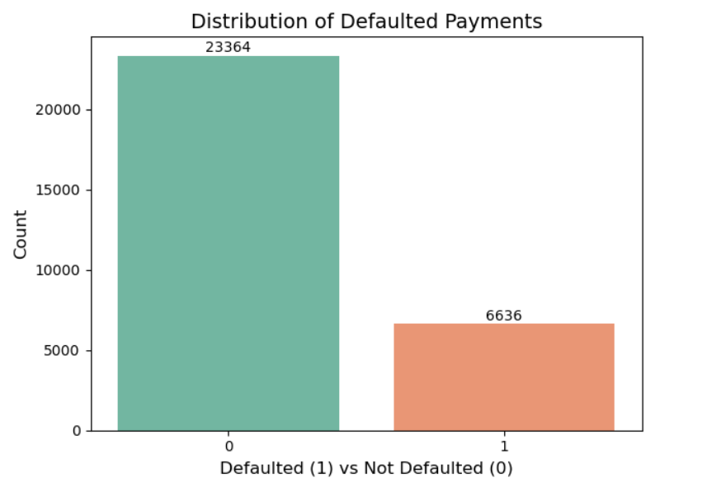
Figure 2 Bar plot target variable “defaulted”
In figure 2, we can see that there are far fewer default payments than non-default payments. There are 6,636 customers who defaulted and 23,364 who did not. This means 22.1% of customers defaulted, while 77.9% made their payments on time. The data is therefore imbalanced, and I will handle this issue later in the feature engineering process.

LIMIT BILL variable Analysis
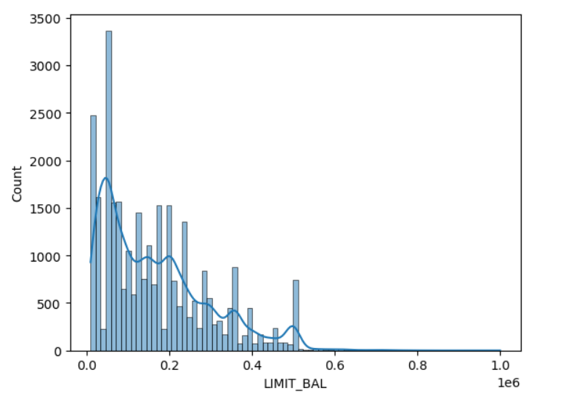
Figure 3 Credit Limit (LIMIT_BAL) Distribution
The distribution of LIMIT_BAL (credit limit) is highly skewed to the right. Most customers have a credit limit between 0 and 200,000, and very few clients have limits above 500,000. The histogram shows that lower credit limits are much more common, while high credit limits are rare. This uneven distribution suggests that most customers receive small to medium credit limits. (Martens, et al., 2007)
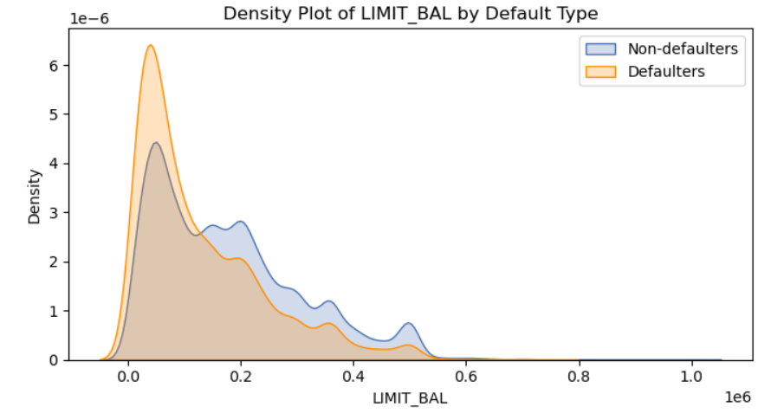
Figure 4 Density plot of LIMIT_BAL by Default type
The density plot shows that both defaulters and non-defaulters usually have lower credit limits, mostly below 200,000. However, defaulters tend to have slightly lower credit limits compared to non-defaulters. As the credit limit increases, the number of defaulters drops more quickly than non-defaulters. This suggests that customers with higher credit limits are less likely to default. (Martens, et al., 2007)

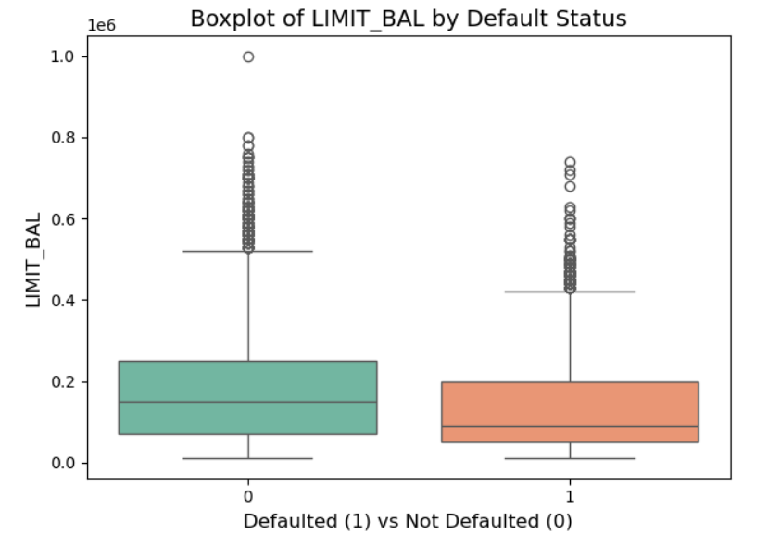
Figure 5 Boxplot of LIMIT_BAL by default

From the figure 5, we can see that customers who did not default generally have higher credit limits than those who defaulted. Both groups show many high-value outliers, but non-defaulters reach higher limits overall. The median credit limit is also higher for non-defaulters. This suggests that customers with higher credit limits are less likely to default. (Martens, et al., 2007)

SEX variable analysis

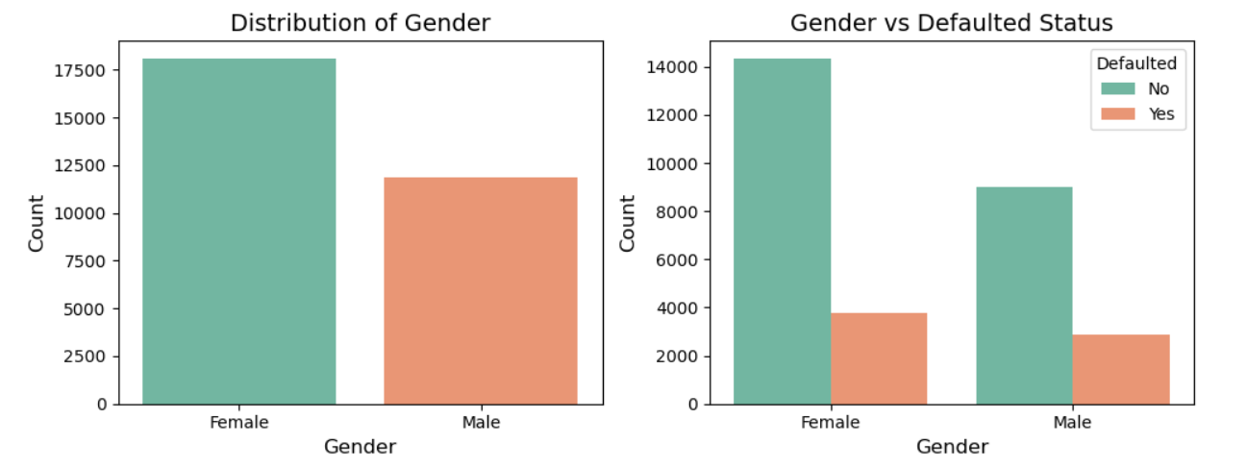
Figure 6 Gender Overview and Default Comparison
From the figure 6, we can see that there are more female customers than male customers in the dataset. When comparing gender with default status, both females and males show similar patterns: most people do not default, and the number of default cases is lower in both groups. The difference in default rates between males and females appears small, suggesting that gender is not a strong factor in predicting default.

EDUCATION variable analysis
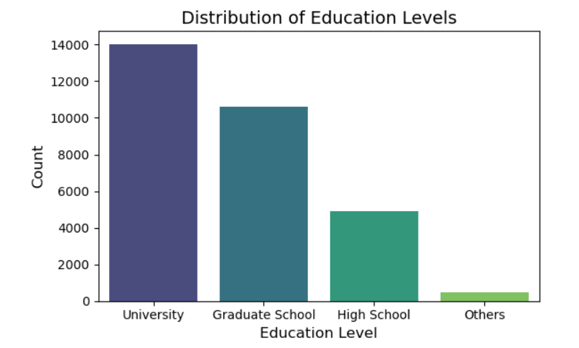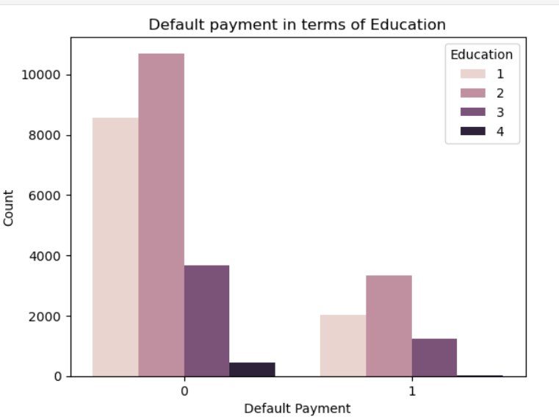
Figure 7 Education Levels and Default Payment Comparison

From the figure 7, we observed that there are 10,585 customers with graduate school degrees, 14,030 with university (college) degrees, and 4,917 with high school degrees. The highest number of customers have university degrees, followed by those from graduate schools and then high schools. We also noticed that as the level of education increases, the proportion of defaults decreases.

MARRIAGE variable analysis
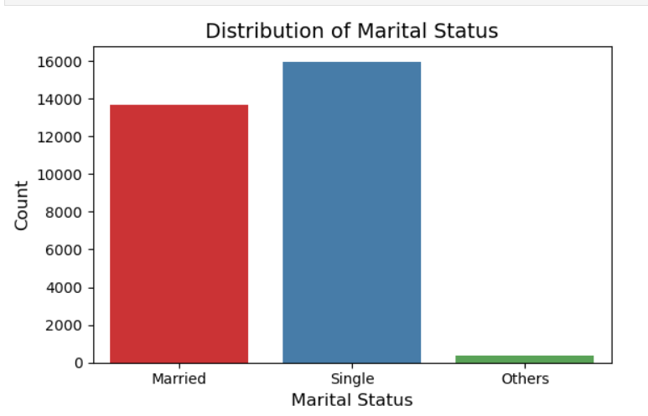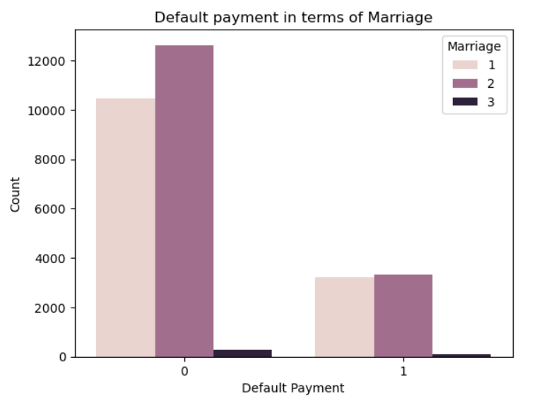
Figure 8 Marital status and Default Payment Comparison

From the figure 8, we can see that most customers in the dataset are either single or married, while very few fall into the “others” category. When comparing marital status with default payment, the pattern is similar for both married and single customers: most of them do not default. The number of defaults is noticeably smaller, and the difference between married and single customers is small. This suggests that marital status does not have a strong impact on default behavior.

AGE variable analysis
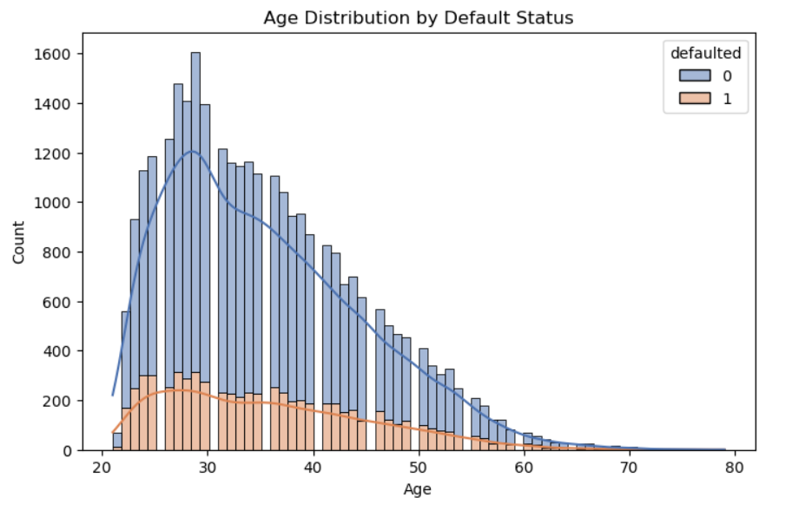
Figure 9 Age Distribution by Default Status
From the figure 9, we can see that most customers are between 25 and 40 years old, and this group also has the highest number of defaults. The age distribution is slightly right-skewed, meaning most customers are younger. As age increases, the number of customers decreases, and the number of defaults also drops. This suggests that younger customers tend to default more often, while older customers are less likely to miss payments. Therefore, age may be an important factor in predicting default behavior.
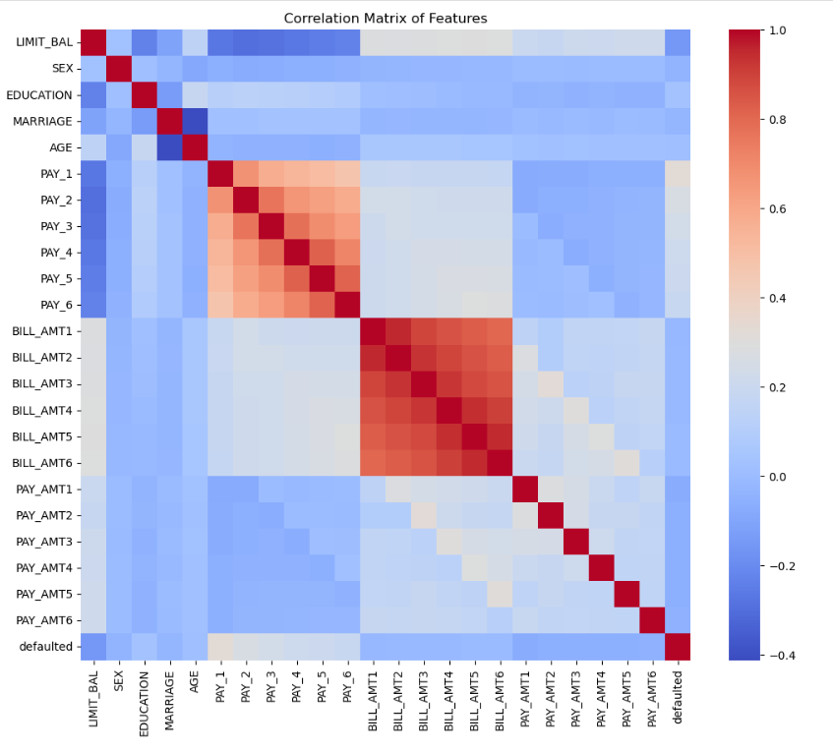
Figure 10 Correlation Matrix of Numerical Features
From the correlation matrix (Figure 10), we can see that the strongest relationships appear within two groups of variables: the PAY_1 to PAY_6 payment history features and the BILL_AMT1 to BILL_AMT6 bill amount features. These variables are highly correlated with each other because they represent repeated monthly values. We also observe a moderate positive correlation between PAY_1 and the default variable, meaning late payments are linked to a higher chance of default. Most other features show weak or very low correlations with default.

Data Cleaning
We started the data cleaning process by checking for missing values and duplicate records. After reviewing the dataset, we found that there were no missing values and 35 duplicates rows were removed to ensure data quality.
From the statistical summary of the numerical features, we noticed a large gap between the 75th percentile and the maximum values. This indicates that many numerical variables are right-skewed and contain outliers. (Tan, 2019)

Skewness

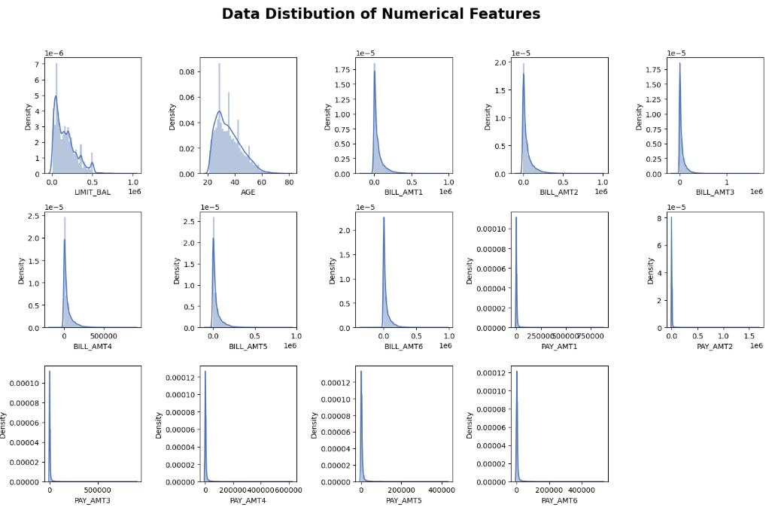
Figure 11 Distribution of Numerical Features
In the figure 11, we observed that most of the numerical distributions are right-skewed. Some variables show a very strong skew, which indicates the presence of many outliers, while a few others are closer to a normal distribution. Because of this, it seems necessary to remove the outliers before applying any transformation. First, we will remove the outliers and then check whether additional transformation techniques are needed. (Field, 2013)

Handling Outlier

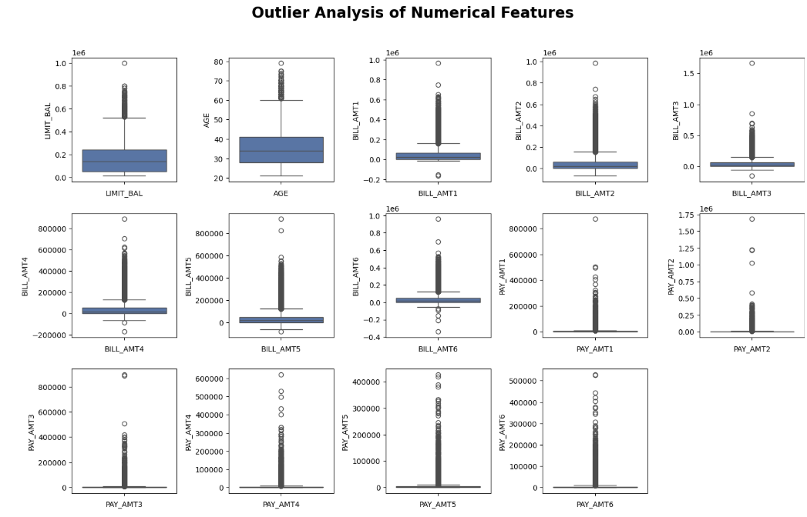
Figure 12 Outlier Analysis of Numerical Features
In the figure 12, we observed that outliers are present in all the bill amount features, all the pay amount features, and in the ‘LIMIT_BAL’ column. To address this issue, I used the clipping method, which involves setting a cap for extreme values. In this approach, any data point that exceeds a defined upper or lower threshold is considered an outlier and replaced with the nearest boundary value—either the minimum or maximum within the specified range. This helps to reduce the impact of extreme values while preserving the overall structure of the data.
To handle outliers in the numerical features, I used the Interquartile Range (IQR) method. For each numerical column, I calculated the first quartile (Q1), the third quartile (Q3), and the IQR. Then I defined the lower and upper limits using Q1 minus 1.5 times the IQR, and Q3 plus 1.5 times the IQR. Any value outside this range was clipped to the nearest limit. This means extreme values were replaced instead of being deleted. After applying this method, the distributions became more stable and suitable for modeling. (Field, 2013)
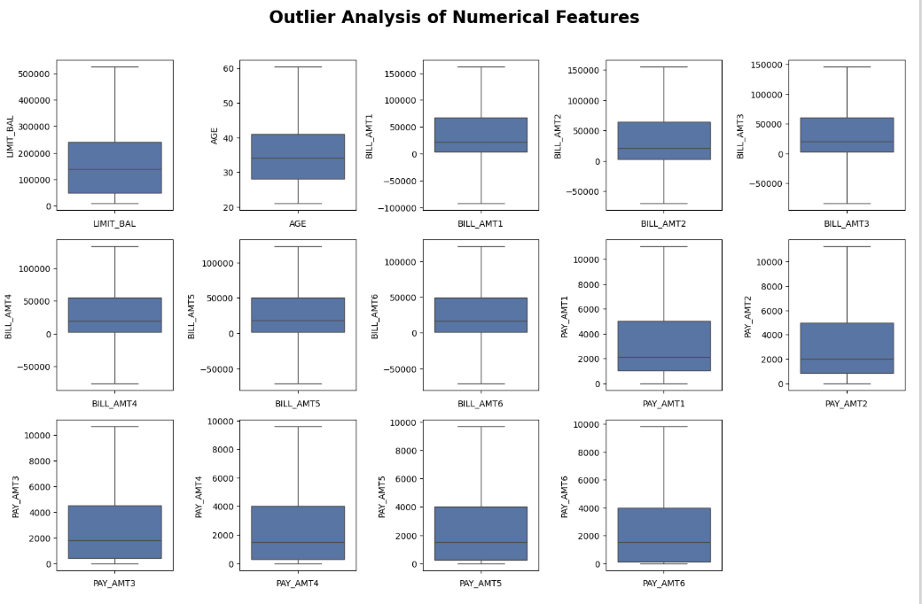
Figure 13 Distribution of Numerical Variables After Removing Outliers

In the figure 13, we can see that the boxplots became much more balanced after removing the outliers. Many features that were extremely skewed now show a smoother and more stable distribution. Some variables even look closer to a normal shape. Since the distributions improved noticeably after clipping the outliers, I decided that no additional transformation (such as log or power transformation) was needed for the numerical features.

Statistical Hypothesis Tests
In this section, we applied hypothesis testing to answer two statistical questions about the credit card clients. Hypothesis testing helps us decide, whether there is enough evidence to support a claim about the population. For each hypothesis, we defined the null hypothesis (H₀), the alternative hypothesis (H₁), selected the appropriate statistical test, and interpreted the results based on the p-value. (Vaisman, et al., 2020)

Hypothesis 1: Age of Non-Defaulting Male Customers
For the first question, I examined whether non-defaulting male customers have an average age of at least 40 years. To test this claim, I used a Z-test because the sample size was very large. The null hypothesis stated that the mean age is 40, and the alternative stated that it is less than 40. The test produced a p-value close to zero, which is far below the 0.05 significance level. Based on this result, I rejected the null hypothesis. This shows that the average age of non-defaulting male customers is significantly lower than 40 years.
Figure 14 Z-Test Result for Mean Age of Non-Defaulting Male Customers

Hypothesis 2: Credit Limit of Defaulting Customers

For the second question, I examined whether customers who defaulted have an average credit limit lower than 100,000. To test this claim, I used a one-sample t-test because the credit limit variable is skewed and the population standard deviation is unknown. The null hypothesis stated that the mean credit limit is 100,000, and the alternative stated that it is less than 100,000. The test result showed a very small p-value, far below the 0.05 significance level. Based on this, I rejected the null hypothesis. This means that customers who defaulted have a significantly lower average credit limit than 100,000.
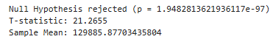
Figure 15 T-Test Result for Average Balance of Defaulting Customers

Feature Engineering
Feature engineering is the process of creating new features from existing ones to improve the performance of a machine-learning model. This involves transforming raw data into a more useful and informative form, by either creating new features from the existing data or selecting only the most relevant features from the raw data. (Provost & Fawcett, 2013)
The goal of feature engineering is to extract relevant information from the raw data and represent it in a way that can be easily understood by the machine learning model. The success of a machine learning model depends heavily on the quality of the features used as inputs, so feature engineering plays an important role in model performance.
During feature engineering, we noticed that some values in the bill amount columns were negative. In a real credit card dataset, this is not possible because a bill represents the amount of money a customer owes, and it should always be positive. Negative values are usually caused by data entry mistakes or other inconsistencies. For this reason, we removed all rows where the bill amount was below zero to ensure the dataset remained realistic and reliable. (Provost & Fawcett, 2013)
After cleaning the bill amounts, we also re-encoded some categorical variables to make them more suitable for machine learning models. For example, we changed the values in the SEX column from 1 and 2 to 0 and 1 to keep the format consistent with binary variables. WE applied similar re-encoding to the EDUCATION and MARRIAGE columns. This step helps the models interpret these categories correctly and improves overall model performance.

Balancing the data
From our previous visualization, we observed that the target variable is highly imbalanced. Most customers did not default, while only a small portion defaulted. This imbalance can cause our machine learning models to become biased toward the majority class, which reduces the model’s ability to correctly identify defaulting customers. (Alam, et al., 2020)
In this project we used SMOTE (Synthetic Minority Oversampling Technique). SMOTE creates synthetic examples for the minority class rather than simply duplicating existing ones, allowing the dataset to become more balanced in a meaningful way. (Chen & Zhang, 2021)
The method is used to oversample the minority class (defaulted = 1) by creating synthetic samples.
Before applying SMOTE, we had 22,883 non-defaulting customers (majority class) and 6,527 defaulting customers (minority class). After applying SMOTE, the dataset became fully balanced, with 22,883 defaulting customers and 22,883 non-defaulting customers, as shown in Figure 16.
Figure 16 Comparison of Class Counts Before and After SMOTE

Building the Machine Learning Models

Splitting the Data
As we are attempting to find the prediction from customers who would default, we determined that the target variable is defaulted. In the character matrix "X" and the target variable "y" are inputs produced by the SMOTE technique. Furthermore, it is specified that the test size should be 20% of the total data size, and the random state is set to 42 for reproducibility. Test sizes of 10% and 30% were performed. However, the 20% test size delivered the best performance in our model.
Figure 17 Train and Test Code

Data Scaling
To prepare the dataset for machine learning, I applied StandardScaler to scale all numerical features. Feature scaling is important because many algorithms are sensitive to the magnitude of the input values. Without scaling, features with larger numeric ranges can dominate the learning process and negatively affect model performance.
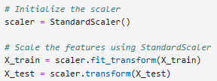
Figure 18 Scaling code

Model Building Process
Three different machine learning models were applied in this analysis: Logistic Regression (LR), K-Nearest Neighbours (KNN) and Random Forest Classifier (RF). The evaluation followed four main steps:
- First, the accuracy of each model was measured by fitting the model using the default hyperparameters.
- Second, 10-fold stratified cross-validation was used to observe the minimum accuracy, maximum accuracy, and average accuracy across all folds.
- Third, GridSearchCV was applied to identify the optimal hyperparameters for each model.
- Fourth, to compare performance improvements, each model was retrained and evaluated using the best hyperparameters. (Raschka, 2015)

Cross-Validation Method

According to previous research, cross-validation is one of the most common techniques for resampling data and estimating the true prediction error of machine learning models. It helps assess how well a model generalizes and reduces the risk of overfitting.
In k-fold cross-validation, the dataset is randomly divided into k subsets. The model is trained on k–1 folds and validated on the remaining fold. This process is repeated until every fold has been used once as the validation set.
Because the dataset was originally imbalanced, stratified cross-validation was used. This ensures that each fold maintains the same class distribution as the complete dataset, providing more reliable performance estimates. (Kohavi, 1995)

Hyperparameter Tuning
In this analysis, GridSearchCV was used to determine the optimal hyperparameters for Logistic Regression, KNN, and Random Forest.
GridSearchCV systematically evaluates all possible combinations of parameter values using cross-validation.
Previous findings highlight the importance of tuning key parameters:
- Logistic Regression: regularization strength (C)
- KNN: number of neighbours, distance metric, and weighting method
- Random Forest: number of trees (n_estimators), number of features to consider at each split (max_features), and minimum samples per leaf

Studies also show that tuning these parameters can significantly improve performance, especially for KNN and Random Forest models. Therefore, these findings were considered during the tuning stage of this project. (Lemaître, et al., 2017)

Building Logistic Regression Model
In this report, we import the Logistic Regression model from the Sklearn library and fit it using the default parameters. Then, we apply GridSearchCV to identify the optimal hyperparameters for the model. After obtaining the best parameters, we fit the Logistic Regression model again using these optimized values.

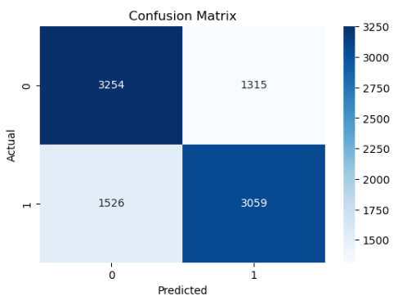
Figure 19 Confusion Matrix : Logistic regression Model
In Figure 19, we observe that the model predicted 3,254 true negatives (TN) and 3,059 true positives (TP), while misclassifying 1,526 instances as false negatives (FN) and 1,315 instances as false positives (FP).
Using the default hyperparameters, the Logistic Regression model performed consistently across the dataset.
The minimum accuracy score was 0.6811, and the maximum accuracy score was 0.6877 across the 5 folds.
The average accuracy score was approximately 0.6846 across the 5 folds.
After tuning the model with GridSearchCV, the performance did not improve.
The minimum accuracy score after tuning was 0.6833, and the maximum accuracy score remained 0.6877 across the 5 folds.
The average accuracy score after tuning was 0.6869, which is almost identical to the default model.
Both the default and tuned models achieved the same precision, recall, and F1-scores (all around 0.69).
This means that hyperparameter tuning did not increase performance, and the model behaved similarly in both cases.

Building KNN Model
According to Cover and Hart (1967), the K-Nearest Neighbors (KNN) algorithm is one of the simplest yet highly effective classification techniques. However, its performance depends strongly on several hyperparameters, such as the number of neighbors (k), the distance metric, and the weighting method. Therefore, identifying the optimal combination of these hyperparameters is essential to improve model accuracy.
Similarly to the previous models, the same evaluation steps were followed for KNN. The model was first tested using the default hyperparameters, then cross-validation was performed, and finally GridSearchCV was used to obtain the best parameter settings.
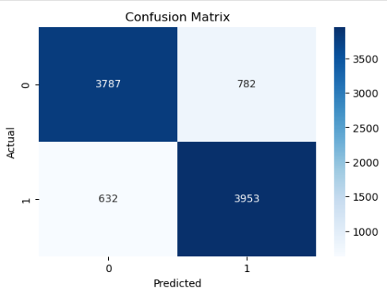
Figure 20 Confusion Matrix: KNN Model

In Figure 20, we observe that the model predicted 3787 true negatives (TN) and 3953 true positives (TP), while misclassifying 632 instances as false negatives (FN) and 782 instances as false positives (FP).
We notice that the model using default hyperparameters performed reasonably well:
The minimum accuracy score across 5 folds was 0.7736, and the maximum accuracy was 0.7981.
The average accuracy score achieved by the model was 0.7870 across 5 folds.
After applying GridSearchCV, the best hyperparameters identified were:
- n_neighbors = 5
- weights = distance
- metric = Manhattan
- p = 1

With these tuned parameters, the KNN model showed a clear improvement in performance:
The tuned model achieved an accuracy score of 0.85, showing a noticeable increase compared to the default model.
The model’s precision and recall improved from 0.79 to 0.85, demonstrating stronger predictive performance after tuning.

Building Random Forest Classifier Model
Random Forest Classifier Model was imported from the Sklearn library. Similarly, to the previous model, we fit the model using the default parameters. Then we used GridSearchCV to find the optimal hyperparameters. After getting the optimal results, we fit the model again using the optimal hyperparameters.
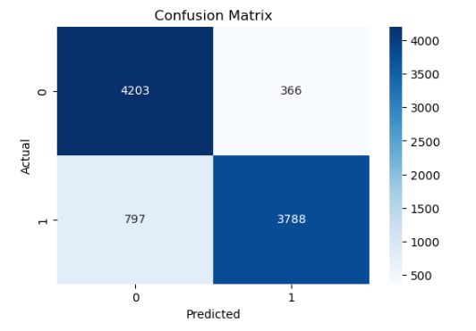
Figure 21 Confusion Matrix: Random Forest Model
In Figure 21, we observe that the tuned KNN model predicted 4203 true negatives (TN) and 3788 true positives (TP).
The model misclassified 797 instances as false negatives (FN) and 366 instances as false positives (FP).
This indicates that the tuned KNN model performs strongly on both classes, with a notably higher number of correctly identified positives and negatives compared to misclassified ones.
For the Random Forest Classifier, the default model showed strong and stable performance during validation. Using 5-fold cross-validation, the accuracy ranged from 0.8718 to 0.8832, with an average accuracy of 0.8790. After applying GridSearchCV, the best hyperparameters identified were: n_estimators = 75, max_depth = 70, min_samples_split = 2, and min_samples_leaf = 3. The tuned model achieved a consistent accuracy of 0.8729 across all folds. Overall, the results show that the default Random Forest model performed slightly better than the tuned version, with higher precision and recall scores. This indicates that hyperparameter tuning did not significantly improve performance, and the baseline Random Forest configuration was already well-suited for this dataset.

Comparison of Machine Learning Models Performance
The Random Forest Classifier Model had the best performance when compared with the other two models used in this analysis.
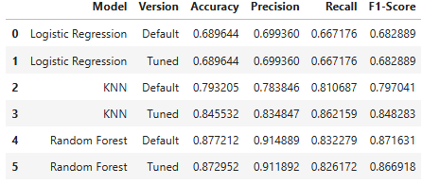

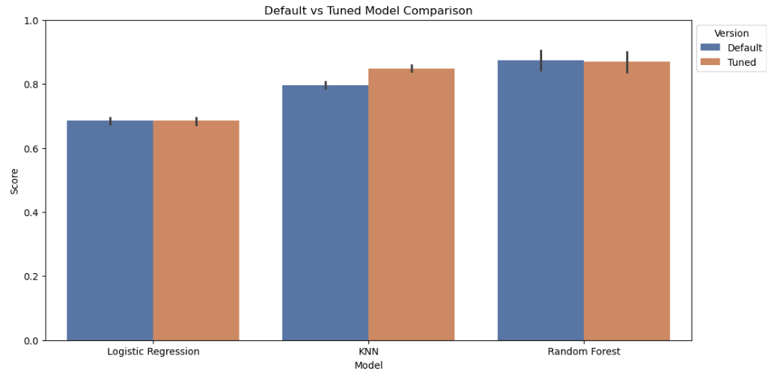
Figure 22 Comparison of Performance: Machine Learning Models

Feature Importance
Since Random Forest was the best-performing model in this study, we used it to analyse feature importance. The feature importance graph shows which variables contribute the most to predicting whether a customer will default. As shown, PAY_1 is by far the most important feature, followed by PAY_2, indicating that recent payment history has the strongest influence on the model’s predictions. Other features such as MARRIAGE, SEX, EDUCATION, BILL_AMT1, LIMIT_BAL, and AGE also play a role, but with lower importance scores. (Brown Iain, 2012)
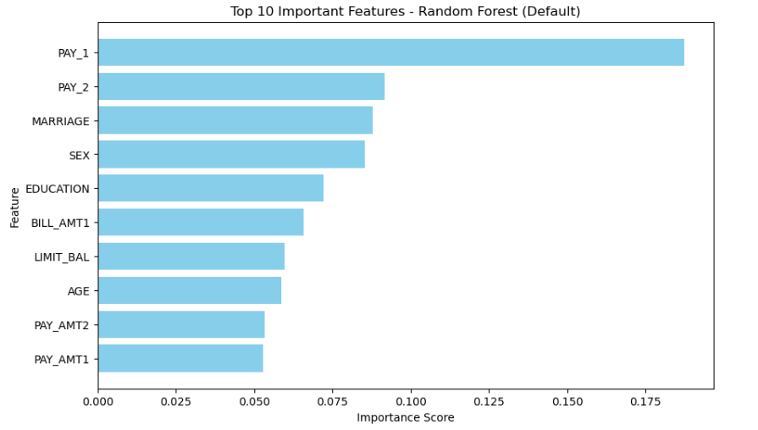
Figure 23 Feature Importances

Model Interpretation with Shapash
To better understand how the Random Forest model makes its predictions, I used Shapash to explain the results. Shapash creates an interactive dashboard that shows how much each feature influences the model’s decisions. After preparing a sample of 300 test records, I compiled the SmartExplainer and launched the Shapash web application. This tool helped me see which features had the strongest impact on the predictions and made the model’s behaviour easier to interpret. (Assegie, et al., 2024)

Conclusion
In this project, we tackled a classification problem in which we had to classify and predict whether a credit card holder is likely to default on their payments. This problem is important for credit card companies, as it allows them to identify risky borrowers and take appropriate measures to minimize their losses.
- We started by importing the dataset, and necessary libraries and conducted exploratory data analysis (EDA) to get a clear insight into each feature by separating the dataset into numeric and categoric features.
- After that, the outliers and null values were checked from the raw data. Data were transformed to ensure that it was compatible with machine learning models.
- In feature engineering we transformed raw data into a more useful and informative form, by encoding and feature selection. We handled target class imbalance using SMOTE.
- Once the data was prepared, we scaled the features and applied three machine learning models: Logistic Regression, K-Nearest Neighbours (KNN), and Random Forest. Each model was first tested with default parameters, and then we used cross-validation and GridSearchCV to tune the hyperparameters and compare performance.
- After comparing all the models, KNN and Random Forest showed the strongest performance, especially in terms of recall. KNN achieved the highest recall score, making it the most effective model for identifying customers who are likely to default. Random Forest also performed very well, offering strong recall and the highest F1-score among the three models.
- Finally, we conducted model interpretation using feature importance and Shapash to understand which features contribute the most to the predictions. This helps ensure the model is reliable, explainable, and suitable for decision-making in a financial context.

References
Alam, T. M. et al., 2020. An investigation of credit card default prediction in the imbalanced datasets. IEEE Access, Volume 8, p. 201 173–201 198.
Assegie, T. A. et al., 2024. Consistency, local stability, and approximation of Shapash explanation. TELKOMNIKA (Telecommunication Computing Electronics and Control), Volume 673–680, p. 22.
Brown Iain, M. C., 2012. An experimental comparison of classification algorithms for imbalanced credit scoring data sets. Expert Systems with Applications, 39(3), p. 3446–3453.
Chen, Y. & Zhang, R., 2021. Research on Credit Card Default Prediction Based on k-Means SMOTE and BP Neural Network. Complexity, Volume 2021, p. Article ID 6618841.
Field, A., 2013. Discovering Statistics Using IBM SPSS Statistics. 4th ed. London: Sage Publications.
Henley, D. J. H. &. W., 1997. Statistical classification methods in consumer credit scoring: a review. Journal of the Royal Statistical Society: Series A, 160(3), p. 523–541.
Kohavi, R., 1995. A Study of Cross-Validation and Bootstrap for Accuracy Estimation and Model Selection. San Francisco, CA, USA, Morgan Kaufmann Publishers Inc..
Kubat, M., 2017. An Introduction to Machine Learning. 2nd ed. Cham: Springer.
Lemaître, G., Nogueira, F. & Aridas, C. K., 2017. Imbalanced-learn: A Python Toolbox to Tackle the Curse of Imbalanced Datasets in Machine Learning. Journal of Machine Learning Research, 18(17), p. 1–5.
Martens, D., Baesens, B., Van Gestel, T. & Vanthienen, J., 2007. Comprehensible credit scoring models using rule extraction from support vector machines. European Journal of Operational Research, 183(3), p. 1466–1476.
Provost, F. & Fawcett, T., 2013. Data Science for Business: What You Need to Know About Data Mining and Data-Analytic Thinking. Sebastopol, CA: O'Reilly Media.
Raschka, S., 2015. Python Machine Learning. 2nd ed. Birmingham, UK: Packt Publishing.
Shearer, C., 2000. The CRISP-DM model: the new blueprint for data mining. Journal of Data Warehousing, 5(4), pp. 13-22.
Tan, P.-N., 2019. Introduction to Data Mining. 2nd: Pearson Education Limited.
Vaisman, D. et al., 2020. Data Science and Machine Learning: Mathematical and Statistical Methods. Boca Raton, FL: CRC Press.
Yeh, I.-C. a. L. C.-h., 2009. The comparisons of data mining techniques for the predictive accuracy of probability of default of credit card clients. Expert Systems with Applications, 36(2), p. 2473–2480.
Zhou L. , 2018. Credit card fraud detection model based on deep learning. International Journal of Security and Its Applications, 10(8), p. 1–10.

