

Assessment Cover Page

Student Full Name | Yassine Zohair
Student Number | 2025118
Module Title | Strategic thinking
Assessment Title | CA 3 Final Submission
Assessment Due Date | 18/05/2025
Date of Submission

Declaration
By submitting this assessment, I confirm that I have read the CCT policy on academic misconduct and understand the implications of submitting work that is not my own or does not appropriately reference material taken from a third party or other source.
I declare it to be my own work and that all material from third parties has been appropriately referenced.
I further confirm that this work has not previously been submitted for assessment by myself or someone else in CCT College Dublin or any other higher education institution.

Contents

Introduction 3
Project plan: 3
Business Understanding: 3
Data Understanding: 4
Data Preparation: 6
Statistical Analysis: 14
Modeling and findings: 15
Conclusion: 16
References: 16

Introduction:
In the last few years, credit card usage has grown, and with that, the risk of default by individuals in paying their credit card dues on time. This creates big problems for bank and credit card companies (Zhou et al., 2018). When a customer defaults on payment, the company losses money. That’s why it’s important to find a way to identify who might default before it happens.
In this project, I put into practice the development of machine learning models that can be used to solve this problem. My goal was to find out if we can use past data set about customers like their age, income, education and how they paid last month to predict if they are going to default on their next payment (Brown & Mues, 2012).
Banks and credit card companies constantly seek ways to reduce the risk of losing money when customers fail to make payments. One of their biggest challenges is identifying in advance which customers are likely to miss their credit card payments. If a company can predict this accurately, it can take proactive steps such as lowering a customer's credit limit or offering financial advice to avoid potential losses (Hand & Henley, 1997).

Project plan:
In this project, I will take a simple step-by-step approach to finish my task. I will work with a real dataset from the UCI Machine Learning Repository. It contains information about 30,000 credit card customers. I followed the CRISP-DM process in this project, which means I will explore the data to see what kind of data it consists. I will clean the data, create visualizations, and preprocess the data. Next, I will do some basic statistics to see which features are important. Lastly, I will build different machine learning models and compare their performance (Shearer, 2000).

Business understanding:
Banks and credit card companies advance money to individuals in anticipation that they pay it back on time. But sometimes the customers don't pay their dues. When customers repeatedly don't pay their dues, it creates a vast monetary risk for the banks. If they could know in advance which customers will default on payments, they can do something to reduce that risk. Prediction if the customer can pay help banks make informed decisions and avoid huge financial losses. In simple terms, this is a classification problem, the model must classify as to whether or not the customer will default (yes or no). Solving this problem enables us to supply companies with an instrument that will assist them in detecting default customers and focusing where it’s needed most (Lessmann et al., 2015).

Data understanding:
At this stage, we need to look closely at the data we have. This is important because it helps us find any problems early and makes the next step, data preparation, easier. Data preparation takes a lot of time, so it's important to understand the dataset well from the start. (Provost & Fawcett, 2013)
I used the .shape function, I found that the dataset contains 30,000 rows and 25 columns. This means we have 30,000 different customers and 25 pieces of information about each one.
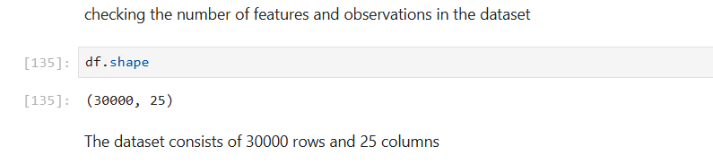
Next, I used .head(), I reviewed the first few rows to understand the data. Each customer has personal details like age, gender, education, and marital status. The ID column isn’t useful. Key columns like PAY_0 to PAY_6 show repayment history, which is valuable for predicting defaults. BILL_AMT1-6 and PAY_AMT1-6 show billing and payment behavior. Overall, the dataset includes both personal info and payment history, and that is essential for building a predictive model. (Martens et al., 2007).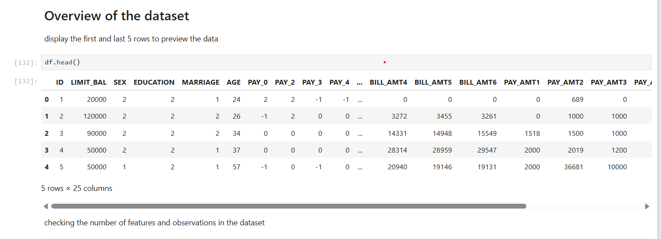
Then, with the.info() function, I verified the data types and missing values. The output showed that most features were integers. Luckily, there were no missing values, so imputation or cleaning in that regard was not necessary.

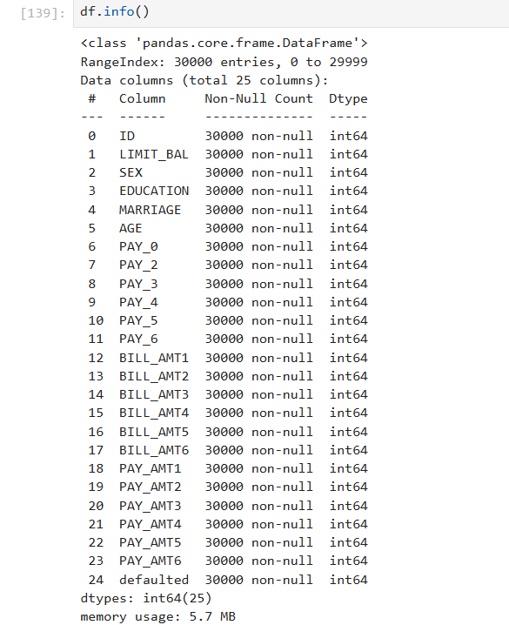

Finally, I used the.describe() function to see summary statistics of the dataset's numerical columns. The function gave me useful numbers like the mean, the median, minimum, maximum, and standard deviation.
I constate that the average age is 35, with customers between 21 and 79 years old. For PAY_0, values range from -2 to 8, where -1/0 means on-time payment and higher values indicate delays, with 8 being a serious late payment. These statistics allowed me to visualize the range and diversity of the data. For example, some people have very high bills and some don't. Some always pay on time and some are always late. This kind of diversity is what is required for the machine learning model to find patterns and make accurate predictions. (Thomas, 2000).

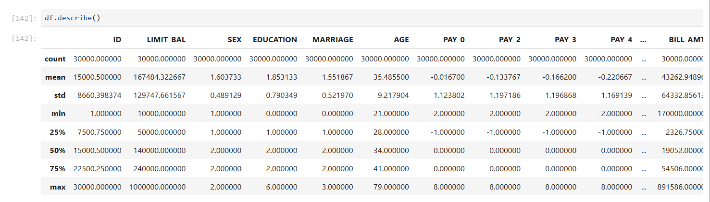

Data preparation:

After understanding the dataset, the next step is to prepare the data so that it could be used in machine learning models. This step is very important because the model can only learn well if the data is clean and in the right format.
The first thing I did was to check for missing values. I used the. isnull().sum() function, and I found that there were no missing values in the dataset.
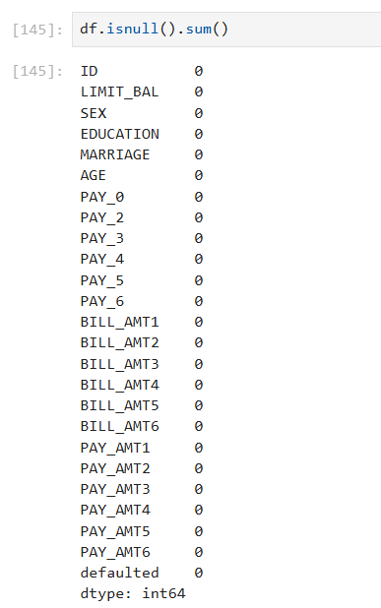

Then I used the .duplicated() function to check if there are a duplicated row, and I found that there were no duplicated rows in the dataset.
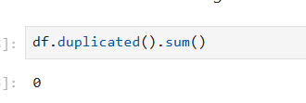

Next, I removed the “ID” column. This column was just a unique identifier for each row and didn’t help with the prediction, so it was not needed.
Then, I renamed the column PAY_0 to PAY_1. I did this because the repayment status columns were named PAY_2, PAY_3, PAY_4, etc. but there was no PAY_1, only PAY_0. This was confusing. So, I changed PAY_0 to PAY_1 to keep the names in the correct order and make the data easier to understand.
To get a better idea of the spread of the target variable, I created a bar chart (Figure 1). With this plot, I was able to see how many customers each category has.
From the chart, I noticed that about 77.88% of the customers did not default and only 22.12% actually defaulted. This shows that the data is imbalanced, there are much more non-defaulters than defaulters. It is very important to realize this even before training any machine learning model (Brown & Mues, 2012).
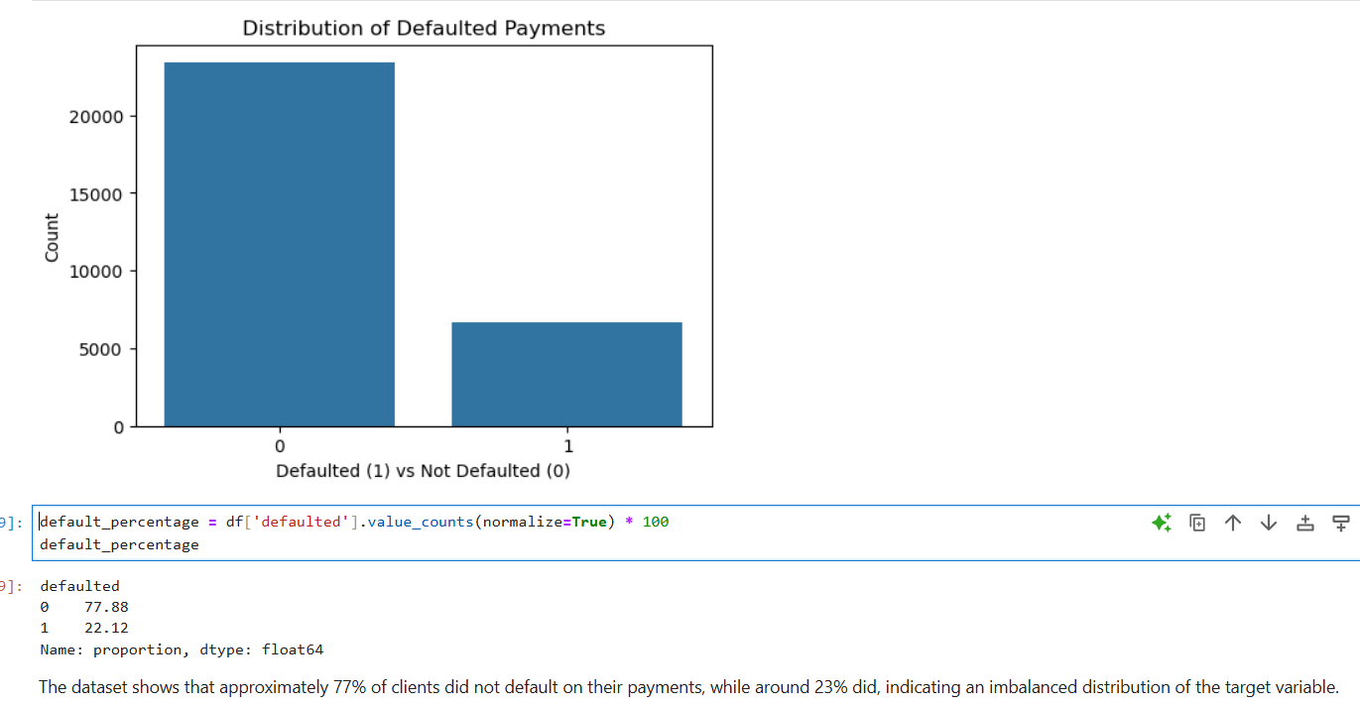
Figure 1 : Distribution of the target variable (defaulted)

To observe how the credit limit is distributed across customers, I constructed a histogram (Figure 2) of the LIMIT_BAL column. This feature shows the maximum amount of credit extended to each customer, and it is one of the most important features in the dataset. I used a histogram with a KDE line in an effort to get a clearer view of the shape of the distribution.
It is evident from the graph that the data is not normally distributed. There are the majority of customers whose credit limit is between 0 and 200,000, and a sharp peak between 50,000 and 100,000. There are fewer with higher credit limits, and very few reach beyond 500,000. This creates a right-skewed distribution in which most of the values are on the lower end and very few are very high. (Martens et al., 2007).
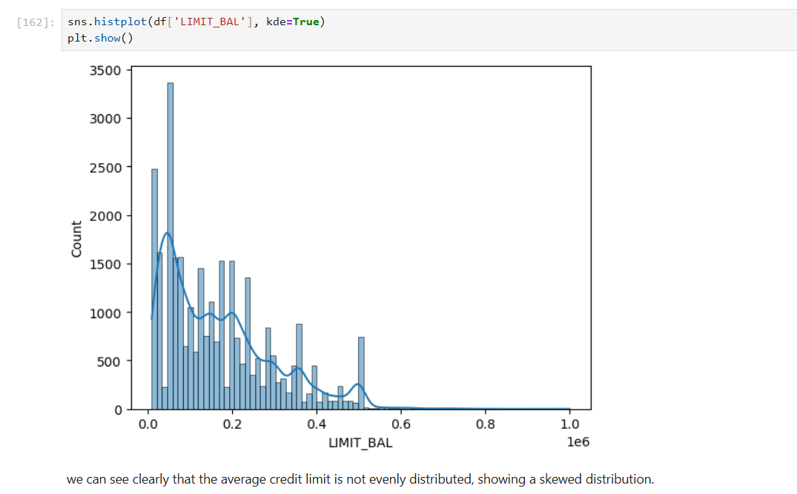
Figure 2: Credit Limit (LIMIT_BAL) Distribution

In order to have more insight into the demographic breakdown of the dataset, I created a count plot of the SEX column.
The bar chart (Figure 3) shows that there are more female customers than male customers in the dataset. Exactly, there are around 18,000 females and 12,000 males.
I came up with this plot to see if the gender is balanced in the dataset, because too many records of one group could potentially influence how the model learns and makes predictions. It is a good idea to also check if gender could be a significant feature to incorporate in making default predictions. (Martens et al., 2007).
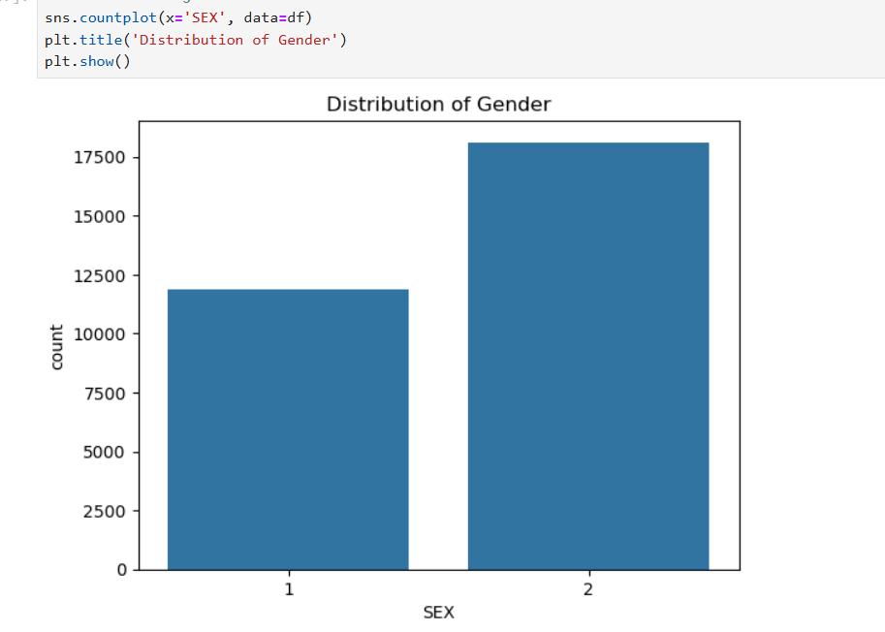
Figure 3: Gender Distribution

While exploring the EDUCATION column, I found that the data has more categories than expected. According to the dataset description, only four values were expected (1 = Graduate school, 2 = University, 3 = High school, 4 = Others), however, I found three unknown values: 0, 5, and 6. These were not mentioned in the dataset description. To fix this and have clean data, I decided to group these unknown values (0, 5, and 6) to the "Others" category (which is 4). I did this using the.replace() method.

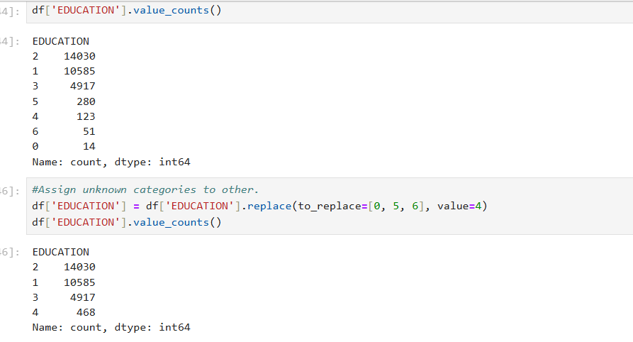
Figure 4: EDUCATION value correction before grouping

In the chart (Figure 5) below we can observe the relationship between education level and defaulting. Most of the people who didn't default were at graduate school or university. Among those who defaulted, most were university students. This tells us that default could be influenced by education, so it would be a good idea to put it in our model.

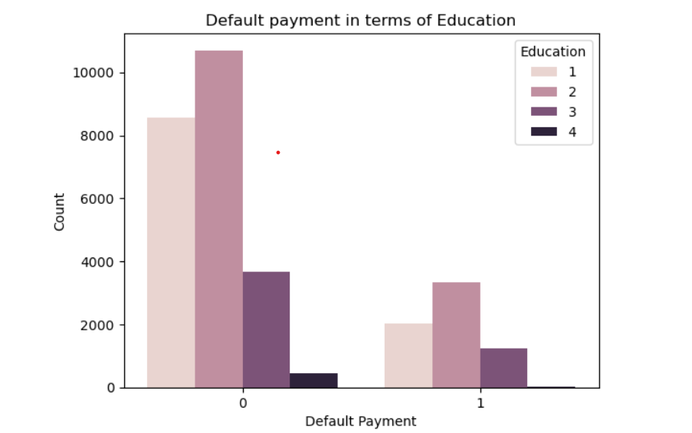
Figure 5: Default Distribution by Education Level

While checking at the MARRIAGE column, we have an additional value in our dataset that's not expected: 0. As per our dataset description, the correct values are: (1 = Married, 2 = Single, 3 = Others). The value 0 was not labeled, so I treated it as an unknown category. To fix this, I replaced 0 with 3 (Others). (Martens et al., 2007).
After this step, the column had only three unique values as required. This made the data more consistent and easier to handle for analysis and model training.
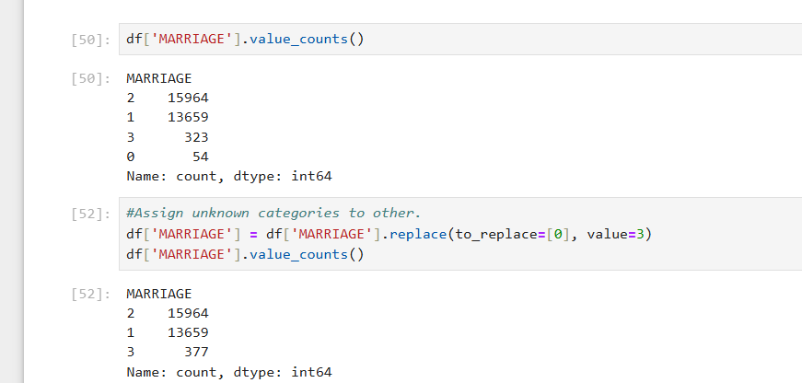
Figure 6: MARRIAGE value correction before grouping

The chart below (Figure 7) we can see that the biggest groups of people who did not default are single or married. For defaulters, the sizes for these two groups are also bigger. The "Others" category includes the smallest sizes, most likely since there are fewer people in this category.

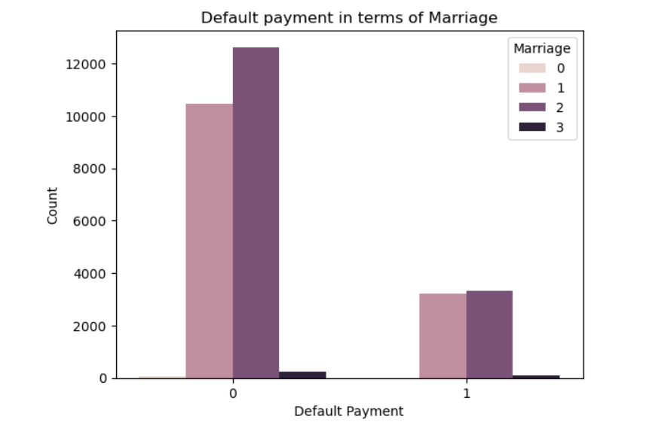
Figure 7: Default Distribution by Marital Status

The above chart (Figure 8) shows that most of the customers are aged between 25 and 40 years, and also the highest defaults are in this age group. Defaults decrease with age. This means that age will have an effect on payment behavior and can turn out to be useful in our model.
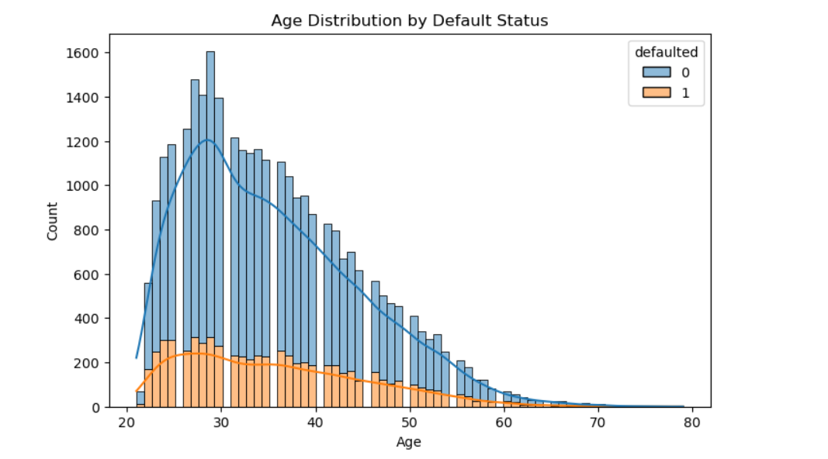
Figure 8: Age Distribution by Default Status

The heatmap above (Figure 9) shows how features are correlated with each other.
Payment history dimension attributes (PAY_1 to PAY_6) are strongly correlated.
PAY_1 is most strongly positively correlated with defaulted, meaning delayed payments can lead to default.
Some bill and payment amount also have high correlations with one another (Martens et al., 2007).
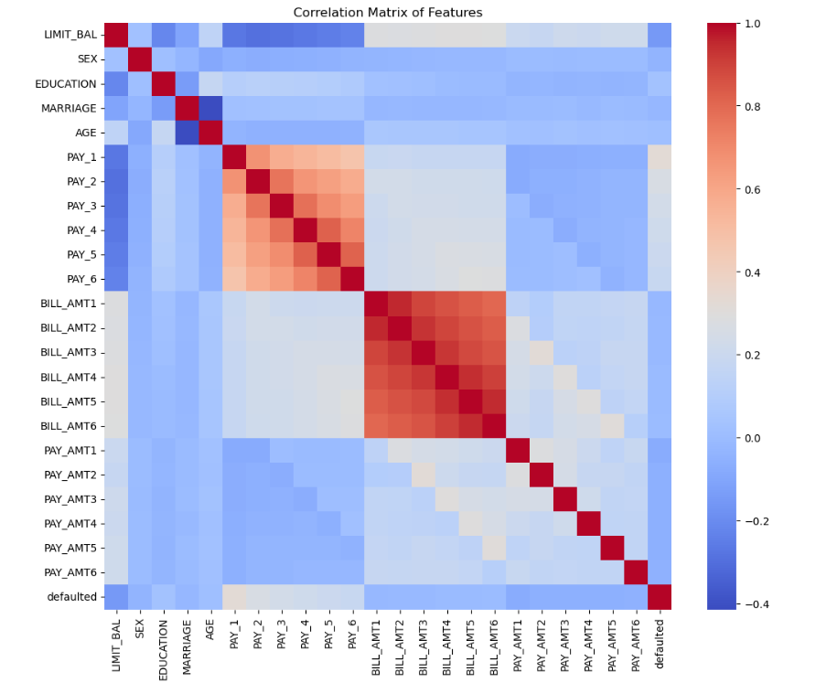
Figure 9: Correlation Matrix

Statistical Analysis:

To compare the differences between customers who defaulted and those who didn’t, I used some statistical tests. From these tests, I was able to understand whether variables like credit limit (LIMIT_BAL), age, and gender (SEX) have a significant relation with default status.
First, I tested if the LIMIT_BAL and AGE columns are normally distributed by the Shapiro-Wilk test. Since the dataset is large, I sampled 500 values randomly. The p-values were very low (less than 0.05), suggesting that the data is not normally distributed.
As the data is not normally distributed, I used the Mann-Whitney U test to compare values between defaulted and non-defaulted groups:
- For LIMIT_BAL, the test showed that the two groups differed by a wide margin (p < 0.05), implying that credit limit could be a factor in default.
- For AGE, the difference was wide as well, so age could have something to do with it as well.
- For SEX, the outcome was significant as well, so gender could be linked to default behavior as well.
These results helped me identify LIMIT_BAL (credit limit), AGE, and SEX (gender) as important features. Since all three showed statistically significant differences between customers defaulters and non-defaulters they may be helpful in predicting default. (Kubat, 2017).

Modeling:

After preparing and exploring the dataset, I built three machine learning models that predict whether a customer will default on a payment of his or her credit card. I have chosen Logistic Regression, KNN, and Random Forest for the comparison of simple and complex models.
These models are commonly used for classification problems like predicting defaults. They helped me with testing accuracy, handling unbalanced data, and figuring out which one gives better results.
I split the dataset into two parts prior to training the models (80% for training and 20% for testing).
For the KNN model, I scaled the features by StandardScaler. This is required since KNN uses distance for prediction, and high-value features can skew the result if they are not scaled.
All the models were trained on the training set and tested on the test set.
After training the models, I compared them based on accuracy, precision, recall, F1-score, and confusion matrices. (Breiman, 2001).
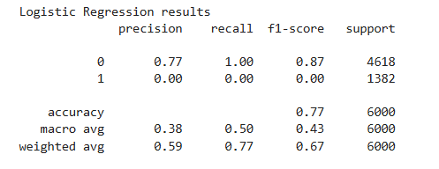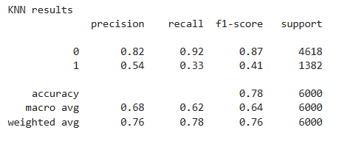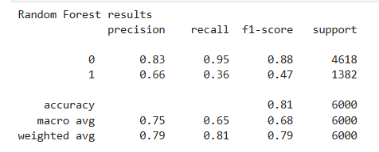

Based on these results, Random Forest was the most effective model. It gave an accuracy of 81%.
The original model performed poorly to identify defaulters (class 1), as shown in the confusion matrix. To fix that I will try another techniques to handle the class imbalance in the dataset like (Over-sampling, under-sampling and SMOTE).
The results show Over-sampling achieved the best performance, reaching 93.8% accuracy, while SMOTE resulted in 84.6%. Over-sampling maintained the full dataset and improved the model’s ability to correctly classify both classes. The confusion matrix (Figure 10) clearly shows improved classification of both classes using over-sampling.( Fernández 2018)

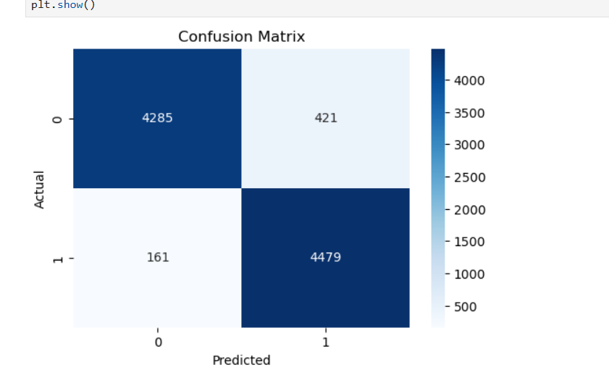
Figure 10: confusion matrix
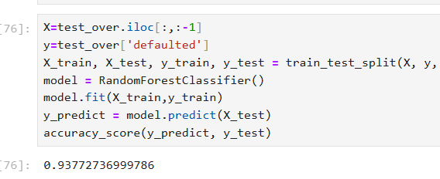
As a future recommendation, I plan to implement cross-validation to ensure the model's performance is consistent across different data splits. Additionally, I aim to apply hyperparameter tuning techniques like Grid Search to optimize model settings and further improve prediction accuracy.

Conclusion:
In this project, I analyzed a credit card default dataset to predict whether a customer would default on their next payment. I began with data exploration and cleaning the data, and then performed statistical analysis and visualization to understand the patterns and relationships between features and the target variable. I tested three machine learning models: Logistic Regression, K-Nearest Neighbors, and Random Forest. Among the three models, the highest performance was with Random Forest at 81% accuracy and better results in detecting customers who defaulted.

References:
- Breiman, L., 2001. Random forests. Machine learning, 45(1), pp.5-32.
- Brown, I. and Mues, C., 2012. An experimental comparison of classification algorithms for imbalanced credit scoring data sets. Expert Systems with Applications, 39(3), pp.3446-3453.
- Field, A., 2013. Discovering statistics using IBM SPSS statistics. 4th ed. London: Sage Publications.
- Kubat, M., 2017. An Introduction to Machine Learning. 2nd ed. Cham: Springer.
- Lessmann, S., Baesens, B., Seow, H.V. and Thomas, L.C., 2015. Benchmarking state-of-the-art classification algorithms for credit scoring: An update of research. European Journal of Operational Research, 247(1), pp.124-136.
- Martens, D., Baesens, B., Van Gestel, T. and Vanthienen, J., 2007. Comprehensible credit scoring models using rule extraction from support vector machines. European Journal of Operational Research, 183(3), pp.1466-1476.
- Provost, F. and Fawcett, T., 2013. Data Science for Business: What You Need to Know About Data Mining and Data-Analytic Thinking. Sebastopol, CA: O'Reilly Media.
- Shearer, C., 2000. The CRISP-DM model: the new blueprint for data mining. Journal of Data Warehousing, 5(4), pp.13-22.
- Thomas, L.C., 2000. A survey of credit and behavioural scoring: forecasting financial risk of lending to consumers. International Journal of Forecasting, 16(2), pp.149-172.
- Yeh, I.C. and Lien, C.H., 2009. The comparisons of data mining techniques for the predictive accuracy of probability of default of credit card clients. Expert Systems with Applications, 36(2), pp.2473-2480.
- Zhou, L., Xie, X., Wu, X. and Zhang, M., 2018. Credit card fraud detection model based on deep learning. International Journal of Security and Its Applications, 10(8), pp.1-10
- Fernández, A., García, S., Galar, M., Prati, R.C., Krawczyk, B. and Herrera, F., 2018. Learning from Imbalanced Data Sets. Cham: Springer.

