C Piscine
C 00
Summary: | THIS document is the subject for the C 00 module of the C Piscine @ 42.
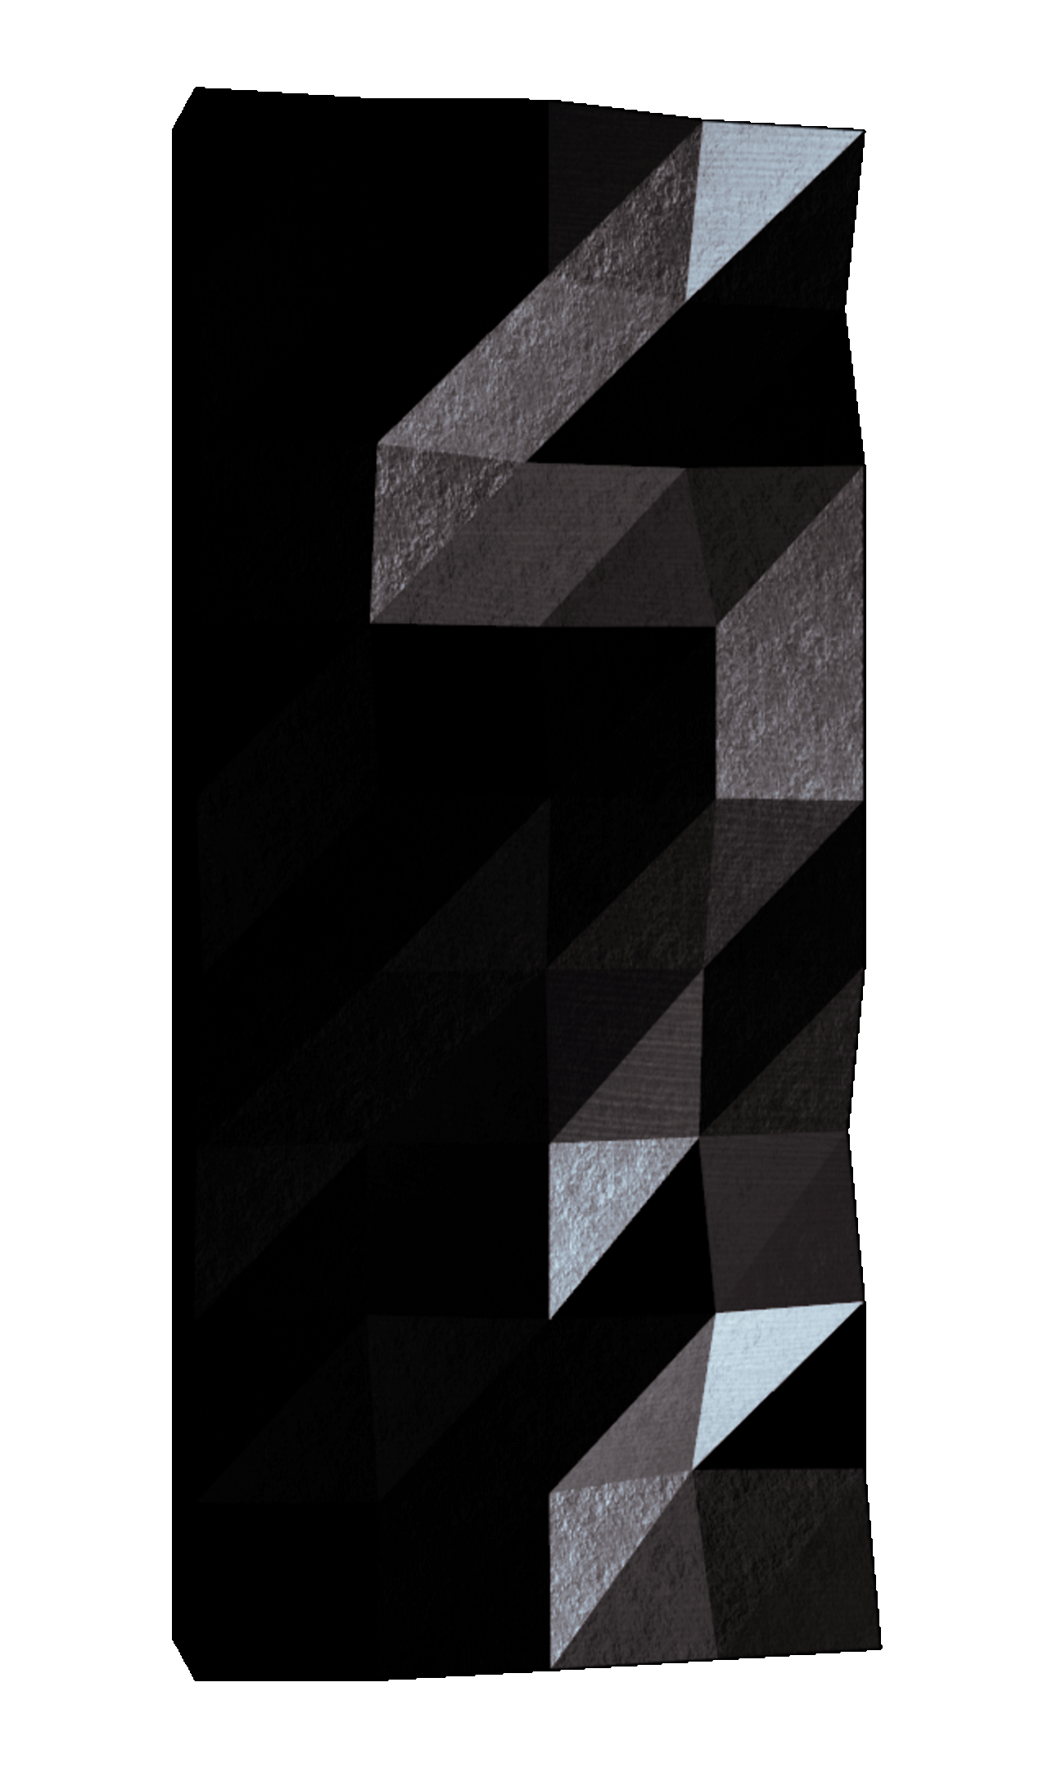

Contents
I | Instructions | 2
II | Foreword | 4
III | Exercice 00 : ft_putchar | 5
IV | Exercise 01 : ft_print_alphabet | 6
V | Exercise 02 : ft_print_reverse_alphabet | 7
VI | Exercise 03 : ft_print_numbers | 8
VII | Exercise 04 : ft_is_negative | 9
VIII | Exercise 05 : ft_print_comb | 10
IX | Exercise 06 : ft_print_comb2 | 11
X | Exercise 07 : ft_putnbr | 12
XI | Exercise 08 : ft_print_combn | 13

1

Chapter I
Instructions
• Only this page will serve as reference: do not trust rumors.
• Watch out! This document could potentially change up before submission.
• Make sure you have the appropriate permissions on your files and directories.
• You have to follow the submission procedures for all your exercises.
• Your exercises will be checked and graded by your fellow classmates.
• On top of that, your exercises will be checked and graded by a program calledMoulinette.
• Moulinette is very meticulous and strict in its evaluation of your work. It is entirelyautomated and there is no way to negotiate with it. So if you want to avoid bad surprises, be as thorough as possible.
• Moulinette is not very open-minded. It won’t try and understand your code if itdoesn’t respect the Norm. Moulinette relies on a program called norminette tocheck if your files respect the norm. TL;DR: it would be idiotic to submit a pieceof work that doesn’t pass norminette’s check.
• These exercises are carefully laid out by order of difficulty - from easiest to hardest.We will not take into account a successfully completed harder exercise if an easier one is not perfectly functional.
• Using a forbidden function is considered cheating. Cheaters get -42, and this gradeis non-negotiable.
• You’ll only have to submit a main() function if we ask for a program.
• Moulinette compiles with these flags: -Wall -Wextra -Werror, and uses gcc.
• If your program doesn’t compile, you’ll get 0.
• You cannot leave any additional file in your directory than those specified in thesubject.
• Got a question? Ask your peer on the right. Otherwise, try your peer on the left.
2

C Piscine | C 00
• Your reference guide is called Google / man / the Internet / ....
• Check out the "C Piscine" part of the forum on the intranet, or the slack Piscine.
• Examine the examples thoroughly. They could very well call for details that arenot explicitly mentioned in the subject...
• By Odin, by Thor ! Use your brain !!!
Norminette must be launched with the -R CheckForbiddenSourceHeader
flag. | Moulinette will use it too.
3

Chapter II
Foreword
Cod liver oil is a nutritional supplement derived from liver of cod
fish (Gadidae).
As with most fish oils, it has high levels of the omega-3 fatty acids,
eicosapentaenoic acid (EPA) and docosahexaenoic acid (DHA).
Cod liver oil also contains vitamin A and vitamin D.
It has historically been taken because of its vitamin A and vitamin D content.
It was once commonly given to children, because vitamin D has been shown toprevent rickets and other symptoms of vitamin D deficiency.
Contrary to Cod liver oil, C is good, eat some!
4

Chapter III
Exercice 00 : ft_putchar
Exercise 00
ft_putchar
Turn-in directory : ex00/
Files to turn in : ft_putchar.c
Allowed functions : write
• Write a function that displays the character passed as a parameter.
• It will be prototyped as follows :
void ft_putchar(char c);
To display the character, you must use the texttt write function as follows.
write(1, &c, 1);
5

Chapter IV
Exercise 01 : ft_print_alphabet
Exercise 01
ft_print_alphabet
Turn-in directory : ex01/
Files to turn in : ft_print_alphabet.c
Allowed functions : write
• Create a function that displays the alphabet in lowercase, on a single line, byascending order, starting from the letter ’a’.
• Here’s how it should be prototyped :
void ft_print_alphabet(void);
6

Chapter V
Exercise 02 :
ft_print_reverse_alphabet
Exercise 02
ft_print_reverse_alphabet
Turn-in directory : ex02/
Files to turn in : ft_print_reverse_alphabet.c
Allowed functions : write
• Create a function that displays the alphabet in lowercase, on a single line, bydescending order, starting from the letter ’z’.
• Here’s how it should be prototyped :
void ft_print_reverse_alphabet(void);
7

Chapter VI
Exercise 03 : ft_print_numbers
Exercise 03
ft_print_numbers
Turn-in directory : ex03/
Files to turn in : ft_print_numbers.c
Allowed functions : write
• Create a function that displays all digits, on a single line, by ascending order.
• Here’s how it should be prototyped :
void ft_print_numbers(void);
8

Chapter VII
Exercise 04 : ft_is_negative
Exercise 04
ft_is_negative
Turn-in directory : ex04/
Files to turn in : ft_is_negative.c
Allowed functions : write
• Create a function that displays ’N’ or ’P’ depending on the integer’s sign enteredas a parameter. If n is negative, display ’N’. If n is positive or null, display ’P’.
• Here’s how it should be prototyped :
void ft_is_negative(int n);
9

Chapter VIII
Exercise 05 : ft_print_comb
Exercise 05
ft_print_comb
Turn-in directory : ex05/
Files to turn in : ft_print_comb.c
Allowed functions : write
• Create a function that displays all different combinations of three different digits inascending order, listed by ascending order - yes, repetition is voluntary.
• Here’s the intended output :
$>./a.out | cat -e
012, 013, 014, 015, 016, 017, 018, 019, 023, ..., 789$>
• 987 isn’t there because 789 already is.
• 999 isn’t there because the digit 9 is present more than once.
• Here’s how it should be prototyped :
void ft_print_comb(void);
10

Chapter IX
Exercise 06 : ft_print_comb2
Exercise 06
ft_print_comb2
Turn-in directory : ex06/
Files to turn in : ft_print_comb2.c
Allowed functions : write
• Create a function that displays all different combination of two digits between 00and 99, listed by ascending order.
• Here’s the expected output :
$>./a.out | cat -e
00 01, 00 02, 00 03, 00 04, 00 05, ..., 00 99, 01 02, ..., 97 99, 98 99$>
• Here’s how it should be prototyped :
void ft_print_comb2(void);
11

Chapter X
Exercise 07 : ft_putnbr
Exercise 07
ft_putnbr
Turn-in directory : ex07/
Files to turn in : ft_putnbr.c
Allowed functions : write
• Create a function that displays the number entered as a parameter. The functionhas to be able to display all possible values within an int type variable.
• Here’s how it should be prototyped :
void ft_putnbr(int nb);
• For example:
◦ ft_putnbr(42) displays "42".
12

Chapter XI
Exercise 08 : ft_print_combn
Exercise 08
ft_print_combn
Turn-in directory : ex08/
Files to turn in : ft_print_combn.c
Allowed functions : write
• Create a function that displays all different combinations of n numbers by ascendingorder.
• n will be so that : 0 < n < 10.
• If n = 2, here’s the expected output :
$>./a.out | cat -e
01, 02, 03, ..., 09, 12, ..., 79, 89$>
• Here’s how it should be prototyped :
void ft_print_combn(int n);
13

