I’m new to AWS and They say the best way to learn is to teach, so bear with me, in this article ill show u how you can deploy a react app using “Amplify”.

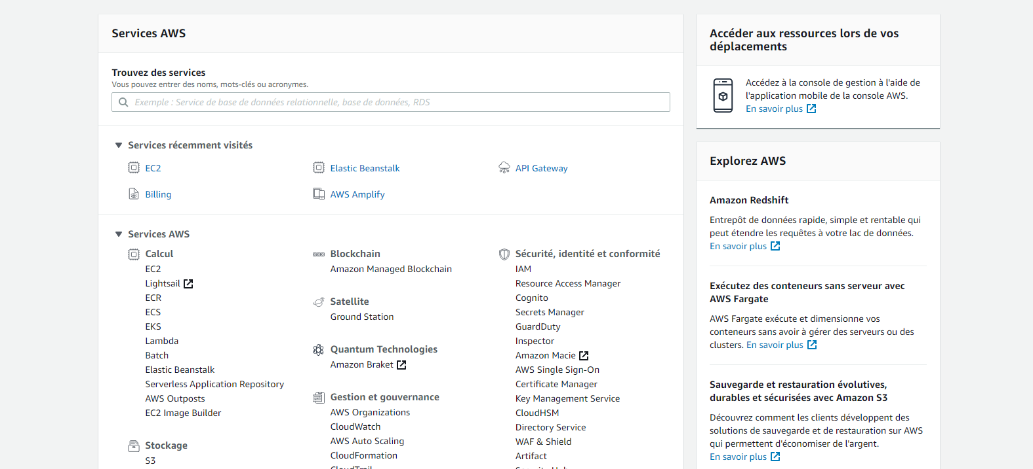First, we access to the aws console where we will type amplify

If there were no previous project this is the interface that you will be likely going to see

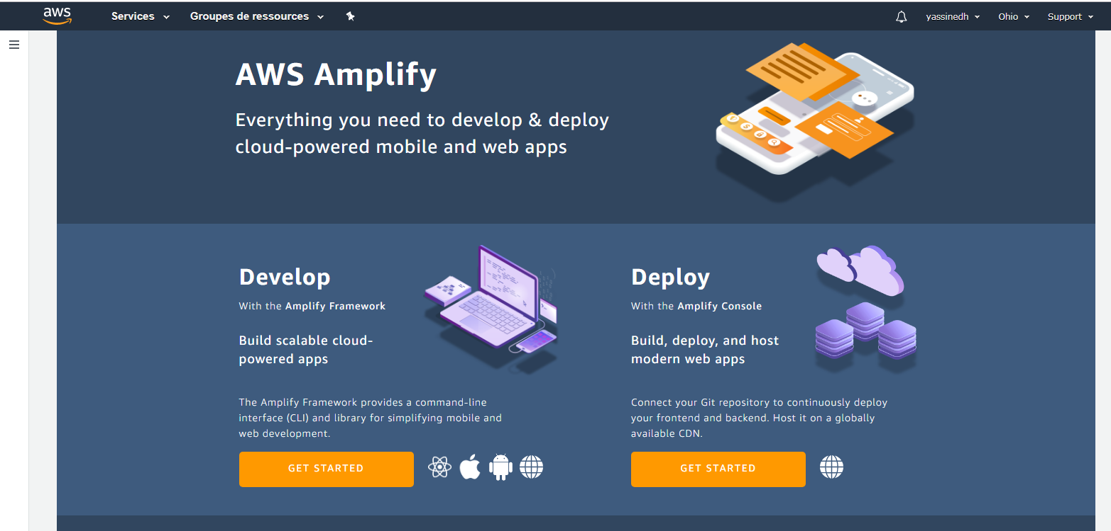

One thing to consider is that our little demo project will be deployed in the region of Ohio, you can simply click on the scroll down button to change it to the nearest region.

Once you set up the region, click on deploy

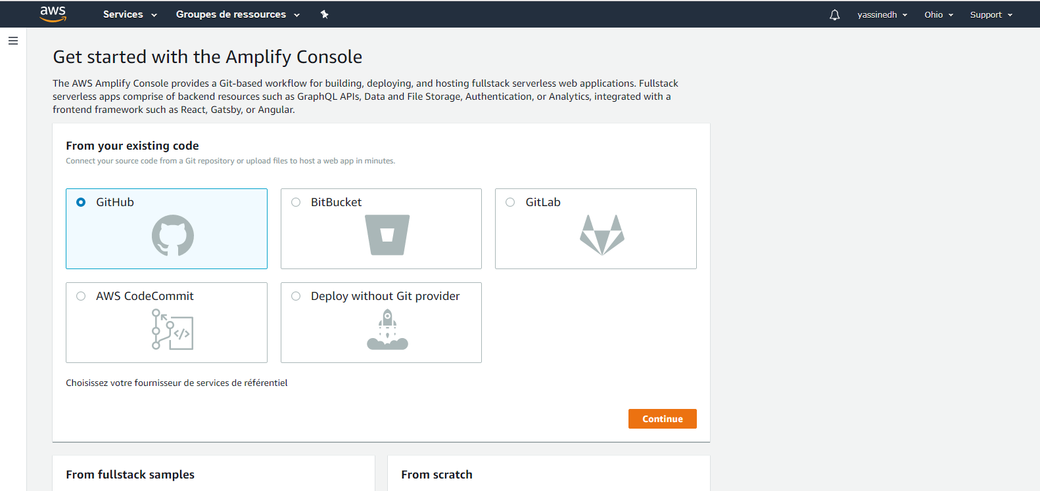

In this step, we choose which git repository has the code source, in this case Its GitHub, pop-up appears asking for permission to access GitHub, after validation we get this interface,

We fill the project name, which branch to deploy and we click next

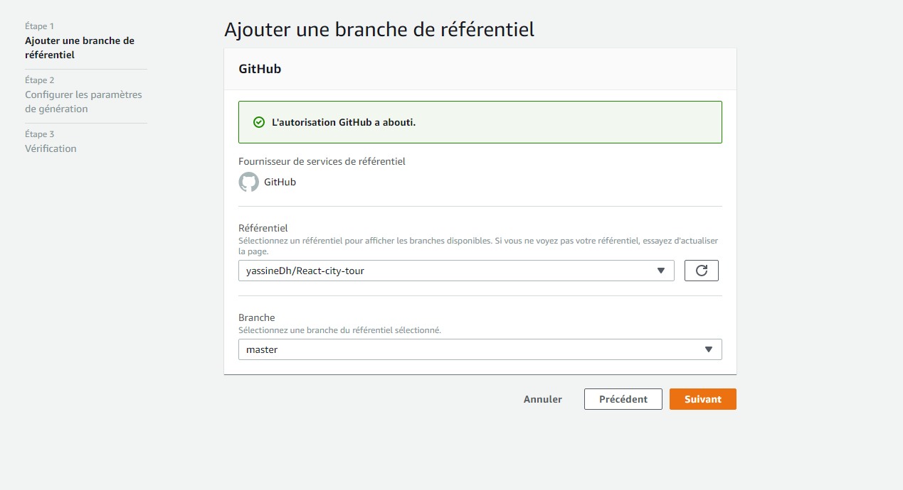

In this phase we have to wait a few minutes in order until all the icons are marked

\

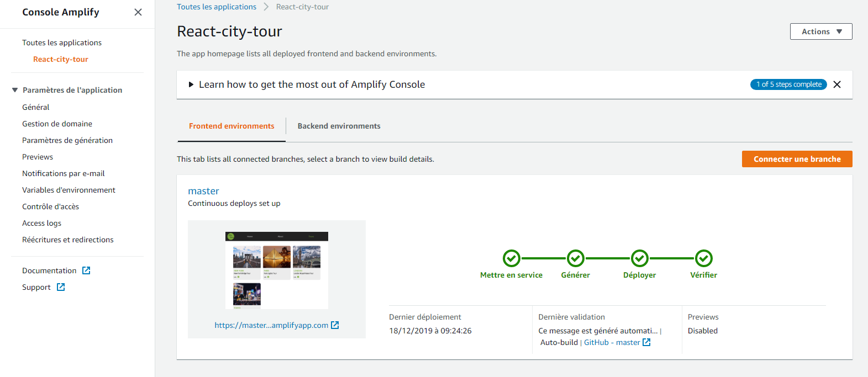

You see that a little image under the master, click on the blue link

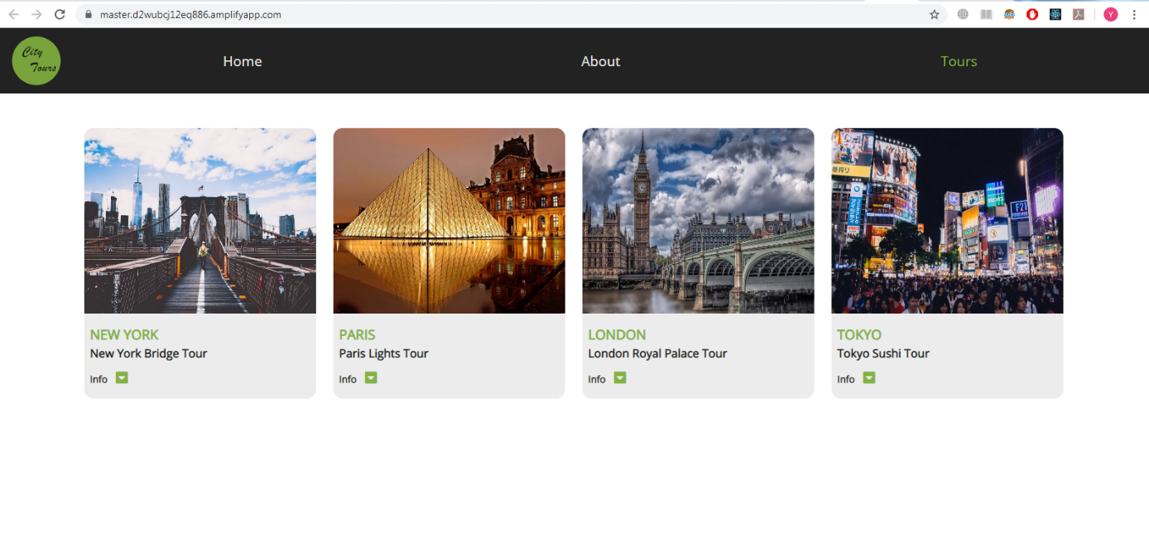

And Voila our website in online , anyone in the world can visit it

P.S: I want to thank the YouTube channel “coding addict” from where I got this app.

To see how to create it, here the link:

https://www.youtube.com/watch?v=HfJjzmSaLuQ