
TITLE : MediaNet incubator Platform

Software Architecture Engineering
By: Yassine cherni

Academic supervisor: Slim Guermazi

Corporate Internship Supervisor: Yassine Mechich

2022 - 2023
Je valide le dépôt du rapport PFE relatif à l’étudiant nommé ci-dessous / I validate the submission of the student’s report:
- Nom & Prénom /Name & Surname : Yassine Cherni

Encadrant Entreprise/ Business site Supervisor
- Nom & Prénom /Name & Surname : Yassine Mechich
Cachet & Signature / Stamp & Signature

Encadrant Académique/Academic Supervisor
- Nom & Prénom /Name & Surname : Slim Guermazi
Signature / Signature

Dedication
To my parents, for their unconditional support and everything they sacrificed along the way,
To my teachers, who passed on their knowledge with patience and rigor,
To my friends and colleagues, for their encouragement and their presence,
To everyone who, directly or indirectly, contributed to this work,
I dedicate this modest achievement.
— Yassine Cherni

Acknowledgements
I would first like to thank Medianet for welcoming me and giving me the opportunity to carry out this end-of-studies project in a genuinely stimulating professional environment.
My sincere thanks go to my company supervisor, Yassine Mechich, for their availability, their sound advice, and the rigorous follow-up they provided throughout this internship.
I would also like to thank my academic supervisor, Slim Guermazi, for their methodological guidance, their constructive feedback, and their availability despite a busy schedule.
I address my thanks to the members of the jury for the honor they do me by agreeing to evaluate this work.
Finally, I thank the entire teaching staff of ESPRIT for the quality of the training I received during my studies, as well as my family and friends for their constant support.

Table of Contents
Dedication 1
Acknowledgements 4
Table of Contents 5
List of Figures 7
List of Tables 8
General Introduction 1
Chapter 1 — General Framework 3
Introduction 3
1.1 Host Organization 3
1.1.1 General Presentation 3
1.1.2 Fields of Activity 3
1.1.3 Company Organization 4
1.1.4 Host Department 4
1.2 Project Overview 4
1.3 Study of the Existing Landscape 4
1.3.1 Description of Existing Practices 5
1.3.2 Critique of the Existing Landscape 5
1.4 Proposed Solution 6
1.5 Development Methodology 7
1.5.1 The Waterfall Cycle 7
1.5.2 Agile Methods (Scrum) 7
1.5.3 Methodology Chosen 7
Conclusion 8
Chapter 2 — Requirements Analysis and Specification 9
Introduction 9
2.1 Project Vision 9
2.1.1 Functional Requirements 9
2.1.2 Non-Functional Requirements 10
2.2 Requirements Specification 11
2.2.1 Identification of Actors 11
2.2.2 Identification of Use Cases 12
2.3 Detailed Requirements Specification 13
2.3.1 Textual Description of Major Use Cases 13
2.3.2 System Sequence Diagrams of Major Use Cases 18
2.3.3 Activity Diagrams 18
Conclusion 19
Chapter 3 — Design 20
Introduction 20
3.1 Class Diagram 20
3.1.1 Design Class Diagram 20
3.1.2 Class Descriptions 20
3.1.3 Data Dictionary 21
3.2 Design Sequence Diagrams 23
3.2.1 Tracked Session Notification 23
3.2.2 Visibility-Based Session Filtering 23
3.3 Component Diagram 24
Conclusion 25
Chapter 4 — Implementation 26
Introduction 26
4.1 Work Environment 26
4.1.1 Software Environment 26
4.1.2 Hardware Environment 26
4.1.3 Frameworks 26
4.1.4 Programming Languages 26
4.2 Architecture Adopted 27
4.3 Interfaces Delivered 28
4.4 Project Planning 29
4.5 Difficulties Encountered and Changes Made 30
4.6 Test Dataset 31
Conclusion 32
General Conclusion 33
Bibliography / Webography 34
Appendix A — Service and Port Map 35
Appendix B — Main REST Endpoints 36
Appendix C — Glossary 37

List of Figures
Figure 1.1 — Host organization logo
Figure 1.2 — Host organization chart
Figure 1.3 — Overview of the proposed solution
Figure 2.1 — Global use case diagram
Figure 2.2 — System sequence diagram: application submission (UC-2)
Figure 2.3 — System sequence diagram: AI-assisted evaluation (UC-7, UC-8)
Figure 2.4 — Activity diagram: application → selection → onboarding
Figure 2.5 — Activity diagram: notifying a session's participants
Figure 3.1 — Design class diagram
Figure 3.2 — Design sequence diagram: tracked session notification
Figure 3.3 — Design sequence diagram: visibility-based session filtering
Figure 3.4 — Component diagram of the platform
Figure 4.1 — Sequence diagram: stateless JWT authentication
Figure 4.2 — Login screen
Figure 4.3 — Programme dashboard (back-office)
Figure 4.4 — Visual Journey builder (back-office)
Figure 4.5 — Session detail (Details / Activities tabs)
Figure 4.6 — Evaluation dashboard and candidature review (with AI scoring)
Figure 4.7 — Participants hub and invitation template (placeholders + tracking link)
Figure 4.8 — Public programme page (front-office)
Figure 4.9 — Application form and jury evaluation page (front-office)
Figure 4.10 — End-of-studies project planning (Gantt chart)

List of Tables
Table 1.1 — Host organization fact sheet
Table 1.2 — Comparison of competing Tunisian offerings
Table 1.3 — Comparison of development methodologies
Table 2.1 — Identification of actors
Table 2.2 — List of major use cases
Table 3.1 — Description of domain classes
Table 3.2 — Data dictionary — Programme
Table 3.3 — Data dictionary — ProgrammePhase (Session)
Table 3.4 — Data dictionary — Candidature
Table 3.5 — Data dictionary — Evaluation
Table 3.6 — Data dictionary — Invitation
Table 4.1 — Software environment
Table 4.2 — Hardware environment
Table 4.3 — Service and port map
Table 4.4 — Project planning (sprints)
Table 4.5 — Test scenarios
Table A.1 — Extract of main REST endpoints

General Introduction
The digital economy has turned the startup into a central engine of value creation and employment, and incubators into the institutions tasked with supporting projects from idea to market. In Tunisia, the adoption of the *Startup Act* and the growing number of incubation and acceleration structures have pushed up, year after year, the number of programs that need to be managed. Each program involves a fairly complex choreography of actors and events: a call for applications, the intake and screening of files, the formation of juries, preselection and pitch sessions, the onboarding of the startups selected, several months of mentoring and training, and finally a demo day in front of investors.
There's something paradoxical about it, though: these same incubators, who help startups through their own digital transformation, mostly run their own programs in a fairly artisanal way — application forms scattered across third-party tools, selection grids kept in spreadsheets, juries contacted by email, agendas kept by hand, communications lost somewhere in an inbox. The result: the process slows down, mistakes pile up, consolidating results becomes a chore, and there's barely any traceability — right when funders and partners are asking for transparency and measurable outcomes.
It's in this context that this end-of-studies project was carried out, at Medianet: to design and develop an integrated platform for managing incubation programs, called Medianet Incubateur. The idea is to give program managers a single, coherent, and secure environment to design a program, receive and evaluate applications, run the sessions of its *journey* (or *parcours*), and manage — while keeping informed — everyone involved. Project carriers, juries, and the general public, for their part, each get an access experience suited to their role.
This project isn't just a matter of digitizing existing practices; it introduces a few ideas that genuinely shape the solution. First, a unified, extensible session model, capable of representing any stage of a program — application, preselection, pitch day, onboarding, incubation, demo day, training — without ever touching the database schema. Then, a visibility dimension that distinguishes public, internal, and private sessions. A centralized validation layer, too, which guarantees date consistency and the integrity of the journey. And finally, an AI-assisted evaluation that helps juries score applications more objectively, against the criteria specific to each program.
The central problem this project tries to solve can be put as a single question: *how do you design a single platform capable of modeling an incubation program as a structured, visual journey of typed, access-controlled sessions, while guaranteeing data reliability, role-based access security, and communication traceability?*
A second question, just as central, emerged as the project advanced: how far can the evaluation of a pitch be made objective, reproducible and useful to the person being evaluated — without the video ever leaving the incubator's own infrastructure? Asking a language model to "rate this pitch" is trivial and, as this report will show, unreliable: it produces confident prose with nothing underneath. The approach defended here is different. Everything that can be measured is measured from the signal itself — speech rate, loudness and its range, real silences from the waveform, hesitations aligned word by word — and the language model is then asked to judge only against those measurements, following a rubric calibrated to the format of the pitch. What cannot be measured reliably, physical presence in particular, is explicitly demoted to weak evidence rather than dressed up as a fact. The whole pipeline is self-hosted: transcription, audio analysis and vision all run locally, so a founder's confidential pitch never leaves the premises.
Four chapters make up the rest of this report. Chapter 1 lays out the general framework — host organization, existing solutions, the proposed answer, the development methodology behind it. Chapter 2 turns that into requirements: actors, use cases, functional and non-functional needs, with the major use cases worked out in detail through dynamic diagrams. Chapter 3 is where the object-oriented design takes shape — class diagram, data dictionary, sequence diagrams, component diagram. And Chapter 4, the last one, is about what actually got built: the work environment, the architecture, the interfaces, the test dataset, the planning, and the difficulties that came up along the way. A general conclusion closes things out and points toward what could come next.

Chapter 1 — General Framework

Introduction
Before getting into the platform itself, it's worth setting the scene. This chapter walks through the host organization, the problem the internship was meant to address, and an early look at what got built — followed by a look at what's already out there, both in Tunisia and beyond, and why it falls short. It ends with the development methodology chosen, and why it won out over the alternative.

1.1 Host Organization

1.1.1 General Presentation
Medianet is a Tunisian company specializing in digital services, web, and software solutions. Since it was founded in 1998, the company has supported both public and private organizations in their digital transformation, notably through web development, hosting, digital marketing, e-business, and software engineering.


Figure 1.1 — Host organization logo
The table below summarizes the key facts about the host organization.
Item | Value
Company name | Medianet
Legal form | SARL
Year founded | 1998
Head office | Ariana, Tunisia
Industry | Digital services / Web / Software
Main activities | Web, hosting, digital marketing, software engineering
Headcount | 50 – 200 employees
Website | www.medianet.tn
Table 1.1 — Host organization fact sheet

1.1.2 Fields of Activity
Concretely, the host organization is active in several areas:
- Web development and custom applications for public and private clients ;
- Hosting and managed services for digital solutions ;
- Digital marketing and support for online presence ;
- Innovation support, in particular helping structure incubation and acceleration programs — precisely the setting this end-of-studies project fits into.

1.1.3 Company Organization

[Insert the company's organization chart]

Figure 1.2 — Host organization chart
Figure 1.2 shows the company's organization chart. It's structured into several departments, one of which hosted this end-of-studies project.

1.1.4 Host Department
The internship took place within the [software engineering / innovation] department, under the supervision of [Company supervisor's name]. This is the team that designs and builds the company's web applications, both for internal use and for its clients.
The table below summarizes the administrative framework of the internship.
Item | Value
Nature | End-of-studies project
Duration | 6 months
Period | 01-02-2026 – 31-07-2026
Academic supervisor | Slim Guermazi
Company supervisor | Yassine Mechich
Specialization | Software Architecture Engineering

1.2 Project Overview
This project consists of designing and developing Medianet Incubateur, a web platform whose purpose is to digitize the entire lifecycle of a startup incubation program. It brings together, in a single tool adapted to each role, the visual design of a program as a journey of typed, visibility-controlled sessions, online applications, jury evaluation assisted by artificial intelligence, the management of participants and organizations, and communications that can actually be tracked.

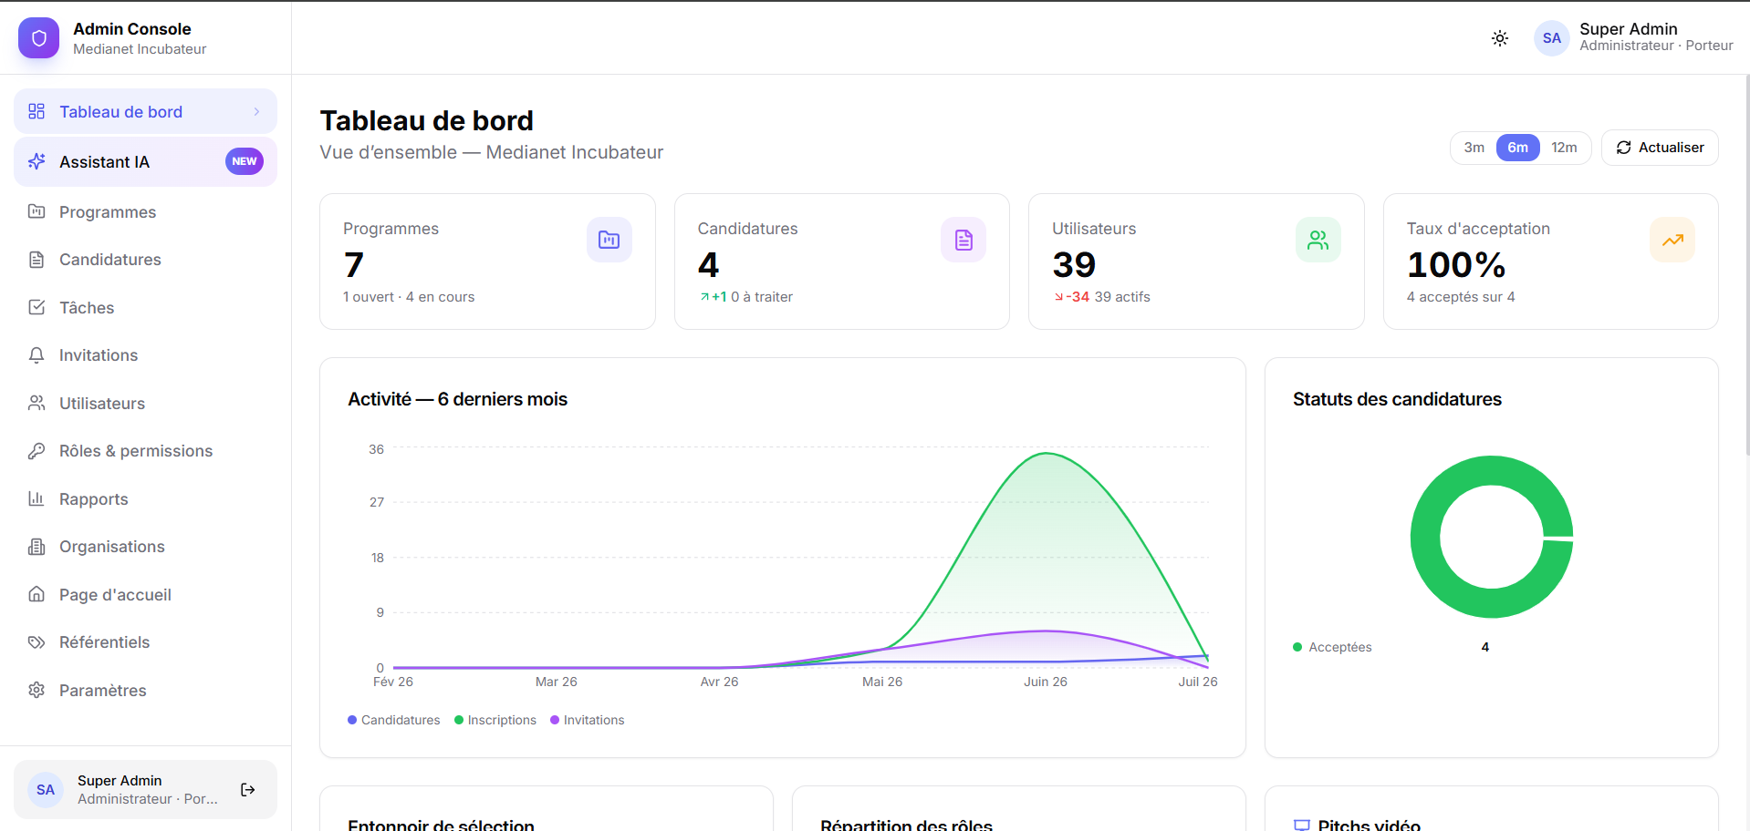

Figure 1.3 — Overview of the proposed solution
As shown in Figure 1.3, the solution rests on two distinct interfaces: a back-office, built for administrators and program managers, and a front-office aimed at project carriers, juries, organization members, and, more broadly, the general public.

1.3 Study of the Existing Landscape

1.3.1 Description of Existing Practices
Whether at the host organization or at comparable players in the Tunisian ecosystem, the management of incubation programs still largely relies on a patchwork of generic tools:
- application forms built with third-party tools, such as Typeform or Google Forms ;
- selection and scoring grids that live in spreadsheets (Excel, Google Sheets) ;
- agendas kept by hand in shared calendars ;
- communications handled by email and instant messaging, with no real centralized archive ;
- progress reports that have to be recalculated manually for every review.
That's the case for several Tunisian incubators — Flat6Labs Tunis, Wiki Start Up, B@Labs (BIAT), Impact Partner, The Dot, Redstart Tunisie — which publish their calls for applications and run their cohorts in a fairly similar way: a presentation page, an external form, and follow-up that stays manual internally. The national Startup Tunisia / Startup Act portal follows a different logic, since it focuses on the legal labeling of startups rather than on the operational management of a program's journey.
The table below compares, feature by feature, what these solutions typically cover against what this project aims for.
Feature | Generic incubator portals | National labeling portal | Medianet Incubateur
Public program presentation | Yes | Partial | Yes
Online application form | Yes (often external) | No | Yes (per program)
Visual program journey | No | No | Yes
Typed sessions with activities | No | No | Yes
Session visibility control | No | No | Yes
Jury evaluation (weighted criteria) | Rare / external | No | Yes
AI-assisted scoring | No | No | Yes
Participant directory & tracked invitations | Partial | No | Yes
Multi-role access (admin/jury/carrier) | Partial | Partial | Yes
Table 1.2 — Comparison of competing Tunisian offerings

1.3.2 Critique of the Existing Landscape
This analysis of the existing landscape brings out a few weaknesses that keep coming up:
- Fragmented tooling. Applications, the selection grid, jury scoring, the agenda, and communications each live in their own corner — separate files, different inboxes. Nothing is centralized, and the same data keeps getting copied back and forth between tools.
- No single source of truth for the journey. The program's calendar — its sessions, their order, their nesting (a training day slipped inside an incubation period), their dependencies — isn't modeled anywhere. In practice, it only exists in the program manager's head and in a handful of scattered documents.
- Manual, non-reproducible evaluation. Juries are contacted by email, receive applications as attachments, then score them on paper or in improvised spreadsheets. Consolidating weighted scores by criterion, by jury, and by session quickly becomes tedious — and re-evaluating the same candidate in a later session, a pitch day following a preselection for instance, is even harder.
- Weak, informal access control. Some sessions are purely internal — planning, jury deliberation, score recalibration — and should never be visible to startups or the public. Yet nothing structurally prevents it. Conversely, an external jury invited to a single private session shouldn't, in theory, get access to the rest of the program.
- Insufficient traceability of communications. When a manager sends an invitation or an update, there's no reliable record of who was contacted, when, with what message, or even whether the email actually reached its destination.
- No consolidated metrics. Funnel metrics (applications received, evaluated, accepted), jury progress, sector breakdown, or the ranking of top candidates — all of this has to be recalculated by hand for every report.
Add it all up and these weaknesses carry a real cost: time lost on repetitive manual tasks, errors in transcription and score consolidation, delays in decisions, a certain frustration among juries and project carriers facing a process they don't really control, and a lot of difficulty producing the transparent reporting that funders and partners expect.

1.4 Proposed Solution
Starting from these observations, the proposed solution takes the form of a single, secure web platform, capable of:
- modeling a program as a structured, visual journey of typed sessions ;
- receiving and managing applications online ;
- supporting reproducible, per-session jury evaluation, assisted where relevant by artificial intelligence ;
- managing every participant and organization, and communicating with them in a traceable way ;
- strictly enforcing business rules — date validation, session visibility — both server-side and in the interface ;
- clearly distinguishing roles: administrator, program manager, project carrier, jury, mentor, and general public.
Among these pillars, one carries most of the project's originality and deserves to be stated plainly. The platform does not merely digitize the presentation day; it makes the evaluation of a pitch measurable. Where an incubator today relies on a jury's subjective impression, jotted down after the fact, the platform produces evidence: how fast the founder actually spoke, how loud and how varied the voice was, where the real silences fell, how many hesitations slipped out and exactly when. Those measurements — not an impression — are what the scoring is built on, and every remark returned to the founder is anchored to a timestamp they can replay. This turns a one-off verdict into something a project carrier can train against, which is why the model distinguishes training pitches, where progress is tracked from one attempt to the next, from the final pitch that counts.
- turning the presentation day into a coaching tool: transcribing each pitch automatically, measuring the delivery objectively from the audio signal, and returning a scored, time-coded, actionable analysis ;
- running that entire analysis on self-hosted models, so no candidate video ever leaves the infrastructure ;
The following chapters go through each of these pillars in turn: the visual journey builder, typed and visibility-controlled session management, online applications, AI-assisted evaluation (nicknamed « Medi »), participant management with tracked invitations, and administrable reference catalogs.

1.5 Development Methodology
Choosing the right development methodology matters just as much as everything else, especially for a project whose requirements keep evolving along the way. Before justifying the choice made, this section briefly presents two reference approaches.

1.5.1 The Waterfall Cycle
The waterfall model moves sequentially: each phase — specification, design, implementation, testing, deployment — has to be finished before moving on to the next. When requirements are locked in from the start, that predictability is a real asset. But as soon as requirements get refined along the way, the model shows its limits, since going back becomes costly.

1.5.2 Agile Methods (Scrum)
Agile methods — Scrum being the best known — work quite differently: development is broken down into short iterations, sprints, each delivering a functional increment that gets reviewed with stakeholders before moving on to the next. Adapting to requirements becomes continuous, problems surface earlier, and collaboration between developers and business stakeholders tightens up.

1.5.3 Methodology Chosen
For this project, the requirements weren't fully known upfront — they became clearer as the work progressed. The session model, the visibility rules, the evaluation flow: each of these matured over several iterations, in discussion with the host organization. A waterfall cycle, which assumes everything is locked down from day one, simply wouldn't have fit that reality. That's why an agile, iterative, incremental approach was chosen instead: the work moves forward in short increments, each delivering a coherent, deployable vertical slice — back-end and front-end together — continuously integrated and validated before moving on.
UML, for its part, is used throughout the project as a design and communication aid: it helps clarify actors, use cases, the domain model, and the main dynamic flows, without ever trying to lock down an exhaustive specification upfront. This lightweight, model-driven agility is close in spirit to the Two-Track Unified Process (2TUP) and to Scrum practices.
The table below summarizes this comparison.
Criterion | Waterfall | Scrum (chosen)
Adaptation to evolving requirements | Low | High
Value delivery | At the end of the project | At every iteration
Risk of costly rework | High | Low
Suited to still-uncertain requirements | No | Yes
Table 1.3 — Comparison of development methodologies
Concretely, the approach adopted rests on the following points:
- Product backlog. Requirements are expressed as user stories per actor, then prioritized.
- Increments / sprints. Each increment targets a coherent set of user stories — first the program builder, then applications, evaluation, AI scoring, visibility, and finally participants.
- Continuous integration and delivery. Every change goes through static typing (`tsc`), a build (`mvn` or Next.js build), and deployment as containers (`docker compose build` / `up`).
- Microservice isolation. Each business context is developed and deployed independently, with its own database.
- Verification. Manual test scenarios and end-to-end checks accompany every increment, systematically covering each session type and each role.

Conclusion
So that's the backdrop: a host organization, a problem that turned out to be real rather than invented, an early sketch of the platform, and the methodology behind how it got built. From here, the next step is turning that sketch into requirements. That's where Chapter 2 picks up.

Chapter 2 — Requirements Analysis and Specification

Introduction
Turning a vision into something buildable means writing it down precisely. That's the job of this chapter: functional and non-functional requirements, the actors involved, the use cases they trigger, and — for the ten that matter most — a full breakdown through textual descriptions, system sequence diagrams, and activity diagrams.

2.1 Project Vision
The vision behind Medianet Incubateur fits in a few lines:
Give incubators a single platform that turns a program into a structured, visual journey of typed, access-controlled sessions; lets candidates apply online; lets juries evaluate (assisted by artificial intelligence); and keeps every participant informed through traceable communications — all while guaranteeing strict data validation and a clear separation of roles.

2.1.1 Functional Requirements
For clarity, functional requirements have been grouped by module.
M1 — Authentication and Accounts
- Sign-up and sign-in with JWT ; password reset.
- User profile management, differentiated by role (carrier, jury, mentor).
- Administration of users, their roles, and their fine-grained permissions.
M2 — Programmes and Journeys
- Create, view, update, and delete programmes, along with their metadata (title, description, type, dates, sectors, eligible organization types, key figures, partners) and a customizable application form.
- Manage evaluation criteria (name, weight, maximum score) per programme.
- Build the visual journey: create sessions (day or range), nest day-sessions inside ranges, organize them into lanes, define their type, visibility, dates, location, owners and guests, and set per-session criteria weights.
- Edit an activity agenda (hourly grid) for day-sessions ; reuse presets and full journey templates.
- Automatically synchronize the programme status based on the dates and statuses of its sessions.
M3 — Applications
- Submit an application to an open programme through the programme's own form, linking the carrier's organization and team.
- Manage an application's status lifecycle (pending, under evaluation/review, accepted, rejected).
- View the full detail of an application, including the answers submitted.
M4 — Evaluation
- Assign juries to an evaluation session.
- Score an application against weighted criteria ; allow re-evaluation per session (a candidate is scored afresh in every evaluation session).
- Run an AI score (Medi) producing per-criterion notes, a weighted score, a recommendation, and a summary ; let administrators score as well.
- Provide a consolidated dashboard with ranking and export.
M5 — Participants and Communications
- List the people associated with a programme (organizations, members, carriers, juries).
- Add already-registered users or invite people by email.
- Compose a personalized invitation from a template with placeholders and a tracking link ; preview before sending.
- Send per-session notifications to the relevant participants and keep a full archive of every send.
M6 — Visibility and Access Control
- Set a session's visibility: Visible, Hidden (internal), or Private.
- Enforce visibility server-side based on the requester's role and invitations, and reflect it in the interface.
M7 — Reference Catalogs
- Manage catalogs (organization types, programme sectors, session types) used by the forms.
M8 — Presentation Day and AI Pitch Analysis
- Flag any session for AI video analysis with a simple checkbox, independently of the session type.
- Let a carrier upload several training videos and one final pitch video (up to 2 GB each), stored in MinIO.
- Transcribe the pitch automatically and time-code it, keeping real hesitations rather than a cleaned-up text.
- Measure delivery objectively from the waveform: speech rate, loudness, loudness range, real pauses and speaking ratio.
- Detect unconscious speech habits word by word: filler sounds, drawn-out sounds, repetitions, hedging and tag questions.
- Describe physical presence from sampled frames using a locally executed vision model, treated as weak evidence.
- Score the pitch per dimension against the programme criteria, after detecting its format (demo day, competition, investor, internal).
- Return time-coded key moments, a criterion mapping and a costed coaching plan (impact in points, effort, ready-to-say wording).
- Stream the pipeline stages live to the interface with time estimates learned from real runs.
- Show progress analytics at three levels: overall, per programme and per training phase.

2.1.2 Non-Functional Requirements
Quality | Requirement
Security | Stateless JWT authentication at the gateway and in each service ; role and permission authorization (`module:action`) ; role-based data filtering, notably for session visibility.
Scalability | Independent, stateless microservices behind a gateway with service discovery ; one database per service.
Maintainability & extensibility | Well-scoped business contexts ; DTO layers ; a centralized validation layer with explicit error codes ; an extensible session model (new types without schema rework).
Usability | Two dedicated interfaces ; a readable, tabbed session interface (details first, activities kept separate) ; confirmation before adding and preview before editing for sensitive actions.
Performance | Lazy loading, parallelized requests, no N+1 cross-service calls thanks to denormalized display fields.
Reliability | Resilient cross-service calls (graceful degradation), structured error handling, reproducible deployments.
Portability | Fully containerized solution (Docker), configuration driven by environment variables.
Localization | French-language interface, adapted to the local context.

2.2 Requirements Specification

2.2.1 Identification of Actors
An actor is a role played by a user, or by an external system, that interacts with the platform.
Actor | Type | Description
Administrator | Human (primary) | Full control over programmes, journeys, criteria, applications, evaluations, users, roles, catalogs, and communications.
Program Manager | Human | A restricted administrator, scoped by permission slugs (`programmes:*`, `candidatures:*`, …) to a programme's operations.
Project Carrier (Porteur) | Human (primary) | Founder who applies to programmes, manages their organization, and follows the journey and their tasks.
Jury | Human (primary) | Evaluates the applications assigned to them, per evaluation session, optionally assisted by AI.
Mentor | Human | Supports the selected startups ; views the sessions and tasks assigned to them.
Organization Member | Human | Member of a participating organization ; follows programme updates.
Visitor | Human | Anonymous user who browses public programmes and the public journey (Visible sessions only).
Medi (LLM) | External system | The AI service that scores applications.
SMTP Relay (Brevo) | External system | Delivers invitation and notification emails.
Table 2.1 — Identification of actors

2.2.2 Identification of Use Cases
The diagram below summarizes how these actors interact with the platform.
@startuml
left to right direction
actor Visitor
actor Carrier
actor Jury
actor Mentor
actor "Program Manager" as PM
actor Administrator as Admin
actor "Medi (LLM)" as Medi
actor "SMTP Relay" as SMTP
rectangle "Medianet Incubateur" {
usecase "Browse public programmes" as UC_browse
usecase "Sign up / Sign in" as UC_auth
usecase "Submit an application" as UC_apply
usecase "Manage organization & members" as UC_org
usecase "Follow the journey & tasks" as UC_follow
usecase "Evaluate an application (per session)" as UC_eval
usecase "AI-score an application" as UC_ai
usecase "Design the programme & criteria" as UC_prog
usecase "Build the visual Journey" as UC_parcours
usecase "Set session type & visibility" as UC_vis
usecase "Assign a jury" as UC_assign
usecase "Manage participants & invitations" as UC_part
usecase "Send tracked notifications" as UC_notify
usecase "Manage users, roles & catalogs" as UC_admin
}
Visitor --> UC_browse
Visitor --> UC_auth
Carrier --> UC_apply
Carrier --> UC_org
Carrier --> UC_follow
Jury --> UC_eval
Mentor --> UC_follow
PM --> UC_prog
PM --> UC_parcours
PM --> UC_assign
PM --> UC_part
Admin --> UC_prog
Admin --> UC_parcours
Admin --> UC_vis
Admin --> UC_assign
Admin --> UC_part
Admin --> UC_notify
Admin --> UC_admin
Admin --> UC_eval
UC_eval ..> UC_ai : <<extend>>
UC_ai --> Medi
UC_notify --> SMTP
UC_part ..> UC_notify : <<include>>
@enduml

[Insert the rendered use case diagram]

Figure 2.1 — Global use case diagram
Figure 2.1 shows the full set of use cases. Ten of them were selected for detailed specification ; they are listed in Table 2.2.
Code | Use Case | Primary Actor
UC-1 | Authenticate | All registered actors
UC-2 | Submit an application | Carrier
UC-3 | Design a programme and its criteria | Administrator
UC-4 | Build the visual Journey | Administrator
UC-5 | Set a session's type and visibility | Administrator
UC-6 | Assign a jury | Administrator
UC-7 | Evaluate an application (per session) | Jury
UC-8 | AI-score an application | Jury / Administrator
UC-9 | Manage participants and send invitations | Administrator
UC-10 | Follow a programme | Carrier / Jury
Table 2.2 — List of major use cases

2.3 Detailed Requirements Specification

2.3.1 Textual Description of Major Use Cases
UC-1 — Authenticate
Field | Description
Actors | All registered actors
Goal | Obtain an authenticated session (JWT) to access role-protected features.
Preconditions | The user has an account.
Postconditions | A signed JWT is issued and stored ; the user is redirected to their dashboard.
Main flow | 1. The user opens the login page. 2. They enter their email and password. 3. The system validates the credentials. 4. The authentication service issues a JWT containing the user's roles and permissions. 5. The front-end stores the token and loads the appropriate workspace.
Alternatives | 3a. Invalid credentials → an error message is shown.
Exceptions | The authentication service is unavailable → a technical error is displayed.
UC-2 — Submit an Application
Field | Description
Actors | Carrier
Goal | Apply to an open programme.
Preconditions | The programme is open (its application session is active and the deadline hasn't passed) ; the carrier is authenticated.
Postconditions | A `Candidature` is created with status *PENDING* and linked to the carrier's organization.
Main flow | 1. The carrier opens the programme page. 2. They start an application and fill in the programme's own form. 3. They link or create their organization and team. 4. They submit. 5. The system checks eligibility and the deadline, creates the application, and confirms.
Alternatives | 5a. The deadline has passed → submission is refused. 5b. Required fields are missing → validation errors are returned.
Exceptions | The candidature service is unavailable → the submission isn't recorded and the user is notified.
UC-3 — Design a Programme and Its Criteria
Field | Description
Actors | Administrator, Program Manager
Goal | Create and configure a programme and its evaluation criteria.
Preconditions | The actor is authenticated and authorized (`programmes:update`).
Postconditions | The programme and its criteria are persisted.
Main flow | 1. The actor creates a programme and fills in its information (dates, sectors, eligible organization types, key figures). 2. They define the application form. 3. They add weighted evaluation criteria. 4. They save.
Alternatives | 1a. Dates are inconsistent → a validation error is returned.
Exceptions | —
UC-4 — Build the Visual Journey
Field | Description
Actors | Administrator, Program Manager
Goal | Model the programme as a sequence of sessions and activities.
Preconditions | The programme exists ; the actor is authorized.
Postconditions | The sessions, their nesting, and their activities are persisted ; the programme status may be recomputed.
Main flow | 1. The actor adds a session (day or range). 2. They set its type, visibility, dates, location, and participants. 3. They optionally nest a day-session inside a range. 4. They add an activity agenda to a day-session. 5. The validation layer checks the dates, overlaps, and activity constraints. 6. The actor confirms the creation and previews sensitive edits.
Alternatives | 5a. A date violates a rule → an explicit error code is returned (e.g. SESSION_OVERLAP_DETECTED). 5b. Moving a range would push a nested day outside of it → the nested days are carried along once confirmed.
Exceptions | —
UC-5 — Set a Session's Type and Visibility
Field | Description
Actors | Administrator
Goal | Define a session's type and who can see it.
Preconditions | The session exists.
Postconditions | The type and visibility are persisted ; visibility is enforced server-side.
Main flow | 1. The actor opens the session. 2. They pick a type (application, preselection, pitch day, …). 3. They pick a visibility (Visible / Internal / Private). 4. They save ; the change is previewed beforehand.
Alternatives | —
Exceptions | —
UC-6 — Assign a Jury
Field | Description
Actors | Administrator, Program Manager
Goal | Designate the juries of an evaluation session.
Preconditions | An evaluation session exists ; the people to assign are known.
Postconditions | Jury assignments are created (with a tokenized evaluation link).
Main flow | 1. The actor opens the evaluation session. 2. They select juries from the directory or by email. 3. They confirm the assignment. 4. The system records the assignments and may notify the juries.
Alternatives | —
Exceptions | —
UC-7 — Evaluate an Application (Per Session)
Field | Description
Actors | Jury, Administrator
Goal | Score an application for a given evaluation session.
Preconditions | The jury is assigned to the session.
Postconditions | An `Evaluation` keyed by (candidature, jury, session) is stored ; the consolidated score is updated.
Main flow | 1. The jury opens an assigned application. 2. They score each weighted criterion and add a comment. 3. They may run Medi and reuse its notes. 4. They submit.
Alternatives | 3a. The jury disagrees with the AI and adjusts the notes manually.
Exceptions | —
UC-8 — AI-Score an Application
Field | Description
Actors | Jury, Administrator (system actor: Medi)
Goal | Obtain an AI-proposed score for an application.
Preconditions | The application exists ; the caller is authorized.
Postconditions | The AI score is displayed (not persisted until reused/submitted).
Main flow | 1. The actor requests an AI score. 2. The AI service fetches the application, the criteria, and the organization/team context. 3. It builds a prompt and calls the LLM. 4. It parses the JSON result (per-criterion notes, weighted score, recommendation, summary). 5. It returns the result to the interface.
Alternatives | 4a. The LLM's answer can't be parsed → a safe fallback is returned.
Exceptions | The LLM is unavailable → an error is shown and manual scoring remains possible.
UC-9 — Manage Participants and Send Invitations
Field | Description
Actors | Administrator
Goal | View the people associated with a programme and invite them via a tracked email.
Preconditions | The actor is authorized.
Postconditions | Invitations are sent and archived (status SENT/FAILED).
Main flow | 1. The actor opens the Participants view. 2. They browse the directory (organizations, members, carriers, juries). 3. They add registered users or type in emails. 4. They personalize the invitation template (placeholders, tracking link) and preview it. 5. They send ; every send is archived.
Alternatives | 5a. An email fails → it's archived with status FAILED.
Exceptions | —
UC-10 — Follow a Programme
Field | Description
Actors | Carrier, Jury
Goal | Follow a programme's journey, updates, and personal tasks.
Preconditions | The actor is authenticated and linked to the programme.
Postconditions | —
Main flow | 1. The actor opens the programme. 2. They see the journey (Visible sessions and, for invited users, the sessions they're invited to). 3. They check their tasks and updates.
Alternatives | —
Exceptions | —

2.3.2 System Sequence Diagrams of Major Use Cases
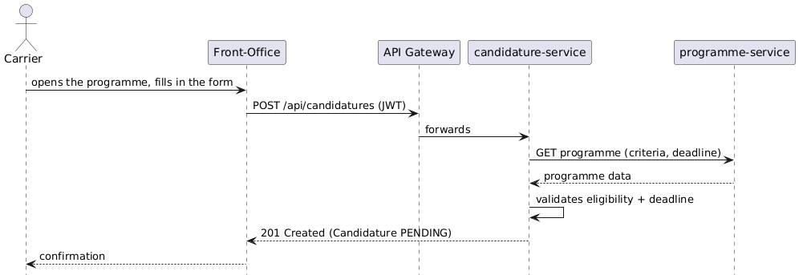

Figure 2.2 — System sequence diagram: application submission (UC-2)
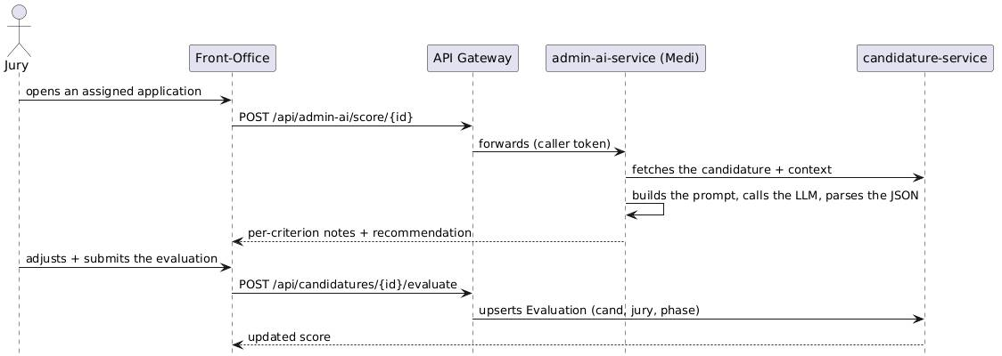
Figure 2.3 — System sequence diagram: AI-assisted evaluation (UC-7, UC-8)

2.3.3 Activity Diagrams
@startuml
start
:Carrier submits their application;
if (Eligible & before the deadline?) then (yes)
:Candidature = PENDING;
:Jury assigned to the preselection session;
:Jury / Medi evaluation;
if (Accepted?) then (yes)
:Status = ACCEPTED;
:Onboarding invitation (tracked email);
:Follows the incubation journey;
else (no)
:Status = REJECTED;
endif
else (no)
:Submission refused;
endif
stop
@enduml

[Insert the rendered diagram]

Figure 2.4 — Activity diagram: application → selection → onboarding
@startuml
start
:Admin opens a session;
:Selects recipients (owners, juries, carriers, members);
:Personalizes the template per type + tracking link;
:Previews;
if (Confirm send?) then (yes)
repeat
:Sends the email to the recipient;
:Records Invitation (SENT/FAILED);
repeat while (more recipients?)
:Shows "N sent, M failed";
else (no)
:Cancels;
endif
stop
@enduml

[Insert the rendered diagram]

Figure 2.5 — Activity diagram: notifying a session's participants

Conclusion
Seven functional modules, a handful of measurable non-functional requirements, nine actors, ten use cases worked out in detail — that's what came out of turning the vision into something concrete. It's also, from here on, the specification the design has to respect. Chapter 3 takes it from there.

Chapter 3 — Design

Introduction
Requirements are one thing; deciding how the system is actually structured is another. This chapter makes that jump, through the design class diagram and its data dictionary, a set of design sequence diagrams showing how the major use cases play out in practice, and the component diagram that maps the platform's deployable pieces.

3.1 Class Diagram

3.1.1 Design Class Diagram
The domain model revolves mainly around the Programme and its sessions — the unified `ProgrammePhase` entity — as well as the Candidature and its Evaluations. Added to this are the User/Organization identities, and two cross-cutting entities, Invitation and Task.
@startuml
skinparam classAttributeIconSize 0
hide circle
class User { +id +email +firstName +lastName +roles +active }
enum Role { ADMIN PROGRAM_MANAGER PORTEUR JURY MENTOR MEMBER }
class Organization { +id +name +type +sector +description }
class OrganizationMember { +email +name +role }
class Programme { +id +title +status +startDate +endDate +applicationDeadline +sectors }
enum ProgrammeStatus { DRAFT OPEN IN_PROGRESS EVALUATION CLOSED CANCELLED ARCHIVED }
class ProgrammeCriteria { +id +name +weight +maxScore +active }
class ProgrammePhase <<Session>> { +id +title +sessionType +visibility +allowActivities +allowOverlap +durationKind +startDate +endDate +status +lane }
enum SessionType { CANDIDATURE_SUBMISSION PRESELECTION PITCH_DAY ONBOARDING INCUBATION DEMO_DAY TRAINING_DAY }
enum SessionVisibility { VISIBLE HIDDEN PRIVATE }
class SessionDay { +id +dayOrder +date }
class SessionActivity { +id +title +type +startTime +endTime }
class Candidature { +id +programmeId +organizationId +carrierEmail +status +totalScore +customAnswers }
enum CandidatureStatus { PENDING UNDER_EVALUATION UNDER_REVIEW ACCEPTED REJECTED }
class Evaluation { +id +juryId +sessionId +weightedScore +comment }
class JuryAssignment { +juryEmail +sessionId +token }
class Task { +id +title +status +priority }
class Invitation { +id +type +status +recipientEmail +subject +token +sentAt }
Programme "1" *-- "many" ProgrammeCriteria
Programme "1" *-- "many" ProgrammePhase
ProgrammePhase "1" *-- "many" SessionDay
SessionDay "1" *-- "many" SessionActivity
ProgrammePhase "0..1" o-- "many" ProgrammePhase : nesting
Organization "1" *-- "many" OrganizationMember
Candidature "many" --> "1" Programme
Candidature "many" --> "0..1" Organization
Candidature "1" *-- "many" Evaluation
Candidature "1" *-- "many" JuryAssignment
Evaluation "many" --> "1" ProgrammePhase
Task "many" --> "1" Programme
Invitation "many" --> "1" Programme
Invitation "many" --> "0..1" ProgrammePhase
@enduml

[Insert the rendered diagram]

Figure 3.1 — Design class diagram

3.1.2 Class Descriptions
Table 3.1 goes back over the role of each class in the domain.
Class | Description
User | A platform account ; carries one or more roles and fine-grained permissions ; backs carriers, juries, mentors, and administrators.
Organization / OrganizationMember | An applying entity and its team ; linked to applications.
Programme | An incubation programme: metadata, dates, sectors, criteria, sessions, and partners ; its status is synchronized from its sessions.
ProgrammeCriteria | A weighted evaluation criterion, used by juries and by Medi.
ProgrammePhase (Session) | The unified session entity (kept under the legacy table name `programme_phases`): typed, access-controlled, dated, possibly nested, with an optional activity agenda.
SessionDay / SessionActivity | The hourly agenda of a day-session.
Candidature | An application linked to a programme and an organization ; carries the custom answers, the consolidated score, its evaluations, and jury assignments.
Evaluation | The weighted score given to an application by a jury (or an administrator) for a given session (`candidature × jury × session`).
JuryAssignment | Assigns a jury (by email) to a session, with a tokenized, no-login evaluation link.
Task | An action item tied to a programme and assigned to a user.
Invitation | An archived communication (type, status, recipient, subject, token), used both for invitations and for tracked session notifications.
Table 3.1 — Description of domain classes

3.1.3 Data Dictionary
Programme
Attribute | Type | Description
id | Long | Unique identifier
title | String | Programme title
description | Text | Detailed description
type | enum | PUBLIC / PRIVATE
status | enum | DRAFT/OPEN/IN_PROGRESS/EVALUATION/CLOSED/CANCELLED/ARCHIVED
startDate / endDate | Date | Programme window
applicationDeadline | Date | Derived from the application session's end date
sectors | List | Targeted sectors
Table 3.2 — Data dictionary — Programme
ProgrammePhase (Session)
Attribute | Type | Description
id | Long | Unique identifier
title | String | Session title
sessionType | enum | CANDIDATURE_SUBMISSION … TRAINING_DAY
visibility | enum | VISIBLE / HIDDEN / PRIVATE
allowActivities | Boolean | False for application sessions
allowOverlap | Boolean | Allows overlapping within the same lane
durationKind | String | "day" or "range"
startDate / endDate | Date | Session window
status | enum | UPCOMING / ACTIVE / COMPLETED
lane | String | Swimlane / track
parentSessionId | Long | Parent range for a nested day
Table 3.3 — Data dictionary — ProgrammePhase (Session)
Candidature
Attribute | Type | Description
id | Long | Unique identifier
programmeId | Long | Target programme
organizationId | Long | Applying organization
carrierEmail | String | Carrier's email address
status | enum | PENDING … ACCEPTED/REJECTED
totalScore | Double | Consolidated weighted score
customAnswers | JSON | Answers to the programme's own form
Table 3.4 — Data dictionary — Candidature
Evaluation
Attribute | Type | Description
id | Long | Unique identifier
juryId | Long | Evaluating jury
sessionId | Long | Evaluation session
weightedScore | Double | 0–10, weighted by criteria
comment | Text | Free-form comment
Table 3.5 — Data dictionary — Evaluation
Invitation
Attribute | Type | Description
id | Long | Unique identifier
type | enum | JURY / PORTEUR / MEMBER / ORGANISATEUR / GUEST / GENERAL
status | enum | PENDING / SENT / FAILED / ACCEPTED / DECLINED
recipientEmail | String | Recipient
subject | String | Email subject
token | String | Unique tracking token
sentAt | DateTime | Delivery timestamp
Table 3.6 — Data dictionary — Invitation

3.2 Design Sequence Diagrams

3.2.1 Tracked Session Notification
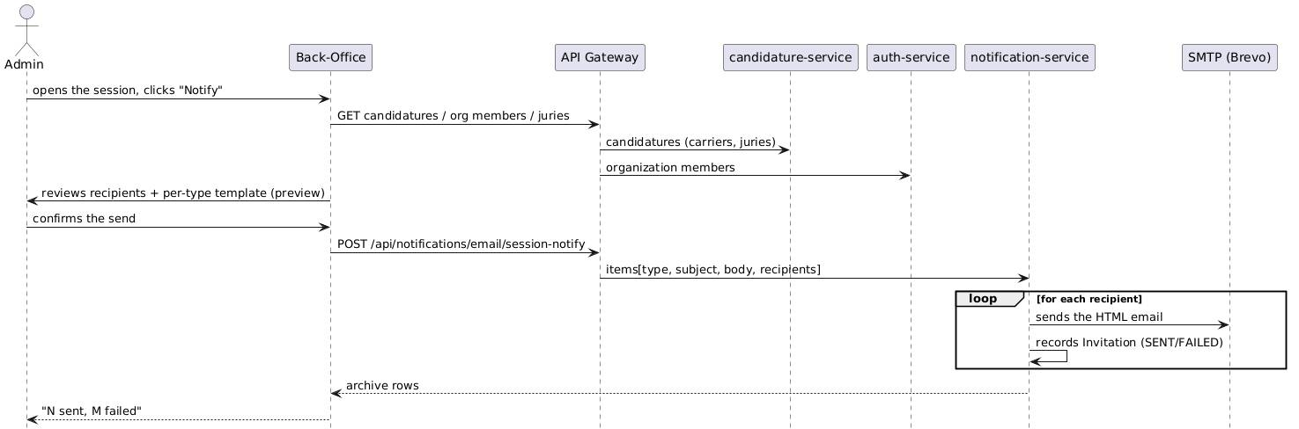

[Insert the rendered diagram]

Figure 3.2 — Design sequence diagram: tracked session notification

3.2.2 Visibility-Based Session Filtering
This last sequence is worth dwelling on for a moment, since it's what actually enforces visibility server-side — a point a good deal of the platform's security rests on.
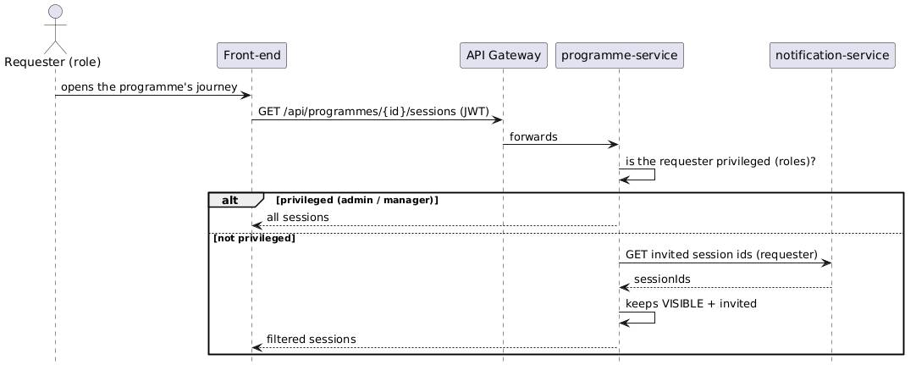

[Insert the rendered diagram]

Figure 3.3 — Design sequence diagram: visibility-based session filtering

3.3 Component Diagram
@startuml
skinparam componentStyle rectangle
package "Front-ends (Next.js)" {
[Back-Office :3001]
[Front-Office :3000]
}
[API Gateway :8080]
[Eureka :8761]
package "Microservices (Spring Boot)" {
[auth-service :8081]
[programme-service :8086]
[candidature-service :8083]
[notification-service :8087]
[admin-ai-service :8088]
}
database "PostgreSQL (per service)" as DB
[MinIO :9000]
cloud "SMTP Brevo" as SMTP
cloud "LLM (OpenRouter / Ollama)" as LLM
[Back-Office :3001] --> [API Gateway :8080]
[Front-Office :3000] --> [API Gateway :8080]
[API Gateway :8080] --> [auth-service :8081]
[API Gateway :8080] --> [programme-service :8086]
[API Gateway :8080] --> [candidature-service :8083]
[API Gateway :8080] --> [notification-service :8087]
[API Gateway :8080] --> [admin-ai-service :8088]
[auth-service :8081] --> DB
[programme-service :8086] --> DB
[candidature-service :8083] --> DB
[notification-service :8087] --> DB
[admin-ai-service :8088] --> DB
[programme-service :8086] ..> [notification-service :8087] : invited sessions
[candidature-service :8083] ..> [programme-service :8086] : programme data
[admin-ai-service :8088] ..> LLM
[notification-service :8087] ..> SMTP
[auth-service :8081] --> [MinIO :9000]
@enduml

[Insert the rendered diagram]

Figure 3.4 — Component diagram of the platform

Conclusion
What comes out of this is a domain-driven, microservices decomposition: an extensible session model sitting at the core, evaluation handled per session, access control that mixes visibility with roles and invitations, and a communication channel that keeps a record of everything it sends. Between the class diagram, the data dictionary, the sequence diagrams, and the component diagram, there's enough here to actually start building. That's Chapter 4.

Chapter 4 — Implementation

Introduction
Design is the plan; this last chapter is what actually got built. It covers the work environment (software and hardware), the frameworks and languages used, the architecture adopted, the interfaces delivered, the test dataset, the planning that was followed, and the difficulties that came up along the way — together with what changed as a result.

4.1 Work Environment

4.1.1 Software Environment
Category | Tools
Operating system | Windows 11 (development), Linux containers (runtime)
Containerization | Docker, Docker Compose
IDEs | IntelliJ IDEA, Visual Studio Code
API & DB tools | Postman, pgAdmin / psql
Version control | Git
Object storage | MinIO (S3-compatible)
Transactional email | Brevo SMTP relay
Artificial intelligence | OpenRouter / local Ollama (LLM)
Table 4.1 — Software environment

4.1.2 Hardware Environment
Item | Specification
Development machine | [CPU], [RAM ≥ 16 GB recommended], [SSD]
Runtime | A Docker host running about a dozen containers (five services + five databases + gateway + two front-ends + MinIO)
Table 4.2 — Hardware environment

4.1.3 Frameworks
- Back-end: Spring Boot, Spring Web, Spring Data JPA, Spring Security, Spring Cloud Gateway, Spring Cloud Netflix Eureka, Hibernate, Lombok.
- Front-end: Next.js (App Router), React, Tailwind CSS, Framer Motion, Recharts, lucide-react, react-hot-toast, Axios.

4.1.4 Programming Languages
- Java 17 — the microservices.
- TypeScript / JavaScript — the Next.js front-ends.
- SQL — PostgreSQL.
- HTML / CSS — markup and Tailwind styling.

4.2 Architecture Adopted
The platform rests on a microservices architecture, sitting behind an API Gateway with service discovery. Each service owns its own database and only exposes its REST API through the gateway — as shown in Figure 3.4.
Here's how responsibilities are split across the different services.
Service | Port | Responsibility
API Gateway | 8080 | Single entry point ; routing of `/api/**` ; CORS ; JWT forwarding
Eureka | 8761 | Service registry / discovery
auth-service | 8081 | Users, roles/permissions, organizations & members, JWT issuance, file uploads (MinIO)
programme-service | 8086 | Programmes, sessions (Journey), criteria, partners, tasks, catalogs ; validation layer ; visibility filtering
candidature-service | 8083 | Applications, jury assignments, evaluations, shortlists
notification-service | 8087 | Invitations, contacts/groups, session notifications, email archive
admin-ai-service | 8088 | AI scoring (Medi) and admin assistant
Table 4.3 — Service and port map
Security. Authentication rests on JWT and works in a stateless manner: the authentication service issues a signed token that embeds the user's identity, roles, and permissions. Each service then runs its own JWT filter, which validates that token and populates the security context ; controllers rely on it to authorize requests via `hasRole(...)` or `hasAuthority("module:action")`. Some sensitive reads — the list of sessions, in particular — go a step further: they're filtered by role and by invitation, which actually enforces visibility rules server-side, and not just in the interface.
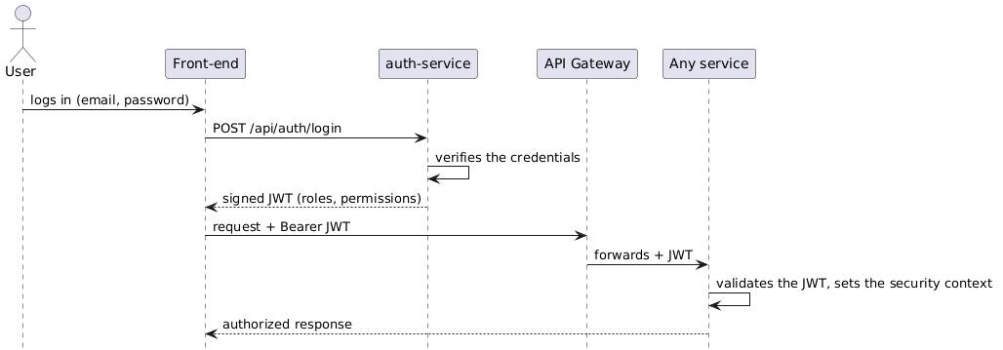

Figure 4.1 — Sequence diagram: stateless JWT authentication

4.3 Interfaces Delivered
This section walks through the main screens of the two front-ends ; each placeholder below should be replaced with the corresponding screenshot.

[Insert a screenshot of the login page]

Figure 4.2 — Login screen

[Insert a screenshot of the programme dashboard]

Figure 4.3 — Programme dashboard (back-office)
The programme dashboard acts as the back-office's central hub: it surfaces the key indicators (applications, evaluations, accepted), the upcoming sessions to notify, the list of missing items, and the top candidates.

[Insert a screenshot of the journey builder]

Figure 4.4 — Visual Journey builder (back-office)
The journey builder, meanwhile, displays sessions on a timeline organized by lane — day and range shapes, nesting, and an hourly agenda for day-sessions.

[Insert a screenshot of the session overlay]

Figure 4.5 — Session detail (Details / Activities tabs)
A session's detail view now opens on a well-structured Details tab — type, dates, status, visibility, description, related counts — while activities and feature panels stay in separate tabs, so the page doesn't get cluttered.

[Insert a screenshot of the evaluation dashboard]

Figure 4.6 — Evaluation dashboard and candidature review (with AI scoring)

[Insert a screenshot of the Participants tab]

Figure 4.7 — Participants hub and invitation template (placeholders + tracking link)

[Insert a screenshot of the front-office programme page]

Figure 4.8 — Public programme page (front-office)
On the front-office side, the programme page brings together public information, sessions — with their type badges, always respecting visibility — as well as criteria and partners.

[Insert screenshots of the application form and the jury evaluation page]

Figure 4.9 — Application form and jury evaluation page (front-office)

4.4 Project Planning
The table below retraces the planning followed during the project, organized into successive increments.
Sprint | Period | Content
Sprint 0 | [Week 1–2] | Getting up to speed on the subject, studying the existing landscape, setting up the environment (Docker, Git repo, microservices skeleton)
Sprint 1 | [Week 3–4] | JWT authentication, user and role management
Sprint 2 | [Week 5–7] | Programme model and visual Journey builder (day/range sessions, nesting)
Sprint 3 | [Week 8–9] | Online applications and customizable form
Sprint 4 | [Week 10–12] | Jury evaluation, weighted criteria, per-session re-evaluation
Sprint 5 | [Week 13–14] | AI scoring integration (Medi)
Sprint 6 | [Week 15–16] | Session visibility (VISIBLE/HIDDEN/PRIVATE) and centralized validation layer
Sprint 7 | [Week 17–18] | Participants, personalized invitations, and communication archive
Sprint 8 | [Week 19–20] | End-to-end testing, fixes, report writing
Table 4.4 — Project planning (sprints)

[Insert a detailed Gantt chart of the planning]

Figure 4.10 — End-of-studies project planning (Gantt chart)

4.5 Difficulties Encountered and Changes Made
The implementation wasn't exactly smooth sailing ; a few difficulties led to adjustments in the initial goals, and a couple of them are worth describing in a bit more detail than the others.
- A naming quirk that took a while to get used to. The session entity is called `ProgrammePhase`, and it still lives in a database table named `programme_phases` — a name carried over from an earlier version of the project, before sessions became the rich, typed, nested thing they are today. Reading "ProgrammePhase" in the code and mentally translating it to "Session" every time took longer to get used to than expected, and more than once led to a diagram, or a variable name, that no longer quite matched what the class had grown into.
- Evolution of the session model. The session model was originally designed around a fixed type per programme. But feedback along the way quickly showed that a single programme needed to contain sessions of different natures, nested, each with its own visibility. The model was therefore generalized into the unified `ProgrammePhase` type described above, extensible without touching the schema.
- Non-admin roles with the wrong access. Early on, permission checks were too coarse: a jury or porteur account could occasionally reach an endpoint it had no business reaching, or find itself blocked from one it actually needed. Tracking these down meant going back through the controllers one by one and replacing broad role checks with fine-grained, per-module permissions (`hasAuthority("module:action")`) — the scheme the platform still uses today.
- A date-related block on type changes. An issue surfaced when simply changing a session's type — with no date changes at all — was, incorrectly, triggering a full revalidation of date and overlap constraints, blocking otherwise legitimate edits. The fix: only revalidate dates when the edit actually touches them.
- Overlap of nested sessions. Moving a range that contained nested days could fail whenever those days ended up outside the new window. Since then, nested days are moved along with the range — or clamped to it — once the user confirms.
- Perceived latency on the Tasks page. The initial load was, mistakenly, waiting on data that wasn't essential to displaying the list. It's now loaded lazily, on demand.
- LLM integration. Making the AI score reliable required putting a fallback mechanism in place — default values whenever the language model's response didn't come back well-formed — so the jury is never left blocked.
A protocol mismatch between two services. The Java service called the Python media service and received an opaque 422. The cause had nothing to do with the payload: Java's HTTP client negotiates HTTP/2 by default, while the Python server only speaks HTTP/1.1. Pinning the protocol version fixed it.
An upload limit that ignored the configuration. Videos far below the configured limit were rejected with "Maximum upload size exceeded". The configuration file was correct; the environment variables declared in docker-compose were silently overriding it. The limit was raised to 2 GB consistently across the gateway, the service and the front-end.
A speech-to-text model that deletes hesitations. Whisper is trained to produce clean prose and removes every "uh" and "um", which made the whole point of the analysis impossible. The first hypothesis — the voice-activity filter — was tested and proved wrong: both settings gave the same result. Priming the model with a deliberately disfluent context sample makes it transcribe verbatim, recovering 59 hesitations on the same audio while preserving the content.
Measurements that looked right and were not. The detector reported 70 drawn-out sounds, but the words involved were "the", "and", "to" — function words. Whisper charges a word for the silence that follows it, so a word before a pause looks stretched. Subtracting the silences measured on the raw audio left 17 genuine ones. A number displayed with the authority of an objective measurement is worse than no number at all.
A vision model that was not reproducible. The model reported "arms crossed" for a speaker whose hand was raised — verified by extracting the frame. The same frame, run five times, produced different answers: the model was sampling. Its temperature and seed were pinned, and single-frame observations are now treated as weak evidence that cannot, on its own, justify coaching advice.
A scoring scale that collapsed. Told the scoring was too lenient, the rubric was tightened with absolute caps ("if the team or the ask is missing, the score cannot exceed 4"). The correction went too far: a deliberately poor talk and a pitch-competition winner both scored 3/10, so the scale no longer discriminated. The caps were replaced by per-dimension deductions, the expected content is now calibrated to the detected pitch format, and the overall score is computed server-side as the mean of the dimensions. Measured on five real videos, the spread went from 1.4 to 5 points.
An external model provider as a failure mode. The generation buttons hung indefinitely. The code was not at fault: the configured model had stopped responding. Two defects made a transient outage look permanent — no client-side timeout, and a four-minute server-side timeout inherited from a very different use case. Small generations now fail fast with a clear message, and a lighter model answers in under a second.
None of these took a single afternoon to sort out, and the naming confusion in particular kept resurfacing at odd moments — usually right when explaining the model to someone else made the mismatch obvious again. But collectively, these episodes left the data model, the access control, and the validation layer noticeably more solid than where they started.

4.6 Test Dataset
To validate the platform, a representative dataset was put together:
- Users and roles: at least one account per role — Administrator, Program Manager, Carrier, Jury, Mentor.
- Organizations: several startups with their members and project carriers.
- Programme: one complete programme with a full journey — an application session, a preselection session, a pitch day, an onboarding, an incubation range with nested training day-sessions, and a demo day — covering every session type, both shapes (day/range), nesting, and all three visibility levels (Visible / Internal / Private).
- Applications: a cohort of candidatures linked to the organizations, with custom answers.
- Evaluations: jury assignments per session and weighted scores, plus AI (Medi) scores for comparison.
- Communications: tracked invitations and session notifications, with SENT/FAILED archive entries.
This dataset was used to test the main flows: date validation (ranges, overlaps, nesting), role-based visibility filtering, the evaluation flow, AI scoring, and the notification/archive flow.
The table below lists the test scenarios that were run.
# | Scenario | Expected Result
T1 | Create a range whose nested day would fall outside its bounds | Explicit error, or the nested day is moved along with the range
T2 | Two overlapping sessions in the same lane | SESSION_OVERLAP_DETECTED (unless overlap is allowed)
T3 | A non-privileged user lists sessions | Only VISIBLE (and invited) sessions are returned
T4 | Submit an application after the deadline | Submission refused
T5 | A jury scores the same candidate in two evaluation sessions | Two independent evaluations are recorded
T6 | AI-score an application | Per-criterion notes + weighted score + recommendation
T7 | Send session notifications | Per-type emails sent + archived (SENT/FAILED)
T8 | Change a session's type | Change persisted and reflected as a badge on the front-office
Table 4.5 — Test scenarios

Conclusion
What came out of this phase is the architecture that had been designed, now actually running: independent, secure microservices, two front-ends built for their respective roles, everything containerized and reproducible through Docker Compose. The main interfaces cover a programme's full lifecycle, and the platform held up against a representative test dataset. Not without a few bumps along the way — but those, as it turned out, pushed the initial model in a better direction.

General Conclusion
Recap of the approach. The introduction made the problem clear from the start: incubation programmes, in practice, suffer from real fragmentation. Four stages followed from there. Studying the context and the existing landscape came first (Chapter 1). Then came a rigorous specification of functional and non-functional requirements, worked out through ten major use cases (Chapter 2). Next, an object-oriented design took shape around a unified session model and a per-session evaluation model (Chapter 3). And finally, all of it got built — a complete microservices platform, tested end to end (Chapter 4).
Presentation of results. Do the results answer the problem posed at the start? Largely, yes. Medianet Incubateur now brings together, in one secure tool, the visual design of a programme, online applications, AI-assisted jury evaluation, participant and organization management, and communications that can actually be traced back. Session visibility, enforced both server-side and in the interface, along with a centralized validation layer with explicit error codes, deliver the reliability and access control that existing solutions simply didn't have.
Problems encountered during implementation. Section 4.5 already goes into these in detail, so a short list will do here: a persistent naming mismatch between the `ProgrammePhase` entity and the session concept it had grown into, permission checks that were too coarse for non-admin roles, the session model needing to be generalized later than expected, a validation bug that blocked legitimate session-type changes for a while, nested sessions needing special handling when a range moved, and the LLM integration needing a fallback to stay reliable. None of it required rethinking the architecture — each case was a targeted fix to the model, the access control, or the validation layer.
Contributions. Technically, this project meant working through the engineering of a genuinely non-trivial distributed system, start to finish: domain modeling and UML design, a microservices architecture built with Spring Cloud, stateless security with role-based access control, modern front-end work in Next.js and TypeScript, integrating an external LLM, DevOps with Docker Compose. Beyond the technical side, following an agile, iterative approach meant value got delivered progressively rather than all at once — and it forced a kind of methodological discipline that's hard to learn any other way, on a project whose requirements kept shifting under it.
The contribution the project is most readily defended on, however, is methodological rather than purely technical: it shows that an AI evaluation is only worth what its measurements are worth. Three episodes documented in section 4.5 make the point concretely. A speech-to-text model that silently deleted every hesitation made the analysis meaningless until it was primed to transcribe verbatim. A detector reporting seventy drawn-out sounds was counting ordinary words followed by a pause, and only subtracting the measured silences brought it back to seventeen genuine ones. A vision model confidently described a speaker as having his arms crossed when the frame showed his hand raised — and, run five times on that same frame, it answered differently each time. In all three cases a plausible, confidently presented number was simply false. The calibration work that followed — deductions applied per dimension rather than as global caps, expectations calibrated to the detected pitch format, the overall score derived from the dimensions server-side — was validated on a reference set of real videos: the gap between the best and the worst pitch widened from 1.4 to 5 points out of 10, and a competition-winning pitch stopped scoring the same as a deliberately poor one. An evaluation tool that cannot tell those two apart is worse than none at all, because it is trusted.
Perspectives. A few things are worth pursuing further. Session types could become fully catalog-driven — migrating from a fixed enumeration to a referenced value, so future types (hackathons, investor days, …) don't require touching the code at all. Real-time notifications (WebSocket / SSE) and calendar export (`.ics` / Outlook, alongside the Google Calendar link already in place) are another natural direction. So is strengthening observability — centralized logging, metrics, tracing — and building out a proper CI/CD pipeline with end-to-end tests. And the analytics side has room to grow: cohort funnels, inter-jury agreement, time-to-decision, maybe even a public, multilingual programme catalog. None of this was strictly required to answer the initial need. But it's exactly what a durable foundation should make possible.

Bibliography / Webography
[1] Spring Boot Reference Documentation, Spring Team / VMware, online: https://docs.spring.io/spring-boot/documentation.html (accessed 2026).
[2] Spring Cloud Gateway Reference Documentation, Spring Team / VMware, online: https://docs.spring.io/spring-cloud-gateway/reference/ (accessed 2026).
[3] Spring Cloud Netflix (Eureka) Reference Documentation, Spring Team / VMware, online: https://docs.spring.io/spring-cloud-netflix/reference/ (accessed 2026).
[4] Next.js Documentation, Vercel Inc., online: https://nextjs.org/docs (accessed 2026).
[5] JSON Web Token (JWT) — RFC 7519, M. Jones, J. Bradley, N. Sakimura, IETF, May 2015, online: https://www.rfc-editor.org/rfc/rfc7519 (accessed 2026).
[6] M. Fowler, J. Lewis, "Microservices: a definition of this new architectural term," martinfowler.com, 2014, online: https://martinfowler.com/articles/microservices.html (accessed 2026).
[7] OWASP Foundation, "OWASP Top Ten," online: https://owasp.org/www-project-top-ten/ (accessed 2026).
[8] PostgreSQL Documentation, PostgreSQL Global Development Group, online: https://www.postgresql.org/docs/ (accessed 2026).
[9] MinIO Documentation, MinIO Inc., online: https://min.io/docs/minio/linux/index.html (accessed 2026).
[10] Docker Compose Documentation, Docker Inc., online: https://docs.docker.com/compose/ (accessed 2026).
To complete: add the specific academic references used during the project's literature review (papers on RBAC systems, AI-assisted evaluation, etc.).

Appendix A — Service and Port Map
Service | Port | Responsibility
api-gateway | 8080 | Entry point, routing, JWT forwarding
eureka-server | 8761 | Service discovery
auth-service | 8081 | Users, roles, organizations, JWT, files
candidature-service | 8083 | Applications, evaluations, jury assignments
programme-service | 8086 | Programmes, sessions, criteria, tasks, validation, visibility
notification-service | 8087 | Invitations, notifications, email archive
admin-ai-service | 8088 | AI scoring (Medi), admin assistant
pitch-media-service | 8089 | Video pipeline: transcription (Whisper), audio measurement (ffmpeg), vision
ollama | 11434 | Local model runtime (vision model for physical presence)
nextjs-frontoffice | 3000 | Public / carrier / jury front-end
nextjs-backoffice | 3001 | Administration front-end
PostgreSQL (×5) | 5432 / 5434–5437 | Database per service
MinIO | 9000 / 9001 | Object storage (S3-compatible)
The legacy `ai-scoring-service` (8084) and `ai-matching-service` (8085) have been superseded by Medi / admin-ai-service.

Appendix B — Main REST Endpoints
Method | Path | Description
POST | /api/auth/login | Authenticate and obtain a JWT
GET | /api/programmes | List public programmes
GET | /api/programmes/{id} | Programme detail (visibility-filtered phases)
GET | /api/programmes/{id}/sessions | List sessions (visibility-filtered)
POST | /api/programmes/{id}/sessions | Create a session
PUT | /api/programmes/{id}/sessions/{sid} | Update a session
POST | /api/candidatures | Submit an application
GET | /api/candidatures/programme/{id} | Applications for a programme
POST | /api/candidatures/{id}/assign-jury | Assign juries to a session
POST | /api/candidatures/{id}/evaluate | Submit a jury evaluation
POST | /api/admin-ai/score/{id} | AI-score an application
POST | /api/notifications/email/session-notify | Send tracked session notifications
GET | /api/notifications/invitations/programme/{id} | Communication archive
POST | /api/pitch/submissions | Create/update a pitch submission (training or final)
GET | /api/pitch/submissions/mine | The carrier's own pitch submissions
GET | /api/pitch/presentations/{programmeId} | Presentation sessions + submissions per session
PUT | /api/pitch/submissions/{id}/analysis | Persist the AI analysis on a submission
POST | /api/admin-ai/pitch/analyze/stream | Run the pitch analysis, streaming pipeline stages (SSE)
POST | /api/admin-ai/field-suggest | Generate or improve a single programme field
GET | /api/programmes/invited | Private programmes the caller was invited to
GET | /api/notifications/invitations/my-programmes | Programme ids the caller was invited to
Table A.1 — Extract of main REST endpoints

Appendix C — Glossary
Term | Definition
Journey (Parcours) | The visual timeline of a programme's sessions and activities.
Session (Phase) | A typed stage of a programme (application, preselection, pitch day, …).
Day / Range | A single-day session / a date-range session.
Carrier (Porteur) | A project carrier / startup founder who applies.
Jury | An evaluator who scores applications.
Visibility | Whether a session is Visible, Hidden (internal), or Private.
JWT | JSON Web Token, the stateless authentication credential.
RBAC | Role-Based Access Control.
Medi | The AI service providing LLM-based scoring.



