|  |
| --- |
| Pizza Analysis |

1. KPI
2. Total Revenue

select SUM(total_price) as TotalPrice from pizza_sales

1. Average Order Value

select SUM(total_price)/count(DISTINCT(order_id)) as AverageOrderValue

from pizza_sales

1. Total Pizza Sold

select SUM(quantity) as TotalPizzaSold

from pizza_sales

1. Total Orders

select count(distinct(order_id)) as TotalOrders

from pizza_sales

1. Average Pizza Per Order

select CAST(SUM(quantity) as decimal(10,2)) / CAST(count(distinct order_id) as decimal(10,2))

as AveragePizzaPerOrder

from pizza_sales

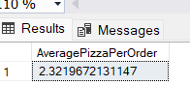

1. Daily Trend of orders

select DATENAME(DW, order_date) as order_date , count(distinct order_id) as totalorders

from pizza_sales

Group by DATENAME(DW, order_date)

1. Monthly Trend of orders

select DATENAME(Month, order_date) as order_date , count(distinct order_id) as totalorders

from pizza_sales

Group by DATENAME(Month, order_date)

1. Percentages of sales per category

select pizza_category, SUM(total_price)*100 / (select SUM(total_price)

from pizza_sales) as TotalPrice

from pizza_sales

group by pizza_category

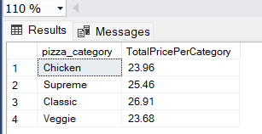

1. Top 5 pizzas by revenue

select TOP 5 pizza_name, Sum(total_price) as TotalRevenue

from pizza_sales

group by pizza_name

order by TotalRevenue DESC

