Requirements Specification TP
Exercise 1 :
1. Implementation Time Calculations
Firefox (~10 million lines of code) :
10,000,000 lines / 100 lines per day = 100,000 days.
100,000 days / 365 = approximately 274 years.
Google (2,000 million lines of code) :
2,000,000,000 lines / 100 lines per day = 20,000,000 days.
20,000,000 days / 365 = approximately 54,795 years.
2. Company Success Factors
- These companies succeed through massive parallel collaboration, employing thousands of developers simultaneously over many decades rather than relying on a single individual's sequential effort.
- They also utilize agile project management to handle immense complexity.
3. Evaluating Productivity
- The developer who writes 50 lines is typically more productive. Achieving the same solution with less code reduces system complexity, decreases the likelihood of bugs, and makes future maintenance easier.
- Better productivity metrics include the number of functional features delivered, bugs resolved, user satisfaction, code quality, and overall business value generated.
4. Unique Human Contributions in an AI Future
- If AI generates the bulk of the code, human developers will shift focus to high-level system architecture, requirements engineering, and translating ambiguous business needs into concrete technical specifications.

Exercise 2 :
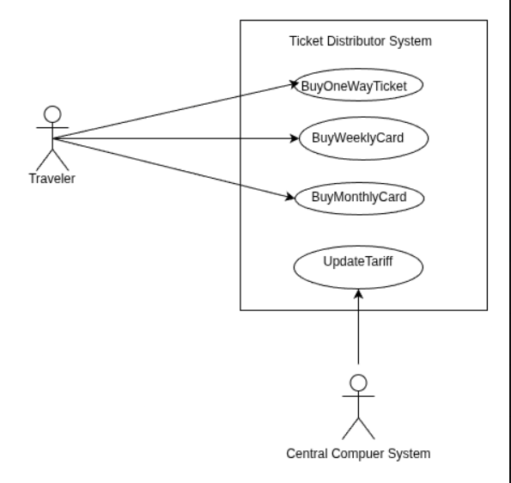
Exercise 3 :
- Requirements :
- The system shall allow job applicants to create their CVs. (Priority : Must Have / Estimlated Effort : Medium )
- The system shall allow career experts to review CVs after they have been validated by the applicant. (Priority : Must Have / Estimated Effort : Medium )
- The system shall allow the client manager to invite shortlisted candidates to take automated tests. (Priority : Must Have / Estimated effort : Medium )
- The system shall evaluate the automated tests and send the list of successful candidates to the recruiter. (Priority : Must Have / Effort : High )
- The system shall analyze user profiles and job postings and send users job announcements for positions matching their preferences.(Priority : Should Have / Effort : High )
- Use Case Diagram
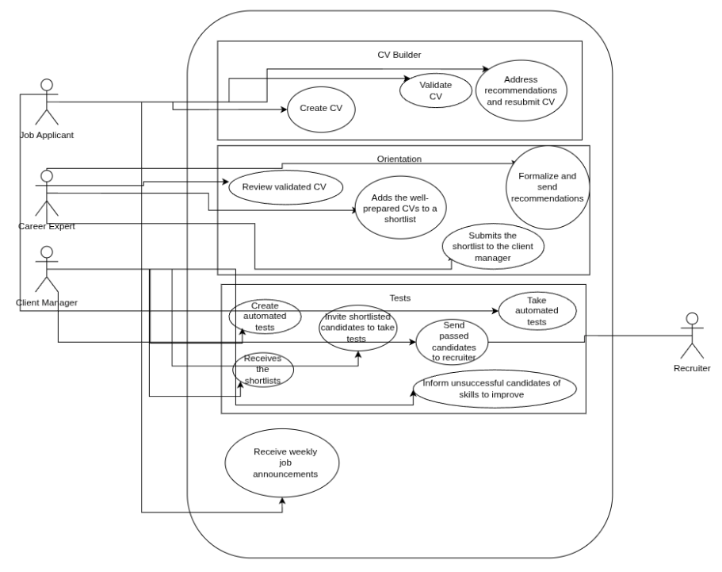
Exercise 4 :
- Actors of the system :
- Client
- Receptionist
- Cashiers
- Cleaning Staff
- Floor Manager
- Actions that occur outside the system :
- Card validation by the bank
- Client arriving at the hotel and giving their criteria to receptionist
- The client consuming meals
- Physical cleaning of room
- The floor manager’s cleaning inspection
- Repairs by maintenance
- The client physically paying and leaving at checkout
- Decompose the system into boundaries :
- Reservation
- Stay (Check-in to Check-out)
- Housekeeping

