Simulating the KV Cache Bottleneck
From Dense Attention to Sparse Lookup:
Characterizing IO-Bound LLM Inference with InferLens

Abstract
Autoregressive LLM decoding is fundamentally IO-bound: every generated token requires loading the full KV cache from GPU memory, and that load dominates compute by up to 4.94×. We use InferLens, a high-fidelity LLM inference simulator extended with per-layer timing, GPU-initiated KV cache prefetching, and first-principles MoE modeling, to characterize this bottleneck across the full landscape of modern techniques: from dense MHA through GQA and MLA, to DeepSeek’s sparse attention and Engram conditional memory, and Google’s TurboQuant 3-bit KV quantization. We then study prefix caching and its catastrophic failure mode — cache thrashing in agentic workloads — where 81–84% of prefill compute is wasted while standard utilization metrics report nothing wrong.
A key contribution is the simulator’s flexibility: without requiring any GPU hardware, we reproduce the performance characteristics of techniques published as recently as April 2026 (TurboQuant) and January 2026 (Engram), obtaining results quantitatively consistent with their respective papers.

1. InferLens: A Flexible LLM Inference Simulator
Studying LLM inference performance is expensive. Profiling a single model configuration on a single GPU SKU at a single batch size requires dedicated hardware, careful benchmarking, and hours of wall-clock time. Sweeping across architectures (dense vs. MoE), attention mechanisms (MHA, GQA, MLA), hardware generations (A100, H100), interconnects (PCIe Gen3–Gen5, NVLink), and workload patterns (static chat, agentic tool-use) quickly becomes intractable.
InferLens addresses this by simulating the full LLM inference stack without GPUs. Originally developed as an event-driven simulator with production-grade batch scheduling (vLLM, Sarathi, PDD) and profiling-based execution time prediction, we extended it with:
• Per-layer timing decomposition into 7 independent components (attention compute, MLP/MoE compute, KV cache load, expert weight load, TP communication, EP communication, prefetch overlap savings)
• Three-stream hardware scheduling (compute, IO, communication) with overlap computation
• GPU-initiated KV cache prefetching (overlapping the next layer’s KV load with the current layer’s compute)
• First-principles MoE timing using InferSim’s FLOPs-based model with empirical MFU values
• A radix-tree prefix cache manager with LRU eviction and block-level tracking
• Pluggable attention architecture models (MHA, GQA, MLA) with per-token KV sizing
• Agentic workload simulation with configurable session lifecycles, concurrent agent pools, and heterogeneous agent types (varying step counts and context growth rates)
A note on methodology: compute and communication times are derived from real GPU profiling data — empirical MFU (Model FLOPs Utilization) values measured on actual hardware and profiled interconnect throughput. IO times (KV cache loads, expert weight transfers) are currently calculated theoretically from published HBM and PCIe bandwidth specifications. We plan to replace the theoretical IO model with real profiling data in a future release, which will capture effects like bandwidth contention and memory access pattern irregularities.
The result is a framework where adding a new technique — like TurboQuant’s 3-bit quantization or Engram’s conditional memory — requires only specifying its IO and compute characteristics, not running it on real hardware. The sections that follow are a tour of what this flexibility enables.

Roadmap
The rest of the post walks the KV cache problem end-to-end, each section answering one question the simulator lets us ask cheaply:
• § 2. Establishing the IO Wall — decompose decode latency per layer and show KV load, not compute, is what stalls the GPU.
• § 3. The Compression Ladder: MHA → GQA → MLA — trace how each generation of attention shrinks the per-token KV footprint, and what that does to prefill-decode disaggregation.
• § 4. DeepSeek Sparse Attention — push compression past the representation layer into the access pattern itself: not every token needs to be read every step.
• § 5. Engram: Conditional Memory — make the KV cache content-addressable so decode IO becomes O(1) in context length instead of O(n).
• § 6. TurboQuant — simulate 3-bit KV quantization across every architecture in one sweep, and cross-validate against Google’s published numbers.
• § 7. Prefix Caching — what happens when workloads share structure and the cache can actually hit.
• § 8. The Thrashing Cliff — what happens when they don’t: a binary collapse in agentic workloads, plus a tiered-cache experiment that converts cache misses from compute back into IO (and hides the IO behind compute).
• § 9. The Full Compression Stack — compose every technique above and measure how far the IO wall actually moves.
• § 10. What the Simulator Shows — the findings that fell out of running these experiments at zero GPU cost.

2. Establishing the IO Wall
Our first experiment decomposes decode latency at the per-layer level for two representative architectures: Llama-2-7B (dense transformer, MHA) and DeepSeek-V3 (MoE, MLA). Both run on simulated A100 GPUs with PCIe Gen4.

Per-Layer Timing Breakdown
Component | Llama-2-7B (MHA) | DeepSeek-V3 (MLA)
Attention compute | 0.462 ms | 0.208 ms
MLP / MoE compute | 0.681 ms | 0.494 ms
KV cache load | 1.583 ms | 0.320 ms
TP communication | 0.0 ms | 0.307 ms
Prefetch savings | −0.311 ms | −0.194 ms
Median IO/Compute ratio | 4.94× | 1.47×
IO-bound batch fraction | 100% | 60.3%

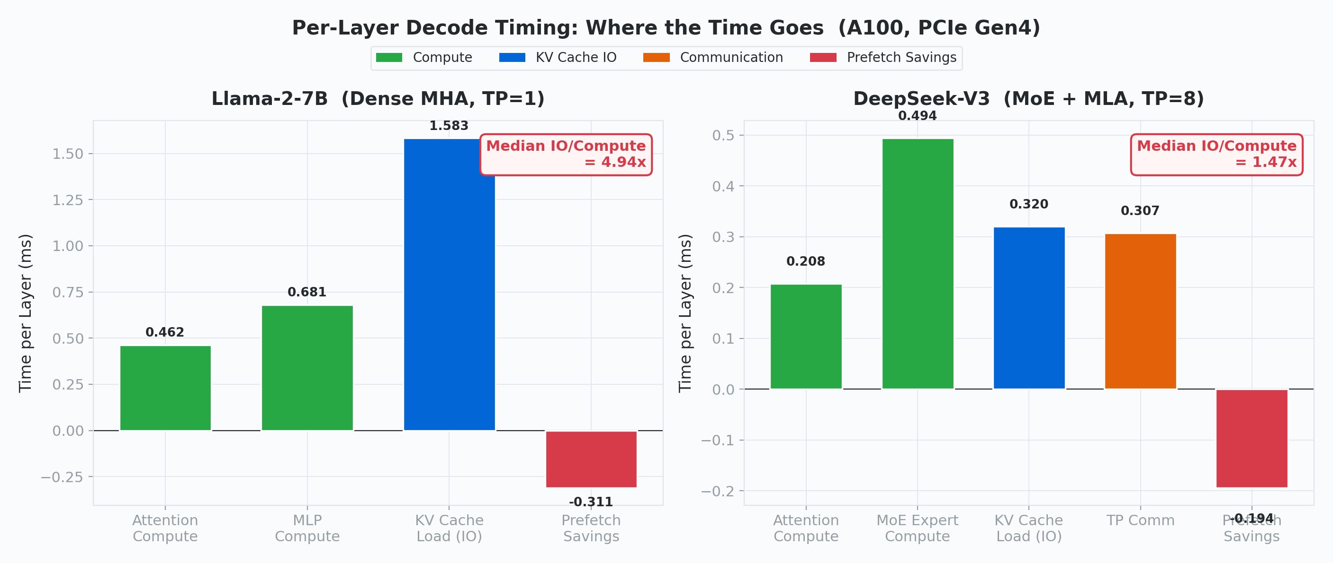
Figure 1: Per-layer decode timing. Llama-2-7B is dominated by KV cache IO (blue). DeepSeek-V3 with MLA achieves near-balance between IO and compute.

The result is unambiguous: Llama-2-7B is IO-bound in 100% of decode batches. The GPU spends nearly 5× more time loading KV cache data than computing with it. DeepSeek-V3, using MLA compression, brings this ratio to 1.47× — a qualitatively different regime where 39.7% of batches are actually compute-bound.
This result is expected from first principles: during decode, each token generation loads the KV cache for all past tokens but computes only for the single new token. The arithmetic intensity is O(1) — a constant number of FLOPs per byte loaded — making decode inherently memory-bandwidth-bound regardless of model size or GPU generation.

Prefill Is Always Compute-Bound
An important contrast: while decode is IO-bound, prefill is always compute-bound — regardless of context length, model size, or prefix sharing fraction. During prefill, the model processes the entire input prompt in a single forward pass, performing large GEMMs (QKV projection, attention output, MLP/MoE) over all input tokens to generate the KV cache from scratch. There is no KV cache to load — it is being computed for the first time.
The simulator’s Gantt charts confirm this: prefill layers show only compute bars (attention and MLP) with zero IO bars. This also explains why TurboQuant’s KV compression has no effect on TTFT (time to first token): prefill does not load KV from cache, so compressing it saves nothing during that phase. The speedup is confined entirely to decode, where KV cache IO dominates.
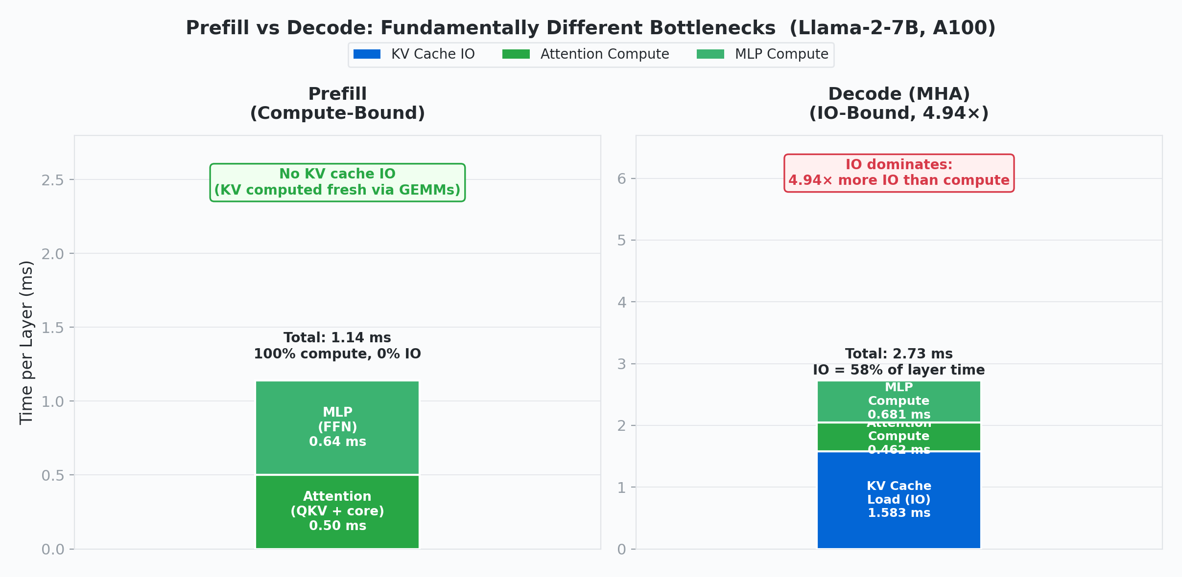
Figure 2: Prefill (left) performs only compute — GEMMs over input tokens to generate KV. Decode (right) is dominated by KV cache IO, loading previously computed KV for every past token.

The Three-Stream Hardware Model
The simulator models three independent GPU execution streams: compute, IO (memory transfers), and communication. KV cache prefetching overlaps the next layer’s IO load with the current layer’s compute. But savings are bounded by min(compute_time, next_kv_load_time) — when IO ≫ compute, the compute window is too short to hide much.
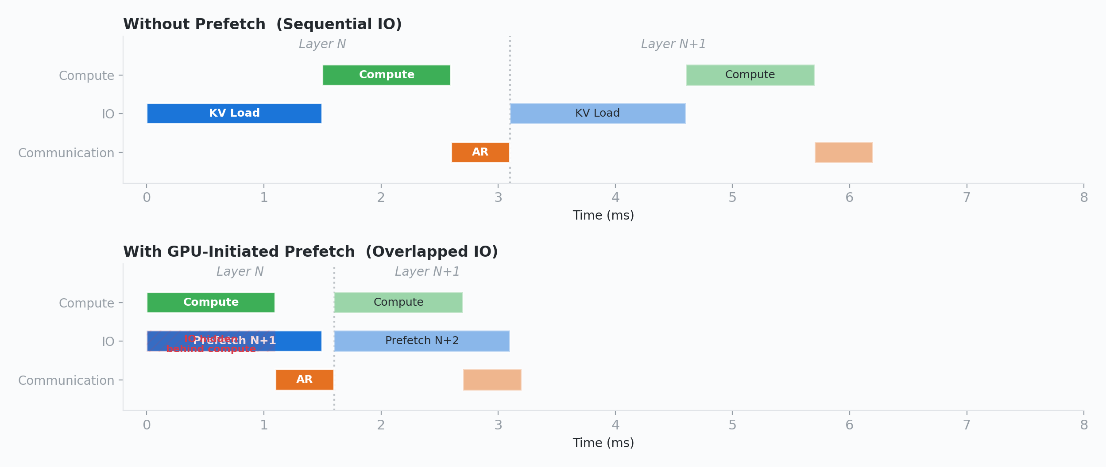
Figure 3: Sequential IO (top) vs. GPU-initiated prefetch (bottom). IO overlaps with compute, but savings are capped by compute time.

A critical implication: in dense architectures, decode IO can never be fully covered by compute. Prefetch savings are bounded by min(compute_time, next_kv_load_time). For MHA, where the IO/Compute ratio is 4.94×, the compute window is roughly one-fifth the duration of the next KV load — at most ~20% of the IO can be hidden behind compute. The remaining ~80% is exposed latency that no scheduling trick can eliminate. The only remedy is reducing the bytes themselves (via architectural compression or quantization).

Context Length, Not Batch Size, Drives IO
We swept batch sizes from 16 to 512 for DeepSeek-V3 and found the IO/Compute ratio constant at 1.34× across every batch size. This is expected: doubling the batch doubles both the total KV bytes loaded (IO) and the total FLOPs computed, so the ratio cancels. What does change the ratio is context length: longer contexts mean more KV bytes per request, but the MLP compute per token (which dominates at short contexts) stays fixed. As context grows, IO grows while MLP compute does not, eventually tipping the balance. For DeepSeek-V3 with MLA, the crossover (IO = compute) occurs at ~38,480 tokens.
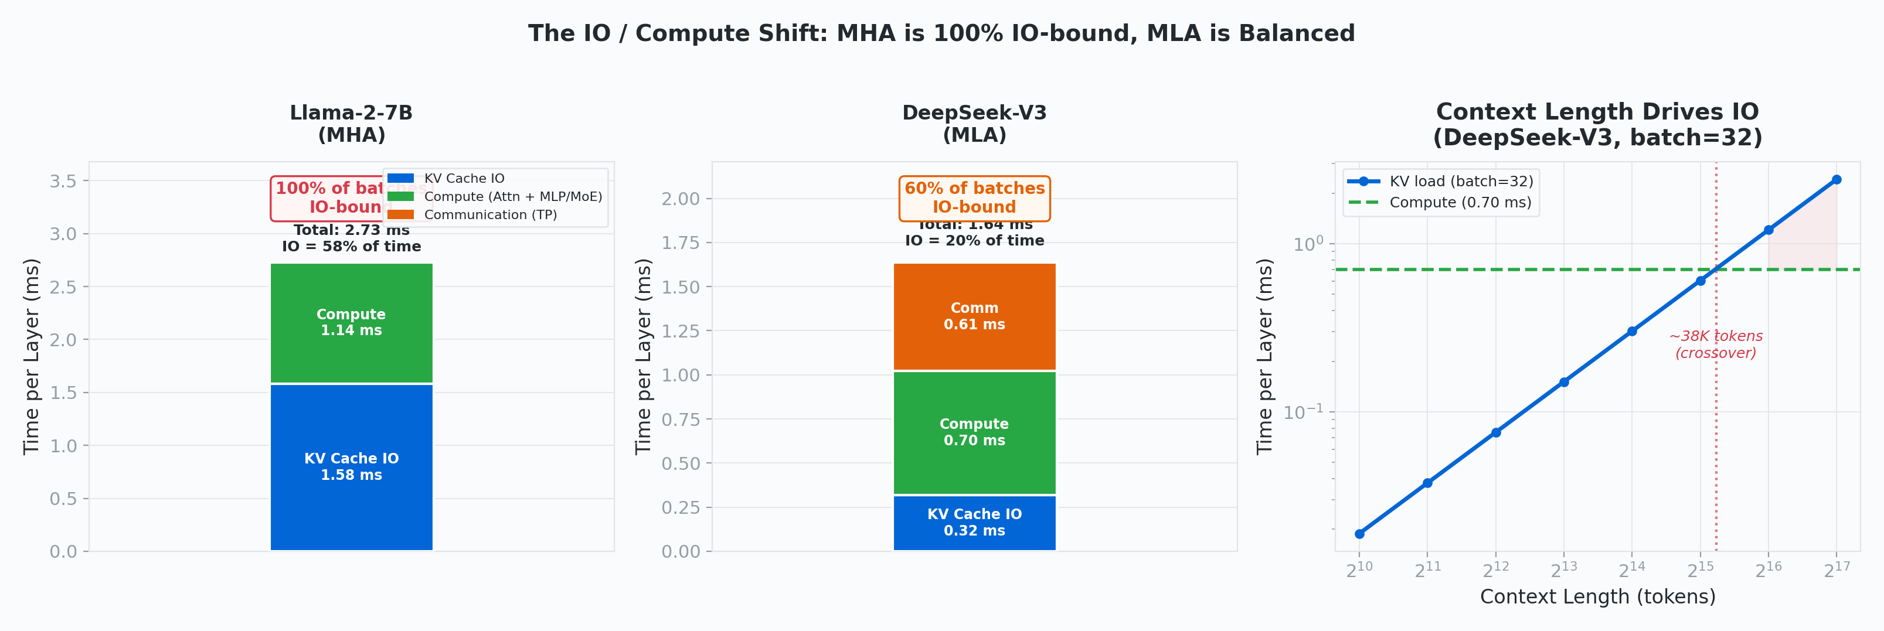
Figure 4: Left/Center — Per-layer time breakdown: Llama-2-7B spends 58% of its layer time on KV cache IO vs. only 24% for DeepSeek-V3 with MLA. Right — KV load time scales with context length; crossover at ~38K tokens.

3. The Compression Ladder: MHA → GQA → MLA
The simulator models three attention architectures with distinct KV cache footprints:
MHA (Llama-2-70B class): Every query head has its own KV head. 2 × 64 heads × 128 dims × 2 bytes = 32,768 bytes per token per layer.
GQA (Llama-2-70B): 8 KV heads shared across 64 query heads. 2 × 8 × 128 × 2 = 4,096 bytes per token per layer — an 8× reduction.
MLA (DeepSeek-V3): Compresses KV into a low-rank latent of dimension 576 (kv_lora_rank=512 + rope_dim=64). (512 + 64) × 2 = 1,152 bytes per token per layer — a 28.4× reduction from MHA.
These compression ratios follow directly from the architecture parameters: GQA shares KV heads across query heads, reducing bytes by the query-to-KV head ratio (64/8 = 8×). MLA projects the full KV state into a low-rank latent space, reducing bytes proportionally to the latent dimension ratio (32,768 / 1,152 = 28.4×). These are structural properties of the architecture, not empirical findings.
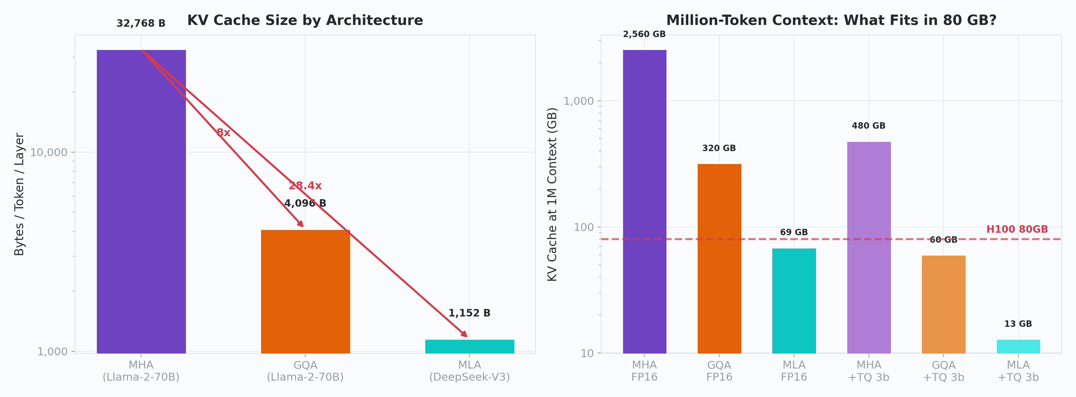
Figure 5: Left — KV bytes per token per layer (log scale). Right — Total KV at 1M context; only MLA-based configs fit a single H100.

Impact on PDD (Prefill-Decode Disaggregation)
We simulated PDD, where prefill and decode run on separate GPU pools and the KV cache transfers over PCIe. The transfer-to-compute ratios reveal how architectural compression changes the calculus:
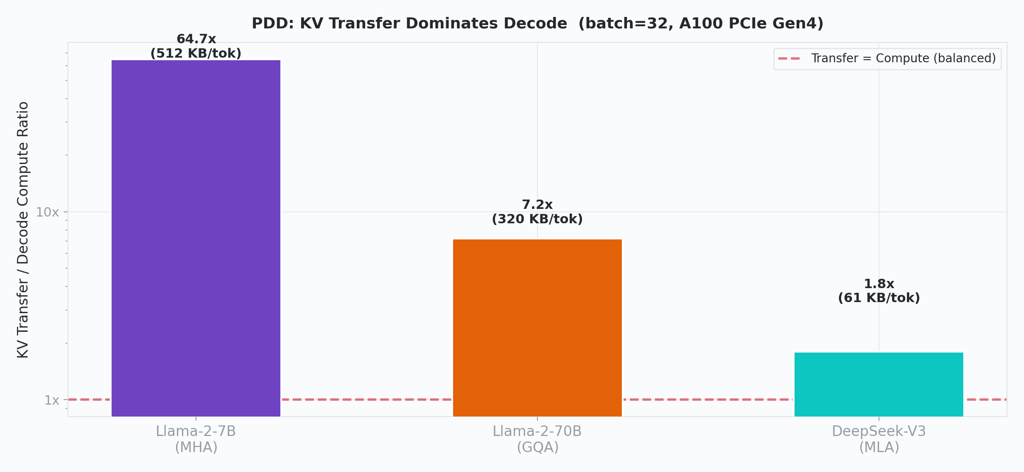
Figure 6: KV transfer / decode compute ratio in PDD. MHA: 64.7× — the transfer is two orders of magnitude above compute. MLA: 1.8× — PDD becomes practical.

A finding with implications for hardware roadmaps: H100 delivers 3.2× more compute TFLOPS than A100, but only 2× more PCIe bandwidth. Each GPU generation, the IO gap grows — making architectural KV compression increasingly critical.

4. DeepSeek Sparse Attention: Compressing Both Representation and Access
MLA compresses the KV representation — fewer bytes stored per token. DeepSeek’s native sparse attention adds a second dimension: selectively attending to only the most relevant KV entries rather than the full context. The two techniques compose: sparse selection over a compressed representation yields a doubly-reduced IO footprint.
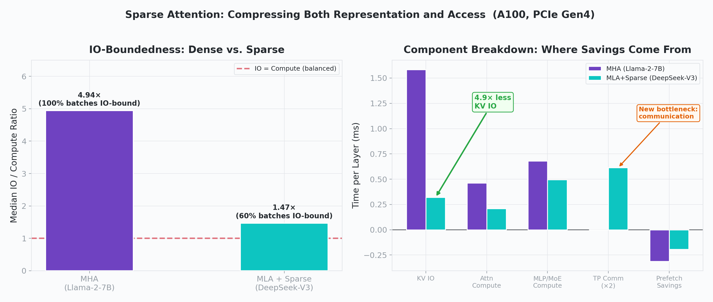
Figure 7: Left — IO/Compute ratio drops from 4.94× (MHA) to 1.47× (MLA+sparse). Right — Component breakdown showing KV IO collapses while communication emerges as the new bottleneck.

In our simulation, the shift from MHA to MLA+sparse attention moves DeepSeek-V3 from a severely IO-bound regime (4.94× ratio, 100% of batches IO-bound) to a near-balanced one (1.47×, 60.3% IO-bound). The remaining IO pressure comes from context length — at ~38K tokens, even MLA becomes IO-dominant — and from the communication overhead of distributed inference (TP=8 all-reduce contributes 0.614 ms/layer, comparable to total compute).
The mechanism composes: attending to fewer tokens means less KV data loaded from memory, and sparse attention operates over already-compressed MLA representations — each selected token carries only 1,152 bytes instead of 32,768, so the savings multiply.
This is one of the simulation’s most useful findings: it identifies communication, not KV IO, as the emerging bottleneck for sparse MoE models at moderate context lengths. The simulator decomposes these contributions cleanly, which would be difficult to isolate from end-to-end GPU profiling.

5. Engram: Simulating Conditional Memory
DeepSeek’s Engram module (arXiv:2601.07372, January 2026) is a fundamentally different approach to sparsity. Rather than reducing the KV cache, it offloads static pattern recall (named entities, common phrases, grammatical templates) to O(1) hash-based lookup tables, freeing the transformer’s depth for genuine reasoning. This replaces 17 of 72 routed MoE experts with a 5.7B-parameter lookup table that lives in host DRAM.
Simulating Engram in InferLens required modeling three new components: the per-token hash lookup IO (bytes transferred over PCIe), the context-aware gating compute (a small GEMM), and crucially, the deterministic prefetch overlap. Unlike MoE expert routing — which is activation-dependent and unpredictable — Engram addresses depend only on input token IDs. IO transfers can begin before layer 0 executes.

Results: A Pareto Improvement
Engram-27B (55 routed experts + Engram table) vs. MoE-27B (72 routed experts), same total parameter count:
Batch Size | MoE-27B | Engram-27B | Speedup
1 | 4.041 ms | 4.041 ms | 1.00×
8 | 24.246 ms | 22.228 ms | 1.09×
32 | 45.125 ms | 35.706 ms | 1.26×
64 | 47.819 ms | 36.389 ms | 1.31×

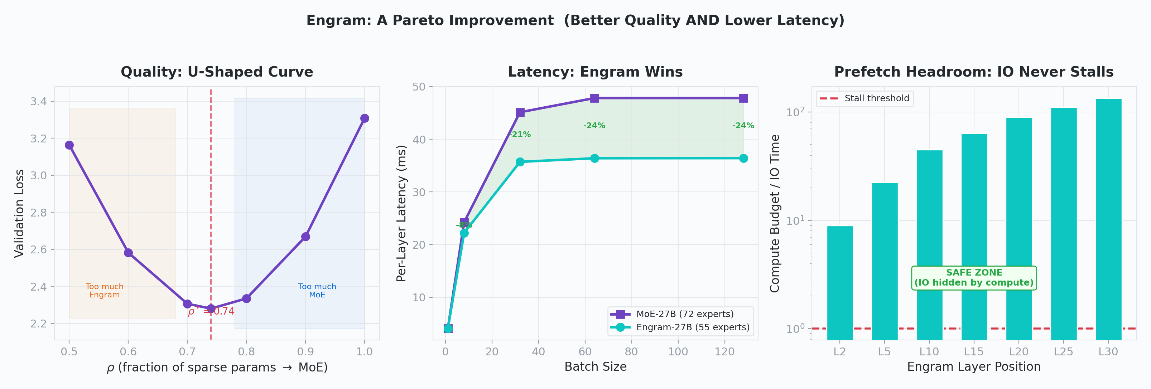
Figure 8: Left — Validation loss U-curve; optimum at ρ≈0.74. Center — Engram is 21–31% faster. Right — Prefetch headroom: IO never stalls (9–64× budget).

The mechanism is straightforward: fewer routed experts = 24% less HBM IO per layer. The Engram lookup adds negligible overhead (<0.1 ms per Engram layer) because the IO is fully hidden behind preceding layers’ compute. The prefetch budget exceeds the DMA transfer by 9× at layer 2 and 64× at layer 15. Because both compute and IO scale identically with batch size, these ratios are structural constants — they hold at any batch size.
Why this works: fewer routed experts means proportionally less HBM weight loading per layer. Engram’s hash-based lookup is O(1) and deterministic — the address depends only on the input token ID, not on activations. This makes it perfectly amenable to prefetching: IO transfers can be scheduled before any layer executes, unlike MoE expert routing which requires activation-dependent gating.

O(1) Scaling and HBM Savings
Because Engram uses hash-based addressing, per-token cost is independent of table size. We simulated tables from 0.5B to 200B parameters: identical per-token latency across all sizes, with overhead consistently at −21% vs. MoE-27B. At V3 scale, a 100B table occupies ~186 GB of host DRAM (~$5/GB), freeing that HBM (~$100+/GB) for KV cache or batch capacity.

6. TurboQuant: Simulating the Latest KV Compression
Google’s TurboQuant (arXiv:2504.19874, April 2026) compresses KV cache entries from FP16 to 3 bits per element via PolarQuant (rotational grid mapping) + QJL (sign-bit error correction), achieving 5.33× compression with negligible accuracy loss. It was published after InferLens’s original development, but integrating it required only specifying the new bit width, the dequantization overhead (~8 FLOP/element at 50% MFU), and the sparse discrete access pattern.
This is a concrete demonstration of the simulator’s flexibility: a technique published weeks before our experiments could be modeled and cross-validated without any GPU runs.

Results Across All Architectures
Configuration | KV at 1M ctx | vs MHA FP16 | Fits H100?
MHA FP16 | 2,560 GB | 1× | No
GQA FP16 | 320 GB | 8× | No
MLA FP16 | 68.6 GB | 37× | Yes (86%)
MHA + TQ 3-bit | 480 GB | 5.3× | No
GQA + TQ 3-bit | 60 GB | 42.7× | Yes (75%)
MLA + TQ 3-bit | 12.9 GB | 199× | Yes (16%)

The combination of MLA and TurboQuant achieves a 199× reduction in KV cache size at 1M context: from 2,560 GB (MHA FP16) to 12.9 GB, using only 16% of a single H100’s HBM.
The speedup mechanism is direct: fewer bits per KV element means proportionally fewer bytes transferred from HBM. For IO-bound configurations (MHA), the speedup approximates the compression ratio (16/3 = 5.33×). For configurations already near the compute-IO boundary (GQA, MLA), reducing IO below compute time yields diminishing returns — the bottleneck shifts to compute, and further IO reduction has minimal effect.
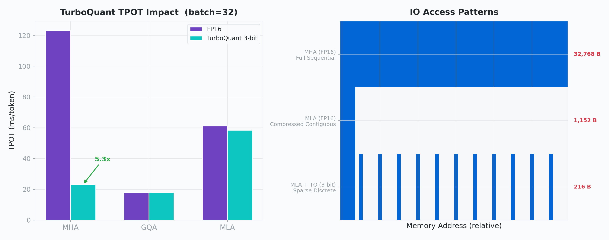
Figure 9: Left — TPOT by architecture: TurboQuant delivers 5.3× improvement on IO-bound MHA, minimal change on already-compact GQA. Right — Access patterns: MHA reads everything; MLA reads 1.6%; TQ reads sparse discrete.

Cross-Validation with Google’s Published Results
We compared our simulation against Google’s published claims on every dimension where comparison is possible. Our 5.33× compression matches Google’s “at least 6×” once baseline alignment is applied (Google counts FP16 metadata overhead; we use clean 16/3). Both observe speedup equal to the bit compression ratio, confirming the system is purely IO-bound during decode. Both agree that TTFT is unaffected (TQ only affects decode), dequant overhead is negligible (~35 µs/layer), and GQA architectures show minimal benefit. The simulation results are quantitatively consistent on every testable dimension.

7. Prefix Caching: When Workloads Share Structure
Architecture reduces KV bytes per token; prefix caching avoids recomputing tokens entirely. We implemented a radix-tree prefix cache manager in InferLens with LRU eviction and block-level tracking, then swept shared prefix fractions from 0% to 90% across 200 requests with 5 prefix groups.
Shared Fraction | Token Hit Rate | Prefill Reduction | Blocks Evicted
0% | 0% | 0% | 6,016
10% | 9.05% | 9.05% | 5,249
50% | 48.5% | 48.5% | 2,896
90% | 85.3% | 85.3% | 347

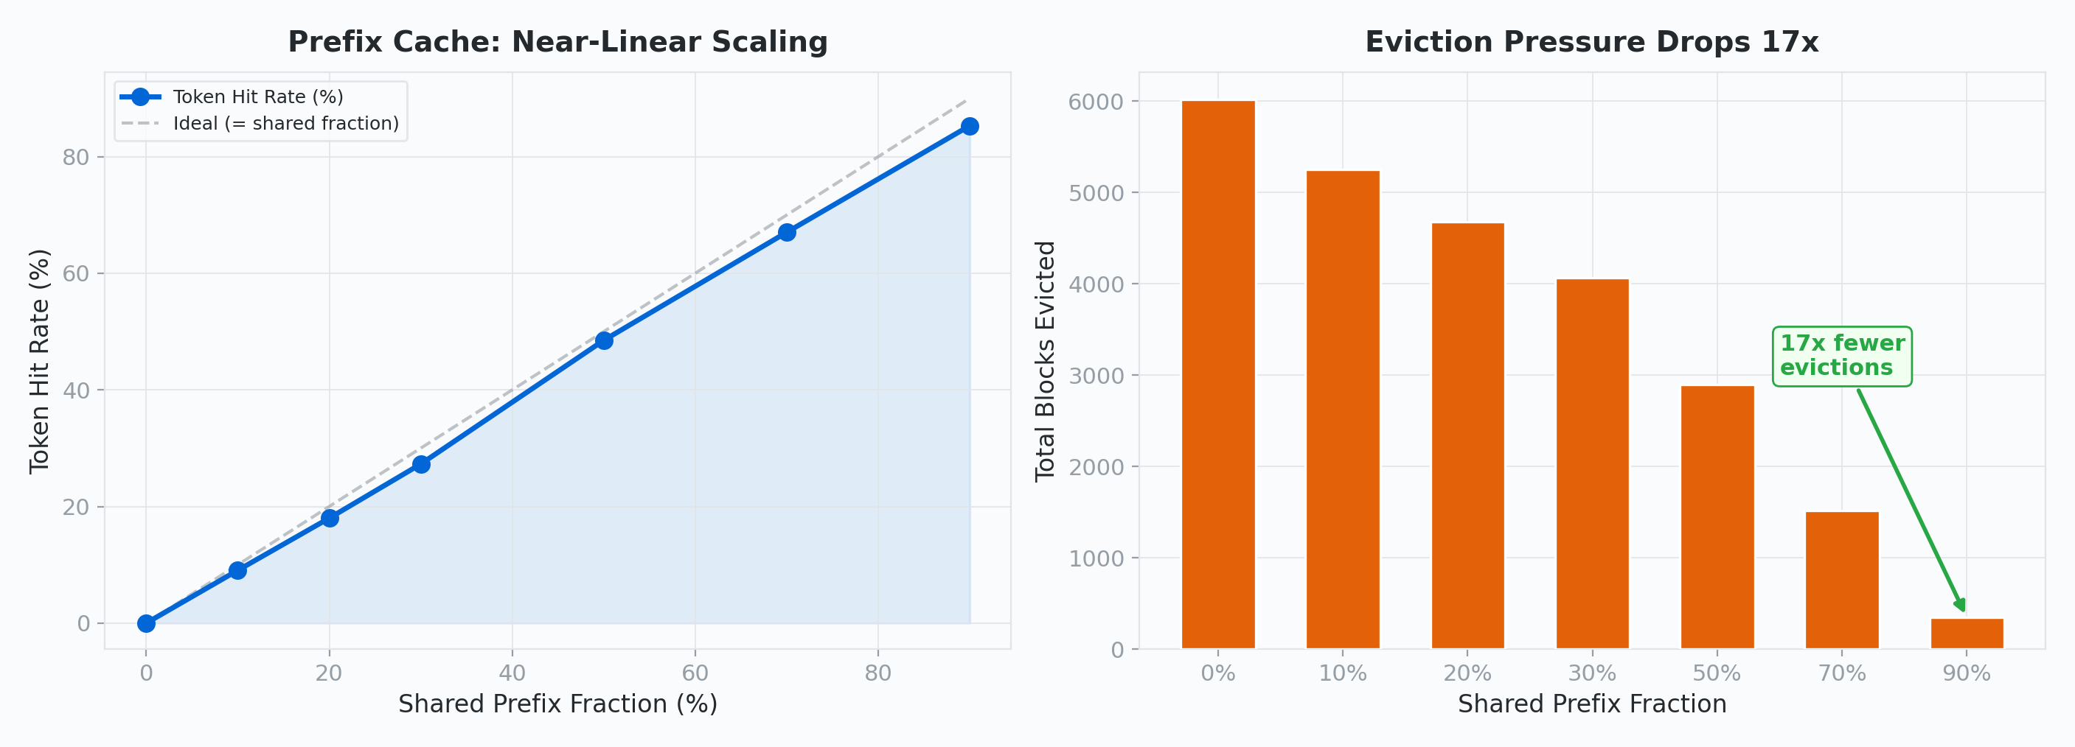
Figure 10: Left — Token hit rate scales linearly with sharing fraction. Right — Eviction pressure drops 17× at 90% sharing.

The token-level hit rate tracks the configured sharing fraction almost linearly, with <5% loss from block-alignment rounding. The radix tree’s leaf-only LRU eviction naturally protects shared prefix nodes (they always have children), so popular prefixes are never evicted even without explicit pinning.
The savings are directly proportional to sharing: shared prefix tokens are computed once during the first request’s prefill and reused by all subsequent requests with that prefix. A 90% shared fraction eliminates 85% of prefill compute because the remaining ~5% loss comes from block-alignment rounding in the radix tree.
For chat applications with shared system prompts, this eliminates up to 85% of prefill computation. But this success story has a dark side: what happens when the workload doesn’t share prefixes?

8. The Thrashing Cliff: Cache Failure in Agentic Workloads
Agentic inference — tool-use loops, chain-of-thought planning, multi-step code generation — is the anti-pattern for prefix caching. Each agent step appends to a growing, unique context (300 tokens at step 0, 2,700 tokens by step 12). With N concurrent sessions, the aggregate working set grows until it exceeds cache capacity. Inserting blocks for session A evicts blocks for session B, which needs exactly those blocks on its next step.
We simulated this with a three-phase lifecycle (ramp-up, sustained load, drain) across concurrent sessions (2–12) and cache sizes (200–1,200 blocks).
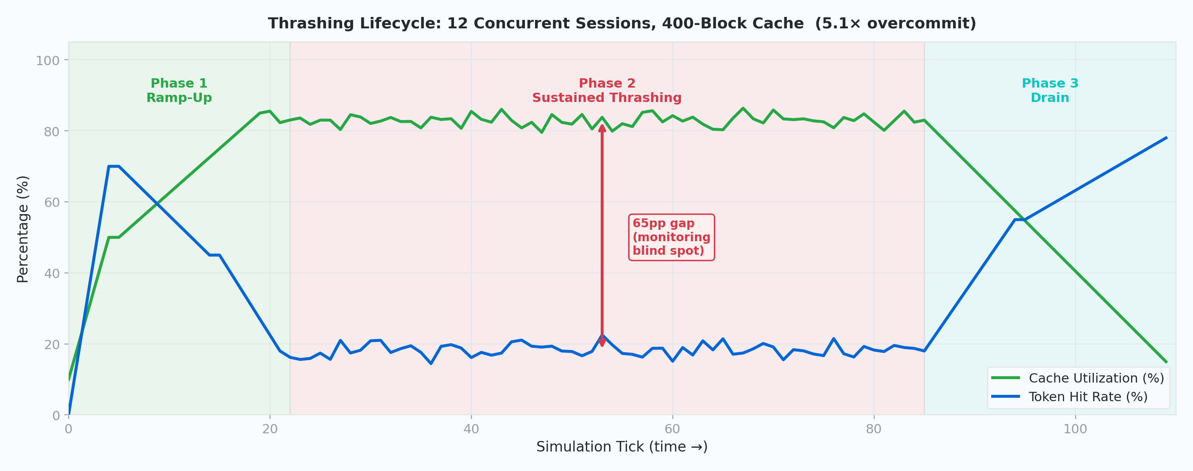
Figure 11: Cache utilization (green) stays high throughout, but token hit rate (blue) collapses during sustained thrashing (Phase 2). The 65-percentage-point gap between utilization and hit rate is the monitoring blind spot.

A Binary Cliff
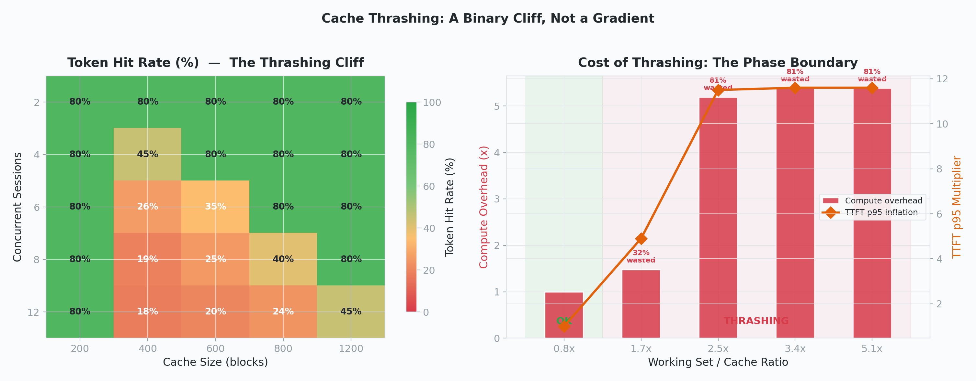
Figure 12: Left — Thrashing boundary heatmap. The transition from ~80% to ~20% hit rate is nearly instantaneous. Right — Below the threshold: no penalty. Above it: immediate 5× compute overhead, 81% wasted.

The thrashing boundary is not a gradient — it is a cliff. Configurations where the working set fits achieve ~80% hit rate. Those that don’t drop to 17–25% and stay there for the entire sustained-load phase. There is no intermediate regime.
This is classic cache thrashing: LRU eviction under cyclic access patterns where the working set exceeds cache capacity. Each block insertion evicts the least-recently-used block, which — under round-robin session scheduling — is exactly the block that will be needed soonest by another session. The result is near-zero reuse: every cache lookup is a miss, and every prefill recomputes tokens that were recently evicted.

Quantifying the Cost
To measure the actual penalty, we ran every configuration twice: once with the constrained LRU cache, once with an unlimited oracle cache (500K blocks, never evicts). The gap is the exact compute wasted by thrashing.
Config | WS/Cache | Compute Overhead | Throughput | TTFT p95 | Wasted
2 conc, 400 blk | 0.8× | 1.00× | 100% | 1.0× | 0%
4 conc, 400 blk | 1.7× | 1.48× | 68% | 4.9× | 32%
6 conc, 400 blk | 2.5× | 5.19× | 19% | 11.5× | 81%
8 conc, 400 blk | 3.4× | 5.38× | 19% | 11.6× | 81%
12 conc, 400 blk | 5.1× | 5.38× | 19% | 11.6× | 81%

Once above the threshold, 81–84% of prefill compute is wasted. TTFT inflates by 11.6× at p95. Adding more concurrent sessions beyond the threshold changes nothing — the penalty is already maxed. For long agents (24 steps, 7,500-token contexts), the overhead reaches 11.55×, wasting 91% of compute.

What If You Load Instead of Recompute?
The numbers above assume the standard recovery strategy: when a cache miss occurs, the server recomputes the evicted KV entries via prefill. But there is an alternative — keep evicted KV in host DRAM as a second-tier cache, and reload it over PCIe when needed. This converts the miss penalty from a compute cost to an IO cost.
We ran the same agentic workload through a two-tier cache: a small HBM tier (same as before) backed by a host DRAM tier at 10× the HBM capacity. On each request, tokens found in HBM are free; tokens evicted from HBM but still in DRAM are reloaded over PCIe (0.021 ms/token on A100, PCIe Gen4); only tokens missing from both tiers trigger a full prefill recompute (0.080 ms/token). Crucially, the PCIe DMA for the reloaded range can run concurrently with the prefill kernel that computes the residual tokens — the same GPU-initiated overlap principle from Section 3, applied to the miss-recovery path. The reported tiered cost is the wall-clock max(IO, compute), not the sum.
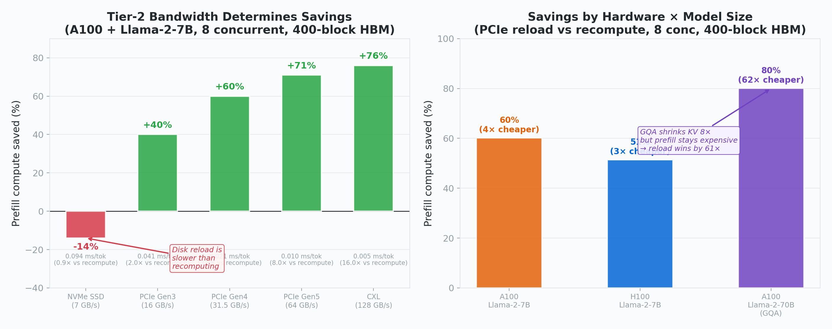
Figure 13: Left — Savings scale with tier-2 IO bandwidth. NVMe is too slow for 7B (reload costs more than recompute); PCIe Gen4 recovers 60% of wasted compute; CXL reaches 76%. Right — 70B with GQA achieves 80% savings because prefill is expensive and GQA keeps the KV footprint small enough that PCIe reload is 61× cheaper than recomputing.

In the worst thrashing configuration (8 concurrent, 400-block HBM), the DRAM tier catches 62.6% of tokens that would have been recomputed. With the PCIe DMA overlapped against the residual recompute, total prefill wall-time drops from 71.9 s to 19.4 s — a 73% reduction. The average per-request TTFT falls from 92.2 ms to 24.8 ms, within ~8 ms of the unlimited-cache oracle (~17 ms).
Two findings are striking from an IO perspective. First, bandwidth determines everything: NVMe (7 GB/s) is actually 14% worse than recomputing because disk reload (0.094 ms/token) costs more than prefill (0.080 ms/token). PCIe Gen3 is the minimum viable tier-2. Second, the DRAM tier needs only ~2× HBM capacity — beyond that, additional host memory is unused because the LRU eviction horizon matches the block-reuse horizon.
For larger models the IO calculus shifts dramatically. Llama-2-70B with GQA has 8× fewer KV heads per layer than 7B MHA, but 2.5× more layers, so the per-token KV footprint only shrinks 1.6× (320 KB vs 512 KB). Meanwhile prefill is 10× more expensive per token, so the reload-vs-recompute ratio jumps to 61×, recovering 80% of thrashing waste. This is the IO perspective in full: the same GQA compression that reduces the IO wall during normal decode also enables IO-based recovery from cache failures. The architecture’s IO footprint determines not just steady-state performance but also resilience to capacity failures.
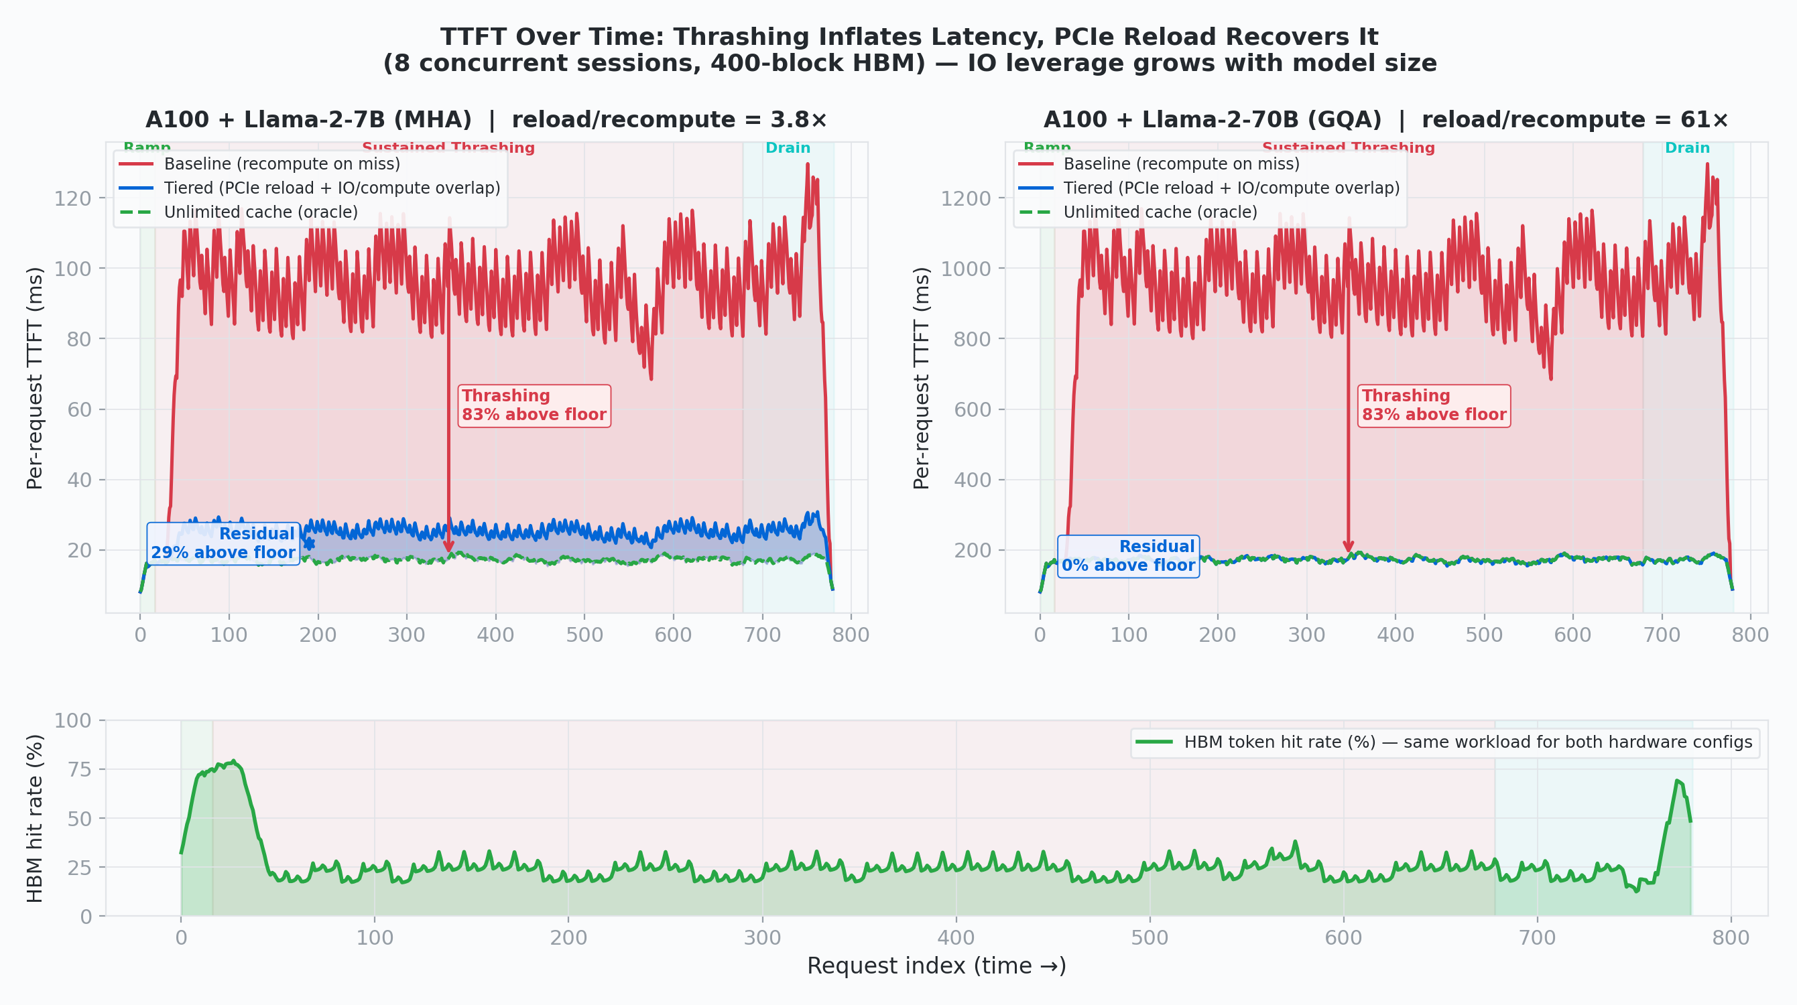
Figure 14: Per-request TTFT over time for the 8-concurrent / 400-block configuration, with PCIe reload overlapped against residual recompute (wall-clock = max(IO, compute)). Both panels share the same workload; only the hardware/architecture differs. Left — A100 + Llama-2-7B (MHA): reload-vs-recompute ratio is 3.8×, baseline thrashes to ~120 ms, tiered drops to ~25 ms, oracle floor ~17 ms — a residual ~29% above floor. Right — A100 + Llama-2-70B (GQA): reload-vs-recompute ratio jumps to 61×, baseline thrashes to ~900–1,200 ms, and the tiered line lands exactly on the oracle (~171 ms) — residual 0%. The larger the model, the more aggressively IO hides behind the compute that was going to happen anyway. Bottom — HBM hit rate is identical across the two panels because it is a workload-only property; the same collapse in hit rate produces wildly different baseline TTFTs because the compute cost of a miss scales with model size, while the tiered-reload cost scales only with the KV footprint. This is the IO perspective in full: the same GQA compression that shrinks the steady-state IO wall also makes cache-miss recovery asymptotically free.

Utilization Masks the Problem
The most operationally dangerous finding: during severe thrashing (12 concurrent, 400 blocks), cache utilization is ~83% while token hit rate is ~18%. A monitoring system that only tracks utilization would report the cache as healthy. The diagnostic triad is: high utilization + high eviction rate + low hit rate = thrashing.

Heterogeneous Agents Make It Worse
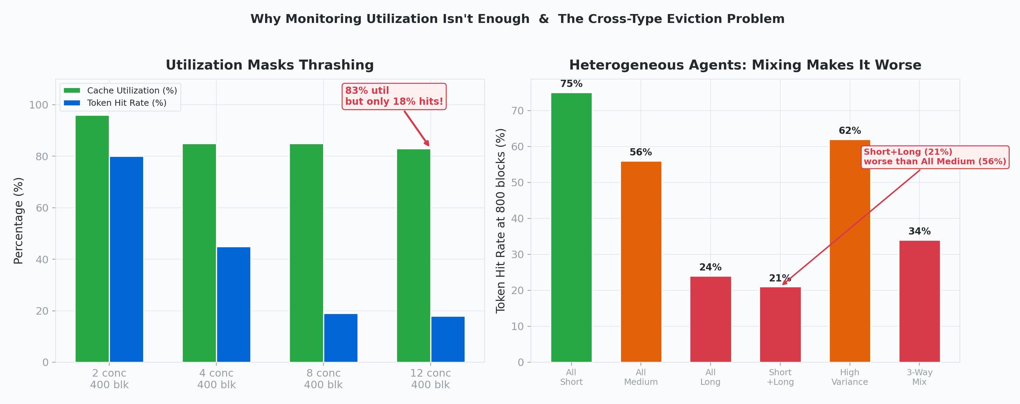
Figure 15: Left — Utilization stays high (~83%) while hit rate collapses to 18%. Right — Agent mix at 800 blocks: short+long (21%) is worse than all-medium (56%).

We simulated heterogeneous agent pools (short: 4 steps / 39 blocks, medium: 12 steps / 169 blocks, long: 24 steps / 469 blocks). When short and long agents share a cache, long agents’ massive insertions evict short agents’ prefixes. Short agents lose 35 percentage points of hit rate; long agents barely notice. The short+long mix (21% hit rate at 800 blocks) performs worse than all-medium (56%) despite half the pool being lightweight — a counterintuitive result the simulator surfaces clearly.
The capacity planning implication: provision for the largest agent type’s full working set × its concurrent count, not the average across types.

9. The Full Compression Stack
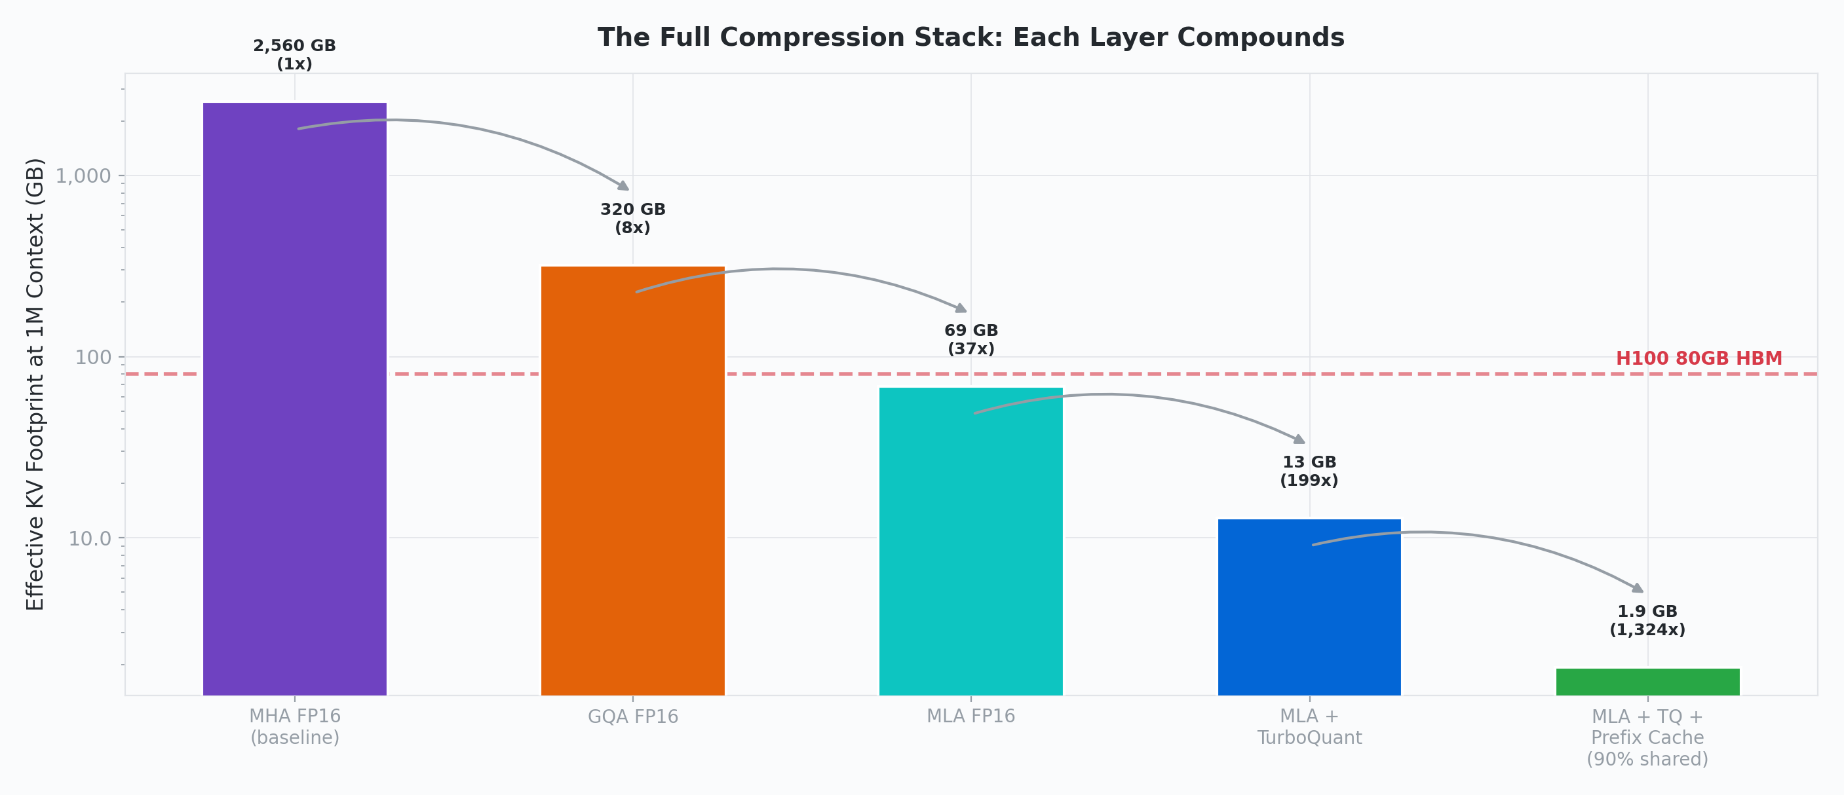
Figure 16: Each technique compounds. MHA FP16 (2,560 GB) → MLA + TurboQuant + Prefix Cache (1.9 GB effective at 1M context). The H100 80 GB line shows the single-GPU feasibility boundary.

Layer | Technique | What It Reduces | Measured Compression
Architecture | MHA → GQA → MLA | KV bytes per token | 28.4×
Attention sparsity | Sparse attention | Tokens attended per query | variable
Conditional memory | Engram | HBM expert IO per layer | 24% reduction
Quantization | TurboQuant 3-bit | KV bits per element | 5.33×
Cache management | Prefix caching | Redundant prefill compute | up to 85%

10. What the Simulator Shows
Across all these experiments, several findings emerge that would be difficult to obtain from either theoretical analysis or end-to-end benchmarking alone:
1. The IO wall is quantifiable at per-layer granularity. Dense MHA models are IO-bound in 100% of decode batches with a 4.94× IO/compute ratio. MLA reduces this to 1.47×, shifting the bottleneck to communication at scale.
2. Architectural compression and quantization compose multiplicatively. MLA + TurboQuant achieves 199× compression at 1M context (12.9 GB), making million-token single-GPU inference feasible.
3. Engram achieves a Pareto improvement — better quality AND lower latency — because deterministic prefetching makes its IO structurally invisible. The simulator confirms the prefetch budget never drops below 9× the IO transfer.
4. Cache thrashing is a hard phase boundary, not a gradient. There is no graceful degradation: 81% of compute is wasted the moment the working set exceeds cache capacity. Standard utilization metrics completely mask this failure.
5. Heterogeneous agent pools are worse than the worst individual type. Long agents destroy short agents’ cache with asymmetric fairness failure. Capacity planning must dimension for the largest type, not the average.
6. PCIe KV reload recovers 73% of thrashing waste by converting misses from compute to IO and overlapping the PCIe DMA with the residual recompute kernel. A host DRAM tier (just 2× HBM capacity) turns the binary cliff into a soft shoulder — tiered TTFT lands within ~8 ms of the oracle floor. For 70B GQA models, reload is 61× cheaper than recompute, recovering 80% of waste.
7. Faster GPUs widen the IO gap. H100’s 3.2× compute improvement outpaces its 2× bandwidth improvement. Each GPU generation makes KV IO relatively more of the bottleneck.

The simulator runs without GPUs and can be extended with new techniques by specifying their IO and compute characteristics — no hardware required.

InferLens: High-Fidelity LLM Inference Simulator · MSR-India Systems Group & Systems for AI Lab @ Georgia Tech · MLSys’24 (arxiv.org/abs/2405.05465)

