EL KOBI Yassir

Java TPn°6

A.

3) With the graph-BFS-SP.txt graph, we have this:

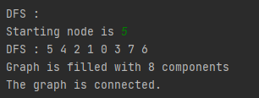

B.

2)

With the graph-BFS-SP.txt graph, we have this:

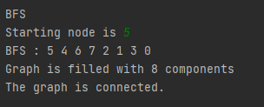

C.

Here is the output:

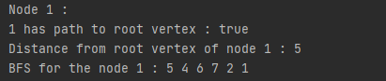

D.

Here is the output:

