FORBIOM-ON ONTARIO FOREST & WOOD SECTOR MODEL |  | PRELIMINARY RESULTS REPORT | OCTOBER 15, 2026    Ontario Forest Biomass  Supply Chain Feasibility, Processing Optimization, and ABM-Integrated Biomass Utilization  Preliminary results · FORBIOM-ON spatial forest-sector model (2020–2030)  
  PREPARED BY  Rasoul Yousefpour  Yasser Elfahli  October 15, 2026 | 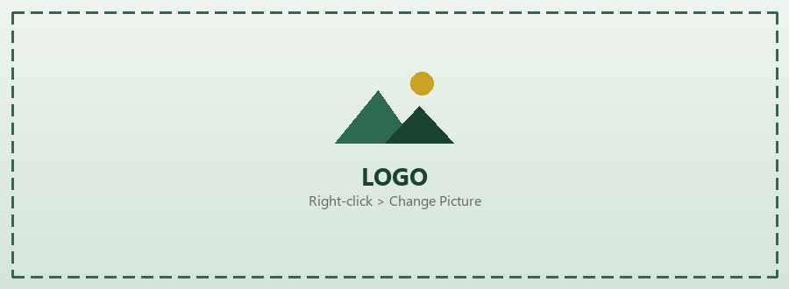

ABSTRACT
This report presents the preliminary results from three core study streams: (i) a feasibility assessment of the forest biomass supply chain, covering sourcing locations, logistics, and material flows; (ii) a technical assessment of optimized biomass processing pathways and their economic sensitivities; and (iii) an agent-based modeling of biomass utilization patterns across Ontario’s regions. To support these studies, we applied FORBIOM-ON, a dynamic spatial model of Ontario’s forest sector, as the shared modeling framework across all three activity areas.
FORBIOM-ON is a spatial, multi-commodity model for wood and wood-based products with a focus on Ontario’s Forest Management Units (FMUs). It is designed to analyze the impacts of market developments and policy changes on forest management, wood processing industries, and regional wood product markets. The model represents the interactions between forest resources, industrial production, and inter-regional trade in major wood products, including lumber, pulpwood, and engineered wood. Implemented in GAMS and formulated as a nonlinear programming (NLP) problem, the model allows the analysis of how changes in market conditions, logistics constraints, industrial capacity, and carbon pricing influence harvest levels, production patterns, regional prices, and trade flows across the forest value chain. Preliminary simulations indicate that the model is able to capture regional developments in the Ontario forest sector and to evaluate the implications of policy and market changes for supply, demand, industrial production, and carbon outcomes.
Sections 5 and 6 document the data processing and the agent-based model; code, data and Appendix A are in the public GitHub repository (link).
Contents
1 Overview 3
2 Existing models for wood markets 4
3 ABM linkage structure 4
3.1 Behavioral harvesting (sigmoid) 4
4 Simulation pathways and methods 5
4.1 Simulation pathways 6
4.2 Model families and data flow 6
5 Data sources and data processing 8
5.1 Data sources 8
5.2 FORBIOM-ON input processing (GAMS data block) 8
5.3 Forest Resources Inventory processing (process_fri_data.py) 10
5.4 Agent-based model data and calibration (calibrate.py) 11
5.5 Data quality and known gaps 13
6 Agent-based model (FORBIOM-ABM): specification and experiments 13
6.1 Purpose and patterns 13
6.2 Entities, state variables and scales 14
6.3 Process overview and scheduling 14
6.4 Behavioural decision rules 15
6.5 Markets, expectations and stochasticity 15
6.6 Biomass utilization strategies 16
6.7 Experimental design and multi-criteria evaluation 16
6.8 Accounting and output indicators 17
6.9 Key parameters, sources and status 18
6.10 Coupling with FORBIOM-ON and limitations 18
7 Results (from a preliminary counterfactual run) 19
Supplementary materials (code, data, scripts) 25
A Appendix — Shareable repository contents 26
A.1 Repository layout 26
A.2 Reproduction pointers 26
A.3 Data and redistribution limits 26
A.4 Citation 27

1 Overview
Building on the three study streams outlined above, namely biomass supply chain feasibility, processing optimization, and biomass utilization, this section describes the structure and scope of the modeling framework used to support them. FORBIOM-ON is a regionalized economic simulation model designed to analyze the economic and environmental impacts of provincial policy shifts and market fluctuations on the forest industry and its related value chains in Ontario. It evaluates the trade-offs between biological forest preservation, industrial production, and carbon sequestration goals.
The model is currently operational for a ten-year planning horizon (2020–2030) and integrates regional biophysical yield data with industrial capacity and logistics constraints across Northern and Southern Ontario. Structurally, it belongs to the class of spatial equilibrium and multi-commodity models. Its core features are:
■ Recursive-dynamic with a yearly resolution, where forest stock levels and available harvests in the current period are functionally dependent on the biological increment and extraction rates of previous years.
■ Distinction between seven tree species and site class (Spruce, Jack Pine, White Birch, Tolerant Hardwoods, White Pine, Red Pine, and Aspen) and three site classes (SC1, SC2, SC3).
■ Manufacturing hierarchy disaggregated by layers: Primary (Lumber, Pulpwood) and Secondary (CLT, Glulam), where secondary production is physically constrained by the mass-balance availability of regional lumber inputs.
■ Supply-side differentiation based on Plonski Yield Tables, which drive species-specific Gross Merchantable Volume (m³/ha) as a function of forest age and dominant site class.
■ Regionalized at the Forest Management Unit level for six key Ontario regions: Trout Lake, Abitibi, Algoma, Kenora, Nipissing, and Algonquin.
■ Bilateral trade flows based on the Spatial Equilibrium concept, which calculates optimal inter-regional shipments by solving for spatial arbitrage conditions subject to transport arc capacities and freight costs.
■ Growth engine driven by Current Annual Increment (CAI), where annual roundwood accumulation is interpolated from yield-age brackets and applied to calculated regional forest areas.
■ Integrated carbon accounting system that evaluates the net balance between process-based manufacturing emissions, freight-related transport emissions, and long-term carbon storage factors within the harvested wood product (HWP) pool.
The model and related data transformations are encoded in GAMS. It is defined as a Non-Linear Program (NLP) and solved using high-performance solvers (e.g., CONOPT or SNOPT). Data exploitation and result processing are handled through GDX-to-CSV translation for integrated reporting of regional revenue, manufacturing tier metrics, and carbon value chains.

2 Existing models for wood markets
FORBIOM-ON belongs to the group of recursive-dynamic partial equilibrium models for the forest sector. The history of these models goes back to the Global Trade Model (GTM), which was the first to study how wood products move between countries (Buongiorno and Gilless, 1983). Around the same time, the PAPYRUS model was created to look at the pulp and paper industry in North America (Buongiorno and Gilless, 1987). These early models created the foundation needed to combine forest growth with market supply and demand.
The most well-known models in this group are the EFI-GTM (Kallio et al., 2004) and the GFPM (Tomberlin and Buongiorno, 1998). The EFI-GTM is used to study wood markets mostly in Europe. The Global Forest Products Model (GFPM) is similar but covers the whole world, dividing it into 180 different regions to see how trade flows on a global scale.
Because global models are too broad to show local policy impacts, researchers have built models for specific countries and regions. Examples include the Norwegian Trade Model (Trømborg and Sjølie, 2011), the Finnish Forest Sector Model (Ronnila, 1995), and the French Forest Sector Model (Caurla et al., 2010). These models use high-resolution local data to provide better policy insights for specific jurisdictions.
FORBIOM-ON contributes to this field by providing a comprehensive vertically integrated framework for the Ontario forest sector. While traditional models often treat the forest and the manufacturing sector as separate units, FORBIOM-ON creates a direct, physical link between the biological growth of specific tree species and the production limits of advanced wood industries. By accounting for the strict industrial dependencies between primary sawmilling and secondary manufacturing, the model ensures that the expansion of the mass timber sector is balanced against the actual sustainable harvest limits of the province. This approach allows for a realistic evaluation of how regional forest management policies impact the entire value chain. This makes the model a practical tool for assessing if new wood policies are both environmentally sustainable and industrially feasible.

3 ABM linkage structure
To align with real-world behavioral harvesting, an agent-based module (ABM) can represent harvest decisions at the level of landowners, contractors, or forest management units (FMUs). Conceptually:
■ ABM outputs → optimization inputs: e.g., effective harvest intensity, adoption of mass timber, or stochastic perturbations to regional supply and costs, passed as parameters or scenario tables into the GAMS model.
■ Optimization outputs → ABM inputs: shadow values, regional prices, or policy signals that agents use to update their decision rules.

3.1 Behavioral harvesting (sigmoid)
Harvest response to incentives can be summarized by a sigmoid (logistic) mapping from a latent index z (e.g., margin, carbon price, or policy score) to a bounded harvest propensity:
$$σ\left(z\right)=\frac{1}{1+e^{-k\left(z-z_{0}\right)}}$$
with steepness k and midpoint z₀. In implementation, this can appear as (i) a post-processing adjustment to harvest, (ii) a smoothed cap on harvest rate, or (iii) an ABM decision rule. The implemented agent-based model (FORBIOM-ABM) uses option (iii): the same logistic form drives contractor supply, mill utilization and investment decisions. Its specification, data and calibration are documented in Sections 5 and 6.
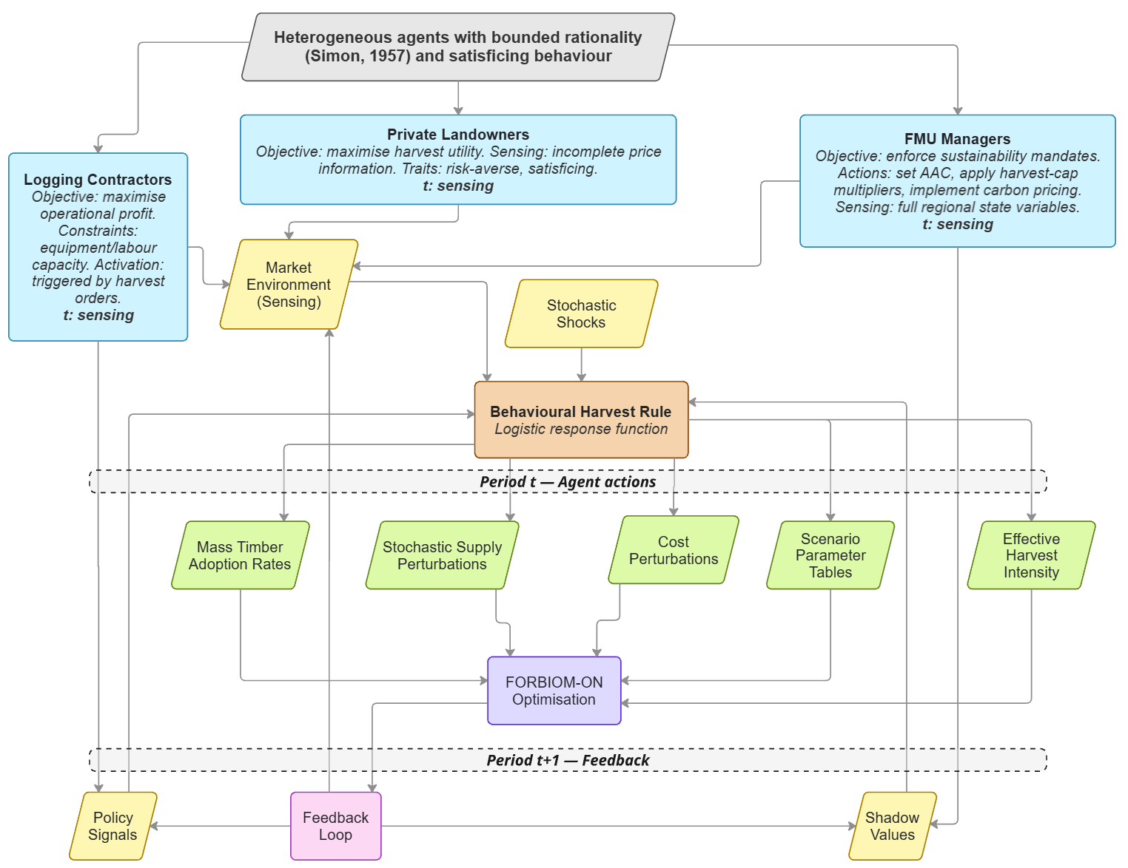
Figure 1. Conceptual structure of the agent-based module (ABM) linked to FORBIOM-ON (Ontario forest and wood-sector spatial optimisation model). Three heterogeneous agent classes operate under bounded rationality (Simon, 1957) and satisficing behaviour: Private Landowners (objective: maximise harvest utility; incomplete price sensing; risk-averse), Logging Contractors (objective: maximise operational profit; equipment/labour constrained; activated by harvest orders), and FMU Managers (objective: enforce sustainability mandates; actions include setting the allowable annual cut, applying harvest-cap multipliers, and implementing carbon pricing). At each period t, agents sense the market environment and stochastic shocks (yellow) and translate these signals into harvest decisions via a logistic behavioural harvest rule (orange rectangle). Five output channels (green) pass agent decisions to the FORBIOM-ON optimisation module (purple rectangle): mass timber adoption rates, stochastic supply perturbations, cost perturbations, scenario parameter tables, and effective harvest intensity. The optimiser returns policy signals and shadow values (yellow diamonds, bottom) through a co-evolutionary feedback loop (pink), informing agent decisions in period t + 1.

4 Simulation pathways and methods
The base model is a multi-region, multi-product forest value-chain formulation in GAMS: regions r, products p (e.g., CLT, glulam, lumber, pulpwood), and years y. Roundwood stock evolves with exogenous or shocked growth; harvest is constrained by sustainability rules and linked to primary processing (lumber, pulpwood) and downstream mass-timber products. Logistics include inter-regional flows with arc and mill capacity limits. The economic objective is optimized under a system of feasibility constraints. Specifically, it selects harvest, production, sales, and inter-regional transport decisions to maximize net value, while simultaneously accounting for carbon through a policy-relevant carbon cost applied to modeled gross processing and transport emissions.

4.1 Simulation pathways
(i) Baseline: fixed exogenous price paths, baseline demand and growth, single solve over the horizon.
(ii) Carbon-price sensitivity: loop over carbon price scenarios; record objective, emissions, net carbon, revenue, harvest, production, sales.
(iii) Mass-timber / demand sensitivity: scale CLT/glulam demand caps; compare infrastructure-limited vs demand-driven outcomes.
(iv) Policy scenario table: coded scenarios (e.g., demand steps, lumber price shocks, harvest-cap multipliers) with regional disaggregation for reporting.
(v) Stochastic elements: region–year shocks to growth, harvest cost, and/or demand caps; use fixed random seed for reproducibility.

4.2 Model families and data flow
Two complementary models share one data foundation. FORBIOM-ON (GAMS) is a normative spatial optimization: it finds the value-maximizing allocation of harvest, processing and inter-regional trade under sustainability, capacity and carbon constraints. FORBIOM-ABM (Python) is a descriptive simulation: it reproduces how heterogeneous, boundedly rational FMU managers, contractors and processing plants actually respond to prices, disturbance and policy, and how new technologies are adopted over time. Both models use the same six FMU regions, harvest cost, lumber-input ratios for mass timber and carbon factors. Figure 2 summarizes the full data-processing workflow, Section 5 documents each dataset and transformation step, and Section 6 specifies the agent-based model.
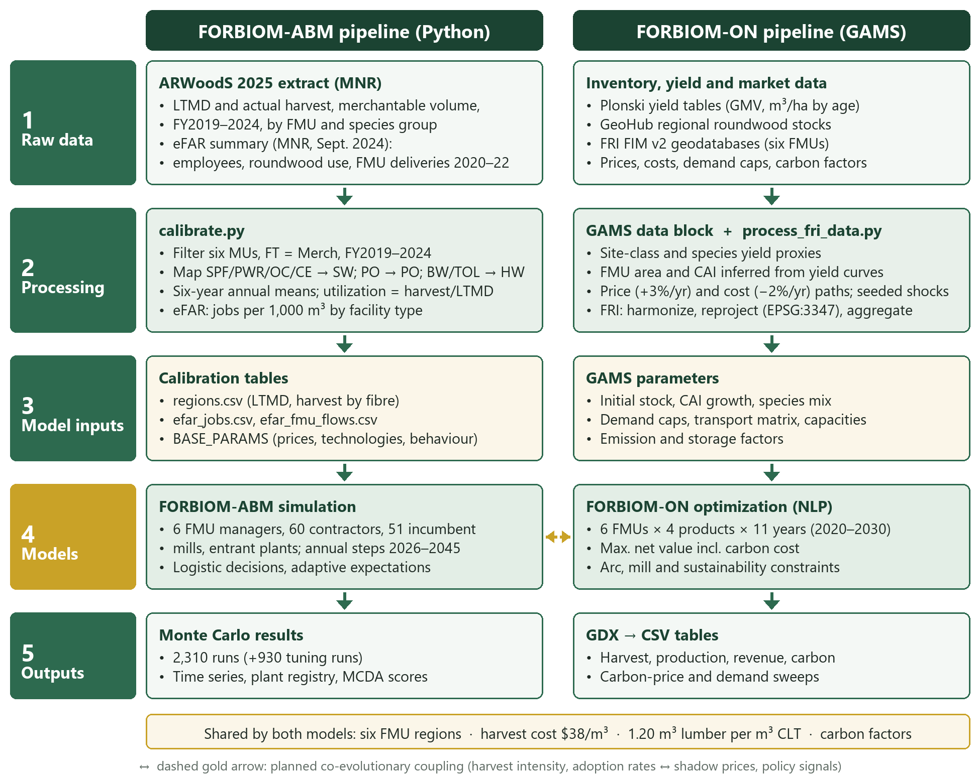
Figure 2. Data-processing workflow of the two FORBIOM models. Raw provincial datasets are filtered, harmonized and aggregated to the six study FMUs by dedicated scripts (calibrate.py, process_fri_data.py) and by the GAMS data block, producing model-ready calibration tables and parameters. The dashed gold arrow marks the planned co-evolutionary coupling between the agent-based simulation and the spatial optimization.

5 Data sources and data processing
This section documents the datasets behind both models, the transformations applied to each, and the resulting model inputs. All processing is scripted, so every input table can be regenerated from the raw sources (see Supplementary materials). Table 1 lists the sources; Sections 5.2–5.4 describe the processing chains for FORBIOM-ON, the Forest Resources Inventory and the agent-based model; Section 5.5 lists the known data gaps.

5.1 Data sources
Table 1. Data sources used by FORBIOM-ON and FORBIOM-ABM.
Dataset | Provider and vintage | Variables used | Used in
ARWoodS data extract (Annual Report on Wood Supply) | Ontario MNR, 2025 update; fiscal years 2019–2024 | Planned available harvest under the Long-Term Management Direction (LTMD) and actual harvest, by management unit, species group and forest type | ABM fibre supply and calibration
eFAR summary (Electronic Forest industry Annual Report) | Ontario MNR, September 2024 release; 2020–2022 | Facility and woodlands employees; roundwood consumed (Section C1); deliveries from source FMUs to facility types (Sections A and B) | ABM employment intensities and wood flows
Forest Resources Inventory (FRI), FIM v2 geodatabases | MNR; Abitibi River 2011, Algonquin Park 2011, Algoma 2013, Trout Lake 2013, Kenora 2015, Nipissing (3D inventory) | Polygon type, species composition, age, height, stocking, crown closure, geometry | Spatial composition and maps (CRIBE ArcGIS dataset)
Plonski normal yield tables (metric) | Ontario yield tables, archived edition | Gross merchantable volume (m³/ha) by age for white pine, jack pine and tolerant hardwoods, site class 1 | FORBIOM-ON forest area and growth (CAI)
Regional roundwood stocks | Ontario GeoHub | Initial standing roundwood stock by FMU | FORBIOM-ON initial state
Market, cost and technology data | Literature, industry benchmarks, model assumptions | Product prices, processing and harvest costs, demand caps, transport costs, capacities, carbon factors | Both models

5.2 FORBIOM-ON input processing (GAMS data block)
Yield curves
Plonski site-class-1 volumes are entered for three reference species at 10-year ages from 30 to 80 years (Table 2). The remaining combinations are derived by proxy rules inside the GAMS data block: site class 2 = 0.80 × site class 1 and site class 3 = 0.60 × site class 1; red pine = white pine; spruce = jack pine; aspen = 0.90 × jack pine; and white birch = 0.80 × jack pine.
Table 2. Plonski gross merchantable volume used as site-class-1 reference curves (m³/ha).
Species | Age 30 | Age 40 | Age 50 | Age 60 | Age 70 | Age 80
White pine | 76 | 157 | 242 | 315 | 372 | 414
Jack pine | 89 | 155 | 196 | 223 | 238 | 243
Tolerant hardwoods | 36 | 68 | 100 | 130 | 158 | 185

Regional composition, inferred area and growth
Each FMU is described by a species mix π_{r,t} (Table 3), a dominant site class s_{r}, a representative initial age a⁰_{r} = 30 years and an initial roundwood stock S⁰_{r} (Table 4). Because the forest area of each FMU is not entered directly, it is inferred so that the composition-weighted yield at the initial age reproduces the observed stock:
$$A_{r}=\frac{S_{r}^{0}×{10}^{6}}{\sum_{t}{π_{r,t}·Y_{t,s_{r}}\left(a_{r}^{0}\right)}}$$
Annual growth is the current annual increment over the next ten-year age bracket, scaled by the inferred area and multiplied by a region- and year-specific growth shock:
$${CAI}_{r}=\frac{A_{r}}{{10}^{6}}\sum_{t}{π_{r,t}·\frac{Y_{t,s_{r}}\left(a_{r}^{0}+10\right)-Y_{t,s_{r}}\left(a_{r}^{0}\right)}{10}}$$
$$G_{r,y}={CAI}_{r}·ε_{r,y}^{G}, ε_{r,y}^{G}=0.88+0.24·\frac{mod\left(31r+17y+7, 97\right)}{97}$$
The growth multiplier ranges from 0.88 to 1.12 (±12%). It is generated by a deterministic hash rather than a random draw, so growth paths are identical across runs and scenarios. Standing stock then evolves recursively as stock plus growth minus harvest, and annual harvest is capped at 1% of standing stock in each FMU.
Table 3. Species composition by FMU used in FORBIOM-ON (% of stock).
Region | Spruce | Jack pine | White birch | Tol. hardwoods | White pine | Red pine | Aspen
Trout Lake | 50 | 30 | 10 | 0 | 0 | 0 | 10
Abitibi | 60 | 20 | 10 | 0 | 0 | 0 | 10
Algoma | 10 | 5 | 10 | 40 | 30 | 5 | 0
Kenora | 40 | 40 | 10 | 0 | 0 | 5 | 5
Nipissing | 10 | 5 | 10 | 30 | 40 | 5 | 0
Algonquin | 5 | 0 | 10 | 50 | 30 | 5 | 0

Table 4. Regional inputs to FORBIOM-ON: initial stock, dominant site class and base final-demand caps (million m³/yr).
Region | Initial stock† | Site class | Lumber | Pulpwood | CLT | Glulam
Trout Lake | 28,999.48 | SC2 | 3.5 | 3.0 | 0.17 | 0.17
Abitibi | 107,775.22 | SC2 | 5.0 | 6.0 | 0.17 | 0.17
Algoma | 54,884.89 | SC1 | 4.5 | 5.0 | 0.17 | 0.17
Kenora | 49,746.19 | SC3 | 2.5 | 2.0 | 0.17 | 0.17
Nipissing | 45,261.69 | SC1 | 6.5 | 7.0 | 0.17 | 0.17
Algonquin | 36,725.26 | SC1 | 4.0 | 4.0 | 0.17 | 0.17
† Values as entered in the GAMS data block (initialStockRegion), where they are labelled million m³. Their magnitude suggests thousand m³; the unit should be verified before final publication.
Demand caps are multiplied each year by (1 + g)^{t} with g = 0 in the baseline and by a stochastic multiplier drawn from U(0.88, 1.12) for each region, product and year.
Prices, processing costs and product chain
Product prices follow exogenous paths that grow by 3% per year from their 2020 base, while unit processing costs decline by 2% per year to represent efficiency gains. Processing cost is the sum of a layer-specific base cost ($100/m³ primary, $50/m³ secondary) and a product mark-up. Secondary products are tied to primary output through the lumber-input ratio, which enforces the mass balance between sawmilling and mass-timber manufacturing. Roundwood harvest costs $38/m³, multiplied by a region–year shock drawn from U(0.90, 1.10).
$$P_{p,y}=P_{p,2020}·{1.03}^{y-2020}, c_{p,y}=c_{p,2020}·{0.98}^{y-2020}$$
Table 5. Product parameters in FORBIOM-ON (2020 values).
Product | Tier | Price ($/m³) | Processing cost ($/m³) | Yield factor | Lumber input (m³/m³) | Process emissions (tCO₂/m³) | Carbon storage (tCO₂/m³)
CLT | Secondary | 700 | 200 | 0.82 | 1.20 | 0.150 | 0.70
Glulam | Secondary | 575 | 170 | 0.85 | 1.10 | 0.170 | 0.70
Lumber | Primary | 375 | 120 | 0.90 | — | 0.065 | 0.40
Pulpwood | Primary | 75 | 20 | 0.98 | — | 0.010 | 0.07

Logistics, capacities and carbon
Inter-regional shipments use the transport cost matrix in Table 6 for every product. Arc capacities (20 million m³/yr per arc and product) and mill capacities (10 million m³/yr for lumber and pulpwood; 1.0 million m³/yr for CLT and glulam) are placeholders that will be replaced with observed mill and road capacities. Freight emissions are 0.018 tCO₂/m³ shipped. The carbon price multiplies process and freight emissions in the objective; carbon stored in products is reported separately as the harvested-wood-product pool.
Table 6. Transport cost proxy between FMUs ($/m³; rows = origin, columns = destination).
Origin \ destination | Trout Lake | Abitibi | Algoma | Kenora | Nipissing | Algonquin
Trout Lake | 0 | 38 | 42 | 100 | 14 | 9
Abitibi | 26 | 0 | 35 | 75 | 25 | 32
Algoma | 31 | 28 | 0 | 60 | 31 | 38
Kenora | 79 | 61 | 49 | 0 | 79 | 87
Nipissing | 14 | 27 | 31 | 79 | 0 | 8
Algonquin | 9 | 34 | 38 | 87 | 8 | 0

Output processing
Solutions are stored in GDX files and exported to CSV (GDX-to-CSV) by region, product, year and manufacturing tier. Post-processing aggregates them into production, revenue and processing cost by tier (Table 16), regional revenue, and gross emissions, stored carbon and net carbon for each carbon-price and demand scenario. R and Python scripts then produce the tables and figures in Section 7.

5.3 Forest Resources Inventory processing (process_fri_data.py)
The FRI geodatabases provide polygon-level forest descriptions for the six FMUs. They are processed with a Python pipeline (GeoPandas, pyogrio, Shapely) in seven steps:
(1) Extract the six FIM v2 archives and locate the forest polygon layer; for Trout Lake, all polygon layers are read and concatenated.
(2) Read large layers in 20,000-row chunks (Nipissing holds about 130,000 polygons) and strip Z/M coordinates from the 3D inventory.
(3) Harmonize attribute names across inventory vintages (OSPCOMP → SPCOMP, OAGE → AGE, OHT → HT) into one schema.
(4) Reproject to Statistics Canada Lambert (EPSG:3347) in 4,000-row slices and compute planar polygon area (m² and ha).
(5) Keep forested polygons only (POLYTYPE = FOR).
(6) Compute a provisional volume index, V = stocking × height × crown closure/100 × area (ha) × 10, and a provisional biomass index of 0.5 × V.
(7) Dissolve polygons by FMU, sum area and biomass, and export GeoPackage layers for mapping.
Step 6 uses placeholder coefficients. The FRI outputs therefore serve spatial composition and mapping only; they are not yet direct model inputs. The planned replacement computes polygon volumes from the yield curves in Section 5.2 and FRI species composition, and converts them to biomass with species-specific expansion factors.

5.4 Agent-based model data and calibration (calibrate.py)
Fibre supply and harvest (ARWoodS)
The ARWoodS extract is filtered to the six management units (Trout Lake Forest, Abitibi River Forest, Algoma Forest, Kenora Forest, Nipissing Forest and Algonquin Park Forest), to merchantable volume (FT = Merch) and to fiscal years 2019–2024. ARWoodS species groups are mapped to three fibre classes: softwood (SW) = spruce–pine–fir (SPF), white and red pine (PWR), other conifers (OC) and cedar (CE); poplar (PO); and hardwood (HW) = white birch (BW) and tolerant hardwoods (TOL). Actual harvest and LTMD volumes are summed by FMU and fibre class and divided by six to give annual means. Utilization is harvest divided by LTMD.
Table 7. Fibre supply, observed harvest and calibration check by FMU (1,000 m³/yr; ARWoodS FY2019–2024 means; simulated values are the mean of 50 business-as-usual runs).
FMU | LTMD | Harvest | Utilization | Unused SW | Unused PO | Unused HW | Simulated 2026 | Error
Trout Lake | 918 | 632 | 69% | 236 | 24 | 27 | 631 | -0.1%
Abitibi | 1,552 | 884 | 57% | 439 | 185 | 44 | 884 | +0.0%
Algoma | 632 | 127 | 20% | 198 | 55 | 252 | 127 | +0.0%
Kenora | 465 | 70 | 15% | 219 | 145 | 32 | 69 | -1.4%
Nipissing | 713 | 222 | 31% | 264 | 120 | 107 | 222 | +0.0%
Algonquin | 722 | 346 | 48% | 181 | 47 | 148 | 346 | +0.0%
Total | 5,002 | 2,280 | 46% | 1,536 | 576 | 610 | 2,279

Across the six FMUs, LTMD averages 5.00 million m³/yr against an actual harvest of 2.28 million m³/yr, a utilization of 46%. Utilization ranges from 15% in Kenora to 69% in Trout Lake. Unused softwood is concentrated in Abitibi, Trout Lake, Kenora and Nipissing; unused poplar and hardwood in Abitibi, Algoma, Algonquin and Kenora.
Employment and wood flows (eFAR)
Three eFAR tables are processed for 2020–2022 and averaged over the three years. Facility and woodlands employees come from the Facility Info section; roundwood consumed by facility type comes from Section C1. Dividing employees by consumption gives direct jobs per 1,000 m³ (Table 8). Deliveries in Sections A and B are matched to the six FMUs by source name to give wood flows from each FMU to each facility type (Table 9). The ABM uses the sawmill intensity (0.36 facility + 0.05 woodlands jobs per 1,000 m³) for softwood mills and the composite intensity (0.36 + 0.01) for poplar mills.
Table 8. Employment intensity by facility type, Ontario, eFAR 2020–2022 annual means.
Facility type | Facility employees | Woodlands employees | Roundwood consumed (1,000 m³) | Facility jobs per 1,000 m³ | Woodlands jobs per 1,000 m³
Sawmill | 3,122 | 387 | 8,611 | 0.36 | 0.04
Composite | 613 | 12 | 1,724 | 0.36 | 0.01
Pulp | 1,526 | 325 | 618 | 2.47 | 0.53
Veneer | 144 | 13 | 170 | 0.85 | 0.08
Bioproduct | 70 | 1 | 58 | 1.22 | 0.01
Fuelwood | 13 | 0 | 5 | 2.63 | 0.00

Table 9. Roundwood delivered from the six FMUs by facility type (1,000 m³/yr, eFAR 2020–2022 means).
FMU | Sawmill | Composite | Pulp | Veneer | Other | Total
Trout Lake | 481.5 | 16.8 | 125.7 | 0.0 | 0.0 | 624.1
Abitibi | 454.2 | 159.7 | 0.0 | 0.1 | 0.0 | 614.1
Algoma | 135.1 | 0.0 | 0.2 | 0.4 | 0.0 | 135.7
Kenora | 26.6 | 22.3 | 0.0 | 0.0 | 0.0 | 48.9
Nipissing | 85.4 | 18.0 | 1.3 | 0.9 | 0.0 | 105.5
Algonquin | 233.6 | 10.0 | 7.6 | 0.0 | 14.7 | 265.9

Agent initialization
Agents are initialized from the calibration tables so that the first simulated year reproduces observed conditions:
■ Harvest contractors: ten per FMU. Total contractor capacity is 1.25 × the observed harvest, split among contractors with Dirichlet(3) weights. Individual cost multipliers are drawn from a lognormal(0, 0.08) distribution. The initial share of Indigenous-owned contractors is 20% (Trout Lake), 15% (Abitibi), 35% (Kenora) and 10% elsewhere.
■ Incumbent mills: three per FMU and fibre class wherever observed harvest exceeds 1,000 m³/yr (51 mills; Kenora has no hardwood mill). They hold 50%, 30% and 20% of the class volume, with cost multipliers drawn from lognormal(0, 0.05). Each mill's capacity is back-solved so that its year-0 desired intake equals its share of observed harvest:
$${Cap}_{j}=\frac{s_{j}·H_{r,f}^{obs}}{σ\left(4·\frac{v_{j,f}-w_{r,f,0}}{w_{r,f,0}}+1\right)}$$
■ Log prices: the initial regional log price is 1.10 × the delivered contractor cost, which combines harvest cost ($38/m³ × regional access factor 1.00–1.15, +10% for poplar and hardwood), 110 km of in-region haul at $0.12/m³·km and $6/m³ stumpage.
■ Distances: road distances are approximated from FMU centroids as great-circle distance × 1.3 circuity. Distances to the Greater Toronto Area (GTA) market are Trout Lake 1,608 km, Abitibi 825 km, Algoma 649 km, Kenora 1,725 km, Nipissing 420 km, Algonquin 308 km.
Calibration check and validation
The simulated 2026 harvest matches the observed 2019–2024 mean exactly in Abitibi, Algoma, Nipissing and Algonquin, and is within 0.06% in Trout Lake and 1.4% in Kenora (Table 7). As a pattern-oriented validation, the 50 business-as-usual runs keep province-wide utilization well below LTMD: the 2041–2045 mean is 41% (standard deviation 8.6 percentage points), compared with 46% observed in 2019–2024. The spread reflects lumber-price cycles and occasional mill exits. Behavioural parameters (logistic slopes and adjustment speeds) were set to give plausible responses and tested in the sensitivity analysis (Section 6.7).

5.5 Data quality and known gaps
■ Placeholder logistics data: arc capacities, mill capacities and the transport cost matrix in FORBIOM-ON are proxies awaiting observed mill-capacity and road-network data.
■ Yield proxies: only three species are entered from Plonski at site class 1; other species and site classes are derived by fixed ratios, so growth differences between FMUs are driven mainly by species mix and site class.
■ Stock units: the initial stock values should be checked against the GeoHub source (see Table 4 note).
■ FRI biomass index: the volume and biomass coefficients in the FRI pipeline are placeholders (Section 5.3).
■ Community parameters in the ABM: northern housing need, community heat demand and fuel costs, and Indigenous labour and contractor shares are planning assumptions that need validation with communities and MNR.
■ Time frames: FORBIOM-ON runs 2020–2030, while the ABM is calibrated to 2019–2024 data and simulates 2026–2045. Coupling the two models will require a common horizon.

6 Agent-based model (FORBIOM-ABM): specification and experiments
FORBIOM-ABM simulates how forest biomass is harvested, processed and used in the six study FMUs when heterogeneous, boundedly rational agents respond to prices, disturbance and policy. It is described here following the ODD protocol (Overview, Design concepts and Details; Grimm et al., 2020). The model is implemented in Python 3.11 (NumPy, pandas) in abm.py; experiments are run by experiments.py.

6.1 Purpose and patterns
The model evaluates how alternative combinations of processing technologies and policies change biomass utilization, regional economic activity, Indigenous and rural benefits, carbon outcomes and investment risk. It is designed to reproduce three observed patterns: (i) FMU-level harvest well below LTMD, with large differences between regions; (ii) persistent under-utilization of poplar and hardwood relative to softwood; and (iii) the sensitivity of harvest to lumber prices, including mill curtailment and closure after sustained losses.

6.2 Entities, state variables and scales
Table 10. Agents and entities in FORBIOM-ABM.
Agent / entity | Key state variables | Behaviour
FMU manager (6) | LTMD by fibre class (SW, PO, HW); available volume after disturbance | Releases sustainable volume; allocates fibre to licence holders, then entrants (Indigenous-majority entrants first under the priority policy)
Harvest contractor (10 per FMU at start) | Capacity (m³/yr), cost multiplier, Indigenous ownership, sales, margin | Offers volume through a logistic response to the log price relative to own cost; expands when fully used and profitable
Incumbent mill (51) | Calibrated capacity, fibre class, cost multiplier, consecutive loss years | Sets utilization from expected margin; exits after three loss years with probability 0.4 per year
Mass-timber hub (entrant) | 150,000 m³/yr log intake; 60,000 m³/yr CLT/glulam; capex $150 M; Indigenous equity | Integrated sawmill and CLT/glulam line selling to southern Ontario; surplus lumber to commodity markets
Urban CLT plant (entrant, GTA) | 60,000 m³/yr; capex $100 M | Converts lumber bought from the north; adds no harvest
Community log-to-panel spoke (entrant) | 25,000 m³/yr logs; 10,000 m³/yr panels; capex $25 M; Indigenous equity | Small sawmill and prefab panel line; serves northern housing first, then southern prefab demand
Community bioheat (entrant) | 5,000 odt/yr; capex $12 M | Displaces heating oil; uses residues first, then low-grade roundwood
Pellet plant (entrant) | 80,000 odt/yr; capex $50 M | Exports pellets by rail via Thunder Bay or Montreal
Markets | AR(1) price shocks; demand levels | Southern mass timber and panels clear on price; northern housing; heat; commodities
Policy agent | Grants, equity rules, allocation priority, capacity building, procurement, clean-heat incentive | Defined by the strategy (Section 6.6)

Spatial scale: six FMU regions plus a GTA market and processing node. Temporal scale: annual steps from 2026 to 2045. Monetary values are 2026 Canadian dollars (real). The implementation operationalizes two of the three agent classes in Figure 1, FMU managers and logging contractors, and adds processing-plant agents. Private landowners are not yet represented because the six study FMUs are managed Crown forests.

6.3 Process overview and scheduling
Each annual step runs in the following order:
(1) Environment: draw correlated price shocks (lumber, OSB, mass timber, panels, pellets, heating fuel) and FMU disturbance (fire or blowdown).
(2) Supply release: FMU managers release available volume by fibre class.
(3) Processor demand: plants form desired roundwood intake from expected margins (logistic utilization rule).
(4) Fibre markets: contractors offer volume (logistic supply rule); each regional market allocates volume by priority group and updates the log price in proportion to excess demand.
(5) Production and product markets: southern mass-timber and panel prices clear against demand; spokes serve local housing first; bioenergy plants use mill surplus residues, then forest residues, then low-grade roundwood.
(6) Accounting: profits after capital charges, jobs, Indigenous jobs and income, carbon and public cost.
(7) Investment: potential entrants evaluate NPV under adaptive expectations, fibre and market headroom, learning-adjusted capex and grants; they build with a logistic probability, come online after two years and ramp up through 50% and 80% of capacity.
(8) Exit and adaptation: loss-making plants may exit, contractors expand capacity, and all agents update price expectations.

6.4 Behavioural decision rules
All firm decisions use the logistic rule from Section 3.1, applied to a relative margin. Agents are boundedly rational (Simon, 1957): rather than optimizing, they respond smoothly to expected margins, and the steepness k controls how close the response is to a switch.
Contractor supply
Contractor i offers volume of fibre class f according to its capacity K_{i}, the share of effort e_{f} allocated to that fibre (proportional to buyers' demand), the regional log price w_{r,f} and its own delivered cost c_{i,r,f}:
$$q_{i,f}=K_{i}·e_{f}·σ\left(12·\frac{w_{r,f}-c_{i,r,f}}{c_{i,r,f}}+1\right)$$
Mill utilization
Plant j demands roundwood according to its willingness to pay v_{j,f}, the net product value per m³ of logs after conversion cost, product freight and residue value, relative to the expected log price:
$$D_{j,f}={Cap}_{j}·σ\left(4·\frac{v_{j,f}-E\left[w_{r,f}\right]}{E\left[w_{r,f}\right]}+1\right)$$
Investment
A candidate plant estimates its expected annual margin at 90% of capacity, after checking fibre headroom (uncommitted softwood of at least 70% of log capacity for hubs and spokes) and market headroom (at least 40% of plant capacity for mass-timber plants). It builds with probability:
$$Pr\left(build\right)=0.6·σ\left(5·\frac{NPV}{I^{net}}-1\right), NPV=\overline{m}·AF\left(8\%, 20 yr\right)-I^{net}$$
Here I^{net} is capex net of grants after learning-by-doing (10% reduction per doubling of plants built), and AF is the annuity factor at an 8% private discount rate over 20 years. Each region can host at most two hubs, three spokes, four bioheat plants and one pellet plant; the GTA can host three urban CLT plants.
Table 11. Parameterization of the logistic decision rules, σ(z) = 1/(1 + e^{−k(z−z0)}).
Decision | Latent index z | Steepness k | Midpoint z0 | Output
Contractor supply | (log price − own cost)/own cost | 12 | −0.083 | Share of capacity offered
Mill utilization | (willingness to pay − expected log price)/expected log price | 4 | −0.25 | Share of capacity demanded
Urban CLT output | Expected margin over lumber cost | 4 | −0.25 | Share of capacity produced
Investment | NPV/net capex | 5 | 0.20 | Build probability (scaled by 0.6)
Negative midpoints mean that agents still operate at about half capacity when margins are slightly negative in the short run, which reflects contractual commitments and fixed-cost recovery.

6.5 Markets, expectations and stochasticity
Log prices. Each regional fibre market clears at min(demand, offered supply, released LTMD). Licence holders are served before entrants; under the Indigenous-priority policy, Indigenous-majority entrants and Indigenous contractors are served first. The log price then moves toward market balance, bounded below by 90% of the lowest contractor cost and above by the highest willingness to pay:
$$w_{r,f,t+1}=w_{r,f,t}·\left(1+0.3·clip\left(\frac{D-S}{S}, -0.5, 0.5\right)\right)$$
Expectations. Agents update price expectations adaptively with weight 0.3:
$$E_{t+1}\left[P\right]=E_{t}\left[P\right]+0.3\left(P_{t}-E_{t}\left[P\right]\right)$$
Product prices. Reference prices are perturbed by autoregressive log-shocks, correlated with the lumber shock z_{L,t}:
$$x_{k,t}=0.6·x_{k,t-1}+\sqrt{1-{0.6}^{2}}·σ_{k}·\left(ρ_{k}z_{L,t}+\sqrt{1-ρ_{k}^{2}}ε_{k,t}\right), P_{k,t}={\overline{P}}_{k}·e^{x_{k,t}}$$
The southern mass-timber price then clears against demand with an elasticity of 1.5: when supply exceeds demand, the price falls to P^{ref}·(D/S)^{1/1.5}. Table 12 lists all stochastic elements in both models.
Table 12. Stochastic elements in FORBIOM-ABM and FORBIOM-ON.
Model | Element | Specification
ABM | Product prices | AR(1) log-shocks, ρ = 0.6; standard deviation 15% (lumber, OSB), 10% (pellets, heating fuel), 6% (mass timber), 5% (panels); correlation with the lumber shock 0.6 (OSB), 0.4 (mass timber), 0.3 (panels)
ABM | Natural disturbance | Fire or blowdown with probability 6% per FMU-year; volume loss U(10%, 30%) of LTMD
ABM | Supply noise | Multiplicative N(1, 0.05) on released volume
ABM | Agent heterogeneity | Contractor capacity shares Dirichlet(3); cost multipliers lognormal(0, 0.08) for contractors and lognormal(0, 0.05) for mills
ABM | Discrete decisions | Investment, exit and contractor expansion use decision-keyed uniform draws, so the same decision faces the same random number in every strategy (common random numbers)
FORBIOM-ON | Growth | Multiplier in [0.88, 1.12] from a deterministic hash of region and year
FORBIOM-ON | Harvest cost | Multiplier U(0.90, 1.10) by region and year
FORBIOM-ON | Demand caps | Multiplier U(0.88, 1.12) by region, product and year; fixed seed for reproducibility

6.6 Biomass utilization strategies
Table 13. Strategies simulated in FORBIOM-ABM.
Code | Strategy | Technologies and policies
S0 | Business as usual | Incumbent mills only; no new technologies or policies
S1 | Southern urban mass-timber plants | Up to three 60,000 m³/yr CLT/glulam plants in the GTA buying northern lumber; no grants
S2 | Northern integrated log-to-mass-timber hubs | Hubs in all six FMUs; 15% capital grant; 20% Indigenous equity
S3 | Distributed Indigenous/community network | Log-to-panel spokes and community bioheat in all FMUs; grants 40% (spokes) and 50% (bioheat); 51% Indigenous equity; contractor capacity building
S4 | Hub-and-spoke hybrid | Hubs, spokes, bioheat and pellet plants; grants 15/40/50/10%; Indigenous equity 20/51/51/20%
S5 | Hybrid + enabling policy | S4 plus capacity building, Indigenous allocation priority, 25% public procurement uplift to southern demand and a $50/tCO₂e clean-heat incentive
S6 | Regionally differentiated portfolio | S5 tuned region by region: the pellet plant is dropped in Algoma, Kenora, Nipissing and Algonquin; the full package is kept in Trout Lake and Abitibi
Capacity building adds Indigenous contractor capacity equal to 2% of LTMD per FMU per year during the first five years, at a public cost of $20 per m³ of capacity, and raises Indigenous contractors' expansion probability by 60%.

6.7 Experimental design and multi-criteria evaluation
Experiments run in three stages. Strategies are compared with common random numbers, so differences between strategies are not confounded by different random draws.
(1) Strategy comparison: S0–S5 under three southern mass-timber demand growth scenarios (Low 3%, Base 8%, High 15% per year), with 50 seeds each.
(2) Regional tuning: for each FMU, variants of S5 that drop one technology or cap spokes at one are tested with 30 seeds (930 runs). A variant is adopted when it improves the weighted regional and provincial score without lowering the provincial score and reduces public cost. The result is S6, which is then run under the three demand scenarios with 50 seeds.
(3) Sensitivity analysis: all seven strategies under six one-at-a-time changes (mass-timber price ±20%, lumber price −20%, capex +30%, private discount rate 10%, heat value −30%), with 30 seeds each.
In total, stages 1 and 3 comprise 2,310 simulations (7 strategies × 3 demand scenarios × 50 seeds, plus 6 sensitivity cases × 7 strategies × 30 seeds), in addition to the 930 tuning runs. Each run is summarized into seven criteria. Each criterion is min–max normalized across strategies (reversed for criteria to be minimized) and combined with four weighting schemes (Table 14). Ranking robustness is assessed across the three demand scenarios and six sensitivity cases. NPVs use a 4% social discount rate.
Table 14. Evaluation criteria and weighting schemes.
Criterion | Indicator | Direction | Equal | Economic | Community | Climate
Fibre utilization | Harvest/LTMD, 2041–2045 | + | 0.14 | 0.20 | 0.10 | 0.20
Value added | NPV of profits, contractor margins and wages | + | 0.14 | 0.35 | 0.10 | 0.15
Rural/northern jobs | Mean FTE 2036–2045, excluding the GTA | + | 0.14 | 0.10 | 0.25 | 0.10
Indigenous community income | NPV of wages, contractor margins and equity income | + | 0.14 | 0.10 | 0.35 | 0.10
Net carbon benefit | Cumulative storage + avoided emissions − emissions | + | 0.14 | 0.10 | 0.10 | 0.35
Public cost | Cumulative grants and programme costs | − | 0.14 | 0.10 | 0.05 | 0.05
Investment risk | Share of new plants with negative cumulative profit | − | 0.14 | 0.05 | 0.05 | 0.05
Equal weights are 1/7 for each criterion.
Score for strategy s: Σ_{c} w_{c} · (x_{s,c} − min_{s} x_{c})/(max_{s} x_{c} − min_{s} x_{c}), using 1 minus the normalized value for criteria to be minimized.

6.8 Accounting and output indicators
■ Jobs: plant jobs follow the eFAR intensities (Table 8) or technology benchmarks for new plants (1.6 FTE per 1,000 m³ of mass timber; 5 FTE per 1,000 m³ of panels). Harvesting and hauling add 0.40 FTE per 1,000 m³.
■ Indigenous income: wages of Indigenous workers (regional labour share; 60% local hiring at Indigenous-majority plants; +15 percentage points at partnership plants; 80% at Indigenous-owned contractors), plus margins of Indigenous-owned contractors, plus the equity share of plant profits after capital charges. Equity losses are counted, so Indigenous investors carry downside risk.
■ Carbon: net benefit = carbon stored in products (FORBIOM-ON storage factors) + fossil emissions avoided by bioheat (1.23 tCO₂e/odt replacing heating oil) − process, freight (0.00005 tCO₂/m³·km) and harvest (0.012 tCO₂/m³) emissions.
■ Residues: sawmills generate 0.40 m³ of residue per m³ of logs (0.42 odt/m³), of which 60% is already absorbed by pulp, composite and cogeneration uses. Harvesting yields 0.12 odt/m³ of forest residue, recoverable at $45/odt.
■ Recorded outputs: annual records by FMU of harvest by fibre class, LTMD, products (lumber, mass timber, panels, OSB, pulp, bioheat, pellets), residue use, prices, plant counts, jobs, Indigenous jobs and income, value added, carbon and cumulative public cost, plus a registry of every new plant.

6.9 Key parameters, sources and status
Table 15. Key FORBIOM-ABM parameters (2026 CAD, real).
Parameter | Value | Source / basis | Status
LTMD and harvest by FMU and fibre class | Table 7 | ARWoodS 2025, FY2019–2024 means | Calibrated
Direct jobs per 1,000 m³ (sawmill; composite) | 0.41; 0.36 | eFAR 2020–2022 | Calibrated
Harvest cost | $38/m³ × access factor 1.00–1.15 | FORBIOM-ON harvestCostRW | Model-consistent
In-region haul; stumpage | 110 km at $0.12/m³·km; $6/m³ | Ontario industry norms | Assumption
SPF lumber price (mill net) | $300/m³ | 2023–2026 market range | Assumption
CLT/glulam price | $1,100/m³ (±20% tested) | Industry quotes | To validate
Prefab panel price (wood equivalent) | $1,300/m³ | Industry estimates | To validate
OSB; pulpwood; residue; pellets | $400/m³; $70/m³; $30/odt; $230/odt | Market references | Assumption
Sawmill lumber recovery; residue fraction | 0.55; 0.40 | Boreal sawmill literature | Literature
Lumber per m³ CLT; per m³ panel | 1.20; 1.15 | FORBIOM-ON lumberInputPerUnit | Model-consistent
Southern mass-timber demand | 165,000 m³/yr in 2026; growth 3/8/15% | Scenario assumption | Scenario
Southern prefab panel demand | 60,000 m³/yr in 2026 | Planning assumption | To validate
Northern housing need | 40–150 units/yr per FMU at 35 m³/unit, +2%/yr | Planning assumption | To validate
Community heat demand | 3,000–10,000 odt/yr per FMU | Planning assumption | To validate
Discount rates | 8% private; 4% social | Standard practice | Sensitivity (10%)
Behaviour | k = 12/4/5; expectation weight 0.3; price adjustment 0.3 | Set for plausible response | Sensitivity-tested

6.10 Coupling with FORBIOM-ON and limitations
The two models are currently soft-linked: they share regions, data and key parameters, but they are run separately. The planned co-evolutionary coupling (Figure 1) will exchange information once per period:
■ ABM to FORBIOM-ON: effective harvest intensity by FMU (simulated harvest/LTMD), mass-timber adoption (installed hub and urban plant capacity), and supply and cost perturbations, written as GAMS parameter tables (CSV/GDX) that replace the current harvest caps, secondary capacities and stochastic multipliers.
■ FORBIOM-ON to ABM: regional shadow prices of the sustainability and capacity constraints and optimal regional prices, which update agents' price expectations and investment screening in the next period.
■ Convergence: the exchange is repeated within each period until harvest by FMU changes by less than a set tolerance, and then the models move to the next year.
Current limitations: logs are sourced within each FMU (no cross-FMU log trade and no Manitoba or export markets for Kenora and Trout Lake), poplar and hardwood engineered-wood pathways are not yet represented, carbon accounting excludes forest carbon dynamics and construction-material substitution, and absolute values should be read as indicative for six FMUs rather than for all of Ontario.

7 Results (from a preliminary counterfactual run)
Table 16. Annual biomass production, revenue, and processing cost by region and manufacturing stream, 2020–2030 (FORBIOM-ON: Forest Biomass Ontario).
Region | Stream | Metric | 2020 | 2021 | 2022 | 2023 | 2024 | 2025 | 2026 | 2027 | 2028 | 2029 | 2030
Trout Lake | Primary | Production (Mt) | 6.784 | 6.975 | 6.925 | 6.690 | 6.764 | 7.189 | 6.589 | 7.169 | 6.390 | 6.845 | 6.814
Trout Lake | Primary | Revenue (M CAD) | 1485.578 | 1709.211 | 1767.787 | 1629.459 | 1686.613 | 1889.770 | 1779.312 | 2044.070 | 1780.536 | 2078.378 | 1909.730
Trout Lake | Primary | Processing cost (M CAD) | 508.568 | 557.896 | 544.155 | 479.960 | 470.609 | 500.285 | 452.121 | 492.863 | 410.823 | 455.563 | 397.284
Trout Lake | Secondary | Production (Mt) | 0.328 | 0.355 | 0.318 | 0.322 | 0.309 | 0.320 | 0.325 | 0.343 | 0.322 | 0.345 | 0.324
Trout Lake | Secondary | Revenue (M CAD) | 210.395 | 232.832 | 215.877 | 224.800 | 222.626 | 236.611 | 246.206 | 271.739 | 260.546 | 288.186 | 277.846
Trout Lake | Secondary | Processing cost (M CAD) | 60.997 | 64.303 | 56.673 | 56.171 | 52.917 | 53.542 | 53.048 | 55.576 | 50.757 | 53.391 | 49.023
Abitibi | Primary | Production (Mt) | 11.616 | 12.101 | 11.157 | 11.083 | 10.539 | 11.236 | 11.595 | 11.281 | 11.377 | 10.561 | 11.492
Abitibi | Primary | Revenue (M CAD) | 2293.021 | 2486.456 | 2518.225 | 2519.889 | 2407.424 | 2745.401 | 2807.892 | 2682.792 | 3165.977 | 2824.694 | 3221.283
Abitibi | Primary | Processing cost (M CAD) | 754.013 | 774.030 | 750.925 | 714.555 | 653.306 | 709.490 | 682.364 | 624.994 | 701.853 | 598.330 | 644.308
Abitibi | Secondary | Production (Mt) | 0.332 | 0.318 | 0.323 | 0.319 | 0.334 | 0.359 | 0.309 | 0.343 | 0.341 | 0.340 | 0.328
Abitibi | Secondary | Revenue (M CAD) | 211.817 | 208.255 | 218.835 | 222.999 | 239.062 | 266.429 | 235.459 | 267.631 | 272.427 | 282.086 | 279.390
Abitibi | Secondary | Processing cost (M CAD) | 61.464 | 57.525 | 57.465 | 55.708 | 56.892 | 60.236 | 50.676 | 54.875 | 53.190 | 52.329 | 49.347
Algoma | Primary | Production (Mt) | 9.440 | 10.956 | 9.348 | 9.634 | 9.066 | 9.721 | 9.034 | 9.326 | 10.150 | 10.322 | 9.416
Algoma | Primary | Revenue (M CAD) | 2015.356 | 2364.439 | 2036.564 | 2114.114 | 2080.283 | 2254.412 | 2213.542 | 2291.430 | 2772.758 | 2780.685 | 2519.347
Algoma | Primary | Processing cost (M CAD) | 669.230 | 745.476 | 616.130 | 606.888 | 568.917 | 587.211 | 554.020 | 541.656 | 621.770 | 585.300 | 510.675
Algoma | Secondary | Production (Mt) | 0.310 | 0.350 | 0.336 | 0.335 | 0.320 | 0.347 | 0.366 | 0.344 | 0.361 | 0.301 | 0.329
Algoma | Secondary | Revenue (M CAD) | 198.123 | 229.897 | 228.631 | 232.074 | 230.186 | 257.426 | 278.884 | 270.305 | 292.790 | 250.200 | 280.681
Algoma | Secondary | Processing cost (M CAD) | 57.482 | 63.458 | 59.984 | 58.077 | 54.710 | 58.225 | 60.035 | 55.356 | 57.015 | 46.394 | 49.559
Kenora | Primary | Production (Mt) | 4.692 | 4.918 | 5.383 | 4.994 | 4.973 | 5.100 | 4.698 | 5.122 | 5.025 | 5.199 | 5.061
Kenora | Primary | Revenue (M CAD) | 987.516 | 1185.063 | 1274.862 | 1198.432 | 1192.944 | 1274.638 | 1181.492 | 1422.141 | 1396.171 | 1505.040 | 1533.381
Kenora | Primary | Processing cost (M CAD) | 356.695 | 400.434 | 406.536 | 366.464 | 344.442 | 356.995 | 317.041 | 351.570 | 334.654 | 341.777 | 328.491
Kenora | Secondary | Production (Mt) | 0.356 | 0.346 | 0.344 | 0.340 | 0.314 | 0.375 | 0.359 | 0.313 | 0.354 | 0.358 | 0.328
Kenora | Secondary | Revenue (M CAD) | 225.237 | 226.894 | 234.760 | 235.804 | 224.037 | 277.347 | 272.470 | 246.774 | 288.170 | 297.771 | 279.273
Kenora | Secondary | Processing cost (M CAD) | 65.440 | 62.650 | 61.579 | 58.975 | 53.320 | 62.752 | 58.697 | 50.514 | 56.096 | 55.206 | 49.323
Nipissing | Primary | Production (Mt) | 14.585 | 13.502 | 12.654 | 14.545 | 13.050 | 15.197 | 13.125 | 13.085 | 13.442 | 13.701 | 13.912
Nipissing | Primary | Revenue (M CAD) | 3162.500 | 2980.163 | 2867.236 | 3271.048 | 3151.354 | 3763.874 | 3225.851 | 3518.512 | 3615.353 | 3827.208 | 4077.295
Nipissing | Primary | Processing cost (M CAD) | 1026.065 | 928.593 | 850.473 | 919.744 | 842.545 | 952.030 | 782.299 | 815.248 | 794.776 | 799.076 | 805.231
Nipissing | Secondary | Production (Mt) | 0.312 | 0.353 | 0.335 | 0.363 | 0.316 | 0.327 | 0.334 | 0.353 | 0.348 | 0.341 | 0.305
Nipissing | Secondary | Revenue (M CAD) | 198.481 | 230.641 | 224.345 | 252.285 | 226.557 | 241.027 | 256.575 | 278.740 | 281.855 | 285.293 | 260.610
Nipissing | Secondary | Processing cost (M CAD) | 57.625 | 63.725 | 59.031 | 63.079 | 53.882 | 54.565 | 55.150 | 57.023 | 54.898 | 52.860 | 45.994
Algonquin | Primary | Production (Mt) | 8.555 | 8.445 | 8.089 | 8.343 | 8.241 | 8.267 | 8.266 | 8.563 | 8.837 | 8.515 | 7.606
Algonquin | Primary | Revenue (M CAD) | 1763.905 | 1801.296 | 1890.919 | 1922.036 | 1904.388 | 2137.592 | 2139.879 | 2258.498 | 2401.540 | 2426.811 | 2153.606
Algonquin | Primary | Processing cost (M CAD) | 593.931 | 581.367 | 579.887 | 555.847 | 528.903 | 561.690 | 535.962 | 534.475 | 543.001 | 525.322 | 445.749
Algonquin | Secondary | Production (Mt) | 0.340 | 0.366 | 0.348 | 0.321 | 0.353 | 0.335 | 0.339 | 0.323 | 0.351 | 0.366 | 0.342
Algonquin | Secondary | Revenue (M CAD) | 215.015 | 239.688 | 236.430 | 222.091 | 252.086 | 246.720 | 260.804 | 251.874 | 283.891 | 305.238 | 295.895
Algonquin | Secondary | Processing cost (M CAD) | 62.497 | 66.196 | 62.061 | 55.570 | 59.992 | 55.864 | 56.056 | 51.656 | 55.320 | 56.573 | 52.128
Regions: Trout Lake, Abitibi, Algoma, Kenora, Nipissing, and Algonquin refer to forest management units in Ontario, Canada.
Streams: Primary stream refers to first-stage industrial processing of roundwood into intermediate products (e.g., lumber), with co-products such as pulpwood, chips, and residues generated during transformation; Secondary stream refers to downstream manufacturing processes that further transform primary products (e.g., lumber) into higher-value engineered wood products, including cross-laminated timber (CLT) and glued laminated timber (glulam).
Metrics: Production is the annual harvested biomass volume (Mt = megatonnes, i.e., millions of metric tons). Revenue is gross annual income from biomass sales. Processing cost is the annual cost of harvesting, transportation, and processing operations. Both financial metrics are in M CAD (millions of Canadian dollars, nominal values).
Scenario: FORBIOM-ON = Forest Biomass Ontario model scenario, a simulation framework projecting sustainable forest biomass supply and economic outcomes under current and counterfactual harvest policies.
Table 17. Exogenous product price paths by region, 2020–2030. CLT: cross-laminated timber; Glulam: glued laminated timber. All prices are in Canadian dollars per cubic metre (CAD/m³). Mean and SD (standard deviation) computed over 2020–2030 (n = 11).
Region | Product | 2020 | 2021 | 2022 | 2023 | 2024 | 2025 | 2026 | 2027 | 2028 | 2029 | 2030 | Mean | SD
 |  |  |  |  |  |  |  |  |  |  |  |  | ($/m³) | ($/m³)
Trout Lake | CLT | 700.000 | 721.000 | 742.630 | 764.909 | 787.856 | 811.492 | 835.837 | 860.912 | 886.739 | 913.341 | 940.741 | 815.042 | 83.614
Trout Lake | Glulam | 575.000 | 592.250 | 610.017 | 628.318 | 647.168 | 666.583 | 686.580 | 707.177 | 728.393 | 750.245 | 772.752 | 669.862 | 68.678
Trout Lake | Lumber | 375.000 | 386.250 | 397.837 | 409.773 | 422.066 | 434.728 | 447.770 | 461.203 | 475.039 | 489.290 | 503.969 | 436.902 | 44.771
Trout Lake | Pulpwood | 75.000 | 77.250 | 79.567 | 81.955 | 84.413 | 86.946 | 89.554 | 92.241 | 95.008 | 97.858 | 100.794 | 87.326 | 8.954
Abitibi | CLT | 700.000 | 721.000 | 742.630 | 764.909 | 787.856 | 811.492 | 835.837 | 860.912 | 886.739 | 913.341 | 940.741 | 815.042 | 83.614
Abitibi | Glulam | 575.000 | 592.250 | 610.017 | 628.318 | 647.168 | 666.583 | 686.580 | 707.177 | 728.393 | 750.245 | 772.752 | 669.862 | 68.678
Abitibi | Lumber | 375.000 | 386.250 | 397.837 | 409.773 | 422.066 | 434.728 | 447.770 | 461.203 | 475.039 | 489.290 | 503.969 | 436.902 | 44.771
Abitibi | Pulpwood | 75.000 | 77.250 | 79.567 | 81.955 | 84.413 | 86.946 | 89.554 | 92.241 | 95.008 | 97.858 | 100.794 | 87.326 | 8.954
Algoma | CLT | 700.000 | 721.000 | 742.630 | 764.909 | 787.856 | 811.492 | 835.837 | 860.912 | 886.739 | 913.341 | 940.741 | 815.042 | 83.614
Algoma | Glulam | 575.000 | 592.250 | 610.017 | 628.318 | 647.168 | 666.583 | 686.580 | 707.177 | 728.393 | 750.245 | 772.752 | 669.862 | 68.678
Algoma | Lumber | 375.000 | 386.250 | 397.837 | 409.773 | 422.066 | 434.728 | 447.770 | 461.203 | 475.039 | 489.290 | 503.969 | 436.902 | 44.771
Algoma | Pulpwood | 75.000 | 77.250 | 79.567 | 81.955 | 84.413 | 86.946 | 89.554 | 92.241 | 95.008 | 97.858 | 100.794 | 87.326 | 8.954
Kenora | CLT | 700.000 | 721.000 | 742.630 | 764.909 | 787.856 | 811.492 | 835.837 | 860.912 | 886.739 | 913.341 | 940.741 | 815.042 | 83.614
Kenora | Glulam | 575.000 | 592.250 | 610.017 | 628.318 | 647.168 | 666.583 | 686.580 | 707.177 | 728.393 | 750.245 | 772.752 | 669.862 | 68.678
Kenora | Lumber | 375.000 | 386.250 | 397.837 | 409.773 | 422.066 | 434.728 | 447.770 | 461.203 | 475.039 | 489.290 | 503.969 | 436.902 | 44.771
Kenora | Pulpwood | 75.000 | 77.250 | 79.567 | 81.955 | 84.413 | 86.946 | 89.554 | 92.241 | 95.008 | 97.858 | 100.794 | 87.326 | 8.954
Nipissing | CLT | 700.000 | 721.000 | 742.630 | 764.909 | 787.856 | 811.492 | 835.837 | 860.912 | 886.739 | 913.341 | 940.741 | 815.042 | 83.614
Nipissing | Glulam | 575.000 | 592.250 | 610.017 | 628.318 | 647.168 | 666.583 | 686.580 | 707.177 | 728.393 | 750.245 | 772.752 | 669.862 | 68.678
Nipissing | Lumber | 375.000 | 386.250 | 397.837 | 409.773 | 422.066 | 434.728 | 447.770 | 461.203 | 475.039 | 489.290 | 503.969 | 436.902 | 44.771
Nipissing | Pulpwood | 75.000 | 77.250 | 79.567 | 81.955 | 84.413 | 86.946 | 89.554 | 92.241 | 95.008 | 97.858 | 100.794 | 87.326 | 8.954
Algonquin | CLT | 700.000 | 721.000 | 742.630 | 764.909 | 787.856 | 811.492 | 835.837 | 860.912 | 886.739 | 913.341 | 940.741 | 815.042 | 83.614
Algonquin | Glulam | 575.000 | 592.250 | 610.017 | 628.318 | 647.168 | 666.583 | 686.580 | 707.177 | 728.393 | 750.245 | 772.752 | 669.862 | 68.678
Algonquin | Lumber | 375.000 | 386.250 | 397.837 | 409.773 | 422.066 | 434.728 | 447.770 | 461.203 | 475.039 | 489.290 | 503.969 | 436.902 | 44.771
Algonquin | Pulpwood | 75.000 | 77.250 | 79.567 | 81.955 | 84.413 | 86.946 | 89.554 | 92.241 | 95.008 | 97.858 | 100.794 | 87.326 | 8.954
Note: Lumber: sawn structural wood; Pulpwood: roundwood for pulp and paper.
Prices are exogenous model inputs. All prices are nominal.
Table 18. Roundwood standing stock by region, 2020–2030 (million m³). SD: standard deviation of the 11 annual stock levels; CAGR (%): compound annual growth rate from 2020 to 2030.
Region | 2020 | 2021 | 2022 | 2023 | 2024 | 2025 | 2026 | 2027 | 2028 | 2029 | 2030 | Mean | SD | CAGR (%)
Trout Lake | 28,992.2 | 31,260.3 | 33,618.8 | 35,552.0 | 37,575.6 | 39,689.1 | 41,893.8 | 44,188.2 | 46,574.0 | 48,533.6 | 50,583.8 | 39,860.1 | 7,069.4 | 5.71
Abitibi | 107,762.9 | 114,901.9 | 122,378.1 | 130,190.5 | 138,339.7 | 146,824.4 | 155,644.8 | 162,883.6 | 170,458.4 | 178,370.2 | 186,617.3 | 146,852.0 | 26,017.2 | 5.64
Algoma | 54,874.8 | 59,749.6 | 64,837.6 | 70,136.9 | 75,648.4 | 80,163.6 | 84,891.1 | 89,829.9 | 94,979.3 | 100,340.0 | 105,913.4 | 80,124.1 | 16,722.6 | 6.80
Kenora | 49,741.2 | 53,677.5 | 57,771.5 | 61,121.6 | 64,630.0 | 68,296.3 | 72,121.3 | 76,103.9 | 80,244.8 | 83,641.3 | 87,196.0 | 68,595.0 | 12,216.6 | 5.78
Nipissing | 45,246.1 | 48,977.8 | 52,888.4 | 56,975.0 | 61,241.3 | 65,683.3 | 70,305.6 | 74,090.1 | 78,052.2 | 82,192.1 | 86,509.8 | 65,651.1 | 13,888.9 | 6.69
Algonquin | 36,716.1 | 40,035.1 | 43,500.0 | 47,110.2 | 50,866.1 | 53,936.9 | 57,153.3 | 60,514.9 | 64,021.8 | 67,674.6 | 71,474.0 | 54,818.5 | 11,366.9 | 6.88
Total | 323,333.3 | 348,602.2 | 374,894.6 | 401,086.3 | 428,321.0 | 454,593.6 | 482,003.6 | 507,614.5 | 535,330.5 | 560,751.9 | 588,294.1 | 455,893.2 | 86,143.0 | 6.16
Regions are forest management units (FMUs) in Ontario, Canada.
Mean and SD computed over n = 11 years (2020–2030); SD uses the population formula.
CAGR uses the 2020 and 2030 endpoint values over a 10-year span.
Commas denote thousands separators (e.g., 28,992 = 28 992).
Table 19. Roundwood harvest by region, 2020–2030 (million m³). SD: standard deviation of the 11 annual harvest volumes; Mean: average annual harvest over 2020–2030.
Region | 2020 | 2021 | 2022 | 2023 | 2024 | 2025 | 2026 | 2027 | 2028 | 2029 | 2030 | Mean | SD
Trout Lake | 7.261 | 7.507 | 7.455 | 7.168 | 7.242 | 7.708 | 7.067 | 7.700 | 6.842 | 7.356 | 7.270 | 7.325 | 0.252
Abitibi | 12.326 | 12.845 | 11.892 | 11.797 | 11.205 | 11.974 | 12.320 | 11.960 | 12.151 | 11.236 | 12.234 | 12.000 | 0.468
Algoma | 10.068 | 11.671 | 9.951 | 10.241 | 9.646 | 10.332 | 9.621 | 9.913 | 10.836 | 10.982 | 10.004 | 10.297 | 0.587
Kenora | 5.026 | 5.299 | 5.779 | 5.359 | 5.323 | 5.470 | 5.033 | 5.501 | 5.393 | 5.583 | 5.437 | 5.382 | 0.210
Nipissing | 15.549 | 14.392 | 13.486 | 15.464 | 13.908 | 16.186 | 13.956 | 13.966 | 14.320 | 14.601 | 14.837 | 14.606 | 0.826
Algonquin | 9.113 | 9.002 | 8.655 | 8.898 | 8.780 | 8.849 | 8.834 | 9.141 | 9.436 | 9.106 | 8.118 | 8.994 | 0.330
Total | 59.343 | 60.716 | 57.218 | 58.927 | 56.104 | 60.519 | 56.831 | 57.181 | 59.014 | 58.864 | 57.900 | 58.602 | 1.456
Regions are forest management units (FMUs) in Ontario, Canada.
Mean and SD computed over n = 11 years (2020–2030); SD uses the population formula.
All harvest volumes are in million cubic metres (million m³) per year.
Table 20. Output production by region and product, 2020–2030 (million m³).
Region | Product | 2020 | 2021 | 2022 | 2023 | 2024 | 2025 | 2026 | 2027 | 2028 | 2029 | 2030 | Mean | SD
Trout Lake | CLT | 0.173 | 0.175 | 0.165 | 0.164 | 0.160 | 0.160 | 0.155 | 0.188 | 0.165 | 0.182 | 0.162 | 0.168 | 0.011
Trout Lake | Glulam | 0.155 | 0.180 | 0.152 | 0.158 | 0.150 | 0.161 | 0.170 | 0.156 | 0.157 | 0.163 | 0.163 | 0.161 | 0.009
Trout Lake | Lumber | 3.729 | 4.298 | 4.281 | 3.761 | 3.749 | 4.097 | 3.786 | 4.244 | 3.551 | 4.095 | 3.500 | 3.917 | 0.276
Trout Lake | Pulpwood | 3.055 | 2.677 | 2.644 | 2.929 | 3.014 | 3.093 | 2.803 | 2.925 | 2.839 | 2.750 | 3.314 | 2.913 | 0.198
Abitibi | CLT | 0.167 | 0.155 | 0.165 | 0.165 | 0.161 | 0.188 | 0.157 | 0.162 | 0.153 | 0.166 | 0.154 | 0.163 | 0.010
Abitibi | Glulam | 0.165 | 0.163 | 0.157 | 0.154 | 0.174 | 0.170 | 0.151 | 0.182 | 0.188 | 0.174 | 0.174 | 0.169 | 0.012
Abitibi | Lumber | 5.217 | 5.478 | 5.587 | 5.375 | 4.975 | 5.602 | 5.384 | 4.943 | 5.974 | 5.064 | 5.587 | 5.381 | 0.298
Abitibi | Pulpwood | 6.399 | 6.623 | 5.570 | 5.708 | 5.564 | 5.635 | 6.211 | 6.338 | 5.403 | 5.497 | 5.905 | 5.987 | 0.401
Algoma | CLT | 0.157 | 0.178 | 0.181 | 0.156 | 0.165 | 0.178 | 0.184 | 0.175 | 0.189 | 0.151 | 0.157 | 0.170 | 0.014
Algoma | Glulam | 0.153 | 0.172 | 0.155 | 0.180 | 0.154 | 0.170 | 0.182 | 0.170 | 0.171 | 0.150 | 0.172 | 0.166 | 0.011
Algoma | Lumber | 4.804 | 5.416 | 4.546 | 4.521 | 4.355 | 4.552 | 4.447 | 4.374 | 5.278 | 4.956 | 4.367 | 4.692 | 0.337
Algoma | Pulpwood | 4.635 | 5.541 | 4.803 | 5.113 | 4.711 | 5.169 | 4.586 | 4.952 | 4.872 | 5.367 | 5.049 | 4.982 | 0.289
Kenora | CLT | 0.166 | 0.172 | 0.188 | 0.164 | 0.150 | 0.188 | 0.173 | 0.163 | 0.190 | 0.181 | 0.154 | 0.172 | 0.014
Kenora | Glulam | 0.190 | 0.173 | 0.156 | 0.176 | 0.164 | 0.187 | 0.186 | 0.150 | 0.165 | 0.177 | 0.174 | 0.173 | 0.013
Kenora | Lumber | 2.629 | 3.103 | 3.156 | 2.895 | 2.740 | 2.929 | 2.639 | 3.025 | 2.929 | 3.059 | 3.008 | 2.920 | 0.178
Kenora | Pulpwood | 2.063 | 1.815 | 2.226 | 2.099 | 2.233 | 2.170 | 2.058 | 2.097 | 2.096 | 2.140 | 2.053 | 2.095 | 0.109
Nipissing | CLT | 0.152 | 0.169 | 0.152 | 0.178 | 0.158 | 0.159 | 0.183 | 0.190 | 0.180 | 0.179 | 0.150 | 0.168 | 0.015
Nipissing | Glulam | 0.160 | 0.183 | 0.183 | 0.185 | 0.158 | 0.168 | 0.151 | 0.163 | 0.168 | 0.162 | 0.155 | 0.167 | 0.012
Nipissing | Lumber | 7.344 | 6.775 | 6.325 | 6.863 | 6.525 | 7.493 | 6.206 | 6.774 | 6.653 | 6.844 | 7.073 | 6.807 | 0.348
Nipissing | Pulpwood | 7.241 | 6.727 | 6.329 | 7.682 | 6.525 | 7.704 | 6.919 | 6.311 | 6.789 | 6.857 | 6.839 | 6.902 | 0.430
Algonquin | CLT | 0.154 | 0.180 | 0.182 | 0.151 | 0.169 | 0.161 | 0.186 | 0.150 | 0.177 | 0.188 | 0.186 | 0.171 | 0.015
Algonquin | Glulam | 0.186 | 0.185 | 0.166 | 0.170 | 0.184 | 0.174 | 0.153 | 0.173 | 0.174 | 0.177 | 0.156 | 0.173 | 0.011
Algonquin | Lumber | 4.228 | 4.243 | 4.420 | 4.237 | 4.086 | 4.561 | 4.397 | 4.444 | 4.615 | 4.598 | 3.934 | 4.342 | 0.193
Algonquin | Pulpwood | 4.326 | 4.202 | 3.669 | 4.106 | 4.155 | 3.707 | 3.869 | 4.119 | 4.222 | 3.917 | 3.671 | 3.997 | 0.225
Note: Output production in million m³.
Mean and SD computed over 2020–2030 (n = 11, population formula).

Table 21. Cumulative mass timber demand and revenue by region and scenario, 2020–2030 (FORBIOM-ON). CLT: cross-laminated timber; Glulam: glued laminated timber; M CAD: millions of Canadian dollars. Baseline: reference mass-timber demand caps; D10–D400: percentage increase in the demand cap relative to the baseline.
Variable | Scenario | Trout Lake | Abitibi | Algoma | Kenora | Nipissing | Algonquin
Quantity (1,000 m³) | Baseline | 3,612.066 | 3,646.042 | 3,699.067 | 3,786.401 | 3,685.933 | 3,784.808
Quantity (1,000 m³) | D10 | 3,973.272 | 4,010.647 | 4,068.973 | 4,165.042 | 4,054.527 | 4,163.289
Quantity (1,000 m³) | D50 | 5,418.098 | 5,469.064 | 5,548.600 | 5,679.602 | 5,528.900 | 5,677.213
Quantity (1,000 m³) | D100 | 7,224.131 | 7,292.085 | 7,398.133 | 7,572.803 | 7,371.867 | 7,569.617
Quantity (1,000 m³) | D200 | 10,836.197 | 10,938.127 | 11,097.200 | 11,359.204 | 11,057.800 | 11,354.425
Quantity (1,000 m³) | D300 | 14,448.262 | 14,584.169 | 14,796.267 | 15,145.606 | 14,743.733 | 15,139.234
Quantity (1,000 m³) | D400 | 18,060.328 | 18,230.212 | 18,495.333 | 18,932.007 | 18,429.667 | 18,924.042
Revenue (M CAD) | Baseline | 2,687.664 | 2,704.390 | 2,749.197 | 2,808.537 | 2,736.410 | 2,809.732
Revenue (M CAD) | D10 | 2,956.430 | 2,974.829 | 3,024.117 | 3,089.390 | 3,010.051 | 3,090.706
Revenue (M CAD) | D50 | 4,031.496 | 4,056.586 | 4,123.795 | 4,212.805 | 4,104.615 | 4,214.599
Revenue (M CAD) | D100 | 5,375.328 | 5,408.781 | 5,498.394 | 5,617.073 | 5,472.819 | 5,619.465
Revenue (M CAD) | D200 | 8,062.992 | 8,113.171 | 8,247.591 | 8,425.610 | 8,209.229 | 8,429.197
Revenue (M CAD) | D300 | 10,750.656 | 10,817.562 | 10,996.788 | 11,234.147 | 10,945.639 | 11,238.930
Revenue (M CAD) | D400 | 13,438.319 | 13,521.952 | 13,745.985 | 14,042.683 | 13,682.049 | 14,048.662
Regions are forest management units (FMUs) in Ontario, Canada.
Quantity is the cumulative CLT + Glulam demand over 2020–2030, in thousands of cubic metres (1,000 m³). Revenue is the corresponding cumulative revenue, in millions of Canadian dollars (M CAD).
Scenarios: Baseline uses reference mass-timber demand caps; D10–D400 denote percentage increases in the demand cap relative to the baseline (e.g., D100 = 100% increase).
Commas denote thousands separators.
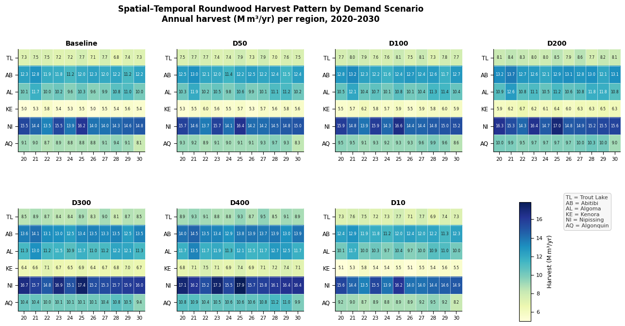
Figure 3. Spatial–temporal roundwood harvest pattern by demand scenario, 2020–2030 (FORBIOM-ON). Each panel is a heatmap of annual harvest volumes (million m³/yr) across six Ontario forest management units (FMUs) and eleven years (2020–2030). Colour intensity indicates harvest level: darker blue = higher harvest. Regions (rows): TL = Trout Lake; AB = Abitibi; AL = Algoma; KE = Kenora; NI = Nipissing; AQ = Algonquin. Scenarios: Baseline = reference mass-timber demand caps; D10–D400 = percentage increase in the demand cap relative to the baseline.
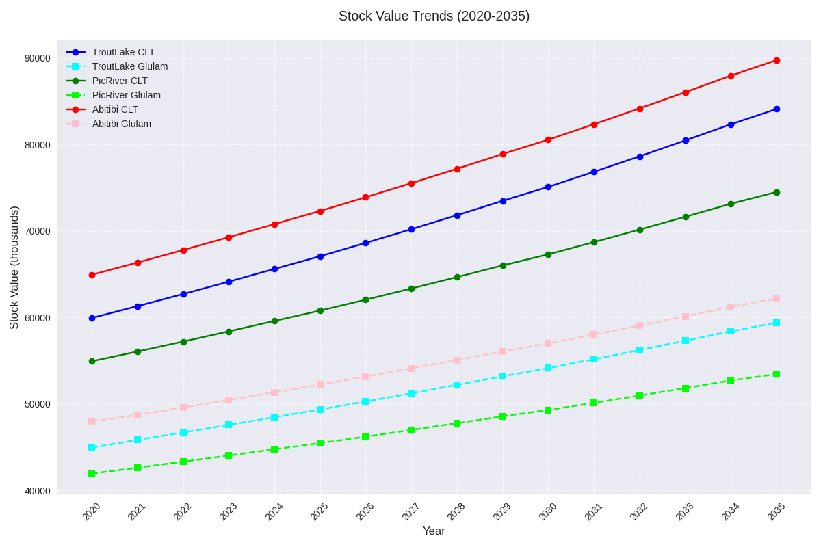
Figure 4. Stock trends by region and product type, 2020–2035 (thousands of m³ per year).
Table 22. Model objective value and carbon cost under alternative carbon-price scenarios. Scenario codes (cpx): carbon price set to x Canadian dollars per tonne CO₂ equivalent (CAD/tCO₂e), e.g., cp50 = 50 CAD/tCO₂e; cp0 = no carbon price. Obj: value of the optimization objective (million CAD). Carbon cost: aggregate carbon cost term implied by the carbon price in the run (million CAD); “—” indicates not applicable at zero carbon price.
Carbon price scenario | Carbon cost (M CAD) | Obj (M CAD)
cp0 | — | 99,011.678
cp50 | 1,328.095 | 97,683.458
cp100 | 2,656.190 | 96,355.363
cp170 | 4,515.523 | 94,496.030
cp250 | 6,640.476 | 92,371.078
cp350 | 9,296.666 | 89,714.888
cp500 | 13,280.951 | 85,730.602

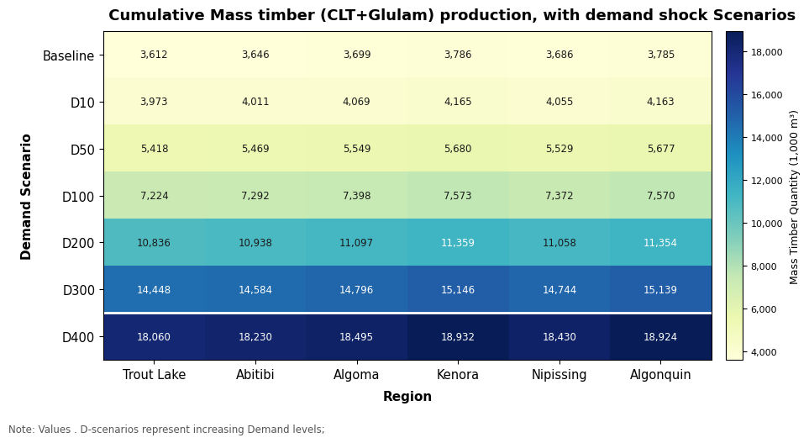
Figure 5. Cumulative mass timber output (CLT + Glulam) by region and demand scenario, 2020–2030 (1,000 m³). CLT: cross-laminated timber; Glulam: glued laminated timber. Scenario labels (e.g., D50) correspond to mass-timber demand-cap multipliers described in the demand scenario table (Table 21).
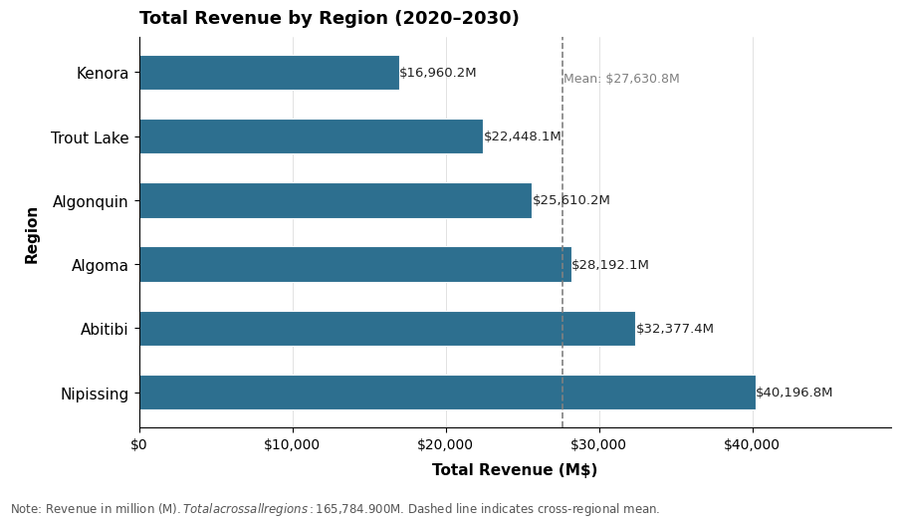  Figure 6. Total revenue by region, cumulative over 2020–2030. M CAD: millions of Canadian dollars. | 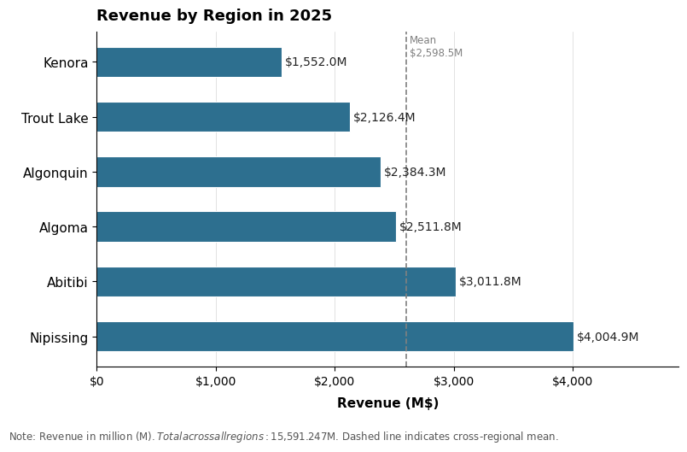  Figure 7. Regional revenue in the year 2025. M CAD: millions of Canadian dollars.

Supplementary materials (code, data, scripts)
GitHub repository Full shareable package (report, GAMS, ABM, scripts, derived data, figures, appendix): https://github.com/yassirelfahli/forbiom-on.
Key code gams/SA15.gms and gams/FORBIOM_ON.gms in the repository (also mirrored on Google Drive).
Data Derived CSV calibration and result tables are in abm/calibration/, abm/results/ and data/gams_outputs/. Raw FRI geodatabases and large GDX binaries are omitted; CRIBE ArcGIS, GeoHub stocks and Plonski yield tables remain with their providers.
Scripts Python FRI processing, mapping and the DOCX builder are under scripts/ (Drive mirror).
Appendix See Appendix A below and docs/APPENDIX.md in the repository for the file map and reproduction notes. Extended ABM docs are in docs/.

A Appendix — Shareable repository contents
This appendix catalogues the public GitHub repository that accompanies the report. Clone or browse it at https://github.com/yassirelfahli/forbiom-on. The package is curated for sharing: model code, derived tables and the report are included; raw MNR extracts, FRI geodatabases and personal working files from the project archive are not.

A.1 Repository layout
Path | Contents
report/ | Preliminary-results DOCX and PDF
gams/ | SA15.gms, FORBIOM_ON.gms, eFAR bridge scripts
abm/ | FORBIOM-ABM Python modules, calibration CSVs, summary tables
scripts/ | FRI processing, report builder, mapping utilities
data/ | Model-ready eFAR bridge CSVs and GAMS summary outputs
figures/ | PNG figures used in this report
docs/ | Appendix guide and extended ABM DOCX reports
README.md | Overview, quick start and citation

A.2 Reproduction pointers
■ GAMS counterfactual (Section 7 tables): run `gams/SA15.gms` in GAMS with an NLP solver (e.g. CONOPT).
■ ABM calibration tables: `abm/calibrate.py` (requires local ARWoodS / eFAR extracts; derived CSVs are already in abm/calibration/).
■ ABM strategies S0–S6: `abm/experiments.py` then analysis.py / figures.py.
■ Regenerate this DOCX: `scripts/build_forbiom_report_docx.py` (Python 3.11+, python-docx, Pillow; Microsoft Word optional to refresh the TOC).

A.3 Data and redistribution limits
■ Included: derived calibration CSVs, GAMS/ABM summary CSV/TXT outputs, model source, report and figures.
■ Not redistributed: raw ARWoodS/eFAR extracts (Ontario MNR), FRI FIM v2 geodatabases, large *.gdx / *.gpkg binaries.
■ Status flags: stock units, FRI biomass coefficients and several logistics capacities remain provisional (see Sections 5.5 and 6.10).

A.4 Citation
Yousefpour, R. & Elfahli, Y. (2026). Ontario Forest Biomass: Supply Chain Feasibility, Processing Optimization, and ABM-Integrated Biomass Utilization (FORBIOM-ON preliminary results). Code and data package: https://github.com/yassirelfahli/forbiom-on.

