FORBIOM-ABM ONTARIO FOREST & WOOD SECTOR MODEL |  | INTERIM REPORT | OCTOBER, 2026  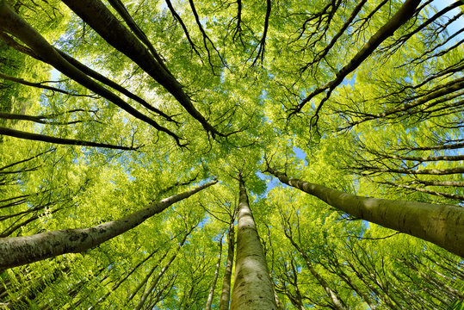  Biomass Utilization  Strategies for Ontario  Supply Chain Feasibility, Processing Optimization, and ABM-Integrated Biomass Utilization  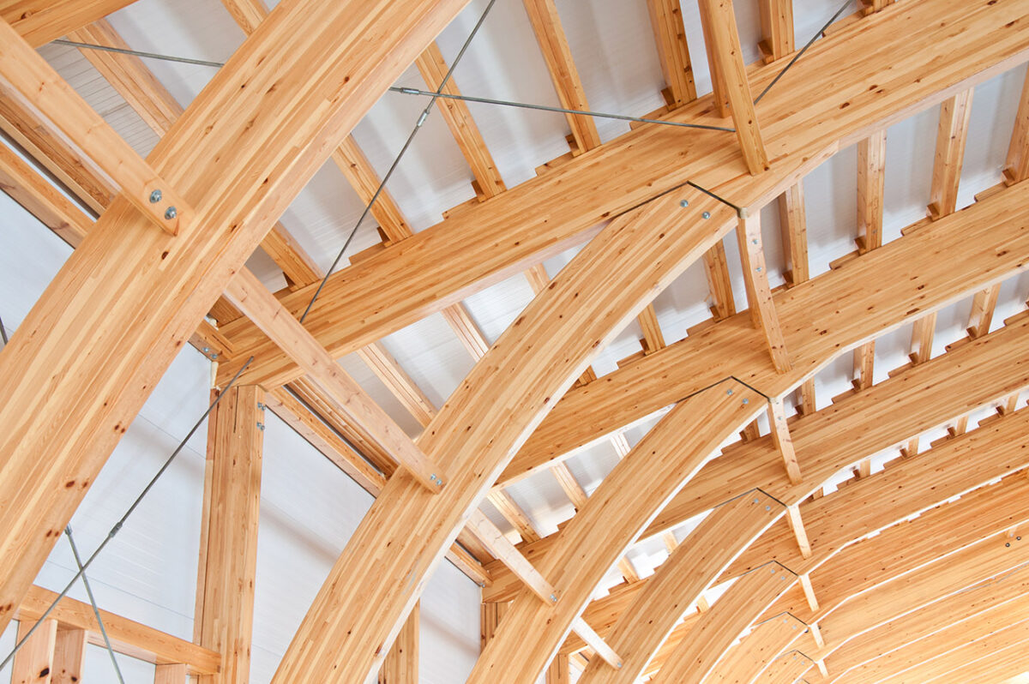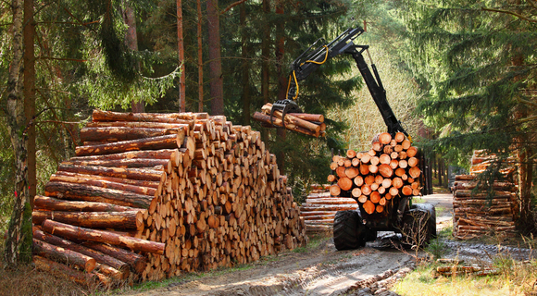
  PREPARED BY  Rasoul Yousefpour  Yasser Elfahli  October 18, 2026 |     Funding provided in part by:

ABSTRACT
In Ontario forest management units, recent harvest is about half of the volume the long-term plans make available. The shortfall is largest where sawmills closed and were not replaced, so wood the plans treat as available has no local buyer. This report asks which new plants would be built and kept running from 2026 to 2045 under different public rules, and what the consequences would be for harvest, rural employment and Indigenous community income.
A planning model can show one coordinated use of the wood, with harvest, milling and shipments chosen together. That model is FORBIOM-ON. That optimization does not say whether the plants would be built and kept running. This report uses an agent-based model. In it, contractors, existing mills and investors decide separately, year by year: how much wood they cut, how much they buy, and which plants they build. That model is FORBIOM-ABM. The recommendation comes from the agent-based model. The two models were conducted on a sample of six management units and are run separately. Section 1.1 describes a later link between them, and Section 4.4 lists what that link would pass.
The comparisons are not a single chain in which each run adds one piece to the last. Plants in southern Ontario that buy lumber and make mass timber do not, by themselves, increase harvest. A large mill in each of the six units, taking logs and making mass timber, does increase harvest. Smaller community mills and heat plants raise Indigenous income by more than those large mills do, and they raise harvest by less. Allowing the large mills and the community plants together, and then four rules at once (Indigenous applicants served first when wood is short, training for Indigenous contractors, higher public purchasing of mass timber and panels, and a payment for wood heat that replaces oil), produces the combined gain. Those four rules are not tested one at a time, so the income gain cannot be assigned to one of them. Pellet mills improve the result only in Trout Lake and Abitibi. In Kenora the large mill is treated as conditional on a secured buyer. Compared with no new plants, the share of planned harvest cut in 2041–2045 is 66% rather than 41%. The 41% is the model in those years with only the mills that already exist. It is not the recent record: harvest in FY2019–2024 was 46% of the planned volume. Rural and northern employment goes from 1,709 to 4,299 full-time jobs, and the present value of Indigenous community income from $431 million to $1,838 million. Public cost is an undiscounted sum of about $331 million. It is not a present value, and it is not on the same basis as the income figure.
Section 1 is the question and the two models. Section 2 is the data. Section 3 points to the planning model, whose results are in a separate report. Section 4 specifies the agent-based model and then reports the comparisons, the figures and the recommendation. Files are in the repository (link).
Contents
1 Introduction 3
1.1 Model linkage 3
2 Data 6
2.1 Sources 6
2.2 Yield curves 6
2.3 Harvest and employment 6
3 FORBIOM-ON 9
4 Agent-based model 10
4.1 Model structure 11
4.2 Decision rules 12
4.3 Strategies and evaluation 13
4.4 Indicators, parameters and coupling 15
4.5 Baseline check 16
4.6 Provincial results 17
4.7 Regional results 22
4.8 Limitations 28
A Repository 29

1 Introduction
In six forest management units in Ontario, the long-term plans make about 5.00 million m³ of wood available each year. Recent harvest has averaged about 2.28 million m³. A forest management unit is the area covered by one forest management plan. The volume the plan makes available is its long-term management direction. This report calls that volume the LTMD, and it calls harvest divided by the LTMD utilization. Across the six units, utilization in FY2019–2024 was 46%. It was not the same everywhere. Kenora and Algoma were near 15% and 20%. Trout Lake was already near 69%.
Most of that unused wood was not left standing for biological reasons. In several units, sawmills closed after the 2000s and were not replaced. Softwood that the plans still treat as available has no local buyer. Indigenous communities are already in that picture: as licence holders, as logging contractors, and as possible owners of the plants that would replace the closed mills.
The policy question is therefore : Which new plants would actually be built and kept running between 2026 and 2045 under different public rules? And what would that do to harvest, to rural employment, and to Indigenous community income?
FORBIOM-ON is a planning model. It answers a different question. If harvest, mills and shipments could be chosen together, how would the wood be used? The latest model version covers 2020 to 2030. Its results are in a separate report and are not repeated here. It does not say whether the plants would be built and kept running.
Contractors, existing mills and investors decide separately, and each one sees only its own marginal gain. A plant that looks efficient when everything is chosen together may never be built. This report uses an agent-based model, labeled as FORBIOM-ABM, which follows those decisions year by year, from 2026 to 2045: how much wood is cut, how much is bought, and which plants are built. Section 4 specifies the parties and the rules, and then compares seven packages. The packages are not a chain of single changes: three of them are alternatives to one another, and one of them turns four rules on together. The recommendation at the end of that section is the package those comparisons support: community plants in all six units, a large mill in each unit, with the Kenora mill conditional on a secured buyer, four public rules taken together, and pellet mills only in Trout Lake and Abitibi. Compared with no new plants, utilization in 2041–2045 is about 66% rather than about 41%. That 41% is the late-period model with existing mills only. Recent utilization, in FY2019–2024, was 46%. Rural and northern employment goes from 1,709 to 4,299 full-time jobs, and the present value of Indigenous community income from $431 million to $1,838 million. Public cost is an undiscounted sum of about $331 million. It is not a present value, and it is not on the same basis as the income figure.

1.1 Model linkage
An agent-based model can represent harvest as a decision by landowners, contractors, or forest management units, rather than as one optimized plan. Figure 1 is that link to FORBIOM-ON. This report does not run it. The two models share the six units and the cost data, and each is run on its own. The exchange, were it run, would work in both directions.
■ ABM outputs → optimization inputs. Effective harvest intensity, adoption of mass timber, and stochastic perturbations to regional supply and costs, passed as parameter or scenario tables into the GAMS model.
■ Optimization outputs → ABM inputs. Shadow values, regional prices, and policy signals, which the agents would use to update their decision rules in the next year. That return is the arrow at the bottom of the figure. It is not used in the runs in this report. A later closed loop would repeat the exchange within the year until harvest in each unit moved by less than a set tolerance. Section 4.4 lists the same exchange.
Behavioral harvesting
Harvest response to an incentive can be written as a logistic function of a latent index z, for example a margin, a carbon price, or a policy score. The result is a propensity between zero and one:
$$σ\left(z\right)=\frac{1}{1+e^{-k\left(z-z_{0}\right)}}$$
with steepness k and midpoint z0. The same function can be used in three ways: a post-processing adjustment to harvest, a smoothed cap on the harvest rate, or a decision rule inside the agent-based model. FORBIOM-ABM uses the third. Contractor supply, mill utilization and the decision to build all use this form. Section 4.2 writes each rule, and Table 6 gives k and z0.
Private landowners are drawn on the figure for a later woodlot version. These six units are Crown forest, so landowners do not act here. The parties in the runs are forest managers, logging contractors and the mills. In the figure their objectives are limited on purpose: contractors maximise operating profit subject to equipment and labour and act when a harvest order arrives; forest managers enforce the sustainability mandate, including the allowable cut, harvest-cap multipliers and a carbon price. Landowners, where a later version included them, would maximise harvest utility with incomplete price information and an aversion to risk (Simon, 1957).
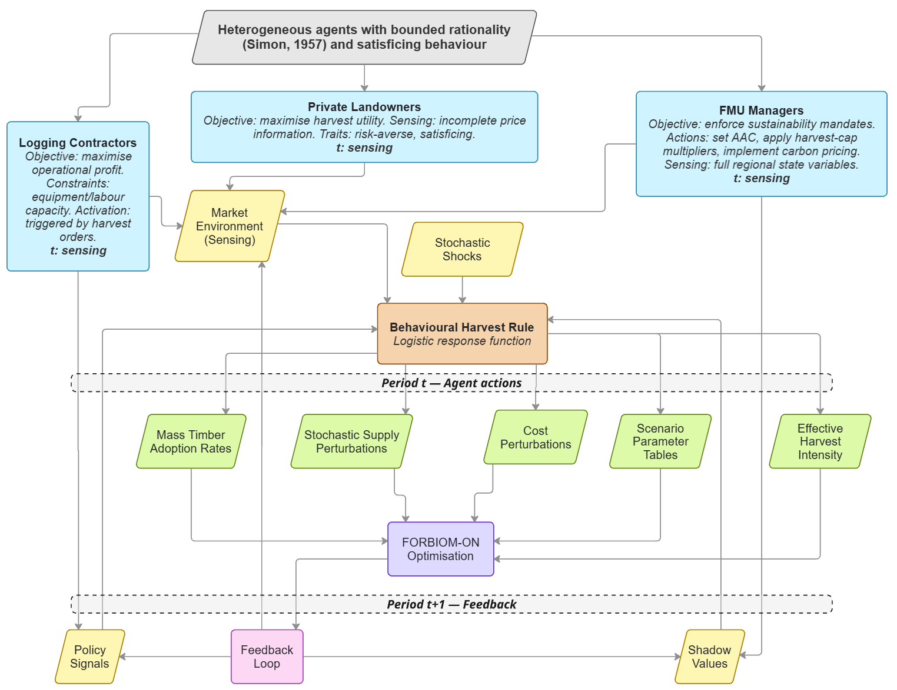
Figure 1. Conceptual structure of the agent-based module linked to FORBIOM-ON, the Ontario forest and wood-sector spatial optimisation model. Three agent classes are drawn. Private landowners would maximise harvest utility with incomplete price information and an aversion to risk; they are drawn for a later woodlot version and do not act in these Crown forests. Logging contractors maximise operating profit, are limited by equipment and labour, and are activated by harvest orders. FMU managers enforce the sustainability mandate: the allowable annual cut, harvest-cap multipliers, and carbon pricing. In each period the agents read prices and shocks and turn them into harvest decisions with the logistic rule in this section. Five channels would pass those decisions to FORBIOM-ON: mass-timber adoption rates, stochastic supply perturbations, cost perturbations, scenario parameter tables, and effective harvest intensity. The optimiser would return policy signals and shadow values for the next period. That return, drawn at the bottom of the figure, is not used in the runs in this report.
The rest of the report proceeds as follows. Section 2 presents the harvest record against which later results are measured, and the employment rates applied to mill output. Section 3 identifies the planning model. Its results are in a separate report and are not repeated here. Section 4 specifies the decisions of contractors, mills and investors, defines the seven packages, and reports the consequences for harvest, rural employment and Indigenous community income.

2 Data
Table 1 is the source list. Section 2.2 cites the yield curves used in FORBIOM-ON. Section 2.3 is the harvest and employment record used by the agent model. The scripts are listed with the repository in Appendix A.

2.1 Sources
Table 1. Data sources used by FORBIOM-ON and FORBIOM-ABM.
Dataset | Provider and vintage | Variables used | Used in
ARWoodS data extract (Annual Report on Wood Supply) | Ontario MNR, 2025 update; fiscal years 2019–2024 | Planned available harvest under the Long-Term Management Direction (LTMD) and actual harvest, by management unit, species group and forest type | ABM fibre supply and calibration
eFAR summary (Electronic Forest industry Annual Report) | Ontario MNR, September 2024 release; 2020–2022 | Mill and woodlands employees, roundwood consumed, and deliveries from source units to mill types | ABM employment intensities and wood flows
Forest Resources Inventory (FRI), FIM v2 geodatabases | MNR; Abitibi River 2011, Algonquin Park 2011, Algoma 2013, Trout Lake 2013, Kenora 2015, Nipissing (3D inventory) | Polygon type, species composition, age, height, stocking, crown closure, geometry | Spatial composition and maps (CRIBE ArcGIS dataset)
Plonski normal yield tables (metric) | Plonski (1981), Ontario Ministry of Natural Resources | Gross merchantable volume (m³/ha) by species, age and site class | FORBIOM-ON growth
Regional roundwood stocks | Ontario GeoHub | Initial standing roundwood stock by FMU | FORBIOM-ON initial state
Market, cost and technology data | Literature, industry benchmarks, model assumptions | Product prices, processing and harvest costs, demand caps, transport costs, capacities, carbon factors | Both models

2.2 Yield curves
Growth in FORBIOM-ON follows Plonski’s normal yield tables. Plonski (1956) published the first tables for black spruce, jack pine, aspen and white birch in northern Ontario. The 1960 edition added tolerant hardwoods, white pine and red pine, and the metric edition is Plonski (1981). These tables, or a close variant of them, have been the yield curves used in forest management planning on Crown land in Ontario (Penner, 2008). The metric tables used in the model are archived here.

2.3 Harvest and employment
Harvest is taken from the Annual Report on Wood Supply. Mill employment and wood deliveries are taken from the Electronic Forest industry Annual Report. The Forest Resources Inventory supplied the maps of these six units.
The harvest record
Section 4 asks whether new plants would raise harvest above the volume mills already take, and what that would do to employment and community income. The answer depends on a starting record: how much wood the plans make available, how much was recently cut, and how much of the remainder is softwood. Table 2 is that record. It is drawn from the 2025 update of the Annual Report on Wood Supply, limited to these six units and to merchantable wood, and stated as the annual average of fiscal years 2019 to 2024.
LTMD is the volume the long-term plan makes available each year. Harvest is the volume cut. Utilization is harvest divided by LTMD. It is the recent use of the plan, and it is the measure Section 4 follows through 2045.
The three unused columns split the planned volume that was not cut into the groups the model uses. Softwood is spruce, pine, fir, other conifers and cedar. Poplar is kept separate. Hardwood is white birch and tolerant hardwoods. Unused softwood is the volume a new softwood mill could draw on, and a new mill is considered in a unit only where that volume exists. Unused poplar and unused hardwood are planned volume of those species that was not cut. The plants compared in Section 4 saw softwood into lumber, mass timber or panels, or they use residues for heat. They do not include a product made from poplar logs or from hardwood logs. Those two columns are included so that this remaining gap is visible. The packages do not close it.
The last two columns confirm that the simulation starts from this record. A later increase in harvest can be attributed to the plants only if 2026 begins at the recent harvest. Existing mills are therefore given a capacity that brings their 2026 intake into line with the Harvest column. Model 2026 is that intake, the mean of 50 runs in which no new plant is added. Difference is Model 2026 compared with Harvest. A value near zero means the later years start from the record. Kenora is the only unit more than one tenth of one percent away: Model 2026 is 1.4% below the recent harvest. The column does not assess 2027 to 2045. Those years are the decisions reported in Section 4.
Table 2. Wood supply the agent model starts from (1,000 m³/yr). Columns through Unused HW are ARWoodS FY2019–2024 means. Model 2026 is the first simulated year with no new plants, mean of 50 runs. Difference is that year compared with the Harvest column.
Unit | LTMD | Harvest | Utilization | Unused SW | Unused PO | Unused HW | Model 2026 | Difference
Trout Lake | 918 | 632 | 69% | 236 | 24 | 27 | 631 | -0.1%
Abitibi | 1,552 | 884 | 57% | 439 | 185 | 44 | 884 | +0.0%
Algoma | 632 | 127 | 20% | 198 | 55 | 252 | 127 | +0.0%
Kenora | 465 | 70 | 15% | 219 | 145 | 32 | 69 | -1.4%
Nipissing | 713 | 222 | 31% | 264 | 120 | 107 | 222 | +0.0%
Algonquin | 722 | 346 | 48% | 181 | 47 | 148 | 346 | +0.0%
Total | 5,002 | 2,280 | 46% | 1,536 | 576 | 610 | 2,279

Across the six units the plans make 5.00 million m³ available each year and recent harvest is 2.28 million, a utilization of 46%. The low end is Kenora, at 15%, and the high end is Trout Lake, at 69%. Unused softwood, the volume a new sawmill could use, is concentrated in Abitibi, Nipissing, Trout Lake and Kenora. Unused poplar is largest in Abitibi, Kenora and Nipissing. Unused hardwood is largest in Algoma, Algonquin and Nipissing.
Employment
Jobs per cubic metre come from the Electronic Forest industry Annual Report (eFAR), the ministry’s mill report. The release used here is September 2024 and covers 2020, 2021 and 2022, averaged. Those three years are the published window in that release. They are not the years the model simulates. The model runs from 2026 to 2045 and applies these observed rates to whatever volume the mills then use.
Table 3 is Ontario as a whole: reported employees in the mill and in the woods, divided by the roundwood that type of mill consumed. Table 4 is the wood the same reports show as delivered from each of the six units to each type of mill. Both are calculated from the ministry file.
The agent model uses two rows of Table 3, and it adds the two columns in each row. A softwood sawmill is given the sawmill facility rate plus the sawmill woodlands rate, about 0.36 + 0.04 = 0.41 jobs per 1,000 m³. A poplar mill is given the composite facility rate plus the composite woodlands rate, about 0.36. The woodlands column counts employees the mill itself reports. It does not count independent logging contractors. Those contractors are added on top, at 0.40 jobs per 1,000 m³ harvested. That 0.40 is an assumption, stated in Section 4.4. It is not a substitute for the 0.04. Both enter the rural job total. New mass-timber and panel plants are not in eFAR, so their plant job rates are stated separately in Section 4.4.
Table 3. Employment intensity by facility type, Ontario, eFAR 2020–2022 annual means.
Facility type | Facility employees | Woodlands employees | Roundwood consumed (1,000 m³) | Facility jobs per 1,000 m³ | Woodlands jobs per 1,000 m³
Sawmill | 3,122 | 387 | 8,611 | 0.36 | 0.04
Composite | 613 | 12 | 1,724 | 0.36 | 0.01
Pulp | 1,526 | 325 | 618 | 2.47 | 0.53
Veneer | 144 | 13 | 170 | 0.85 | 0.08
Bioproduct | 70 | 1 | 58 | 1.22 | 0.01
Fuelwood | 13 | 0 | 5 | 2.63 | 0.00

Table 4. Roundwood delivered from the six FMUs by facility type (1,000 m³/yr, eFAR 2020–2022 means).
FMU | Sawmill | Composite | Pulp | Veneer | Other | Total
Trout Lake | 481.5 | 16.8 | 125.7 | 0.0 | 0.0 | 624.1
Abitibi | 454.2 | 159.7 | 0.0 | 0.1 | 0.0 | 614.1
Algoma | 135.1 | 0.0 | 0.2 | 0.4 | 0.0 | 135.7
Kenora | 26.6 | 22.3 | 0.0 | 0.0 | 0.0 | 48.9
Nipissing | 85.4 | 18.0 | 1.3 | 0.9 | 0.0 | 105.5
Algonquin | 233.6 | 10.0 | 7.6 | 0.0 | 14.7 | 265.9

Table 4 does not equal the Harvest column of Table 2. Abitibi is 884 in Table 2 and 614.1 in Table 4. Nipissing is 222 and 105.5. Algoma goes the other way, 127 and 135.7. The two tables record different things over different years. Table 2 is merchantable wood cut on the unit, the annual average of fiscal years 2019 to 2024. Table 4 is roundwood that mills in the September 2024 eFAR release reported receiving in calendar years 2020, 2021 and 2022, from a source name matched to the unit. Those differences can leave wood out of Table 4, or put a different year's deliveries above the six-year harvest mean. This report does not split any unit's gap into a year effect, an unmatched source name, and wood that was never delivered. It is not a cubic-metre reconciliation. The agent model starts from Table 2. It does not reset harvest to Table 4. The employment rates in Table 3 are provincial totals from the same mill survey, so they do not require Table 4 to add up to Table 2.
Initial conditions
Agents are initialized so that the first simulated year reproduces the harvest in Table 2. The shares, prices and distances below are model settings. They are not counts or prices taken from a ministry table. Only the harvest volumes are taken from the ministry record.
■ Harvest contractors: ten per FMU. Total contractor capacity is 1.25 × the observed harvest, split among contractors with Dirichlet(3) weights. Individual cost multipliers are drawn from a lognormal(0, 0.08) distribution. The initial share of Indigenous-owned contractors is a model setting, not an observed count: 20% (Trout Lake), 15% (Abitibi), 35% (Kenora) and 10% elsewhere.
■ Incumbent mills: three per FMU and fibre class wherever observed harvest exceeds 1,000 m³/yr (51 mills; Kenora has no hardwood mill). They hold 50%, 30% and 20% of the class volume, with cost multipliers drawn from lognormal(0, 0.05). Capacity is set so that first-year intake equals each mill's share of observed harvest. The formula is in the note to the harvest record.
■ Log prices: the initial regional log price is 1.10 × the delivered contractor cost, which combines harvest cost ($38/m³ × regional access factor 1.00–1.15, +10% for poplar and hardwood), 110 km of in-region haul at $0.12/m³·km and $6/m³ stumpage.
■ Distances: road distances are approximated from FMU centroids as great-circle distance × 1.3 circuity. Distances to the Greater Toronto Area (GTA) market are Trout Lake 1,608 km, Abitibi 825 km, Algoma 649 km, Kenora 1,725 km, Nipissing 420 km, Algonquin 308 km.
What the first year is checked against
Table 2 already shows the check. The first simulated year matches the 2019–2024 harvest exactly in Abitibi, Algoma, Nipissing and Algonquin, within 0.06% in Trout Lake, and within 1.4% in Kenora. That match is the starting point. Existing mills are sized so that this year reproduces recent harvest; that sizing is described with the initial conditions above. After 2026, with no new plants, the model does not climb to the full LTMD. Across 50 such runs, utilization in 2041–2045 averages 41%, against 46% observed in 2019–2024. The spread across those runs is lumber-price cycles and the occasional mill that closes.

3 FORBIOM-ON
FORBIOM-ON chooses harvest, milling and shipments together for these six units, from 2020 to 2030. Growth follows the Plonski yield tables in Section 2.2. The results of that model are reported separately and are not repeated here. The numbers in Section 4 come from the agent-based model. The two models use the same six units, the same harvest cost, the same lumber requirement for mass timber, and the same carbon factors. Figure 2 shows how those files are prepared. The dashed arrow is the link already described in Section 1.1.

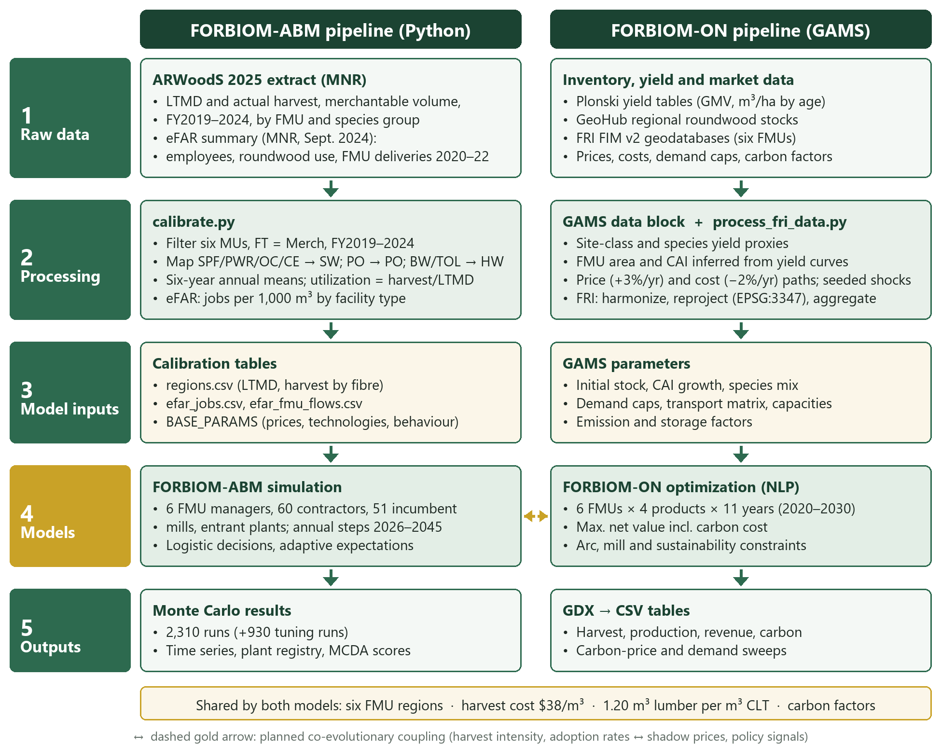
Figure 2. How the provincial files reach both models. The same six units, harvest cost and conversion ratios are prepared once. The dashed arrow is the link described in Section 1.1.

4 Agent-based model
The agent-based model, FORBIOM-ABM, does not choose a provincial plan. Each year from 2026 to 2045, the parties in the six units decide separately, on the profit each one can see. A plant that would look efficient if harvest, milling and shipments were chosen together may still not be built. That is the difference from FORBIOM-ON. The runs below ask which plants and which public rules those parties actually take up.
Four decisions make a year. The forest manager in each unit releases the volume the long-term plan allows, separately for softwood, poplar and hardwood. A fire or blowdown can reduce it. Logging contractors then offer logs only to the extent the log price covers their own cost: a thin margin produces a partial offer, not a full one. Mills, including mills already operating, ask for logs only to the extent the product price covers the log price. A mill that loses money for several years may close, which is how a low lumber price reduces harvest. An investor builds a new plant only when unused softwood is available, a buyer exists for the product, and the expected profit covers the capital after any grant. Even then the plant is built with a probability, comes online after two years, and ramps up. The strategy sets which plants are allowed and which rules apply. It does not order anyone to build.
The same price shocks are used in every strategy, so a difference between strategies is not a difference in luck. Prices are formed inside this model. The program is abm.py; the strategy runs are experiments.py. Section 4.1 describes the parties. Section 4.2 gives the decision rules. Section 4.3 defines the seven packages, and Section 4.6 reports the comparisons.

4.1 Model structure
The results are credible only if the model first reproduces three observed patterns: harvest well below the LTMD, and different in every unit; poplar and hardwood used less than softwood; and harvest that falls when lumber prices remain low, including mills that curtail or close.
Agents
Table 5. Agents and entities in FORBIOM-ABM.
Agent / entity | Key state variables | Behaviour
FMU manager (6) | LTMD by fibre class (SW, PO, HW); available volume after disturbance | Releases sustainable volume; allocates fibre to licence holders, then entrants (Indigenous-majority entrants first under the priority policy)
Harvest contractor (10 per FMU at start) | Capacity (m³/yr), cost multiplier, Indigenous ownership, sales, margin | Offers volume through a logistic response to the log price relative to own cost; expands when fully used and profitable
Incumbent mill (51) | Calibrated capacity, fibre class, cost multiplier, consecutive loss years | Sets utilization from expected margin; exits after three loss years with probability 0.4 per year
Mass-timber hub (entrant) | 150,000 m³/yr log intake; 60,000 m³/yr CLT/glulam; capex $150 M; Indigenous equity | Integrated sawmill and CLT/glulam line selling to southern Ontario; surplus lumber to commodity markets
Urban CLT plant (entrant, GTA) | 60,000 m³/yr; capex $100 M | Converts lumber bought from the north; adds no harvest
Community log-to-panel spoke (entrant) | 25,000 m³/yr logs; 10,000 m³/yr panels; capex $25 M; Indigenous equity | Small sawmill and prefab panel line; serves northern housing first, then southern prefab demand
Community bioheat (entrant) | 5,000 odt/yr; capex $12 M | Displaces heating oil; uses residues first, then low-grade roundwood
Pellet plant (entrant) | 80,000 odt/yr; capex $50 M | Exports pellets by rail via Thunder Bay or Montreal
Markets | AR(1) price shocks; demand levels | Southern mass timber and panels clear on price; northern housing; heat; commodities
Policy agent | Grants, equity rules, allocation priority, capacity building, procurement, clean-heat incentive | Defined by the strategy (Section 4.3)

The model covers six units plus a Greater Toronto Area market. A year is one step, from 2026 to 2045, in 2026 dollars. The parties in these runs are the forest manager in each unit, the logging contractors and the mills. Private landowners are outside these runs, as Section 1.1 notes.
Annual sequence
The year just described is executed in this order:
(1) Environment: draw correlated price shocks (lumber, OSB, mass timber, panels, pellets, heating fuel) and FMU disturbance (fire or blowdown).
(2) Supply release: FMU managers release available volume by fibre class.
(3) Processor demand: plants form desired roundwood intake from expected margins (logistic utilization rule).
(4) Fibre markets: contractors offer volume (logistic supply rule); each regional market allocates volume by priority group and updates the log price in proportion to excess demand.
(5) Production and product markets: southern mass-timber and panel prices clear against demand; spokes serve local housing first; bioenergy plants use mill surplus residues, then forest residues, then low-grade roundwood.
(6) Accounting: profits after capital charges, jobs, Indigenous jobs and income, carbon and public cost.
(7) Investment: potential entrants evaluate NPV under adaptive expectations, fibre and market headroom, learning-adjusted capex and grants; they build with a logistic probability, come online after two years and ramp up through 50% and 80% of capacity.
(8) Exit and adaptation: loss-making plants may exit, contractors expand capacity, and all agents update price expectations.

4.2 Decision rules
A higher margin does not switch a contractor, a mill or an investor from idle to fully used. The volume offered, the volume bought and the probability of building each rise with the margin, and only part of the way. The same partial response applies to the log price, to price expectations and to the southern mass-timber price. Each of those responses is the same logistic function of a margin. Table 6 gives the steepness and the midpoint used for each decision.
$$σ\left(z\right)=\frac{1}{1+e^{-k\left(z-z_{0}\right)}}$$
Contractor supply
A contractor offers a share of its capacity. The share rises as the log price rises above the contractor's own delivered cost. Where a contractor cuts more than one species group, effort is split in proportion to what the mills are asking for.
$$q_{i,f}=K_{i}·e_{f}·σ\left(12·\frac{w_{r,f}-c_{i,r,f}}{c_{i,r,f}}+1\right)$$
Mill intake
A mill asks for a share of its capacity. The share rises as the value of the product, after conversion, freight and any residue credit, rises above the expected log price.
$$D_{j,f}={Cap}_{j}·σ\left(4·\frac{v_{j,f}-E\left[w_{r,f}\right]}{E\left[w_{r,f}\right]}+1\right)$$
The decision to build
A new plant is considered only when unused softwood covers at least 70% of its log intake, and, for a mass-timber plant, when buyers can take at least 40% of its output. The probability of building then rises with the ratio of expected value to capital after grants. Capital cost falls by 10% with each doubling of plants of that kind already built. Each unit can host at most two large mills, three community mills, four heat plants and one pellet plant. The Greater Toronto Area can host three urban plants.
$$Pr\left(build\right)=0.6·σ\left(5·\frac{NPV}{I^{net}}-1\right), NPV=\overline{m}·AF\left(8\%, 20 yr\right)-I^{net}$$
Table 6. Parameters of the decision rules.
Decision | Latent index z | Steepness k | Midpoint z0 | Output
Contractor supply | (log price − own cost)/own cost | 12 | −0.083 | Share of capacity offered
Mill utilization | (willingness to pay − expected log price)/expected log price | 4 | −0.25 | Share of capacity demanded
Urban CLT output | Expected margin over lumber cost | 4 | −0.25 | Share of capacity produced
Investment | NPV/net capex | 5 | 0.20 | Build probability (scaled by 0.6)
Negative midpoints mean that agents still operate at about half capacity when margins are slightly negative in the short run, which reflects contractual commitments and fixed-cost recovery.
Markets and expectations
Each regional market allocates the minimum of what mills ask for, what contractors offer, and what the plan released. Licence holders are served before new entrants. Where the priority rule applies, Indigenous-majority entrants and Indigenous contractors are served first. The log price then moves toward the balance of demand and supply, and it stays between 90% of the lowest contractor cost and the highest price a mill will pay. Expected prices for the next year put a weight of 0.3 on the price just observed. Product prices move with a persistent shock that is tied to the lumber price. When the supply of southern mass timber exceeds demand, the price falls; the elasticity of that adjustment is 1.5. Table 7 lists the random draws.
$$w_{r,f,t+1}=w_{r,f,t}·\left(1+0.3·clip\left(\frac{D-S}{S}, -0.5, 0.5\right)\right)$$
$$E_{t+1}\left[P\right]=E_{t}\left[P\right]+0.3\left(P_{t}-E_{t}\left[P\right]\right)$$
$$P=P_{ref}·{\left(\frac{D}{S}\right)}^{\frac{1}{1.5}}$$
Table 7. Stochastic elements in FORBIOM-ABM.
Element | Specification
Product prices | AR(1) log-shocks, ρ = 0.6; standard deviation 15% (lumber, OSB), 10% (pellets, heating fuel), 6% (mass timber), 5% (panels); correlation with the lumber shock 0.6 (OSB), 0.4 (mass timber), 0.3 (panels)
Natural disturbance | Fire or blowdown with probability 6% per FMU-year; volume loss U(10%, 30%) of LTMD
Supply noise | Multiplicative N(1, 0.05) on released volume
Agent heterogeneity | Contractor capacity shares Dirichlet(3); cost multipliers lognormal(0, 0.08) for contractors and lognormal(0, 0.05) for mills
Discrete decisions | Investment, exit and contractor expansion use decision-keyed uniform draws, so the same decision faces the same random number in every strategy (common random numbers)

4.3 Strategies and evaluation
Seven runs are compared. They are not one chain in which each run adds a single piece to the run before it. S0 is the mills already operating. S1, S2 and S3 are three alternatives, each added to S0 on its own. S1 allows up to three CLT and glulam plants in the Greater Toronto Area; they buy lumber, not logs. S2 allows one integrated mill, a hub, in each unit, taking about 150,000 m³ of logs a year, and does not include the southern plants. S3 allows community panel mills and heat plants only, with no hubs. S4 allows the hubs, the community plants and a pellet mill in every unit at the same time, and adds none of the rules below. S5 is S4 plus four rules switched on together: Indigenous applicants are served first when wood is short, contractor training, public buyers taking 25% more mass timber and panels, and $50 per tonne of CO₂ avoided by wood heat. The runs do not separate those four rules, so a gain from S4 to S5 belongs to the bundle. S6 was not specified in advance. From S5, a plant type was withdrawn in a unit only when the average of the regional and provincial scores rose, the provincial score was not lower by more than 0.005 on the normalized scale, and public cost fell. The only withdrawal that met those conditions was the pellet mill outside Trout Lake and Abitibi. Hubs and community plants stayed available in every unit. Section 4.7 says why the Kenora hub is still treated as conditional. The table gives the sizes, grants and ownership shares. Section 4.6 reads the outcomes in this order.
Table 8. Strategies simulated in FORBIOM-ABM.
Code | Strategy | Technologies and policies
S0 | Business as usual | Incumbent mills only; no new technologies or policies
S1 | Southern urban mass-timber plants | Up to three 60,000 m³/yr CLT/glulam plants in the GTA buying northern lumber; no grants
S2 | Northern integrated log-to-mass-timber hubs | Hubs in all six FMUs; 15% capital grant; 20% Indigenous equity
S3 | Distributed Indigenous/community network | Log-to-panel spokes and community bioheat in all FMUs; grants 40% (spokes) and 50% (bioheat); 51% Indigenous equity; contractor capacity building
S4 | Hub-and-spoke hybrid | Hubs, spokes, bioheat and pellet plants; grants 15/40/50/10%; Indigenous equity 20/51/51/20%
S5 | Hybrid + enabling policy | S4 plus capacity building, Indigenous allocation priority, 25% public procurement uplift to southern demand and a $50/tCO₂e clean-heat incentive
S6 | Regionally differentiated portfolio | S5 tuned region by region: the pellet plant is dropped in Algoma, Kenora, Nipissing and Algonquin; the full package is kept in Trout Lake and Abitibi
Capacity building adds Indigenous contractor capacity equal to 2% of LTMD per FMU per year during the first five years, at a public cost of $20 per m³ of capacity, and raises Indigenous contractors' expansion probability by 60%.
Sizes, grants and ownership shares are the values used in the runs, not the only rates worth testing. S6 permits a plant; agents may still choose not to build. The screen used 930 runs and 30 seeds.
Evaluation
The runs are in three stages. Every strategy sees the same random draws, so a difference between strategies is not a difference in luck.
(1) Strategy comparison: S0–S5 under three southern mass-timber demand growth scenarios (Low 3%, Base 8%, High 15% per year), with 50 seeds each.
(2) Regional tuning: for each FMU, variants of S5 that drop one technology or cap spokes at one are tested with 30 seeds (930 runs). A variant is kept only when the average of the regional and provincial scores rises, the provincial score is not lower by more than 0.005 on the normalized scale, and public cost falls. The result is S6, which is then run under the three demand scenarios with 50 seeds.
(3) Sensitivity analysis: all seven strategies under six one-at-a-time changes (mass-timber price ±20%, lumber price −20%, capex +30%, private discount rate 10%, heat value −30%), with 30 seeds each.
Stages 1 and 3 together are 2,310 simulations: seven strategies, three demand paths and 50 seeds, plus six one-at-a-time changes, seven strategies and 30 seeds. The tuning stage adds 930 runs. Each run is scored on seven measures. Each measure is scaled from the worst strategy to the best in that run (and reversed when lower is better), then combined under four sets of weights (Table 9). The order of the strategies is checked against the three demand paths and the six one-at-a-time changes. Indigenous income and value added are present values at 4% a year. Public cost is the undiscounted sum of grants and programme payments. Carbon is a cumulative sum of tonnes, not a present value.
Table 9. Evaluation criteria and weighting schemes.
Criterion | Indicator | Direction | Equal | Economic | Community | Climate
Fibre utilization | Harvest/LTMD, 2041–2045 | + | 0.14 | 0.20 | 0.10 | 0.20
Value added | NPV of profits, contractor margins and wages | + | 0.14 | 0.35 | 0.10 | 0.15
Rural/northern jobs | Mean FTE 2036–2045, excluding the GTA | + | 0.14 | 0.10 | 0.25 | 0.10
Indigenous community income | NPV of wages, contractor margins and equity income | + | 0.14 | 0.10 | 0.35 | 0.10
Net carbon benefit | Cumulative storage + avoided emissions − emissions | + | 0.14 | 0.10 | 0.10 | 0.35
Public cost | Undiscounted sum of grants and programme costs | − | 0.14 | 0.10 | 0.05 | 0.05
Investment risk | Share of new plants with negative cumulative profit | − | 0.14 | 0.05 | 0.05 | 0.05
Equal weights are 1/7 for each criterion.
The score of a strategy is the weighted sum of its criteria after each criterion is scaled from the worst value in the set to the best. For a criterion that should be small, the scaled value is replaced by one minus that value.
$$S_{s}=\sum_{c}{w_{c}·\frac{x_{s,c}-\min_{s}x_{c}}{\max_{s}x_{c}-\min_{s}x_{c}}}$$

4.4 Indicators, parameters and coupling
■ Jobs: plant jobs follow Table 3 with the facility and woodlands columns added (0.41 per 1,000 m³ at a softwood sawmill; 0.36 at a composite mill), or technology benchmarks for new plants (1.6 FTE per 1,000 m³ of mass timber; 5 FTE per 1,000 m³ of panels). Logging and hauling then add a further 0.40 FTE per 1,000 m³ harvested. That 0.40 counts independent contractors. It is an assumption, not the woodlands column of Table 3, and the rural total includes both.
■ Indigenous income: wages of Indigenous workers (regional labour share; 60% local hiring at Indigenous-majority plants; +15 percentage points at partnership plants; 80% at Indigenous-owned contractors), plus margins of Indigenous-owned contractors, plus the equity share of plant profits after capital charges. Equity losses are counted, so Indigenous investors carry downside risk.
■ Carbon: net benefit = carbon stored in products (FORBIOM-ON storage factors) + fossil emissions avoided by bioheat (1.23 tCO₂e/odt replacing heating oil) − process, freight (0.00005 tCO₂/m³·km) and harvest (0.012 tCO₂/m³) emissions.
■ Residues: sawmills generate 0.40 m³ of residue per m³ of logs (0.42 odt/m³), of which 60% is already absorbed by pulp, composite and cogeneration uses. Harvesting yields 0.12 odt/m³ of forest residue, recoverable at $45/odt.
■ Recorded outputs: annual records by FMU of harvest by fibre class, LTMD, products (lumber, mass timber, panels, OSB, pulp, bioheat, pellets), residue use, prices, plant counts, jobs, Indigenous jobs and income, value added, carbon and cumulative public cost, plus a registry of every new plant.
Parameters
Table 10. Key FORBIOM-ABM parameters (2026 CAD, real).
Parameter | Value | Source / basis | Status
LTMD and harvest by FMU and fibre class | Table 2 | ARWoodS 2025, FY2019–2024 means | Calibrated
Plant jobs per 1,000 m³ (sawmill; composite) | 0.41; 0.36 | eFAR facility + woodlands, Table 3 | Calibrated
Logging and hauling jobs per 1,000 m³ | 0.40 | Assumption, added on top of plant jobs | Assumption
Harvest cost | $38/m³ × access factor 1.00–1.15 | FORBIOM-ON harvestCostRW | Model-consistent
In-region haul; stumpage | 110 km at $0.12/m³·km; $6/m³ | Ontario industry norms | Assumption
SPF lumber price (mill net) | $300/m³ | 2023–2026 market range | Assumption
CLT/glulam price | $1,100/m³ (±20% tested) | Industry quotes | To validate
Prefab panel price (wood equivalent) | $1,300/m³ | Industry estimates | To validate
OSB; pulpwood; residue; pellets | $400/m³; $70/m³; $30/odt; $230/odt | Market references | Assumption
Sawmill lumber recovery; residue fraction | 0.55; 0.40 | Boreal sawmill literature | Literature
Lumber per m³ CLT; per m³ panel | 1.20; 1.15 | FORBIOM-ON lumberInputPerUnit | Model-consistent
Southern mass-timber demand | 165,000 m³/yr in 2026; growth 3/8/15% | Scenario assumption | Scenario
Southern prefab panel demand | 60,000 m³/yr in 2026 | Planning assumption | To validate
Northern housing need | 40–150 units/yr per FMU at 35 m³/unit, +2%/yr | Planning assumption | To validate
Community heat demand | 3,000–10,000 odt/yr per FMU | Planning assumption | To validate
Discount rates | 8% private; 4% social | 4% on income and value added only; public cost is not discounted | Sensitivity (10%)
Behaviour | k = 12/4/5; expectation weight 0.3; price adjustment 0.3 | Set for plausible response | Sensitivity-tested

Coupling and limitations
Section 1.1 already states that these runs do not close the loop in Figure 1. A later version that did close it would exchange the following once a year:
■ ABM to FORBIOM-ON: effective harvest intensity by FMU (simulated harvest/LTMD), mass-timber adoption (installed hub and urban plant capacity), and supply and cost perturbations, written as GAMS parameter tables (CSV/GDX) that replace the current harvest caps, secondary capacities and stochastic multipliers.
■ FORBIOM-ON to ABM: regional shadow prices of the sustainability and capacity constraints and optimal regional prices, which update agents' price expectations and investment screening in the next period.
■ Convergence: the exchange is repeated within each period until harvest by FMU changes by less than a set tolerance, and then the models move to the next year.
The limits of the runs themselves, including log trade, species, carbon and the six-unit scope, are collected in Section 4.8.

4.5 Baseline check
The comparisons in Section 4.6 come from the agent-based model, calibrated to the observed harvest in Table 2. A difference between runs can be read as the effect of the package only if, before any new plant is permitted, the model reproduces recent harvest. The 2026 harvest under S0 is compared with the FY2019–2024 mean. The largest absolute error is 1.4%, in Kenora. The other five units are within 0.1% (Table 11). Table 11 repeats the check already shown in the last two columns of Table 2, so the results section can be read without turning back.
FMU | Observed harvest | Simulated 2026 | Error | Observed utilization
Trout Lake | 632 | 631 | −0.06% | 69%
Abitibi | 884 | 884 | 0% | 57%
Algoma | 127 | 127 | 0% | 20%
Kenora | 70 | 69 | −1.4% | 15%
Nipissing | 222 | 222 | 0% | 31%
Algonquin | 346 | 346 | 0% | 48%
Table 11. Opening harvest against ARWoodS FY2019–2024 means (1,000 m³/yr). Utilization is harvest divided by LTMD.
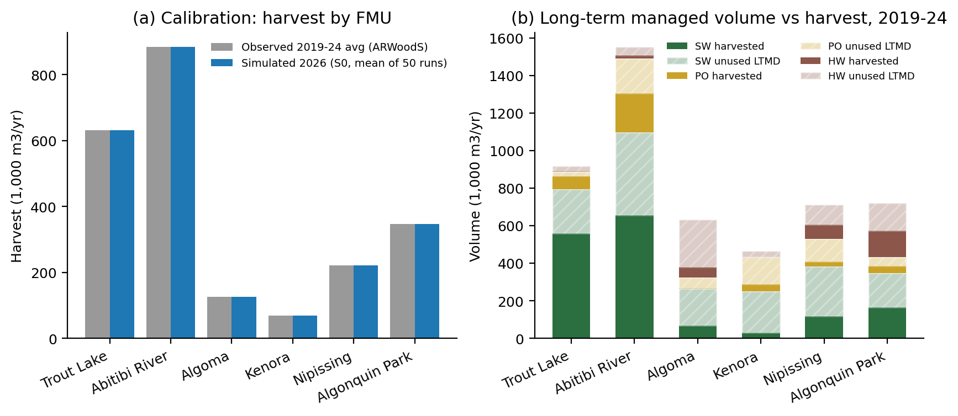
Figure 3. (a) Observed harvest, FY2019–2024 mean, and simulated 2026 harvest under S0, mean of 50 runs (calibration_check.csv). (b) Long-term managed volume and observed harvest by softwood, poplar and hardwood (ARWoodS calibration table). Hatched portions are unused long-term volume.

4.6 Provincial results
Table 12 follows the order in Section 4.3. S1, S2 and S3 are alternatives, each compared with S0. S4 combines plants. S5 adds the four rules together. S6 drops some pellet mills. Panel A is the mean of 50 runs. The figure in parentheses is the standard error of that mean. It is not the spread of the runs. A standard error near one percentage point means the average is stable. A single run can still land far from the average: under S6, late-period utilization averages 65.7%. The 5th to 95th percentile of those 50 runs is 51% to 74%. Panel B subtracts S0 from each run, seed by seed. Read across a row. The paragraphs use the same figures.
S1 adds southern plants and does not add harvest. Utilization, rural jobs, Indigenous income and public cost stay at the S0 figures: 40.7%, 1,709 jobs, $431 million and zero. Three plants are built, and none loses money. They buy lumber the existing mills already saw, so the present value of profits, contractor margins and wages rises from $2,615 million to $3,236 million, and carbon rises from 6.97 to 8.32 Mt. The unused harvest is not caused by a lack of CLT and glulam capacity in the Greater Toronto Area.
S2 puts a hub beside the unused softwood. It does not include the southern plants from S1. Utilization rises to 59.2% and rural employment to 3,081. Indigenous income rises to $917 million. That is the gain from a 20% Indigenous share in a small number of large mills. Public cost is $168 million. About 8.6 new plants are built. A separate figure, also 8.6, is the percentage of those new plants that lose money.
S3 raises Indigenous income and does not close the harvest gap. Community panel mills and heat plants, 51% Indigenous-owned, reach $1,196 million of Indigenous income and 3,088 rural jobs. Utilization is 48.7%. None of the 27 new plants loses money. Public cost is $201 million. These plants employ about as many rural people as the hubs and cut less additional wood. They are not a substitute for the hub.
S4 combines the plants, and the public cost is already almost the whole bill. Utilization reaches 62.5%, jobs 4,089 and Indigenous income $1,448 million. Public cost is $330 million. About 9.2% of new plants lose money, the highest share in the set. No new rule has been added yet.
S5 switches the four rules on together. Utilization reaches 66.1%, jobs 4,327 and Indigenous income $1,842 million, $394 million above S4 on the unrounded means. Public cost rises by $4.7 million, from $330 million to $335 million once each total is rounded to the nearest million. The share of new plants that lose money falls from 9.2% to 2.5%. The runs do not turn the rules on one at a time, so that income gain cannot be traced to priority for Indigenous applicants, to contractor training, to public purchasing, or to the $50 per tonne heat payment. It is the gain from the four together.
S6 keeps that result and drops the pellet mills that do not earn it. Pellet mills remain only in Trout Lake and Abitibi. Utilization is 65.7%, a little below S5. The 5th to 95th percentile of those 50 runs is 51% to 74%. Jobs are 4,299. Indigenous income is $1,838 million. Public cost is $331 million. The share of plants that lose money is 1.5%, and about 33 plants are built. S6 ranks first, and S5 second, because the score penalizes public cost and plants that lose money. Dropping the pellet mills outside Trout Lake and Abitibi trims both and gives up almost none of the gain.
 | S0 | S1 | S2 | S3 | S4 | S5 | S6
A. Level
Utilization, 2041–45 (%) | 40.7  (1.2) | 40.7  (1.2) | 59.2  (1.2) | 48.7  (1.4) | 62.5  (1.1) | 66.1  (1.1) | 65.7  (1.1)
Rural employment (FTE) | 1,709  (46) | 1,709  (46) | 3,081  (42) | 3,088  (52) | 4,089  (37) | 4,327  (32) | 4,299  (31)
Indigenous income (M CAD) | 431  (9) | 431  (9) | 917  (10) | 1,196  (13) | 1,448  (13) | 1,842  (16) | 1,838  (16)
Public cost (M CAD) | 0  (0) | 0  (0) | 168  (3) | 201  (0.1) | 330  (4) | 335  (5) | 331  (5)
Carbon (MtCO₂e) | 6.97  (0.15) | 8.32  (0.14) | 9.62  (0.14) | 9.03  (0.15) | 10.84  (0.13) | 11.55  (0.12) | 11.57  (0.12)
New plants | 0  (0) | 3  (0) | 8.6  (0.2) | 27  (0) | 34.4  (0.4) | 33.9  (0.5) | 33.0  (0.4)
Value added (M CAD) | 2,615  (74) | 3,236  (72) | 4,336  (75) | 3,913  (79) | 5,265  (74) | 5,761  (68) | 5,748  (67)
Plants losing money (%) | 0  (0) | 0  (0) | 8.6  (0.8) | 0  (0) | 9.2  (0.6) | 2.5  (0.5) | 1.5  (0.4)
B. Difference from S0
Utilization (percentage points) | n.a. | 0.0  (0.0) | 18.5  (0.4) | 8.0  (0.5) | 21.8  (0.5) | 25.4  (0.5) | 25.0  (0.5)
Rural employment (FTE) | n.a. | 0  (0) | 1,372  (13) | 1,379  (14) | 2,380  (26) | 2,618  (32) | 2,590  (32)
Indigenous income (M CAD) | n.a. | 0  (0) | 485  (4) | 765  (5) | 1,017  (11) | 1,411  (13) | 1,407  (13)
Public cost (M CAD) | n.a. | 0  (0) | 168  (3) | 201  (0.1) | 330  (4) | 335  (5) | 331  (5)
Carbon (MtCO₂e) | n.a. | 1.35  (0.02) | 2.65  (0.04) | 2.06  (0.03) | 3.87  (0.05) | 4.58  (0.05) | 4.60  (0.05)
New plants | n.a. | 3  (0) | 8.6  (0.2) | 27  (0) | 34.4  (0.4) | 33.9  (0.5) | 33.0  (0.4)
Value added (M CAD) | n.a. | 621  (16) | 1,721  (19) | 1,298  (12) | 2,650  (31) | 3,146  (29) | 3,133  (29)
Plants losing money (pp) | n.a. | 0.0  (0.0) | 8.6  (0.8) | 0.0  (0.0) | 9.2  (0.6) | 2.5  (0.5) | 1.5  (0.4)
N (seeds) | 50 | 50 | 50 | 50 | 50 | 50 | 50
Same price shocks | ✓ | ✓ | ✓ | ✓ | ✓ | ✓ | ✓
Base demand, +8%/yr | ✓ | ✓ | ✓ | ✓ | ✓ | ✓ | ✓
Table 12. Provincial outcomes under base demand, and the difference from no new plants.
Each cell is the mean across 50 simulation seeds. The figure in parentheses is the standard error of that mean, using the sample variance. In Panel B the difference is taken seed by seed against S0, and the standard error is the standard error of that paired difference.
These are not regression coefficients. The seeds are repeated draws of the same model, not a sample of firms or households, so the table does not report significance stars.
Utilization is harvest divided by LTMD in 2041–2045. Rural employment is the mean full-time equivalent in 2036–2045, excluding the Greater Toronto Area. Indigenous income is a present value at 4% per year, in million Canadian dollars. Public cost is the undiscounted sum of grants and programme payments, in million Canadian dollars. It is not a present value and is not on the same basis as Indigenous income or value added. Carbon is the cumulative net benefit in MtCO₂e, not a present value. Value added is the present value of profits, contractor margins and wages. Plants losing money is the share of new plants with negative cumulative profit; S0 has no new plants, so the share is zero. Source: runs_summary.csv, scenario Base, Ontario total.
Figure 4 shows the same runs as a path. The line is the median across the 50 runs, and the band is the 5th to 95th percentile of those runs. It is not the standard error printed in Table 12. S5 is omitted from the chart. S1 lies on S0, because the southern plants do not add harvest. S2, S4 and S6 pull away once new mills come online.
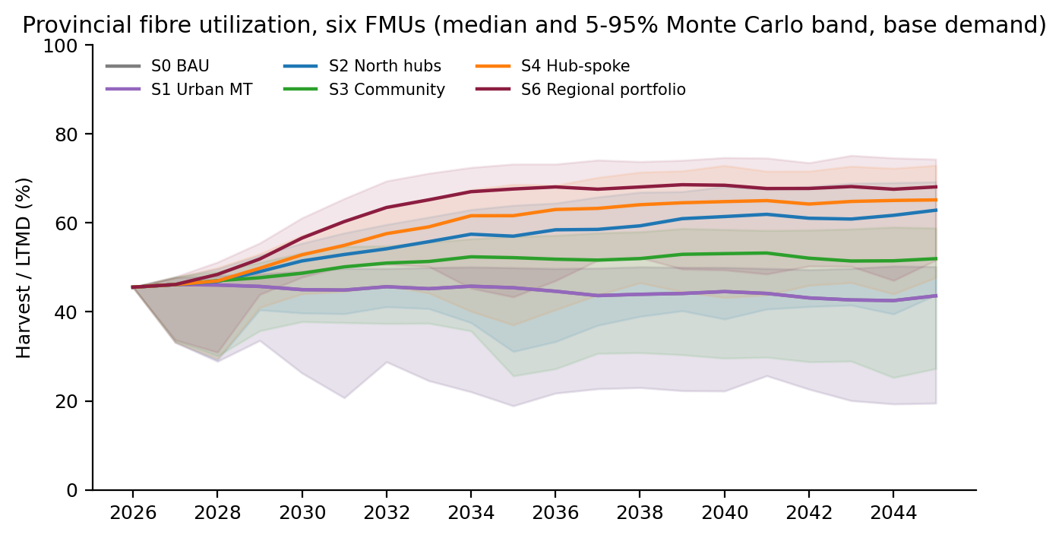
Figure 4. Provincial harvest divided by LTMD, 2026–2045, base demand. Medians and 5th–95th percentile bands from util_quantiles_base.csv. Strategies drawn: S0, S1, S2, S3, S4 and S6.
Figure 5 shows six of the provincial outcomes as means, with the same 5th to 95th percentile. Indigenous jobs are included here and are not a row in Table 12.
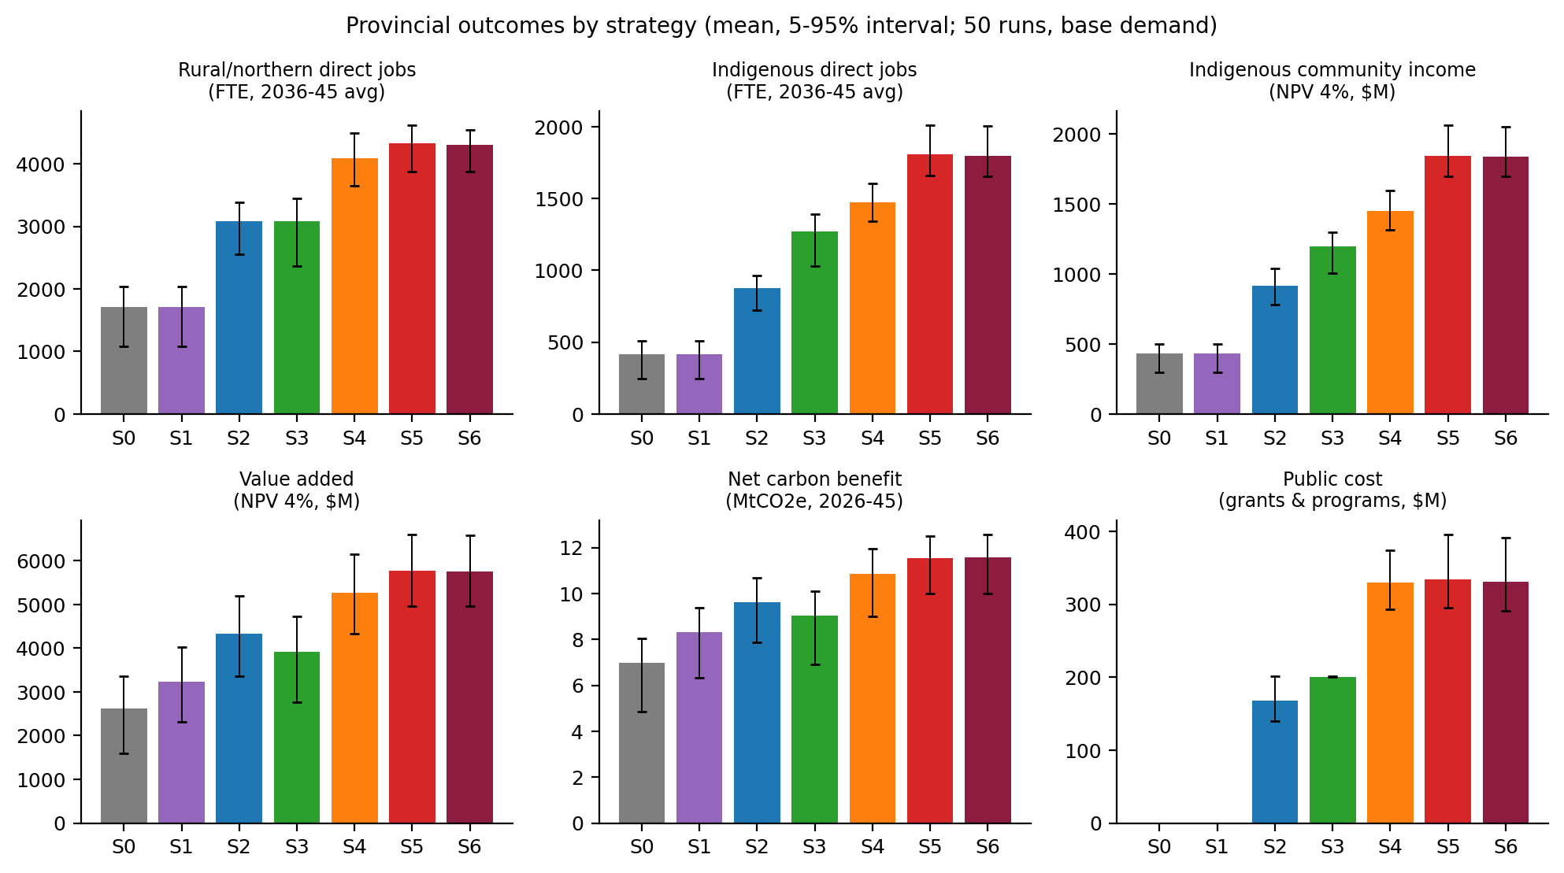
Figure 5. Provincial means under base demand, 50 runs, with the 5th to 95th percentile. Source: provincial_base.csv. The interval is the spread of the runs, not the standard error in Table 12.
Rank stability
Table 13 tests whether that order depends on the demand path or on one changed assumption at a time. S6 remains rank 1, and S5 rank 2, in every column. S0 is retained in the table so that the reference case is still visible when a price shock is severe. S1 and S2 never rank first, and they are omitted from the table for that reason only.
 | Low | Base | High | MT− | MT+ | Lum− | Cap+ | r=10% | Heat−
S6 | 1 | 1 | 1 | 1 | 1 | 1 | 1 | 1 | 1
S5 | 2 | 2 | 2 | 2 | 2 | 2 | 2 | 2 | 2
S4 | 3 | 3 | 3 | 3 | 4 | 3 | 3 | 3 | 3
S3 | 4 | 4 | 4 | 4 | 5 | 4 | 4 | 4 | 5
S0 | 7 | 7 | 7 | 6 | 7 | 7 | 7 | 7 | 7
Table 13. Equal-weight rank (1 = best). Column definitions are in the footnote above. Source: rank_robustness.csv.
Figure 6 is that ranking in full, together with the score behind it. Panel (a) is the weighted score under base demand. Panel (b) is the equal-weight rank in every demand path and every one-at-a-time change. S6 is 1 in every column, and S5 is 2. Figure 7 is the same three demand paths as levels, for utilization and for Indigenous income.
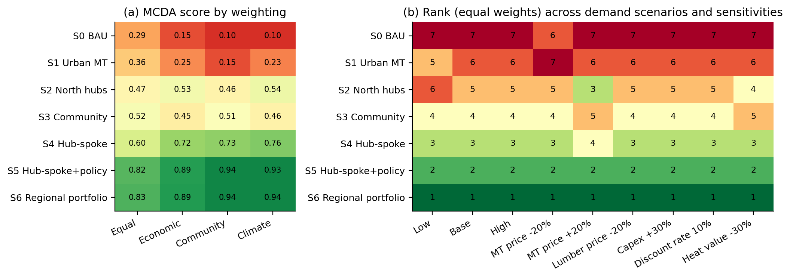
Figure 6. (a) Score of each package under base demand, on a scale from 0 to 1. The four columns use the same seven results and change only the weights: equal weight on each result, more weight on value added, more weight on Indigenous income and rural jobs, and more weight on carbon. (b) Rank of the same packages when the weights are equal. Rank 1 is best and rank 7 is worst. The columns change how fast mass-timber demand grows, or change one price or cost at a time. Green is better and red is worse. S6 is the best package in every column, and S5 is second.
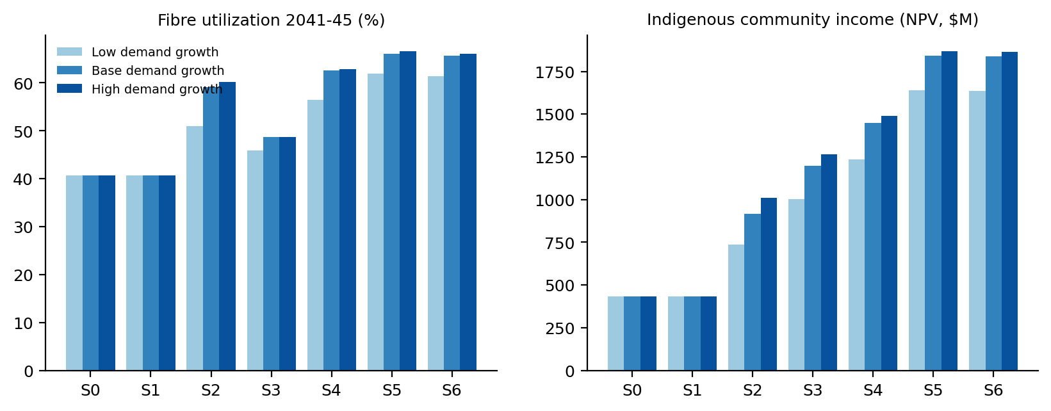
Figure 7. Mean utilization in 2041–2045 and mean Indigenous community income under mass-timber demand growth of 3%, 8% and 15% a year. Source: provincial_by_demand.csv. Bars are means, with no percentile band.

4.7 Regional results
The provincial 65.7% is not the same shift in every unit (Table 14). Abitibi and Trout Lake already use a larger share of their LTMD, and they still contribute the largest absolute gains in employment and income. Kenora and Algoma start from a much lower base and show the largest relative gains. The notes below are a reading of the S6 means. They are not a second scoring of the runs.
Figure 8 is utilization by unit for every strategy. The top row is simulated 2026 under S0, not the observed 2019–2024 harvest. The other rows are means for 2041–2045. The cells are rounded to the nearest percent; Table 14 uses the same late-period source. Trout Lake is 69% in the recent record and 61% in the S0 column of Table 14 because that column is 2041–2045, after harvest has drifted down with no new plants.
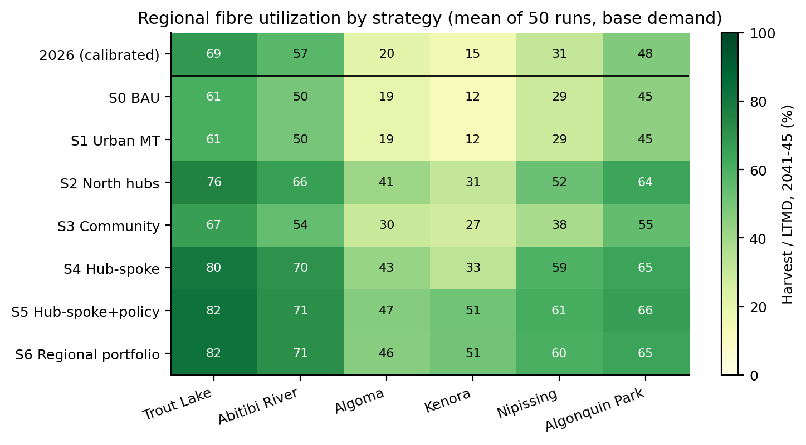
Figure 8. Utilization by unit. Top row: simulated 2026 under S0. Other rows: 2041–2045 means of 50 runs, base demand. Source: regional_base.csv.
FMU | S0 late | S6 late | Rural jobs S6 | Indig. income S0 | Indig. income S6 | What is built
Trout Lake | 61% | 82% | 842 | 164 | 380 | Hub, spokes, bioheat, pellet
Abitibi | 50% | 71% | 1,323 | 162 | 527 | Two hubs, spokes, bioheat, pellet
Nipissing | 29% | 60% | 652 | 31 | 272 | Hub and spokes; no pellet
Algoma | 19% | 46% | 467 | 19 | 210 | Hub and spokes; no pellet
Algonquin | 45% | 65% | 574 | 34 | 177 | Hub mean 0.88; spokes
Kenora | 12% | 51% | 441 | 21 | 272 | Spokes first; hub if offtake holds
Table 14. S0 against S6, base demand. S0 late and S6 late are harvest divided by LTMD in 2041–2045, not the FY2019–2024 rates in Table 2. Jobs are FTE. Indigenous income is million CAD, a present value at 4%, and includes wages, contractor margins and equity income accruing in the FMU. Algonquin's hub entry is the mean number of hubs operating in 2045, not a mill of a smaller size.
Figure 9 is the mean number of plants operating in 2045 under S6. Pellet mills appear only in Trout Lake and Abitibi. Kenora shows a hub in that mean. The phasing suggested below, spokes first and a hub only with a secured buyer, is a judgment. It is not a bar in the figure. Figure 10 compares Indigenous jobs and income for S0, S2, S3 and S6. S1, S4 and S5 are not drawn.
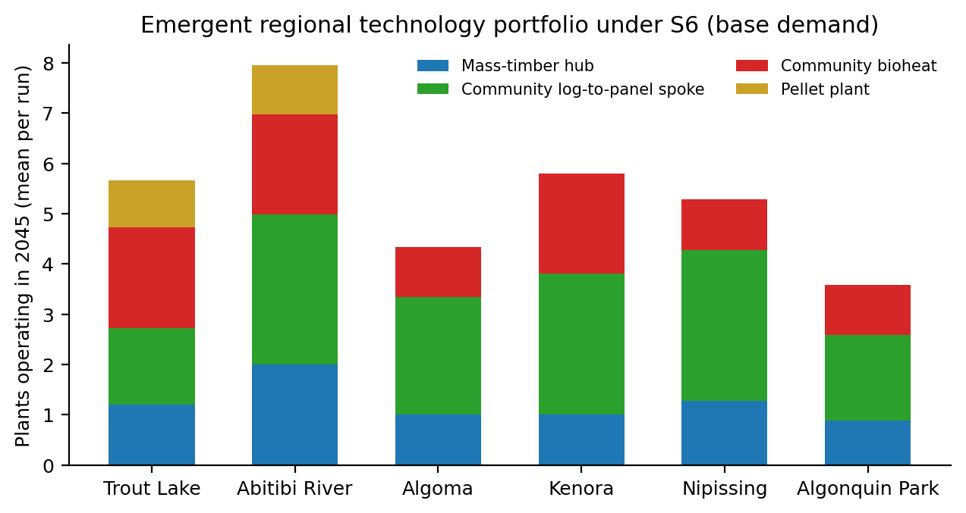
Figure 9. Mean number of plants operating in 2045 under S6, base demand. Source: regional_base.csv (n_mt_hub, n_spoke, n_bioheat, n_pellet).
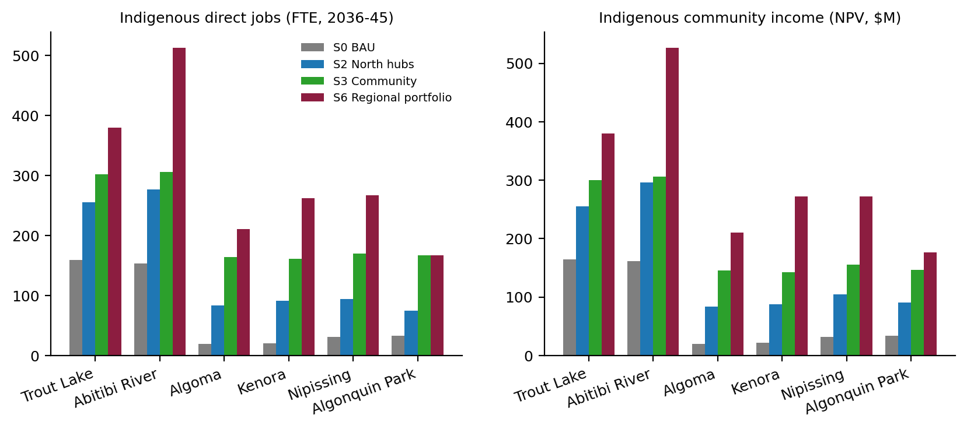
Figure 10. Indigenous direct jobs and Indigenous community income by unit for S0, S2, S3 and S6. Means of 50 runs, base demand. Source: regional_base.csv.
Abitibi River is the unit around which a construction sequence would be organized. It has the largest softwood surplus, two hubs in the mean outcome, and the largest Indigenous income ($527 million in present value). The pellet plant improves the result in this unit.
Trout Lake is the other unit in which the pellet mill is retained. At about 1,600 km from the Greater Toronto Area, southern panel sales are a weak reason to size the community mill. Bioheat and pellets account for more of the activity. Utilization rises from 61% to 82%, but from a harvest that was already relatively high.
Nipissing and Algoma are the units in which a hub together with community mills changes the harvest path. Utilization roughly doubles from a low base, and neither unit retains a pellet mill. Nipissing is closer to southern markets, which is visible in the uptake of panels and of the hub. Algoma moves in the same direction, by a smaller amount.
Kenora is the result that should be treated with the most caution if it is read as a construction program. Utilization rises from 12% to 51%, and Indigenous income from $21 million to $272 million in present value, the largest proportional community gain in the set. 6.9% of new plants in Kenora still lose money under S6, against 0.5% in Abitibi. The appropriate reading is therefore to phase Indigenous-majority community mills against regional and Prairie housing demand, and to treat the hub as conditional on secured offtake.
Algonquin Park has a mean of 0.88 hubs operating in 2045, so some runs build one and some do not. The hub, when it is built, is the same 150,000 m³ mill used in the other units. The mean number of community mills is 1.7. The remaining limit is species. Late-period harvest under S6 is still dominated by the softwood the hubs can saw. Poplar and tolerant hardwood, which account for much of Algonquin and for a large share of unused LTMD in several units, barely increase under any strategy. No hardwood or poplar product (hardwood glulam, poplar OSB or LVL) was included. S6 should not be described as a hardwood strategy. Figure 11 is that comparison for softwood, poplar and hardwood.
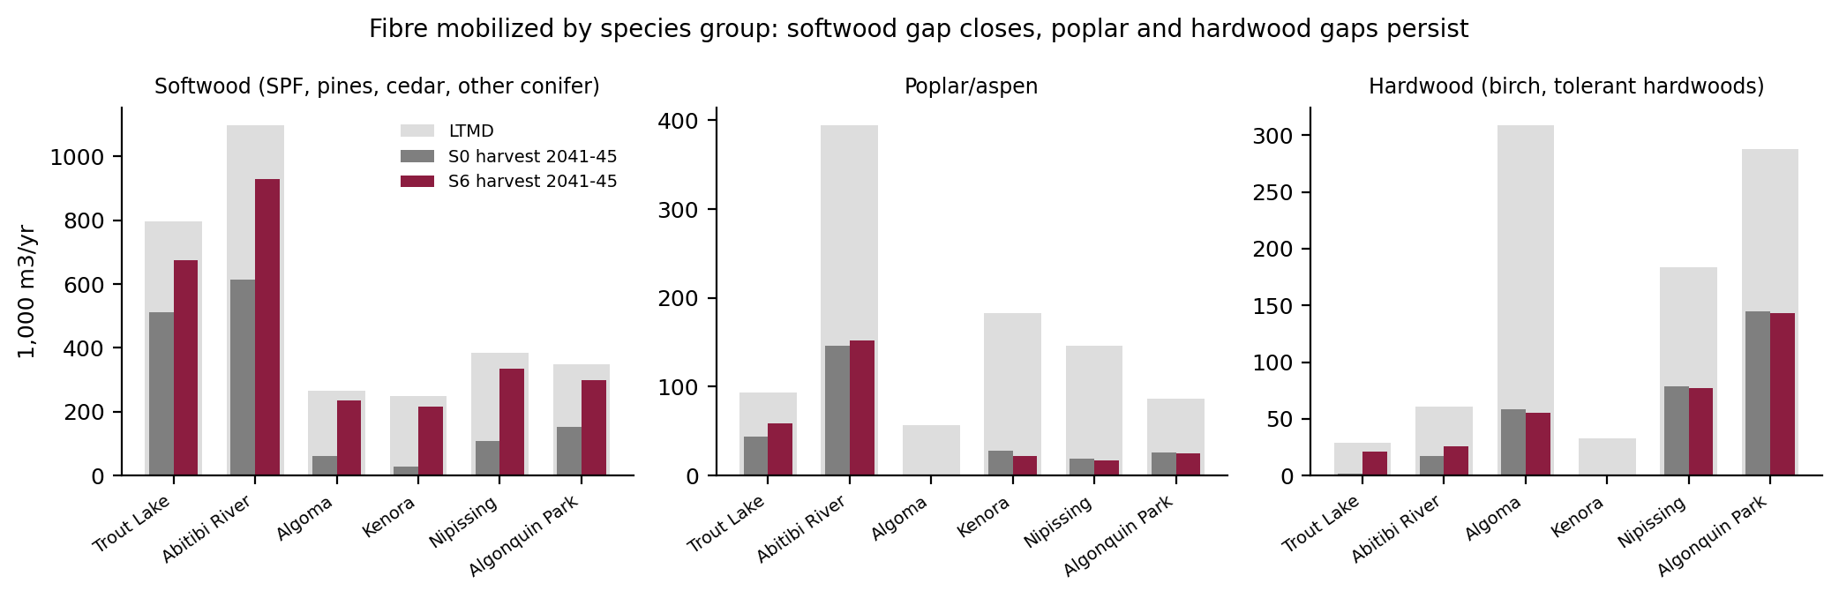
Figure 11. Harvest in 2041–2045 under S0 and S6, set against long-term managed volume, for softwood, poplar and hardwood. Source: regional_base.csv and the ARWoodS calibration table. The softwood gap narrows. The poplar and hardwood gaps do not.
The same runs support three further readings. None of them is a new case. Each is a view of the simulations already reported, of the kind used to test an agent-based result before it is treated as a management direction.
Figure 12 asks what the public cost buys. The cost on this figure is the undiscounted sum, not a present value. Southern plants sit on the same point as no new plants: no public cost, and no gain in harvest or in Indigenous income. Community plants alone cost $201 million on the rounded total. They raise Indigenous income to $1,196 million and leave harvest at 48.7%. The recommended package costs $331 million on the rounded total. At that cost, harvest is 65.7% and Indigenous income is $1,838 million. Offering pellet mills in the other four units raises the unrounded public-cost mean by $3.5 million and does not raise either outcome. The harvest gain and the income gain are not bought by the same package. Community plants buy income. The large mills, added to those plants, buy harvest.
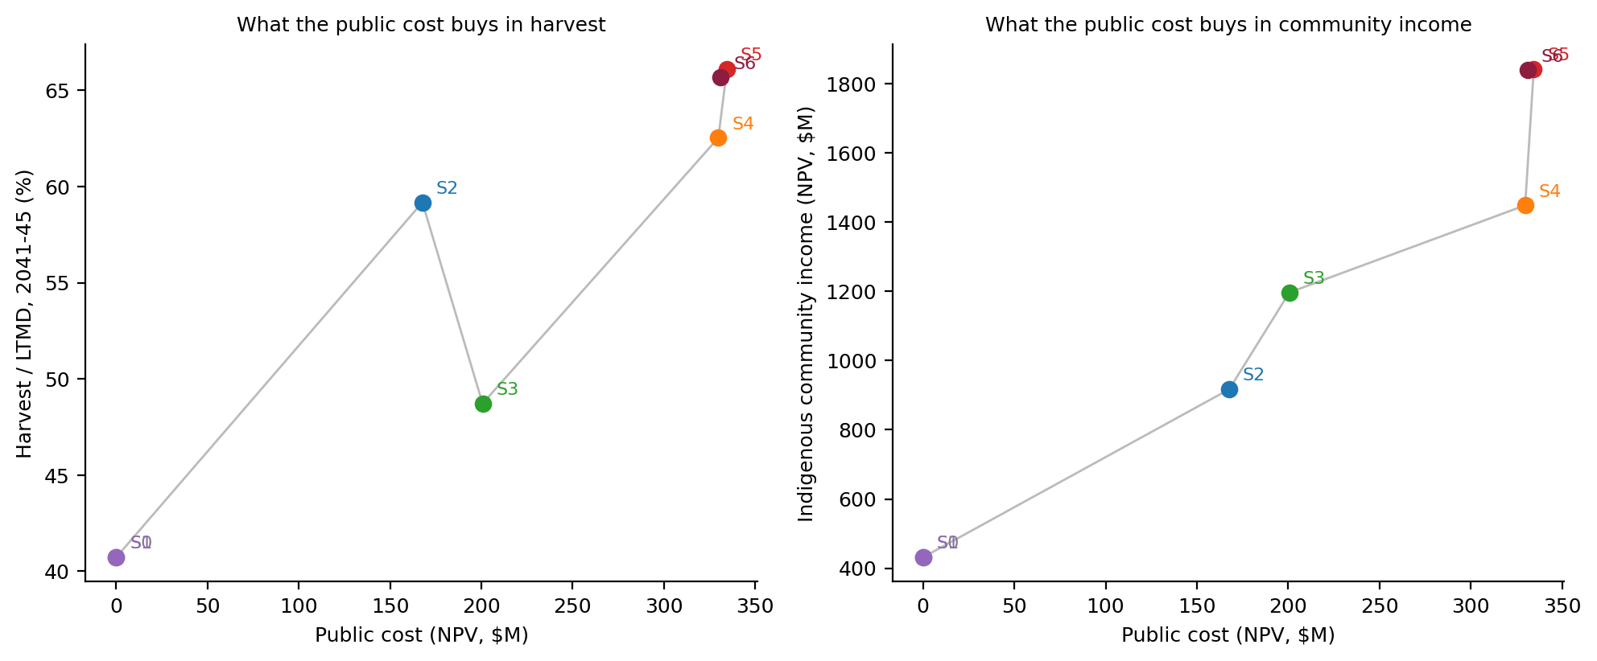
Figure 12. Public cost against late-period harvest and against Indigenous community income. Each point is the mean of 50 base-demand runs. Source: provincial_base.csv. S0 and S1 coincide. S6 lies next to S5 at a slightly lower cost.
Figure 13 follows the three species groups through every year of the simulation. No new plants and the recommended package start at the same 2026 harvest. Over 2041 to 2045, softwood use rises from 47% of planned softwood volume to 86%. Poplar stays near 27% under no new plants and 29% under the package. Hardwood stays near 33% and 36%. The package is a softwood strategy. It does not create a market for the unused poplar and hardwood in Table 2.
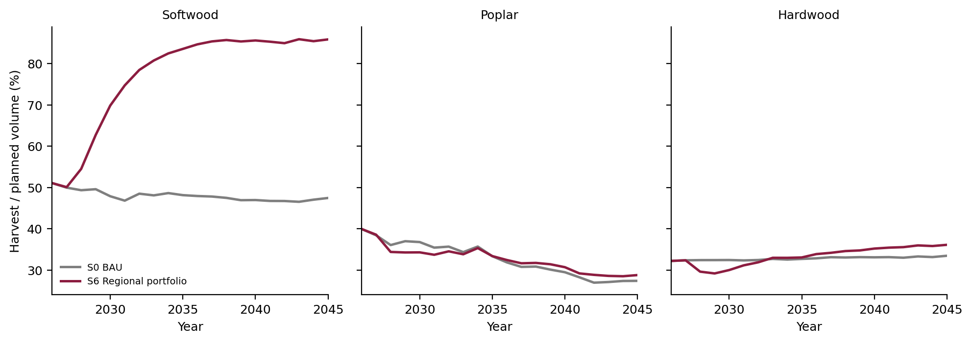
Figure 13. Harvest divided by planned volume, by species group and year, Ontario total of the six units. Means of the 50 base-demand runs. Source: timeseries_base_mean.csv. Both strategies start together in 2026. Only softwood diverges.
Figure 14 is why the harvest path does not rise in the first year. Under the recommended package, no new plant is operating in 2026. Construction follows the two-year lag, and then a ramp. By 2030 the mean across the 50 runs is about 5 large mills, 8 community mills, 7 heat plants and 1 pellet mill. By 2045 it is about 7 large mills, 14 community mills, 9 heat plants and 2 pellet mills. That count is an average of runs in which some plants are not built. It is not a list of mills to approve.
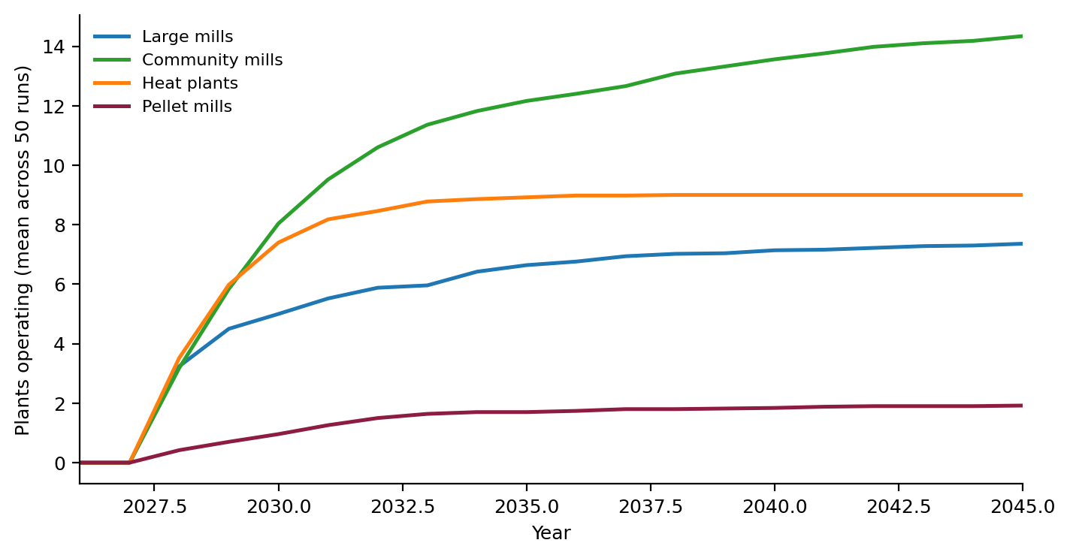
Figure 14. Plants operating under the recommended package, summed across the six units. Mean of 50 base-demand runs. Source: timeseries_base_mean.csv. No new plant is operating in 2026.
Figure 15 asks whether the harvest gain depends on one assumption. Each line is a separate set of 30 runs. The grey point is no new plants. The coloured point is the recommended package. In five of the six cases the two points stay near 40% and 65%. A 20% lower lumber price is the case that moves the level: harvest is 21% with no new plants and 52% with the package. The package still cuts more wood than doing nothing. It does not protect the six units from a lumber-price collapse. These levels come from the 30-run checks, not from the 50-run base in Table 12, which is why the no-new-plants point here is 40.2% rather than 40.7%.
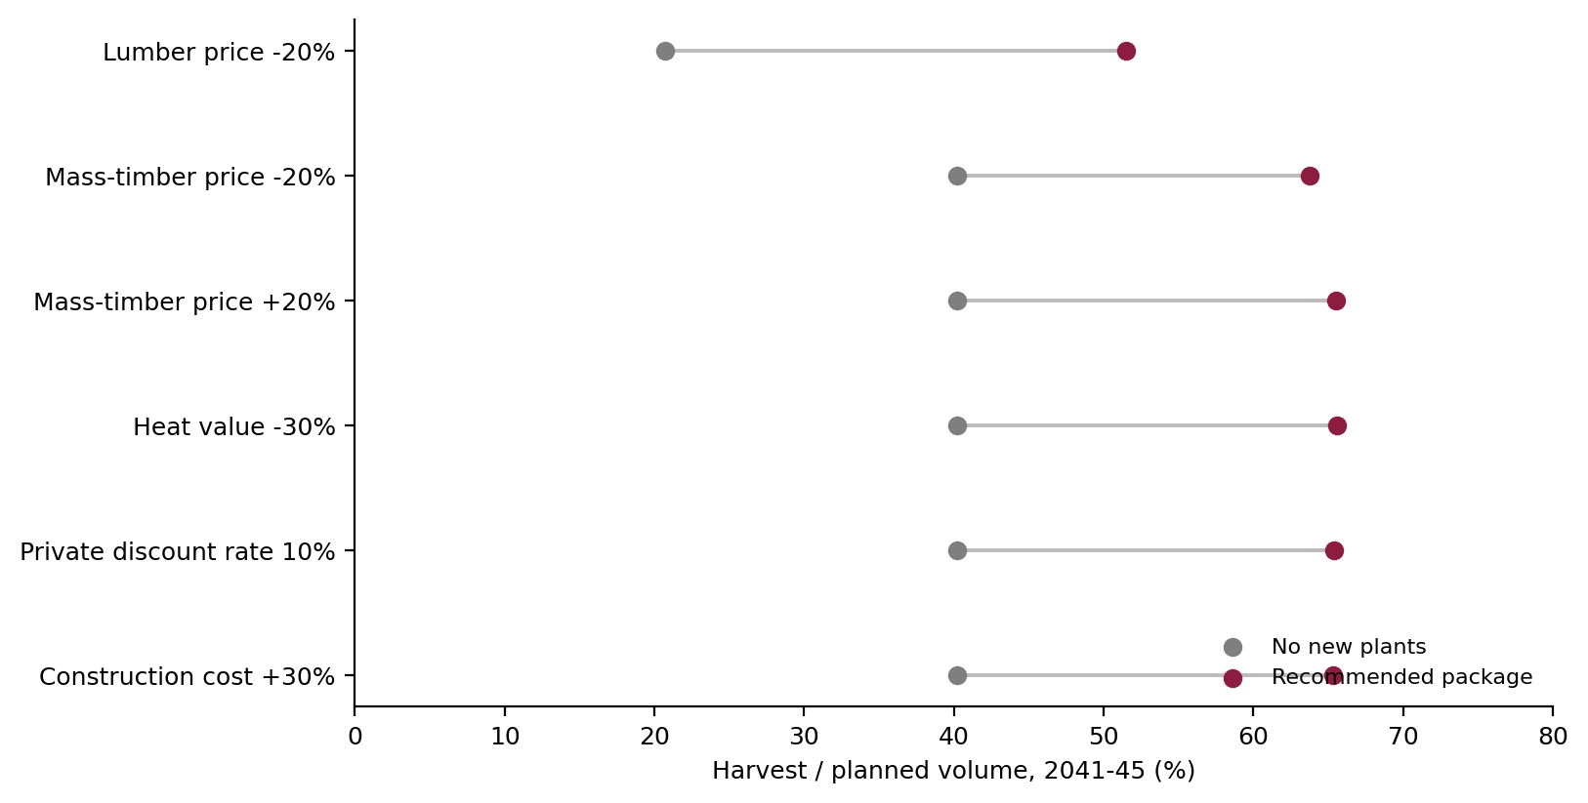
Figure 15. Late-period harvest under no new plants and under the recommended package, for each one-at-a-time change. Means of 30 runs. Source: sensitivity_ontario.csv. The lumber-price case lowers both points. The other five leave them near the base-demand result.
Recommendation
The package to take forward is S6. Community panel mills and bioheat in every unit. A hub in Trout Lake, Abitibi, Nipissing, Algoma and Algonquin. In Kenora the runs build a hub on average, and 6.9% of new plants there still lose money, against 0.5% in Abitibi, so the Kenora hub is conditional on a secured buyer and the community mills come first. That phasing is a judgment about the Kenora result. It is not a separate strategy the model was told to run. In every unit, the four rules together: Indigenous applicants served first when wood is short, contractor training, public buyers taking 25% more mass timber and panels, and $50 per tonne of CO₂ avoided by wood heat. The runs do not say which of those four rules does the work. Pellet mills only in Trout Lake and Abitibi. S5 is the same package with pellet mills still offered in the other four units. It ranks second in every column of Table 13. Figure 12 is the reason to prefer the combined package to community plants alone: the added cost is what raises harvest, not only income. Figure 13 limits that claim to softwood. Figure 14 shows that the plants are not operating in 2026. Figure 15 shows that a lower lumber price lowers harvest under this package and under no new plants alike.
Southern plants alone raise value added and do not raise harvest. A hub alone raises harvest and leaves most of the Indigenous income gain unrealized. Community plants alone do the reverse. The regional paragraphs above say where the package shows up. They are not a second ranking.

4.8 Limitations
These totals refer to six units, not to Ontario as a whole. Logs stay inside the unit that cut them: there is no trade in logs between units, and no Manitoba or export market for Kenora and Trout Lake. No poplar or hardwood engineered-wood product is included. S6 is the best of the packages that were run. It is not the best package that could be designed, and the four rules in S5 were not tested separately. Under S6 the mean number of new plants is about 33. The 5th to 95th percentile is 28 to 38, because construction occurs with a probability rather than as a fixed program. The figure is not a capital plan. The Kenora hub in that average is not, by itself, a reason to build one. Algonquin's mean of 0.88 hubs is not a smaller mill. Northern housing need, heat demand, product prices, equity shares, the starting Indigenous contractor shares, and the 0.40 logging jobs per 1,000 m³ are model settings, not ministry measurements. Public cost is an undiscounted sum and is not comparable, dollar for dollar, with the present value of Indigenous income. A 30% lower value of heat did not change the ranking, but it would change the dollar results. The carbon account includes carbon stored in products, heating oil displaced by wood heat, and emissions from processing, freight and harvest. It excludes carbon in the standing forest, and it excludes any concrete or steel displaced by mass timber.
Code, data and scripts
GitHub repository Full shareable package (report, GAMS, ABM, scripts, derived data, figures, appendix): https://github.com/yassirelfahli/forbiom-on.
Key code gams/SA15.gms and gams/FORBIOM_ON.gms in the repository (also mirrored on Google Drive).
Data Derived CSV calibration and result tables are in abm/calibration/, abm/results/ and data/gams_outputs/. Raw FRI geodatabases and large GDX binaries are omitted; CRIBE ArcGIS, GeoHub stocks and Plonski yield tables remain with their providers.
Scripts Python FRI processing, mapping and the DOCX builder are under scripts/ (Drive mirror).
Appendix See Appendix A below and docs/APPENDIX.md in the repository for the file map and reproduction notes. Extended ABM docs are in docs/.

A Repository
The public repository that accompanies this report is at https://github.com/yassirelfahli/forbiom-on. It holds the model code, the derived tables and the report. It does not hold the raw MNR extracts, the inventory geodatabases, or working files from the project archive.
Contents
Path | Contents
report/ | Preliminary-results DOCX and PDF
gams/ | SA15.gms, FORBIOM_ON.gms, eFAR bridge scripts
abm/ | FORBIOM-ABM Python modules, calibration CSVs, summary tables
scripts/ | FRI processing, report builder, mapping utilities
data/ | Model-ready eFAR bridge CSVs and GAMS summary outputs
figures/ | PNG figures used in this report
docs/ | Appendix guide and extended ABM DOCX reports
README.md | Overview, quick start and citation

■ Status flags: FRI biomass coefficients and several logistics capacities remain provisional. Parameters marked Assumption or To validate are listed in Section 4.4. The limits of the runs are in Section 4.8.
Citation
Yousefpour, R. & Elfahli, Y. (2026). Biomass Utilization Strategies for Ontario: Plants, Harvest, Jobs and Indigenous Income, 2026–2045 (FORBIOM-ON preliminary results). The two models are run separately; the recommendation is from the agent-based model, FORBIOM-ABM. Code and data package: https://github.com/yassirelfahli/forbiom-on.

This figure is the mean across 50 base-demand runs of the recommended package, S6
ARWoodS, Ontario MNR, 2025 update. The six units are the study set, not a sample of all forest management units.
Both models use the same study sample of six units, the same harvest cost and the same mass-timber conversion ratios. The agent model is set so that its first year reproduces the recent harvest above. The later years are then a consequence of the decisions, not a second copy of the historical record.
Mill capacity is set so that desired intake in the first year equals the mill's share of observed harvest: Cap = s · H / σ(4 · (v − w) / w + 1), where s is the mill's share, H is observed harvest of that fibre, v is willingness to pay, w is the initial log price, and σ is the response in Section 4.2.
Demand starts at 165,000 m³ of mass timber in 2026 and grows 8%/yr. Income and value added are present values at 4%/yr. Public cost is not discounted. The 51–74% band is the 5th to 95th percentile of utilization across the 50 S6 runs. The share of plants losing money is among new plants. S0 has none, so that share is zero.
Low, base and high are mass-timber demand growth of 3%, 8% and 15%/yr. Other columns change one assumption: mass-timber price ±20%, lumber price −20%, construction cost +30%, private discount rate 10%, heat value −30%.
Road distance is great-circle distance × 1.3. Trout Lake is about 1,610 km from the GTA; Algonquin about 310 km.
Kenora 6.9% of new plants lose money under S6; Abitibi 0.5%. The phasing is our judgment, not a rule inside the model.
Carbon factors are in Section 4.4. These figures are not a life-cycle result.

