ACTIVITY 3 DELIVERABLE: ABM SIMULATION REPORT
Agent-Based Modelling of Forest Biomass Utilization Strategies across Ontario's Regions, with a Focus on Indigenous and Rural Communities
Results from FORBIOM-ABM, the agent-based companion to the FORBIOM-ON forest value-chain model

Project: Optimizing Biomass-Based Modular Mass Timber Housing for Affordable Construction in Ontario Using Agent-Based Modeling
Ontario Transfer Payment Agreement, Ministry of Natural Resources (Schedule "C", Activity 3)

Forest Economy and Decision Support Systems (FEDSS) Lab
Bioeconomy and Sustainable Materials Institute (BSMI)
Institute of Forestry and Conservation, University of Toronto
Rasoul Yousefpour, Ph.D. (Principal Investigator)
Yasser Elfahli, M.A.
October 2026

Acknowledgement and disclaimer. This project is supported by the Government of Ontario through the Ministry of Natural Resources. The views expressed in this report are the views of the authors and do not necessarily reflect those of the Province.

Executive summary
The six Forest Management Units (FMUs) represented in FORBIOM-ON (Trout Lake, Abitibi River, Algoma, Kenora, Nipissing and Algonquin Park) harvested on average 2.28 million m3 per year in 2019-2024, against a long-term managed directional volume (LTMD) of 5.00 million m3 per year (ARWoodS 2025). About 2.72 million m3 per year (54%) of sustainably available fibre is therefore unused, of which 1.54 million m3 is softwood, 0.58 million m3 poplar and 0.61 million m3 hardwood. Utilization ranges from 15% in Kenora and 20% in Algoma to 69% in Trout Lake.
Activity 3 developed and applied FORBIOM-ABM, an agent-based model in which FMU managers, harvest contractors (Indigenous-owned and other), incumbent mills, prospective investors in new processing capacity, product and heat markets, and a policy agent interact every year from 2026 to 2045. Unlike the optimization in FORBIOM-ON (Activity 2), the ABM does not assume a central planner: investment, harvest and exit decisions emerge from heterogeneous agents with bounded rationality, adaptive price expectations and imperfect foresight. The model is calibrated to observed FMU harvest by species group (start-year error below 1.4% in every FMU) and to eFAR employment intensities. Seven biomass utilization strategies were simulated with 50 Monte Carlo replications each, under three mass-timber demand trajectories and six sensitivity cases, and compared with a seven-criterion multi-criteria decision analysis (MCDA).
Key findings
- The optimal strategy is a regionally differentiated hub-and-spoke portfolio (S6) backed by an enabling policy package. It ranks first under base, low and high demand, under all six sensitivity cases, and under all four MCDA weightings (economic, community, climate and equal priority). It is practically tied with the province-wide version of the same policy package (S5) but reaches the same outcomes with fewer plants, lower public cost and lower investment risk. Relative to business as usual it raises fibre utilization in 2041-45 from 41% to 66% (90% interval 51%-74%), mobilizing an additional 18.4 million m3 over 2026-2045.
- The portfolio has four components: (i) one or two integrated log-to-mass-timber hubs per FMU, which add the sawmilling capacity that unlocks softwood; (ii) community-scale log-to-panel plants ("spokes") with majority Indigenous ownership serving northern housing and southern prefab markets; (iii) community bioheat plants using mill and forest residues; and (iv) pellet plants in Abitibi River and Trout Lake only.
- Indigenous and rural outcomes improve most under this portfolio. Direct rural and northern jobs rise from 1,709 to 4,299 FTE, Indigenous direct jobs from 415 to 1,799 FTE, and Indigenous community income (wages, contractor margins and equity returns, NPV at 4%) from $431 M to $1,838 M.
- The public cost has high leverage. The portfolio costs about $331 M in capital grants and capacity-building programs over 20 years and adds $3,133 M in value added (NPV), about $9.5 per public dollar. The net carbon benefit rises from 7.0 to 11.6 MtCO2e.
- Enabling policy matters as much as technology. Adding Indigenous fibre-allocation priority, contractor capacity-building, public procurement of mass timber and panels, and a clean-heat incentive (S4 to S5) raises Indigenous community income by $394 M. It also cuts the share of new plants that lose money from 9% to 2%, for less than $5 M of extra public cost.
- Mass-timber plants near Toronto (S1) add value added (+$621 M) but do nothing for biomass utilization, rural jobs or Indigenous communities, because they process lumber the existing mills already produce. Northern hubs alone (S2) mobilize fibre but deliver half the Indigenous benefit of the hybrid. The community network alone (S3) delivers substantial Indigenous benefit at low public cost but leaves most softwood unused.
- Poplar and hardwood remain underused under every strategy. In 2041-45 the portfolio harvests about 276 thousand m3/yr of poplar and 323 thousand m3/yr of hardwood, against LTMDs of 959 and 902 thousand m3/yr. Closing this gap requires an additional product pathway, such as poplar OSB/LVL or hardwood glulam/CLT, which Activity 6 should assess.
Region-specific optimal strategies (Section 6) differ in the scale and mix of technologies the agents adopt:
- Abitibi River: anchor hub region (two hubs, three spokes, bioheat, one pellet plant). It has the largest softwood surplus and the largest absolute gains.
- Nipissing and Algoma: early hub plus a full spoke network. These regions are close to southern markets, and utilization roughly doubles from a low base.
- Trout Lake: hub plus residue-based bioheat and pellets. Remote communities give the highest bioheat value; spokes are sized to northern housing demand.
- Kenora: the largest relative gain (15% to about 50% utilization) and the highest Indigenous share of benefits, but also the highest investment risk because of the distance to southern markets. Phase in Indigenous-led spokes tied to regional and Prairie housing demand, and make the hub conditional on secured offtake.
- Algonquin Park: one hub and a smaller spoke network. Its hardwood-dominated supply needs a hardwood product pathway to go further.

1. Introduction and objectives
Ontario's Crown forests can sustainably supply far more fibre than is currently harvested. In the six FMUs used as the study regions of this project, about half of the long-term managed volume is unused, and the shortfall is greatest in Kenora, Algoma and Nipissing, where processing capacity has contracted since the mid-2000s. At the same time, Ontario's housing targets and growing interest in prefabricated and panelized construction create new demand for mass timber (CLT, glulam) and wood-based building components.
Schedule "C" of the Agreement describes Activity 3 as: "Undertake ABM simulation identifying optimal biomass utilization strategies across Ontario's regions, with a focus on Indigenous and rural communities", with the milestone "ABM simulation reports identifying resulting optimal biomass utilization strategies". This report is that deliverable. It builds directly on:
- Activity 1 (supply chain feasibility): sourcing locations, logistics and material flows. The ABM uses the same FMU regions and species groups as the supply chain analysis.
- Activity 2 (processing optimization): FORBIOM-ON, a spatial multi-commodity NLP model in GAMS. The ABM uses the same six regions, the CLT/glulam lumber-input ratios (1.20 and 1.10 m3 lumber per m3), the harvest-cost basis ($38/m3), the carbon storage and process-emission factors, and the baseline mass-timber demand caps (about 165,000 m3/yr across the six regions).
FORBIOM-ON identifies the system-optimal allocation of fibre, processing and trade for a single decision-maker. Real outcomes depend on many independent actors (licensees, contractors, First Nations development corporations, municipalities, investors) who decide under uncertainty and with different objectives and capacities. Agent-based modelling (ABM) is the standard tool for representing such decentralized, adaptive behaviour and for testing whether strategies that look optimal on paper are reachable, robust and fair in practice. The objectives of Activity 3 were to:
- represent the main actors of Ontario's forest biomass value chain as heterogeneous, interacting agents;
- calibrate the model to observed harvest, fibre supply and employment in the six FMU regions;
- simulate alternative biomass utilization strategies, combining technology options and policy instruments, under market uncertainty;
- evaluate the strategies against economic, social (rural and Indigenous), environmental and fiscal criteria; and
- identify the optimal strategy for each region, with explicit attention to Indigenous and rural communities.

2. Model description (ODD protocol)
The model is described following the Overview, Design concepts and Details (ODD) protocol for agent-based models (Grimm et al., 2020). The full source code is provided with this report (Appendix B).

2.1 Purpose and patterns
FORBIOM-ABM evaluates how alternative combinations of processing technologies and policies change biomass utilization, regional economic activity, Indigenous and rural benefits, carbon outcomes and investment risk across six Ontario FMU regions. The model is designed to reproduce three observed patterns: (i) current FMU-level harvest well below LTMD, with large differences between regions; (ii) persistent under-utilization of poplar and hardwood relative to softwood; and (iii) the cyclical sensitivity of harvest to lumber prices, including mill curtailment and closure after sustained losses.
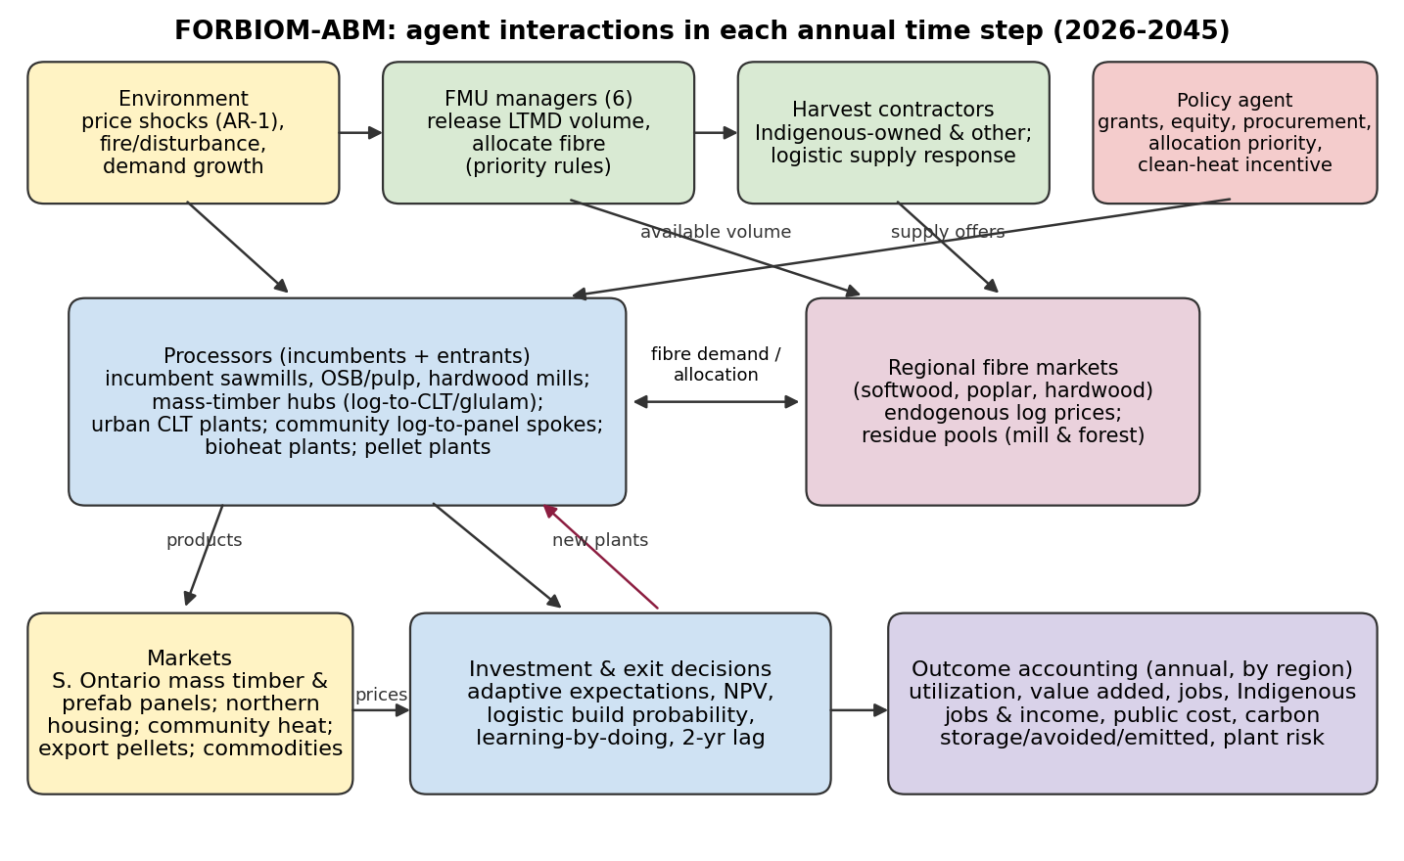
Figure 1. Agent types and interactions in FORBIOM-ABM. Each annual time step runs from environment and policy signals through fibre and product markets to investment, exit and outcome accounting.

2.2 Entities, state variables and scales
Table 1. Agents and entities in FORBIOM-ABM.
Agent / entity | Key state variables | Behaviour
FMU manager (6) | LTMD by species group (SW, PO, HW); available volume after disturbance; allocation rules | Releases sustainable volume; allocates fibre to licence holders, then entrants (Indigenous-majority entrants first under the priority policy)
Harvest contractor (10 per FMU initially) | Capacity (m3/yr), cost multiplier, Indigenous ownership, sales, margin | Offers volume via a logistic response to log price relative to own cost; expands capacity when fully used and profitable
Incumbent mill (3 per FMU x species group) | Capacity calibrated to observed harvest, cost multiplier, consecutive loss years | Sets utilization from expected margin; exits after 3 loss years (probability 0.4)
Mass-timber hub (entrant) | 150,000 m3/yr log intake; 60,000 m3/yr CLT/glulam; capex $150 M; Indigenous equity | Integrated sawmill + CLT/glulam line; sells mass timber to southern Ontario, surplus lumber to commodity markets
Urban CLT plant (entrant, GTA) | 60,000 m3/yr; capex $100 M; buys lumber from the north | Converts purchased lumber; does not add harvest
Community log-to-panel spoke (entrant) | 25,000 m3/yr logs; 10,000 m3/yr panels; capex $25 M; Indigenous equity | Small sawmill + prefab panel line; serves northern community housing first, then southern prefab demand
Community bioheat (entrant) | 5,000 odt/yr; capex $12 M | Displaces heating oil/propane; residues first, then low-grade roundwood
Pellet plant (entrant) | 80,000 odt/yr; capex $50 M | Export pellets via Thunder Bay or Montreal
Markets | Price paths with AR(1) shocks; demand caps | Southern mass timber and panels (price-clearing), northern housing, heat demand, commodities
Policy agent | Grants, equity rules, allocation priority, capacity building, procurement, clean-heat incentive | Defined by the strategy (Section 4)

Spatial scale: six FMU regions plus a Greater Toronto Area (GTA) market/processing node. Road distances are approximated from FMU centroids (great-circle distance x 1.3 circuity), e.g. Trout Lake 1,608 km, Abitibi River 825 km, Algoma 649 km, Kenora 1,725 km, Nipissing 420 km, Algonquin Park 308 km to the GTA. Temporal scale: annual steps, 2026-2045. Monetary values are 2026 Canadian dollars (real).

2.3 Process overview and scheduling
- Environment: draw correlated price shocks (lumber, OSB, mass timber, panels, pellets, heating fuel) and FMU disturbance (fire/blowdown probability 6%/yr, 10-30% volume loss).
- FMU managers release available volume by species group.
- Processors form desired roundwood intake from expected margins (logistic utilization rule).
- Contractors offer volume (logistic supply rule); regional fibre markets allocate volume by priority and update log prices in proportion to excess demand.
- Production, residues and product sales: southern mass-timber and panel prices clear against demand (elasticity 1.5); spokes serve local housing first; bioheat and pellet plants use mill surplus residues, then forest residues, then low-grade roundwood.
- Accounting: profits after capital charges, jobs, Indigenous jobs and income, carbon, public cost.
- Investment: potential entrants evaluate NPV with adaptive expectations, fibre and market headroom, learning-adjusted capex and grants; build with a logistic probability; plants come online after two years with a 50%/80% ramp-up.
- Exit and contractor dynamics; agents update price expectations.

2.4 Design concepts
- Emergence: regional technology portfolios, log prices, fibre utilization, plant failures and the distribution of benefits emerge from agent interactions; none are imposed.
- Adaptation and objectives: firms maximize expected profit under bounded rationality, using logistic (sigmoid) decision rules that translate margins into utilization, supply or investment probabilities. This is the behavioural harvest rule proposed in the March 2026 preliminary report, sigma(z) = 1/(1+exp(-k(z-z0))).
- Prediction and learning: adaptive expectations (smoothing weight 0.3) for prices; learning-by-doing reduces capex by 10% per doubling of plants built.
- Sensing: agents observe last-period regional log prices, product prices, demand headroom and uncommitted fibre in their FMU.
- Interaction: indirect, through regional fibre markets (shared contractors, shared LTMD) and product markets (shared southern demand); direct, through FMU allocation priority.
- Stochasticity: price shocks, disturbance, agent heterogeneity and discrete investment/exit decisions. Strategies are compared with common random numbers (identical environment draws and decision-keyed random numbers).
- Observation: annual regional indicators and plant-level outcomes (Section 4.3).

2.5 Key submodels
Contractor supply. Contractor i offers q_i = K_i x e_f x sigma(12 x (w_rf - c_irf)/c_irf + 1), where K_i is capacity, e_f the share of effort to species group f (proportional to buyer demand), w_rf the regional log price and c_irf the delivered cost (harvest $38/m3 x regional access factor x agent multiplier, plus in-region haul and stumpage).
Mill utilization. Plant j demands D_jf = Cap_j x sigma(4 x (v_jf - E[w_rf])/E[w_rf] + 1), where v_jf is the plant's willingness to pay per m3 (net product value after conversion cost and product freight, including residue value).
Fibre market. Allocated volume is min(D, S, available LTMD). Licence holders are served before entrants; under the Indigenous-priority policy, Indigenous-majority entrants and Indigenous contractors are served first. The log price adjusts by 30% of the relative excess demand each year, bounded by contractor cost and the highest willingness to pay.
Investment. Expected annual margin (at 90% of capacity, with market-share and fibre-headroom checks) gives NPV = margin x annuity(8%, 20 yr) - capex x (1 - grant) x learning factor. The build probability is 0.6 x sigma(5 x NPV/net capex - 1), with at most two hubs, three spokes, four bioheat plants and one pellet plant per region.
Indigenous accounting. Indigenous income is the sum of (i) wages of Indigenous workers (regional Indigenous labour share; 60% local hiring at Indigenous-majority plants; +15 percentage points at partnership plants; 80% at Indigenous-owned contractors), (ii) margins of Indigenous-owned contractors and (iii) the equity share of plant profits after capital charges. Equity losses are counted, so Indigenous investors carry downside risk in the model.
Carbon accounting. Net benefit = carbon stored in products (FORBIOM-ON factors) + fossil emissions avoided by bioheat (1.23 tCO2e/odt replacing heating oil) - process, freight and harvest emissions. Biogenic emissions from bioheat are treated as carbon-neutral at the point of combustion, following energy-sector reporting conventions. Full life-cycle and substitution effects are part of Activity 4.

3. Data and calibration
FMU-level supply and harvest were taken from the ARWoodS 2025 extract (merchantable volume, fiscal years 2019-2024). Species groups were aggregated into softwood (SPF, white/red pine, other conifer, cedar), poplar (PO) and hardwood (white birch, tolerant hardwoods). Employment intensities come from the eFAR summary (2020-2022): bioproduct 1.22; composite 0.36; pulp 2.47; sawmill 0.36 direct facility jobs per 1,000 m3 of roundwood consumed. Prices, costs and technology parameters are listed with their basis in Appendix A.
Table 2. Fibre supply, observed harvest and calibration check by FMU (ARWoodS 2025; simulated values are the mean of 50 business-as-usual runs).
FMU | LTMD (1,000 m3/yr) | Harvest 2019-24 (1,000 m3/yr) | Utilization | Unused SW | Unused PO | Unused HW | Simulated 2026 (1,000 m3) | Error
Trout Lake | 918 | 632 | 69% | 236 | 24 | 27 | 631 | -0.1%
Abitibi River | 1,552 | 884 | 57% | 439 | 185 | 44 | 884 | +0.0%
Algoma | 632 | 127 | 20% | 198 | 55 | 252 | 127 | +0.0%
Kenora | 465 | 70 | 15% | 219 | 145 | 32 | 69 | -1.4%
Nipissing | 713 | 222 | 31% | 264 | 120 | 107 | 222 | +0.0%
Algonquin Park | 722 | 346 | 48% | 181 | 47 | 148 | 346 | +0.0%

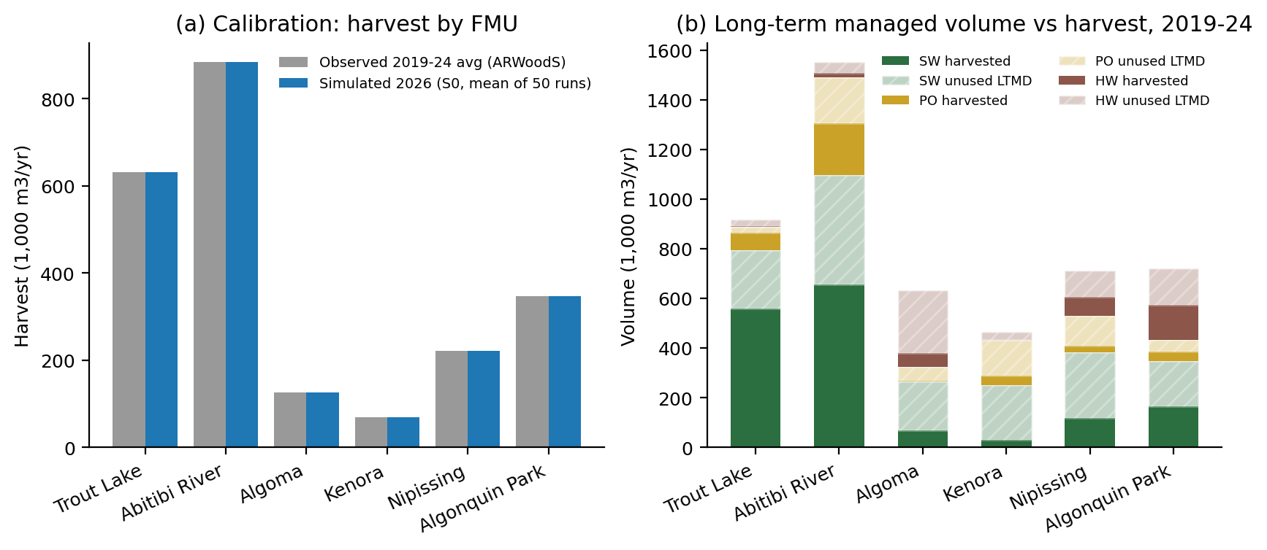
Figure 2. (a) Observed vs simulated start-year harvest by FMU. (b) LTMD vs harvest by species group, 2019-2024: unused volume is concentrated in softwood in Abitibi River, Trout Lake, Kenora and Nipissing, and in poplar and hardwood in Abitibi River, Algoma, Algonquin Park and Kenora.
Validation. Beyond matching start-year harvest, business-as-usual runs reproduce the observed long-run pattern of persistent under-utilization: province-wide harvest has been 42%-54% of LTMD in every year since 2010 (ARWoodS). The simulated 2041-45 business-as-usual mean is 41% with a 90% range of 23%-50%, reflecting lumber-price cycles and occasional mill exits. Behavioural parameters (logistic slopes, adjustment speeds) were set to give plausible responses. For example, a sustained 20% lumber price drop lowers business-as-usual utilization from 41% to 21%, consistent with the 2006-2009 contraction. Their influence was checked through the sensitivity analysis.

4. Strategies and experimental design

4.1 Biomass utilization strategies
Table 3. Strategies simulated.
Code | Strategy | Description
S0 | Business as usual | Incumbent mills only; no new technologies or policies
S1 | Southern urban mass-timber plants | Up to three 60,000 m3 CLT/glulam plants near the GTA, buying northern lumber; no grants
S2 | Northern integrated log-to-mass-timber hubs | Integrated log-to-CLT/glulam hubs in FMU regions; 15% capital grant; 20% Indigenous equity partnership
S3 | Distributed Indigenous/community network | Community log-to-panel spokes and bioheat in all FMUs; 51% Indigenous ownership; 40-50% grants; contractor capacity building
S4 | Hub-and-spoke hybrid | Hubs + spokes + bioheat + pellets (S2 and S3 technologies); grants and equity as above
S5 | Hub-and-spoke hybrid + enabling policy | S4 + Indigenous fibre-allocation priority + contractor capacity building + 25% public procurement of mass timber/panels + $50/tCO2 clean-heat incentive
S6 | Regionally differentiated portfolio | S5 tuned region by region: technologies dropped where they add cost or risk without benefit (result: pellets only in Trout Lake and Abitibi River)

4.2 Scenarios, replication and sensitivity
Each strategy was run 50 times (Monte Carlo) under three mass-timber/prefab demand growth trajectories: Low 3%/yr, Base 8%/yr, High 15%/yr. Six one-at-a-time sensitivity cases (MT price -20%; MT price +20%; Lumber price -20%; Capex +30%; Discount rate 10%; Heat value -30%) were run with 30 replications each. In total 2,310 simulations of 20 years were performed, plus the regional tuning runs described in Section 4.3 (runtime a few minutes on a laptop).

4.3 Evaluation criteria and MCDA
Seven criteria were evaluated at provincial and FMU level: Fibre utilization 2041-45; Value added (NPV); Rural/northern jobs; Indigenous community income (NPV); Net carbon benefit; Public cost; Share of new plants unprofitable. Value added and Indigenous income are discounted at a 4% social rate to 2026. Criteria were min-max normalized across strategies and aggregated with four weighting schemes (Equal, Economic priority, Community priority, Climate priority) to test the robustness of rankings to stakeholder priorities. S6 was derived in a second stage. Starting from S5, each technology was removed (or spokes capped at one) in each FMU in turn, and a change was kept only if it was no worse regionally and provincially and it reduced public cost (Appendix C).

5. Results

5.1 Provincial outcomes
Table 4. Provincial outcomes (six FMUs + GTA), base demand, mean of 50 runs. Jobs are 2036-45 averages; cumulative values cover 2026-2045.
Strategy | Utilization 2041-45 (90% range) | Harvest 2026-45 (Mm3) | Mass timber (1,000 m3) | Panels (1,000 m3) | Rural jobs (FTE) | Indigenous jobs (FTE) | Indigenous income NPV ($M) | Value added NPV ($M) | Net carbon (MtCO2e) | Public cost ($M) | New plants unprofitable
S0 | 41% (23%-50%) | 42.3 | 0 | 0 | 1,709 | 415 | 431 | 2,615 | 7.0 | 0 | 0%
S1 | 41% (23%-50%) | 42.3 | 2,670 | 0 | 1,709 | 415 | 431 | 3,236 | 8.3 | 0 | 0%
S2 | 59% (42%-68%) | 54.0 | 5,918 | 0 | 3,081 | 875 | 917 | 4,336 | 9.6 | 168 | 9%
S3 | 49% (31%-59%) | 48.3 | 0 | 2,375 | 3,088 | 1,269 | 1,196 | 3,913 | 9.0 | 201 | 0%
S4 | 63% (47%-72%) | 57.1 | 5,452 | 1,821 | 4,089 | 1,471 | 1,448 | 5,265 | 10.8 | 330 | 9%
S5 | 66% (51%-75%) | 60.9 | 6,106 | 1,978 | 4,327 | 1,807 | 1,842 | 5,761 | 11.6 | 335 | 2%
S6 | 66% (51%-74%) | 60.8 | 6,108 | 1,978 | 4,299 | 1,799 | 1,838 | 5,748 | 11.6 | 331 | 1%
S0 and S1 have identical rural and Indigenous outcomes because urban plants add no FMU-region activity.
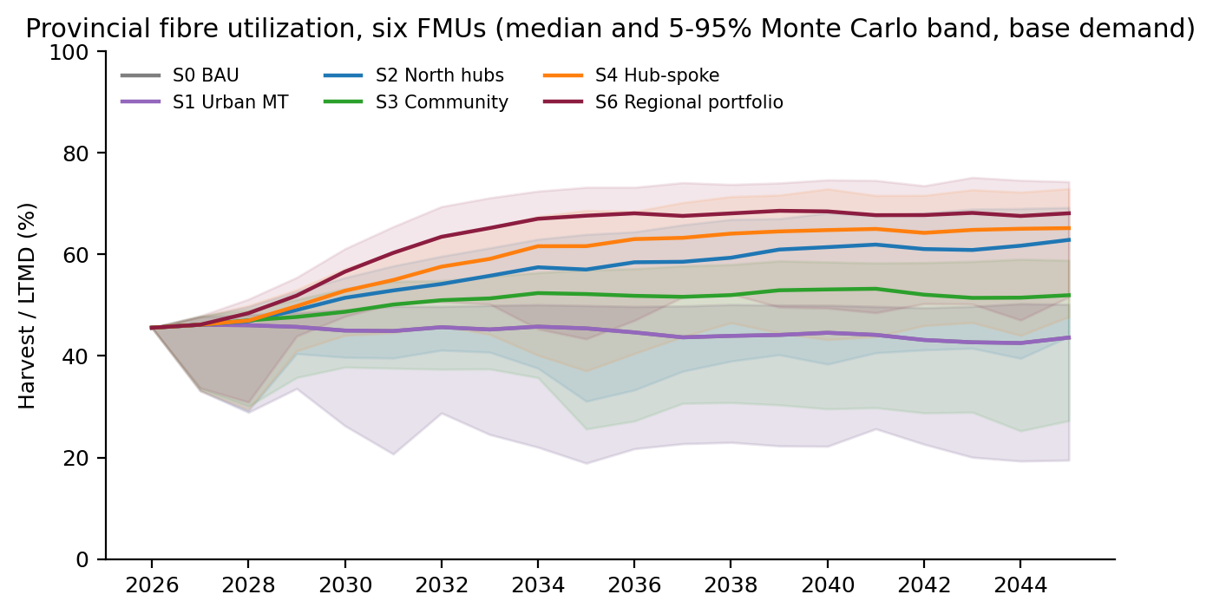
Figure 3. Provincial fibre utilization (harvest/LTMD) over time. Lines show medians; shaded bands show the 5-95% Monte Carlo range. S1 coincides with S0 because urban plants do not add harvest.
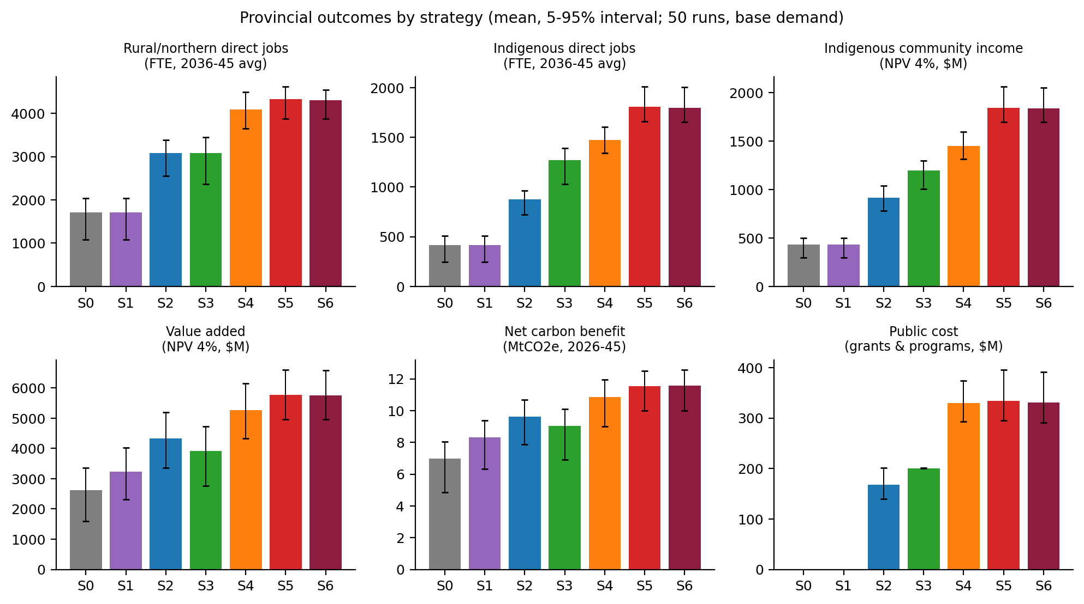
Figure 4. Provincial outcomes by strategy (mean and 5-95% interval).
Three results stand out. First, adding processing capacity where the fibre is (S2, S4-S6) is what raises utilization; the softwood gap is a capacity gap, not a supply gap. Second, community-scale and Indigenous-owned assets (S3-S6) are what move Indigenous outcomes: S3 delivers $1,196 M of Indigenous income with $201 M of public cost, compared with $917 M for S2. Third, the hybrid strategies combine both effects, and the enabling policy package (S5, S6) improves every outcome relative to S4, for a marginal increase in public cost, and sharply lowers investment risk. With Indigenous fibre-allocation priority and procurement-backed demand, community plants obtain fibre and offtake more reliably, so fewer fail.

5.2 Regional utilization and emergent technology portfolios
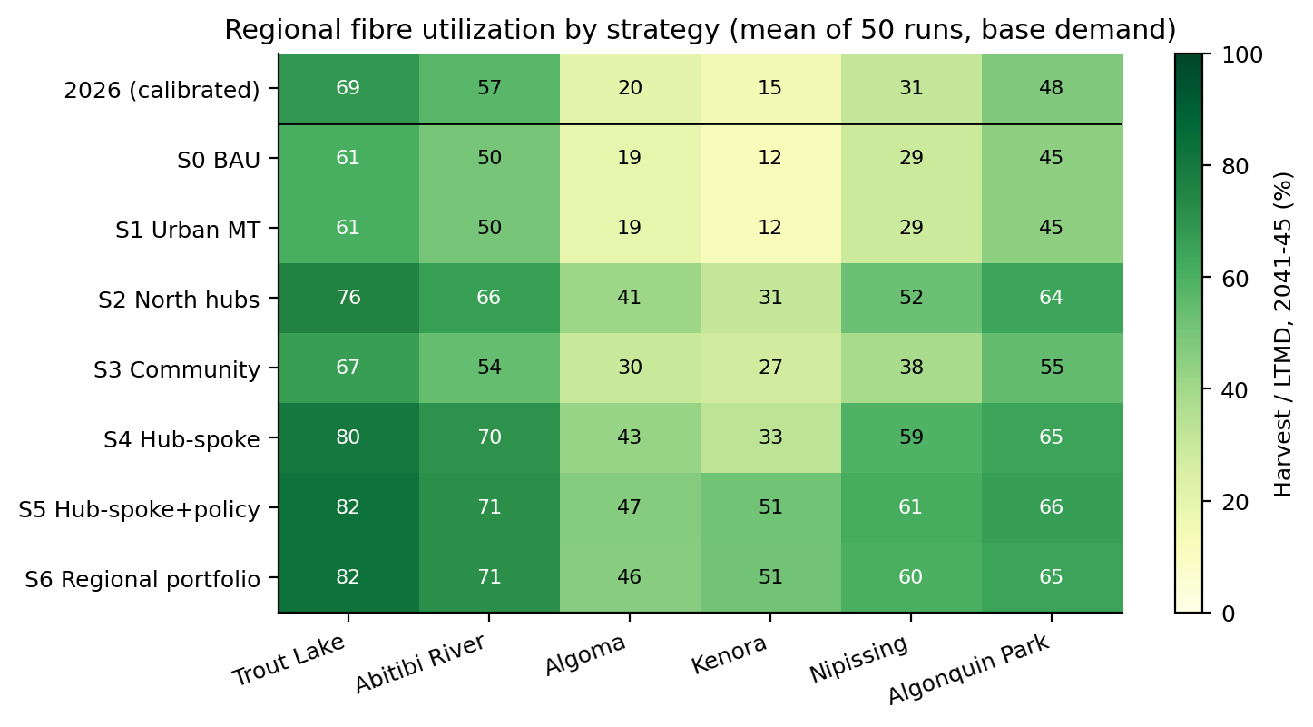
Figure 5. Fibre utilization by FMU and strategy (2041-45 mean); the top row shows the calibrated 2026 value.
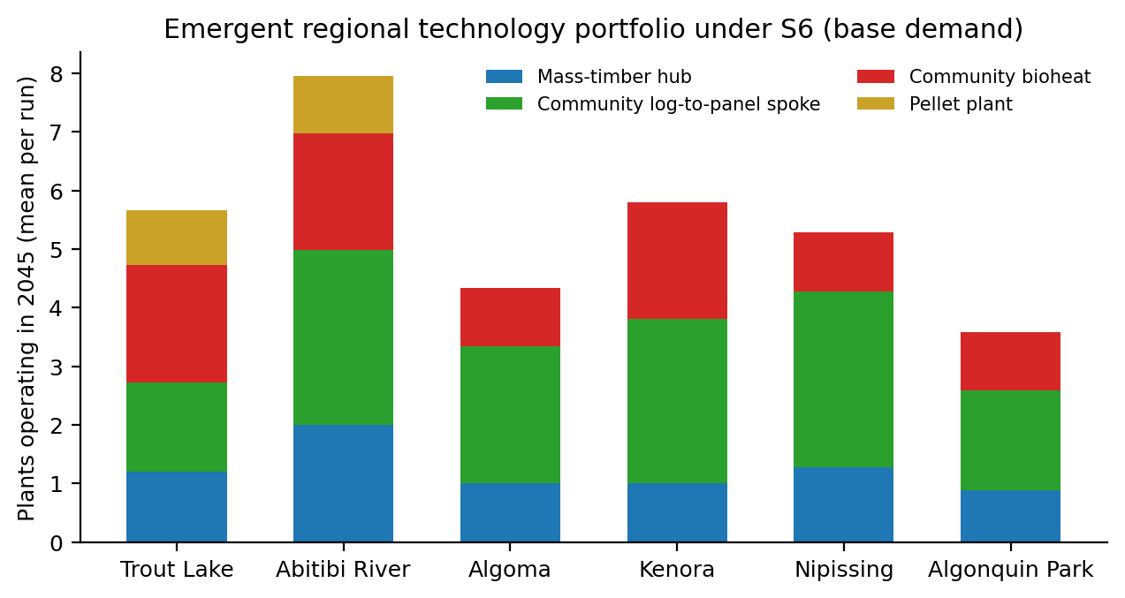
Figure 6. Plants operating in 2045 by FMU under S6 (mean per run).
Under S6, hubs are built in every FMU, but their economics differ sharply. Mean cumulative hub profit over 2026-2045 is Algonquin Park $261 M, Abitibi River $241 M, Nipissing $238 M, Algoma $225 M, Trout Lake $155 M, Kenora $48 M. The difference is driven by freight to southern markets. In Kenora, 12% of hubs lose money over the horizon, and 10% of Kenora spokes do. Bioheat is profitable everywhere it is built, and most profitable where it displaces expensive heating fuel in remote communities (Trout Lake, Abitibi River, Kenora). Pellet plants are viable only where residue pools are large (Abitibi River, Trout Lake).
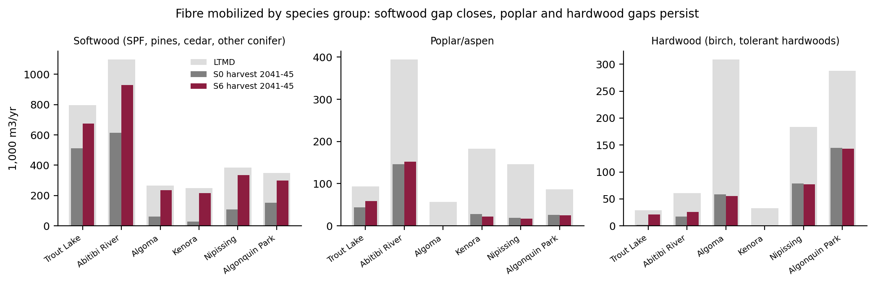
Figure 7. Harvest by species group in 2041-45, S0 vs S6, against LTMD.
The softwood gap largely closes under S6, but poplar and hardwood mobilization barely changes (poplar 276 vs LTMD 959 thousand m3/yr; hardwood 323 vs 902). Bioheat and pellet plants mostly use residues, which is economically efficient but leaves low-grade roundwood standing. A dedicated poplar/hardwood value-added pathway is the main missing piece for Algoma, Algonquin Park, Kenora (poplar) and Abitibi River (poplar).

5.3 Indigenous and rural community outcomes
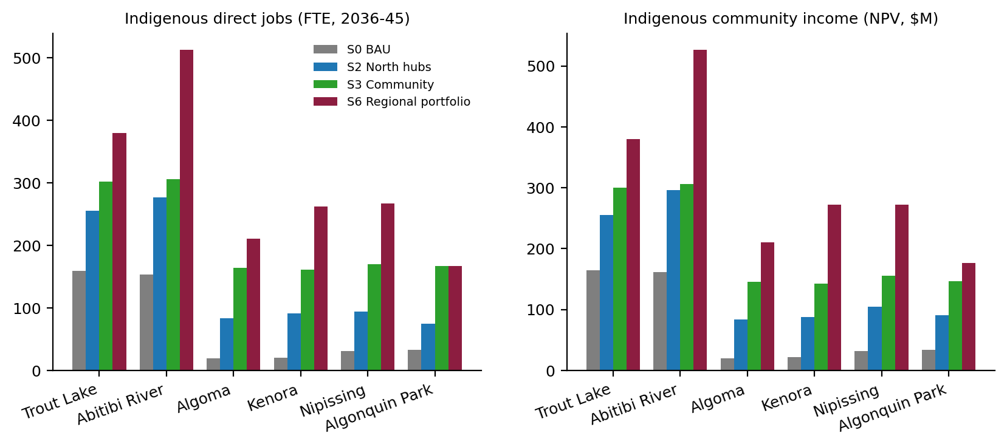
Figure 8. Indigenous direct jobs and Indigenous community income by FMU for four strategies.
Table 5. Rural and Indigenous outcomes by FMU, business as usual (S0) vs regional portfolio (S6), base demand.
FMU | Rural jobs S0 | Rural jobs S6 | Indig. jobs S0 | Indig. jobs S6 | Indig. income S0 ($M NPV) | Indig. income S6 ($M NPV) | Indig. contractor vol. S0 (1,000 m3/yr) | Indig. contractor vol. S6 | Northern housing units supplied (S6, 2026-45)
Trout Lake | 455 | 842 | 159 | 380 | 164 | 380 | 112 | 327 | 2,161
Abitibi River | 630 | 1,323 | 153 | 513 | 162 | 527 | 159 | 558 | 2,567
Algoma | 108 | 467 | 19 | 211 | 19 | 210 | 11 | 212 | 1,286
Kenora | 45 | 441 | 20 | 262 | 21 | 272 | 23 | 227 | 2,620
Nipissing | 182 | 652 | 31 | 267 | 31 | 272 | 19 | 197 | 1,085
Algonquin Park | 289 | 574 | 33 | 167 | 34 | 177 | 33 | 168 | 565

Under S6, Indigenous direct employment rises about 4.3-fold and Indigenous community income 4.3-fold. The largest absolute gains are in Abitibi River and Trout Lake; the largest relative gains are in Kenora, Algoma and Nipissing, where Indigenous participation starts from a very low base. Equity returns on Indigenous-majority spokes and bioheat plants and on partnership stakes in hubs total about $601 M (undiscounted, 2026-2045). The rest comes from wages and from Indigenous-owned harvesting contractors, whose volume rises roughly 4.7-fold. Spokes supply about 10,285 housing-unit equivalents of panels to northern communities over 2026-2045, roughly 78% of the assumed northern housing need, linking biomass utilization directly to the project's affordable-housing objective.

5.4 Strategy ranking and robustness
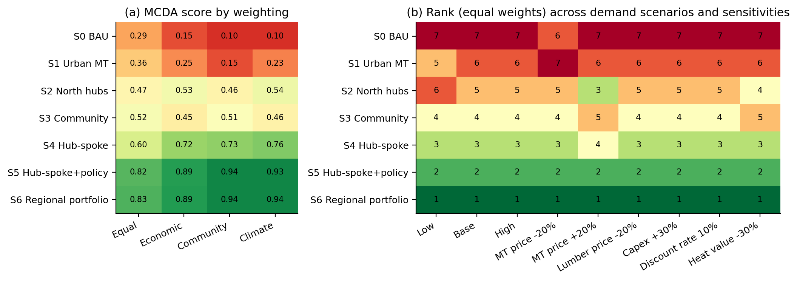
Figure 9. (a) MCDA scores under four weighting schemes (base demand). (b) Rank under equal weights across demand scenarios and sensitivity cases (1 = best).
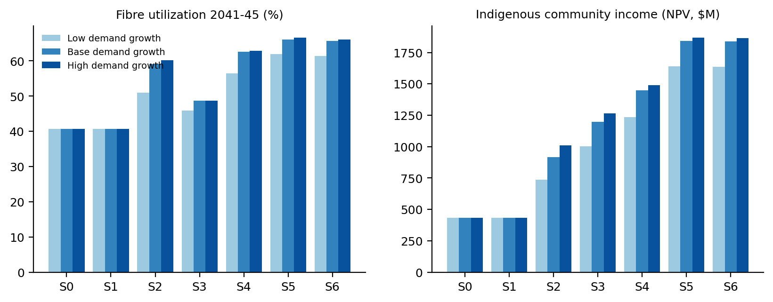
Figure 10. Fibre utilization and Indigenous community income under low, base and high mass-timber demand growth.
Table 6. Sensitivity of S6 outcomes (30 runs per case, base demand).
Sensitivity case | Utilization S0 | Utilization S6 | Value added gain S6-S0 ($M) | Indigenous income gain S6-S0 ($M) | S6 plants unprofitable | S6 rank
MT price -20% | 40% | 64% | 2,164 | 1,175 | 6% | 1
MT price +20% | 40% | 65% | 3,978 | 1,582 | 1% | 1
Lumber price -20% | 21% | 52% | 2,878 | 1,244 | 4% | 1
Capex +30% | 40% | 65% | 2,708 | 1,274 | 8% | 1
Discount rate 10% | 40% | 65% | 2,911 | 1,336 | 4% | 1
Heat value -30% | 40% | 66% | 3,056 | 1,373 | 2% | 1

S6 ranks first in every demand scenario and sensitivity case, and S5 second. The two are close: S6 equal-weight score 0.831 vs 0.818. S6's advantage is that it removes pellet plants that add little in four FMUs, which lowers public cost and the share of failing plants without measurable loss of benefits. Weaker mass-timber demand (Low) reduces S6 utilization to 61%, and the lumber-price downturn case lowers utilization in all strategies (S0 falls to 21%). In that case S6 value added is still 3.0 times business as usual, because mass timber and panels buffer lumber-price risk. Higher capex (+30%) and a lower mass-timber price (-20%) raise the share of failing plants to about 6-8%, which is the main downside risk to manage.

6. Optimal biomass utilization strategies by region
Combining the provincial ranking, the regional outcomes and the region-by-region tuning test (Appendix C), the simulations identify the following optimal strategies. Plant counts are model means for 2045 under base demand and indicate scale rather than exact numbers.
Table 7. Optimal biomass utilization strategy by FMU region (S6 vs business as usual, base demand).
FMU | Optimal portfolio | Utilization | Jobs: rural / Indigenous (FTE) | Indigenous income ($M NPV) | Rationale and conditions
Abitibi River | Anchor hub region: 2 integrated mass-timber hubs, about 3 Indigenous-majority spokes, 2 bioheat plants, 1 residue-based pellet plant. | 57% -> 71% | +693 / +360 | +365 | Largest softwood surplus (about 440,000 m3/yr) and largest absolute gains in value added and Indigenous income. Engage Treaty 9 First Nations in the Cochrane-Iroquois Falls area as equity partners in the hubs.
Nipissing | Early hub plus full spoke network: 1-2 hubs, 3 spokes, 1 bioheat plant. | 31% -> 60% | +470 / +236 | +241 | Close to southern markets with low freight. Utilization roughly doubles (31% to about 60%); strong hub profitability makes it a priority first-wave location.
Algoma | Hub plus spokes, hardwood pathway needed: 1 hub, 2-3 spokes, 1 bioheat plant. | 20% -> 46% | +359 / +192 | +191 | Utilization rises from 20% to about 46%, limited by hardwood-dominated supply (tolerant hardwoods and birch about 309,000 m3/yr LTMD) for which no new pathway is modelled.
Trout Lake | Hub plus residue economy: 1 hub, 1-2 spokes sized to northern housing, 2 bioheat plants, 1 pellet plant. | 69% -> 82% | +387 / +221 | +216 | Already the most utilized FMU (69%), reaching about 82%. Remote communities give the highest bioheat value; residues from hub and incumbent mills feed bioheat and pellets.
Algonquin Park | One hub and a smaller spoke network: about 1 hub, 2 spokes, 1 bioheat plant. | 48% -> 65% | +285 / +134 | +143 | High hub profitability and short haul to markets, but limited free softwood. Further gains depend on hardwood and white-pine products (glulam, hardwood CLT) and on Algonquins of Ontario participation.
Kenora | Indigenous-led spokes first, hub conditional: up to 3 spokes and 2 bioheat plants; 1 hub only with secured offtake. | 15% -> 51% | +396 / +242 | +251 | Largest relative gain (15% to about 50%) and highest Indigenous share of benefits, but the highest risk (hub and spoke failures) because of the roughly 1,900 km distance to the GTA. Markets in Manitoba and north-western Ontario, not modelled here, would improve viability. Build on existing First Nations-led forest management.

Cross-cutting elements of the optimal strategy
- A common provincial enabling framework. Indigenous fibre-allocation priority on uncommitted Crown volume, capacity building for Indigenous harvesting contractors, procurement of mass timber and prefab panels in public and community housing, and a clean-heat incentive for bioheat. For less than $5 M of extra public cost, these instruments improve every outcome and reduce plant failures.
- Indigenous ownership where the asset is community-scale; partnership where it is large. Majority Indigenous ownership of spokes and bioheat plants with 40-50% capital grants, and around 20% equity partnerships in hubs.
- Investment phasing by risk. First wave: Abitibi River, Nipissing and Algoma hubs, plus bioheat and spokes in all FMUs. Second wave: Trout Lake and Algonquin Park hubs and pellets. Third wave: a Kenora hub only once offtake agreements are in place.
- Size spokes to secured demand. Spokes that rely on long-haul southern sales are the main source of stranded assets in remote FMUs; northern housing programs and procurement should anchor them.
- Do not rely on urban mass-timber plants for rural or Indigenous objectives. They are commercially viable, but they do not mobilize additional biomass.

7. Limitations and next steps
- Assumed parameters. Several community-level inputs are planning assumptions that need validation with communities and MNR (Appendix A): northern housing need, community heat demand and fuel costs, Indigenous labour and contractor shares, and mass-timber and panel prices. They will be refined through the Activity 5 market survey and stakeholder consultations, including engagement with First Nations whose territories overlap the study FMUs.
- No cross-FMU log trade. Logs are sourced within each FMU and products are shipped to the GTA. Cross-FMU log trade, Manitoba/Prairie markets for Kenora and Trout Lake, and export markets for mass timber are not represented, so Kenora outcomes are likely conservative.
- Missing poplar and hardwood pathway. Poplar OSB/LVL and hardwood EWP options are not modelled; adding them is the priority model extension for Activity 6.
- Not yet coupled to FORBIOM-ON. The ABM shares data and parameters with FORBIOM-ON but is not dynamically coupled. The planned co-evolutionary link, with ABM adoption rates and harvest intensities passed to the GAMS model and shadow prices returned to agents, is the next methodological step.
- Carbon accounting is partial. It covers product storage, avoided fossil heat and process/transport emissions. Forest carbon dynamics and construction-material substitution are addressed in the Activity 4 life cycle assessment.
- Indicative scale. Results describe six FMUs, not all of Ontario. Absolute values should be read as indicative and relative rankings as robust.

References
Grimm, V., Railsback, S.F., Vincenot, C.E., et al. (2020). The ODD protocol for describing agent-based and other simulation models: a second update. Journal of Artificial Societies and Social Simulation 23(2): 7.
Ontario Ministry of Natural Resources. Annual Report on Wood Supply (ARWoodS) data extract, 2025 update.
Ontario Ministry of Natural Resources. Electronic Forest industry Annual Report (eFAR) summary data, 2020-2022 (September 2024 release).
Ontario Ministry of Natural Resources and Forestry (2022). Forest Biomass Action Plan.
Yousefpour, R., Elfahli, Y. (2026). Ontario Forest Biomass: Supply Chain Feasibility, Processing Optimization, and ABM-Integrated Biomass Utilization - preliminary results (Activities 1-3 interim report), University of Toronto.
Yousefpour, R., Elfahli, Y. (2026). Future Pathways for Mass Timber and Offsite Wood Construction in Ontario: an economic evaluation and policy scan informed by the FORBIOM-ON model. FEDSS Lab, University of Toronto.
Simon, H.A. (1957). Models of Man: Social and Rational. Wiley, New York.

Appendix A. Parameters, sources and status
Table 8. Model parameters (2026 CAD, real). Values marked 'to validate' are planning assumptions to be refined through Activity 5 consultations.
Parameter | Value | Source / basis | Status
LTMD and harvest by FMU and species group | Table 2 | ARWoodS 2025, FY2019-2024 mean | Calibrated
Direct jobs per 1,000 m3, facility + woodlands (sawmill, composite) | 0.41, 0.36 | eFAR 2020-2022 | Calibrated
Harvest cost (stump to roadside) | $38/m3 x access factor 1.00-1.15 | FORBIOM-ON harvestCostRW | Model-consistent
In-region haul; stumpage | 110 km at $0.12/m3-km; $6/m3 | Ontario industry norms | Literature/assumption
Lumber (SPF) mill-net price | $300/m3, AR(1) rho 0.6, sd 15% | 2023-2026 market range | Literature/assumption
CLT/glulam price | $1100/m3 (sensitivity +/-20%) | Industry quotes; FORBIOM-ON ratio tested | Assumption, to validate (Activity 5)
Prefab panel price (wood-equivalent) | $1300/m3 | Industry estimates | Assumption, to validate (Activity 5)
OSB; pulpwood; mill residue; pellets | $400/m3; $70/m3; $30/odt; $230/odt | Market references | Literature/assumption
Lumber recovery; residue fraction (sawmill) | 0.55; 0.4 | Boreal sawmill literature | Literature
Lumber per m3 CLT / panel | 1.2 / 1.15 | FORBIOM-ON lumberInputPerUnit | Model-consistent
Mass-timber hub | 150k m3 logs, 60k m3 MT, capex $150M, MT conversion $250/m3 | Comparable plants | Assumption
Community spoke | 25k m3 logs, 10k m3 panels, capex $25M, panel conversion $550/m3, 5 jobs per 1,000 m3 panels | Modular plant benchmarks | Assumption
Bioheat; pellet plant | 5k odt, $12M; 80k odt, $50M | Project benchmarks | Assumption
Mass-timber demand (six regions) | 165,000 m3/yr in 2026; growth 3/8/15% | FORBIOM-ON demand caps | Model-consistent / scenario
Southern prefab panel demand | 60,000 m3/yr | Planning assumption | To validate (Activity 5)
Northern housing need (units/yr) | Trout Lake 150, Abitibi River 120, Algoma 60, Kenora 120, Nipissing 50, Algonquin Park 40 | Planning assumption | To validate with communities
Community heat demand (odt/yr) | Trout Lake 10,000, Abitibi River 9,000, Algoma 5,000, Kenora 8,000, Nipissing 4,000, Algonquin Park 3,000 | Planning assumption | To validate with communities
Displaced heat value ($/odt) | Trout Lake 600, Abitibi River 550, Algoma 350, Kenora 450, Nipissing 250, Algonquin Park 300 | Heating oil/propane/diesel costs | Assumption
Indigenous labour share | Trout Lake 30%, Abitibi River 18%, Algoma 15%, Kenora 35%, Nipissing 14%, Algonquin Park 8% | Approx. Census 2021 district shares | To verify
Indigenous contractor share (initial) | Trout Lake 20%, Abitibi River 15%, Algoma 10%, Kenora 35%, Nipissing 10%, Algonquin Park 10% | Planning assumption | To validate with MNR/communities
Discount rate (private; social) | 8%; 4% | Standard practice | Sensitivity 10%
Carbon factors | FORBIOM-ON storage/process factors; 1.23 tCO2e/odt avoided by bioheat | FORBIOM-ON; fuel emission factors | Model-consistent
Behaviour | Contractor k=12; mill k=4; investment k=5, max probability 0.6; expectation weight 0.3; price adjustment 0.3 | Calibrated for plausible response | Tested in sensitivity

Appendix B. Software and reproducibility
FORBIOM-ABM is implemented in Python 3.11 (NumPy, pandas, Matplotlib) and runs on a standard laptop. Files in the ABM_Activity3 folder:
- calibrate.py: builds calibration tables from ARWoodS and eFAR.
- abm.py: model (agents, markets, strategies, parameters).
- experiments.py: Monte Carlo runs, regional tuning (S6), sensitivity analysis and MCDA.
- analysis.py, figures.py, build_report.py: tables, figures and this report.
- To reproduce: py calibrate.py; py experiments.py --seeds 50 --sens-seeds 30; py analysis.py; py figures.py; py build_report.py.

Appendix C. Region-by-region tuning of the enabling-policy hybrid (S5)
Table 9. Effect of removing one technology (or capping spokes at one) in one FMU, relative to full S5. Gains are weighted changes in units of the S0-to-S5 improvement; a variant is adopted only if it is no worse regionally and provincially and reduces public cost. Selected: Trout Lake: full; Abitibi River: full; Algoma: no pellet plant; Kenora: no pellet plant; Nipissing: no pellet plant; Algonquin Park: no pellet plant.
FMU | Variant | Utilization | VA NPV ($M) | Rural jobs | Indig. income ($M) | Public cost ($M) | Unprofitable | Regional gain | Provincial gain
Trout Lake | full | 82% | 1,136 | 837 | 380 | 54 | 0% | +0.000 | +0.000
Trout Lake | max one spoke | 82% | 1,119 | 808 | 368 | 49 | 1% | -0.027 | -0.004
Trout Lake | no bioheat | 78% | 1,088 | 813 | 348 | 43 | 0% | -0.075 | -0.013
Trout Lake | no community spoke | 80% | 1,073 | 759 | 337 | 43 | 2% | -0.099 | -0.016
Trout Lake | no mass-timber hub | 71% | 975 | 755 | 344 | 42 | 2% | -0.237 | -0.021
Trout Lake | no pellet plant | 78% | 1,091 | 778 | 360 | 49 | 0% | -0.043 | -0.008
Abitibi River | full | 71% | 1,861 | 1,329 | 528 | 82 | 0% | +0.000 | +0.000
Abitibi River | max one spoke | 70% | 1,739 | 1,187 | 443 | 66 | 1% | -0.081 | -0.024
Abitibi River | no bioheat | 70% | 1,815 | 1,307 | 501 | 72 | 1% | -0.035 | -0.011
Abitibi River | no community spoke | 68% | 1,663 | 1,112 | 396 | 57 | 1% | -0.140 | -0.042
Abitibi River | no mass-timber hub | 57% | 1,311 | 950 | 353 | 43 | 3% | -0.398 | -0.103
Abitibi River | no pellet plant | 70% | 1,804 | 1,273 | 510 | 78 | 0% | -0.014 | -0.008
Algoma | full | 46% | 587 | 467 | 212 | 47 | 1% | +0.000 | +0.000
Algoma | max one spoke | 42% | 533 | 388 | 176 | 36 | 1% | -0.078 | -0.012
Algoma | no bioheat | 46% | 570 | 460 | 203 | 41 | 1% | -0.022 | -0.004
Algoma | no community spoke | 41% | 468 | 320 | 126 | 28 | 1% | -0.164 | -0.026
Algoma | no mass-timber hub | 30% | 394 | 354 | 162 | 31 | 0% | -0.240 | -0.027
Algoma | no pellet plant | 46% | 587 | 467 | 212 | 47 | 0% | +0.008 | +0.001
Kenora | full | 51% | 460 | 452 | 274 | 55 | 7% | +0.000 | +0.000
Kenora | max one spoke | 43% | 375 | 322 | 199 | 40 | 1% | -0.039 | -0.003
Kenora | no bioheat | 51% | 427 | 440 | 256 | 45 | 11% | -0.088 | -0.007
Kenora | no community spoke | 39% | 311 | 247 | 147 | 31 | 1% | -0.126 | -0.017
Kenora | no mass-timber hub | 27% | 310 | 293 | 166 | 36 | 1% | -0.179 | -0.016
Kenora | no pellet plant | 51% | 460 | 451 | 274 | 55 | 7% | +0.005 | +0.001
Nipissing | full | 61% | 844 | 654 | 268 | 56 | 2% | +0.000 | +0.000
Nipissing | max one spoke | 56% | 721 | 509 | 189 | 41 | 2% | -0.135 | -0.025
Nipissing | no bioheat | 60% | 836 | 647 | 263 | 51 | 1% | -0.008 | -0.002
Nipissing | no community spoke | 54% | 661 | 449 | 149 | 33 | 3% | -0.201 | -0.038
Nipissing | no mass-timber hub | 39% | 512 | 426 | 172 | 32 | 2% | -0.332 | -0.055
Nipissing | no pellet plant | 60% | 842 | 649 | 267 | 55 | 0% | +0.020 | +0.003
Algonquin Park | full | 65% | 807 | 585 | 176 | 39 | 1% | +0.000 | +0.000
Algonquin Park | max one spoke | 67% | 798 | 565 | 153 | 36 | 2% | -0.012 | -0.001
Algonquin Park | no bioheat | 64% | 801 | 579 | 172 | 34 | 2% | -0.017 | -0.003
Algonquin Park | no community spoke | 66% | 748 | 518 | 122 | 31 | 2% | -0.094 | -0.011
Algonquin Park | no mass-timber hub | 55% | 668 | 534 | 178 | 32 | 1% | -0.184 | -0.017
Algonquin Park | no pellet plant | 64% | 801 | 573 | 175 | 37 | 0% | +0.009 | +0.001

