* **Objective:** Riyadh Roads Traffic Analysis
* **About Data**
* At first, let me clarify the information in this data, it includes:

road name, direction, station no, day, date, weather condition, latitude, longitude, hourly volume (Number of vehicles throughout the day), peak hours (AM, Mid-Day, PM).

Each sheet has a data for a road for three days.

* I've extracted the information needed to meet our objective, which includes the road name, direction, station number, day, date, hourly volume, and peak hour
* **TrafficDataAnalysis python Script:**
* To make a code more organized and clear I made this script that has all the functions needed to load and process our data.
* The script has three functions:

1. load_data(folder_path)

It has one argument (folder path) it may be one of those:

["ATC's Data ERR",

"ATC's Data King Fahd Road",

"ATC's Data King Khalid Road",

"ATC's Data King Salman Rd",

"ATC's Data Makkah - Khurais Rd",

"ATC's Data NRR",

"ATC's Data WRR Rd"]

This function reads the excel sheets in the folder, extract, and save the info in a data frame format, and csv file. It returns the DataFrame.

1. extract_info(data)

It has one argument (our DataFrame).

This function responsible for process the data to make it suitable for analysis.

It returns:

(hourly_volume1, date1, day1), (hourly_volume2, date2, day2)

, (hourly_volume3, date3, day3), road_name, direction.

Each sheet has this information.

1. Peak_hours(data)

This function responsible for extract the peak hours for each sheet, and make it suitable for analysis.

Each sheet has three days, and each day has 3 peak hours (AM, Mid-Day, PM).

It returns (x_wed, y_wed), (x_thurs, y_thurs), (x_fri,y_fri)

X -> number of vehicles

Y -> time

* **Traffic-analysis notebook**

For each folder:

I loaded the data, extract info, and save in csv file using the python script.

Analysis for Eastern Ring Road on Wednesday, Thursday, Friday

X axis -> number of vehicles

Y axis -> hours

Each plot is an analysis for hourly volume for each road and its direction

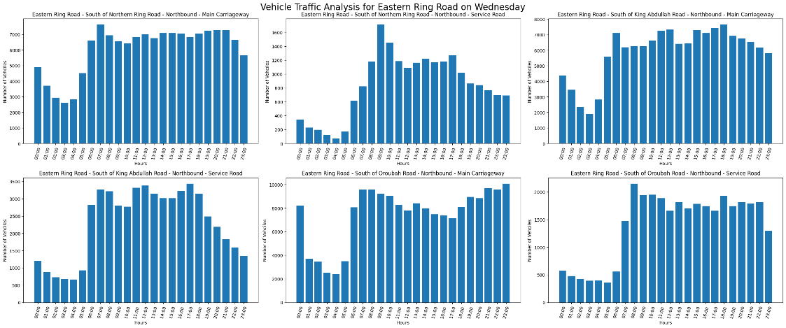

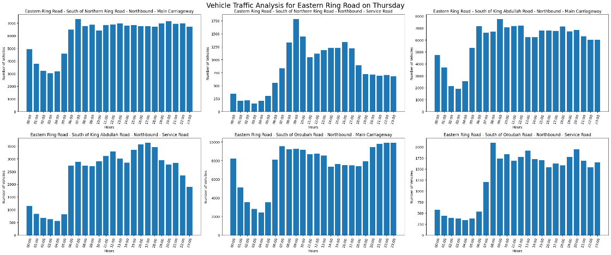

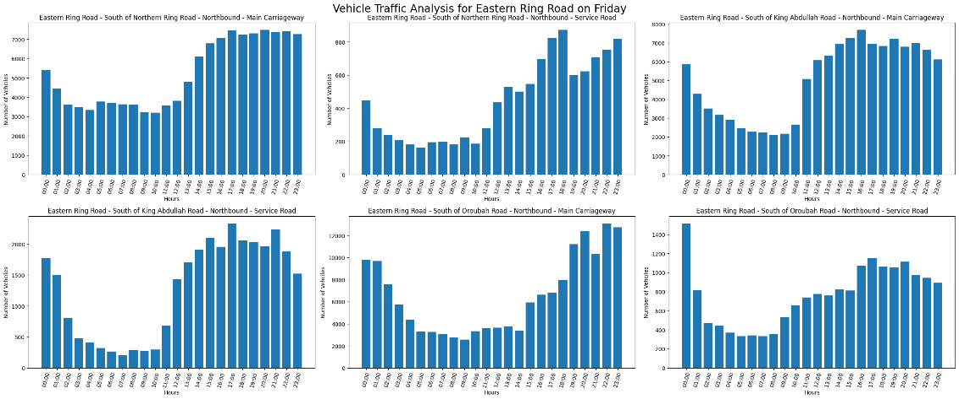

* Peak hours analysis for each road in Wednesday, Thursday, Friday.

