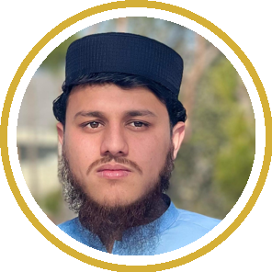  MUHAMMAD YASIR  COMPUTER OPERATOR  CONTACT  ▪ New Lakhti Banda, Hangu, KPK  ▪ Domicile: Orakzai  ▪ 0336-0414131  ▪ yark1717@gmail.com  LANGUAGES  ▪ Pashto — Native  ▪ Urdu — National / Fluent  ▪ English — Fluent  SKILL LEVEL  C++  HTML & CSS  Java  Python  MS Office (Word, Excel) | Professional Resume  BS Computer Science Student | Computer Operator  Motivated BS Computer Science student (5th semester) with strong command of MS Office and foundational programming skills in C++, HTML, CSS, Java, and Python. Seeking a Computer Operator position to apply my technical knowledge and computer proficiency in a professional environment.  BS Computer Science — Kohat University of Science & Technology  5th Semester, current CGPA: 3.24  FSc (Computer Science) — Kohat Board  1024 / 1200 marks  Matric (Science) — Kohat Board  957 / 1100 marks  DIT — Khyber Pakhtunkhwa Board of Technical & Commerce Education, Peshawar  1071 / 1400 marks  ◆ C++ Programming  ◆ HTML & CSS  ◆ Java  ◆ Python  ◆ MS Office — Word, Excel (strong command)  New Life — Hospital Information Website  Designed and developed a hospital website using HTML and CSS, displaying doctors' information for patients.  Hospital Management System — MS Access  Built a database system to add and display records of doctors, patients, wards, and nurses, along with dedicated reports for each.  Clerk (DIT Internship) — 3 Months  Gained hands-on office and clerical experience during the DIT program.  Available upon request.
  OBJECTIVE
  EDUCATION
  TECHNICAL SKILLS
  PROJECTS
  EXPERIENCE
  SUITABLE FOR
  Computer Operator | Office Assistant / Clerk
  Data Entry Operator | IT / Web Support
  REFERENCES

