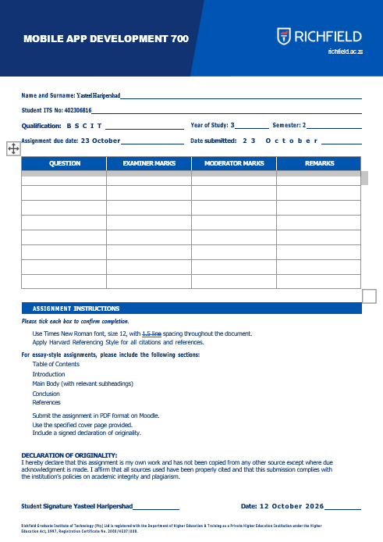
Table of Contents
1. Introduction 1
1.1 Aims 1
1.2 Scope 1
2. System Design 1
2.1 Screens and navigation 1
2.2 Data storage – why SQLite 1
2.3 Class structure 1
2.4 The strict matching algorithm 1
3. Implementation 1
3.1 Core matching logic (RecipeMatcher) 1
3.2 Name normalisation (NameUtil) 1
3.3 Unit conversion (UnitUtil) 1
3.4 Database creation (DatabaseHelper) 1
3.5 Expiry highlighting (PantryAdapter) 1
4. Screenshots and Testing 1
5. Challenges and Solutions 1
Matching plurals and different units 1
The pantry list not refreshing 1
Wrong bottom-navigation tab highlighted 1
Emulator showing a black or blank screen 1
Gradle and JDK version mismatch 1
Setting up Git and GitHub 1
6. Conclusion and Reflection 1
6.1 Possible improvements 1
7. References (Harvard style) 1

1. Introduction
Smart Pantry Manager is an Android application written in Java that helps a household keep track of the food it already owns and decide what to cook with it. The user records pantry items with a name, quantity, unit and an optional expiry date. The app then suggests recipes from a built-in collection of 18 recipes.
The central rule of the app is strict matching: a recipe is suggested only if every ingredient it needs is in the pantry in a sufficient quantity. One missing or insufficient ingredient means the recipe is not shown. This avoids the frustration of being offered a recipe and discovering halfway through that something is missing.

1.1 Aims
- Create, view, edit and delete pantry items with validation.
- Suggest only the recipes that can be made completely from the current pantry.
- Highlight items that are close to or past their expiry date, with a setting to switch this off.
- Store all data locally so the app works offline and keeps data between sessions.

1.2 Scope
As required by the brief, the app does not use maps or GPS. It is built with Java in Android Studio, minSdk 24 (Android 7.0) and compileSdk 34, and uses Gradle 8.2 with Android Gradle Plugin 8.2.2.

2. System Design

2.1 Screens and navigation
The app has five activities. Three (My Pantry, Suggested Recipes and Settings) are top-level screens connected by a bottom navigation bar. Add/Edit Ingredient and Recipe Detail are opened from them using explicit Intents that carry the item or recipe id as an extra.
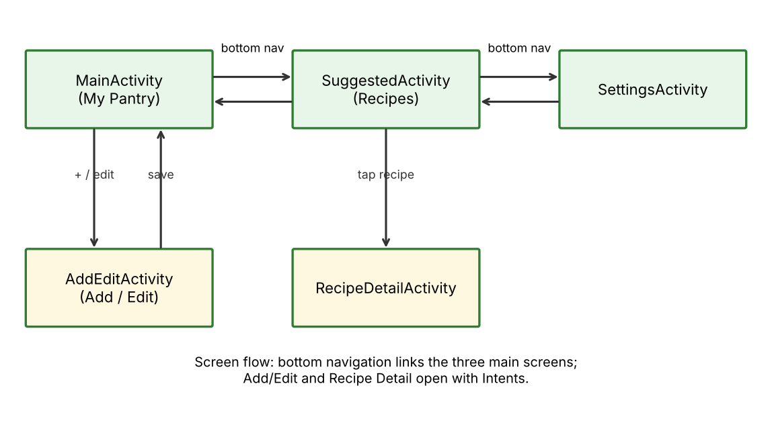
Figure A: Screen flow of Smart Pantry Manager

2.2 Data storage – why SQLite
SQLite (through SQLiteOpenHelper) was chosen because the data is relational and queried repeatedly: a recipe has many ingredients, and the matching logic must read every recipe with all of its ingredients. SharedPreferences is only suited to small key-value data and would make this awkward, while Room would have added a library and annotation processing that were not needed for three small tables. SharedPreferences is still used for the one simple setting, the expiry-alert toggle.
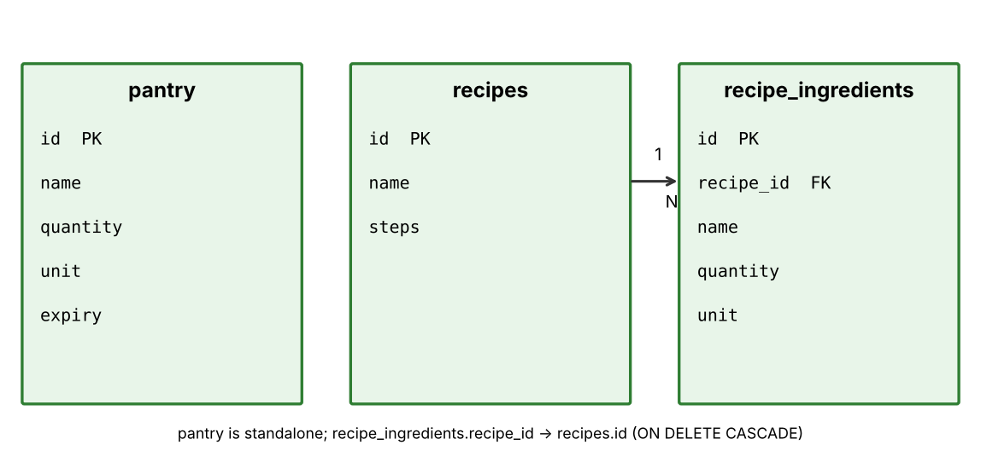
Figure B: Entity-relationship diagram of the database
Deleting a recipe removes its ingredients automatically because of ON DELETE CASCADE on the foreign key. The 18 recipes are inserted once, when the database is created.

2.3 Class structure
- PantryItem, Recipe, RecipeIngredient – Plain model classes holding the data.
- DatabaseHelper – Creates the tables, seeds the recipes and provides add, read, update and delete methods.
- NameUtil / UnitUtil – Normalise ingredient names and convert units to a base unit so values can be compared.
- RecipeMatcher – Applies the strict matching rule.
- PantryAdapter / RecipeAdapter – RecyclerView adapters that bind data to list rows.
- BaseActivity – Shared bottom-navigation setup used by the main screens.
- MainActivity, AddEditActivity, SuggestedActivity, RecipeDetailActivity, SettingsActivity – The five screens.

2.4 The strict matching algorithm
Matching works in two steps. First, the pantry is totalled per ingredient: each item name is normalised and its quantity is converted to a base unit (grams, millilitres or pieces), and duplicate entries are added together. Second, every recipe is checked ingredient by ingredient; as soon as one ingredient is absent or the amount in stock is smaller than the amount needed, the recipe is rejected. Only recipes that pass every check are returned.

3. Implementation

3.1 Core matching logic (RecipeMatcher)
private static boolean canMake(Recipe recipe, Map<String, Double> stock) {
if (recipe.getIngredients().isEmpty()) return false;
for (RecipeIngredient ing : recipe.getIngredients()) {
Double have = stock.get(key(ing.getName(), ing.getUnit()));
double need = UnitUtil.toBase(ing.getQuantity(), ing.getUnit());
if (have == null || have + 0.0001 < need) {
return false; // missing or not enough -> strictly excluded
}
}
return true;
}
The loop returns false the moment any ingredient fails, which is what makes the matching strict. The small tolerance of 0.0001 prevents floating-point rounding from rejecting an exact match.

3.2 Name normalisation (NameUtil)
public static String normalize(String name) {
String n = name.toLowerCase(Locale.ROOT).replaceAll("[^a-z ]", " ")
.replaceAll("\\s+", " ").trim();
int lastSpace = n.lastIndexOf(' ');
String head = lastSpace >= 0 ? n.substring(0, lastSpace + 1) : "";
String last = lastSpace >= 0 ? n.substring(lastSpace + 1) : n;
return head + singular(last); // "Tomatoes" -> "tomato", "Eggs" -> "egg"
}
Without this, "Eggs" in the pantry would not match "egg" in a recipe. Case, punctuation, extra spaces and simple plurals are all ignored.

3.3 Unit conversion (UnitUtil)
public static double toBase(double quantity, String unit) {
switch (clean(unit)) {
case "kg": return quantity * 1000; // -> grams
case "l": return quantity * 1000; // -> millilitres
case "tsp": return quantity * 5;
case "tbsp": return quantity * 15;
case "cup": case "cups": return quantity * 250;
default: return quantity; // g, ml, pcs
}
}
This lets 0.5 kg of flour in the pantry satisfy a recipe that asks for 200 g.

3.4 Database creation (DatabaseHelper)
db.execSQL("CREATE TABLE pantry (id INTEGER PRIMARY KEY AUTOINCREMENT, "
+ "name TEXT NOT NULL, quantity REAL NOT NULL, unit TEXT NOT NULL, expiry TEXT)");
db.execSQL("CREATE TABLE recipes (id INTEGER PRIMARY KEY AUTOINCREMENT, "
+ "name TEXT NOT NULL, steps TEXT NOT NULL)");
db.execSQL("CREATE TABLE recipe_ingredients (id INTEGER PRIMARY KEY AUTOINCREMENT, "
+ "recipe_id INTEGER NOT NULL, name TEXT NOT NULL, quantity REAL NOT NULL, "
+ "unit TEXT NOT NULL, FOREIGN KEY(recipe_id) REFERENCES recipes(id) ON DELETE CASCADE)");
seedRecipes(db);

3.5 Expiry highlighting (PantryAdapter)
long days = daysUntil(exp);
if (alertsOn && days < 0) {
h.tvExpiry.setText("Expired on " + exp);
h.tvExpiry.setTextColor(Color.parseColor("#C62828")); // red
} else if (alertsOn && days <= 3) {
h.tvExpiry.setText("Expires in " + days + " day(s)");
h.tvExpiry.setTextColor(Color.parseColor("#E65100")); // orange
}
Items already expired show in red and items expiring within three days show in orange, but only when the user has the alert setting switched on in SharedPreferences.

4. Screenshots and Testing
The app was tested on the Android Studio emulator (Medium Phone, API 37). The figures below show each feature working. The tests carried out were:
- Add, edit and delete an ingredient, and confirm the list refreshes and keeps its data after the app is closed and reopened.
- Try to save an empty name and a quantity of 0, and confirm a validation message appears.
- Check that Scrambled Eggs (3 eggs, 10 g butter, 1 g salt) is not suggested while any ingredient is missing, and appears once all are present.
- Set an expiry date of today and confirm the orange expiry alert, then switch the alert setting off.
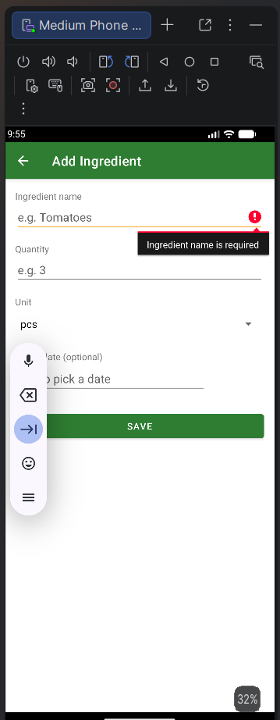  Figure 1: Add Ingredient screen – empty name is rejected | 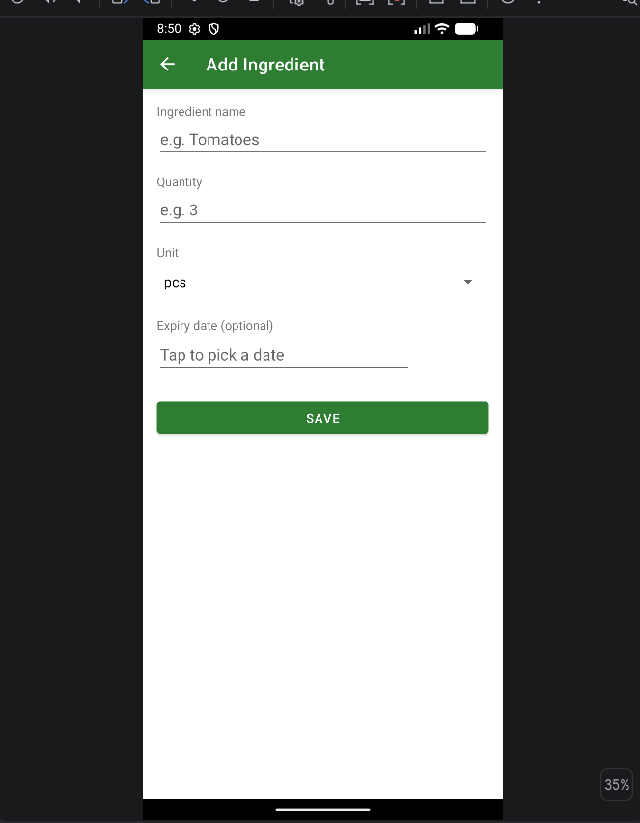  Figure 2: Add Ingredient form with name, quantity, unit and optional expiry
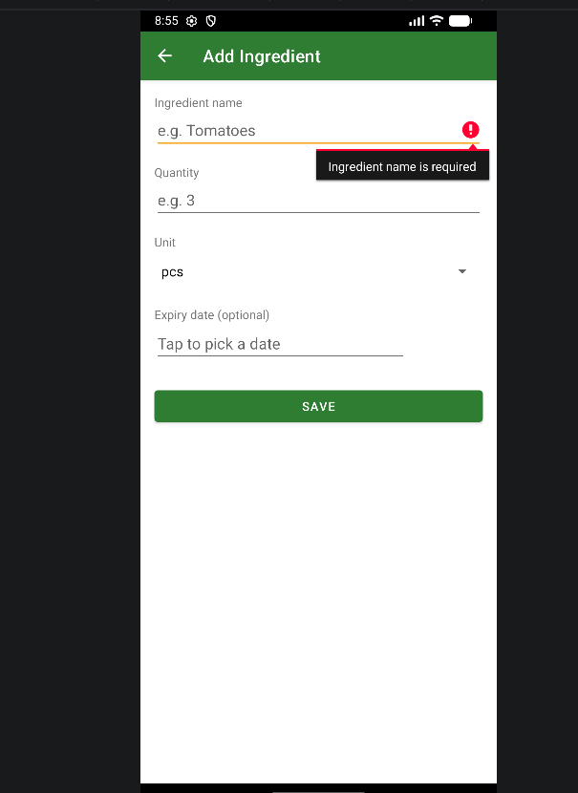  Figure 3: Validation message "Ingredient name is required" | 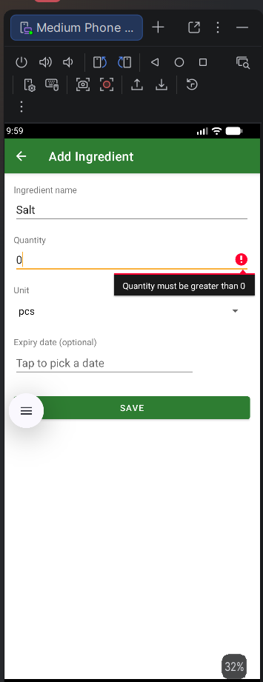  Figure 4: Validation message "Quantity must be greater than 0"
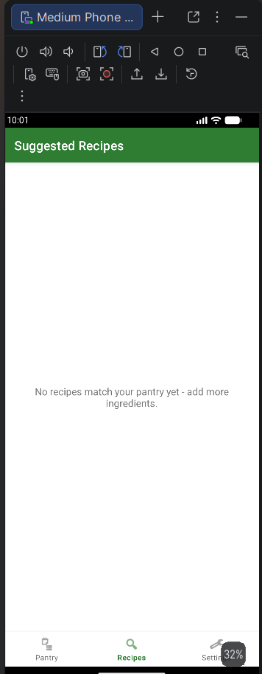  Figure 5: Suggested Recipes empty state with an empty pantry | 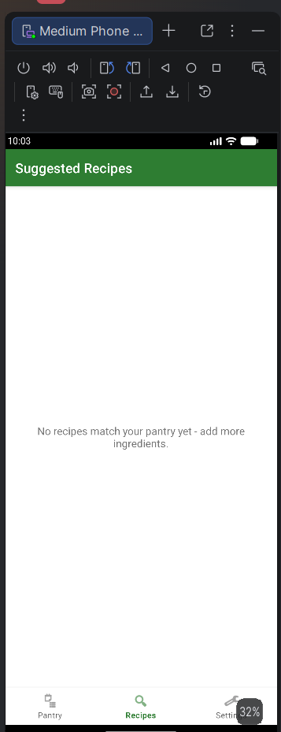  Figure 6: Recipe not suggested while an ingredient is missing
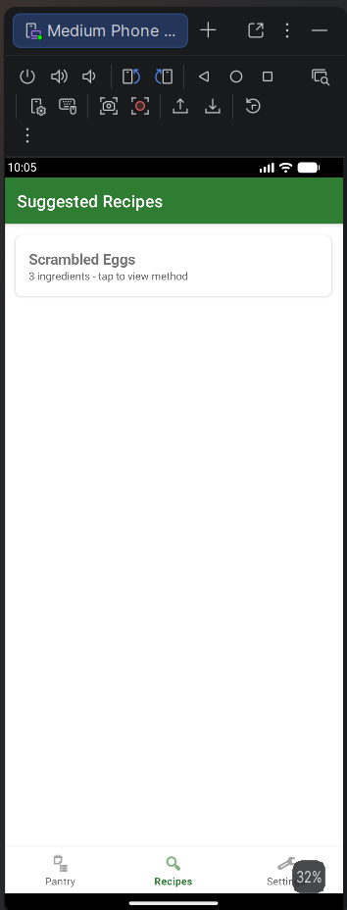  Figure 7: Scrambled Eggs suggested once all ingredients are present | 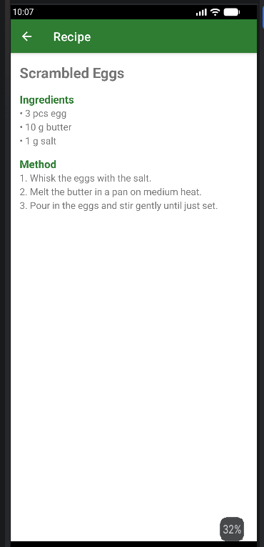  Figure 8: Recipe detail with ingredients and method
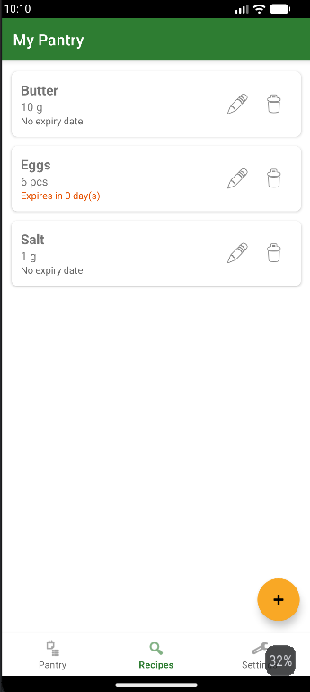  Figure 9: Expiry alert shown in orange ("Expires in 0 day(s)") | 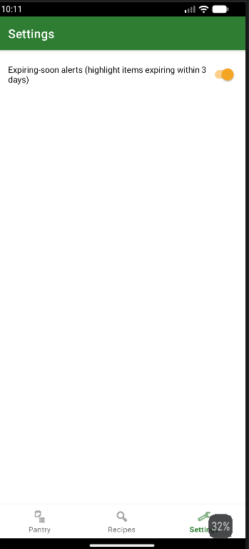  Figure 10: Settings screen with expiry-alert toggle
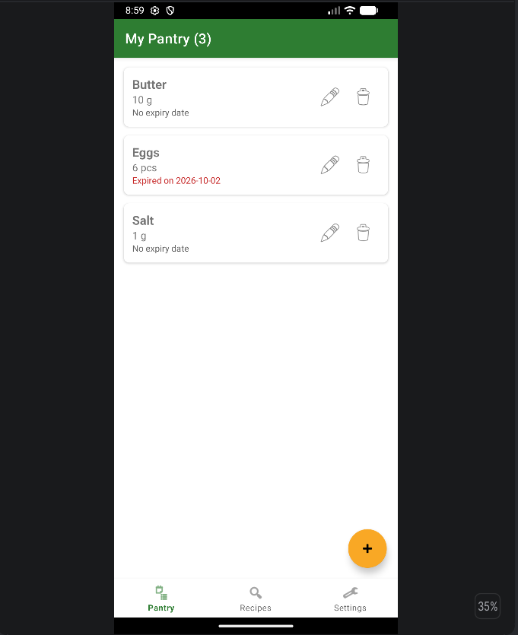  Figure 11: My Pantry list with three items | 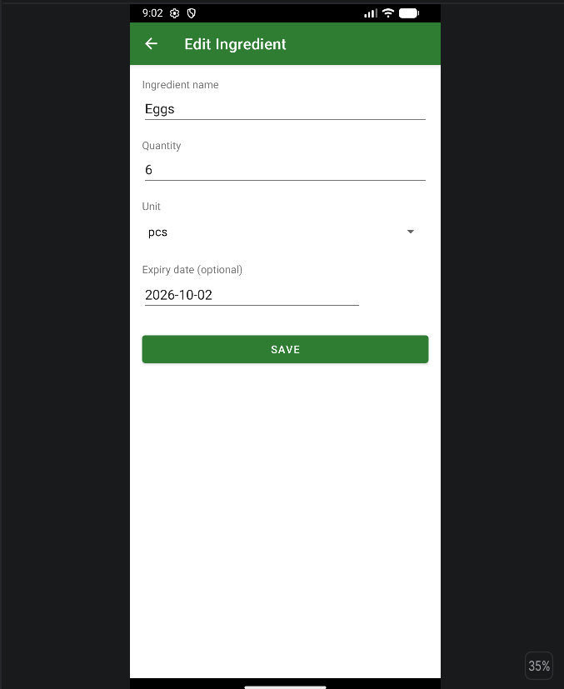  Figure 12: Edit Ingredient screen
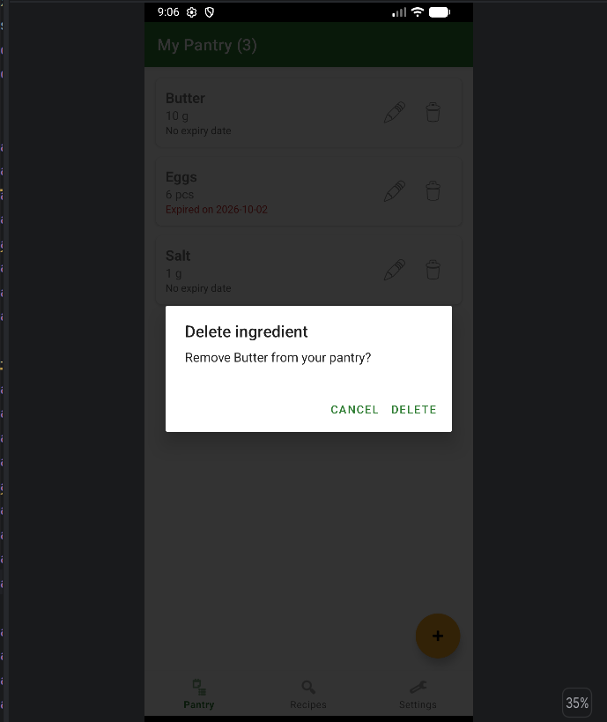  Figure 13: Delete confirmation dialog | 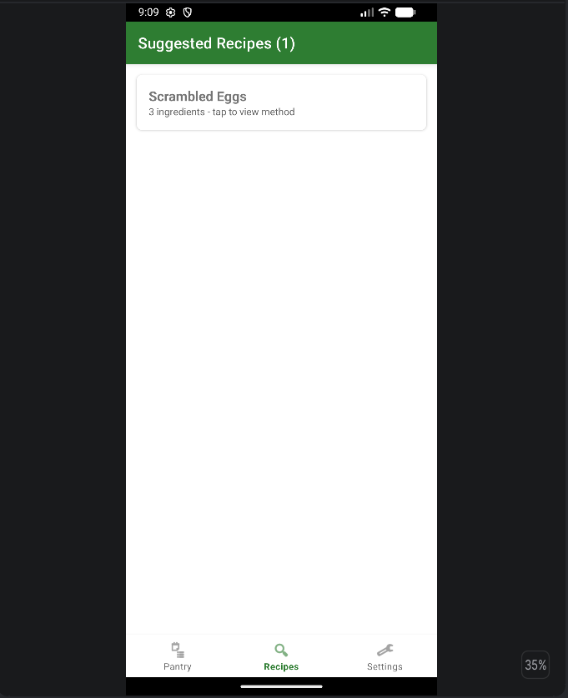  Figure 14: Suggested Recipes (1) with recipe count in the title
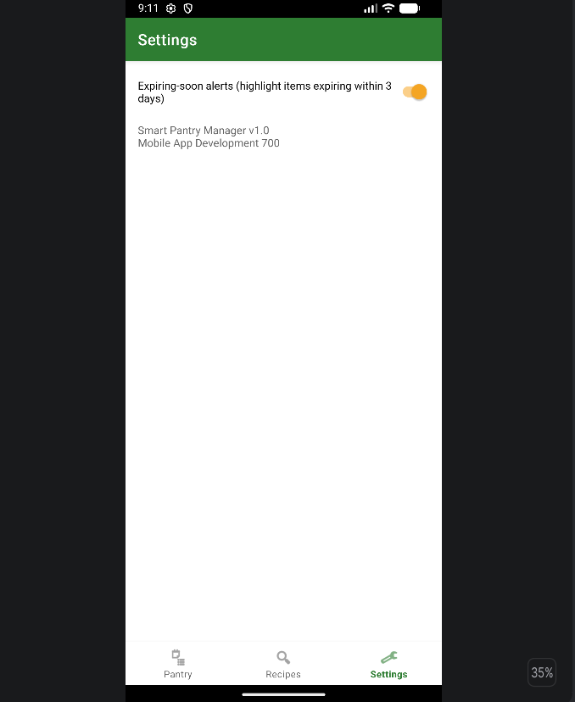
Figure 15: Settings screen with About text
Note: Figure 1 and Figure 3 both show the empty-name validation; Figure 10 shows Settings before the About text was added (Figure 15).

5. Challenges and Solutions

Matching plurals and different units
Early on, a recipe asking for "egg" did not match "Eggs" in the pantry, and "0.5 kg" could not be compared with "200 g". I wrote NameUtil to normalise names and UnitUtil to convert everything to a base unit before comparing.

The pantry list not refreshing
After adding or editing an item the list still showed old data when returning to the screen. I moved the reload into onResume so the list is rebuilt each time the screen becomes visible again.

Wrong bottom-navigation tab highlighted
Going back from another screen left the wrong tab highlighted. I stored the screen's menu id in BaseActivity and reset the selected item in onResume.

Emulator showing a black or blank screen
The emulator sometimes started with a black screen. Stopping and re-running did not help; using Cold Boot Now in the Device Manager fixed it.

Gradle and JDK version mismatch
Android Studio defaulted to a newer JDK than Gradle 8.2 supports. I switched the Gradle JVM to JDK 17 and the project synced and built successfully.

Setting up Git and GitHub
Committing from Android Studio failed at first because my Git name and email were not set, and some commits were made with an empty message or with files unticked. I set my identity and learned to check the Commit panel before committing.

6. Conclusion and Reflection
Smart Pantry Manager meets its aims: users can manage their pantry, receive expiry warnings and see only the recipes they can make completely. Building it taught me how an Android app is structured around activities, Intents and lifecycle methods such as onResume, how RecyclerView adapters bind data to lists, and why a relational database such as SQLite suits data with relationships.
The most valuable lesson was that a feature that looks simple, such as "does the pantry have this ingredient?", needs careful handling of real-world input like plurals and mixed units. Working through the GitHub commit process also showed me the value of small commits with clear messages.

6.1 Possible improvements
- A shopping list generated from the ingredients missing for a nearly-matching recipe.
- Letting users add their own recipes.
- Notifications that remind users before items expire.
- Automated unit tests for RecipeMatcher, NameUtil and UnitUtil.

7. References (Harvard style)
Android Developers (2024) Save data using SQLite. Available at: https://developer.android.com/training/data-storage/sqlite (Accessed: 8 October 2026).
Android Developers (2024) Create dynamic lists with RecyclerView. Available at: https://developer.android.com/develop/ui/views/layout/recyclerview (Accessed: 8 October 2026).
Android Developers (2024) Intents and intent filters. Available at: https://developer.android.com/guide/components/intents-filters (Accessed: 8 October 2026).
Android Developers (2024) Save key-value data with SharedPreferences. Available at: https://developer.android.com/training/data-storage/shared-preferences (Accessed: 8 October 2026).
Android Developers (2024) Bottom navigation (Material Components). Available at: https://developer.android.com/reference/com/google/android/material/bottomnavigation/BottomNavigationView (Accessed: 8 October 2026).

