Things to do:

* Create that B2B mecanisme ( the persmission stuff )
* **^ LEFTOFF ^** 
  + [Create a Node.js Application In cPanel With Node.js Selector](https://www.a2hosting.com/kb/cpanel/cpanel-software/create-application-with-nodejs-selector)
  + [Host your Node.js app on Shared hosting. Go beyond localhost.](https://medium.com/@pampas93/host-your-node-js-app-on-shared-hosting-go-beyond-localhost-73ab923e6691)
  + [How to host a Node.Js application in shared hosting](https://stackoverflow.com/questions/24777750/how-to-host-a-node-js-application-in-shared-hosting)
* Sync the button with auto location
  + if you just could stop the live sniffing
  + the button: start location => location goes life >> could use docs para
  + the button: stop location => doesn’t fire the location error
    - >> get a pulse of location intruption
* if location problem occures after the deploimenet try to find a solution :
  + a tuto guid => html file with steps ( use screen )
  + or fixed techniclay using code
* see how to push new value into json
* system: under stress (two refereshes or ++ at the same sec ) => dificulty in deleting records (could shut/break down the server)
  + >> try to deploy somekind of orginisator event.

GUI stuff :

* add tutorial :
  + vedio

Ressoures:

Delete markers

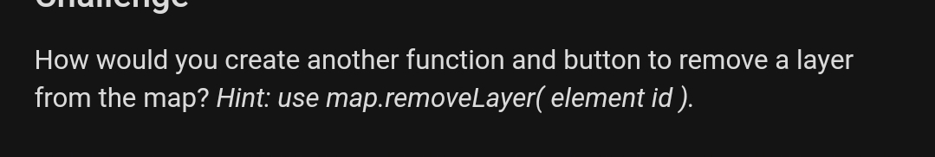

Use broadcast : [Socket.IO - Broadcasting](https://www.tutorialspoint.com/socket.io/socket.io_broadcasting.htm)

Add & remove map circule: [Add and Remove Leaflet Circle on Click · GitHub](https://gist.github.com/mollietaylor/8564724)

Check point:

Node js

Create Files: [Node.js File System Module](https://www.w3schools.com/nodejs/nodejs_filesystem.asp)

**Project descriptive :**

Current Goal :

* Create a real time, based on people’s location data.

Next Goal :

* A static one shows all the activity statistics
* See if there some api to handle the statistics output
* Mathematical / statistical ways to output history data

technical :

* Create a web and mobile application.

Permissions :

* to use app u should give you current location in return (some browsers don’t support geolocation)

**Done:**

* See a better way to relate the id to location (better to create the array on the server side ) :

[How to get user id using username in socket io](https://stackoverflow.com/questions/43464617/how-to-get-user-id-using-username-in-socket-io)

[Socket.IO handling disconnect event](https://stackoverflow.com/questions/17287330/socket-io-handling-disconnect-event)

* Drop the circle when a user log off

GUI

* Add real time users number:
  + [Change the Value of h1 Element within a Form with JavaScript](https://stackoverflow.com/questions/9529327/change-the-value-of-h1-element-within-a-form-with-javascript)
* Random location
  + <https://jsfiddle.net/brettdewoody/5FFnP/>
* Make representation using clusters:
  + [https://github.com/Leaflet/Leaflet.markercluster#usage](https://github.com/Leaflet/Leaflet.markercluster" \l "usage)

[How to clear leaflet map of all markers and layers before adding new ones?](https://stackoverflow.com/questions/28636723/how-to-clear-leaflet-map-of-all-markers-and-layers-before-adding-new-ones)

**Content:**

معلومات اضافية

* خصوصية محمية 100% :لا نقوم بحفظ بياناتكم، كل البيانات الواردة في الخريطة هي بيانات حية تحذف بمجرد خروجكم من الموقع، حيث هويتهم تبقى مجهولة، فقط قرص احمر يمثلكم في الخريطة
* add the cluster information