 

**Placement Empowerment Program**

***Cloud Computing and DevOps Centre***

**Set Up a Local Git Repository**:

Initialize Git repository locally and version control your static website

Name: Yasvanth Rajan E Department: AML



**Introduction and Overview**

Backing up your GitHub repositories is crucial to ensure that your code, version history, and project data are secure. This guide outlines the steps to create an automated backup system using a batch script with Git and Robocopy, scheduled to run daily.

**Objectives**

* This document provides a comprehensive guide to setting up an automated backup of a GitHub repository to a local directory on your computer.
* The process involves cloning the repository (or pulling updates if already cloned) and using Robocopy to maintain mirrored backups with date-wise organization.

**Importance**

* **Automate the backup process for a GitHub repository.**
* **Ensure daily backups with minimal manual intervention.**
* **Maintain an organized backup structure with date-based folders.**
* **Log backup activities for easy monitoring.**

**STEPS:**

**STEP 1: Prerequisites:**

* Install Git for Windows: <https://git-scm.com/downloads>
* Ensure Robocopy is available (comes pre-installed with Windows).

**STEP 2:Script Setup:**

* Open Notepad and paste the following batch script:

@echo off

set REPO_URL=https://github.com/Sivakumar950/Saber9-8.git

set LOCAL_REPO_PATH=D:\Development\BackupGit

set BACKUP_DIR=D:\Development\GitBackups

set DATE=%DATE:~10,4%-%DATE:~4,2%-%DATE:~7,2%

if exist %LOCAL_REPO_PATH% (

cd %LOCAL_REPO_PATH%

git pull origin main

) else (

git clone %REPO_URL% %LOCAL_REPO_PATH%

)

robocopy %LOCAL_REPO_PATH% %BACKUP_DIR%\%DATE% /MIR /E /Z /R:3 /W:5

echo Backup completed at %DATE% >> %BACKUP_DIR%\backup_log.txt

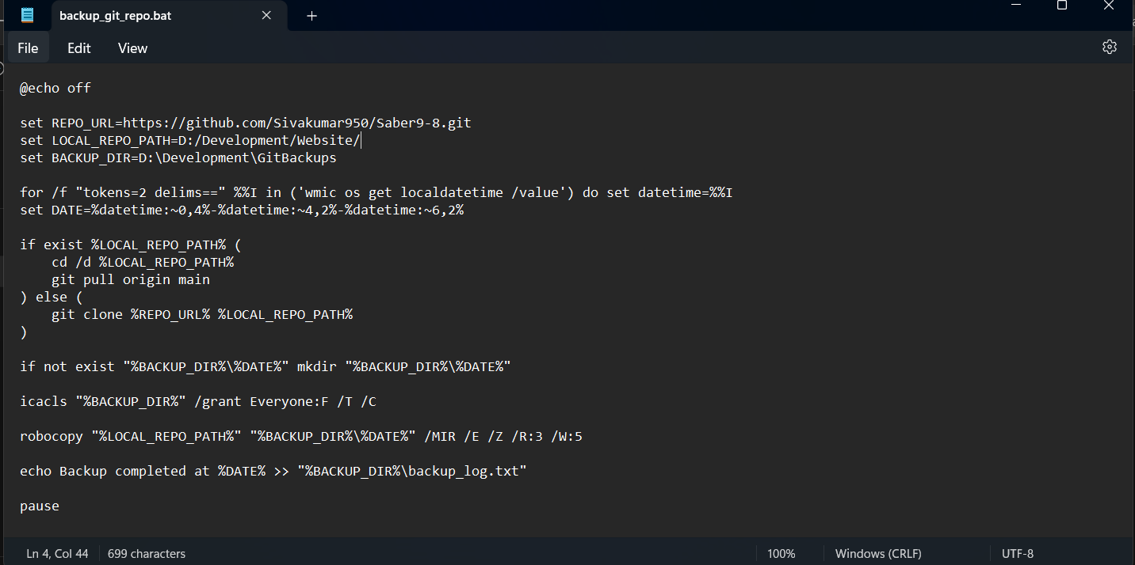

* Save the file as backup_script.bat.

**STEP 3: Testing the Script:**

* Right-click on the backup_script.bat file and select Run as administrator.
* Check D:\Development\GitBackups for date-wise backup folders.

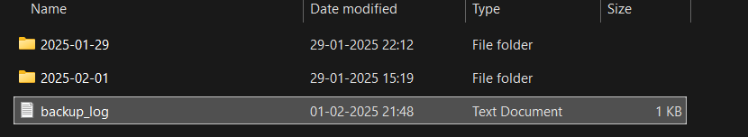

**STEP 4: Automating the Script with Task Scheduler:**

* Open Task Scheduler in Windows.

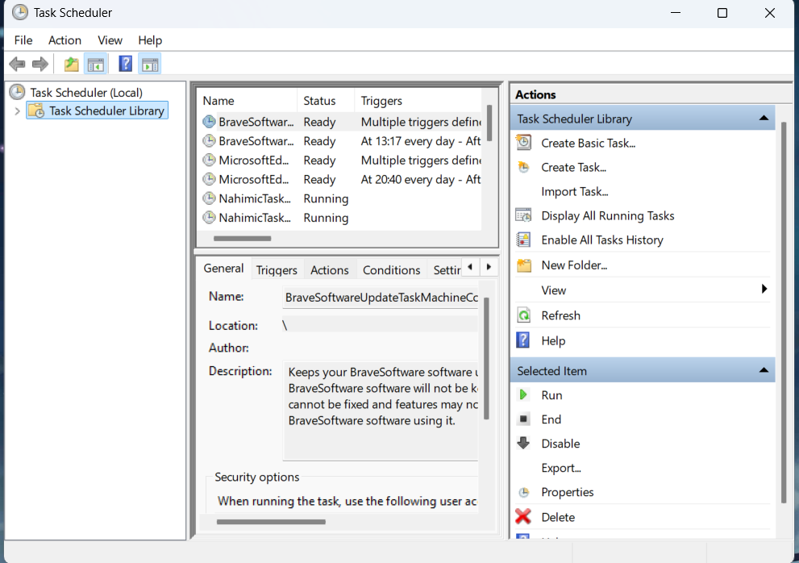

* Click Create Basic Task.
* Set a name (e.g., "GitHub Daily Backup") and click Next.

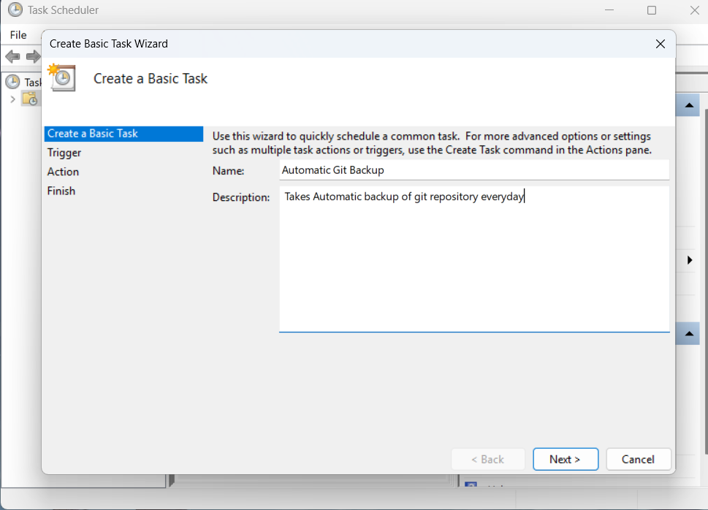

* + Choose Daily, set the desired time, and click Next.

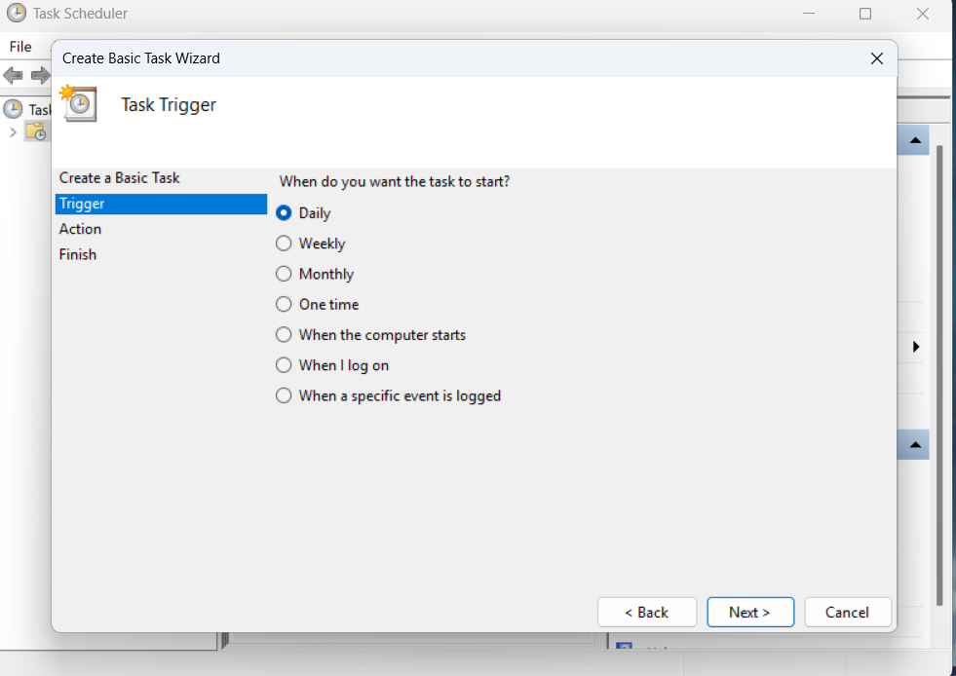

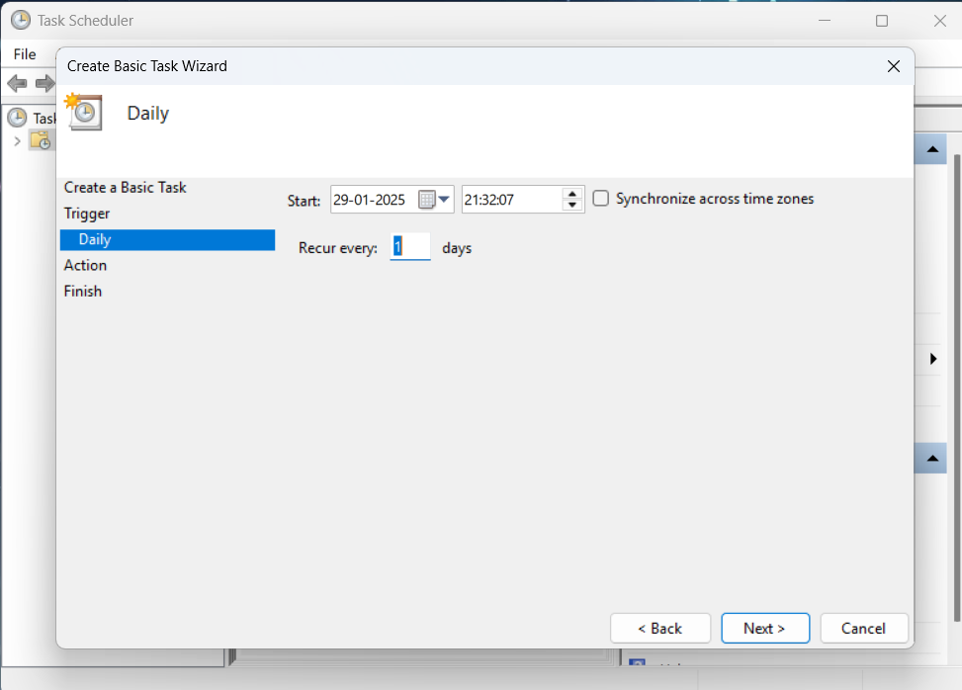

* Select Start a Program, browse to backup_script.bat, and click Next.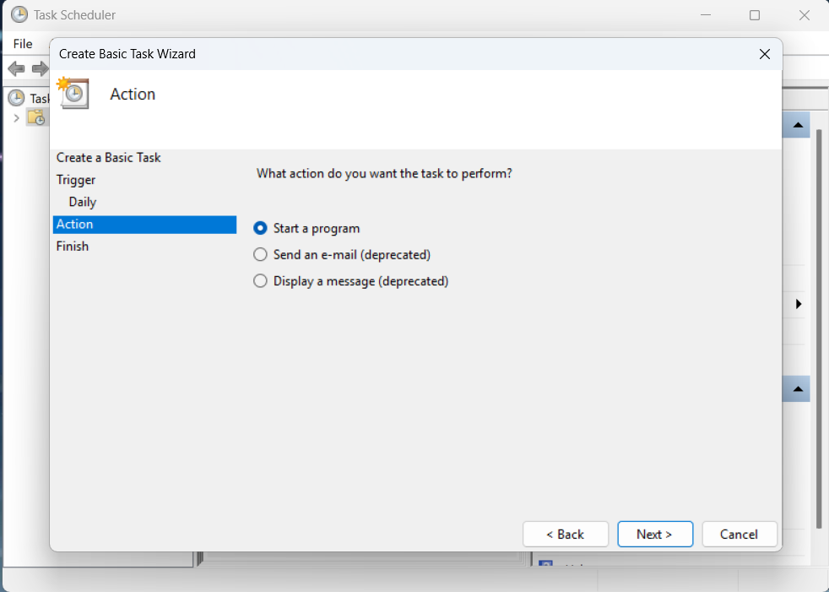

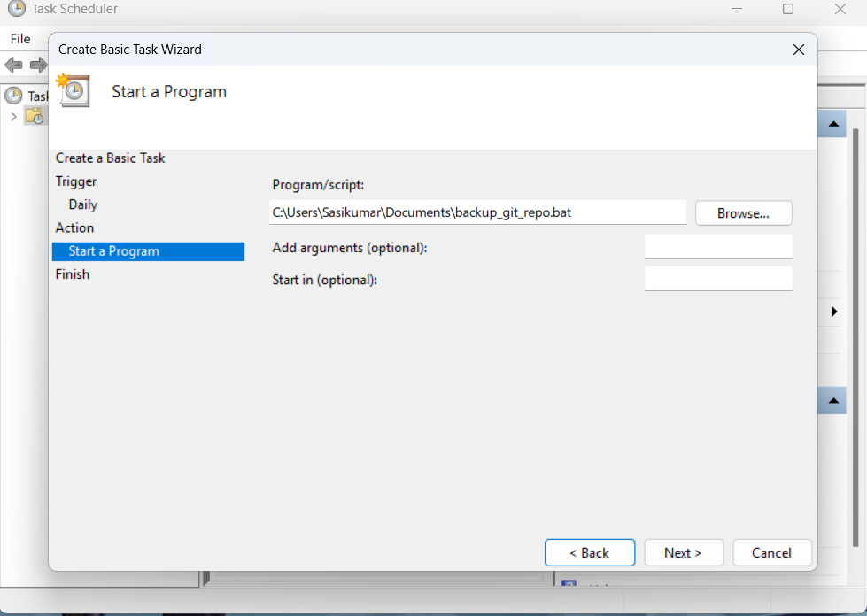

* Finish the setup.

**STEP 5: Verification:**

* Ensure that backups are being created in the correct directory.
* Check backup_log.txt for timestamps confirming successful backups.

