 

**Placement Empowerment Program**

***Cloud Computing and DevOps Centre***

**Use Cloud Storage**

*Create a storage bucket on your cloud platform and upload/download files. Configure access permissions for the bucket.*

Name:Yasvanth Rajan E Department : AML



**Introduction and Overview**

In this (PoC), we will explore AWS S3 (Simple Storage Service) to understand its functionality as a reliable cloud storage solution. The task involves creating an S3 bucket, uploading and downloading files, and configuring access permissions to manage who can access the stored data. This PoC demonstrates S3's versatility in securely storing and retrieving files, both publicly and privately. We will also set bucket policies to control access and test public URLs for hosted files. By completing this task, we gain hands-on experience with S3 and its key features, such as scalability, security, and cost-efficiency.

**Objective**

The goal of this project is to:

1. Understand AWS S3 Basics: Learn how to create, configure, and manage an S3 bucket for cloud storage.
2. File Operations: Gain hands-on experience in uploading, downloading, and managing files within the S3 bucket.
3. Access Control: Configure bucket policies and permissions to manage secure and public access to stored data.

**Importance of Storage Bucket(S3)**

**Foundation for Advanced Use Cases**: Learning how to handle S3 storage is a stepping stone for mastering cloud computing and deploying large-scale applications.

**Hands-On Learning of Cloud Storage**: AWS S3 provides a practical platform to learn cloud storage concepts, enabling users to create buckets, upload/download files, and manage data at scale.

**Data Security and Access Control**: By configuring bucket policies and permissions, users can secure their data and manage who can access it.

**Step-by-Step Overview**

Step1:

Go to the AWS Management Console, Search for and click on S3

Click the "Create bucket" button.

Enter a unique bucket name (samplebucket).

Leave "Block all public access" enabled for now (you can modify it later).

Click "Create bucket".

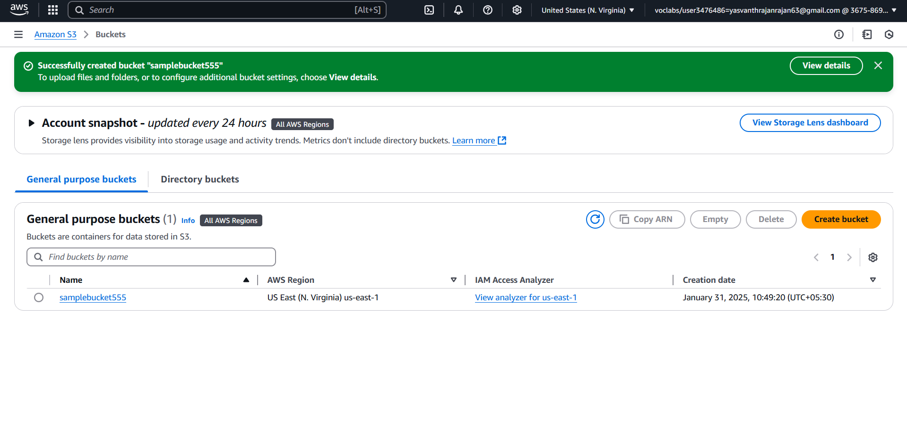

Step 2 :

Open your newly created bucket from the S3 console.

Click "Upload" and then,

Drag and drop your file(s) or use the Add files button.Click Upload to complete.

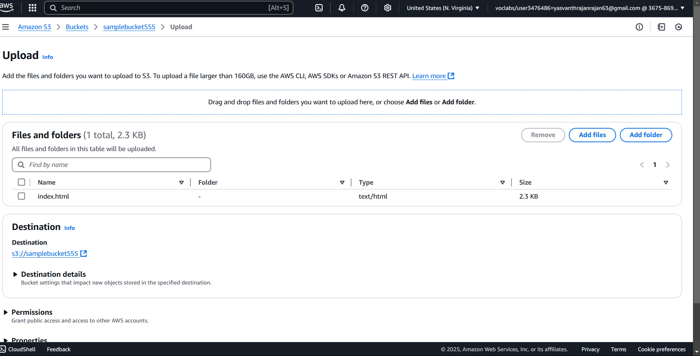

Step 3 :

Go to the uploaded file in your bucket. Click the file name to open its details. Select Download to save the file locally.

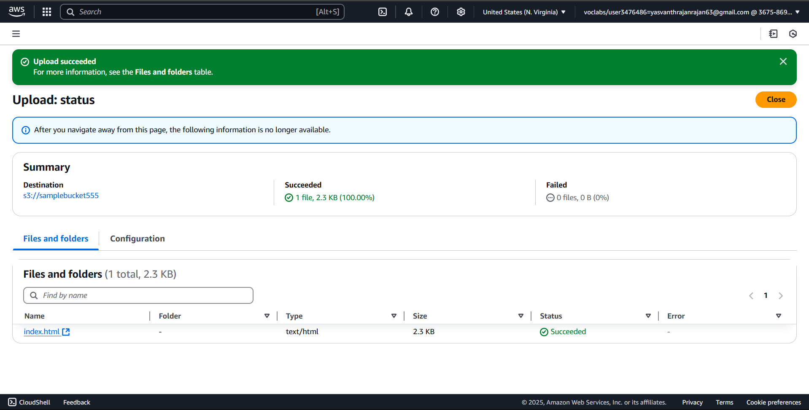

Step 4 :

Open your bucket and navigate to the "Permissions" tab.

Under Block public access, click Edit and uncheck "Block all public access". Confirm by typing "confirm" and save.

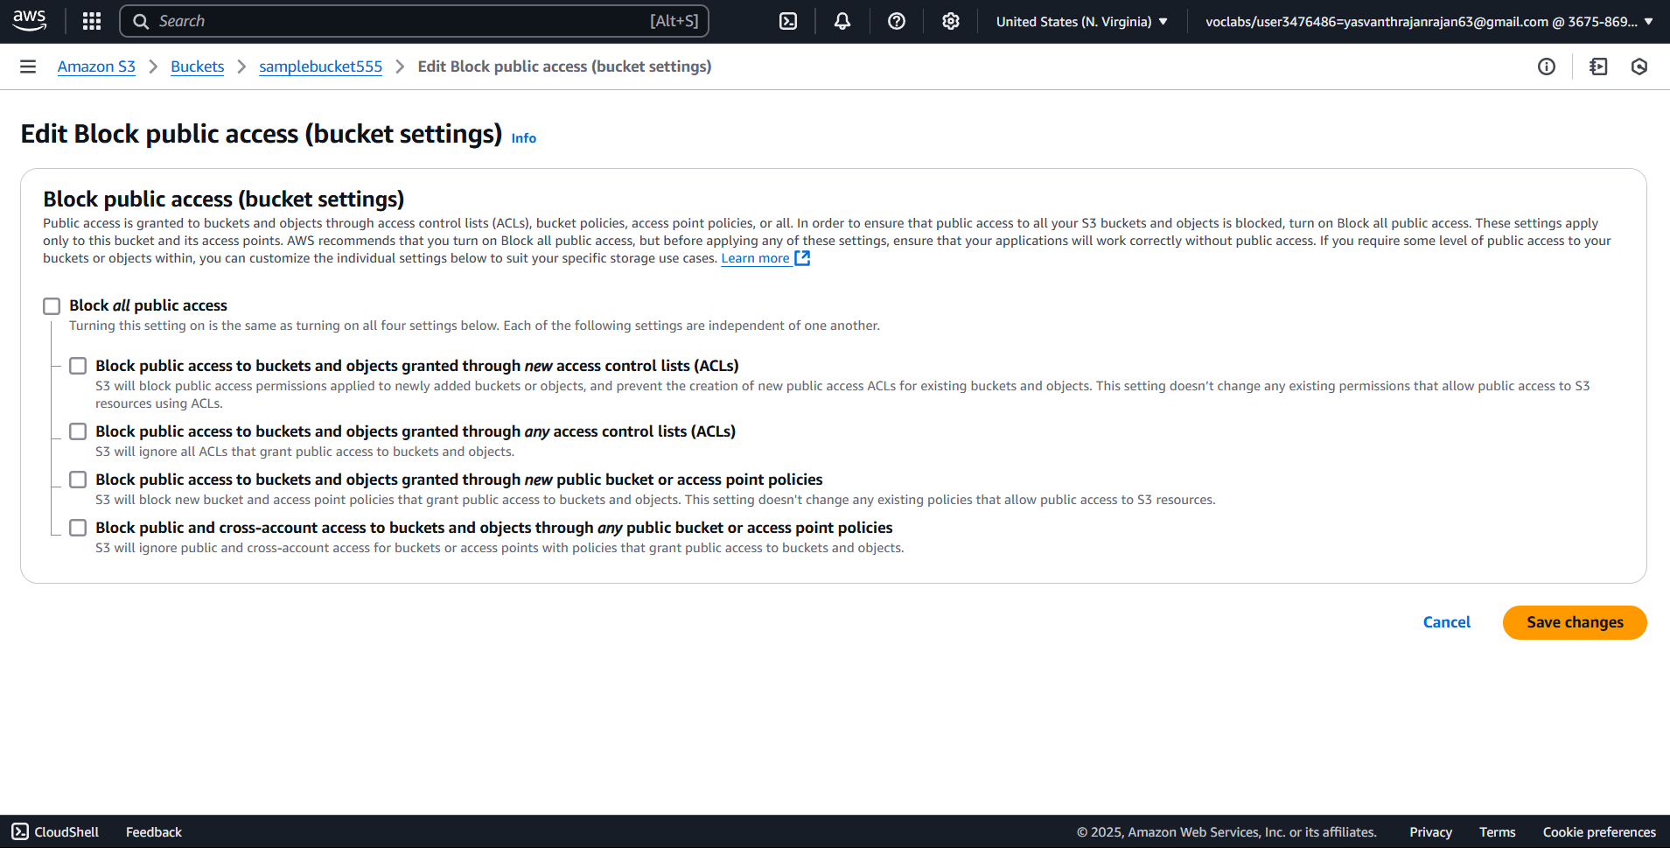

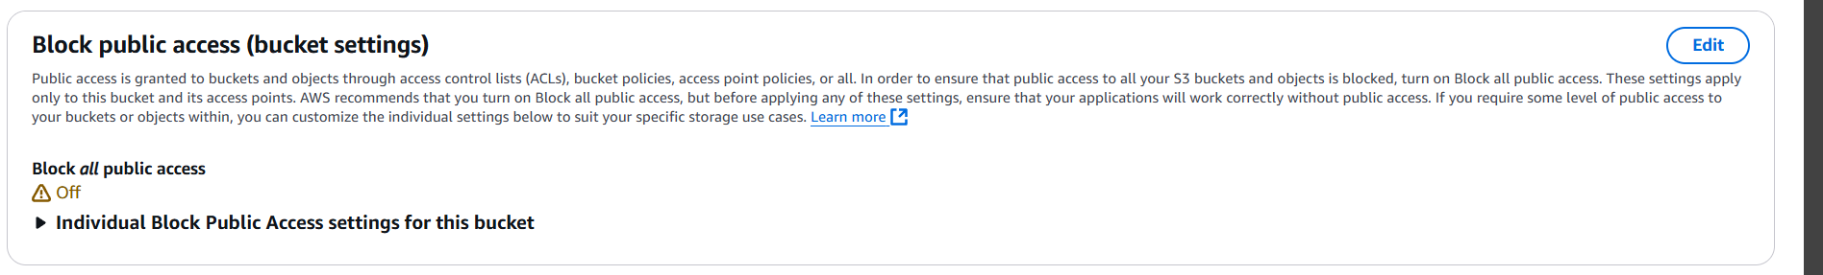

Step 5 :

In the "Permissions" tab, scroll to Bucket Policy and click Edit.Replace your-bucket-name with your actual bucket name.Save changes.

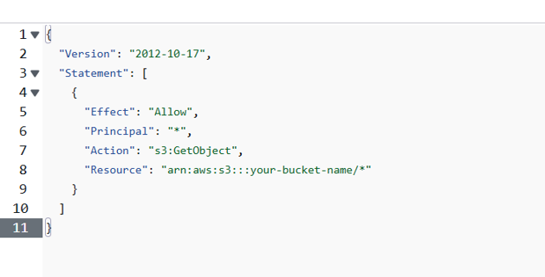

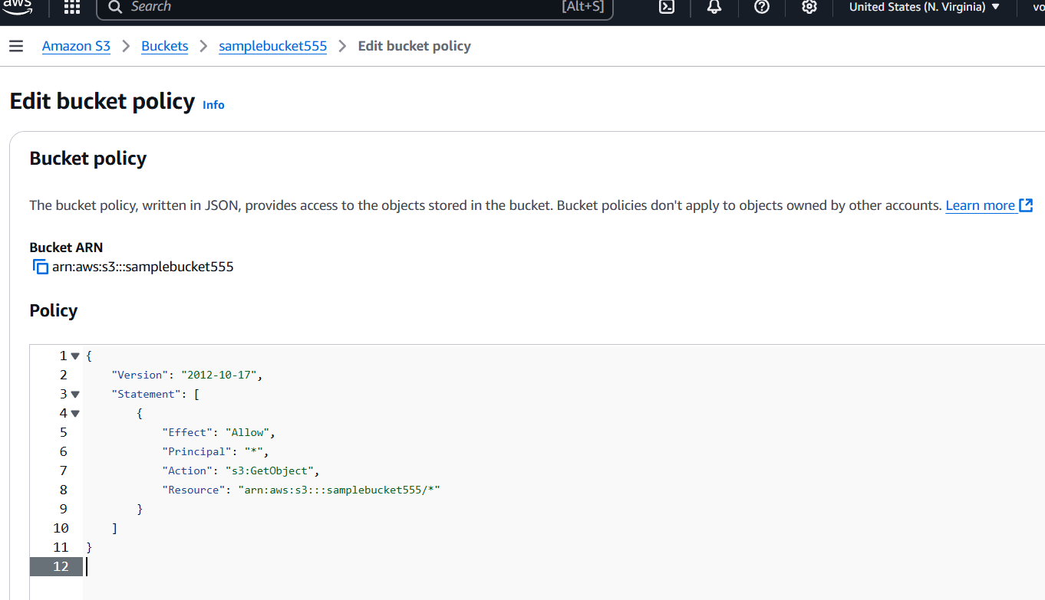

Step 6:

Use the S3 bucket URL or public file URL to test access permissions.

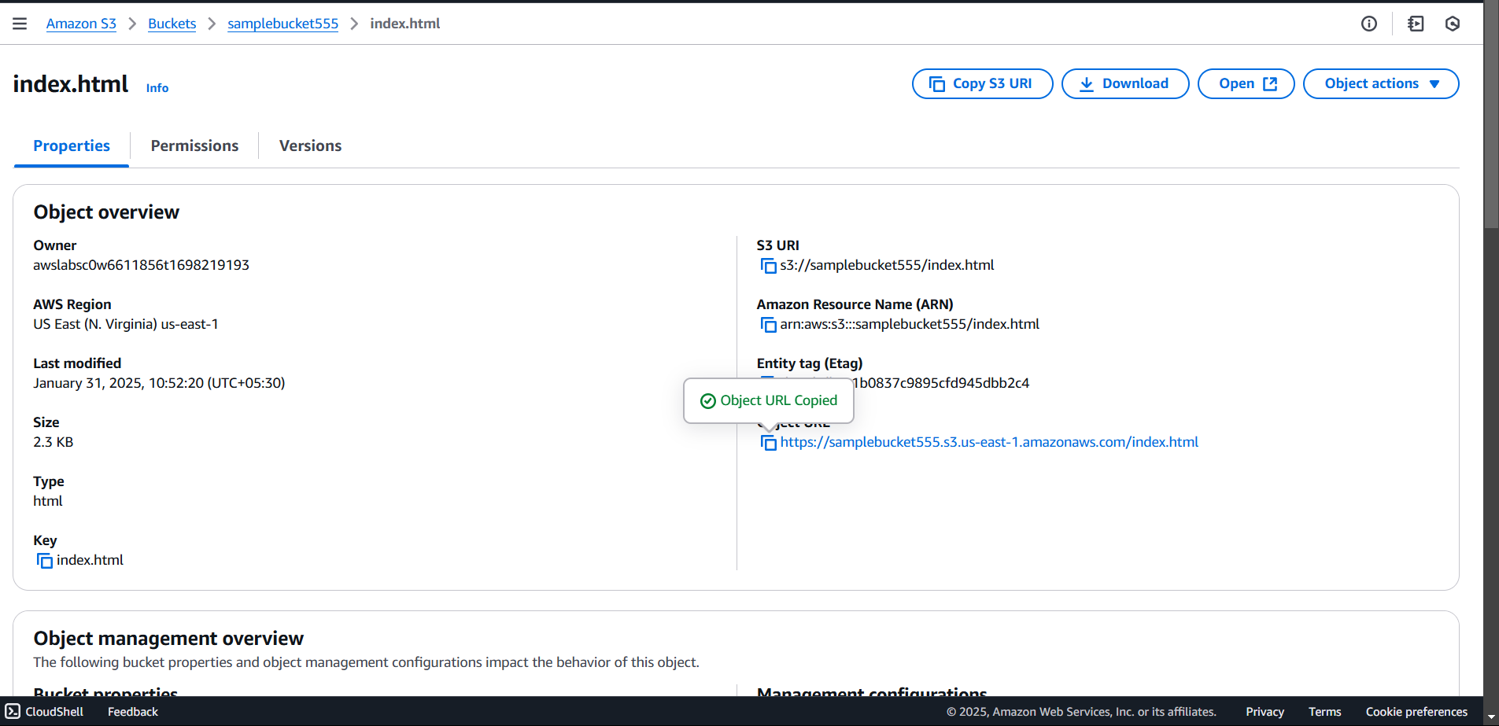

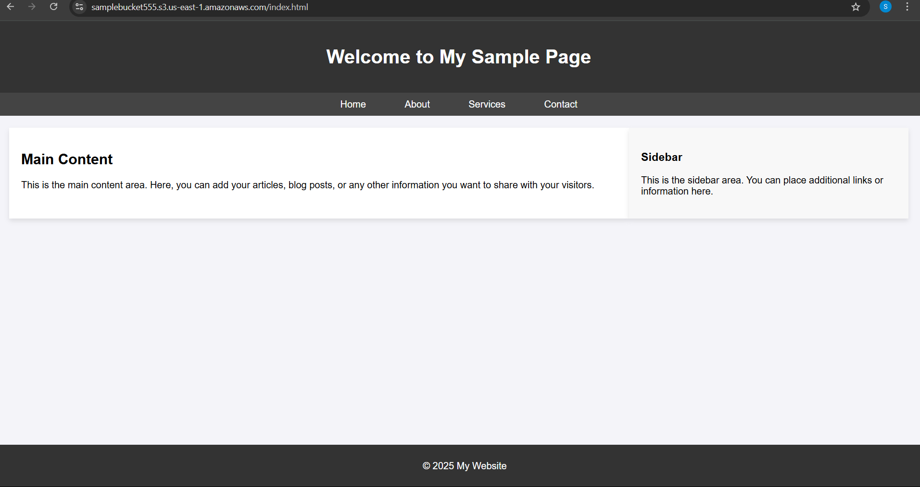

**Expected Outcome**

By completing this POC, you will:

1. Successfully create an AWS S3 bucket and perform file upload/download operations.
2. Configure and validate access permissions, ensuring secure or public access as needed.
3. Gain a solid understanding of S3's functionality, enabling its use in real-world cloud-based applications.