16 Mar 2026 (DAY 1)

Introduction to SDLC and Agile
12 Principles of Agile
Agile manifesto
5 values of Agile – Communication, Simplicity, constant feedback, courage, Humanity
Common characteristics of Agile – Incremental & Iterative model, Cooperative, Adaptive
Agile methods and practices (frameworks)
- Scrum ***
- Kanban **
- Srumban * (Scrum + Kanban)
- Extreme programming (XP)
Agile vs Waterfall
SRUM :
REQUIREMENT USER STORIES RPM(by product owner) PB (outcome of RPM) SPM SB (by scrum master) owned by development team Start Sprints (Start date, end date, sprint goal) DSC if challenges then written in IB which is owned by scrum master once the sprint is done SR DOD definition of Done SRE

REQUIREMENT
get requirements into modules – User Story
Acceptance testing – when requirement is matched then AT
USER STORY
As a “role”, I want to “perform task”, so that “achievement”
Eg :
As a “user”, I want to “login on UST page”, so that “I can access all of its tools”
As a “guest”, If I try to “login on UST page”, then “I should not able to access the tools”
Assign each user story to each employee
How to assign – using meetings with 3 roles
Roles of Scrum:
- Product owner [po]
- Scrum master [sm]
- Development team [dt]
Meeting:
- Release Planning meeting [RPM]
- Scrum/Sprint Planning meeting [SPM]
- Daily Scrum Call/Standup call [DSC]
3 questions in DSC
- Task you did yesterday?
- Task you are going to do today?
- Any challenges?
- Spring Review [SR]
- Spring Retrospective [SRE]
Documentation:
- Backlogs [Documentation]
- Product Backlog [PB]
- Sprint Backlog [SB]
- Impediment Backlog [IB]
Estimation:
- Planning Poker
- Story Points

Project management tools
- Jira
- Rally
- Monday
KanBan – Kan : virtual ; Ban : Board
Jira login Create story epic assign to people create sub task etc etc

17 Mar 2026 (DAY 2)

TESTING
What and why testing
What is QA, QC
Impact of poor testing
7 principles of software testing
Types of testing:
- Functional Testing
  - Black Box Testing – Source code is not exploit (tested with UI)
    - Equivalence partitioning testing
    - Boundary value analysis testing
    - State transition testing
    - Decision table technique
    - Etc etc
  - White box Testing – Source code is visible
    - Statement coverage
    - Branch coverage
    - Path coverage
  - Grey Box Testing – Black box + grey box
- Non-Functional Testing (Performance Testing)

V-Model:
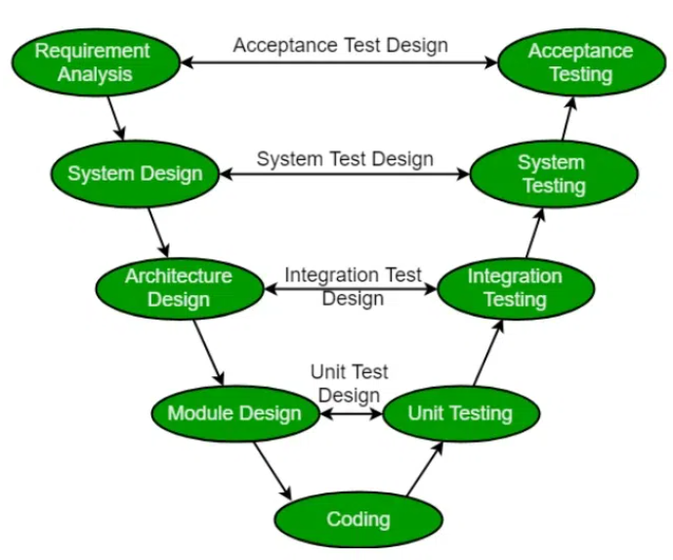
Other functional testing
- Re-testing: when bug is found and reported, solved and testing again
- Regression testing: when new update is done, testing is done to see if there are any bugs. Usually happens once in fortnight or once in a month
- Smoke testing
- Sanity testing
STLC (Software Testing Life Cycle):
- Requirement Analysis
- Test Planning
- Test Case Development
- Test Environment Setup
- Test Execution
- Test Closure
Error/Bug/Failure:
Error:
Bug:
Failure:
Defects: It is error or bug in application, if large number of defects are found then it is Buggy.
Defect Life cycle:
- Find Defect
- Verify defect with Test Lead/Manager
- Bug is assigned to developer
- If developer don’t accept, mark it rejected
- If not solved reopen
- If accepted fixed verified closed
- If deferred, then the defect will be solved in next release
Defect Severity
Defect Priority

