**Team Members:**

Yaswanth Bandaru

Tanuja Pollineni

Lakshmi Vandana Nunna

**Questions:**

**1. Why we use stop words? Why stop words are not necessary for NLP frequency distribution.**

Stop words are used to eliminate words with little meaning, but they are also essential in certain scenarios, such as sentiment classification, to provide context. In frequency distributions, stop words are unnecessary as they cause data noise and reduce the accuracy of the prediction.

**2. Based on high frequency words what information you can extract from the graph?**

We can understand a topic better by understanding the words that are appearing most frequently and what emotions are associated with it.

**3. Can you provide different visualization for frequency distribution? If yes, please perform. If no, why?**

Word Cloud without removing stop words

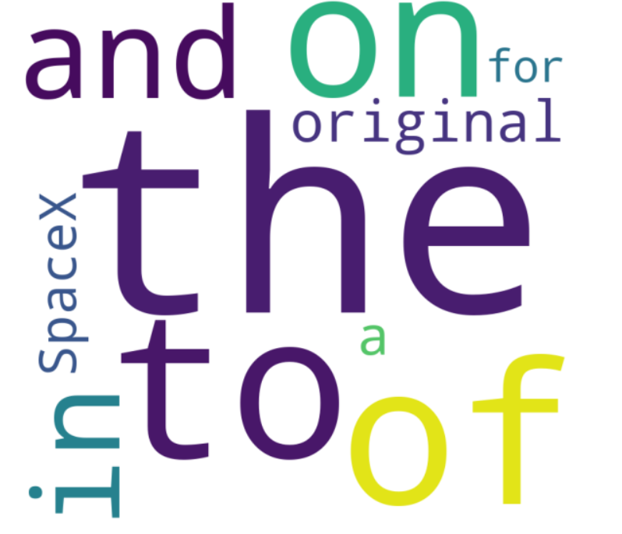

Word Cloud after removing stop words and less frequent words

