SIMATS ENGINEERING (SAVEETHA SCHOOL OF ENGINEERING)
Department of Computer Science and Engineering
CO1 ASSESSMENT TOOL 1 – CASE STUDY ANALYSIS
Course Code | CSA10 / CSA1004 | Course Title | Software Engineering
CO Assessed | CO1 | Assessment | Case Study Analysis
Student Name | Yaswanth Kumar H | Register Number | 1911260228
Year / Batch | First Year / Batch 2 | Programme | B.Tech CSE
SMART INTERNSHIP AND PLACEMENT MANAGEMENT SYSTEM

1. Understand the Problem Statement
Our project is about making a website that helps a college manage internships and campus placements in one place. Usually, information about jobs, student details, interview dates, and offers may be shared through different messages, emails, forms, or spreadsheets. Because of this, students may miss updates and placement staff may have to check the same information many times. There can also be mistakes or duplicate records.
In our proposed system, students, placement officers, and company recruiters can use the same platform. Students can create their profiles, see job and internship openings, check whether they are eligible, apply, and follow their application status. Recruiters can post opportunities and update selection details. Placement officers can manage the process and keep records updated.

Objectives
- To maintain student profiles with academic details, skills, projects, and resumes.
- To store company and recruiter information in one place.
- To publish job and internship opportunities with their requirements and last dates.
- To check whether students meet the eligibility requirements.
- To help students track their applications.
- To manage interview dates and share interview information.
- To record offer details and joining status.
- To prepare simple reports about placement activities.

Scope of the project
The system will mainly cover the placement process, starting from student registration and opportunity posting to applications, interviews, offers, and joining updates. It is planned for use by students, placement officers, and recruiters. At first, it can be used within one college and later improved for more departments or campuses.

2. Key Stakeholders and Challenges
Stakeholders are the people who use the system or are affected by it. The main stakeholders in this project are students, placement officers, recruiters, faculty coordinators, and college administration.
Stakeholder | Role | Challenges faced
Students | Create profiles, upload resumes, apply for openings, and attend interviews. | They may miss announcements or find it difficult to know their eligibility and application status.
Placement officers | Manage student details, verify eligibility, coordinate interviews, and prepare reports. | Checking details manually takes time and can lead to errors or duplicate records.
Recruiters / companies | Post job openings, mention requirements, shortlist students, and share results. | It may be difficult to collect complete student details and coordinate interviews.
Faculty coordinators | Help students and support the placement team with required academic information. | Updates may be delayed or different records may not match.
College administration | Review placement reports and understand overall placement performance. | Collecting accurate information from many files can take extra time.
All these users need correct information and timely updates. The system must also protect student details and make sure only the right people can view or change information.

3. Analyze the Current Approach
At present, a college may share placement information through notice boards, emails, messaging groups, online forms, and spreadsheets. Students send their details, and placement staff compare them with company requirements. Interview schedules and offer information may be maintained separately. This method can work for a small number of students, but it becomes harder to manage when many students and companies are involved.

Strengths
- It is easy to start using forms, emails, and spreadsheets.
- It does not require a specially developed system at the beginning.
- Staff can manually handle unusual cases when needed.

Limitations and problems
- Student details may be entered more than once or become outdated.
- Manual eligibility checking takes time and mistakes may happen.
- Students can miss deadlines if updates are shared in different places.
- Interview schedules and application status are harder to track.
- Preparing placement reports requires collecting information from several files.
- Shared files may not have clear access control or updated versions.
Therefore, the main problem is that the information is spread across different places. A single system can help keep the details together and make the process easier to follow.

4. Proposed Solution and Software Engineering Principles
We propose a website with separate login access for students, placement officers, and recruiters. Each user will see the options needed for their role. The website will store information in a common database. When a company posts a job, the system can compare the job requirements with the details in student profiles and show whether a student appears eligible. Users can then follow applications, interviews, and offers through the website.

Main modules
- Login and user profiles: Users can sign in, and students can add or update their details.
- Student profile management: Stores academic details, skills, projects, and resumes.
- Company and opportunity management: Recruiters can add company details and publish job or internship openings.
- Eligibility checking: Compares student information with the requirements given for an opportunity.
- Application tracking: Shows whether an application is submitted, shortlisted, selected, or rejected.
- Interview scheduling: Stores interview dates, times, and other instructions.
- Offer management: Records offers and whether students accept them, reject them, or join.
- Reports: Shows basic information such as applications, shortlists, and offers.

Requirements
Functional requirements: The system should allow users to log in, update profiles, add companies and openings, check eligibility, apply for jobs, track applications, schedule interviews, update offers, and prepare reports.
Non-functional requirements: The website should be easy to use, secure, reliable, and able to handle more users in the future. It should work properly on common devices, protect private student information, and keep backup copies of important records.

Software engineering principles used
- Modularity: The system is divided into smaller parts, such as profiles, applications, interviews, and reports. This makes each part easier to update.
- Scalability: The design should allow more students, companies, and departments to be added later.
- Maintainability: Clear code and documentation will make it easier to fix errors and add new features.
- Reliability: Checking entered data, avoiding duplicate applications, and keeping backups can help reduce errors.
- Usability: Simple menus, clear status messages, and reminders can make the website easier to use.
- Security: Login and different access permissions can help protect student and company information.

5. Chosen Methodology: Agile
For this project, we suggest using the Agile method. Agile means developing the software in small steps and improving it using feedback. This is suitable because we may understand some requirements better after students, placement staff, and recruiters try an early version of the website.
First, we can create login and student profiles. Next, we can add company details and job postings. After that, we can work on eligibility checking and application tracking, followed by interview scheduling, offers, and reports. Each part can be tested before moving to the next part. Feedback can be used to correct mistakes and improve the system.
Agile is useful because it helps the team focus on the most important features first. It also allows changes during development and helps find problems earlier. Team members can divide the work, review each other's progress, and test the system regularly. This can make the project easier to develop and maintain.

6. Expected Outcomes, Limitations, and Future Enhancements

Expected outcomes
- Placement activities can be managed more easily in one place.
- Placement officers may spend less time doing repeated manual work.
- Students can find suitable jobs and internships more easily.
- Students and recruiters can receive clearer updates.
- Application, interview, offer, and joining records can be kept more accurately.
- Reports can help the college understand placement performance.

Limitations and risks
The system will work well only if the information entered by students and recruiters is correct and updated. Developing and testing the website will take time. Some users may need help learning to use it. Student data must be protected, and wrong eligibility rules can show incorrect results. For special cases, placement staff should be able to review the details instead of depending only on automatic checking.

Future improvements
- Connect the website with the college student information system.
- Suggest jobs based on students' skills and interests.
- Make a mobile-friendly version or mobile application.
- Add calendar reminders for interviews and deadlines.
- Show more detailed placement reports by department and year.
- Add a record of important changes to improve accountability.

7. Feasibility, Benefits, and Future Improvements
Before developing the system, it is useful to consider whether it is practical for a college project. The proposed website can be built in stages, starting with a small version and adding features after the basic functions are checked.

7.1 Feasibility Study

Technical feasibility
A web-based system is practical because students, recruiters, and placement officers can access it through a browser. The first version can use common web technologies and a database to store profiles, openings, applications, and interview details. It can begin with simple forms and lists before more advanced features are added.

Operational feasibility
The system supports activities that colleges already perform. Users would continue following the usual placement process, but the information would be kept in one place. Simple instructions and role-based screens can help different users learn how to use the website.

Economic feasibility
A student prototype can use available learning tools and open-source technologies, keeping the initial cost low. If the college later uses it officially, hosting, maintenance, backups, and user support costs would need to be considered.

7.2 Expected Benefits
- Students can check opportunities and application status without searching through many separate messages.
- Placement officers can reduce repeated data entry and prepare reports from one set of records.
- Recruiters can publish requirements in a consistent format and review applications more easily.
- Interview dates and offer details can be stored with the relevant application.
- Shared records can reduce confusion, although accuracy still depends on correct information being entered.

7.3 Future Improvements
After the core features work, the system could be improved with email or calendar reminders, a mobile-friendly interface, job suggestions based on skills, and more detailed placement analytics. It may also connect with the college's existing student information system. These features should be considered after privacy, access permissions, and the basic workflow have been checked.

8. System Requirements and Main Process Flow
This section describes the main requirements of the proposed website and how users may interact with it. These are planned requirements based on the problem statement.

8.1 Functional Requirements
ID | Requirement | Purpose
FR1 | Users can sign in with assigned access. | Identify users and protect records.
FR2 | Students can create and update profiles. | Keep academic and skill details current.
FR3 | Recruiters can manage company details and openings. | Make opportunities available.
FR4 | The system compares profiles with eligibility criteria. | Support eligibility checking.
FR5 | Students can apply and view application status. | Follow selection progress.
FR6 | Authorized users can record interviews and offers. | Keep placement steps organized.
FR7 | Placement officers can view basic reports. | Review placement activity.

8.2 Non-Functional Requirements
- Usability: Pages should use simple labels and clear instructions.
- Security: Users should only view or change information allowed by their role.
- Reliability: Saved information should remain available during normal use.
- Performance: Common actions should respond without unnecessary delay.
- Maintainability: The website should be divided into modules that can be updated separately.
- Scalability: The design should allow more students, recruiters, and opportunities later.

8.3 Main Process Flow
A student signs in and completes a placement profile. A recruiter adds a company opening with eligibility criteria and a closing date. The system compares the student's recorded details with the criteria and shows a result. If the student applies, the application is saved and its status can be updated by an authorized user. Shortlisted students receive interview details. After selection, the placement officer records offer and joining information. The saved records can then be used to prepare placement reports.

9. Testing Approach and Risk Management
Testing is important because the system will store student details and support important placement activities. The checks below are planned tests for a future working version, not claims that a finished system has already been tested.

9.1 Basic Test Plan
Feature | Test Check | Expected Result
Student registration | Submit a form with all required fields. | Profile is saved and confirmation appears.
Required fields | Leave a required field empty and submit. | The missing information is identified.
Opportunity listing | Add an opening and view the list. | The opening appears with its main details.
Eligibility checking | Compare a sample profile with the criteria. | A result is shown based on recorded details.
Application status | Change an application to shortlisted. | The latest status is displayed.
Interview scheduling | Save an interview date and time. | The correct schedule appears with the application.
Access control | Try to open a restricted page. | Access is denied or sign-in is requested.

9.2 Main Risks and Possible Solutions
Risk | Possible Effect | Possible Solution
Incorrect student details | Eligibility results may be wrong. | Validate fields and let students review profiles.
Outdated job requirements | Students may use old information. | Show posting dates and allow authorized updates.
Privacy problem | Information may be seen by the wrong person. | Use role-based access and secure login.
Missed notifications | Students may miss deadlines. | Show dates clearly and consider reminders.
Duplicate records | Reports may contain incorrect totals. | Check for existing records before saving.

9.3 Testing Process
Testing can begin with sample student and company records. Each form should be checked with complete and incomplete information. The team can then test the path from publishing an opportunity to submitting an application and recording an interview. Problems should be written down, corrected, and tested again. This will help find mistakes before real placement data is entered.

Conclusion
The Smart Internship and Placement Management System is a useful idea for making college placement activities easier to manage. It brings student details, job openings, applications, interviews, and offers together in one place. It can reduce manual work, help students receive updates, and support accurate reports. By using simple modules and developing the website step by step with Agile, the project can be improved based on feedback and future needs.

OUTPUT
Jira Scrum Board – Smart Internship and Placement Management System
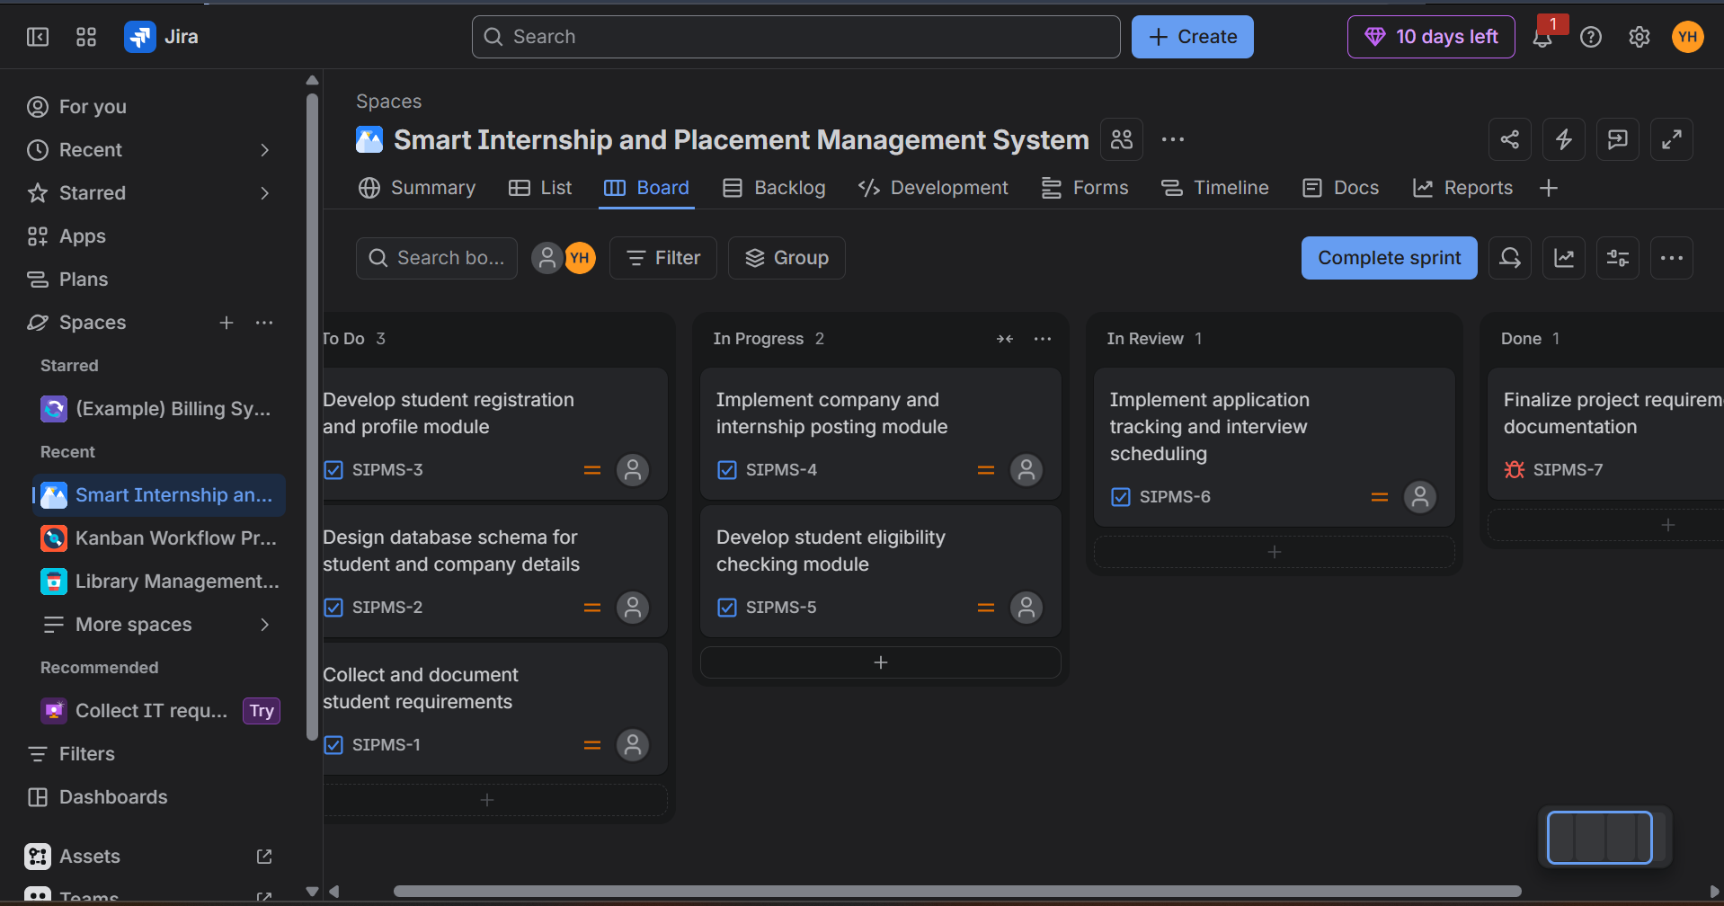
Figure: Jira Scrum board showing the project tasks and workflow statuses.

