SIMATS ENGINEERING
(SAVEETHA SCHOOL OF ENGINEERING)
Department of Computer Science and Engineering
CO1 ASSESSMENT TOOL 2
AGILE SPRINT PLANNING & USER STORY WORKSHOP

Student / Assessment Details | Information
Project Title | Smart Internship and Placement Management System
Student Name | Yaswanth Kumar H
Register Number | 1911260228
Year / Batch | First Year / Batch 2
Programme / Department | B.Tech CSE / Computer Science and Engineering
Course Code and Name | CSA1004 – Software Engineering
Faculty Name | Dr. K Anita Davamani
Assessment | CO1 Assessment Tool 2 – Agile Sprint Planning & User Story Workshop

Code of Conduct
I, Yaswanth Kumar H (Register Number 1911260228), certify that this submission has been prepared for the given assessment and that I have followed the academic guidelines provided by the department.
Student Signature: ______________________________

1. Project Vision and Stakeholders

1.1 Project Vision
The vision of this project is to make internship and campus placement activities easier to manage through one website. Students should be able to maintain their profiles, view suitable opportunities, apply for them, and check their application status. Recruiters should be able to publish openings and review applications, while placement officers can coordinate interviews and keep records in one place. The aim is to reduce repeated manual work and help everyone receive clear updates.

1.2 Main Objectives
- Maintain student profiles with academic details, skills, projects, and resumes.
- Store company details and publish job or internship openings.
- Check student eligibility against the requirements of an opportunity.
- Track applications, interviews, offers, and joining updates.
- Help placement officers prepare simple and accurate reports.

1.3 Key Stakeholders and Their Roles
Stakeholder | Role in the System | Main Need
Students | Create profiles, upload resumes, view openings, apply, and check status. | Clear eligibility information and timely updates.
Placement Officers | Manage student details, verify eligibility, coordinate interviews, and prepare reports. | Accurate records and less repetitive manual work.
Recruiters / Companies | Post vacancies, review applicants, shortlist students, and share results. | Relevant student details and easier coordination.
Faculty Coordinators | Support students and share required academic information with the placement team. | Consistent information and clear communication.
College Administration | Review placement summaries and overall placement performance. | Reliable reports for planning and decisions.

These stakeholders may use different parts of the system, so access should depend on their role. For example, a student should be able to update their own profile, while a recruiter should manage their company openings and applications assigned to them. Student information should not be visible to people who do not need it.

2. Epics and User Stories
An epic is a larger area of work that can be divided into smaller user stories. The user stories below are written from the point of view of the person using the system and explain why the feature is useful.
Epic | User Story | Priority
Student Profile | As a student, I want to create and update my placement profile, so that recruiters can review my academic details and skills. | High
Opportunity Management | As a recruiter, I want to post job and internship openings, so that eligible students can find and apply for them. | High
Eligibility Checking | As a student, I want to see whether I meet an opportunity's criteria, so that I can focus on suitable openings. | High
Application Tracking | As a student, I want to view my application status, so that I know whether it is submitted, shortlisted, selected, or rejected. | High
Interview Scheduling | As a placement officer, I want to record interview dates and instructions, so that students and recruiters know the schedule. | Medium
Offer Management | As a placement officer, I want to record offer and joining details, so that placement records remain up to date. | Medium
Reports | As a college administrator, I want to view placement summaries, so that I can understand placement activity. | Medium

3. Acceptance Criteria
Acceptance criteria are checks that help decide whether a user story works as expected. The Given–When–Then format is used below so the requirements are clear and can be tested.

Story 1: Student Profile
Given a student has opened the registration page, when the student enters the required details and submits the form, then the system should save the profile and show a confirmation message.
Given a student has an existing profile, when the student updates permitted fields and saves them, then the updated details should appear when the profile is opened again.

Story 2: Opportunity Posting
Given a recruiter is signed in, when the recruiter enters the role, eligibility criteria, location, and last date and submits the opening, then the opportunity should appear in the list of available openings.
Given a required field is missing, when the recruiter submits the form, then the system should identify the missing information and ask the recruiter to complete it.

Story 3: Eligibility Checking
Given an opportunity has eligibility rules and a student profile contains the required academic details, when the student views the opportunity, then the system should show whether the recorded details meet the stated rules.
Given some required student information is missing, when eligibility is checked, then the system should explain that the result cannot be confirmed until the information is completed.

Story 4: Application Tracking
Given a student has submitted an application, when the placement officer or authorized recruiter updates its status, then the student should see the latest status on the application page.
Given a student has not applied for an opening, when the student opens the application list, then that opening should not be shown as an application submitted by the student.

Story 5: Interview Scheduling
Given an applicant has been shortlisted, when an authorized user enters the interview date, time, and instructions, then the schedule should be saved and displayed with the relevant application.
Given an interview date or time is not entered, when the schedule is saved, then the system should ask for the missing information.

Story 6: Offer Records
Given a student has received an offer, when an authorized placement officer records the offer status, then the offer details should be available in the student's placement record.
Given an offer status is changed, when the record is saved, then the latest status should be displayed in the offer section.

4. Prioritized Product Backlog
The product backlog is the list of work that may be needed for the project. I have placed the basic features first because other features depend on having student, company, and opportunity information available. The order can be reviewed when more feedback is received.
Order | Backlog Item | Business Value / Reason | Priority
1 | Student registration and profile | Student information is needed for applications and eligibility checks. | High
2 | Company and recruiter details | The system needs company information before recruiters can publish openings. | High
3 | Create and publish job / internship openings | Students need to see real opportunities to use the system. | High
4 | Eligibility checking | Helps students understand whether they meet the listed criteria. | High
5 | Application submission and tracking | Lets students apply and follow their progress. | High
6 | Interview scheduling | Supports coordination after students are shortlisted. | Medium
7 | Offer and joining records | Keeps the final placement result in one place. | Medium
8 | Placement reports and analytics | Useful for reviewing results after core records are available. | Medium
9 | Reminders and future integrations | Can improve convenience after the basic system is stable. | Low / Later

Why this order was chosen
- Student and company records are the foundation for most of the other features.
- Posting opportunities comes before eligibility checking and applications because students need openings to respond to.
- Interview scheduling and offer management are later steps in the placement process.
- Reports become more useful when the system already contains application, interview, and offer data.
- Reminders and external system connections can be considered after the main features work reliably.

Dependencies
The profile module depends on registration and login. Eligibility checking depends on student profile details and opportunity criteria. Application tracking depends on published openings and submitted applications. Interview scheduling depends on the shortlisting process, and offer records depend on selection information.

5. First Sprint Backlog
For the first sprint, I selected a small set of high-priority tasks that form the base of the system. The sprint is planned as a one-week example. The exact duration and work items can be adjusted depending on the team's progress and feedback.

Sprint Goal
By the end of Sprint 1, prepare the basic student profile flow and the initial company / opportunity information structure, so that later sprints can build eligibility checking and application tracking on top of it.
Selected Story / Item | Development Tasks | Expected Result
Student profile | List required student fields; sketch the profile form; validate required fields; test saving and editing a profile. | A student can enter and update basic profile details.
Company details | List company fields; prepare the company information form; check required fields; test saving company details. | Company information can be recorded consistently.
Opportunity posting (basic) | List opportunity fields; create the opening form layout; include eligibility and last-date fields; test missing-field messages. | A recruiter can prepare an opening with the main details.

Sprint Task Checklist
- Confirm the required fields for student and company records.
- Create a simple screen or form layout for the selected features.
- Check that required fields are clearly marked.
- Try valid and incomplete sample entries.
- Record issues found during testing and correct the simple ones.
- Review the work against the user stories and acceptance criteria.

Work not selected for Sprint 1
Advanced reports, reminders, mobile application support, and external college-system integration are not included in this first sprint. They are useful ideas, but the core profile and opportunity features should be planned first.

6. Story Point Estimation
Story points are a relative estimate of effort, complexity, and uncertainty. For this plan, I used a simple Fibonacci scale (1, 2, 3, 5, 8). The values are estimates for planning, not exact hours. A team could discuss them using Planning Poker and change them after learning more about the work.
User Story | Points | Reason for Estimate
Create and update a basic student profile | 3 | A small form with required fields and basic validation; moderate effort.
Record company / recruiter details | 3 | Similar form-based work, with a few company-specific fields.
Post a basic job or internship opening | 5 | Includes several fields, eligibility details, and a last date, so it has more checks.
Check eligibility against listed criteria | 5 | Needs comparison between student details and opportunity requirements.
Track application status | 5 | Requires an application record and status changes to be shown correctly.

Why the estimates are reasonable
The profile and company forms are estimated at 3 points because their basic versions are straightforward but still need validation and testing. Opportunity posting is 5 points because it has more fields and date-related checks. Eligibility and application tracking are also 5 points because they depend on information from more than one part of the system. These estimates should be reviewed by the team before work begins.

7. Sprint Goal and Expected Deliverables

Expected Deliverables
- A draft student profile form with required fields identified.
- A basic structure for recording company and recruiter details.
- A draft opportunity-posting form with eligibility criteria and last date.
- A small set of test cases for valid and incomplete entries.
- A list of issues or improvements to carry into the next sprint.

Definition of Done
For this sprint, a task can be treated as done when the agreed fields are included, basic validation has been checked, the feature matches its user story, and the result has been reviewed. If something is incomplete, it should remain open and be moved to a later sprint.

Conclusion
This sprint plan breaks the Smart Internship and Placement Management System into smaller pieces that can be developed and checked step by step. The user stories describe what each stakeholder needs, while acceptance criteria explain how to check the features. Prioritizing the student and company information first gives the project a useful base. The estimates and sprint tasks are initial planning values and can be updated after feedback or testing.

JIRA SPRINT PLANNING OUTPUT
SIPMS – AT2 Sprint Planning
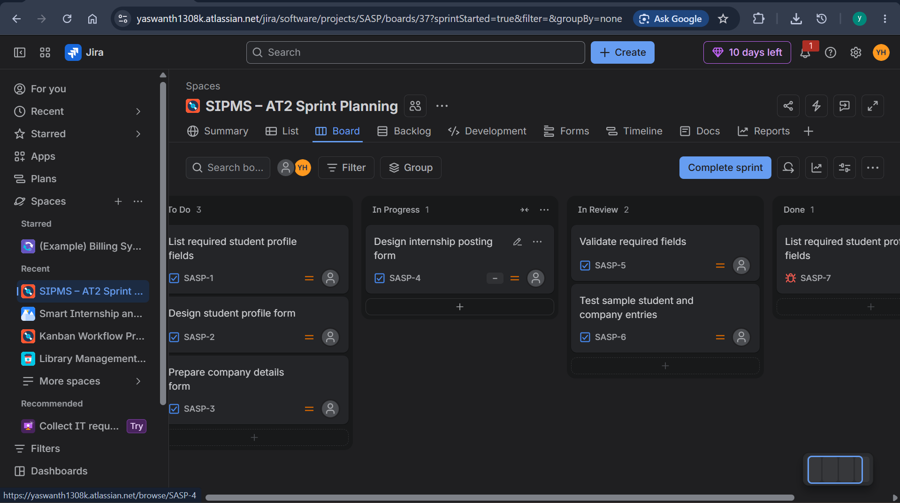
Figure: Jira Scrum board showing the sprint tasks across To Do, In Progress, In Review, and Done.

