Comparisition Graphs for Training and Testing for different Machine Learning Algorithms

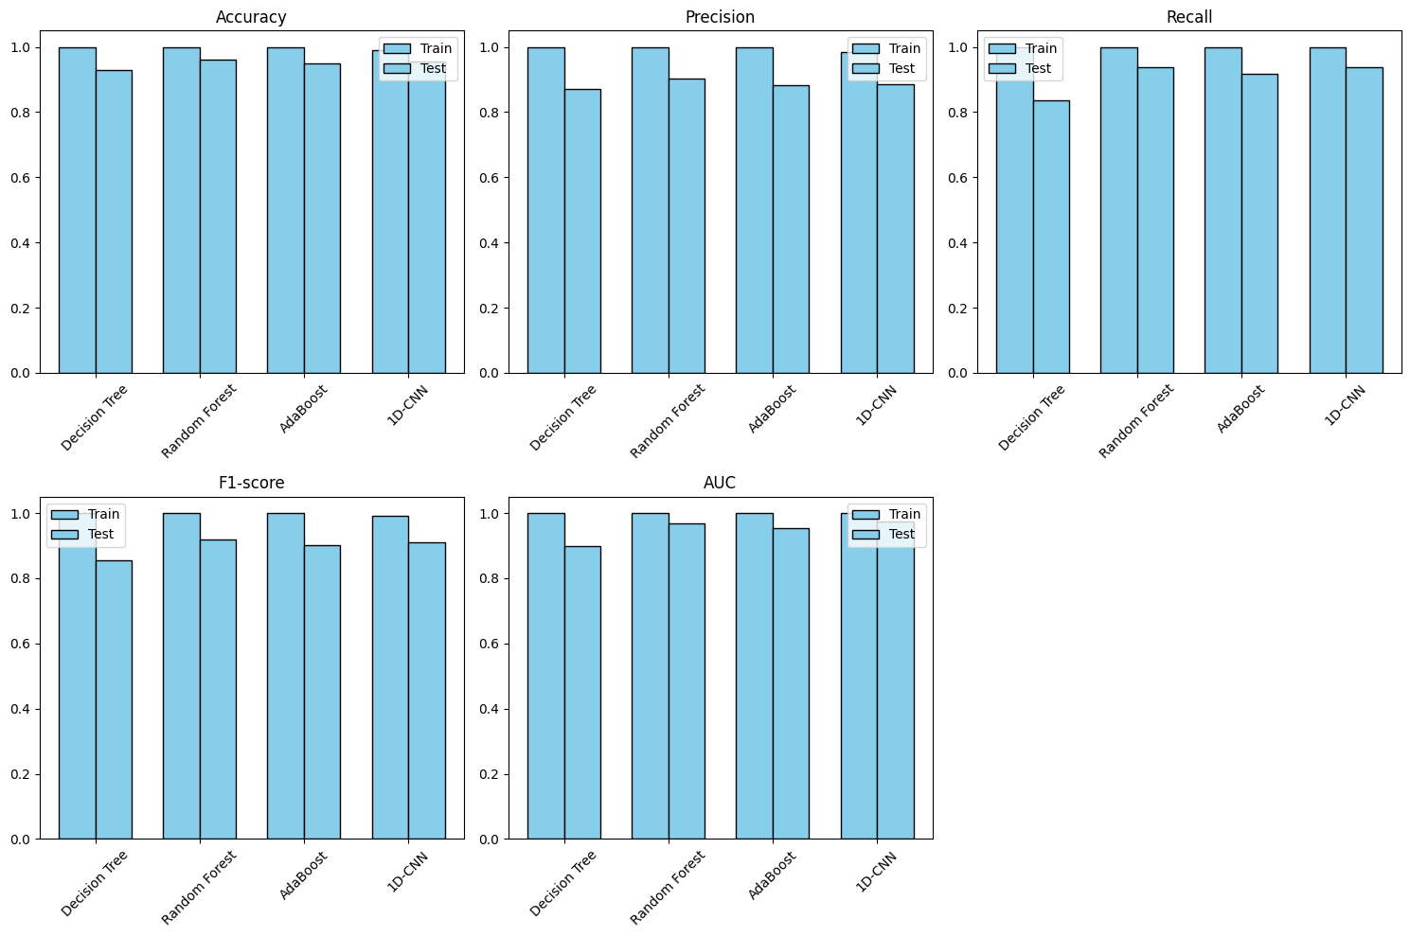

Metrics Comparisition for different Algorithms

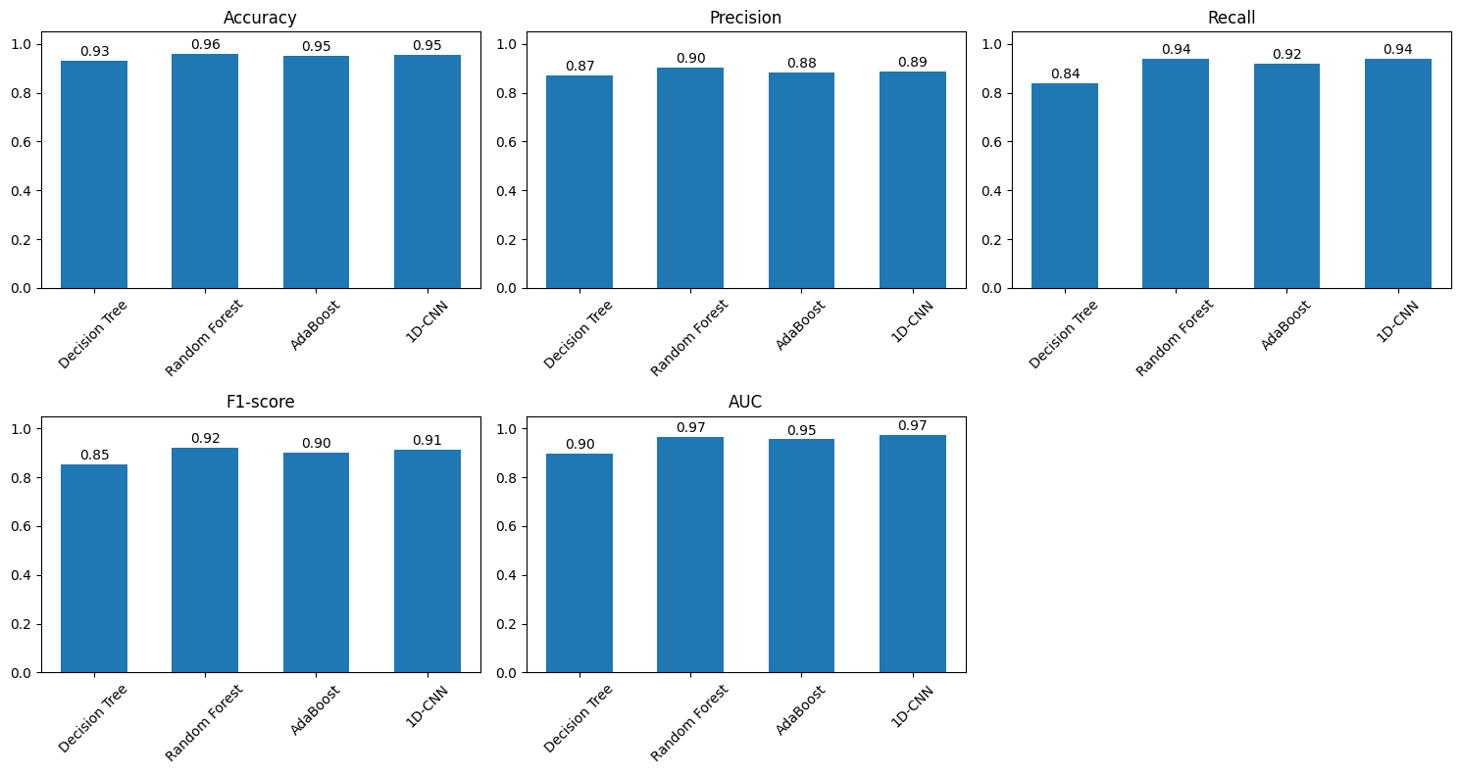
Roc Curve on test Set

7/7 ━━━━━━━━━━━━━━━━━━━━ 0s 5ms/step
