727722EUIT519-YASWANTH SS

QUESTION-1

package com.test.test;

import org.openqa.selenium.By;

import org.openqa.selenium.WebDriver;

import org.openqa.selenium.chrome.ChromeDriver;

import org.openqa.selenium.chrome.ChromeOptions;

import io.github.bonigarcia.wdm.WebDriverManager;

public class CC1 {

public static void main(String[] args) {

// TODO Auto-generated method stub

ChromeOptions co=new ChromeOptions();

co.addArguments ("--remote-allow-origins=*");

WebDriverManager.chromedriver().setup ();

WebDriver driver=new ChromeDriver(co);

driver.get ("https://www.saucedemo.com/");

driver.manage().window().maximize() ;

driver.findElement(By.xpath("//*[@id=\"user-name\"]")).sendKeys("standard_user");

driver.findElement(By.xpath("//*[@id=\"password\"]")).sendKeys("secret_sauce");

driver.findElement(By.xpath("//*[@id=\"login-button\"]")).click();

driver.findElement(By.xpath("//*[@id=\"add-to-cart-sauce-labs-backpack\"]")).click();

driver.findElement(By.xpath("//*[@id=\"shopping_cart_container\"]/a")).click();

String information=driver.findElement(By.xpath("//*[@id=\"header_container\"]/div[2]/span")).getText();

System.out.println(information);

String expectedinformation="Your Cart";

if(information.equals(expectedinformation))

{

System.out.println("Verified");

}

else

{

System.out.println("Not Verified");

}

driver.findElement(By.xpath("//*[@id=\"checkout\"]")).click();

driver.findElement(By.xpath("//*[@id=\"first-name\"]")).sendKeys("Yesh");

driver.findElement(By.xpath("//*[@id=\"last-name\"]")).sendKeys("ss");

driver.findElement(By.xpath("//*[@id=\"postal-code\"]")).sendKeys("1157");

driver.findElement(By.xpath("//*[@id=\"continue\"]")).click();

String product=driver.findElement(By.xpath("//*[@id=\"item_4_title_link\"]/div")).getText();

System.out.print(product);

String price=driver.findElement(By.xpath("//*[@id=\"checkout_summary_container\"]/div/div[1]/div[3]/div[2]/div[2]/div")).getText();

System.out.print(price);

String currentTitle=driver.getTitle();

System.out.println(currentTitle);

String expectedTitle="Swag Labs";

if(currentTitle.equals(expectedTitle)) {

System.out.println("Title Matched!");

}

else {

System.out.println("Title not Matched!!");

}

String currenturl=driver.getCurrentUrl();

System.out.println(currentTitle);

String expectedurl="https://www.saucedemo.com/checkout-step-two.html";

if(currenturl.equals(expectedurl)) {

System.out.println("Url Matched!");

}

else {

System.out.println("url not Matched!!");

}

}

}

OUTPUT:

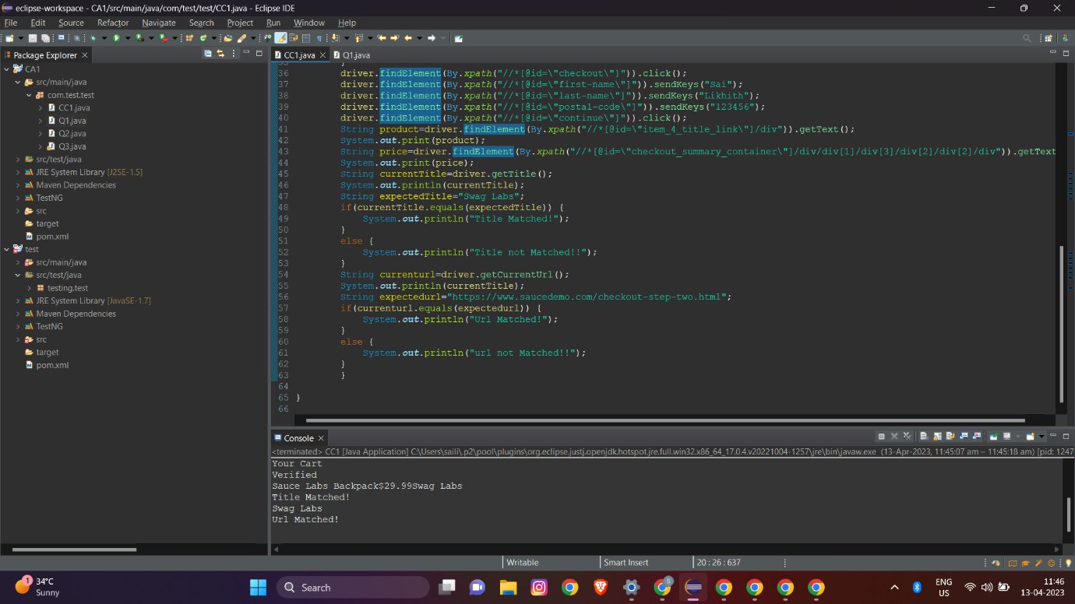

QUESTION-2

package com.test.test;

import org.openqa.selenium.By;

import org.openqa.selenium.WebDriver;

import org.openqa.selenium.chrome.ChromeDriver;

import org.openqa.selenium.chrome.ChromeOptions;

import io.github.bonigarcia.wdm.WebDriverManager;

public class CC1Q2 {

public static void main(String[] args) {

// TODO Auto-generated method stub

ChromeOptions co=new ChromeOptions();

co.addArguments ("--remote-allow-origins=*");

WebDriverManager.chromedriver().setup ();

WebDriver driver=new ChromeDriver(co);

driver.get ("https://www.saucedemo.com/");

driver.manage().window().maximize() ;

driver.findElement(By.xpath("//*[@id=\"user-name\"]")).sendKeys("standard_user");

driver.findElement(By.xpath("//*[@id=\"password\"]")).sendKeys("secret_sauce");

driver.findElement(By.xpath("//*[@id=\"login-button\"]")).click();

driver.findElement(By.xpath("//*[@id=\"header_container\"]/div[2]/div/span/select")).click();

driver.findElement(By.xpath("//*[@id=\"header_container\"]/div[2]/div/span/select/option[1]")).click();

String product=driver.findElement(By.xpath("//*[@id=\"item_4_title_link\"]/div")).getText();

System.out.println(product);

driver.findElement(By.xpath("//*[@id=\"header_container\"]/div[2]/div/span/select")).click();

driver.findElement(By.xpath("//*[@id=\"header_container\"]/div[2]/div/span/select/option[2]")).click();

String product1=driver.findElement(By.xpath("//*[@id=\"item_3_title_link\"]/div")).getText();

System.out.println(product1);

driver.findElement(By.xpath("//*[@id=\"header_container\"]/div[2]/div/span/select")).click();

driver.findElement(By.xpath("//*[@id=\"header_container\"]/div[2]/div/span/select/option[3]")).click();

String product2=driver.findElement(By.xpath("//*[@id=\"item_2_title_link\"]/div")).getText();

System.out.println(product2);

driver.findElement(By.xpath("//*[@id=\"header_container\"]/div[2]/div/span/select")).click();

driver.findElement(By.xpath("//*[@id=\"header_container\"]/div[2]/div/span/select/option[4]")).click();

String product3=driver.findElement(By.xpath("//*[@id=\"item_5_title_link\"]/div")).getText();

System.out.println(product3);

}

}

OUTPUT:

