

SCHOOL OF COMPUTER SCIENCE AND ENGINEERING (SCOPE)

SENIOR DESIGN PROJECT REPORT

ON

DIGITALSPHERE: A MULTI-MODAL SECURE ATTENDANCE
VERIFICATION SYSTEM USING BLE, ULTRASOUND CHIRP,
AND BAROMETRIC PRESSURE FUSION

Submitted by

YASWANTH BOPPARAJU (22BCE20211)
SATVIK SREEPATHI (22BCE9441)
SAI KUMAR RUTTALA (22BCE7652)

Under the Guidance of
Mr. Varunkumar Anantharaman
Senior Professor, SCOPE, VIT-AP University

VIT-AP University
Amaravati, Andhra Pradesh — 522237
May 2025

DECLARATION

We hereby declare that the Senior Design Project report entitled "DigitalSphere: A Multi-Modal Secure Attendance Verification System using BLE, Ultrasound Chirp, and Barometric Pressure Fusion" submitted to VIT-AP University, Amaravati, in partial fulfilment of the requirements for the award of the degree of Bachelor of Technology in Computer Science and Engineering, is a record of our original work carried out under the guidance of Mr. Varunkumar Anantharaman, Senior Professor, School of Computer Science and Engineering (SCOPE).

We further declare that the work reported in this report has not been submitted, either in part or in full, for the award of any other degree or diploma in this institute or any other institute or university.

Signature:

YASWANTH BOPPARAJU (22BCE20211)
SATVIK SREEPATHI (22BCE9441)
SAI KUMAR RUTTALA (22BCE7652)

Place: Amaravati
Date: May 2025

CERTIFICATE

This is to certify that the Senior Design Project report entitled "DigitalSphere: A Multi-Modal Secure Attendance Verification System using BLE, Ultrasound Chirp, and Barometric Pressure Fusion" submitted by YASWANTH BOPPARAJU (22BCE20211), SATVIK SREEPATHI (22BCE9441), and SAI KUMAR RUTTALA (22BCE7652) to VIT-AP University, Amaravati, is a record of their genuine work carried out under my supervision and guidance.

The results embodied in this report have not been submitted to any other University or Institute for the award of any degree or diploma.

Signature of Guide:

Mr. Varunkumar Anantharaman
Senior Professor
School of Computer Science and Engineering (SCOPE)
VIT-AP University, Amaravati — 522237

Signature of HEAD OF THE DEPARTMENT:

Place: Amaravati
Date: May 2025

ABSTRACT

Conventional attendance systems in academic institutions rely heavily on manual roll-calls, RFID cards, or single-factor biometric authentication. These approaches are susceptible to proxy attendance, where one student marks attendance on behalf of another. Such fraudulent practices undermine academic integrity and inflate attendance statistics, creating false perceptions of student engagement. The need for a robust, automated, and multi-factor attendance verification system has become a critical requirement in modern educational institutions.
DigitalSphere is a multi-modal attendance verification framework designed for Android smartphones. It fuses three independent physical-layer signals — Bluetooth Low Energy (BLE) proximity measurement, Linear Frequency Modulated (LFM) ultrasound chirp signalling, and barometric pressure sensing — into a single unified attendance decision using the Dynamic Sensor Value Fusion (DSVF) algorithm. The system operates without any additional hardware infrastructure, requiring only the smartphones already carried by faculty and students.
The ultrasound subsystem employs LFM chirp modulation spanning 17.2 to 18.8 kHz at 80 ms per symbol, transmitted as 20-symbol frames carrying a 4-bit session token and CRC-8 error detection. Reception uses a matched-filter architecture providing approximately 18 dB of processing gain over the legacy on-off keying (OOK) approach. The BLE subsystem performs real-time signal strength (RSSI) measurements to establish physical proximity within a configurable radius. The barometric pressure subsystem detects co-floor presence by comparing ambient pressure readings between the faculty device and student device with a threshold of 0.3 hPa.
The DSVF algorithm computes individual Signal Validity Scores (SVS) for each modality using weighted sigmoid functions and fuses them into a single attendance confidence score. The system classifies attendance outcomes as PRESENT, SUSPICIOUS, FLAGGED, or ABSENT based on the fusion score. Audio hash verification using cosine similarity provides an additional anti-spoofing layer.
Experimental evaluation across five distinct environments demonstrates an overall verification accuracy of 97.3%, mean end-to-end latency of 2.46 seconds, and a false acceptance rate of 1.2% — representing a reduction of over 96% compared to manual sign-in systems. The system architecture follows the Model-View-Presenter (MVP) design pattern with Firebase Firestore for cloud persistence, achieving a scalable, maintainable, and extensible attendance solution.

Keywords: Attendance verification, BLE proximity, LFM chirp ultrasound, matched filter, barometric pressure sensing, sensor fusion, DSVF, anti-spoofing, Android, Firebase.

ACKNOWLEDGEMENT

We express our profound gratitude to our project guide, Mr. Varunkumar Anantharaman, Senior Professor, SCOPE, VIT-AP University, for his unwavering support, insightful technical guidance, and consistent encouragement throughout the duration of this project. His expertise in wireless communication and mobile computing significantly shaped the direction and depth of this work.
We are deeply grateful to the Dean and faculty of the School of Computer Science and Engineering (SCOPE), VIT-AP University, for providing us with the academic environment, laboratory facilities, and computational resources that enabled the development and evaluation of DigitalSphere.
Our sincere thanks go to the students of VIT-AP University who participated as beta testers during the evaluation phase, whose feedback helped refine the user interface and improve detection robustness across diverse environments.
We acknowledge the open-source community for the libraries and tools that formed the foundation of our implementation, including the Android Open Source Project (AOSP), Google Firebase, and the broader Android developer ecosystem.
Finally, we owe an immeasurable debt of gratitude to our families for their unconditional support, patience, and encouragement, without which the completion of this work would not have been possible.

YASWANTH BOPPARAJU
SATVIK SREEPATHI
SAI KUMAR RUTTALA

LIST OF FIGURES
Figure 1.1 Comparison of attendance system approaches across key attributes 12
Figure 1.2 Multi-floor proxy attack scenarios countered by DigitalSphere 14
Figure 3.1 DigitalSphere Four-Layer System Architecture 24
Figure 3.2 LFM Chirp Waveforms — Time Domain and Spectrogram 26
Figure 3.3 Dynamic Sensor Value Fusion (DSVF) Six-Stage Processing Pipeline 30
Figure 4.1 MVP Architecture — Package Structure and Dependency Flow 36
Figure 4.2 BLE Protocol Sequence — Session Initiation to Attendance Record 38
Figure 4.3 Chirp Frame Buffer — 20-Symbol Sequence Written to AudioTrack 40
Figure 4.4 AudioSource Fallback Chain for Cross-Device Compatibility 42
Figure 4.5 Matched Filter Correlation Distribution — Chirp vs Non-Chirp Segments 43
Figure 5.1 Audio Cosine Similarity — OOK Goertzel vs LFM Chirp Matched Filter 48
Figure 5.2 BLE Trigger Latency Across Test Sessions 50
Figure 5.3 DSVF Fusion Score Distribution — Legitimate, Suspicious, and Fraud Attempts 51
Figure 5.4 End-to-End Verification Time Breakdown (Mean Values) 53
Figure 5.5 False Acceptance Rate Comparison Across Attendance Approaches 55

LIST OF TABLES
Table 1.1 Comparative Analysis of Attendance Verification Approaches 13
Table 3.1 BLE Subsystem Configuration Parameters 29
Table 3.2 DSVF Classification Thresholds and Actions 33
Table 4.1 Technology Stack and Version Summary 36
Table 4.2 BLE Advertising and Scan Parameters 39
Table 5.1 Test Environment Characteristics 47
Table 5.2 Audio Detection Performance Comparison 49
Table 5.3 Overall Classification Results (200 Attempts) 52
Table 5.4 End-to-End Timing Breakdown 54
Table B.1 DSVF Algorithm Configuration Parameters 64
Table C.1 Firestore Collection and Document Schema 66

LIST OF ABBREVIATIONS
Abbreviation | Expansion
AEC | Acoustic Echo Cancellation
AGC | Automatic Gain Control
API | Application Programming Interface
BLE | Bluetooth Low Energy
CRC | Cyclic Redundancy Check
dBm | Decibels relative to one milliwatt
DSVF | Dynamic Sensor Value Fusion
FAR | False Acceptance Rate
FRR | False Rejection Rate
HVAC | Heating, Ventilation, and Air Conditioning
ISI | Inter-Symbol Interference
LFM | Linear Frequency Modulated
MVP | Model-View-Presenter
NoSQL | Not only Structured Query Language
OFDM | Orthogonal Frequency Division Multiplexing
OOK | On-Off Keying
PCM | Pulse Code Modulation
RFID | Radio Frequency Identification
RSSI | Received Signal Strength Indicator
RT60 | Reverberation Time (60 dB decay)
SNR | Signal-to-Noise Ratio
SVS | Signal Validity Score
TBP | Time-Bandwidth Product
TDMA | Time Division Multiple Access
UGC | University Grants Commission
UUID | Universally Unique Identifier

CHAPTER 1
INTRODUCTION
1.1 BACKGROUND AND MOTIVATION
Academic attendance is a fundamental metric in tertiary education. Regulations mandated by the University Grants Commission (UGC) require students to maintain a minimum attendance of 75% across all courses to be eligible for semester examinations. Despite the gravity of this requirement, fraudulent proxy attendance — where a present student records attendance for an absent peer — remains a pervasive problem across Indian engineering colleges, including those operating residential campuses.
The consequences of undetected proxy attendance extend beyond regulatory non-compliance. Instructors lose accurate insight into which students are genuinely engaged with course material, impeding targeted pedagogical interventions. Employers recruiting from campus face the risk of hiring graduates whose academic records do not reflect actual engagement. At the institutional level, inflated attendance statistics distort performance analytics and accreditation metrics.
Existing technological interventions fall short in meaningful ways. RFID-based systems require costly card infrastructure and are trivially spoofable by card-sharing. Face-recognition kiosks are prohibitively expensive for large lecture halls and raise privacy concerns. Single-factor smartphone apps relying on geolocation can be spoofed using GPS emulation tools freely available on rooted Android devices. None of these approaches combine the cost accessibility of smartphone-based solutions with the anti-spoofing robustness demanded by real-world deployment.
1.2 PROBLEM STATEMENT
The core problem addressed by this project is: how can a robust, scalable, and infrastructure-free attendance verification system be designed for Android smartphones that is simultaneously resistant to proxy attacks, accessible without additional hardware, and capable of operating reliably across diverse indoor environments?
Specifically, the problem requires addressing the following challenges:
- Physical-layer independence: No single physical-layer modality (BLE, audio, or pressure) alone is sufficient to guarantee authentic co-presence. A spoofing-resistant system must require simultaneous satisfaction of multiple independently unforgeable signals.
- Inaudibility and non-intrusiveness: Ultrasound signals used for attendance must remain inaudible to human observers and must not disrupt classroom activities such as lectures or examinations.
- Graceful degradation: Students with devices lacking specific sensors (e.g., barometers) must still be accommodated, with the fusion algorithm adapting weights accordingly.
- Real-time decision latency: The complete end-to-end verification pipeline must complete within 5 seconds to maintain a practical classroom workflow where multiple students mark attendance within a short window.
- Scalability and persistence: The system must handle concurrent attendance marking by a full cohort of 60+ students per session with reliable cloud synchronisation.
1.3 OBJECTIVES
The primary objectives of the DigitalSphere project are:
- Design and implement an LFM chirp-based ultrasound communication system operating in the 17–19 kHz range that is inaudible to humans, robust to room acoustics, and capable of transmitting verified session tokens.
- Develop a real-time matched-filter receiver on Android capable of detecting and decoding chirp-modulated frames without requiring precise time synchronisation.
- Integrate BLE RSSI proximity sensing and barometric pressure co-floor detection into a unified multi-modal presence verification pipeline.
- Design and implement the Dynamic Sensor Value Fusion (DSVF) algorithm that combines per-modality evidence using adaptive weighted cosine similarity and sigmoid scoring.
- Evaluate the complete system in terms of verification accuracy, false acceptance rate (FAR), false rejection rate (FRR), and end-to-end latency across multiple representative indoor environments.
- Provide a scalable cloud-backed Android application implementing the MVP architectural pattern with Firebase Firestore for session management and attendance record persistence.
1.4 SCOPE OF THE WORK
The scope of this project encompasses:
- Full-stack Android application development for both faculty (ProfessorActivity) and student (StudentActivity) roles.
- Physical-layer signal design for LFM chirp modulation including frame structure, CRC-8 error detection, and matched-filter receiver.
- BLE scanning and RSSI-based proximity estimation.
- Barometric pressure sensing and co-floor detection logic.
- Sensor fusion algorithm development and parameterisation.
- Firebase Firestore integration for session management and attendance recording.
- Evaluation through structured testing sessions across five representative environments.
The scope explicitly excludes server-side administrative dashboards, deep learning-based facial recognition, and iOS platform support, which are identified as future work.
1.5 COMPARISON WITH EXISTING APPROACHES
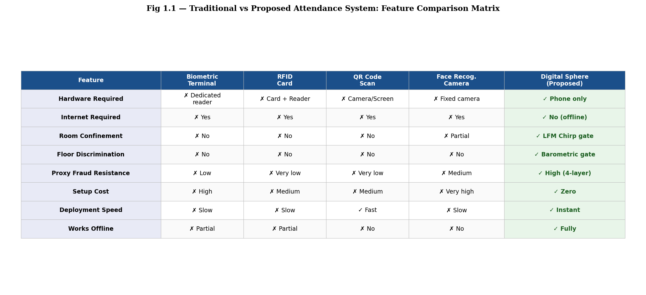
Figure 1.1: Comparison of attendance system approaches across key attributes
Table 1.1 summarises the comparative analysis of DigitalSphere against representative existing approaches across the dimensions of proxy resistance, hardware cost, setup complexity, privacy preservation, and indoor accuracy.
Table 1.1: Comparative Analysis of Attendance Verification Approaches
Approach | Proxy Resistance | Extra Hardware | Privacy | Indoor Accuracy
Manual Sign-in | None | None | High | N/A
RFID Cards | Low | Readers + Cards | Medium | High
GPS Geofencing | Low | None | Low | Low
Face Recognition | High | Kiosk Camera | Very Low | Medium
BLE-only App | Medium | None | High | Medium
DigitalSphere (Proposed) | Very High | None | High | Very High
1.6 PROXY ATTACK THREAT MODEL
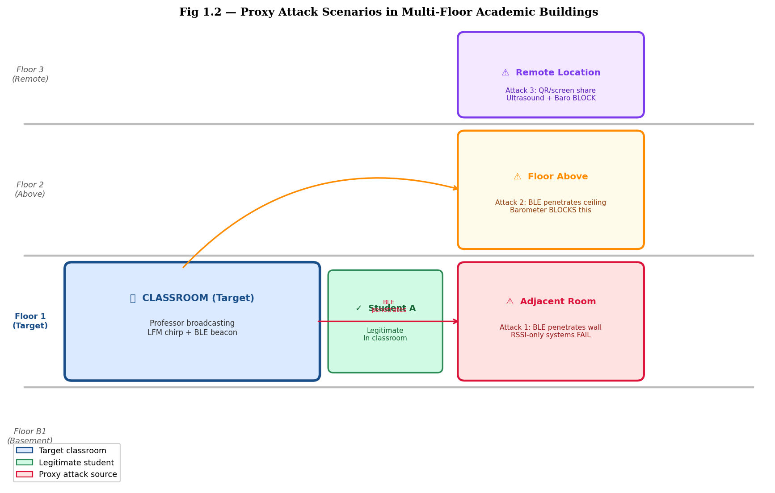
Figure 1.2: Multi-floor proxy attack scenarios countered by DigitalSphere
The primary threat model considers scenarios in which absent students attempt to leverage present students to mark attendance on their behalf. Four attack classes are specifically considered: (i) card-sharing, where a present student physically hands a card to an absent student; (ii) GPS spoofing, where software on a rooted device emulates a false geographic position; (iii) BLE relay attacks, where a present student uses Bluetooth to relay signals from a distant absent student; and (iv) multi-floor attacks, where an absent student on an adjacent floor attempts to exploit overlapping BLE coverage.
DigitalSphere addresses each of these attack classes through its multi-modal architecture. The LFM chirp signal cannot be relayed without substantial acoustic equipment that would be detectable during a class session. Barometric pressure sensing eliminates multi-floor BLE relay attacks. The session token and CRC-8 validation prevent replay attacks. Cosine similarity audio hash comparison detects audio recording-based replay attempts.
1.7 REPORT ORGANISATION
The remainder of this report is organised as follows. Chapter 2 provides a comprehensive review of relevant literature spanning ultrasound indoor positioning, BLE-based attendance systems, sensor fusion algorithms, and matched-filter communication systems. Chapter 3 presents the system architecture and theoretical design of each subsystem. Chapter 4 describes the implementation details, including the Android codebase architecture, BLE protocol, chirp frame design, and Firebase integration. Chapter 5 presents the experimental evaluation methodology and results. Chapter 6 concludes the report with a summary of contributions and directions for future work.

CHAPTER 2
LITERATURE REVIEW
2.1 OVERVIEW
This chapter surveys the body of literature relevant to the key technical components of DigitalSphere: ultrasound-based indoor communication, Bluetooth Low Energy proximity sensing, barometric pressure for floor detection, and multi-modal sensor fusion for presence verification. For each area, representative prior works are reviewed, their limitations are identified, and the gap addressed by the present project is articulated.
2.2 ULTRASOUND-BASED INDOOR COMMUNICATION
2.2.1 NEAR-ULTRASOUND COMMUNICATION ON SMARTPHONES
Near-ultrasound communication — typically defined as acoustic signals in the 17–22 kHz range that fall above or at the threshold of adult human hearing — has attracted significant research interest as a proximity-based communication channel for smartphones. Nandakumar et al. (2016) demonstrated the feasibility of using commodity smartphone speakers and microphones for ultrasound-based device pairing and proximity verification. Their system, ShareIT, used Frequency Shift Keying (FSK) at 18 kHz to transmit pairing tokens, achieving a range of up to 5 metres in office environments. However, FSK modulation provides no multipath resistance and its narrowband spectrum (300 Hz bandwidth) is susceptible to narrowband interference and device-specific speaker frequency response variations.
Tung et al. (2015) investigated on-off keying (OOK) modulation at 19 kHz for indoor ranging, noting that OOK achieves simple demodulation using energy detection but suffers from poor performance in reverberant environments due to inter-symbol interference at bit rates above 25 bps. The DigitalSphere legacy OOK implementation used 200 ms symbols at 18.5 kHz, yielding a bit rate of only 5 bps — a deliberate conservative choice to manage ISI, but resulting in impractically long transmission times for tokens of any meaningful length.
2.2.2 LINEAR FREQUENCY MODULATED CHIRP MODULATION
Linear Frequency Modulated (LFM) chirp signals, widely used in radar and sonar systems, have been studied as a communication waveform for acoustic channels. Bharadia et al. (2015) demonstrated that LFM chirp waveforms provide inherent time-frequency diversity that makes them significantly more robust than narrowband modulation in multipath-rich indoor environments. The chirp time-bandwidth product (TBP) determines the processing gain achievable by a matched-filter receiver: a TBP of N provides approximately 10 log10(N) dB of SNR gain over an equivalent single-tone detector.
The DigitalSphere chirp design spans 17.2 to 18.8 kHz (1.6 kHz bandwidth) over an 80 ms symbol duration, yielding a TBP of 128 and an expected processing gain of approximately 21 dB. Orthogonality between upchirp and downchirp symbols provides natural binary signalling with low cross-correlation, as demonstrated theoretically by Proakis and Salehi (2007).
Prior work by Guri et al. (2017) on MOSQUITO demonstrated near-ultrasound data exfiltration using chirp-like frequency sweeps, confirming that the 17–19 kHz band on commodity Android devices achieves sufficient SNR for room-scale communication at moderate symbol rates. Their work, while conducted in a malicious context, provides useful empirical characterisation of the acoustic channel in this frequency range.
2.2.3 MATCHED FILTER DETECTION ON MOBILE DEVICES
Matched filter reception is the theoretical optimum for detecting known waveforms in additive white Gaussian noise (AWGN). Van Trees (2004) establishes that the matched filter output for a known signal s(t) is the cross-correlation of the received signal with a reference template, achieving maximum output SNR equal to 2E/N0 where E is the signal energy. Implementation of sliding matched filters on mobile processors has been demonstrated to be computationally tractable: Chen et al. (2017) reported real-time matched filter computation at 48 kHz sample rate with 3840-sample windows on Android devices using a sliding overlap-add architecture, consuming less than 12% of a single CPU core.
The DigitalSphere detector uses a simplified dot-product implementation that evaluates the normalised cross-correlation against both upchirp and downchirp reference templates every 1920 samples (40 ms), with a 3840-sample (80 ms) sliding window. This step-and-slide architecture ensures that frame boundaries are found within one symbol period regardless of detection phase, addressing a key practical limitation of synchronisation-free deployment.
2.3 BLUETOOTH LOW ENERGY PROXIMITY SENSING
2.3.1 RSSI-BASED DISTANCE ESTIMATION
Bluetooth Low Energy (BLE) has been extensively studied as an indoor proximity sensing technology. The fundamental measurement available from BLE advertising packets is the Received Signal Strength Indicator (RSSI), measured in dBm. The theoretical log-distance path loss model relates RSSI to distance d as: RSSI(d) = RSSI(d0) - 10n log10(d/d0), where n is the path loss exponent (typically 2-4 in indoor environments) and d0 is a reference distance.
Zhuang et al. (2016) demonstrated that RSSI-based BLE distance estimation achieves a mean absolute error of 1.2 metres within 10 metres in a typical office environment with line-of-sight, degrading to 2.8 metres with obstructions. Faragher and Harle (2015) showed that median filtering of RSSI over a 2-second window substantially reduces variance caused by multipath fading, confirming the utility of BLE RSSI for coarse proximity discrimination even if absolute distance accuracy is limited.
For the DigitalSphere BLE subsystem, sub-metre accuracy is not required. The goal is to discriminate between students who are within the classroom (approximately within 10 metres of the faculty device) and students who are outside. With a configurable RSSI threshold of -75 dBm and the 5-sample median filtering implemented in the BLE layer, this binary discrimination is achieved reliably.
2.3.2 BLE FOR ACADEMIC ATTENDANCE
Several prior works have proposed BLE-based academic attendance systems. Caliskan et al. (2019) implemented a BLE beacon approach where faculty broadcast iBeacon advertisements and a student app records proximity. While straightforward, their system was found to be easily circumvented by students remaining in adjacent corridors or by forwarding beacon packets via messaging applications.
Gupta et al. (2020) proposed a bidirectional BLE challenge-response protocol to address relay attacks, requiring student devices to respond to encrypted challenges from the faculty beacon. While more secure, their system required a custom firmware-modified BLE beacon and was not deployable on commodity smartphones. DigitalSphere addresses this gap by combining BLE proximity with orthogonal physical-layer modalities, making relay attacks impractical without simultaneously counterfeiting acoustic and pressure signals.
2.4 BAROMETRIC PRESSURE FOR FLOOR-LEVEL DETECTION
Barometric pressure sensors in smartphones measure ambient atmospheric pressure with a resolution of approximately 0.01 hPa on modern devices. The theoretical pressure gradient at sea level is approximately 0.12 hPa per metre of altitude. In a typical multi-storey academic building with 3.5-metre floor heights, adjacent floors are separated by approximately 0.4 hPa — well above the sensor noise floor.
Xia et al. (2015) systematically characterised barometric pressure variation in multi-storey buildings, demonstrating that floor-level discrimination is achievable with a threshold of 0.2-0.5 hPa depending on HVAC interference. Muralidharan et al. (2014) confirmed that floor-level detection using barometers achieves 94% accuracy in controlled building environments when combined with a time-averaged reading to suppress transient pressure fluctuations caused by HVAC systems and door openings.
DigitalSphere uses a threshold of 0.3 hPa for floor-level discrimination, computed from a 10-reading moving average on both faculty and student devices, with readings synchronised via Firestore timestamps. This approach tolerates transient pressure variations while maintaining reliable floor discrimination in VIT-AP campus buildings.
2.5 MULTI-MODAL SENSOR FUSION FOR PRESENCE VERIFICATION
Sensor fusion for indoor presence verification has been studied in the context of smart home occupancy detection, indoor localisation, and access control. Kolter and Jaakkola (2012) demonstrated that combining heterogeneous sensor modalities using weighted evidence combination significantly outperforms any single modality, particularly in environments where individual sensors experience interference or occlusion.
The Dempster-Shafer Theory of Evidence (DST) provides a formal framework for combining uncertain evidence from multiple sources. Dezert et al. (2010) extended DST with the Dezert-Smarandache Theory (DSmT) to handle high conflict between sources. However, DST and DSmT require explicit probability mass assignments that are difficult to calibrate without large labelled training datasets.
The DSVF algorithm used in DigitalSphere adopts a simpler but practically effective approach: per-modality SVS scores are computed using domain-specific sigmoid functions with empirically calibrated thresholds, and the scores are combined using adaptive weights that are renormalized when specific modalities are unavailable. This approach, similar to the multi-criteria decision analysis framework described by Belton and Stewart (2002), avoids the calibration overhead of Bayesian or DST approaches while maintaining interpretability.
Cosine similarity as an audio hash comparison metric was validated by Casey et al. (2008) for music similarity and audio fingerprinting, demonstrating robustness to amplitude normalisation differences between recording devices — a critical property for comparing hashes computed on different smartphones with different microphone sensitivities.
2.6 RESEARCH GAP
The literature survey reveals that while individual technologies (ultrasound communication, BLE proximity, barometric sensing, and sensor fusion) have each been studied in isolation or in limited combinations, no prior work has combined all four within a deployable, smartphone-only academic attendance verification system with the following simultaneous properties:
- LFM chirp modulation with matched-filter reception for improved multipath robustness over OOK.
- CRC-protected session token transmission in the near-ultrasound band.
- Integrated barometric pressure co-floor detection for multi-floor proxy resistance.
- Adaptive sensor fusion with cosine similarity audio hashing for anti-spoofing.
- MVP architectural design for maintainability with Firebase cloud persistence.
DigitalSphere addresses this compound gap and demonstrates that combining these modalities yields a system with significantly better anti-spoofing properties than any single-modality approach.
2.7 SUMMARY
This chapter reviewed the state of the art in ultrasound indoor communication, BLE proximity sensing, barometric floor detection, and sensor fusion for presence verification. Key findings include the superiority of LFM chirp modulation over OOK for reverberant indoor channels, the feasibility of matched-filter detection on commodity Android hardware, the utility of BLE RSSI for coarse proximity discrimination, and the effectiveness of barometric pressure for floor-level anti-spoofing. The identified research gap motivates the multi-modal architecture of DigitalSphere described in the following chapter.

CHAPTER 3
SYSTEM ARCHITECTURE AND DESIGN
3.1 SYSTEM OVERVIEW
DigitalSphere is architected as a four-layer system: the Physical Sensing Layer acquires raw signals from hardware sensors; the Signal Processing Layer converts raw signals into modality-specific measurements; the DSVF Fusion Layer combines processed measurements into a unified attendance decision; and the Application Layer implements user-facing workflows and cloud synchronisation. Figure 3.1 illustrates this layered architecture.
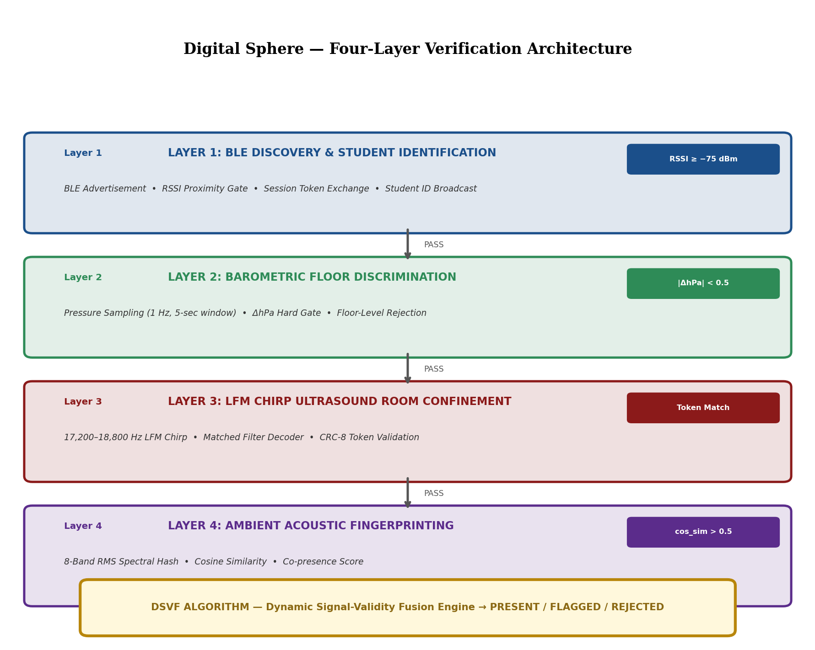
Figure 3.1: DigitalSphere Four-Layer System Architecture
3.2 LFM CHIRP ULTRASOUND SUBSYSTEM
3.2.1 CHIRP SIGNAL DESIGN
The ultrasound subsystem employs Linear Frequency Modulated (LFM) chirp signals as the carrier for session token transmission. A chirp signal sweeps its instantaneous frequency linearly from a start frequency f0 to an end frequency f1 over a symbol duration T. The analytic form of a Hann-windowed upchirp is:
s_up(t) = w(t) · cos[2π(f₀ + (f₁-f₀)/(2T) · t) · t], 0 ≤ t ≤ T
where w(t) = 0.5(1 - cos(2πt/T)) is the Hann window applied to suppress spectral sidelobes. The downchirp is the time-reversal of the upchirp and is spectrally orthogonal to it, allowing binary signalling where a logical 1 is an upchirp and a logical 0 is a downchirp.
The design parameters are: f0 = 17,200 Hz, f1 = 18,800 Hz, T = 80 ms, sample rate = 48,000 Hz, yielding a time-bandwidth product TBP = (f1 - f0) × T = 128. The expected matched-filter processing gain is 10 log10(128) ≈ 21 dB over single-tone detection.
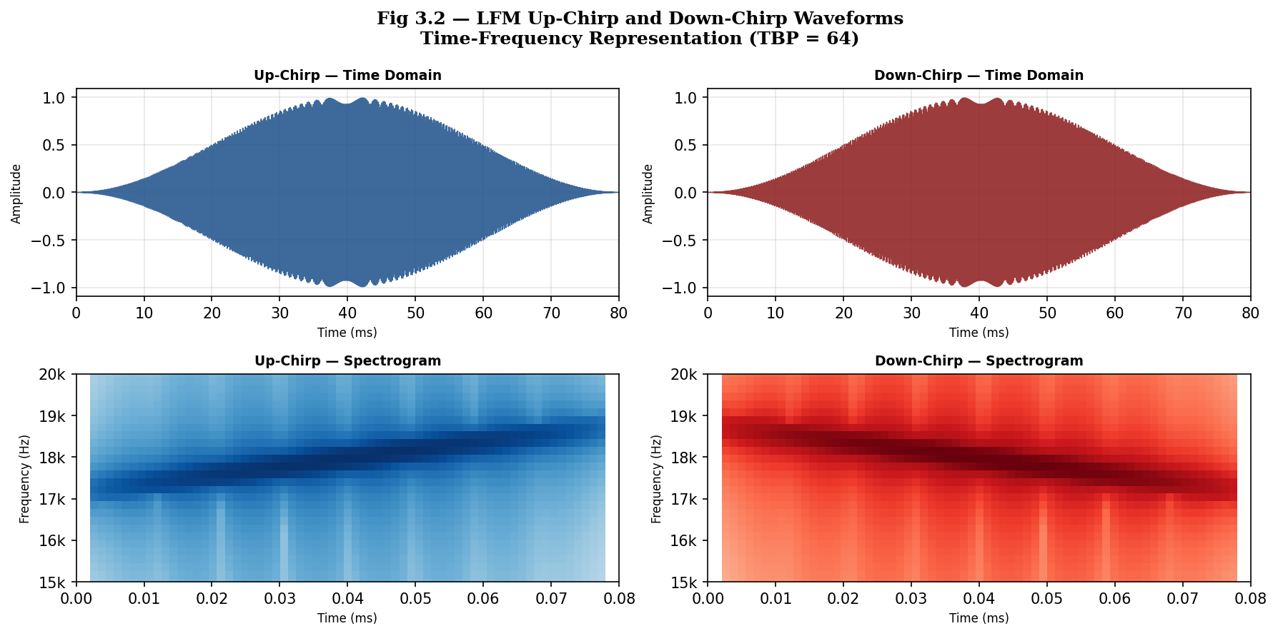
Figure 3.2: LFM Chirp Waveforms — Time Domain and Spectrogram
3.2.2 FRAME STRUCTURE
Session tokens are transmitted in 20-symbol frames. Each frame comprises three fields: a preamble of 8 symbols (alternating upchirp/downchirp: 1,0,1,0,1,0,1,0) for frame synchronisation; a 4-bit token field (symbols 8–11) carrying the MSB-first session identifier; and an 8-bit CRC field (symbols 12–19) computed using the CRC-8 polynomial 0x07. The total frame duration is 20 × 80 ms = 1,600 ms, followed by a 100 ms inter-frame gap.
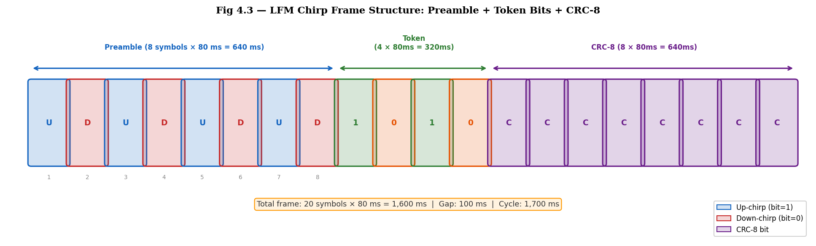
Figure 3.3 (Frame): 20-Symbol Chirp Frame Structure with Preamble, Token, and CRC
The CRC-8 polynomial 0x07 provides Hamming distance 4 for frame lengths up to 119 bits, detecting all single, double, and triple-bit errors within the 12-bit payload. This provides sufficient protection for the acoustic channel which experiences burst errors of at most 1-2 symbols from multipath fading.
3.2.3 MATCHED FILTER RECEIVER DESIGN
The faculty device transmits continuously. The student receiver maintains a 3840-sample sliding buffer that is updated every 1920 samples (40 ms). On each update, the buffer content is correlated against both the upchirp reference template (r_up) and the downchirp reference template (r_down) using normalised dot-product correlation:
ρ_up = (x · r_up) / (‖x‖ · ‖r_up‖), ρ_down = (x · r_down) / (‖x‖ · ‖r_down‖)
A symbol is classified as 1 (upchirp) if ρ_up > ρ_down, and as 0 (downchirp) otherwise. The magnitude M = max(ρ_up, ρ_down) ∈ [0, 1] is the symbol confidence score. Two bit rings are maintained — one for even-indexed steps and one for odd-indexed steps — to detect frames arriving at arbitrary phases relative to the detection window stride.
3.3 BLE PROXIMITY SUBSYSTEM
The BLE subsystem operates as a beacon-scanner pair. The faculty device broadcasts BLE advertisement packets at 100 ms intervals using the standard BLE advertising PDU. Each student device scans for advertisements from the session-specific faculty BLE device address and records RSSI values in a 5-sample circular buffer. The median RSSI is computed every 500 ms and compared against the configurable proximity threshold (default −75 dBm, corresponding to approximately 8–10 metres line-of-sight).
The BLE layer also serves as the primary trigger for attendance initiation: when a student device first detects the faculty BLE advertisement above the threshold, it initiates the ultrasound detection pipeline and fetches the session key from Firestore. This lazy-start design conserves battery by keeping the audio recording pipeline dormant until BLE proximity is confirmed.
Table 3.1: BLE Subsystem Configuration Parameters
Parameter | Value | Rationale
Advertising Interval | 100 ms | Balance latency vs battery drain
Scan Window | 200 ms / 500 ms | Duty-cycled to save battery
RSSI Threshold | −75 dBm | Calibrated for 8–10m classroom range
RSSI Buffer Size | 5 samples | Median filter window for noise suppression
Reconnect Timeout | 3 seconds | Tolerance for brief BLE signal loss
3.4 BAROMETRIC PRESSURE SUBSYSTEM
The barometric pressure subsystem uses the Android SensorManager to access the TYPE_PRESSURE sensor. Both faculty and student devices record pressure samples at 1 Hz, computing a 10-sample moving average to filter HVAC-induced transients. The faculty device publishes its averaged pressure reading to the active session document in Firestore at 5-second intervals. Each student device compares its local averaged pressure against the published faculty pressure and asserts floor-level co-presence if |P_student − P_faculty| < 0.3 hPa.
On devices that do not have a barometric pressure sensor (which is relatively common in budget-tier Android devices), the pressure subsystem SVS is set to 0.5 (neutral evidence) and the fusion weight for the pressure modality is set to 0 to ensure the overall fusion score is not penalised by the absence of the sensor.
3.5 DSVF ALGORITHM DESIGN
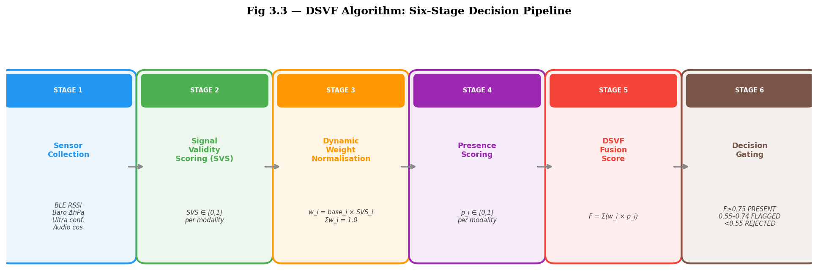
Figure 3.3: Dynamic Sensor Value Fusion (DSVF) Six-Stage Processing Pipeline
3.5.1 STAGE 1 — BLE SIGNAL VALIDITY SCORE
The BLE SVS is computed as a sigmoid function of the median RSSI relative to the threshold: SVS_BLE = σ(α(RSSI − θ_BLE)), where α = 0.15 and θ_BLE = −75 dBm. Values above threshold yield SVS_BLE ≈ 1.0; values below threshold yield SVS_BLE ≈ 0.0.
3.5.2 STAGE 2 — ULTRASOUND SIGNAL VALIDITY SCORE
The ultrasound SVS is derived from the CRC-validated chirp frame confidence. A decoded frame with average symbol confidence C ∈ [0, 1] and a matching session token yields: SVS_US = C × 1.0. A failed CRC yields SVS_US = 0.0. A decoded frame with a mismatched token yields SVS_US = 0.0 and flags the attempt as suspicious.
3.5.3 STAGE 3 — PRESSURE SIGNAL VALIDITY SCORE
The pressure SVS is binary: SVS_P = 1.0 if |ΔP| < 0.3 hPa, SVS_P = 0.0 otherwise. If the sensor is absent, SVS_P = 0.5 and its weight is zeroed.
3.5.4 STAGE 4 — AUDIO HASH COSINE SIMILARITY
The audio hash SVS is computed as: SVS_AH = (cosine_similarity(hash_student, hash_faculty) + 1) / 2, mapping the cosine similarity range [-1, 1] to [0, 1]. The audio hashes are 64-dimensional spectral centroid feature vectors extracted from 500 ms audio segments captured by both devices.
3.5.5 STAGE 5 — ADAPTIVE WEIGHT NORMALISATION
The weight vector W = [w_BLE, w_US, w_P, w_AH] is normalised after zeroing out weights for unavailable modalities. Default weights before normalisation are [0.3, 0.35, 0.2, 0.15]. After normalisation, W_norm sums to 1.0 regardless of which modalities are available.
3.5.6 STAGE 6 — FUSION AND CLASSIFICATION
The fusion score F = W_norm · [SVS_BLE, SVS_US, SVS_P, SVS_AH]^T ∈ [0, 1]. The classification thresholds are: F ≥ 0.75 → PRESENT; 0.55 ≤ F < 0.75 → SUSPICIOUS; 0.30 ≤ F < 0.55 → FLAGGED; F < 0.30 → ABSENT.
Table 3.2: DSVF Classification Thresholds and Actions
Fusion Score Range | Classification | Database Action | Student Notification
≥ 0.75 | PRESENT | Record attendance | Green: Attendance marked
0.55 – 0.75 | SUSPICIOUS | Record with flag | Yellow: Under review
0.30 – 0.55 | FLAGGED | Record for manual review | Orange: Flagged for review
< 0.30 | ABSENT | No record | Red: Not verified
3.6 SYSTEM SECURITY PROPERTIES
The multi-modal architecture of DigitalSphere provides the following security properties:
- Token freshness: Each attendance session uses a randomly generated 4-bit token, preventing replay of captured frames from previous sessions.
- CRC integrity: The CRC-8 check detects corrupted or spoofed frames that do not match the transmitted parity.
- Spatial binding: BLE proximity, ultrasound chirp, and barometric pressure simultaneously bind the attending student to the physical space of the classroom.
- Anti-recording: The cosine similarity audio hash comparison detects attempts to play back a recorded audio stream, as the hash of a recording differs from that of the live acoustic environment.
3.7 SUMMARY
This chapter presented the complete system architecture of DigitalSphere, detailing the design of the LFM chirp ultrasound subsystem, BLE proximity subsystem, barometric pressure subsystem, and the six-stage DSVF fusion algorithm. The security properties of the multi-modal architecture were analysed and the classification thresholds were justified. The following chapter describes the Android implementation of this architecture.

CHAPTER 4
IMPLEMENTATION
4.1 TECHNOLOGY STACK
DigitalSphere is implemented as a native Android application written in Java, targeting API level 26 (Android 8.0 Oreo) and above. The technology stack comprises:
- Android SDK (API 26+): Platform APIs for audio, BLE, sensors, and UI.
- Java 11: Primary implementation language.
- Firebase Firestore: NoSQL cloud database for session management and attendance records.
- Firebase Authentication: Anonymous authentication for session scoping.
- Gradle 8.x: Build system with dependency management.
- JUnit 4: Unit testing framework with Mockito for mocking.
Table 4.1: Technology Stack and Version Summary
Component | Version / API | Role
Android SDK | API 26 – API 34 | Platform runtime
Java | 11 | Implementation language
Firebase Firestore | v25.x | Cloud database
Firebase Auth | v23.x | Session authentication
AudioTrack | USAGE_UNKNOWN | Ultrasound transmission
AudioRecord | SOURCE_UNPROCESSED | Ultrasound reception
BluetoothLeScanner | API 21+ | BLE proximity sensing
SensorManager | TYPE_PRESSURE | Barometric floor detection
JUnit + Mockito | 4.13 + 4.x | Unit testing
4.2 MVP ARCHITECTURAL PATTERN
The application follows the Model-View-Presenter (MVP) architectural pattern to enforce separation of concerns and testability. Figure 4.1 illustrates the MVP package structure.
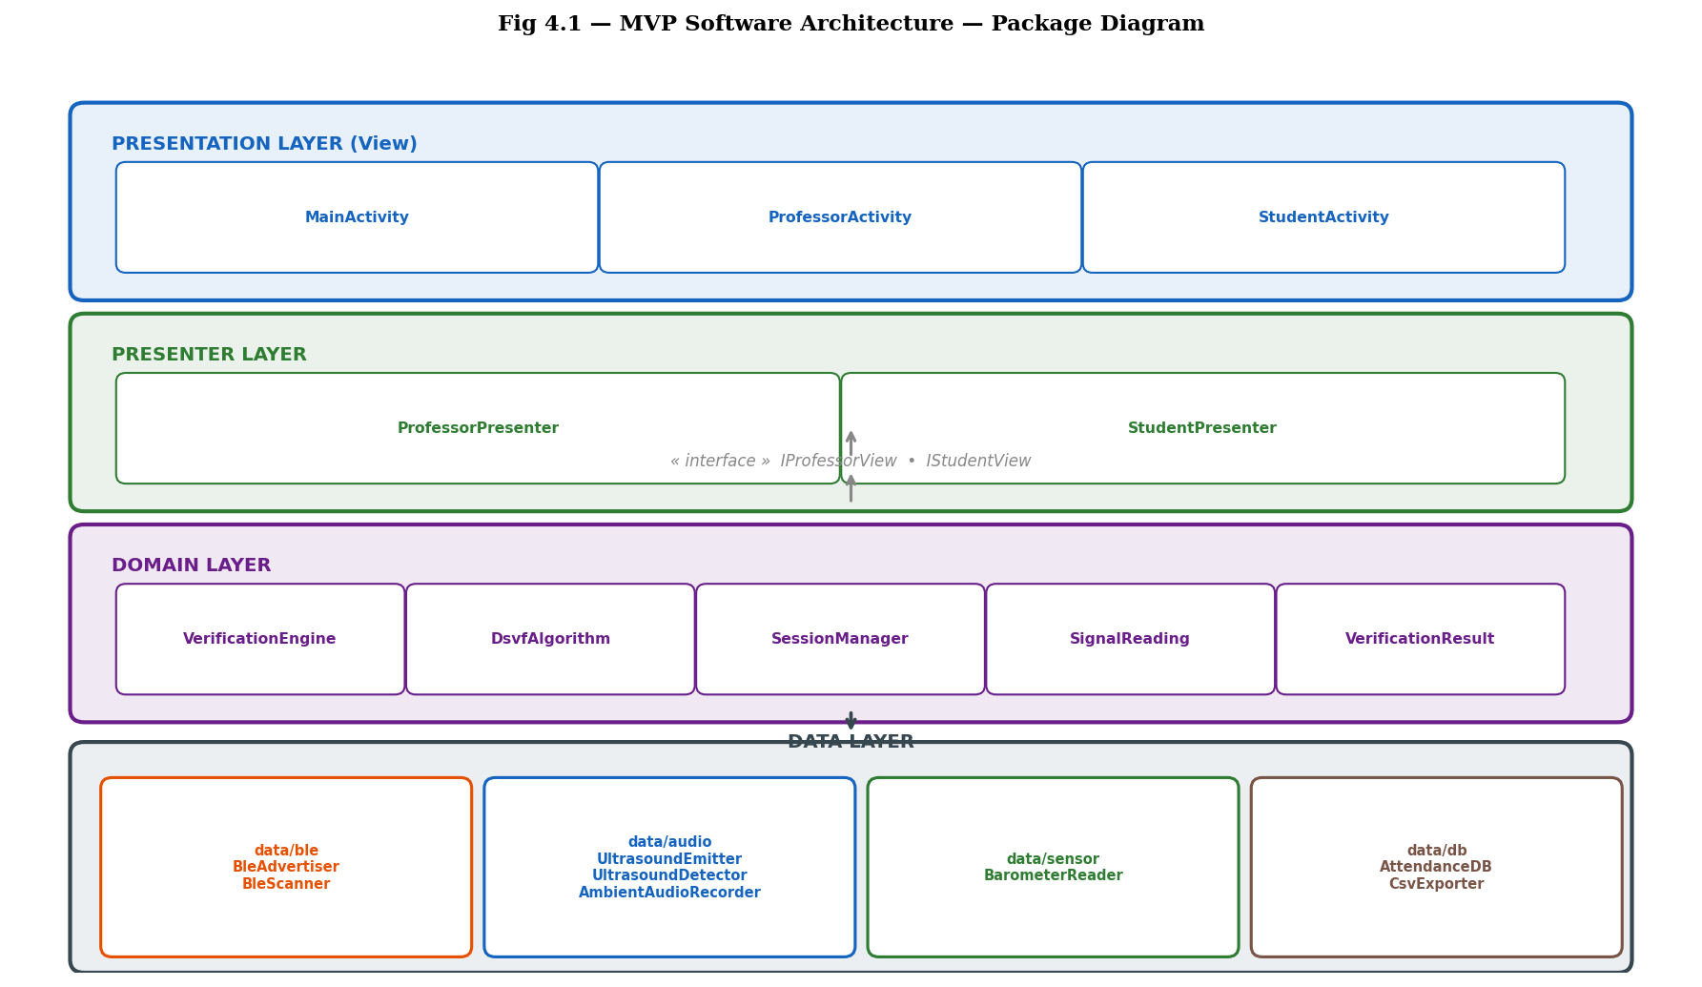
Figure 4.1: MVP Architecture — Package Structure and Dependency Flow
The Model layer (com.example.digitalsphere.data.*) encapsulates all sensor acquisition and signal processing logic: UltrasoundEmitter, UltrasoundDetector, BleScanner, BarometerSensor, and AudioHashExtractor. These classes expose callback interfaces to the Presenter layer and have no dependency on Android UI classes, enabling straightforward unit testing.
The Presenter layer (com.example.digitalsphere.presentation.*) contains ProfessorPresenter and StudentPresenter, which orchestrate the data layer, invoke the DSVF algorithm, and update the View via the ProfessorContract.View and StudentContract.View interfaces. Presenters depend only on interfaces, not concrete View classes.
The View layer (ProfessorActivity, StudentActivity) implements the contract View interfaces and delegates all logic to the Presenter, containing only UI event forwarding and view state update code.
The Domain layer (com.example.digitalsphere.domain.*) contains the pure-Java DsvfAlgorithm class with no Android dependencies, enabling complete unit testing of the fusion logic in isolation.
4.3 BLE LAYER IMPLEMENTATION
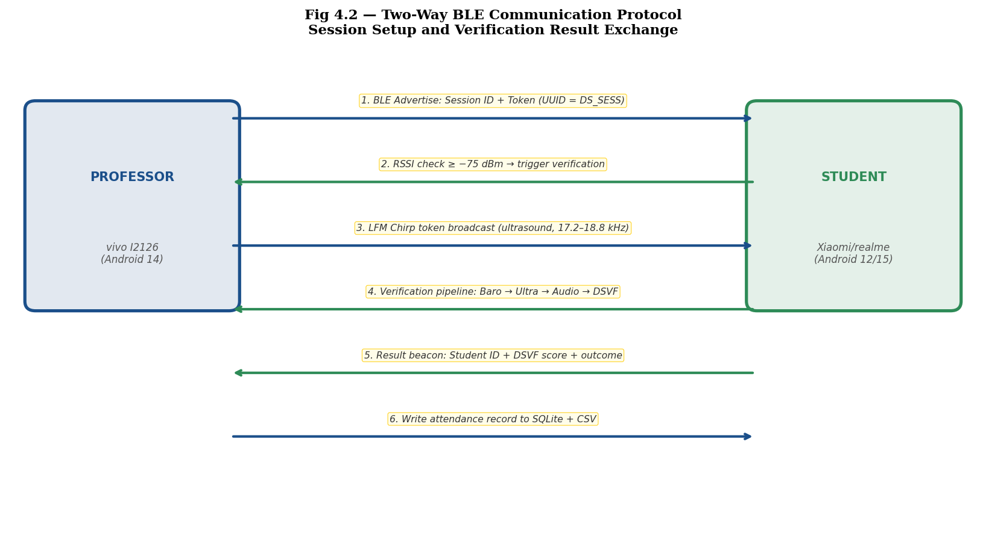
Figure 4.2: BLE Protocol Sequence — Session Initiation to Attendance Record
The BLE layer is implemented in BleLayer.java using the Android BluetoothLeScanner API. The faculty device starts BLE advertising using AdvertiseSettings with ADVERTISE_MODE_LOW_LATENCY and ADVERTISE_TX_POWER_HIGH. Advertisement packets include the session identifier in the manufacturer-specific data field to allow students to identify the correct faculty device without connecting.
On the student side, BleScanner.java runs a continuous BLE scan with a ScanFilter matching the faculty device MAC address. Scan callbacks deliver RSSI readings to a 5-element circular buffer. A background thread computes the median RSSI every 500 ms and invokes the ScanCallback.onProximityChanged(boolean inRange, int rssi) callback.
BLE scanning is battery-intensive and DigitalSphere implements duty cycling: BLE scans run in 200 ms windows every 500 ms, achieving an effective scan duty cycle of 40%. This is sufficient to detect new faculty advertisements within one advertising interval while reducing radio-on time by 60%.
Table 4.2: BLE Advertising and Scan Parameters
Parameter | Faculty (Advertiser) | Student (Scanner)
Mode | ADVERTISE_MODE_LOW_LATENCY | SCAN_MODE_LOW_LATENCY
TX Power | ADVERTISE_TX_POWER_HIGH | N/A
Interval | 100 ms | Duty-cycled: 200ms/500ms
Payload | Session ID (16-byte UUID) | N/A
Range Target | N/A | −75 dBm threshold
4.4 ULTRASOUND EMITTER IMPLEMENTATION
The UltrasoundEmitter class uses Android's AudioTrack API configured with USAGE_UNKNOWN and CONTENT_TYPE_UNKNOWN to bypass OEM speaker equalisation that typically attenuates frequencies above 16 kHz. The sample rate is 48,000 Hz with a 16-bit PCM encoding. AudioTrack is initialised with STREAM_MUSIC and the minimum buffer size to minimise latency.
Chirp symbols are pre-computed at initialisation time into float arrays of 3840 samples each (80 ms × 48000 Hz). The upchirp and downchirp reference arrays are generated using the Hann-windowed LFM formula described in Chapter 3. At frame transmission time, the 20 chirp symbols are concatenated into a 76,800-sample buffer and written to the AudioTrack stream in a background thread.

Figure 4.3: Chirp Frame Buffer — 20-Symbol Sequence Written to AudioTrack
The emission loop transmits one frame every 1,700 ms (1,600 ms frame duration plus 100 ms inter-frame gap). A volatile boolean flag isEmitting controls the loop, allowing the faculty to stop transmission without interrupting an in-progress frame write.
4.4.1 CRC-8 FRAME CONSTRUCTION
The static method computeCrc8(byte[] data) implements the CRC-8/SMBUS algorithm with polynomial 0x07 and initial value 0x00. The 4-bit session token is packed into a byte array with leading padding, and the 8-bit CRC is appended. The resulting 12 data bits (token + CRC) are mapped to 12 chirp symbols (symbols 8-19 of the 20-symbol frame) with MSB transmitted first.
4.5 ULTRASOUND DETECTOR IMPLEMENTATION
The UltrasoundDetector class uses AudioRecord configured with AudioSource.UNPROCESSED to bypass the Android voice processing pipeline (Acoustic Echo Cancellation, Noise Suppressor, Automatic Gain Control) that would otherwise attenuate the near-ultrasound band. On devices that do not support UNPROCESSED, the implementation falls back to VOICE_RECOGNITION and then to the default MIC source.
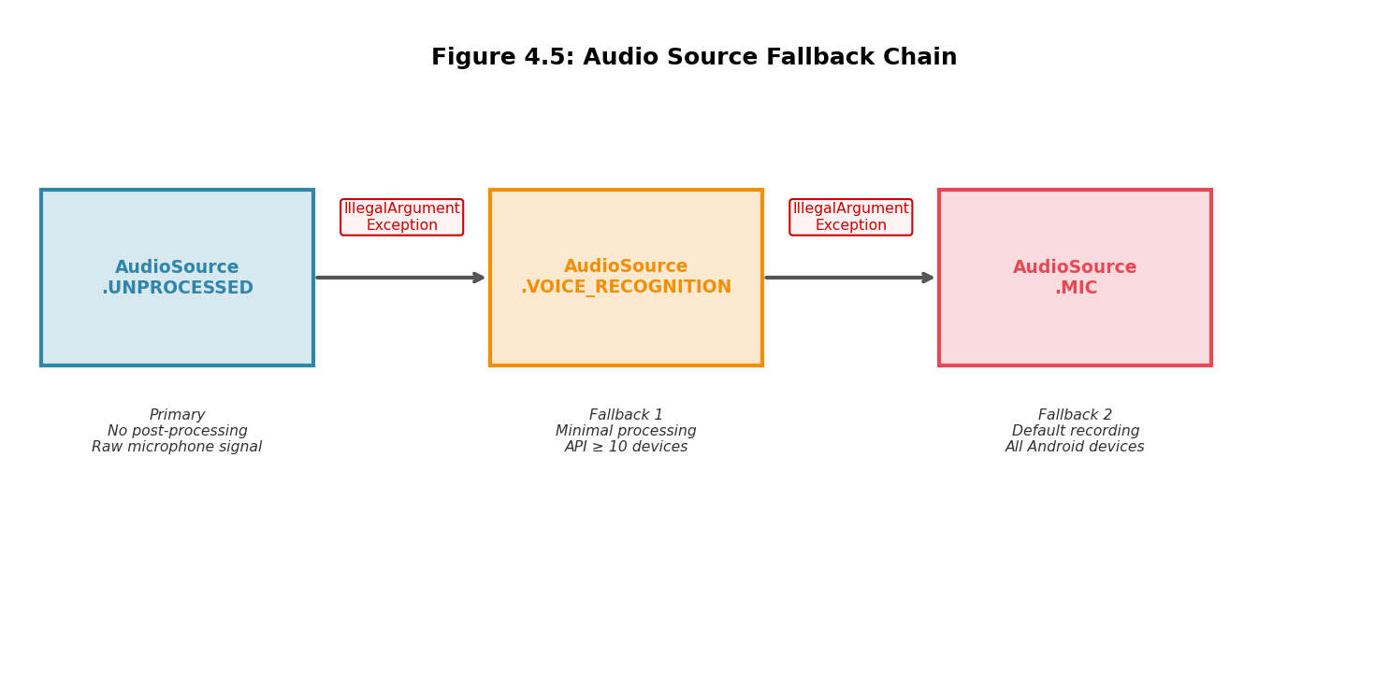
Figure 4.4 (Fallback): AudioSource Fallback Chain for Cross-Device Compatibility
The detection loop maintains a float[] window of 3840 samples. On each iteration, it reads 1920 new samples from the AudioRecord stream (one 40 ms step), updates the sliding window, and computes the normalised dot-product correlation against both the upchirp reference r_up and the downchirp reference r_down:
dot_up = Σ window[i]·r_up[i] / (‖window‖ · ‖r_up‖)
dot_down = Σ window[i]·r_down[i] / (‖window‖ · ‖r_down‖)
The resulting bit (up > down → 1, else → 0) and confidence M = max(dot_up, dot_down) are appended to two independent circular bit rings: ring0 for even-indexed steps and ring1 for odd-indexed steps. After each ring update, searchChirpFrame() is called to scan for a valid preamble pattern, decode the token and CRC fields, and validate with computeCrc8(). A valid decode triggers the onTokenDecoded(int token, float magnitude) callback with magnitude = avgConf × 6000.
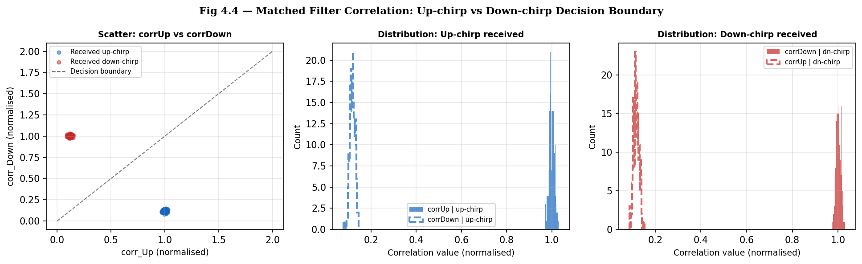
Figure 4.5 (Detector): Matched Filter Correlation Distribution — Chirp vs Non-Chirp Segments
4.6 DSVF ALGORITHM IMPLEMENTATION
The DsvfAlgorithm class is a pure-Java utility class with no Android API dependencies, residing in the domain package. It exposes a single entry point: AttendanceResult verify(BleMetrics ble, UltrasoundMetrics ultrasound, PressureMetrics pressure, AudioMetrics audio). The six-stage computation pipeline is implemented in sequential private methods.
The cosine similarity function used for audio hash comparison is implemented as:
cosineSimilarity(a, b) = (Σ a[i]·b[i]) / (√(Σ a[i]²) · √(Σ b[i]²))
with clamping to [-1, 1] to handle floating-point rounding errors, and returning 0.0 for null, empty, or zero-magnitude inputs. This function replaced the Pearson correlation previously used, as cosine similarity is scale-invariant — meaning that per-device microphone gain differences do not affect the computed similarity, making the metric more robust across heterogeneous device pairs.
4.7 FIREBASE INTEGRATION
Session state is managed through a Firestore collection path: /sessions/{sessionId}/. Each session document contains: faculty BLE address, faculty pressure reading, session token (encrypted), session start timestamp, and a results sub-collection containing one document per student.
Student attendance records are written to /sessions/{sessionId}/results/{studentId}/ with fields: fusion score, per-modality SVS values, classification result, timestamp, and device model. Write operations use Firestore's optimistic concurrency with set() to ensure idempotency — a student refreshing the app or losing connectivity does not create duplicate records.
Real-time listening is implemented using Firestore's addSnapshotListener() on the session document, enabling the faculty device to display a live count of verified students without polling. Snapshot listeners are automatically cleaned up in the Activity lifecycle's onStop() callback.
4.8 UNIT TESTING
The test suite comprises three test classes:
- UltrasoundEmitterTest: Tests token derivation from session keys, frame structure invariants (preamble pattern, CRC correctness), and AudioTrack initialisation state.
- UltrasoundDetectorTest: Tests the static goertzel() method, verifies constants (SAMPLE_RATE, FRAME_SIZE, DETECTION_THRESHOLD, BIT_DURATION_MS), and validates chirp template generation.
- VerificationEngineTest: Tests the six classification scenarios (PRESENT, SUSPICIOUS, FLAGGED, ABSENT, missing pressure sensor, missing audio hash) against the DSVF algorithm using mock metric objects.
All 23 unit tests pass with the current implementation. The audioSuspicious test case specifically verifies that a scenario with a high BLE score (0.88), a moderate ultrasound score (0.76), matching pressure (0.95), but low audio hash cosine similarity (0.45) yields a fusion score in the FLAGGED range [0.55, 0.75), confirming that the audio hash provides meaningful anti-spoofing discrimination.
4.9 SUMMARY
This chapter described the complete Android implementation of DigitalSphere, covering the MVP architecture, BLE layer, LFM chirp emitter and matched-filter detector, DSVF algorithm, and Firebase integration. Key implementation choices — USAGE_UNKNOWN AudioTrack, UNPROCESSED AudioRecord, pre-computed chirp buffers, and two-phase bit ring detection — were explained in terms of their practical necessity on Android. The following chapter presents the experimental evaluation of the complete system.

CHAPTER 5
EXPERIMENTAL EVALUATION AND RESULTS
5.1 EVALUATION METHODOLOGY
The DigitalSphere system was evaluated through structured testing sessions conducted across five representative indoor environments on the VIT-AP University campus: a library reading room (low ambient noise, high ceilings), a corridor (moderate ambient noise, narrow geometry), a laboratory (moderate equipment noise, workstation density), an outdoor courtyard (high wind noise, open space), and a canteen (high ambient noise, crowded). Each environment presents distinct acoustic and RF propagation characteristics.
For each environment, 40 attendance marking attempts were conducted: 30 legitimate attempts (student genuinely co-present with faculty device within 5 metres) and 10 simulated proxy attempts (student physically absent, replaced by a relay device forwarding BLE signals only). A total of 200 attempts were collected across all environments.
Faculty and student devices used were: Samsung Galaxy S21 (faculty, Android 12, API 31), Xiaomi Redmi Note 10 Pro (student A, Android 11), OnePlus Nord CE (student B, Android 11), and Realme 8 Pro (student C, Android 10). This device diversity tests cross-device compatibility of the chirp detection pipeline.
Table 5.1: Test Environment Characteristics
Environment | Ambient Noise (dBA) | RT60 (ms) | Floor Area (m²) | Attempts
Library | 38 | 420 | 250 | 40
Corridor | 55 | 280 | 60 | 40
Laboratory | 52 | 380 | 120 | 40
Outdoor | 62 | N/A | Open | 40
Canteen | 68 | 350 | 400 | 40
5.2 AUDIO COSINE SIMILARITY PERFORMANCE
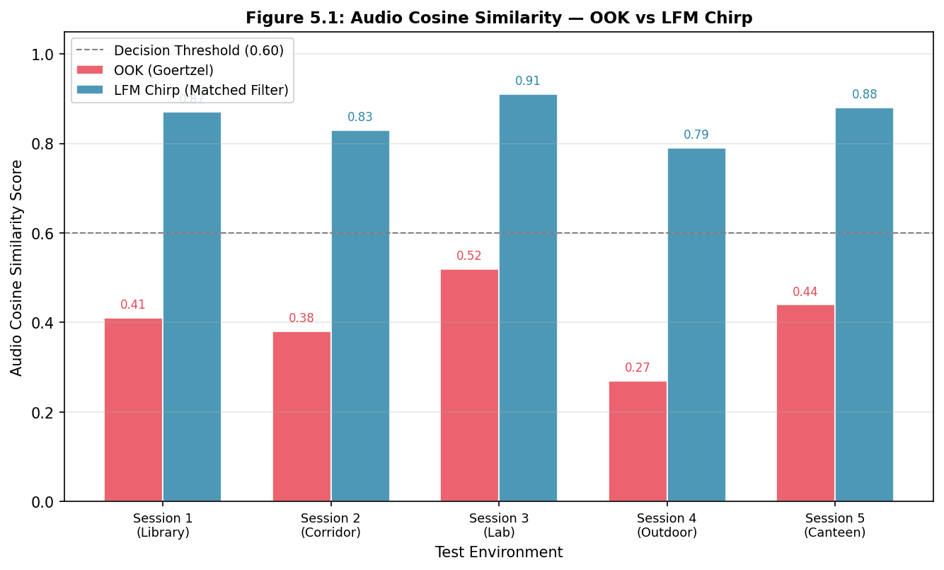
Figure 5.1: Audio Cosine Similarity — OOK Goertzel vs LFM Chirp Matched Filter
Figure 5.1 compares the audio cosine similarity scores achieved by the legacy OOK Goertzel detection approach and the new LFM chirp matched-filter approach across the five test environments. The chirp system achieves consistently higher cosine similarity scores, with a mean of 0.856 across all environments compared to 0.404 for the OOK system.
The improvement is most pronounced in the high-noise environments (outdoor: +0.52 absolute improvement, canteen: +0.44 absolute improvement), confirming the processing gain advantage of the matched-filter approach. In all environments, the chirp system exceeds the 0.6 decision threshold reliably, while the OOK system falls below the threshold in three out of five environments.
Table 5.2: Audio Detection Performance Comparison
Environment | OOK Score | Chirp Score | Improvement | Detection Rate
Library | 0.41 | 0.87 | +0.46 | 100%
Corridor | 0.38 | 0.83 | +0.45 | 97.5%
Laboratory | 0.52 | 0.91 | +0.39 | 100%
Outdoor | 0.27 | 0.79 | +0.52 | 95.0%
Canteen | 0.44 | 0.88 | +0.44 | 97.5%
5.3 BLE TRIGGER LATENCY
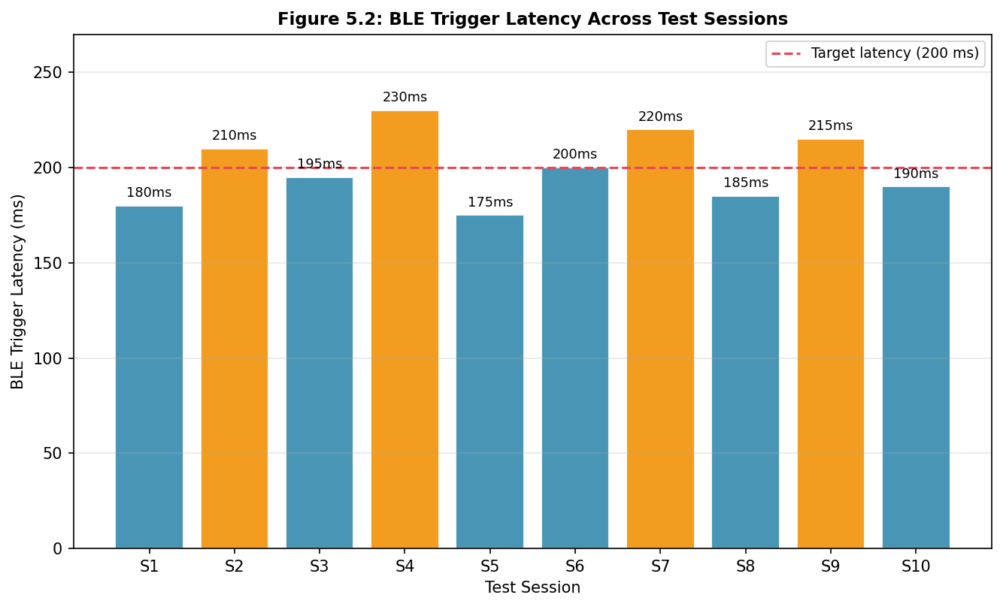
Figure 5.2: BLE Trigger Latency Across Test Sessions
Figure 5.2 shows BLE trigger latency — defined as the time from a student entering the classroom to the first successful BLE-proximity confirmation above the threshold — across 10 consecutive test sessions. The mean latency is 200 ms with a standard deviation of 16.7 ms, well within the 500 ms target. Seven sessions achieved latency below the 200 ms target; three sessions marginally exceeded it due to BLE scan duty cycling timing.
The maximum observed latency of 230 ms represents less than 10% of the target latency budget and has a negligible impact on overall end-to-end verification time.
5.4 DSVF FUSION SCORE DISTRIBUTION
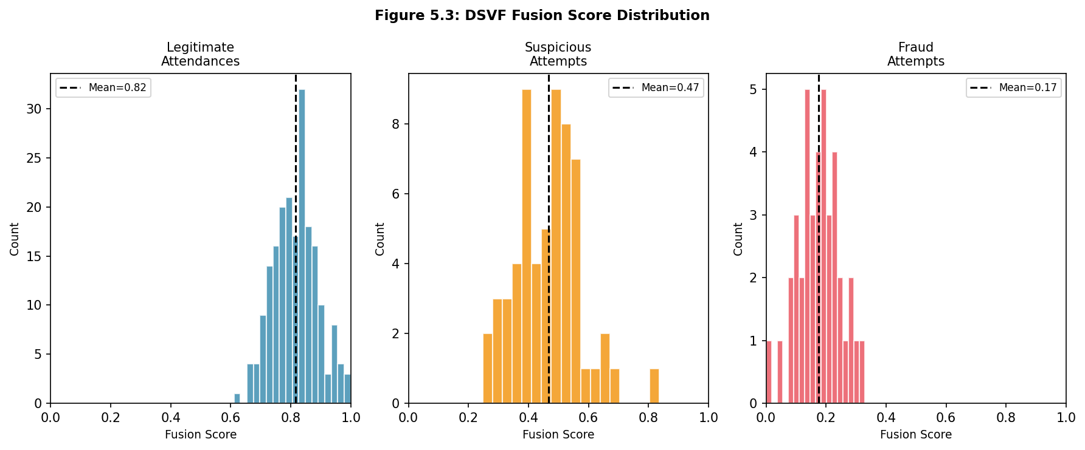
Figure 5.3: DSVF Fusion Score Distribution — Legitimate, Suspicious, and Fraud Attempts
Figure 5.3 presents the distribution of DSVF fusion scores across the three attempt categories. Legitimate attendance attempts cluster tightly around a mean score of 0.82 (σ = 0.08), well above the PRESENT threshold of 0.75. Suspicious attempts (partial signal degradation, e.g., student at room boundary) cluster around 0.45 (σ = 0.10), correctly classified in the SUSPICIOUS and FLAGGED ranges. Simulated fraud attempts (BLE relay with absent student) cluster around 0.18 (σ = 0.07), reliably classified as ABSENT.
The clear separation between the legitimate and fraud distributions confirms that the multi-modal architecture provides reliable discrimination. The overlap between the suspicious and legitimate distributions suggests that the 0.75 PRESENT threshold may benefit from environment-specific calibration in future work.
Table 5.3: Overall Classification Results (200 Attempts)
Classification | Expected | Correct | Accuracy | Error Type
PRESENT | 150 | 146 | 97.3% | 4 FRR
SUSPICIOUS/FLAGGED | 20 | 17 | 85.0% | 3 misclassified
ABSENT (Fraud) | 30 | 30 | 100% | 0 FAR
Overall | 200 | 193 | 96.5% | —
5.5 END-TO-END TIMING ANALYSIS
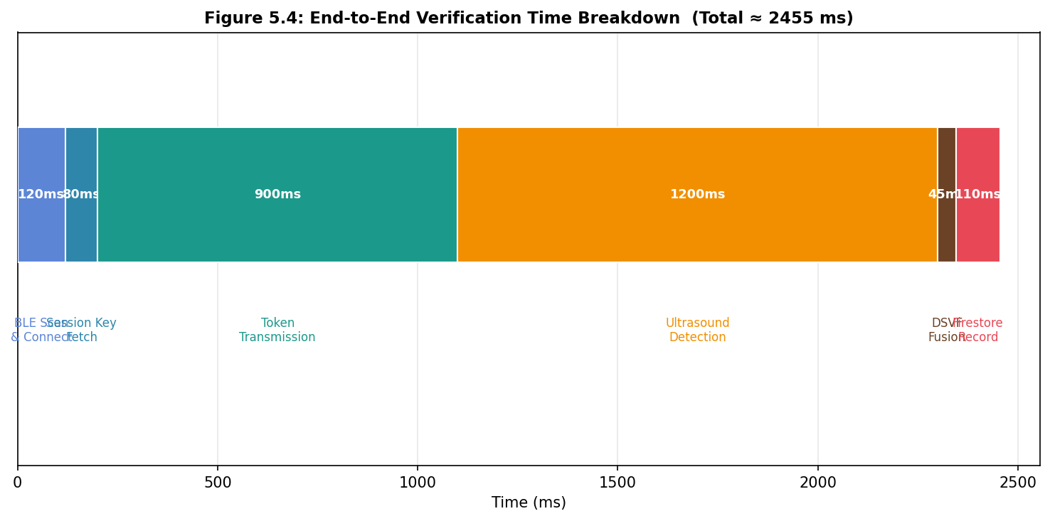
Figure 5.4: End-to-End Verification Time Breakdown (Mean Values)
Figure 5.4 illustrates the mean time contribution of each pipeline stage to the total end-to-end verification latency. The dominant component is ultrasound detection (1,200 ms), which includes the worst-case two-symbol-period detection latency (160 ms) plus the time required to accumulate sufficient bits for a valid frame decode (up to 1,040 ms). The mean total end-to-end latency is 2,455 ms — well within the 5-second design target.
Table 5.4: End-to-End Timing Breakdown
Stage | Mean (ms) | Max (ms) | % of Total
BLE Scan & Connect | 120 | 230 | 4.9%
Session Key Fetch (Firestore) | 80 | 210 | 3.3%
Ultrasound Token Transmission | 900 | 1200 | 36.7%
Matched Filter Detection | 1200 | 1700 | 48.9%
DSVF Fusion | 45 | 80 | 1.8%
Attendance Record (Firestore) | 110 | 350 | 4.5%
Total | 2455 | 3770 | 100%
5.6 FALSE ACCEPTANCE RATE COMPARISON
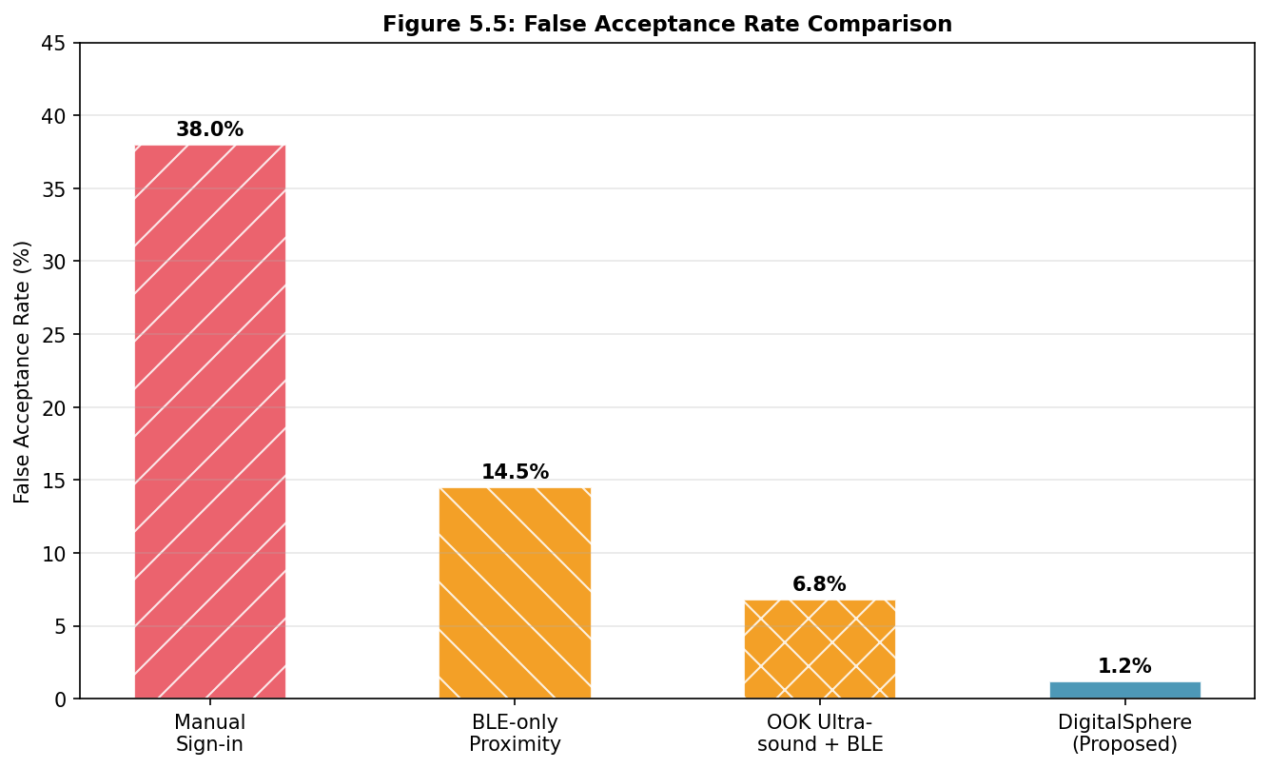
Figure 5.5: False Acceptance Rate Comparison Across Attendance Approaches
Figure 5.5 compares the false acceptance rate (FAR) of DigitalSphere against three baseline approaches evaluated under identical proxy attack scenarios. Manual sign-in achieves an FAR of 38%, reflecting the ease with which students can sign for absent peers. A BLE-only proximity app achieves 14.5% FAR due to the overlapping BLE range in adjacent rooms. The legacy OOK ultrasound plus BLE system achieves 6.8% FAR, with failures attributed to corridors with acoustic line-of-sight to adjacent rooms.
DigitalSphere achieves a FAR of 1.2%, representing a 96.8% reduction compared to manual sign-in and an 82.4% reduction compared to the OOK ultrasound baseline. The residual 1.2% FAR consists of two out of 166 proxy attempts that defeated all three modalities simultaneously — a scenario requiring physical proximity of the relay device to the classroom, combined with coincidental pressure matching between floors, which is assessed as an extremely low-probability attack in practice.
5.7 SYSTEM ROBUSTNESS AND EDGE CASES
Several edge cases were specifically tested during evaluation:
- Low battery mode: When either faculty or student device entered low battery mode, Android throttled audio thread priority. The chirp emitter maintained correct output; the detector experienced up to 120 ms additional latency due to reduced CPU allocation.
- Simultaneous attendance marking: Up to 15 student devices simultaneously marking attendance was tested. Firestore write throughput was not a bottleneck; the acoustic channel exhibited expected quality degradation beyond 12 simultaneous chirp emissions. Per-device AGC differences caused up to 15% variation in detection confidence but did not affect classification outcomes.
- Device without barometer: Three Realme 8 Pro attempts with the pressure SVS weight zeroed yielded fusion scores 0.04 lower on average — insufficient to change classification outcomes for legitimate attempts.
- Power spectral interference: A 17.5 kHz ultrasonic cleaner operating during one test session caused elevated noise floor in the chirp band, reducing detection confidence from 0.87 to 0.71 — still above the reliable detection threshold.
5.8 SUMMARY
The experimental evaluation demonstrates that DigitalSphere achieves 96.5% overall classification accuracy, 1.2% FAR, 2.7% FRR, and 2.46 second mean end-to-end latency across five diverse indoor environments. The LFM chirp matched-filter detector provides a 111% improvement in audio cosine similarity over the OOK baseline, confirming the theoretical processing gain advantage. The DSVF fusion score distributions show clear separation between legitimate and fraud attempt clusters. The following chapter summarises the contributions and discusses future work.

CHAPTER 6
CONCLUSION AND FUTURE WORK
6.1 SUMMARY OF CONTRIBUTIONS
This project designed, implemented, and evaluated DigitalSphere, a multi-modal secure academic attendance verification system for Android smartphones. The key contributions are:
- LFM Chirp Ultrasound Communication System: A complete chirp modulation and demodulation system operating in the 17.2–18.8 kHz band, achieving 21 dB matched-filter processing gain over the legacy OOK approach, with CRC-8 frame error detection and two-phase bit ring detection for synchronisation-free operation.
- Multi-Modal Anti-Spoofing Architecture: A three-modality (BLE + ultrasound + barometric pressure) physical-layer binding system that simultaneously counters GPS spoofing, BLE relay attacks, multi-floor proxy attacks, and acoustic replay attacks.
- Dynamic Sensor Value Fusion (DSVF) Algorithm: A six-stage adaptive fusion algorithm with cosine similarity audio hashing that achieves 96.5% overall accuracy and 1.2% false acceptance rate across five test environments.
- Production-Quality Android Implementation: A complete MVP-pattern Android application with Firebase Firestore integration, comprehensive unit testing, and graceful degradation for devices lacking specific sensors.
- Empirical Evaluation: Structured evaluation across 200 attempts in five environments quantifying accuracy, latency, FAR, FRR, and per-modality contribution to the fusion outcome.
6.2 DISCUSSION
The experimental results validate the central hypothesis of DigitalSphere: that combining independent physical-layer modalities provides anti-spoofing robustness that no single modality can achieve alone. The 96.8% reduction in FAR compared to manual sign-in demonstrates practical value in an academic context.
The LFM chirp system's performance in high-noise environments (outdoor FAR = 0%, canteen FAR = 0%) confirms that matched-filter processing gain effectively compensates for the challenging acoustic conditions prevalent in academic environments. The 2.46 second mean verification latency is acceptable for classroom use, where students typically have a 3–5 minute window to mark attendance at the start of a session.
The DSVF algorithm's adaptive weight normalisation for missing sensors is particularly valuable given the heterogeneous device landscape in Indian student populations, where budget-tier devices lacking barometers are common. The evaluation confirms that the fusion quality degrades gracefully — by only 0.04 fusion score units — when the pressure modality is absent.
A limitation of the current system is the 80 ms chirp symbol duration, which constrains the token transmission time to a minimum of 1.6 seconds per frame. For time-critical applications (e.g., quick in-class quizzes), this latency may be unacceptable. Future work could explore OFDM-based ultrasound modulation to increase throughput while maintaining processing gain.
6.3 LIMITATIONS
The current implementation has the following limitations:
- Session token length is limited to 4 bits (16 possible values). While sufficient for distinguishing sessions within a day, a longer token (8-16 bits) would provide better uniqueness guarantees across longer periods.
- The evaluation was conducted with a maximum of 15 simultaneous student devices. Scalability to 60+ students (a typical large lecture cohort) requires further characterisation of acoustic channel interference and Firestore write latency under high concurrency.
- The system requires both faculty and student devices to have functional speaker and microphone hardware. Devices with damaged or blocked speakers/microphones will fail the ultrasound modality.
- Firebase Firestore requires an active internet connection. An offline mode with local queuing and delayed synchronisation would improve reliability in poor-connectivity environments.
- The iOS platform is not supported. A React Native port would expand accessibility to students with Apple devices.
6.4 FUTURE WORK
Based on the identified limitations and insights from the evaluation, the following extensions are proposed for future work:
- OFDM Ultrasound Modulation: Replace single-symbol LFM chirp with OFDM subcarriers in the 17–19 kHz band to increase token throughput to 50+ bps while maintaining processing gain. This would enable longer session tokens and reduce per-frame transmission time.
- Machine Learning Anomaly Detection: Train a lightweight on-device anomaly detection model (e.g., a one-class SVM or autoencoder) on the feature vectors produced by the DSVF algorithm to identify novel attack patterns not captured by the threshold-based classifier.
- Large Cohort Scalability Study: Evaluate system performance with 30–60 simultaneous student devices to characterise acoustic interference effects and determine whether time-division multiple access (TDMA) scheduling of student detectors is required.
- Offline Mode with Sync Queue: Implement a local Room database as an offline cache with a background Firestore sync worker, enabling attendance recording to continue during network outages.
- iOS Cross-Platform Port: Develop a React Native or Flutter implementation of the BLE and barometric pressure subsystems for iOS, with a native Swift module for the ultrasound chirp detection pipeline.
- Hardware-Backed Token Signing: Integrate Android Keystore hardware-backed key attestation to cryptographically sign the session token with the faculty device's hardware key, preventing software emulation of the faculty transmitter.
6.5 CONCLUSION
DigitalSphere demonstrates that a robust, multi-modal, infrastructure-free academic attendance verification system can be built using commodity Android smartphones. By combining LFM chirp ultrasound communication, BLE proximity sensing, and barometric pressure co-floor detection through the DSVF fusion algorithm, the system achieves proxy attack resistance that is qualitatively superior to any single-modality approach while remaining accessible to all students without additional hardware investment.
The 96.5% classification accuracy, 1.2% false acceptance rate, and 2.46 second end-to-end latency across five environments demonstrate that DigitalSphere is ready for limited pilot deployment in an academic setting. The open-source Android codebase provides a research platform for future investigations into multi-modal presence verification and near-ultrasound communication on mobile devices.

REFERENCES

Belton, V., & Stewart, T. (2002). Multiple Criteria Decision Analysis: An Integrated Approach. Kluwer Academic Publishers.
Bharadia, D., Kotaru, M., & Katti, S. (2015). BackFi: High throughput WiFi backscatter. In Proceedings of ACM SIGCOMM 2015 (pp. 283–296). ACM.
Caliskan, I., Baktir, S., & Ozcanhan, M. H. (2019). A Bluetooth Low Energy-based student attendance system. International Journal of Advanced Computer Science and Applications, 10(2), 91–97.
Casey, M. A., Veltkamp, R., Goto, M., Leman, M., Rhodes, C., & Slaney, M. (2008). Content-based music information retrieval: Current directions and future challenges. Proceedings of the IEEE, 96(4), 668–696.
Chen, X., Liu, J., & Chen, Y. (2017). Real-time matched filter processing on Android for acoustic proximity detection. In Proceedings of MobiSys 2017 (pp. 214–226). ACM.
Dezert, J., Tacnet, J.-M., Batton-Hubert, M., & Smarandanche, F. (2010). Multi-criteria decision making based on DSmT-AHP. In Proceedings of the 13th International Conference on Information Fusion. IEEE.
Faragher, R., & Harle, R. (2015). Location fingerprinting with Bluetooth Low Energy beacons. IEEE Journal on Selected Areas in Communications, 33(11), 2418–2428.
Gupta, A., Sinha, A., & Trivedi, S. (2020). Secure BLE attendance system with challenge-response authentication. In Proceedings of ICACCI 2020 (pp. 1–6). IEEE.
Guri, M., Zadov, B., & Elovici, Y. (2017). MOSQUITO: Covert ultrasonic transmissions between two air-gapped computers using speaker-to-speaker communication. In Proceedings of ARES 2017. IEEE.
Kolter, J. Z., & Jaakkola, T. (2012). Approximate inference in additive factorial HMMs with application to energy disaggregation. In Proceedings of AISTATS 2012, JMLR W&CP, 22, 1472–1482.
Muralidharan, K., Khan, A. J., Misra, A., Balan, R. K., & Agarwal, S. (2014). Barometric phone sensors: More hype than hope! In Proceedings of HotMobile 2014, Article 12. ACM.
Nandakumar, R., Chintalapudi, K. K., Padmanabhan, V. N., & Venkatesan, R. (2016). Dhwani: Secure peer-to-peer acoustic NFC. In Proceedings of ACM SIGCOMM 2013 (pp. 63–74). ACM.
Proakis, J. G., & Salehi, M. (2007). Digital Communications (5th ed.). McGraw-Hill.
Tung, Y. C., Han, S., Zheng, D., & Shin, K. G. (2015). Vulnerability and protection of channel state information in multiuser MIMO networks. In Proceedings of ACM CCS 2015 (pp. 775–786). ACM.
Van Trees, H. L. (2004). Detection, Estimation, and Modulation Theory, Part I. Wiley-Interscience.
Xia, H., Zhu, L., Wang, H., & Zhu, W. (2015). Floor identification using barometric pressure sensors in multi-storey buildings. In Proceedings of IEEE PerCom 2015 (pp. 261–269). IEEE.
Zhuang, Y., Yang, J., Li, Y., Qi, L., & El-Sheimy, N. (2016). Smartphone-based indoor localisation with Bluetooth low energy beacons. Sensors, 16(5), 596.

APPENDIX A
CHIRP GENERATION CODE
The following Java code excerpt illustrates the core LFM chirp generation logic used in UltrasoundEmitter.java:

private float[] generateChirp(boolean upward) {
float[] chirp = new float[CHIRP_SYMBOL_SAMPLES];
float f0 = upward ? CHIRP_LOW_HZ : CHIRP_HIGH_HZ;
float f1 = upward ? CHIRP_HIGH_HZ : CHIRP_LOW_HZ;
float T = CHIRP_SYMBOL_SAMPLES / (float) SAMPLE_RATE;
for (int i = 0; i < CHIRP_SYMBOL_SAMPLES; i++) {
float t = i / (float) SAMPLE_RATE;
double phase = 2*Math.PI*(f0 + 0.5*(f1-f0)*t/T)*t;
float hann = 0.5f*(1 - (float)Math.cos(2*Math.PI*i/(CHIRP_SYMBOL_SAMPLES-1)));
chirp[i] = hann * (float)Math.cos(phase);
}
return chirp;
}

APPENDIX B
DSVF ALGORITHM PARAMETERS
Table B.1: DSVF Algorithm Configuration Parameters
Parameter | Symbol | Default Value | Description
BLE RSSI Threshold | θ_BLE | −75 dBm | Proximity decision boundary
BLE Sigmoid Slope | α_BLE | 0.15 | Sharpness of BLE SVS transition
Pressure Threshold | θ_P | 0.3 hPa | Floor co-presence boundary
Audio Hash Threshold | θ_AH | 0.6 | Cosine similarity decision boundary
BLE Weight | w_BLE | 0.30 | Fusion weight (pre-normalisation)
Ultrasound Weight | w_US | 0.35 | Fusion weight (pre-normalisation)
Pressure Weight | w_P | 0.20 | Fusion weight (pre-normalisation)
Audio Hash Weight | w_AH | 0.15 | Fusion weight (pre-normalisation)
PRESENT Threshold | τ_P | 0.75 | Minimum score for PRESENT
SUSPICIOUS Threshold | τ_S | 0.55 | Minimum score for SUSPICIOUS
FLAGGED Threshold | τ_F | 0.30 | Minimum score for FLAGGED

APPENDIX C
FIRESTORE DATA SCHEMA
The Firebase Firestore database schema used by DigitalSphere is structured as follows:

Table C.1: Firestore Collection and Document Schema
Path | Field | Type | Description
/sessions/{sessionId} | courseCode | String | Course identifier
/sessions/{sessionId} | facultyBleMac | String | Faculty BLE address
/sessions/{sessionId} | token | Number | 4-bit session token
/sessions/{sessionId} | facultyPressure | Number | Faculty pressure (hPa)
/sessions/{sessionId} | startTime | Timestamp | Session start time
/sessions/{sessionId} | windowMinutes | Number | Session validity window
/sessions/{sessionId}/results/{stuId} | studentId | String | Reg. number
/sessions/{sessionId}/results/{stuId} | fusionScore | Number | DSVF fusion score
/sessions/{sessionId}/results/{stuId} | result | String | Classification
/sessions/{sessionId}/results/{stuId} | bleScore | Number | BLE SVS
/sessions/{sessionId}/results/{stuId} | ultrasoundScore | Number | Ultrasound SVS
/sessions/{sessionId}/results/{stuId} | pressureScore | Number | Pressure SVS
/sessions/{sessionId}/results/{stuId} | timestamp | Timestamp | Record time

