AWS EC2:

=============

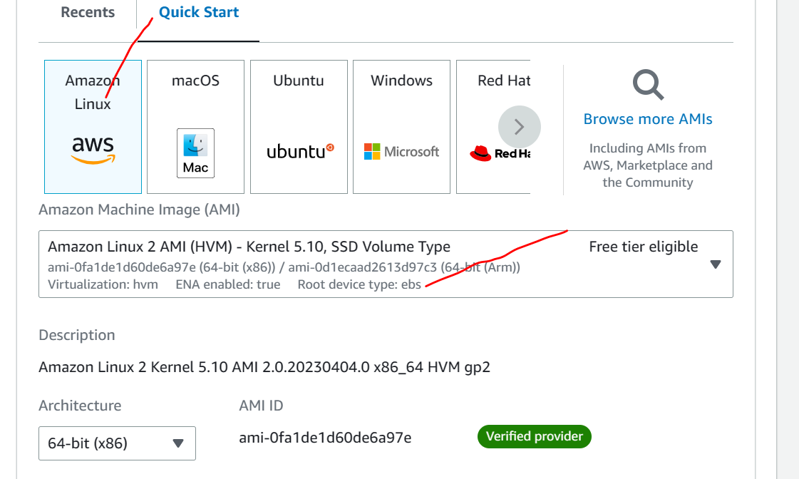

Git install

yum install git -y

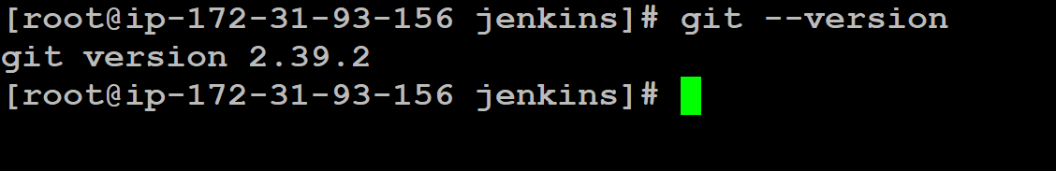

Java install:

# java11 install

yum install fontconfig java-11-openjdk

sudo amazon-linux-extras install java-openjdk11

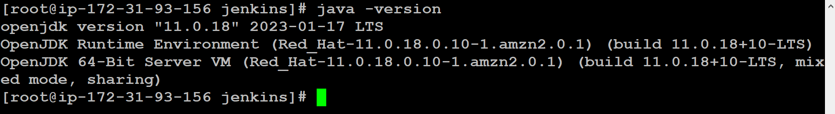

Alternatives –config java

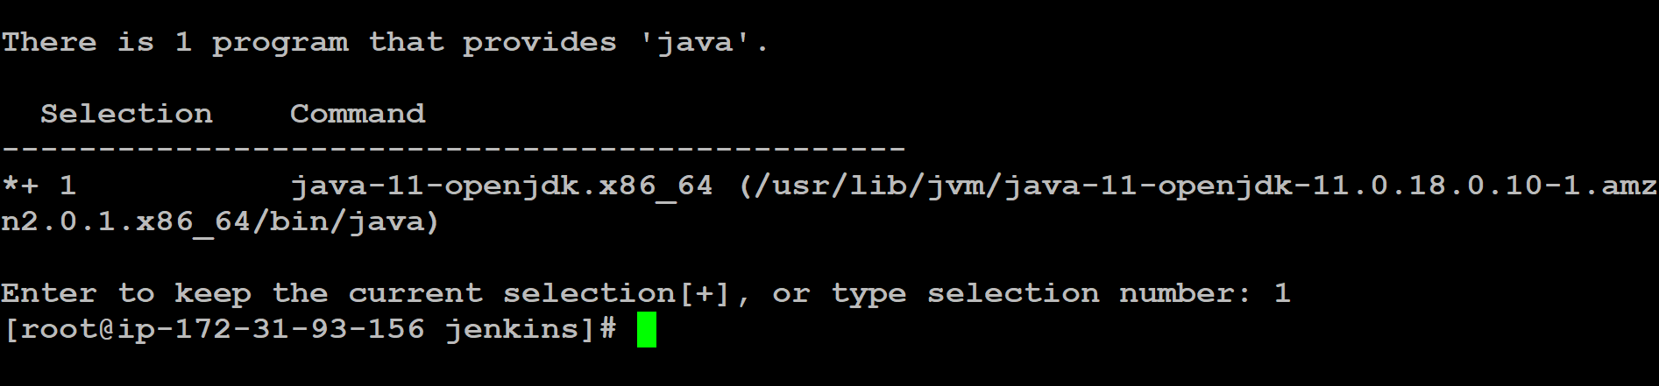

/usr/lib/jvm/java-11-openjdk-11.0.18.0.10-1.amzn2.0.1.x86_64

Vim /etc/profile



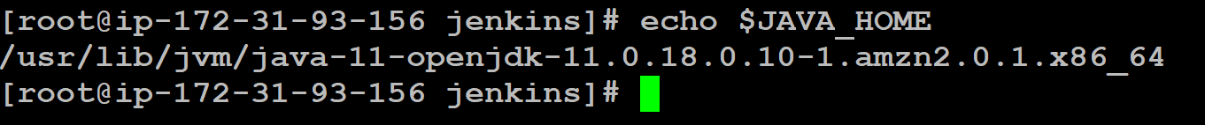

Maven Installation:

Yum install maven –y

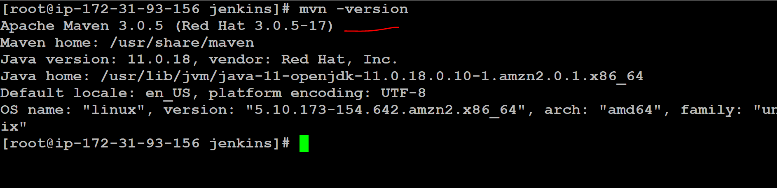

export MAVEN_HOME=/usr/share/maven

Vim /etc/profile



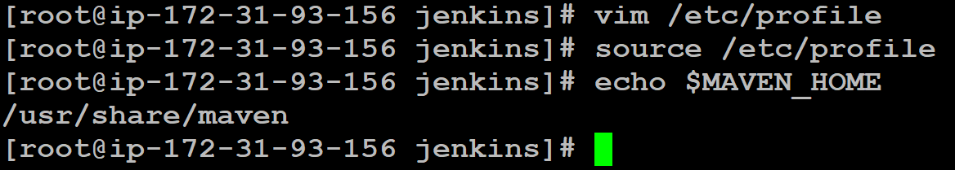

Jenkins Installation:

sudo wget -O /etc/yum.repos.d/jenkins.repo https://pkg.jenkins.io/redhat-stable/jenkins.repo

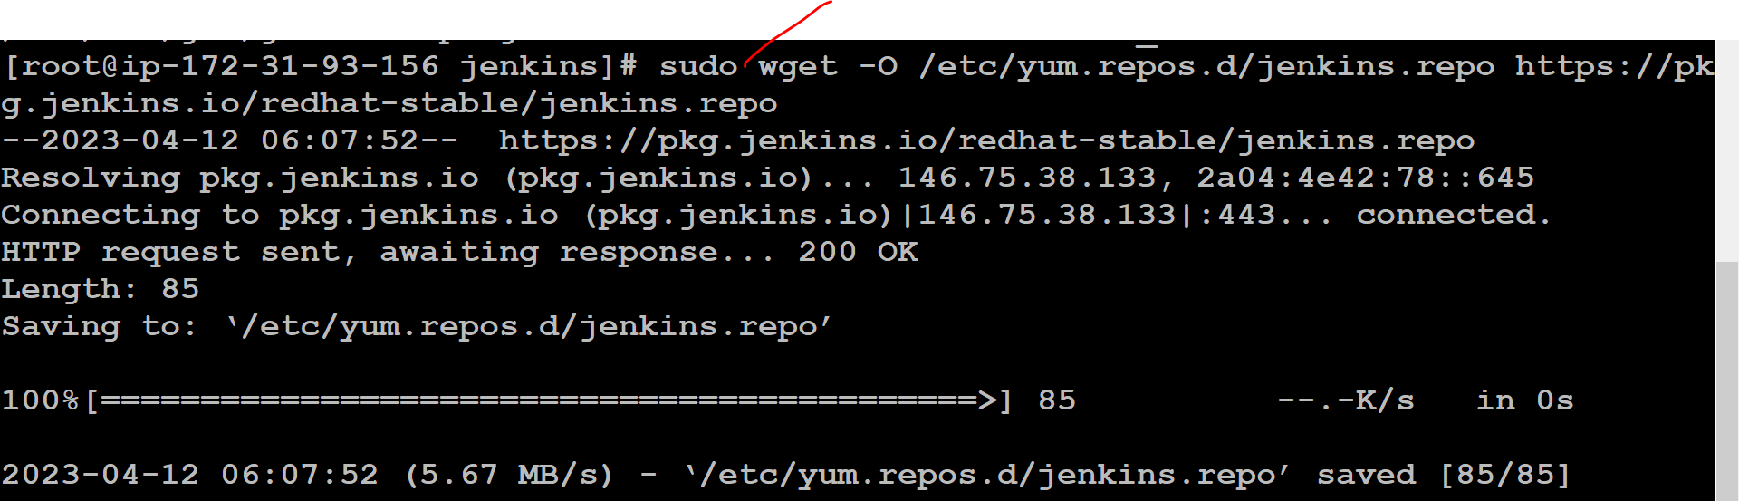

sudo rpm --import https://pkg.jenkins.io/redhat-stable/jenkins.io-2023.key



yum install jenkins

Systemctl status Jenkins

Jenkins-master-publicip:8080

