**C Programming : Day 1 : ( May 10th ) _**

**Task 1 : Hello World Program**

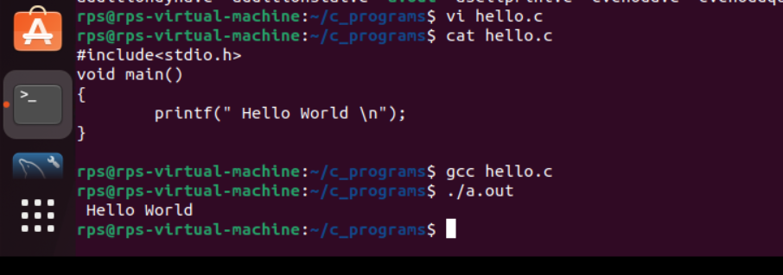

**Task 2 : Static addition**

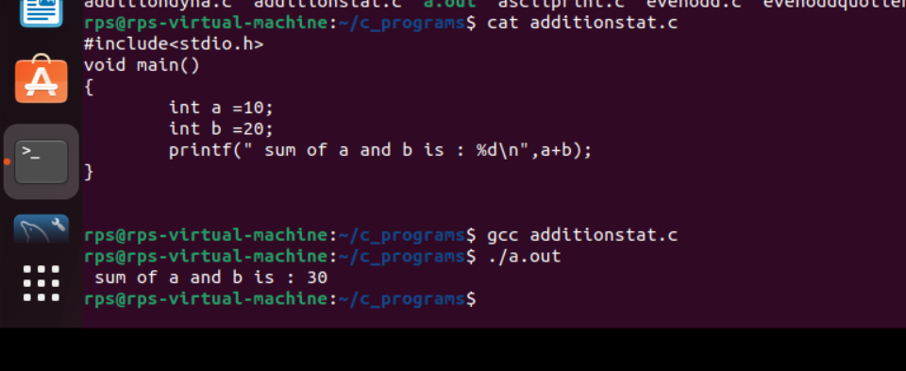

**Task 3 : Dynamic addition**

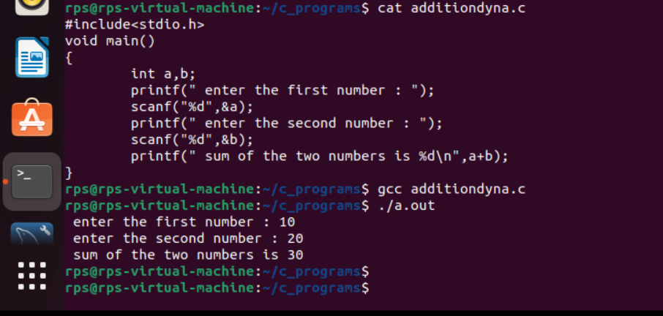

**Task 4 : Print date and time**

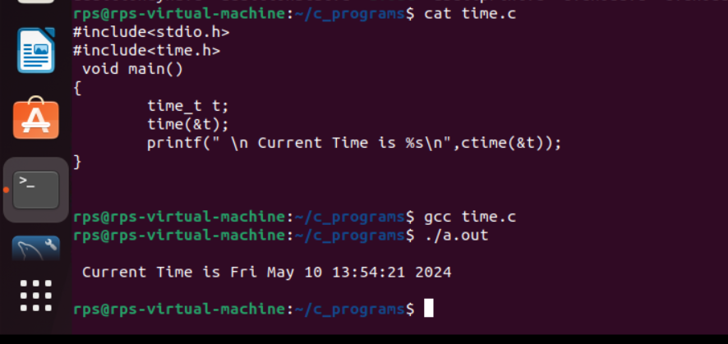

**Task 5 : Printing the name given by the user**

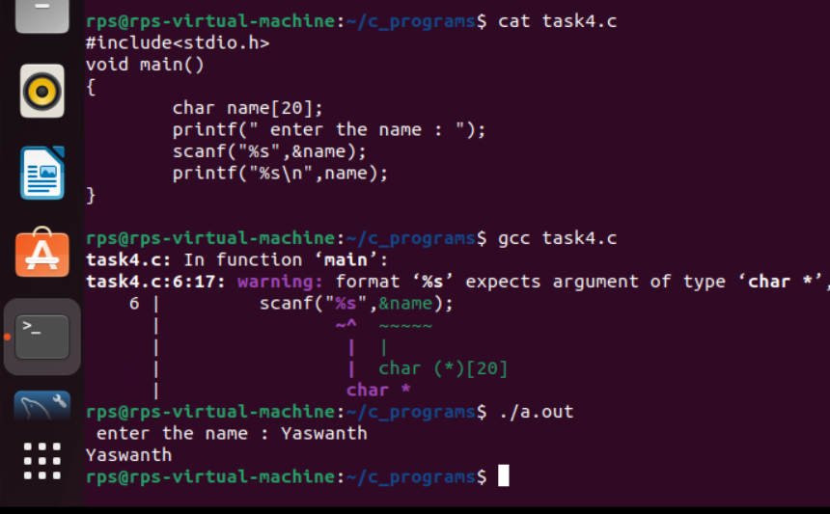

**Task 6 : Check even or odd**

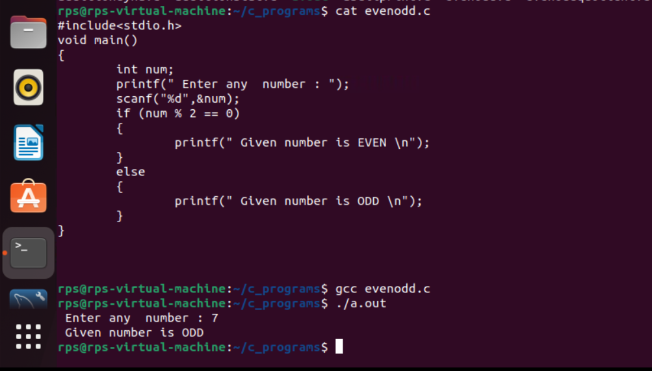

**Task 7 : Printing Quotient and Remainder**

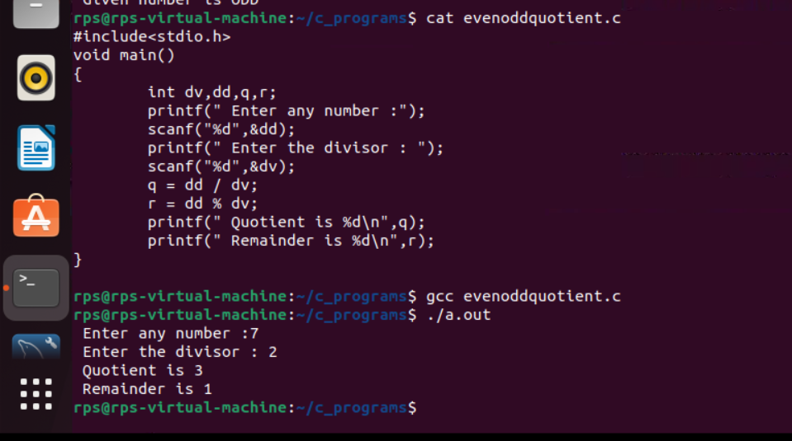

**Task 8 : Printing ASCII value of the given character**

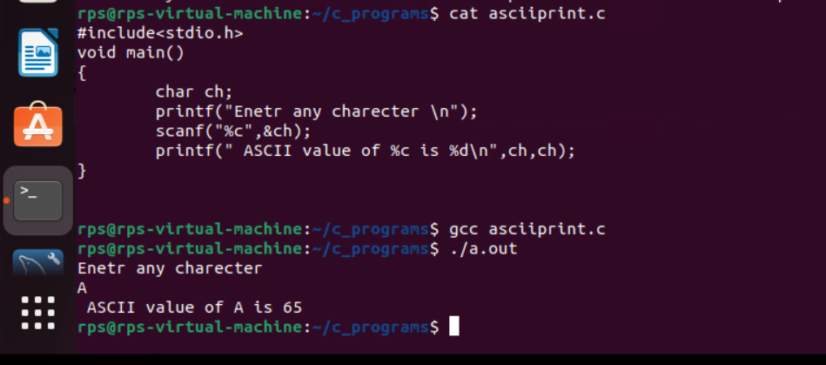

**Task 9 : sizes of data types**

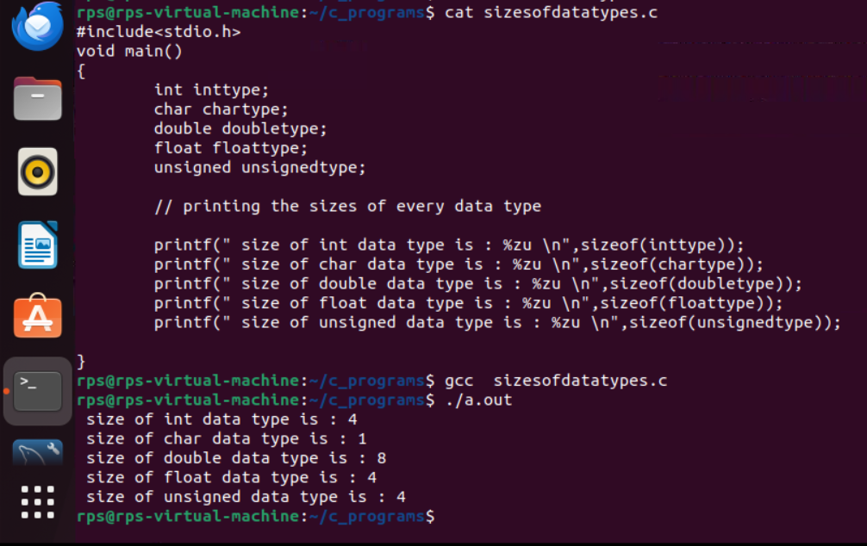

**Task 10 : Reverse of a number**

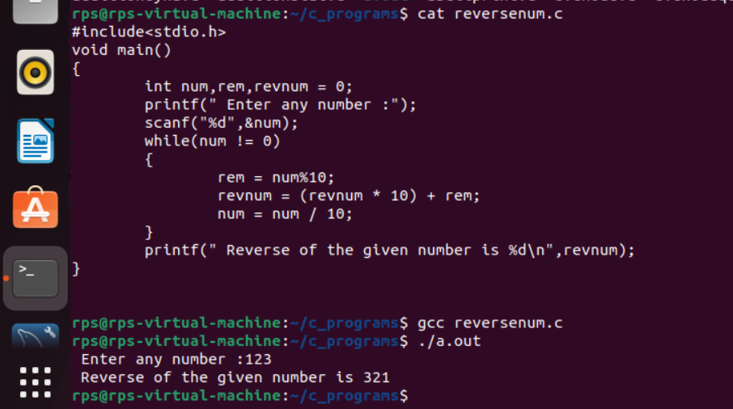

**____________________THANK YOU _________________________**