**C Programming : Day 2 : ( May 13th ) _**

**Task 1 : Star pattern printing**

**Code :**

#include<stdio.h>

void main()

{

int i,j,ns;

printf(" Enter the number of stars : ");

scanf("%d",&ns);

for (i=0;i<ns;i++)

{

for (j=0;j<=i;j++)

{

printf("* ");

}

printf("\n");

}

}

**Output :**

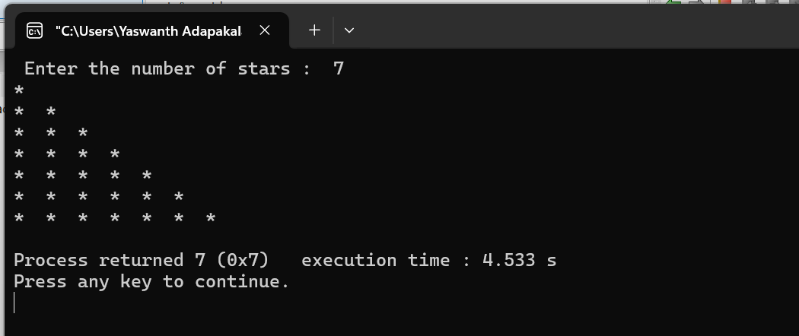

**Task 2 : Fibonacci Series**

**Code :**

#include<stdio.h>

int main()

{

int num1=0,num2=1,num3,i,num;

printf("Enter the number of elements:");

scanf("%d",&num);

printf(" Required Fibonacci series is : " );

printf("%d %d ",num1,num2);

for(i=2;i<num;i++)

{

num3=num1+num2;

printf("%d ",num3);

num1=num2;

num2=num3;

}

}

**Output :**

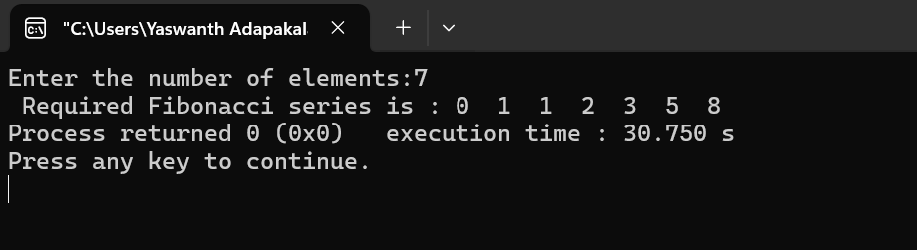

**Task 3 : Factorial of a number**

**Code :**

#include<stdio.h>

void main()

{

int i,fact=1,num;

printf("Enter any number : ");

scanf("%d",&num);

for(i=1;i<=num;i++)

{

fact=fact*i;

}

printf("Factorial of %d is : %d",num,fact);

}

**Output :** 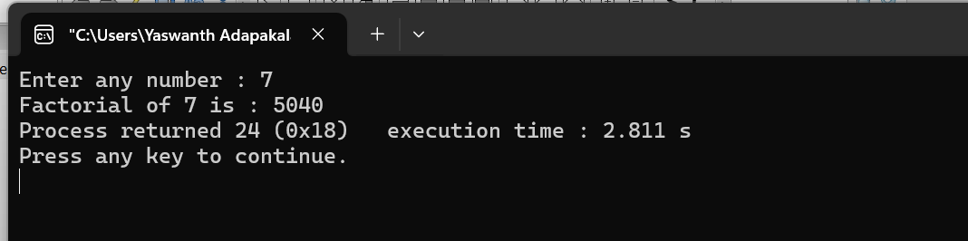

**Task 4 : while loop**

**Code :**

#include<stdio.h>

void main()

{

char username[20], domain[30];

int ch=1;

while(ch==1)

{

printf(" Enter user name : ");

scanf("%s",&username);

printf("\nEnter Domain name : ");

scanf("%s",&domain);

printf("\n Do you want to continue (0/1) : ");

scanf("%d",&ch);

}

}

**Output :**

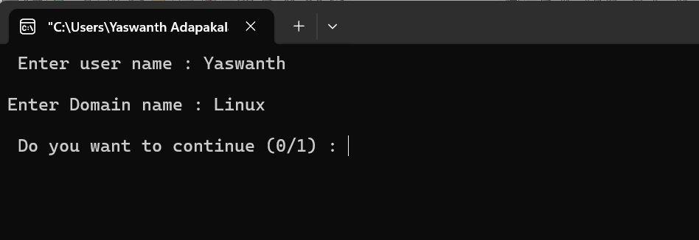

**Task 5 : do-while loop**

**Code :**

#include<stdio.h>

void main()

{

char username[20], domain[30];

int ch=1;

do{

printf(" Enter user name : ");

scanf("%s",&username);

printf("\nEnter Domain name : ");

scanf("%s",&domain);

printf("\n Do you want to continue (0/1) : ");

scanf("%d",&ch);

}while(ch==1);

}

**Output :**



**Task 6 : printing matrices**

**Code :**

#include<stdio.h>

#include<stdlib.h>

void main()

{

int a[2][2],b[2][2],res[2][2],i,j,k;

system("cls");

printf("enter the first matrix elements : \n");

for(i=0;i<2;i++)

{

for(j=0;j<2;j++)

{

scanf("%d",&a[i][j]);

}

}

printf("enter the second matrix elements : \n");

for(i=0;i<2;i++)

{

for(j=0;j<2;j++)

{

scanf("%d",&b[i][j]);

}

}

// Printing the matrices -------------------

printf("\n printing the first matrix elements : \n");

for(i=0;i<2;i++)

{

for(j=0;j<2;j++)

{

printf("%d ",a[i][j]);

}

printf("\n");

}

printf("\n printing the second matrix elements : \n");

for(i=0;i<2;i++)

{

for(j=0;j<2;j++)

{

printf("%d ",b[i][j]);

}

printf("\n");

}

}

**Output :**

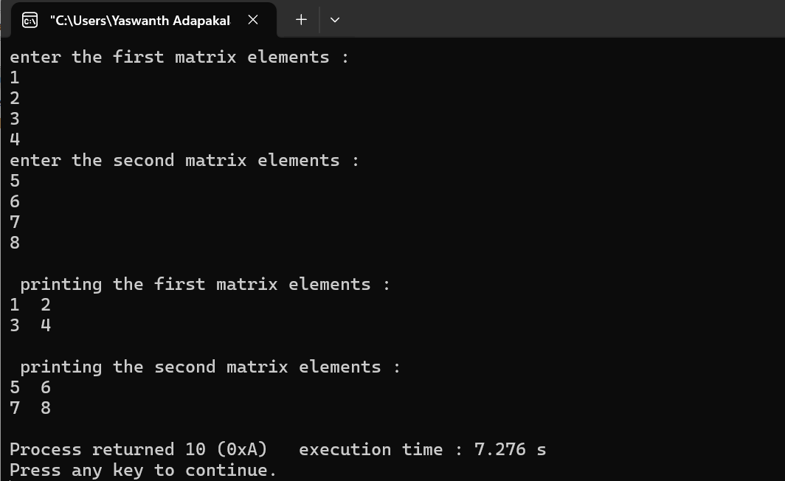

**Task 7 : Matrix multiplication**

**Code :**

#include<stdio.h>

#include<stdlib.h>

void main()

{

int a[2][2],b[2][2],res[2][2],i,j,k;

system("cls");

printf("enter the first matrix elements : \n");

for(i=0;i<2;i++)

{

for(j=0;j<2;j++)

{

scanf("%d",&a[i][j]);

}

}

printf("enter the second matrix elements : \n");

for(i=0;i<2;i++)

{

for(j=0;j<2;j++)

{

scanf("%d",&b[i][j]);

}

}

printf("Multiply of the matrix : \n");

for(i=0;i<2;i++)

{

for(j=0;j<2;j++)

{

res[i][j]=0;

for(k=0;k<2;k++)

{

res[i][j]+=a[i][k]*b[k][j];

}

printf("%d ",res[i][j]);

}

printf("\n");

}

}

**Output :**

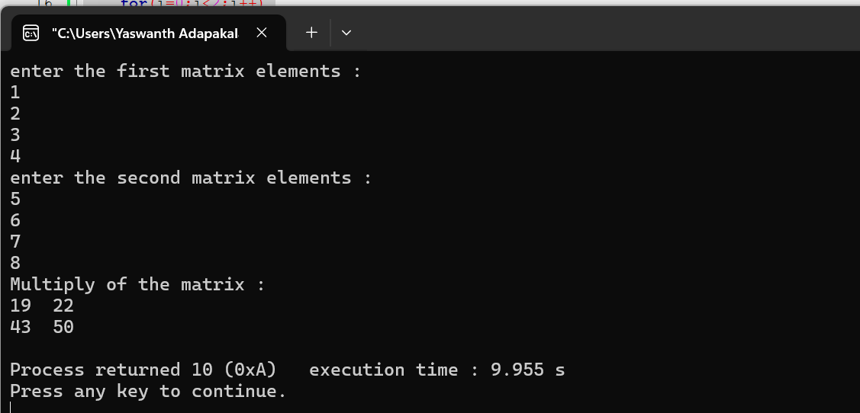

**Tasks on Arrays : _**

**Task 1 :**

**Code :**

#include<stdio.h>

void main()

{

int a[20],i;

printf(" Enter the elements of the array of 20 : \n ");

for(i=0;i<20;i++)

{

scanf("%d",&a[i]);

}

}

**Output :**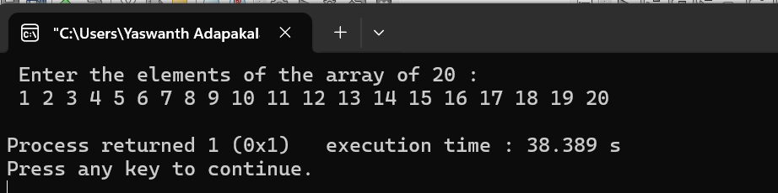

**Task 2 :**

**Code :**

#include<stdio.h>

void main()

{

int a[20],i;

printf(" Enter the elements of the array of 20 : \n ");

for(i=0;i<20;i++)

{

scanf("%d",&a[i]);

}

printf("\n printing the elements of the array with index values :\n");

for(i=0;i<20;i++)

{

printf("a[%d] = %d\n",i,a[i]);

}

}

**Output :**

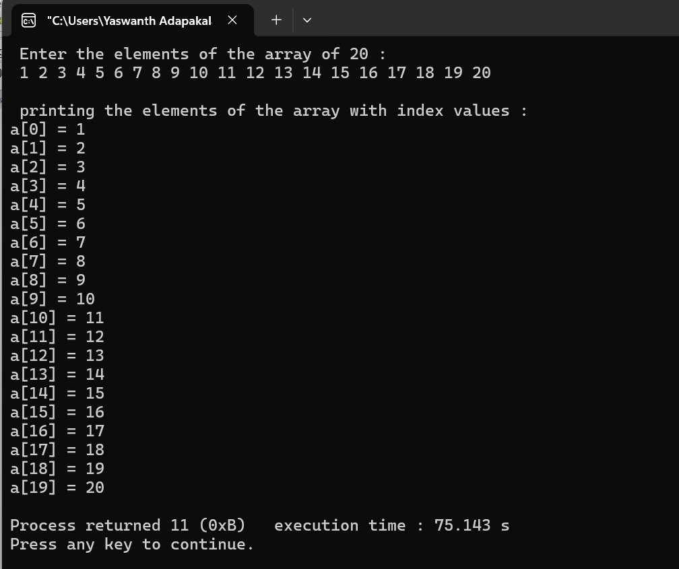

**Task 3 :**

**Code :**

#include<stdio.h>

void main()

{

int a[20],i,j;

printf(" Enter the elements of the array of 20 : \n ");

for(i=0;i<20;i++)

{

scanf("%d",&a[i]);

}

printf("\n Enter the index of value which is to be deleted : ");

scanf("%d",&j);

a[j]=0;

printf("\n printing the elements of the array after deleting the element :\n");

for(i=0;i<20;i++)

{

printf("%d ",a[i]);

}

}

**Output :**

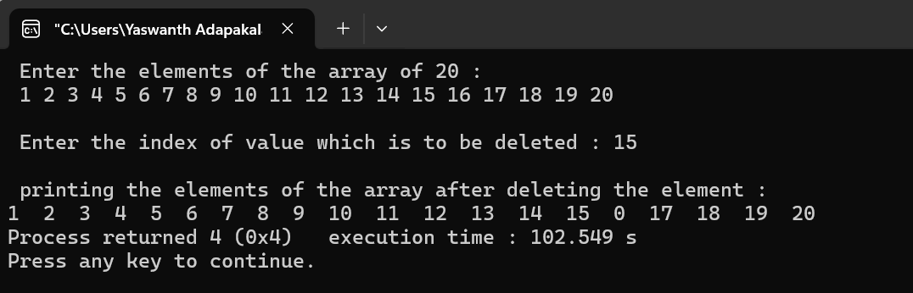

**Task 4 :**

**Code :**

#include<stdio.h>

void main()

{

int a[20],i,j;

printf(" Enter the elements of the array of 20 : \n ");

for(i=0;i<20;i++)

{

scanf("%d",&a[i]);

}

printf("\n Printing index values of duplicate elements : \n");

for (i=0;i<20;i++)

{

for(j=i+1;j<20;j++)

{

if(a[i]==a[j])

{

printf("%d and %d \n",i,j);

}

}

}

}

**Output :**

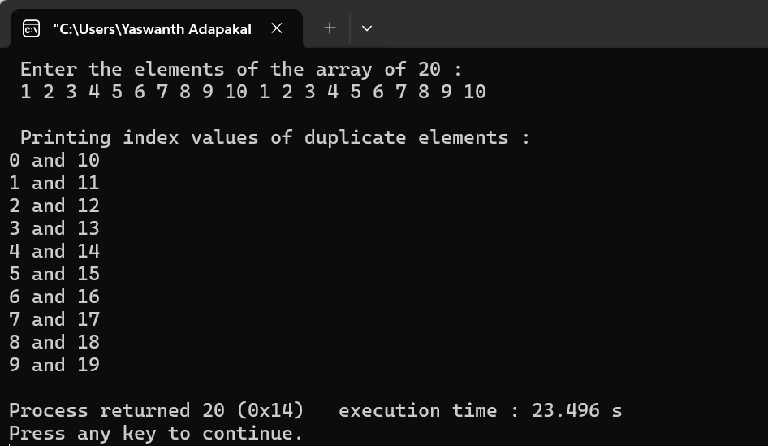

**Task 5 :**

**Code :**

#include<stdio.h>

void main()

{

int a[20],i,num,flag=0;

printf(" Enter the elements of the array of 20 : \n ");

for(i=0;i<20;i++)

{

scanf("%d",&a[i]);

}

printf("\n Enter the element which is to be searched :\n");

scanf("%d",&num);

for(i=0;i<20;i++)

{

if(a[i]==num)

{

printf(" Given number is found at index value : %d \n",i);

flag++;

}

}

if(flag==0)

{

printf(" Element NOT FOUND ");

}

}

**Output :**

