**Project on Calculator _**

**Code :**

#include <conio.h>

#include <stdlib.h>

void main ()

{

int choice, a, b, result=0,y, rem;

start:

printf("\nWelcome to my calculator\n");

printf("\n 1. Add numbers");

printf("\n 2. Subtract numbers");

printf("\n 3. Multiply numbers");

printf("\n 4. Divide Numbers");

printf("\n 5. Exit");

printf("\nEnter your choice:: ");

scanf("%d", &choice);

switch(choice)

{

case 1:

{

add:

printf(" ******* Addition ********");

printf("\nEnter first number::");

scanf("%d", &a);

printf("\nEnter Second number::");

scanf("%d", &b);

result = a+b;

printf("\nAddition is :: %d", result);

printf("\n Do you want to continue ? (0/1)?\n");

scanf("%d",&y);

if (y==1)

{

system("cls");

goto add;

}

else

goto start;

break;

}

case 2:

{

sub:

printf(" ******* Subtraction ********");

printf("\nEnter first number::");

scanf("%d", &a);

printf("\nEnter Second number::");

scanf("%d", &b);

result = a-b;

printf("\nResult is :: %d", result);

printf("\n Do you want to continue ? (0/1)?\n");

scanf("%d",&y);

if (y==1)

{

system("cls");

goto sub;

}

else

goto start;

break;

}

case 3:

{

mul:

printf(" ******* Multiplication ********");

printf("\nEnter first number::");

scanf("%d", &a);

printf("\nEnter Second number::");

scanf("%d", &b);

result = a*b;

printf("\nResult is :: %d", result);

printf("\n Do you want to continue ? (0/1)?\n");

scanf("%d",&y);

if (y==1)

{

system("cls");

goto mul;

}

else

goto start;

break;

}

case 4:

{

div:

printf(" ******* Division ********");

printf(" \n** Divisor must not be Zero **");

printf("\nEnter first number::");

scanf("%d", &a);

printf("\nEnter Second number::");

scanf("%d", &b);

if (b==0)

{

printf(" Its not possible");

goto start;

}

else

{

result = a/b;

printf("\nQoutient is :: %d", result);

rem = a%b;

printf("\nRemainder is :: %d", rem);

}

printf("\n Do you want to continue ? (0/1)?\n");

scanf("%d",&y);

if (y==1)

{

system("cls");

goto div;

}

else

goto start;

break;

}

default:

printf("Bye");

}

}

**Outputs :**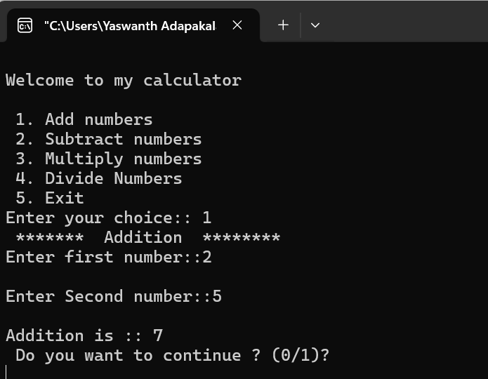

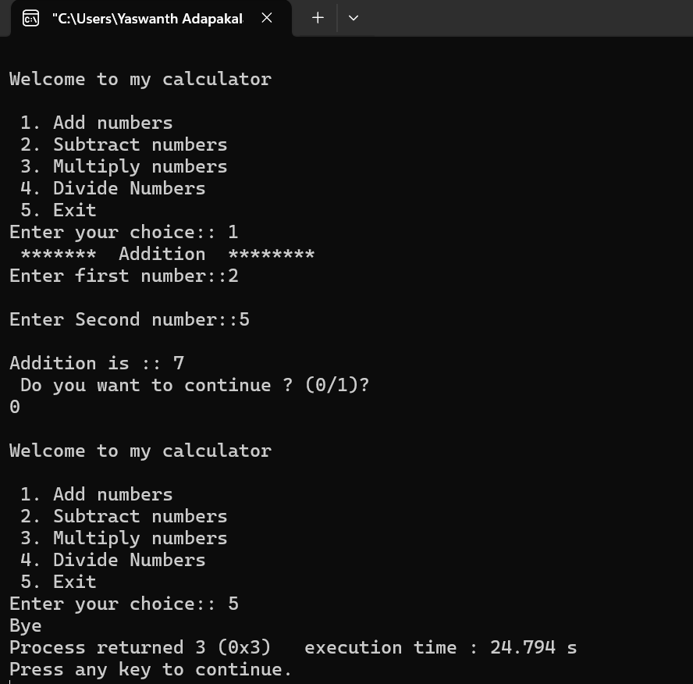

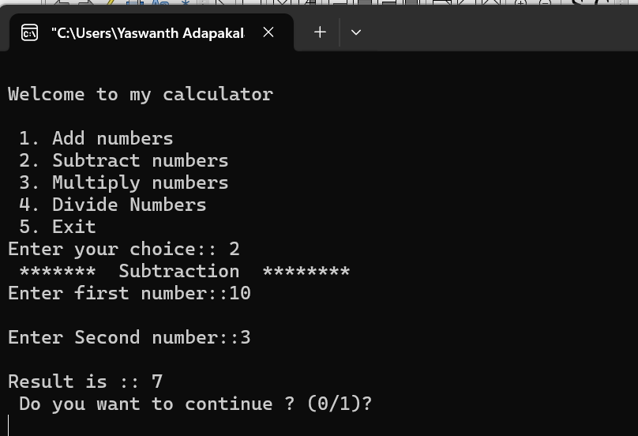

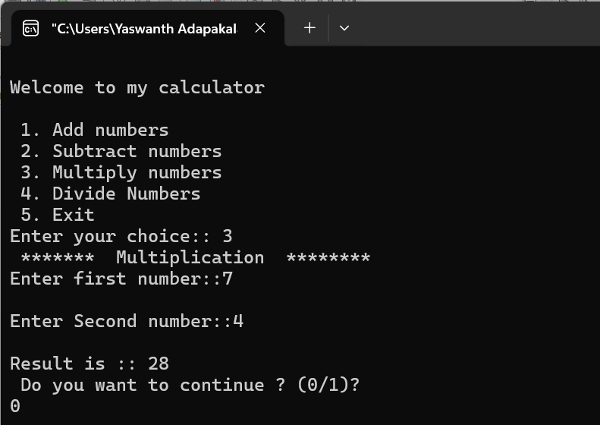

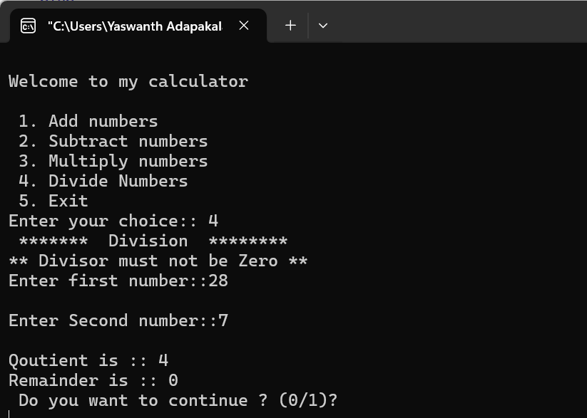

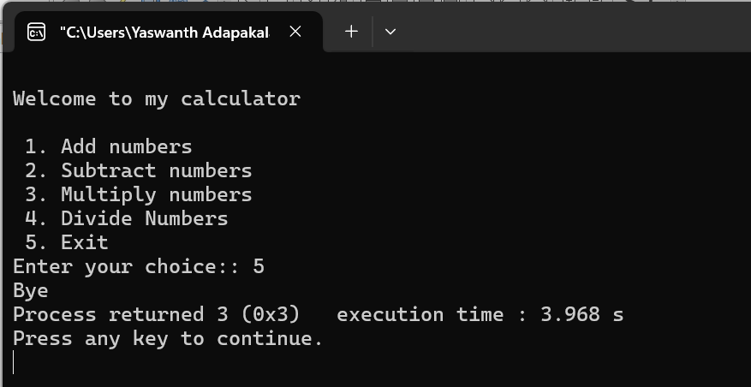

**_____________THANK YOU ______________**