**Project on Employee Management System**

**Name : YASWANTH ADAPAKALA**

**Batch : Linux Device Driver Training**

**Trainer : Satinnder**

**Code :**

#include <stdio.h>

#include <string.h>

void create();

void view();

void edit();

void delete();

void choice();

void choice(){

int choic;

printf("\nWELCOME TO OMG COMPANY\n");

start:

printf("--------------------------------\n");

printf("Press 1 to Create a new Data\n");

printf("Press 2 to View the Data\n");

printf("Press 3 to edit the Data\n");

printf("Press 4 to delete the Data\n");

printf("Press 5 to exit the Program...!\n");

printf("--------------------------------\n");

int choice;

scanf("%d",&choice);

if(choice==5){

printf("Exiting the Program...\n");

return ;

}

switch (choice)

{

case 1:

create();

printf("Do you wish to continue? 1 for Yes 0 for No\n");

scanf("%d",&choic);

if(choic==1){

goto start;

}

else if(choic==0){

printf(" exiting the program......!\n");

}

break;

case 2:

view();

printf("Do you wish to continue? 1 for Yes 0 for No\n");

scanf("%d",&choic);

if(choic==1){

goto start;

}

else if(choic==0){

printf(" exiting the program......!\n");

}

break;

case 3:

edit();

printf("Do you wish to continue? 1 for Yes 0 for No\n");

scanf("%d",&choic);

if(choic==1){

goto start;

}

else if(choic==0){

printf(" exiting the program......!\n");

}

break;

case 4:

delete();

printf("Do you wish to continue? 1 for Yes 0 for No\n");

scanf("%d",&choic);

if(choic==1){

goto start;

}

else if(choic==0){

printf(" exiting the program......!\n");

}

break;

default:

break;

}

}

struct emp

{

int id;

char name[30];

int age;

char branch[20];

char designation[20];

}emp;

void create(){

struct emp p1;

FILE *fp=fopen("C:\\Users\\Yaswanth Adapakala\\Desktop\\Linux\\Codeblocks_programs\\empdetails.txt", "a");

if(fp==NULL){

printf("Error opening File");

return ;

}

printf("\nEnter Employee Id:");

scanf("%d",&p1.id);

// fflush(stdin);

printf("\nEnter Employee name: ");

scanf("%s", p1.name);

strcpy (p1.name, p1.name);

printf("\nEnter Employee Age: ");

scanf("%d", &p1.age);

printf("\nEnter Employee Branch:");

scanf("%s", p1.branch);

printf("\nEnter Employee Designation:");

scanf("%s", p1.designation);

fwrite(&p1,sizeof(emp),1,fp);

printf("Data Uploaded Successfully\n");

fclose(fp);

}

void view(){

struct emp p1;

FILE *ptr;

ptr=fopen("C:\\Users\\Yaswanth Adapakala\\Desktop\\Linux\\Codeblocks_programs\\empdetails.txt", "r");

if(ptr==NULL){

printf("Failed to open File\n");

return;

}

while(fread(&p1,sizeof(emp),1,ptr)){

printf("%d %s %d %s %s\n",p1.id,p1.name,p1.age,p1.branch,p1.designation);

}

fclose(ptr);

}

void edit(){

struct emp p1;

FILE *ptr, *ptr1;

int c = 0;

int a;

ptr = fopen("C:\\Users\\Yaswanth Adapakala\\Desktop\\Linux\\Codeblocks_programs\\empdetails.txt", "r");

if (ptr == NULL) {

printf("Error opening file for reading\n");

return ;

}

ptr1 = fopen("C:\\Users\\Yaswanth Adapakala\\Desktop\\Linux\\Codeblocks_programs\\empdetails.txt", "w");

if (ptr1 == NULL) {

printf("Error opening file for writing\n");

fclose(ptr);

return ;

}

printf("Enter the Employee Id to Modify the Data:\n");

scanf("%d", &a);

while (fread(&p1, sizeof(struct emp), 1, ptr)) {

if (a == p1.id) {

c = 1;

printf("Enter New Employee name: \n");

scanf("%s", p1.name);

printf("Enter New Employee Age: \n");

scanf("%d", &p1.age);

printf("Enter New Employee Branch:\n");

scanf("%s", p1.branch);

printf("Enter New Employee Designation:\n");

scanf("%s", p1.designation);

}

fwrite(&p1, sizeof(struct emp), 1, ptr1);

}

fclose(ptr);

fclose(ptr1);

if (c == 0) {

printf("Employee Not found\n");

} else {

ptr1 = fopen("C:\\Users\\Yaswanth Adapakala\\Desktop\\Linux\\Codeblocks_programs\\empdetails.txt", "r");

ptr = fopen("C:\\Users\\Yaswanth Adapakala\\Desktop\\Linux\\Codeblocks_programs\\empdetails.txt", "w");

if (ptr == NULL) {

printf("Error opening file for writing\n");

fclose(ptr1);

return ;

}

if (ptr1 == NULL) {

printf("Error opening file for reading\n");

fclose(ptr);

return ;

}

while (fread(&p1, sizeof(struct emp), 1, ptr1)) {

fwrite(&p1, sizeof(struct emp), 1, ptr);

}

fclose(ptr);

fclose(ptr1);

remove("C:\\Users\\Yaswanth Adapakala\\Desktop\\Linux\\Codeblocks_programs\\empdetails.txt ");

}

}

void delete(){

FILE *ptr, *ptr1;

struct emp p1;

ptr = fopen("C:\\Users\\Yaswanth Adapakala\\Desktop\\Linux\\Codeblocks_programs\\empdetails.txt", "r");

ptr1 = fopen("C:\\Users\\Yaswanth Adapakala\\Desktop\\Linux\\Codeblocks_programs\\empdetails.txt", "w");

if(ptr == NULL){

printf("Error opening files for deleting\n");

fclose(ptr);

return;

}

if(ptr1==NULL){

printf("Error opening files for deleting\n");

fclose(ptr1);

return ;

}

printf("Enter the employee id to delete\n");

int a;

scanf("%d", &a);

int c = 0;

while (fread(&p1, sizeof(struct emp), 1, ptr)){

printf("%d",p1.id);

if(a == p1.id){

c = 1;

} else {

fwrite(&p1, sizeof(struct emp), 1, ptr1);

}

}

fclose(ptr1);

fclose(ptr);

if(c == 1){

ptr = fopen("C:\\Users\\Yaswanth Adapakala\\Desktop\\Linux\\Codeblocks_programs\\empdetails.txt", "r");

ptr1 = fopen("C:\\Users\\Yaswanth Adapakala\\Desktop\\Linux\\Codeblocks_programs\\empdetails.txt", "w");

if(ptr == NULL || ptr1 == NULL){

printf("Failed to open the file\n");

if(ptr) fclose(ptr);

if(ptr1) fclose(ptr1);

return;

}

while(fread(&p1, sizeof(struct emp), 1, ptr)){

fwrite(&p1, sizeof(struct emp), 1, ptr1);

}

fclose(ptr1);

fclose(ptr);

remove("C:\\Users\\Yaswanth Adapakala\\Desktop\\Linux\\Codeblocks_programs\\empdetails.txt");

printf("Deleted the employee successfully\n");

} else {

printf("Record not found\n");

}

}

int main()

{

choice();

return 0;

}

**Outputs :**

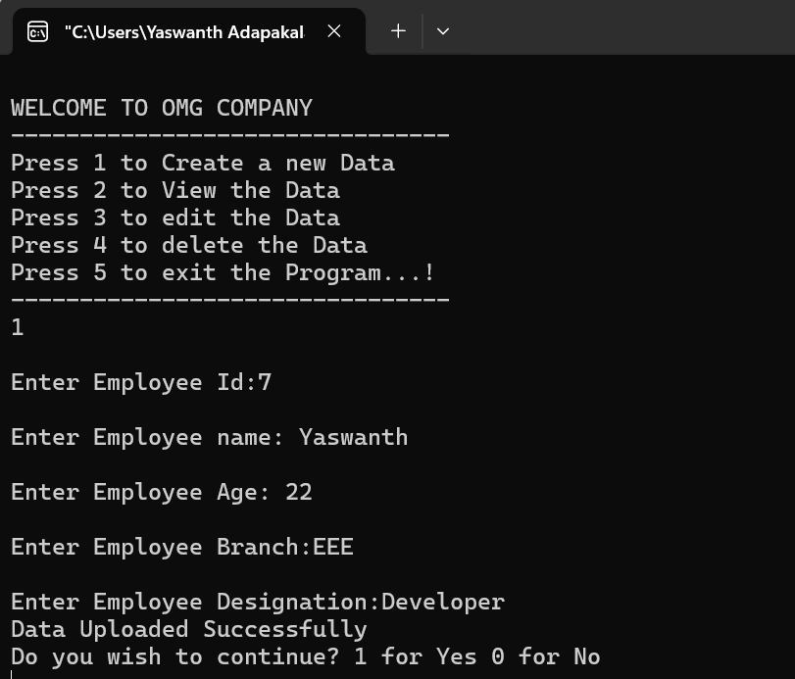

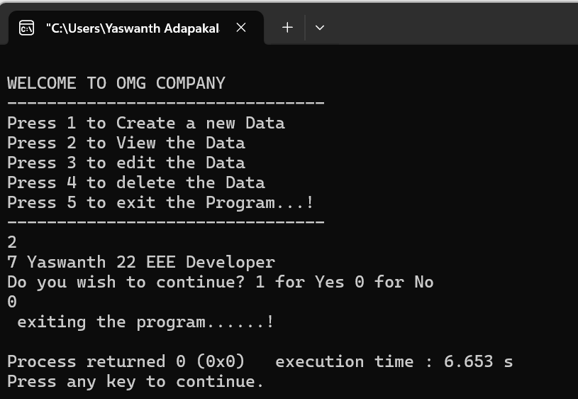

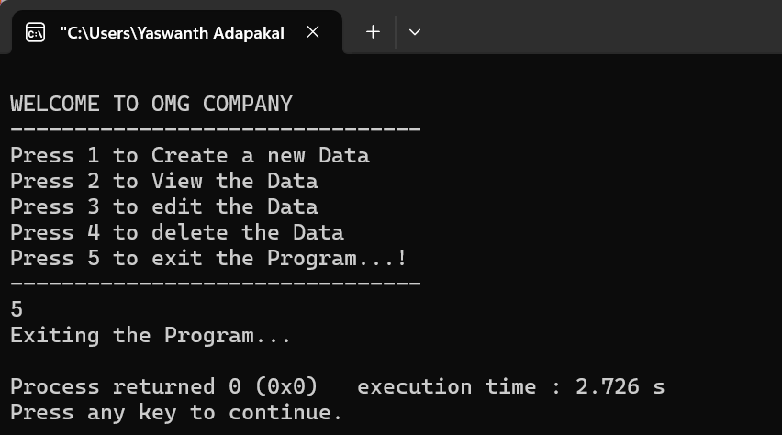

**_____________THANK YOU ______________**