**Project on Value Conversions _**

**Name : YASWANTH ADAPAKALA**

**Batch : Linux Device Driver Training**

**Trainer : Satinnder**

**Code :**

#include<stdio.h>

#include<string.h>

#include<math.h>

void start();

void convert();

void binary_Values();

int bin_to_dec();

void bin_to_oct();

void bin_to_hexa();

void decimal_values();

void dec_to_binary();

void dec_to_oct();

void dec_to_hexa();

void octal_values();

void oct_bin();

void hexa_values();

void hexa_bin();

void wish();

void wish(){

wis:

printf("----------------------------------\n");

printf("Do you wish to Continue?\n");

printf("Press 1 to continue or press 0 to cancel.\n");

printf("----------------------------------\n");

int c;

scanf("%d", &c);

if (c == 1)

{

// system("cls");

start();

}

else if(c==0) {

printf("Exiting...\n");

return ;

}

else{

printf("Please enter a valid Keyword.\n");

goto wis;

}

}

void start(){

start:

printf("press 1 for Binary Conversions\n");

printf("Press 2 for Decimal Conversions\n");

printf("Press 3 for Octal Conversions\n");

printf("Press 4 for HexDecimal Conversions\n");

printf("Press 5 for Exit Conversions\n");

printf("----------------------------------\n");

int option;

scanf("%d", &option);

if(option ==5){

printf("Exiting.....!\n");

return ;

}

else if(option>4){

printf("Choose the correct option\n");

printf("----------------------------------\n");

goto start;

}

else{

convert(option);

}

}

void convert(int a){

switch (a)

{

case 1:

binary_Values();

wish();

break;

case 2:

decimal_values();

wish();

break;

case 3:

octal_values();

wish();

break;

case 4:

hexa_values();

wish();

break;

default:

break;

}

}

void binary_Values(){

bin:

printf("Please Enter the Binary Value\n");

char a[20];

scanf("%s",a);

for(int i=0;i<20;i++)

{

if(!a[i]==0 && !a[i]==1){

printf("Enter the Binary Values only\n");

goto bin;

}

}

printf("Decimal value of %s is : %d\n",a,bin_to_dec(a));

bin_to_oct(a);

bin_to_hexa(a);

}

int bin_to_dec(char a[]){

int dec=0;

int c=0;

for(int i=strlen(a)-1;i>=0;i--){

dec=dec+(a[i]-'0')*(int)pow(2,c);

c++;

}

return dec;

}

void bin_to_oct(char a[]){

int dec=bin_to_dec(a);

char a1[20];

sprintf(a1,"%o",dec);

printf("Octal value of %s is : %s\n",a,a1);

}

void bin_to_hexa(char a[]){

int dec=bin_to_dec(a);

char a1[20];

sprintf(a1,"%x",dec);

printf("Hexa value of %s is: %s\n",a,a1);

}

void decimal_values(){

printf("Enter a decimal value:\n");

int i;

scanf("%d",&i);

if(!i>0){

printf("Enter a decimal value\n");

}

dec_to_binary(i);

dec_to_oct(i);

dec_to_hexa(i);

}

void dec_to_binary(int a){

int c=0,temp=a;

int bin[20];

while(a>0){

bin[c++]=a%2;

a=a/2;

}

printf("Binary value of %d is :",temp);

for(int i=c-1;i>=0;i--){

printf("%d",bin[i]);

}

printf("\n");

}

void dec_to_oct(int a){

char dec[20];

sprintf(dec, "%o",a);

printf("Octal value of %d is :%s\n",a,dec);

}

void dec_to_hexa(int a){

char hex[20];

sprintf(hex, "%x",a);

printf("Hexadecimal value of %d is :%s\n",a,hex);

}

void octal_values(){

printf("Enter your Octal Number:\n");

char i[20];

scanf("%s",i);

oct_bin(i);

}

void oct_bin(char a[]){

int dec=0;

int c=0;

for(int i=strlen(a)-1;i>=0;i--){

dec=dec+(a[i]-'0')*(int)pow(8,c);

c++;

}

printf("Decimal Value of %s is :%d\n",a,dec);

dec_to_binary(dec);

dec_to_hexa(dec);

}

void hexa_values(){

hexa:

printf("Enter the hexadecimal Values\n");

char c[20];

scanf("%s",c);

for(int i=0;i<strlen(c);i++){

if((c[i]>='0' && c[i]<='9') || (c[i]>='a' && c[i]<='f')){

}

else{

printf("Invalid hexadecimal value\n");

// system("cls");

goto hexa;

}

}

hexa_bin(c);

}

void hexa_bin(char a[]){

int dec=0;

int c=0;

for(int i=strlen(a)-1;i>=0;i--){

if((a[i]>='0' && a[i]<='9')){

dec=dec+(a[i]-'0')*(int)pow(16,c);

}

else{

dec=dec+(a[i]-'a'+10)*(int)pow(16,c);

}

c++;

}

printf("Decimal Value of %s is: %d\n",a,dec);

dec_to_binary(dec);

dec_to_oct(dec);

}

int main(){

printf(" Welcome to Value Conversions...\n\n");

start();

}

**Outputs :**

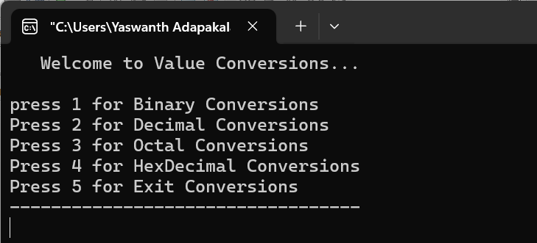

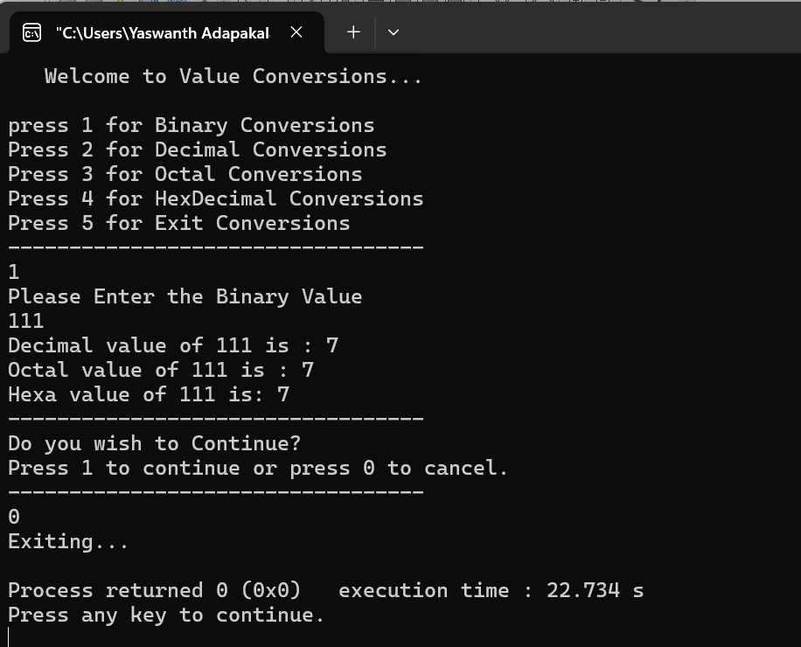

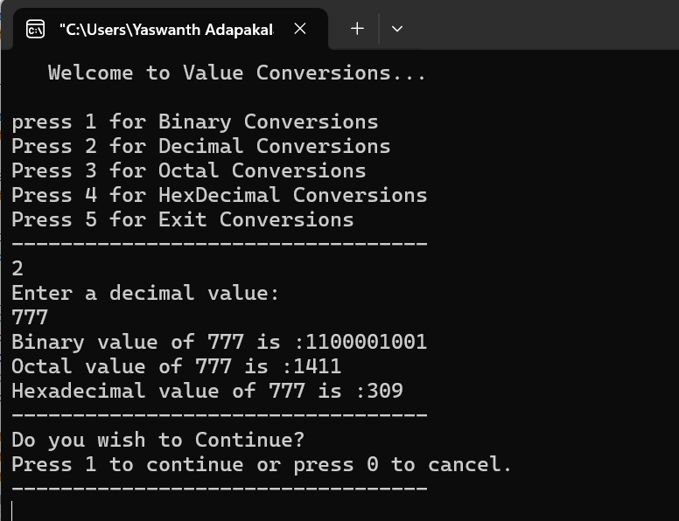

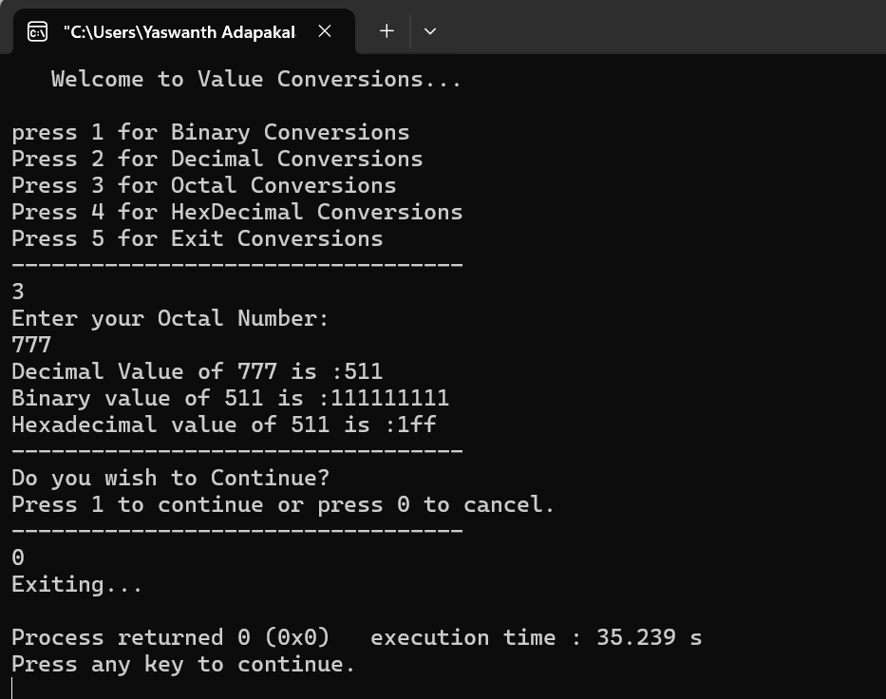

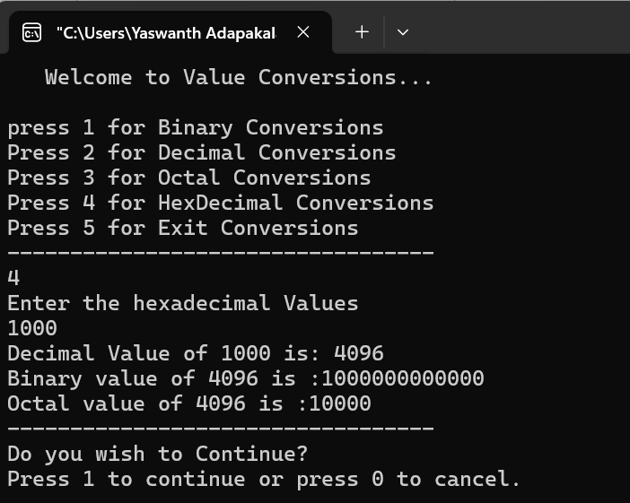

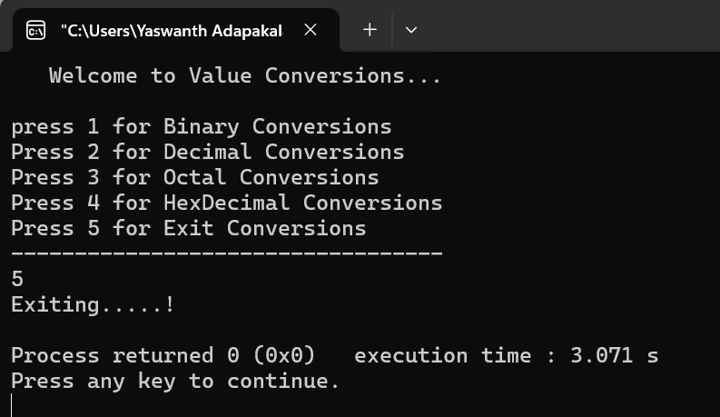

**_____________THANK YOU ______________**