SET-13
AIM
To analyze geographic data using a map chart, scatter plot, data table, and Tableau dashboard.

Dataset: GEOGRAPHIC DATA
City | Population | Avg. Temperature | Elevation
City A | 500000 | 75 | 1000
City B | 700000 | 68 | 800
City C | 600000 | 80 | 1200

PROGRAM 1 – MAP CHART
Create a map chart to visualize the distribution of cities on a geographic map. Label the map
elements.

R-Code:
city <- c("City A", "City B", "City C")
population <- c(500000, 700000, 600000)
temperature <- c(75, 68, 80)
elevation <- c(1000, 800, 1200)

data <- data.frame(city, population, temperature, elevation)

# Display geographic data
print(data)
The dataset displays the geographic information of City A, City B and City C.
Output:
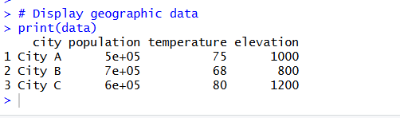
Map elements:
- City → Location
- Population → Size
- Average Temperature → Colour
- Elevation → Information/Tooltip
Observation
The map can be used to compare cities based on population, temperature and elevation.
Note: The given dataset does not contain latitude and longitude values. Therefore, exact geographic positions cannot be plotted from this data alone.

PROGRAM 2 – SCATTER PLOT
Generate a scatter plot to explore the relationship between average temperature and population size. Explain any insights.
R-Code:
city <- c("City A", "City B", "City C")
population <- c(500000, 700000, 600000)
temperature <- c(75, 68, 80)

plot(temperature, population,
pch = 19,
main = "Average Temperature vs Population",
xlab = "Average Temperature",
ylab = "Population")

text(temperature, population,
labels = city,
pos = 3)
Output:
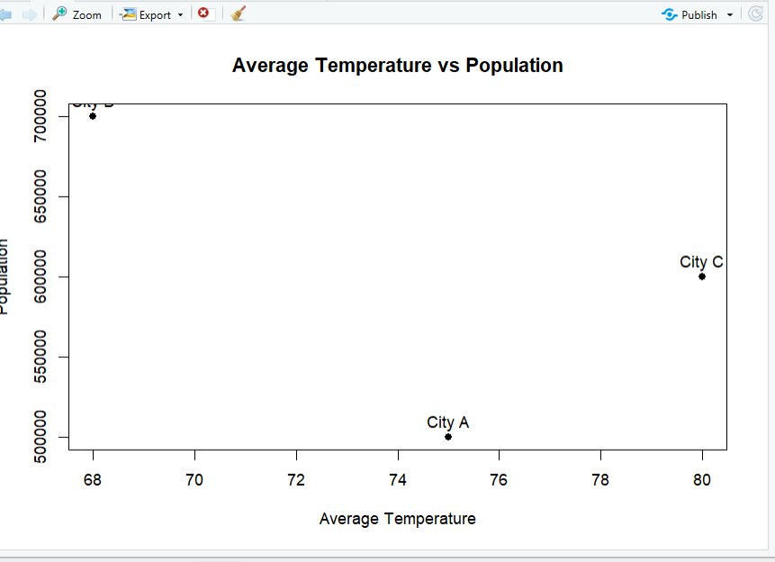

Observation
- City B has the highest population (700000) and lowest temperature (68).
- City C has the highest temperature (80) and population of 600000.
- City A has 500000 population and temperature of 75.
- With only three cities, no strong relationship can be concluded.

PROGRAM 3 – GEOGRAPHIC DATA TABLE
Build a table to display the geographic data for each city. Label the table elements.
R-Code:
data <- data.frame(
City = c("City A", "City B", "City C"),
Population = c(500000, 700000, 600000),
Avg_Temperature = c(75, 68, 80),
Elevation = c(1000, 800, 1200)
)

print(data)

Output:
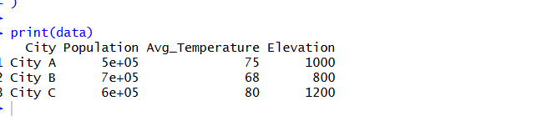
Observation
The table provides a clear and simple comparison of the geographic information for all three cities.
PROGRAM 4 – TABLEAU DASHBOARD
Procedure
- Open Tableau.
- Connect the geographic dataset.
- Create a Map Chart.
- Create a Scatter Plot.
- Create a Data Table.
- Create a new dashboard.
- Add the map, scatter plot and table.
- Add filters for interactive exploration.
Map Chart
- City → Detail
- Population → Size
- Avg. Temperature → Colour
Scatter Plot
- Columns → Avg. Temperature
- Rows → Population
- City → Label
Table
Add:
- City
- Population
- Avg. Temperature
- Elevation
Dashboard
Combine:
Map Chart + Scatter Plot + Geographic Data Table
Output:
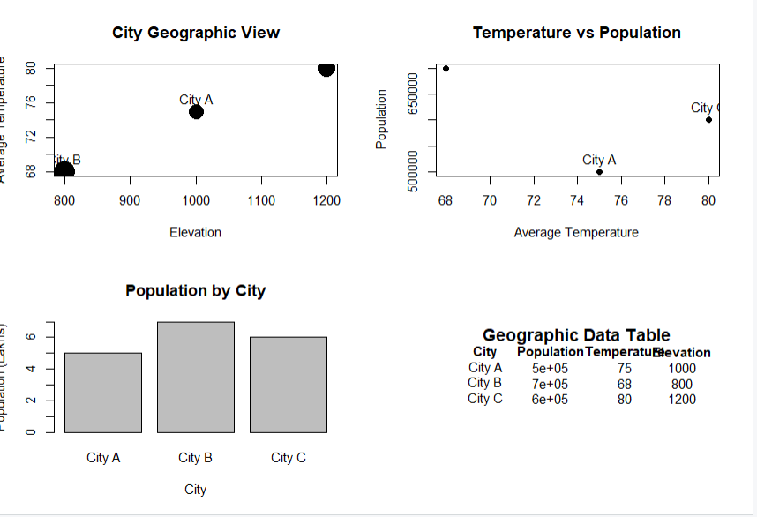
Observation
The Tableau dashboard provides an interactive view of geographic data. Users can compare population, temperature and elevation using the map, scatter plot and table.

SET13 PROCEDURE
- Create the geographic dataset.
- Visualize cities using a map chart.
- Analyze temperature and population using a scatter plot.
- Display geographic information in a table.
- Import the dataset into Tableau.
- Create map, scatter plot and table worksheets.
- Combine all worksheets into one dashboard.
- Add filters for interactive analysis.
SET13 RESULT
The geographic dataset was successfully analyzed using map visualization, scatter plot and tabular representation. A Tableau dashboard was designed by combining these visualizations, allowing users to interactively explore city population, average temperature and elevation.

