Set-25
A. Yaswanth - 192324179
Dataset: Website Traffic
Date | Page Views | Click-through Rate
2023-01-01 | 1500 | 2.3%
2023-01-02 | 1600 | 2.7%
2023-01-03 | 1400 | 2.0%
2023-01-04 | 1650 | 2.4%
2023-01-05 | 1800 | 2.6%

Question 1. Line chart for page views in Tableau
Procedure:
- Enter the website traffic data into Excel and save it as Website_Traffic.xlsx.
- Open Tableau and connect to the Excel file.
- Drag Date to Columns and Page Views to Rows.
- Set Date to Exact Date and select continuous date if needed.
- Choose Line from the Marks card.
- Set the chart title to Website Page Views Over Time.
- Label the axes as Date and Page Views.
Output:
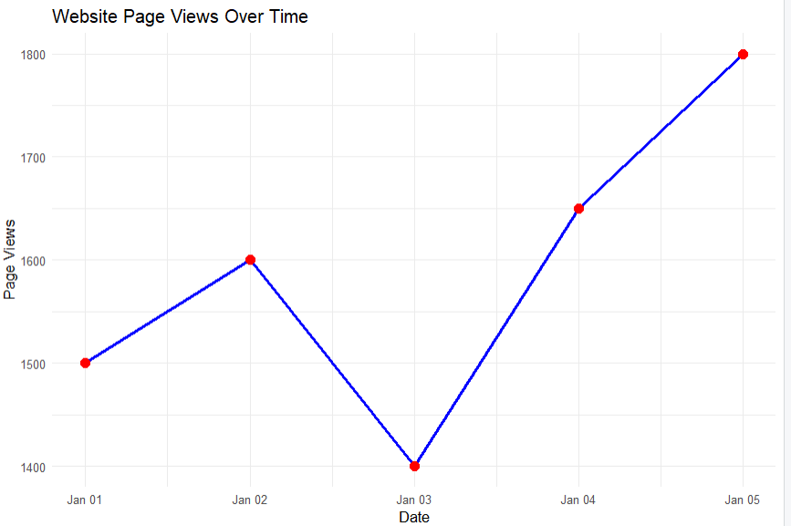

Result: The line chart displays page views over time.
Question 2. Bar chart for the top N days with the highest click-through rates
R-code:

library(ggplot2)

traffic <- data.frame(
Date = as.Date(c(
"2023-01-01", "2023-01-02", "2023-01-03",
"2023-01-04", "2023-01-05"
)),
Click_Through_Rate = c(2.3, 2.7, 2.0, 2.4, 2.6)
)

N <- 3

top_days <- head(
traffic[order(-traffic$Click_Through_Rate), ],
N
)

ggplot(top_days,
aes(x = reorder(as.character(Date), Click_Through_Rate),
y = Click_Through_Rate)) +
geom_col(fill = "steelblue") +
geom_text(aes(label = paste0(Click_Through_Rate, "%")),
vjust = -0.4) +
labs(
title = "Top 3 Days by Click-through Rate",
x = "Date",
y = "Click-through Rate (%)"
) +
theme_minimal()

Output:
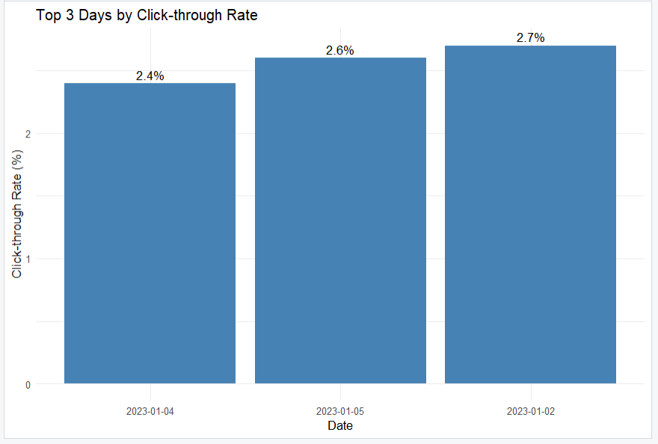
Result: The bar chart displays the three days with the highest click-through rates.

Question 3. Stacked area chart for user interactions
R-code:

library(ggplot2)

interactions <- data.frame(
Date = as.Date(c(
"2023-01-01", "2023-01-02", "2023-01-03",
"2023-01-04", "2023-01-05"
)),
Likes = c(120, 140, 110, 150, 170),
Shares = c(30, 35, 25, 40, 45),
Comments = c(20, 25, 18, 30, 35)
)

interactions_long <- data.frame(
Date = rep(interactions$Date, 3),
Interaction = factor(
rep(c("Likes", "Shares", "Comments"), each = 5),
levels = c("Likes", "Shares", "Comments")
),
Count = c(
interactions$Likes,
interactions$Shares,
interactions$Comments
)
)

ggplot(interactions_long,
aes(x = Date, y = Count, fill = Interaction)) +
geom_area() +
labs(
title = "Distribution of Website User Interactions",
x = "Date",
y = "Number of Interactions",
fill = "Interaction Type"
) +
theme_minimal()

Output:
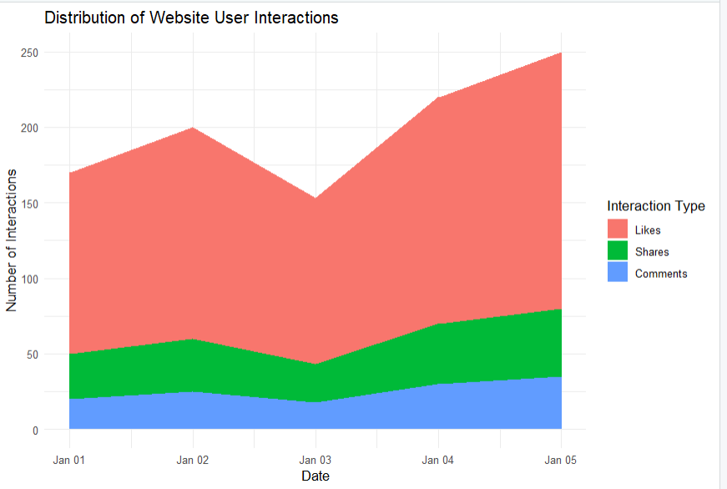
Result: The stacked area chart displays likes, shares, and comments over time.

Question 4. Interactive Tableau dashboard for traffic sources
Procedure:
- Enter the traffic source data into Excel and save it as Traffic_Sources.xlsx.
- Open Tableau and connect to both the website traffic data and traffic source data.
- Create a map using Longitude and Latitude. Set the Marks type to Map or Circle.
- Drag Traffic Source to Detail and Page Views to Size or Color.
- Create a bar chart using Traffic Source on Columns and Page Views on Rows.
- Click New Dashboard and name it Website Traffic Sources Dashboard.
- Drag the map and bar chart onto the dashboard.
- Enable Use as Filter on the map and add titles and labels.
Output:
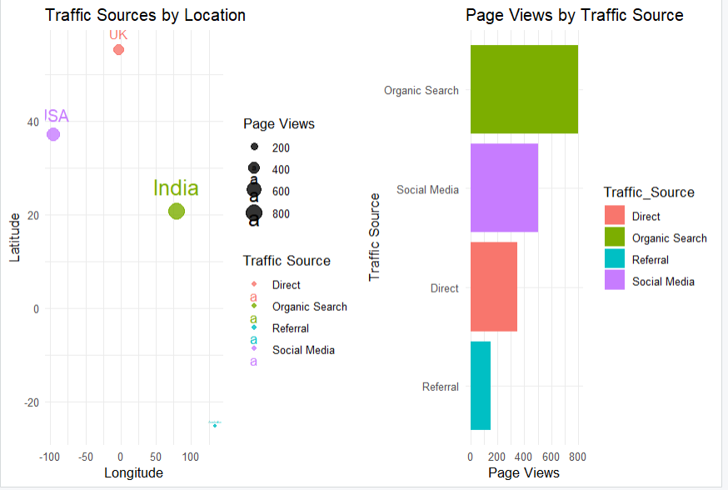
Result: The dashboard layout displays traffic source locations and page views by source.

