Set-27

A. Yaswanth - 192324179
Dataset: Patient Health Risk Analysis
Patient ID | Age | BMI | BP | Cholesterol
P1 | 25 | 22 | 120 | 180
P2 | 40 | 28 | 135 | 210
P3 | 55 | 30 | 145 | 240
P4 | 35 | 26 | 130 | 200
P5 | 60 | 32 | 150 | 260

Question 1. Scatterplot matrix for health indicators
R-code:

patients <- data.frame(
Patient_ID = c("P1", "P2", "P3", "P4", "P5"),
Age = c(25, 40, 55, 35, 60),
BMI = c(22, 28, 30, 26, 32),
BP = c(120, 135, 145, 130, 150),
Cholesterol = c(180, 210, 240, 200, 260)
)

pairs(
patients[, c("Age", "BMI", "BP", "Cholesterol")],
main = "Scatterplot Matrix of Patient Health Indicators",
pch = 19,
col = "blue"
)

Output:
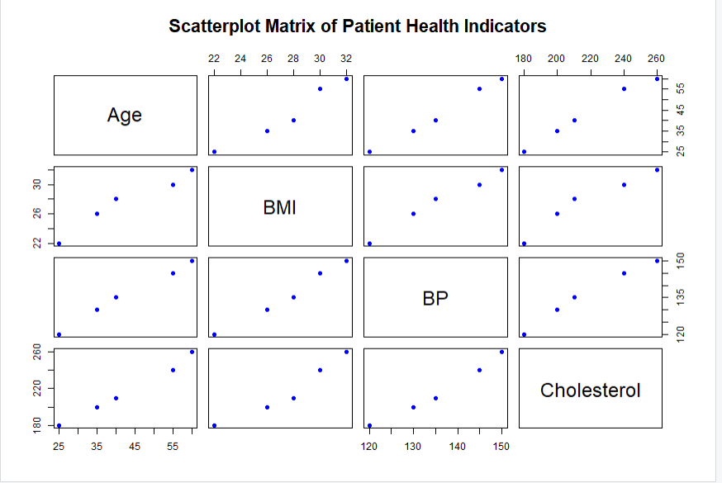
Result: The scatterplot matrix displays pairwise relationships among Age, BMI, BP, and Cholesterol.

Question 2. Q-Q plot and ECDF for Cholesterol levels
R-code:

patients <- data.frame(
Patient_ID = c("P1", "P2", "P3", "P4", "P5"),
Age = c(25, 40, 55, 35, 60),
BMI = c(22, 28, 30, 26, 32),
BP = c(120, 135, 145, 130, 150),
Cholesterol = c(180, 210, 240, 200, 260)
)

par(mfrow = c(1, 2))

qqnorm(
patients$Cholesterol,
main = "Q-Q Plot of Cholesterol",
pch = 19,
col = "blue"
)

qqline(
patients$Cholesterol,
col = "red",
lwd = 2
)

plot(
ecdf(patients$Cholesterol),
main = "ECDF of Cholesterol",
xlab = "Cholesterol",
ylab = "Cumulative Probability",
verticals = TRUE,
do.points = TRUE,
col = "blue",
lwd = 2
)

par(mfrow = c(1, 1))

Output:
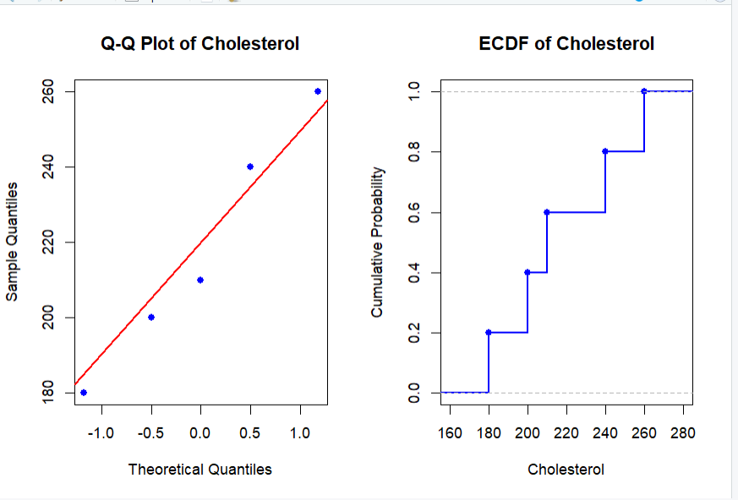
Result: The Q-Q plot compares Cholesterol levels with a normal distribution, and the ECDF displays cumulative probabilities.

Question 3. Bar chart for average health indicators
R-code:

library(ggplot2)

patients <- data.frame(
Patient_ID = c("P1", "P2", "P3", "P4", "P5"),
Age = c(25, 40, 55, 35, 60),
BMI = c(22, 28, 30, 26, 32),
BP = c(120, 135, 145, 130, 150),
Cholesterol = c(180, 210, 240, 200, 260)
)

averages <- data.frame(
Indicator = c("Age", "BMI", "BP", "Cholesterol"),
Average = c(
mean(patients$Age),
mean(patients$BMI),
mean(patients$BP),
mean(patients$Cholesterol)
)
)

ggplot(
averages,
aes(x = Indicator, y = Average, fill = Indicator)
) +
geom_col() +
geom_text(
aes(label = round(Average, 2)),
vjust = -0.4
) +
labs(
title = "Average Patient Health Indicators",
x = "Health Indicator",
y = "Average Value"
) +
theme_minimal()

Output:
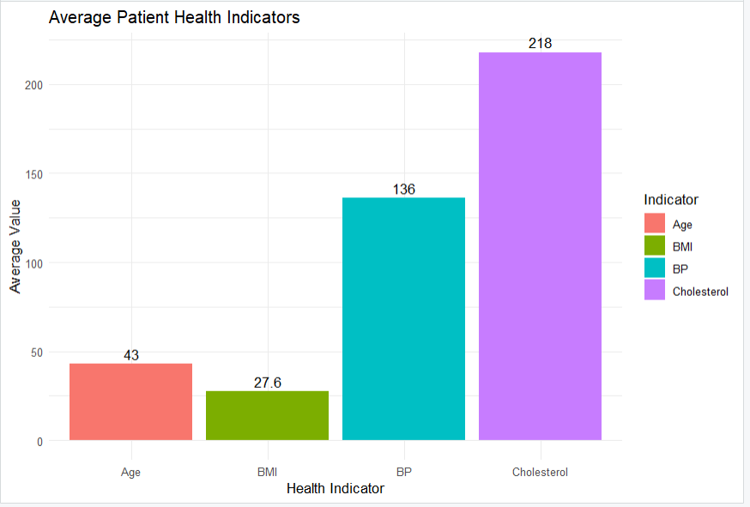
Result: The bar chart displays the average values of Age, BMI, BP, and Cholesterol.

Question 4. Interactive Tableau dashboard for patient health risk
Procedure:
- Enter the patient data into Excel and save it as Patient_Health_Risk.xlsx.
- Open Tableau and connect to the Excel file.
- Create a heatmap by placing Patient ID on Rows and Measure Names on Columns.
- Drag Measure Values to Color and retain Age, BMI, BP, and Cholesterol.
- Add Patient ID, Age, BMI, BP, and Cholesterol to Tooltip.
- Drag Age to Filters and select Show Filter.
- Click New Dashboard and name it Patient Health Risk Dashboard.
- Drag the heatmap onto the dashboard and adjust the layout.
- Set suitable color formatting to highlight higher indicator values.

Output:
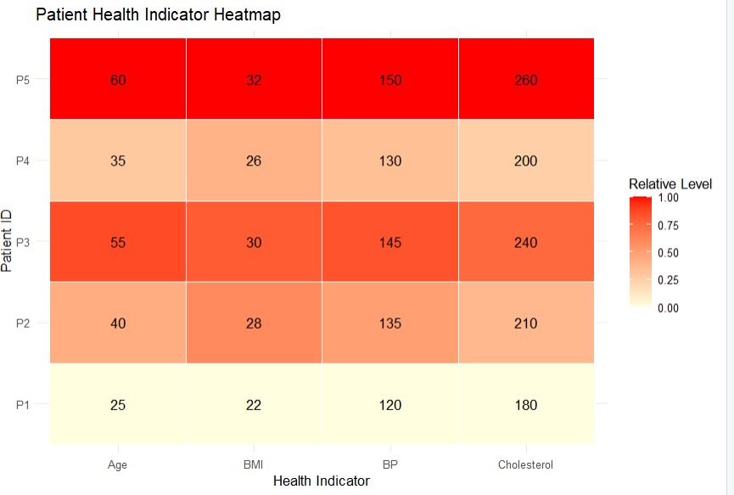
Result: The heatmap displays patient health indicators using relative values for visual comparison.

