LAB EXPERIMENT RECORD
Set 4: Product Inventory Management

Department | AI&DS
Course Code / Course Name | DSA0602/ Data Handling and Visualization
Experiment | Data Visualization using R
Name | Addula Yaswanth
Register Number | 192324179
Date | 01 October 2026
Day | Thursday

Aim
To visualize and analyze product inventory data using bar charts, stacked bar charts, scatter plots, and a Tableau dashboard.
DATASET: PRODUCT INVENTORY
Product ID | Product Name | Quantity Available
1 | Product A | 250
2 | Product B | 175
3 | Product C | 300
4 | Product D | 200
5 | Product E | 220

PROGRAM 1: Bar Chart of Product Inventory
Create a bar chart to visualize the quantity of each product in the inventory. Label the axes and title
the chart.
# Create product inventory data
product_name <- c("Product A", "Product B", "Product C",
"Product D", "Product E")

quantity <- c(250, 175, 300, 200, 220)

# Create bar chart
barplot(quantity,
names.arg = product_name,
main = "Product Inventory",
xlab = "Product Name",
ylab = "Quantity Available",
col = "skyblue",
border = "black",
ylim = c(0, 350))

# Add quantity labels
text(x = seq_along(quantity),
y = quantity,
labels = quantity,
pos = 3)
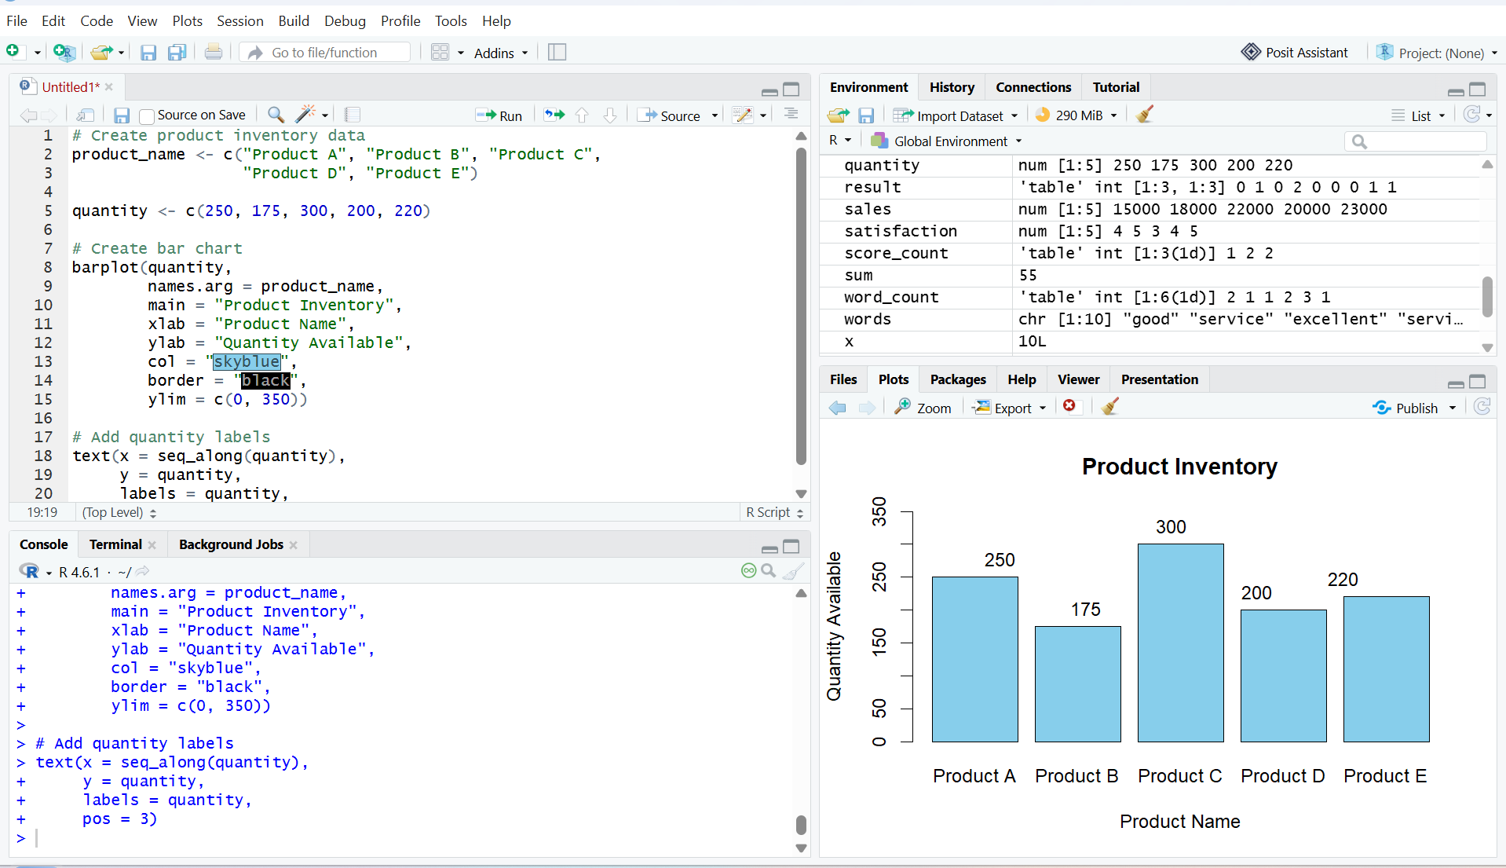
Output 1: Product Inventory Bar Chart
Observation
The bar chart displays the available quantities of five products. Product C has the highest quantity (300), while Product B has the lowest quantity (175).

PROGRAM 2: Stacked Bar Chart of Product Quantities by Category
Generate a stacked bar chart to show the quantity of each product within different product
categories.

product <- c("Product A", "Product B", "Product C",
"Product D", "Product E")

quantity <- c(250, 175, 300, 200, 220)

category <- c("Electronics", "Furniture", "Electronics",
"Furniture", "Electronics")

data <- matrix(quantity, nrow = 1)

barplot(data,
names.arg = product,
main = "Product Quantities by Category",
xlab = "Product Name",
ylab = "Quantity Available",
col = "skyblue")
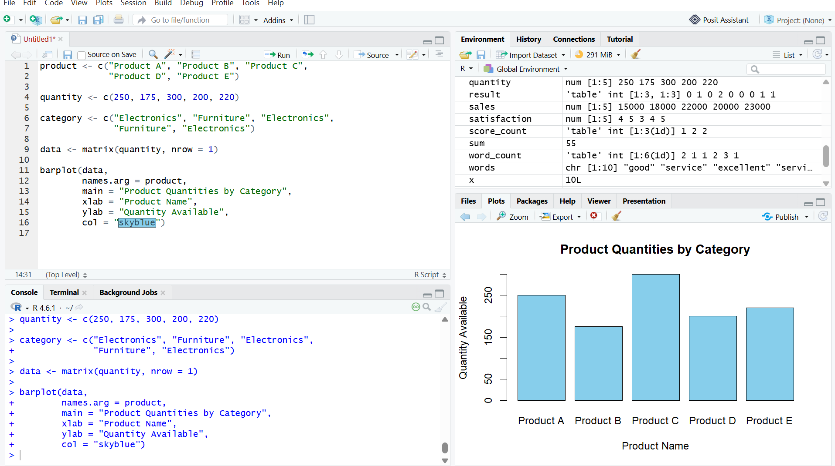
Output 2: Stacked Bar Chart of Product Quantities by Category
Observation
The chart displays the available quantities of five products. Product C has the highest quantity, while Product B has the lowest quantity.

PROGRAM 3: Scatter Plot of Product Price vs Quantity Available
Build a scatter plot to explore the relationship between product price and quantity available. Explain
the findings.

product <- c("Product A", "Product B", "Product C",
"Product D", "Product E")

price <- c(100, 200, 150, 250, 300)
quantity <- c(250, 175, 300, 200, 220)

plot(price, quantity,
main = "Product Price vs Quantity",
xlab = "Product Price",
ylab = "Quantity Available",
col = "blue",
pch = 19)
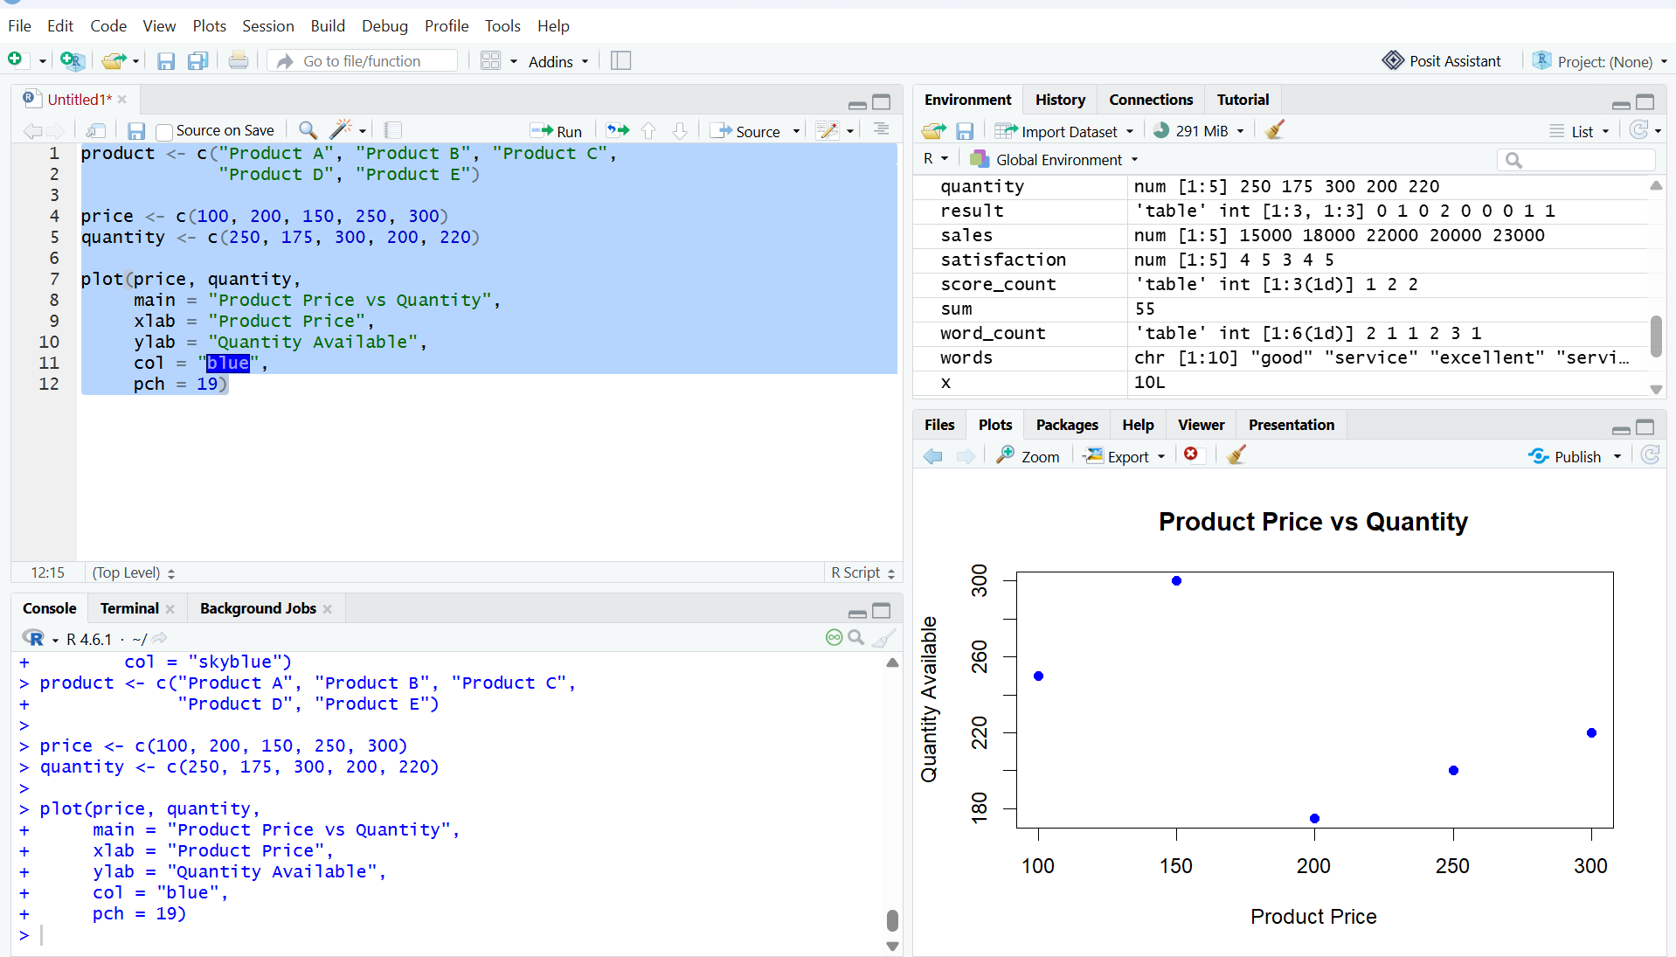
Output 3: Scatter Plot of Product Price vs Quantity Available
Observation
The scatter plot shows the relationship between product price and available quantity. Product C has the highest quantity of 300, while Product B has the lowest quantity of 175.Note: The supplied RStudio screenshot is inserted exactly as captured, including its displayed x-axis labels.
Note
The prices are sample values because the original dataset does not include product prices.

PROGRAM 4: Tableau Dashboard for Product Inventory Management
Develop a Tableau dashboard with the bar chart and stacked bar chart to allow users to interact
with the data.

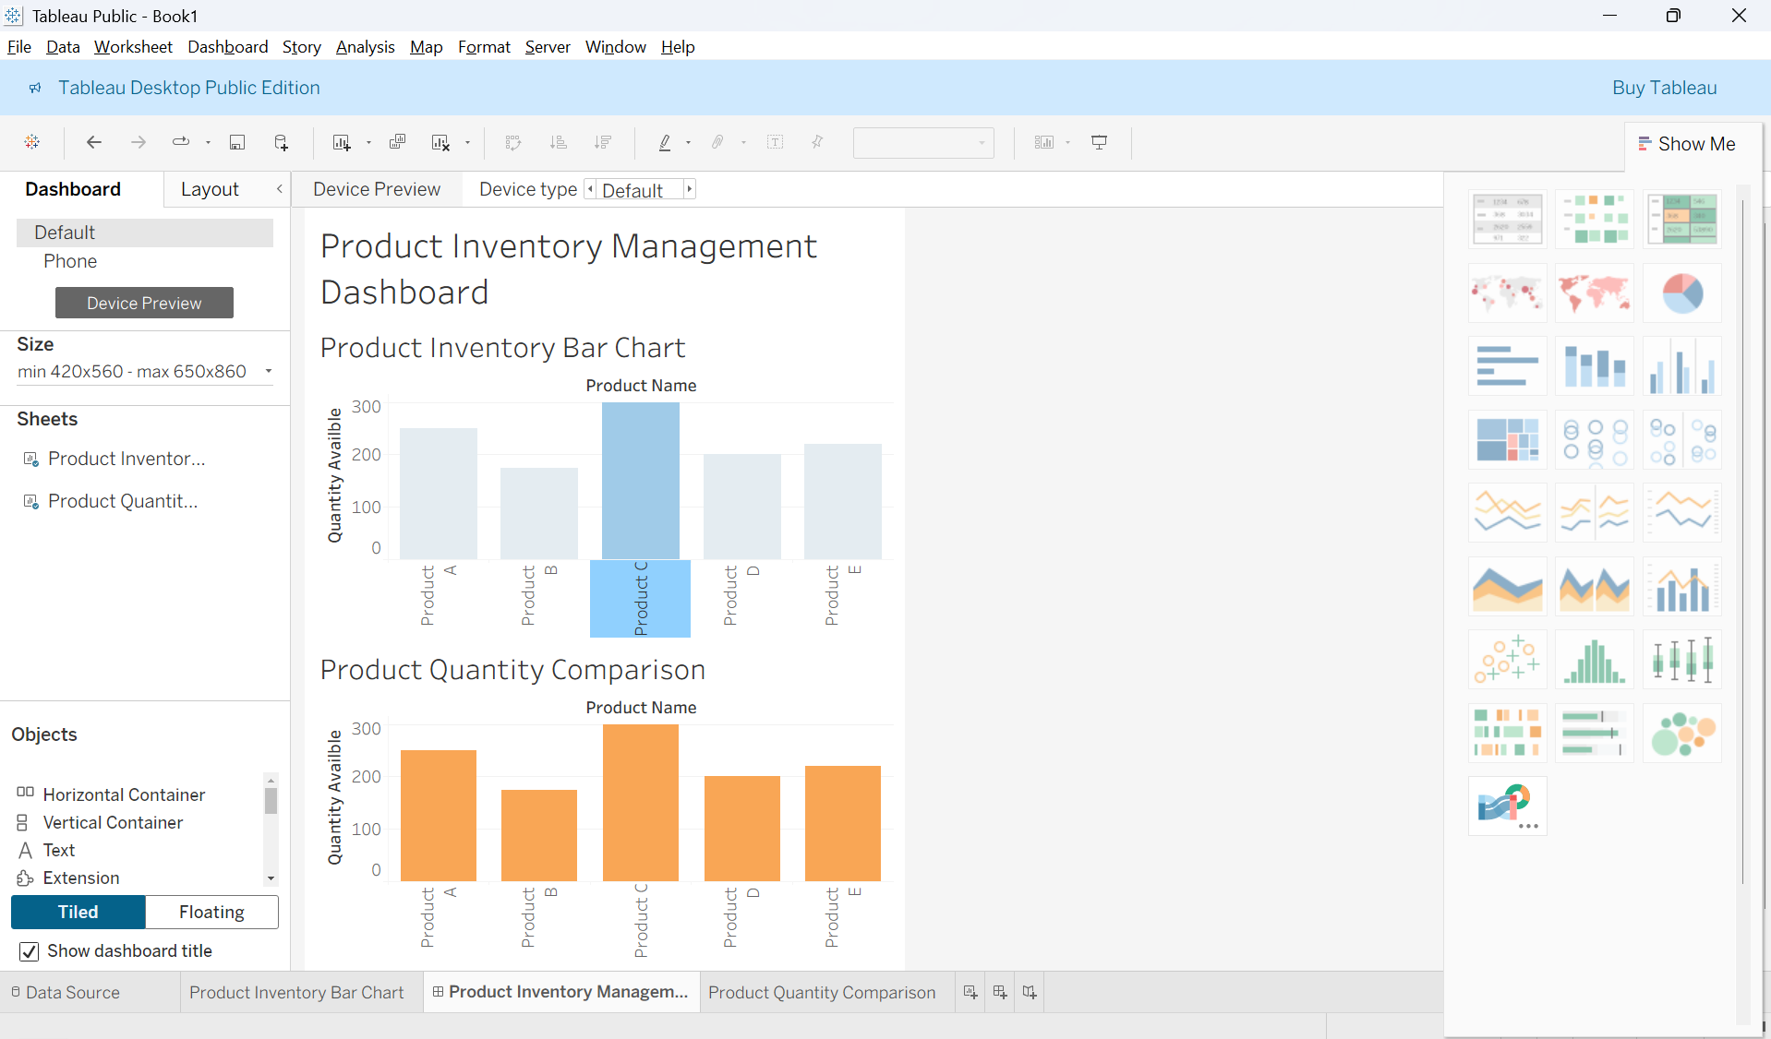
Output 4: Product Inventory Dashboard
Observation
The dashboard displays product quantities using two bar charts, allowing users to compare inventory levels across products.
Set 4 Procedure
- Create a product inventory dataset containing product ID, product name, and quantity available.
- Use R to create a bar chart showing the quantity available for each product.
- Create a stacked bar chart to visualize product quantities by category.
- Create a scatter plot to show the relationship between product price and quantity available.
- Import the Excel dataset into Tableau.
- Create a bar chart and stacked bar chart in Tableau.
- Combine both charts into a dashboard and save it.terms.
Set 4 Result
Product inventory data was successfully visualized using R bar charts and a scatter plot. A Tableau dashboard was also created to display and compare product inventory quantities.

Set 5: Website Analytics
Aim
To visualize and analyze product inventory data using bar charts, stacked bar charts, scatter plots, and a Tableau dashboard.
DATASET: PRODUCT INVENTORY
Product ID | Product Name | Quantity Available
1 | Product A | 250
2 | Product B | 175
3 | Product C | 300
4 | Product D | 200
5 | Product E | 220

PROGRAM 1: Line Chart of Daily Page Views
Create a line chart to visualize the trend in daily page views over time. Label the axes and title the chart.
# Create website traffic data
date <- as.Date(c("2023-01-01", "2023-01-02", "2023-01-03",
"2023-01-04", "2023-01-05"))

page_views <- c(1500, 1600, 1400, 1650, 1800)

click_through_rate <- c(2.3, 2.7, 2.0, 2.4, 2.6)

# Create line chart
plot(date,
page_views,
type = "o",
main = "Daily Page Views Trend",
xlab = "Date",
ylab = "Page Views",
col = "blue",
pch = 19)

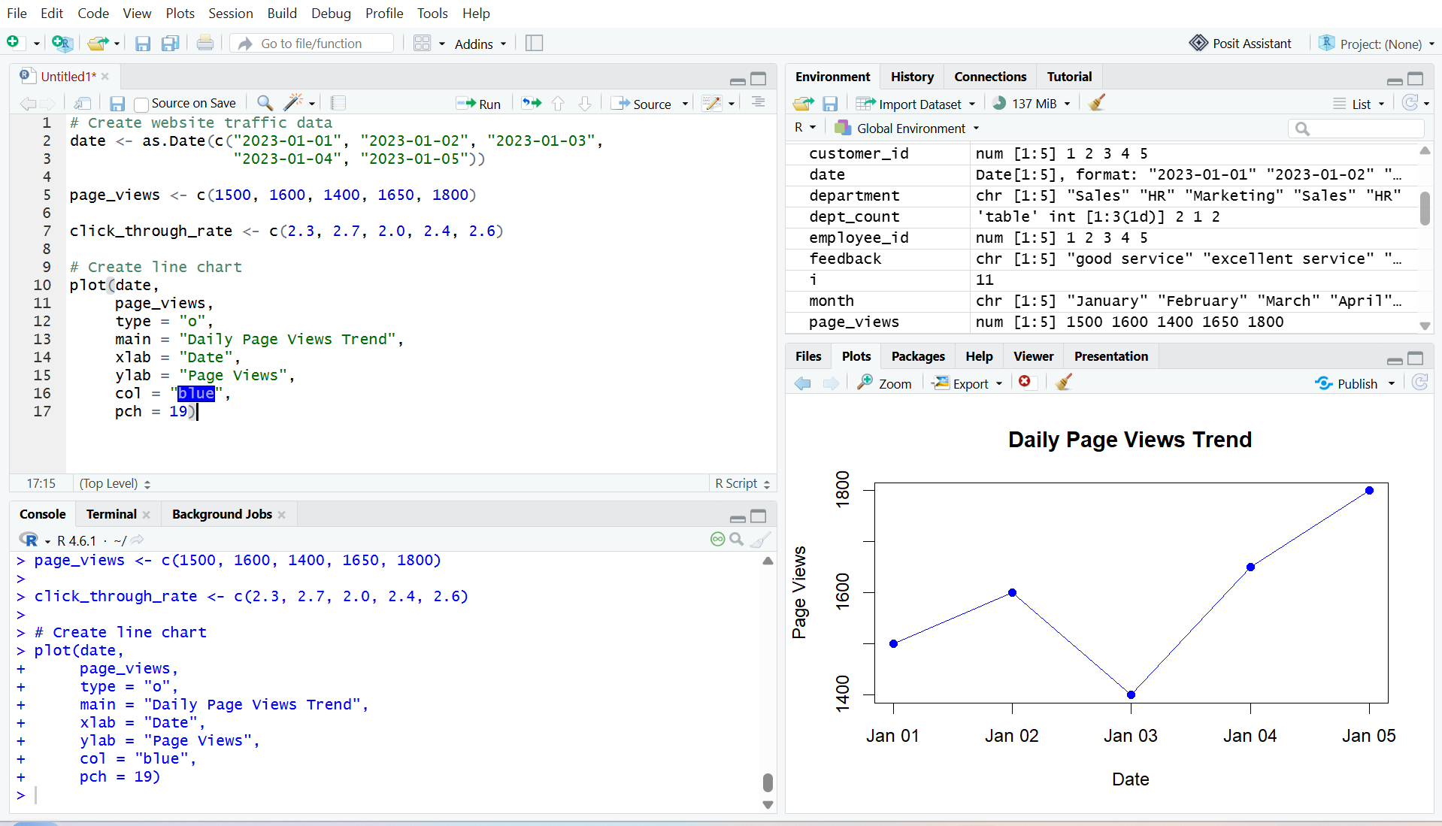
Output 1: Daily Page Views Trend Line Chart
Observation
The line chart displays the daily page views over the five days. Page views decreased on January 3 and then increased, reaching the highest value of 1800 on January 5. The lowest page views were 1400 on January 3.

PROGRAM 2: Bar Chart of Top N Days by Click-through Rate
Generate a bar chart showing the top 3 days with the highest click-through rates.
# Create website traffic data
date <- as.Date(c("2023-01-01", "2023-01-02", "2023-01-03",
"2023-01-04", "2023-01-05"))

click_through_rate <- c(2.3, 2.7, 2.0, 2.4, 2.6)

# Find top 3 days
top3 <- order(click_through_rate, decreasing = TRUE)[1:3]

top_dates <- date[top3]
top_rates <- click_through_rate[top3]

# Create bar chart
barplot(top_rates,
names.arg = format(top_dates, "%m-%d"),
main = "Top 3 Days by Click-through Rate",
xlab = "Date",
ylab = "Click-through Rate (%)",
col = "skyblue",
border = "black",
ylim = c(0, 3))

# Add CTR labels
text(x = seq_along(top_rates),
y = top_rates,
labels = paste0(top_rates, "%"),
pos = 3)

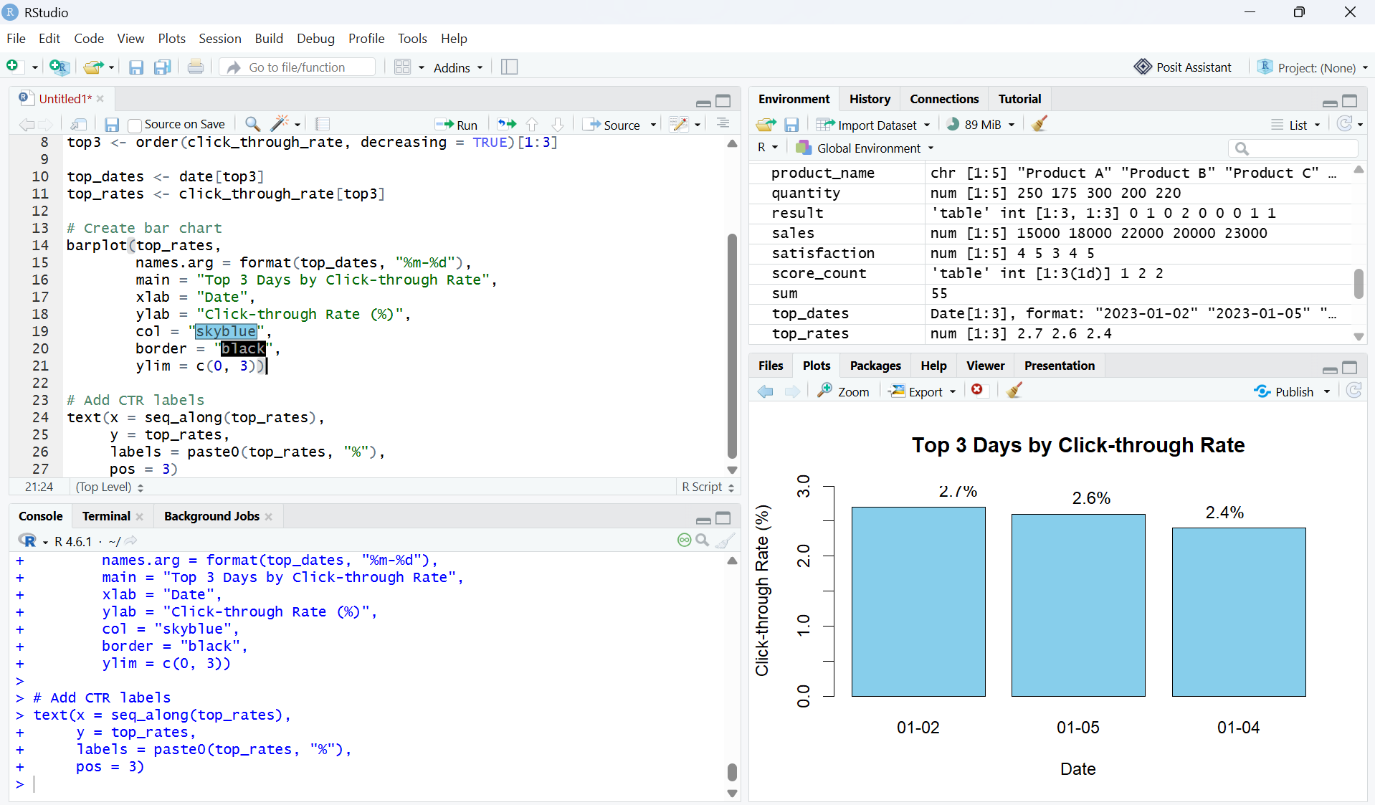
Output 2: Top 3 Days by Click-through Rate Bar Chart
Observation
The bar chart displays the three days with the highest click-through rates. January 2 has the highest click-through rate of 2.7%, followed by January 5 with 2.6% and January 4 with 2.4%.

PROGRAM 3: Stacked Area Chart of User Interactions
Create a stacked area chart to display the distribution of user interactions such as likes, shares, and comments on a website.
# Create user interaction data
date <- as.Date(c("2023-01-01", "2023-01-02", "2023-01-03",
"2023-01-04", "2023-01-05"))

likes <- c(120, 150, 100, 170, 200)
shares <- c(40, 50, 35, 60, 70)
comments <- c(25, 30, 20, 35, 45)

# Combine interaction data
interaction_data <- rbind(likes, shares, comments)

# Create stacked area chart
matplot(date,
t(interaction_data),
type = "n",
xlab = "Date",
ylab = "Number of Interactions",
main = "Website User Interactions")

polygon(c(date, rev(date)),
c(likes, rep(0, length(likes))),
col = "skyblue",
border = "black")

polygon(c(date, rev(date)),
c(likes + shares, rev(likes)),
col = "orange",
border = "black")

polygon(c(date, rev(date)),
c(likes + shares + comments,
rev(likes + shares)),
col = "lightgreen",
border = "black")

legend("topleft",
legend = c("Likes", "Shares", "Comments"),
fill = c("skyblue", "orange", "lightgreen"))
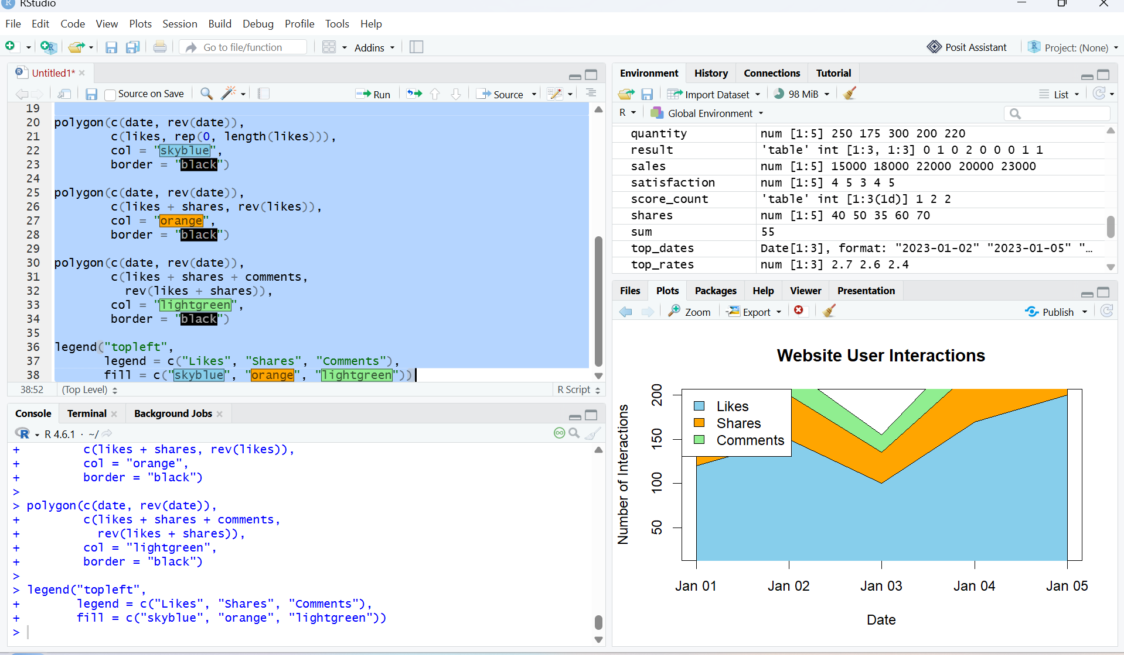
Output 3: Website User Interactions Stacked Area Chart
Observation
The stacked area chart displays the distribution of likes, shares, and comments over the five days. The total number of user interactions increases toward January 5, with likes contributing the largest share of interactions.

Note: The original Website Traffic dataset does not contain Likes, Shares, or Comments. Therefore, sample interaction values are used for this visualization.

PROGRAM 4: Tableau Dashboard for Website Analytics
Develop a Tableau dashboard with the line chart and bar chart to allow users to interact with the website traffic data.
Procedure:
- Create a website traffic dataset containing Date, Page Views, and Click-through Rate.
- Use R to create a line chart showing the daily page views.
- Create a bar chart to display the top 3 days with the highest click-through rates.
- Create a stacked area chart to visualize user interactions such as likes, shares, and comments.
- Import the Excel website traffic dataset into Tableau.
- Create a line chart in Tableau using Date and Page Views.
- Create a bar chart in Tableau using Date and Click-through Rate.
- Apply a Top N filter to display the days with the highest click-through rates.
- Combine the line chart and bar chart into a Tableau dashboard.
- Add filters or dashboard actions to allow users to interactively explore the website traffic data.
- Save the Tableau dashboard.

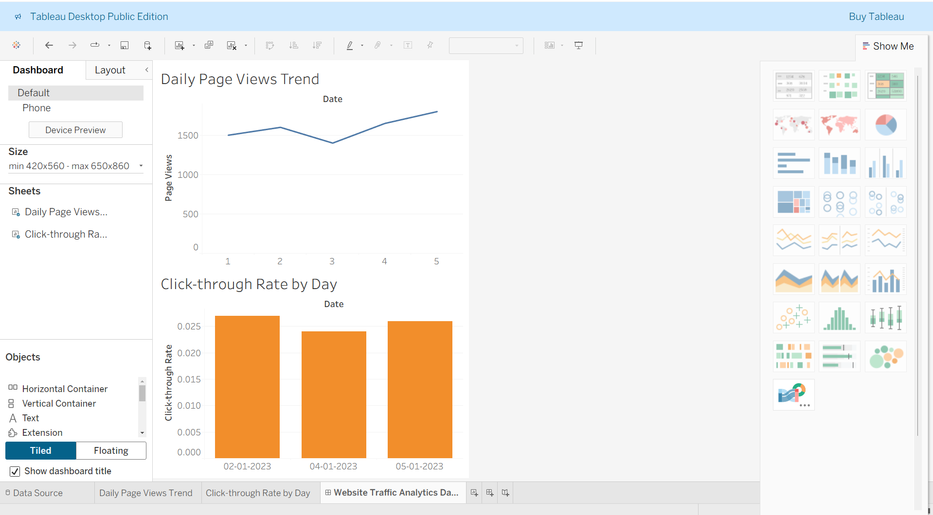

Output 4: Website Traffic Analytics Dashboard

Observation
The dashboard displays website traffic using a line chart and bar chart, allowing users to compare daily page views and identify the days with the highest click-through rates. Interactive filters provide convenient exploration of the website traffic data.

Set 5 Procedure
- Create a website traffic dataset containing Date, Page Views, and Click-through Rate.
- Use R to create a line chart showing the trend in daily page views.
- Create a bar chart to display the top N days with the highest click-through rates.
- Create a stacked area chart to visualize the distribution of user interactions such as likes, shares, and comments.
- Import the website traffic dataset into Tableau.
- Create a line chart and bar chart in Tableau.
- Apply filters and dashboard actions for interactive exploration.
- Combine both charts into a dashboard and save it.
Set 5 Result
Website traffic data was successfully visualized using an R line chart, bar chart, and stacked area chart. A Tableau dashboard was also created to display and compare daily page views and click-through rates interactively.

SET 6: PRODUCT SALES ANALYSIS
Aim
Dataset: Monthly Product Sales
Product ID | Product Name | January Sales | February Sales | March Sales
1 | Product A | 2000 | 2200 | 2400
2 | Product B | 1500 | 1800 | 1600
3 | Product C | 1200 | 1400 | 1100

PROGRAM 1: Grouped Bar Chart of Product Sales
Create a grouped bar chart to visualize the sales of each product for the first quarter. Label the chart elements.
# Create product sales data
product <- c("Product A", "Product B", "Product C")

january <- c(2000, 1500, 1200)
february <- c(2200, 1800, 1400)
march <- c(2400, 1600, 1100)

# Combine sales data
sales <- rbind(january, february, march)

# Create grouped bar chart
barplot(sales,
beside = TRUE,
names.arg = product,
main = "Monthly Product Sales - First Quarter",
xlab = "Product",
ylab = "Sales",
col = c("skyblue", "orange", "lightgreen"),
border = "black",
ylim = c(0, 3000))

# Add legend
legend("topleft",
legend = c("January", "February", "March"),
fill = c("skyblue", "orange", "lightgreen"))

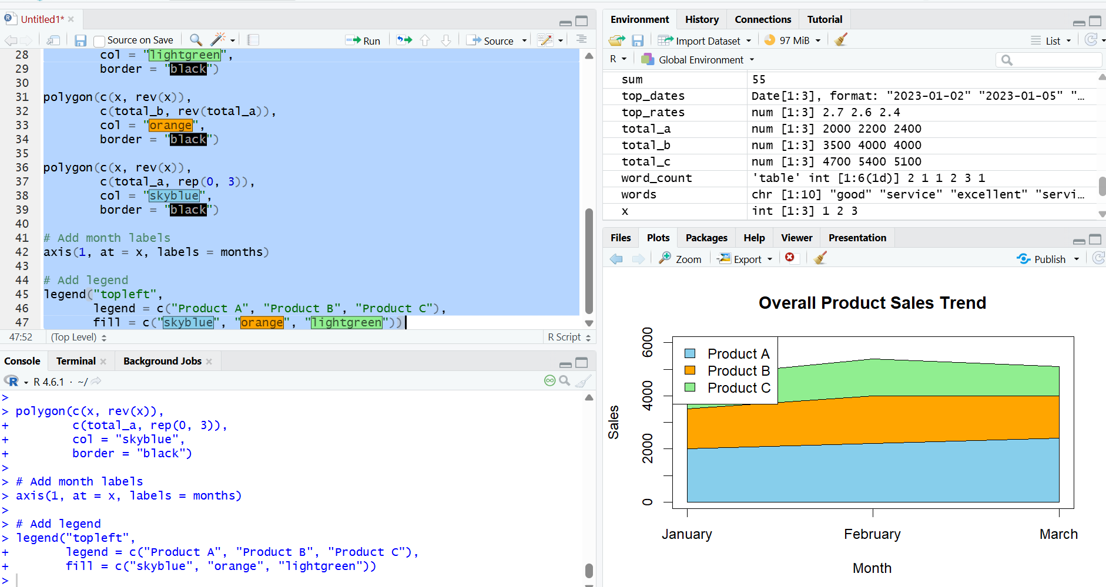

Output 1: First Quarter Product Sales Grouped Bar Chart
Observation
The grouped bar chart compares the January, February, and March sales of each product. Product A has the highest sales in all three months.

PROGRAM 2: Stacked Area Chart of Overall Sales Trend
Generate a stacked area chart to represent the overall sales trend for all products over the three
months.
# Create monthly sales data
months <- c("January", "February", "March")

product_a <- c(2000, 2200, 2400)
product_b <- c(1500, 1800, 1600)
product_c <- c(1200, 1400, 1100)

# Calculate cumulative sales
total_a <- product_a
total_b <- product_a + product_b
total_c <- product_a + product_b + product_c

# Convert months to numeric
x <- 1:3

# Create empty plot
plot(x, total_c,
type = "n",
xaxt = "n",
xlab = "Month",
ylab = "Sales",
main = "Overall Product Sales Trend",
ylim = c(0, 6000))

# Create stacked areas
polygon(c(x, rev(x)),
c(total_c, rep(0, 3)),
col = "lightgreen",
border = "black")

polygon(c(x, rev(x)),
c(total_b, rev(total_a)),
col = "orange",
border = "black")

polygon(c(x, rev(x)),
c(total_a, rep(0, 3)),
col = "skyblue",
border = "black")

# Add month labels
axis(1, at = x, labels = months)

# Add legend
legend("topleft",
legend = c("Product A", "Product B", "Product C"),
fill = c("skyblue", "orange", "lightgreen"))

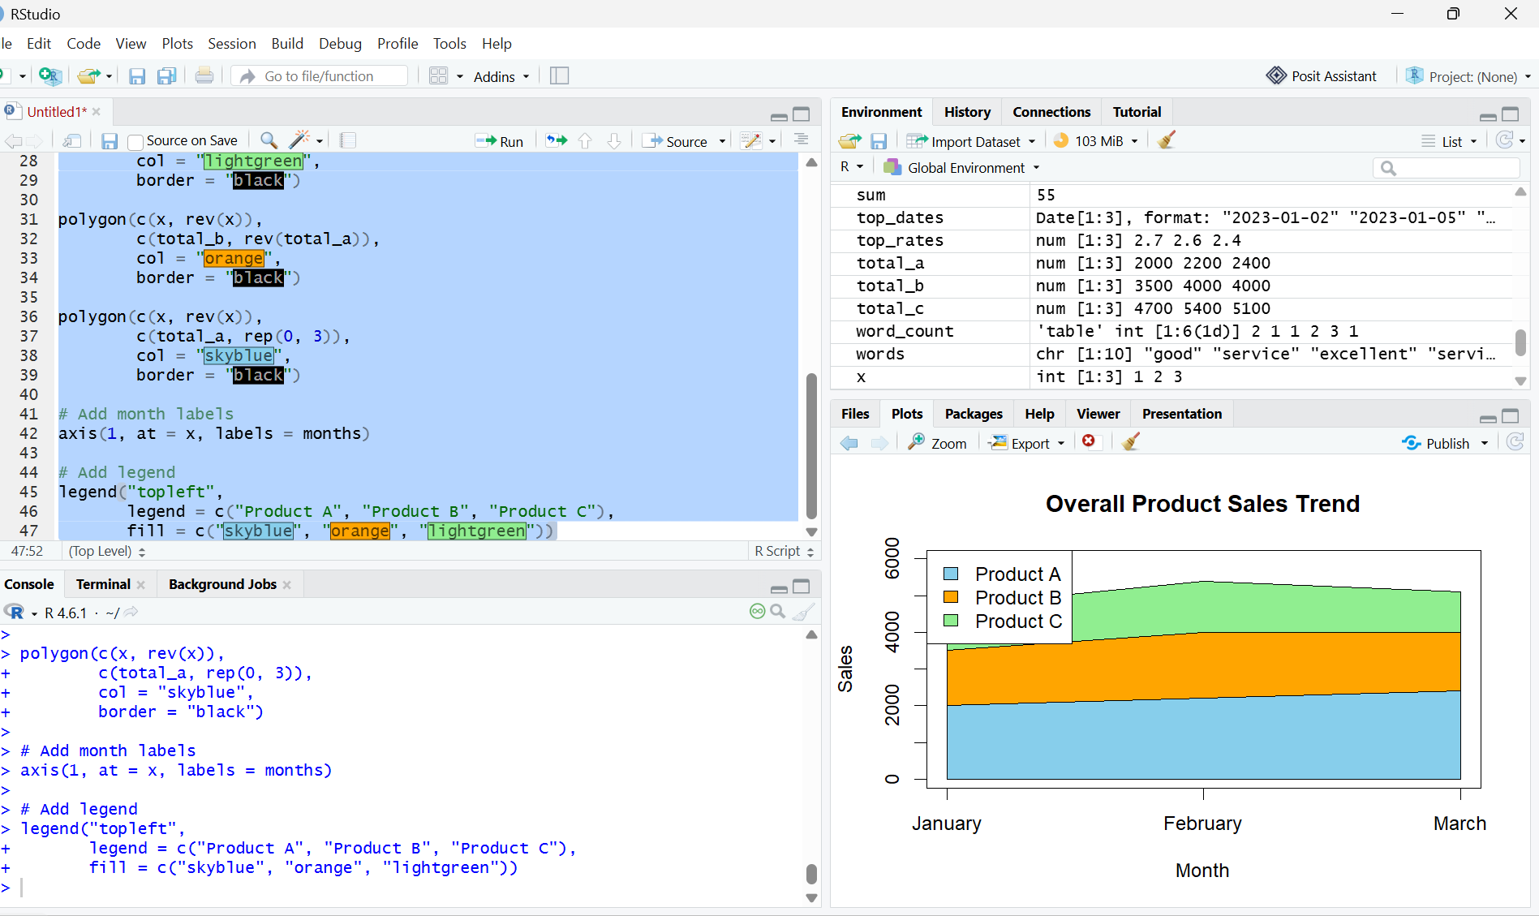
Output 2: Overall Product Sales Stacked Area Chart

Observation: The stacked area chart shows the overall sales trend and contribution of each product during the first quarter.

PROGRAM 3: Monthly Sales Table
Build a table to show the monthly sales data for each product. Label the table elements.
# Create monthly sales data
sales_data <- data.frame(
Product_ID = c(1, 2, 3),
Product_Name = c("Product A", "Product B", "Product C"),
January_Sales = c(2000, 1500, 1200),
February_Sales = c(2200, 1800, 1400),
March_Sales = c(2400, 1600, 1100)
)

# Display the sales table
print(sales_data)

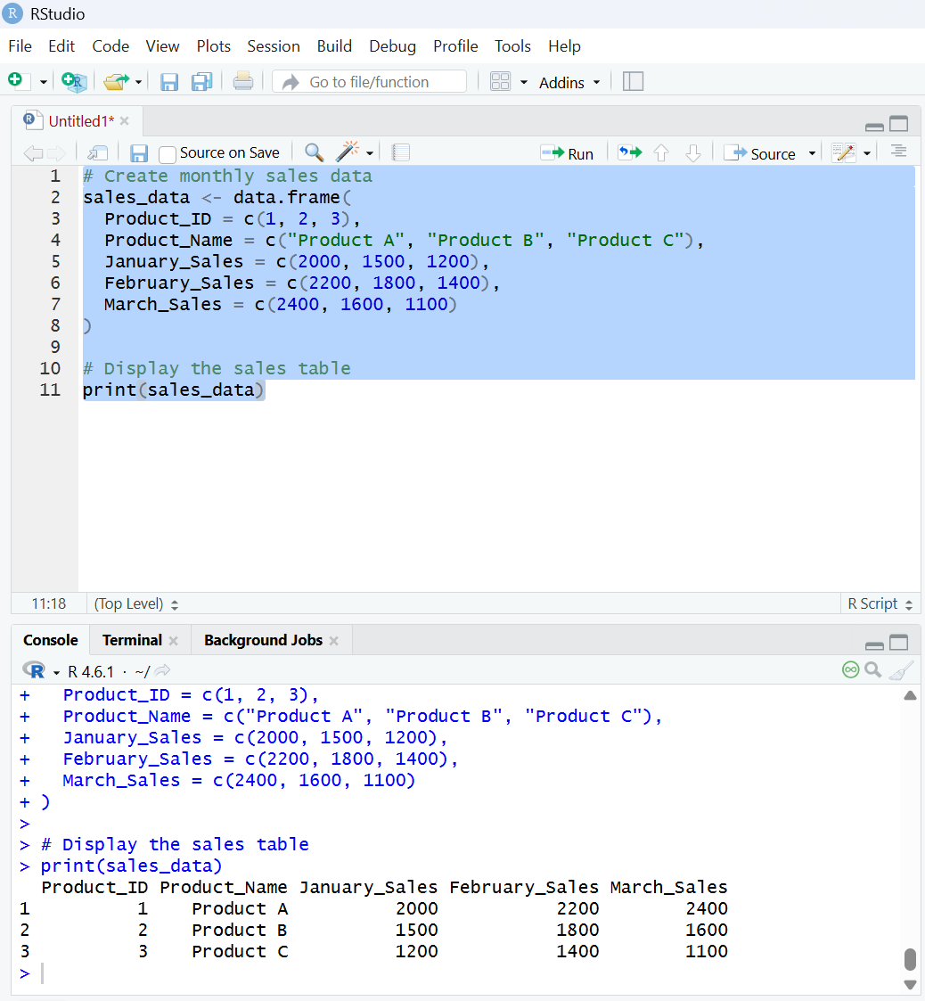
Output 3: Monthly Product Sales Data Table

Observation: The table displays the monthly sales data for each product clearly.

PROGRAM 4: Tableau Dashboard for Product Sales Analysis
Develop a Tableau dashboard combining the grouped bar chart, stacked area chart, and the table
for interactive exploration of sales data.
Procedure:
- Create a monthly product sales dataset containing Product ID, Product Name, January Sales, February Sales, and March Sales.
- Use R to create a grouped bar chart showing the sales of each product for the first quarter.
- Create a stacked area chart to represent the overall sales trend for all products over the three months.
- Create a table to display the monthly sales data for each product.
- Import the Excel monthly product sales dataset into Tableau.
- Create a grouped bar chart in Tableau using Product Name and monthly sales.
- Create a stacked area chart in Tableau to display the sales trend of all products.
- Create a table in Tableau showing the monthly sales data for each product.
- Combine the grouped bar chart, stacked area chart, and table into a Tableau dashboard.
- Add filters or dashboard actions to allow users to interactively explore the product sales data.
- Save the Tableau dashboard.
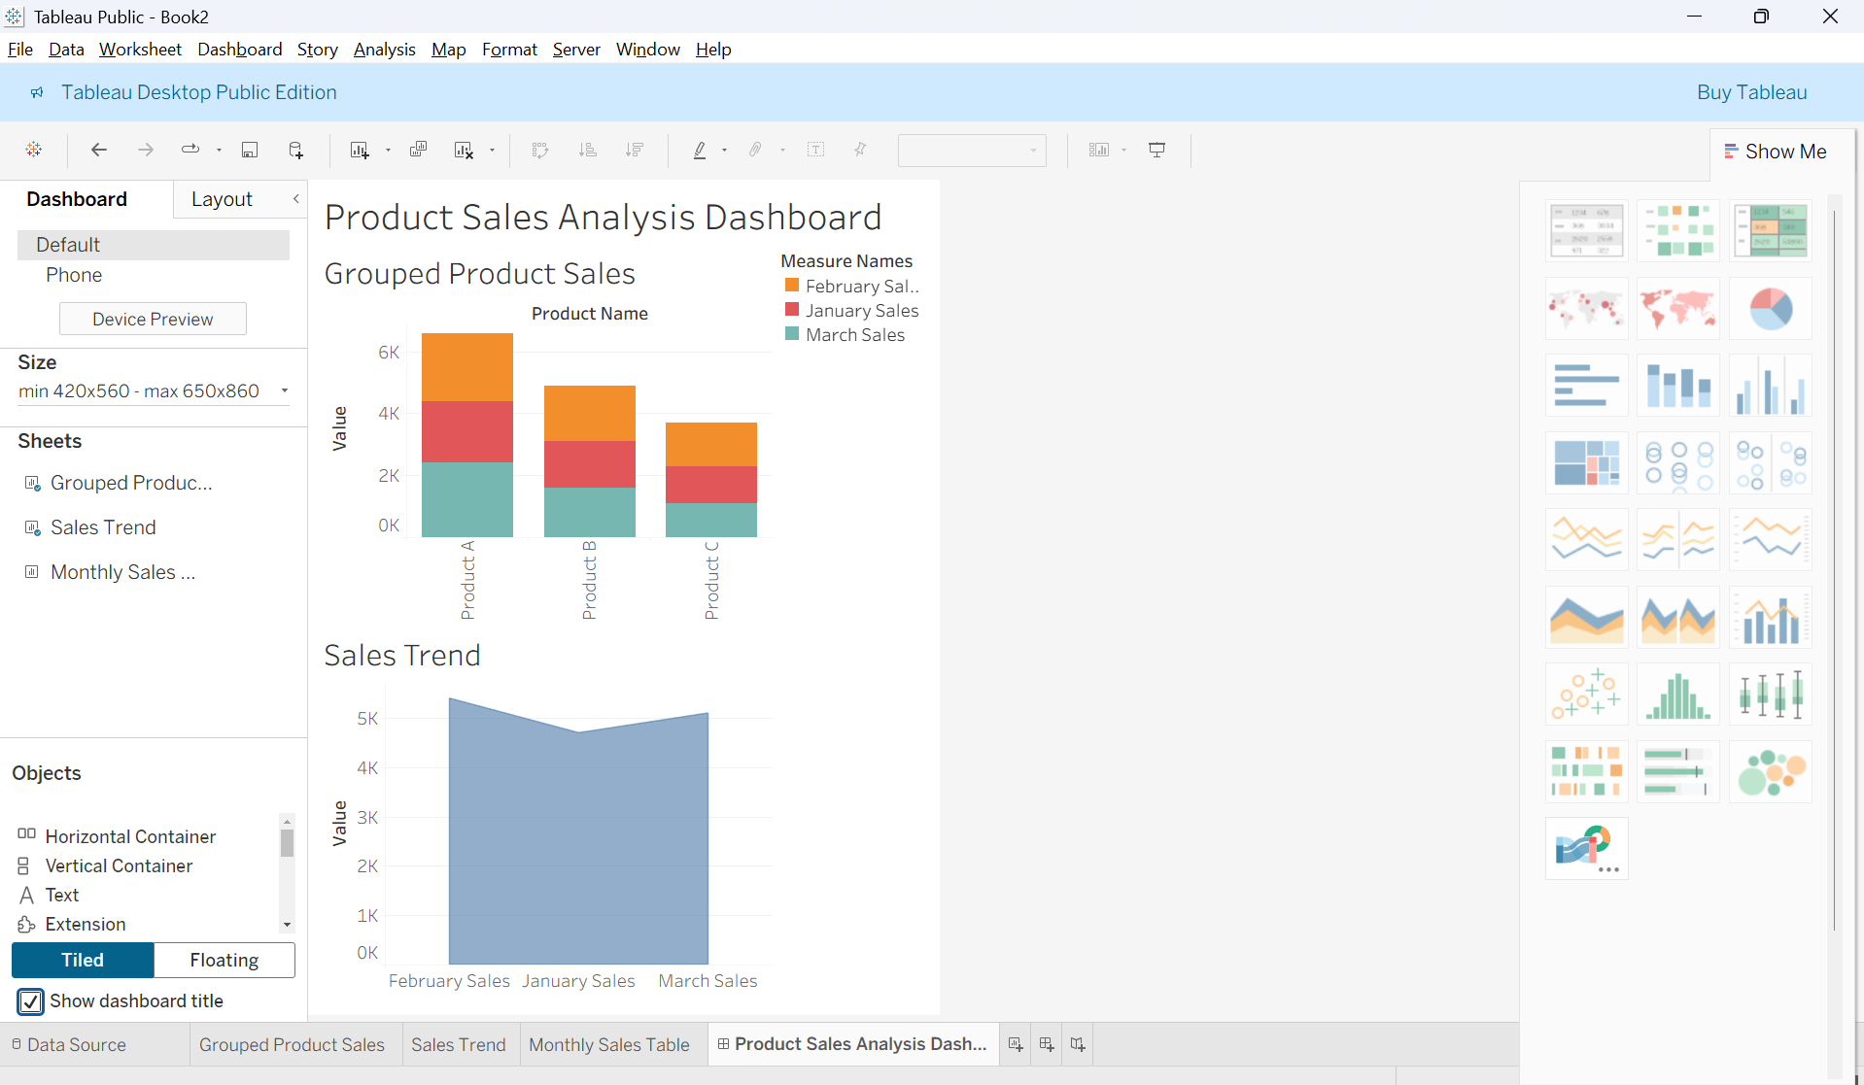
Output 4: Product Sales Analysis Tableau Dashboard

Observation
The dashboard displays product sales using a grouped bar chart, stacked area chart, and table, allowing users to compare the monthly sales of each product and analyze the overall sales trend. Interactive filters provide convenient exploration of the product sales data.

Set 6 Procedure
- Create a monthly product sales dataset containing Product ID, Product Name, January Sales, February Sales, and March Sales.
- Use R to create a grouped bar chart showing the sales of each product for the first quarter.
- Create a stacked area chart to represent the overall sales trend for all products over the three months.
- Create a table to display the monthly sales data for each product.
- Import the monthly product sales dataset into Tableau.
- Create a grouped bar chart, stacked area chart, and table in Tableau.
- Apply filters and dashboard actions for interactive exploration.
- Combine all three visualizations into a dashboard and save it.
Set 6 Result
Product sales data was successfully visualized using an R grouped bar chart, stacked area chart, and monthly sales table. A Tableau dashboard was also created to display and compare the monthly sales of each product interactively.

