LAB EXPERIMENT RECORD
Set 16: Customer Demographics Analysis

SET 16: Customer Demographics Analysis
Aim
To visualize and analyze customer demographic data using a bar chart, pie chart, table, and a Tableau dashboard.
Data: CUSTOMER DEMOGRAPHICS
Customer ID | Age | Gender | Income ($)
1 | 28 | Female | 50000
2 | 35 | Male | 60000
3 | 42 | Female | 75000

PROGRAM 1: Bar Chart of Customer Ages
Create a bar chart to visualize the distribution of customer ages.
library(ggplot2)

customer <- data.frame(
Customer_ID = c(1, 2, 3),
Age = c(28, 35, 42),
Gender = c("Female", "Male", "Female"),
Income = c(50000, 60000, 75000)
)

ggplot(customer, aes(x = factor(Age))) +
geom_bar(fill = "skyblue") +
labs(
title = "Distribution of Customer Ages",
x = "Age",
y = "Number of Customers"
) +
theme_minimal()
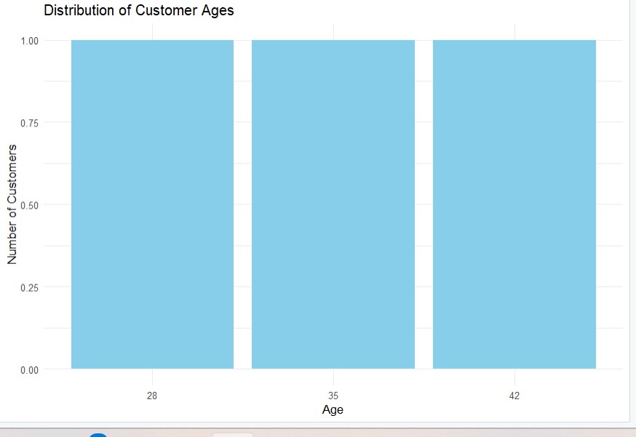
Output 1: Customer Age Bar Chart
Observation: The bar chart displays the ages of the three customers. Each age, 28, 35, and 42, occurs once.

PROGRAM 2: Pie Chart of Customer Gender
Generate a pie chart to represent the distribution of customers by gender.
library(ggplot2)

customer <- data.frame(
Gender = c("Female", "Male", "Female")
)

gender_count <- as.data.frame(table(customer$Gender))
colnames(gender_count) <- c("Gender", "Count")

ggplot(gender_count, aes(x = "", y = Count, fill = Gender)) +
geom_bar(stat = "identity", width = 1) +
coord_polar("y") +
labs(
title = "Distribution of Customers by Gender",
fill = "Gender"
) +
theme_void()

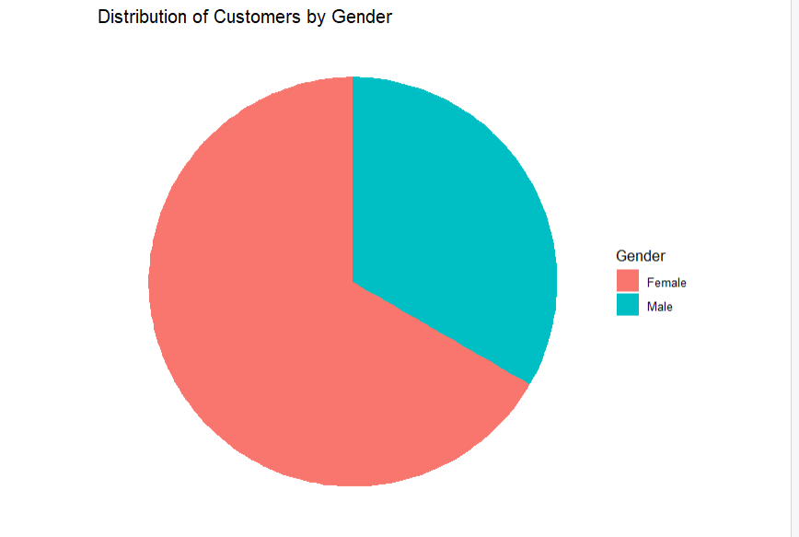
Output 2: Customer Gender Pie Chart
Observation: The pie chart shows that two customers are female and one is male. Females represent 66.67% and males represent 33.33% of the customers.

PROGRAM 3: Table of Customer Demographic Data
Build a table to display the demographic information for each customer.
customer_table <- data.frame(
Customer_ID = c(1, 2, 3),
Age = c(28, 35, 42),
Gender = c("Female", "Male", "Female"),
Income = c(50000, 60000, 75000)
)

print(customer_table)

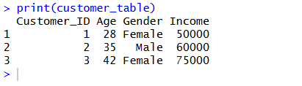
Output 3: Customer Demographic Table
Observation: The table displays the customer ID, age, gender, and income of each customer.

PROGRAM 4: Tableau Dashboard for Customer Demographics
Procedure
- Open Tableau and connect to the Customer Demographics dataset.
- Create a bar chart using Age and Number of Records.
- Create a pie chart using Gender and Number of Records.
- Create a table containing Customer ID, Age, Gender, and Income.
- Create a new Dashboard in Tableau.
- Add the bar chart, pie chart, and table to the dashboard.
- Arrange the visualizations properly.
- Add filters for Age and Gender for interactive exploration.
- Give the dashboard the title “Customer Demographics Dashboard”.
- Save the Tableau dashboard.
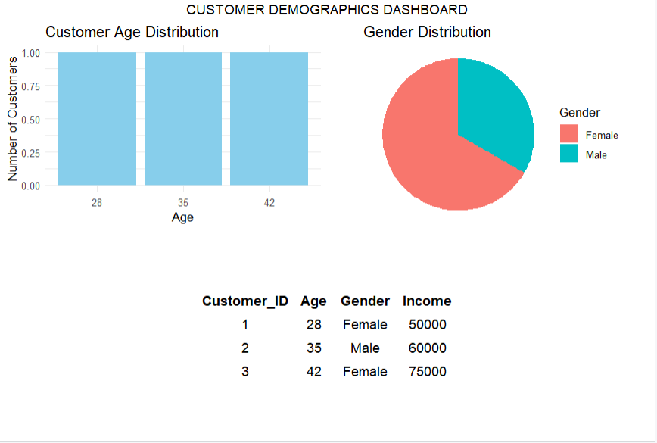
Output: Customer Demographics Dashboard
Observation: The dashboard combines the age chart, gender pie chart, and demographic table in one view. It allows users to explore customer information easily.
Set 16 Procedure
- Create a customer demographic dataset containing customer ID, age, gender, and income.
- Use R to create a bar chart showing the distribution of customer ages.
- Create a pie chart to visualize the distribution of customers by gender.
- Create a table displaying the demographic information for each customer.
- Import the customer dataset into Tableau.
- Create the bar chart, pie chart, and table in Tableau.
- Combine the visualizations into a dashboard for interactive exploration.
Set 16 Result
Customer demographic data was successfully visualized using a bar chart, pie chart, and table. A Tableau dashboard was designed to provide a clear view of customer ages, gender distribution, and income.

