LAB EXPERIMENT RECORD
Set 7 Customer Demographics Analysis

Department | AI&DS
Course Code / Course Name | DSA0602/ Data Handling and Visualization
Experiment | Data Visualization using R
Name | Addula Yaswanth
Register Number | 192324179
Date | 03 October 2026
Day | Saturday

Aim
To analyze customer demographic data using bar charts, pie charts, tables, and an interactive Tableau dashboard.
Dataset: Customer Demographics
Customer ID | Age | Gender | Income ($)
1 | 28 | Female | 50000
2 | 35 | Male | 60000
3 | 42 | Female | 75000

PROGRAM 1: Customer Age Distribution Bar Chart
Create a bar chart to visualize the distribution of customer ages.
# Create customer age data
customer_id <- c(1, 2, 3)
age <- c(28, 35, 42)

# Create bar chart
barplot(age,
names.arg = customer_id,
main = "Customer Age Distribution",
xlab = "Customer ID",
ylab = "Age",
col = "skyblue",
border = "black")

# Add values on bars
text(x = seq_along(age),
y = age,
labels = age,
pos = 3)
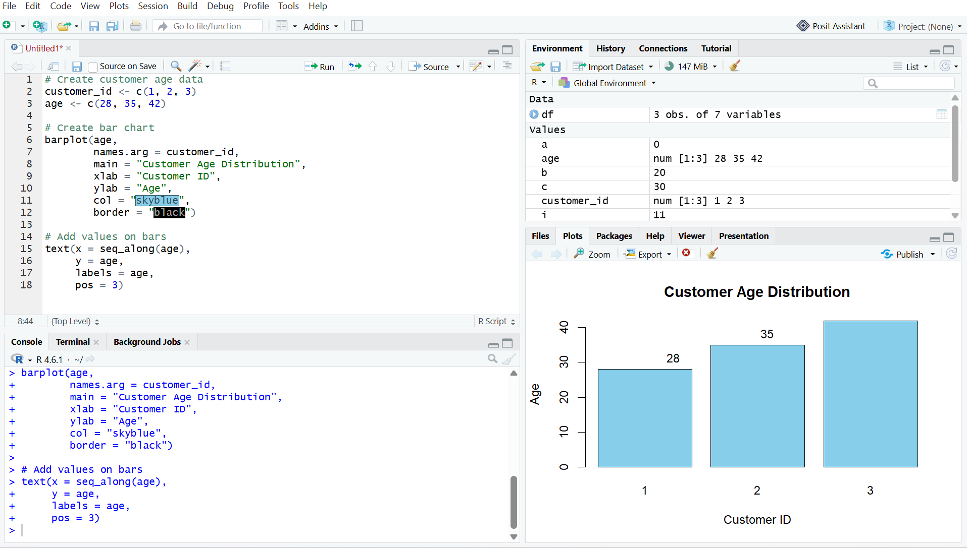
Output 1: Customer Age Distribution Bar Chart
Observation
The bar chart displays the age of each customer. Customer 3 has the highest age of 42 years, while Customer 1 has the lowest age of 28 years.

PROGRAM 2: Customer Gender Distribution Pie Chart
Generate a pie chart to represent the distribution of customers by gender.
# Create gender data
gender <- c("Female", "Male")
count <- c(2, 1)

# Create pie chart
pie(count,
labels = gender,
main = "Customer Gender Distribution",
col = c("pink", "skyblue"))

# Add percentage labels
percentage <- round(count / sum(count) * 100, 1)

legend("topright",
legend = paste(gender, percentage, "%"),
fill = c("pink", "skyblue"))

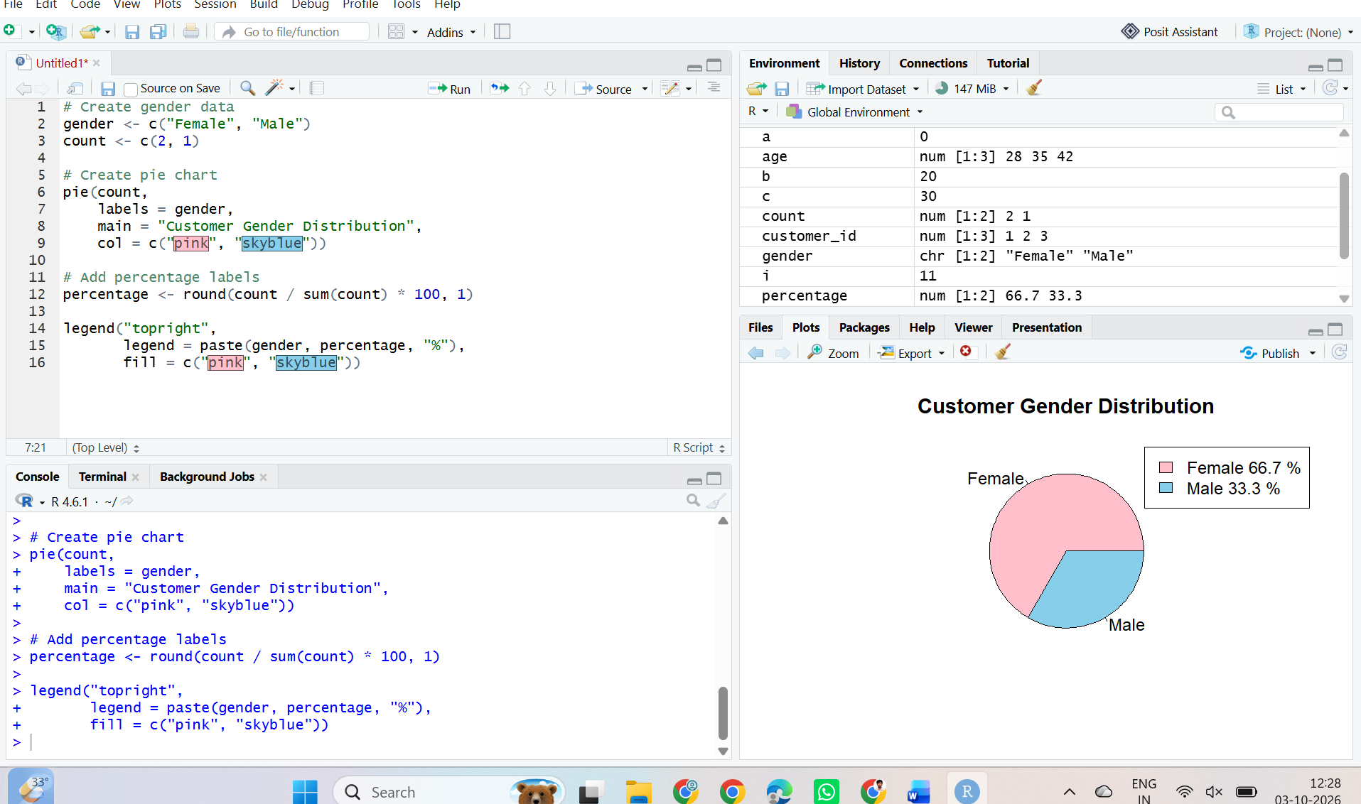

Output 2: Customer Gender Distribution Pie Chart
Observation
The pie chart shows that there are 2 female customers and 1 male customer. Female customers represent 66.7% and male customers represent 33.3% of the dataset.

PROGRAM 3: Customer Demographic Information Table
Build a table to show the demographic information for each customer.
# Create customer demographic data
customer_data <- data.frame(
Customer_ID = c(1, 2, 3),
Age = c(28, 35, 42),
Gender = c("Female", "Male", "Female"),
Income = c(50000, 60000, 75000)
)

# Display the demographic table
print(customer_data)

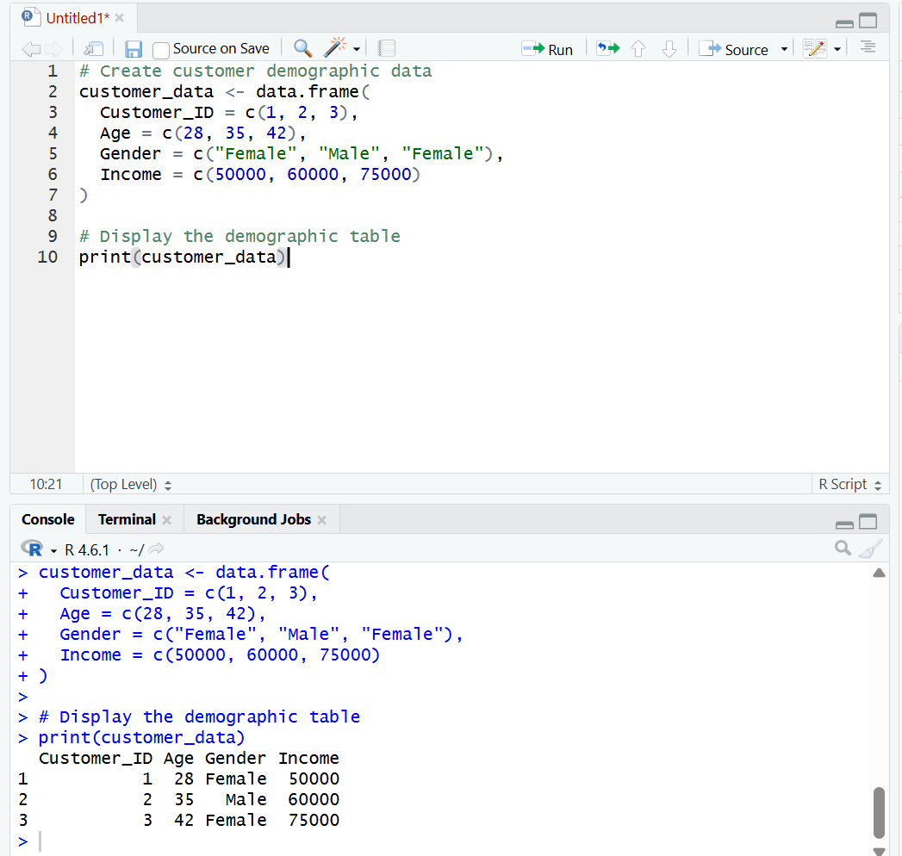
Output 3: Customer Demographic Information Table

Observation
The table displays the Customer ID, age, gender, and income of each customer clearly.
PROGRAM 4: Tableau Dashboard for Customer Demographics Analysis
Develop a Tableau dashboard with the bar chart, pie chart, and table to allow users to interactively explore customer demographic data.
Procedure:
- Create customer demographics dataset containing Customer ID, Age, Gender, and Income.
- Use R to create a bar chart showing the age of each customer.
- Create a pie chart showing the distribution of customers by gender.
- Create a table displaying Customer ID, Age, Gender, and Income.
- Import the customer demographics dataset into Tableau.
- Create a bar chart in Tableau using Customer ID and Age.
- Create a pie chart in Tableau using Gender and Customer ID/count.
- Create a table in Tableau showing Customer ID, Age, Gender, and Income.
- Combine the bar chart, pie chart, and table into a Tableau dashboard.
- Add filters/dashboard actions for interactive exploration.
- Save the dashboard.

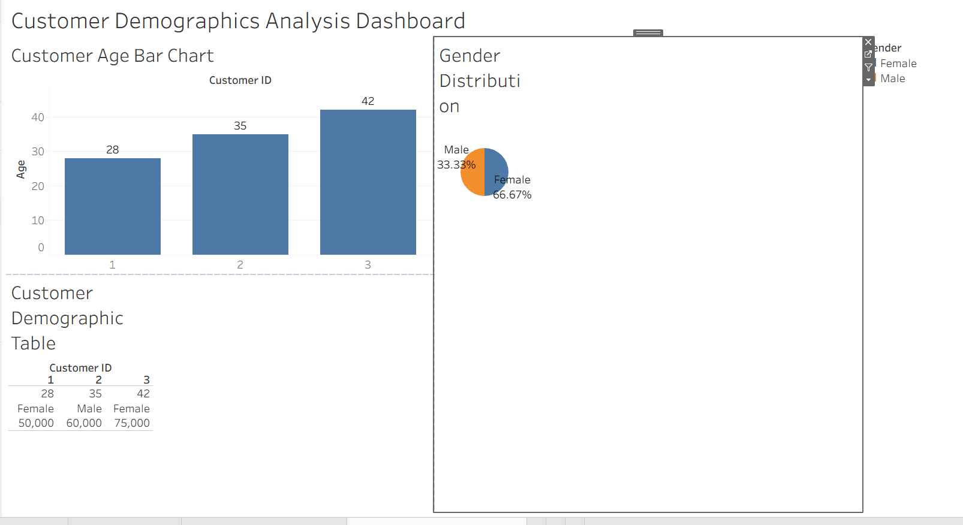

Output 4: Customer Demographics Analysis Tableau Dashboard

Observation
The dashboard displays customer demographics using a bar chart, pie chart, and table, allowing users to compare customer ages, analyze gender distribution, and view individual demographic information interactively.

Set 7 Procedure
- Create customer demographics dataset containing Customer ID, Age, Gender, and Income.
- Use R to create a bar chart showing customer age distribution.
- Create a pie chart to represent customer distribution by gender.
- Create a table to display demographic information for each customer.
- Import the customer demographics dataset into Tableau.
- Create the bar chart, pie chart, and table in Tableau.
- Apply filters and dashboard actions for interactive exploration.
- Combine all three visualizations into a dashboard and save it.
Set 7 Result
Customer demographic data was successfully visualized using an R bar chart, pie chart, and demographic information table. A Tableau dashboard was also created to display and explore customer age, gender, and income information interactively.

Set 8 Employee Performance Analysis
Aim
To analyze employee performance data using line charts, bar charts, tables, and an interactive Tableau dashboard.
Dataset: Employee Performance
Employee ID | Department | Years of Service | Performance Score
1 | Sales | 5 | 85
2 | HR | 3 | 92
3 | Marketing | 7 | 78

PROGRAM 1: Employee Performance Trend Line Chart
Create a line chart to visualize the performance trend of employees based on years of service.
employee <- c("Employee 1", "Employee 2", "Employee 3")
years <- c(5, 3, 7)
score <- c(85, 92, 78)

plot(years, score,
type = "o",
main = "Employee Performance Trend",
xlab = "Years of Service",
ylab = "Performance Score")
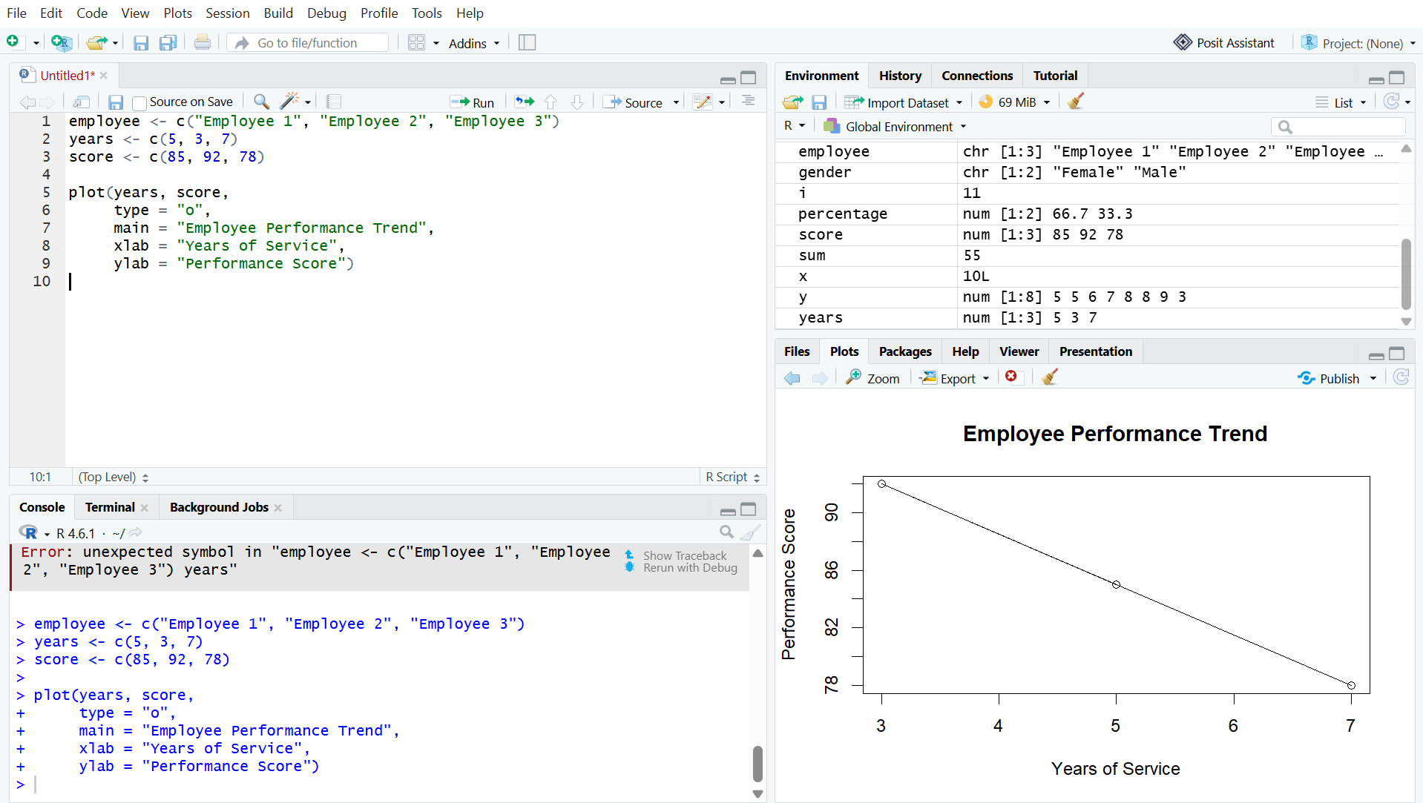
Output 1: Employee Performance Trend Line Chart
Observation
The line chart shows the performance scores of employees based on their years of service.
PROGRAM 2: Employee Distribution by Department Bar Chart
Create a bar chart showing the distribution of employees across different departments.
department <- c("Sales", "HR", "Marketing")
employees <- c(1, 1, 1)

barplot(employees,
names.arg = department,
main = "Employees by Department",
xlab = "Department",
ylab = "Number of Employees")

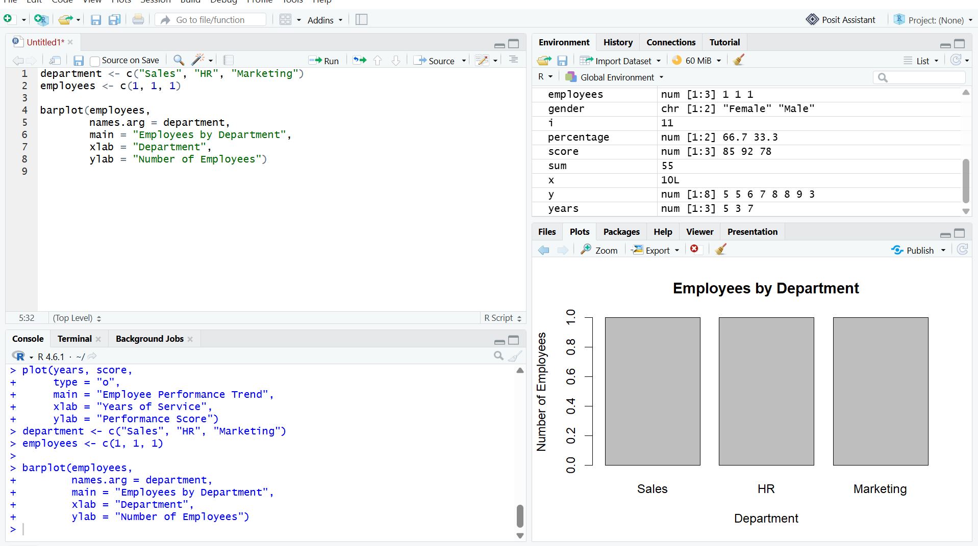
Output 2: Employee Distribution by Department Bar Chart

Observation
The bar chart shows the number of employees in the Sales, HR, and Marketing departments.

PROGRAM 3: Employee Performance Data Table
Create a table to display the performance data of each employee.
data <- data.frame(
Employee_ID = c(1, 2, 3),
Department = c("Sales", "HR", "Marketing"),
Years_of_Service = c(5, 3, 7),
Performance_Score = c(85, 92, 78)
)

print(data)

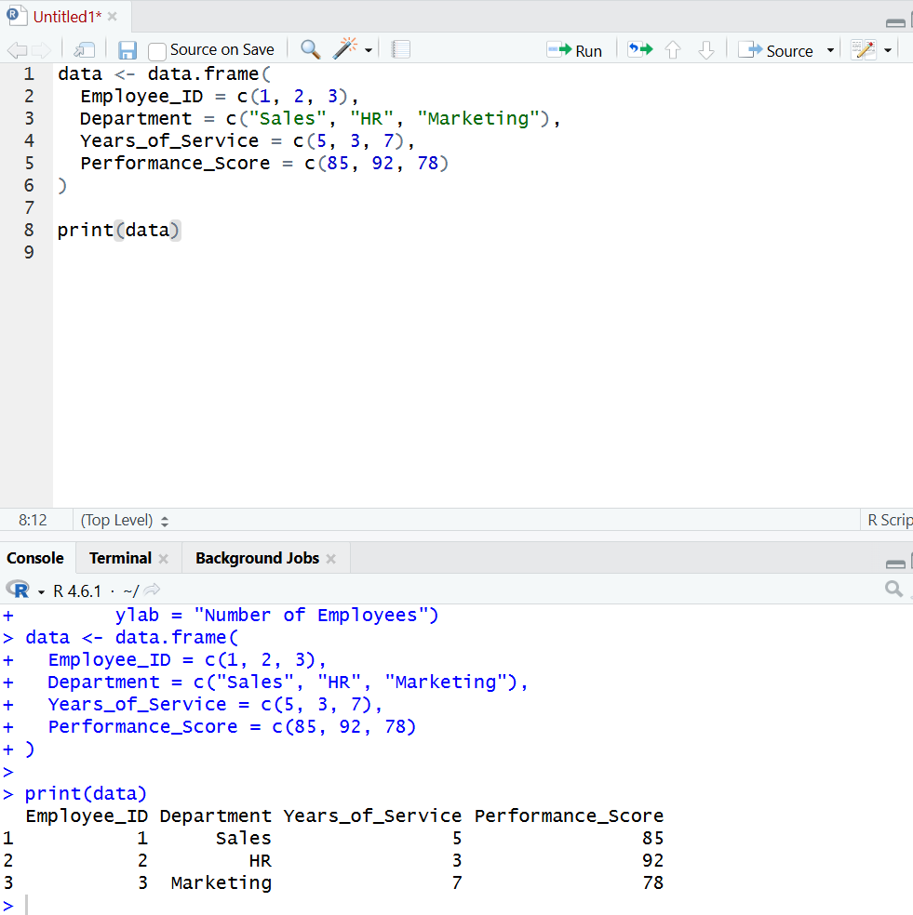
Output 3: Employee Performance Data Table

Observation
The table displays the employee ID, department, years of service, and performance score clearly.

PROGRAM 4: Tableau Dashboard for Employee Performance Analysis
Develop a Tableau dashboard with the line chart, bar chart, and table for interactive exploration of employee performance data.
Procedure:
- Create the employee performance dataset in Excel.
- Open Tableau and connect the Excel file.
- Create a line chart using Years of Service and Performance Score.
- Create a bar chart using Department and employee count.
- Create a table using Employee ID, Department, Years of Service, and Performance Score.
- Create a new dashboard.
- Drag the line chart, bar chart, and table into the dashboard.
- Add filters or dashboard actions for interactive exploration.
- Give the dashboard the title Employee Performance Analysis Dashboard.
- Save the Tableau workbook.

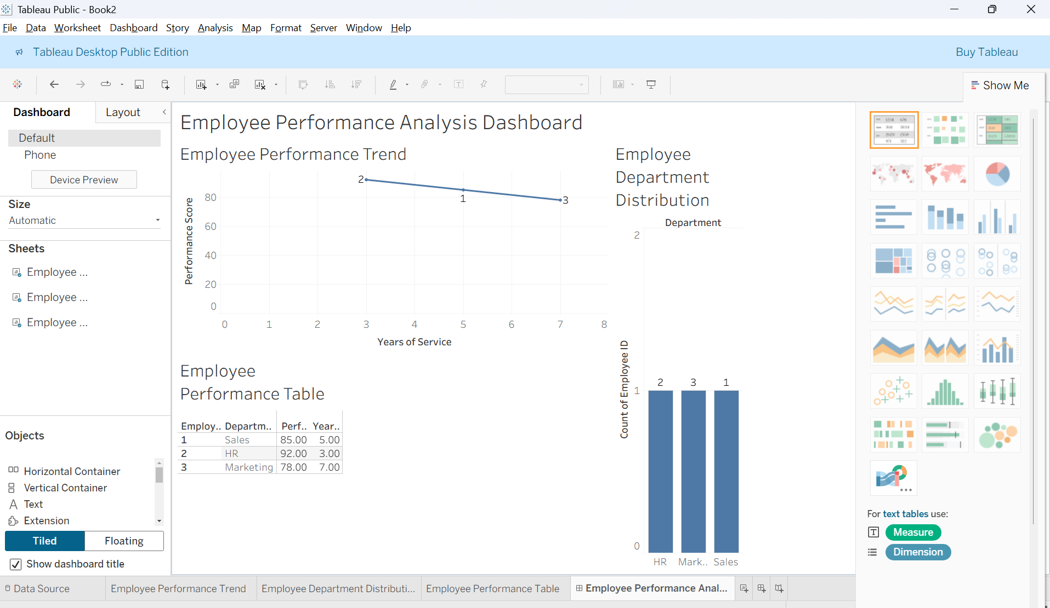
Output 4: Employee Performance Analysis Tableau Dashboard

Observation
The dashboard displays employee performance using a line chart, department bar chart, and performance table, allowing users to explore the employee performance data interactively.

Set 8 Procedure
- Create employee performance dataset containing Employee ID, Department, Years of Service, and Performance Score.
- Use R to create a line chart showing employee performance.
- Create a bar chart showing employees across departments.
- Create a table displaying employee performance data.
- Import the dataset into Tableau.
- Create the line chart, bar chart, and table in Tableau.
- Apply filters and dashboard actions.
- Combine all three visualizations into a Tableau dashboard and save it.
Set 8 Result
Employee performance data was successfully visualized using a line chart, bar chart, and data table in R. A Tableau dashboard was also created to display and explore employee performance data interactively.

SET 9 – ONLINE LEARNING ACTIVITY ANALYSIS
Aim
To analyze online learning activity and student performance using histograms, boxplots, scatter plots, moving average line charts, and an interactive Tableau dashboard.

Dataset: Monthly Product Sales
Product ID | Product Name | January Sales | February Sales | March Sales
1 | Product A | 2000 | 2200 | 2400
2 | Product B | 1500 | 1800 | 1600
3 | Product C | 1200 | 1400 | 1100

PROGRAM 1: Histogram and Boxplot of Quiz Score
Import the Online_Learning_Activity dataset into R. Create a histogram of Quiz_Score and a boxplot of Quiz_Score by Course.
Procedure:
- Import the CSV dataset into R.
- Select the Quiz_Score column.
- Create a histogram to show the distribution of quiz scores.
- Create a boxplot to compare quiz scores for different courses.
- Add titles and axis labels.
- Observe the student performance.
# Import dataset
library(readxl)
data <- read.csv("Online_Learning_Activity.xlsx")

# Histogram of Quiz Score
hist(data$Quiz_Score,
main = "Distribution of Quiz Scores",
xlab = "Quiz Score",
ylab = "Number of Students")

# Boxplot of Quiz Score by Course
boxplot(Quiz_Score ~ Course,
data = data,
main = "Quiz Score by Course",
xlab = "Course",
ylab = "Quiz Score")

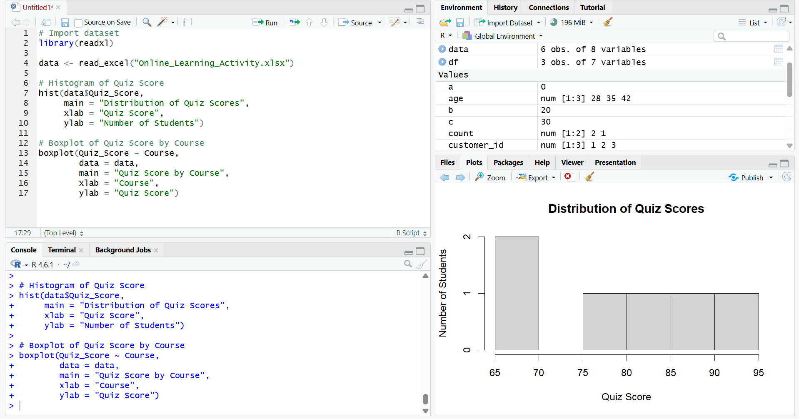

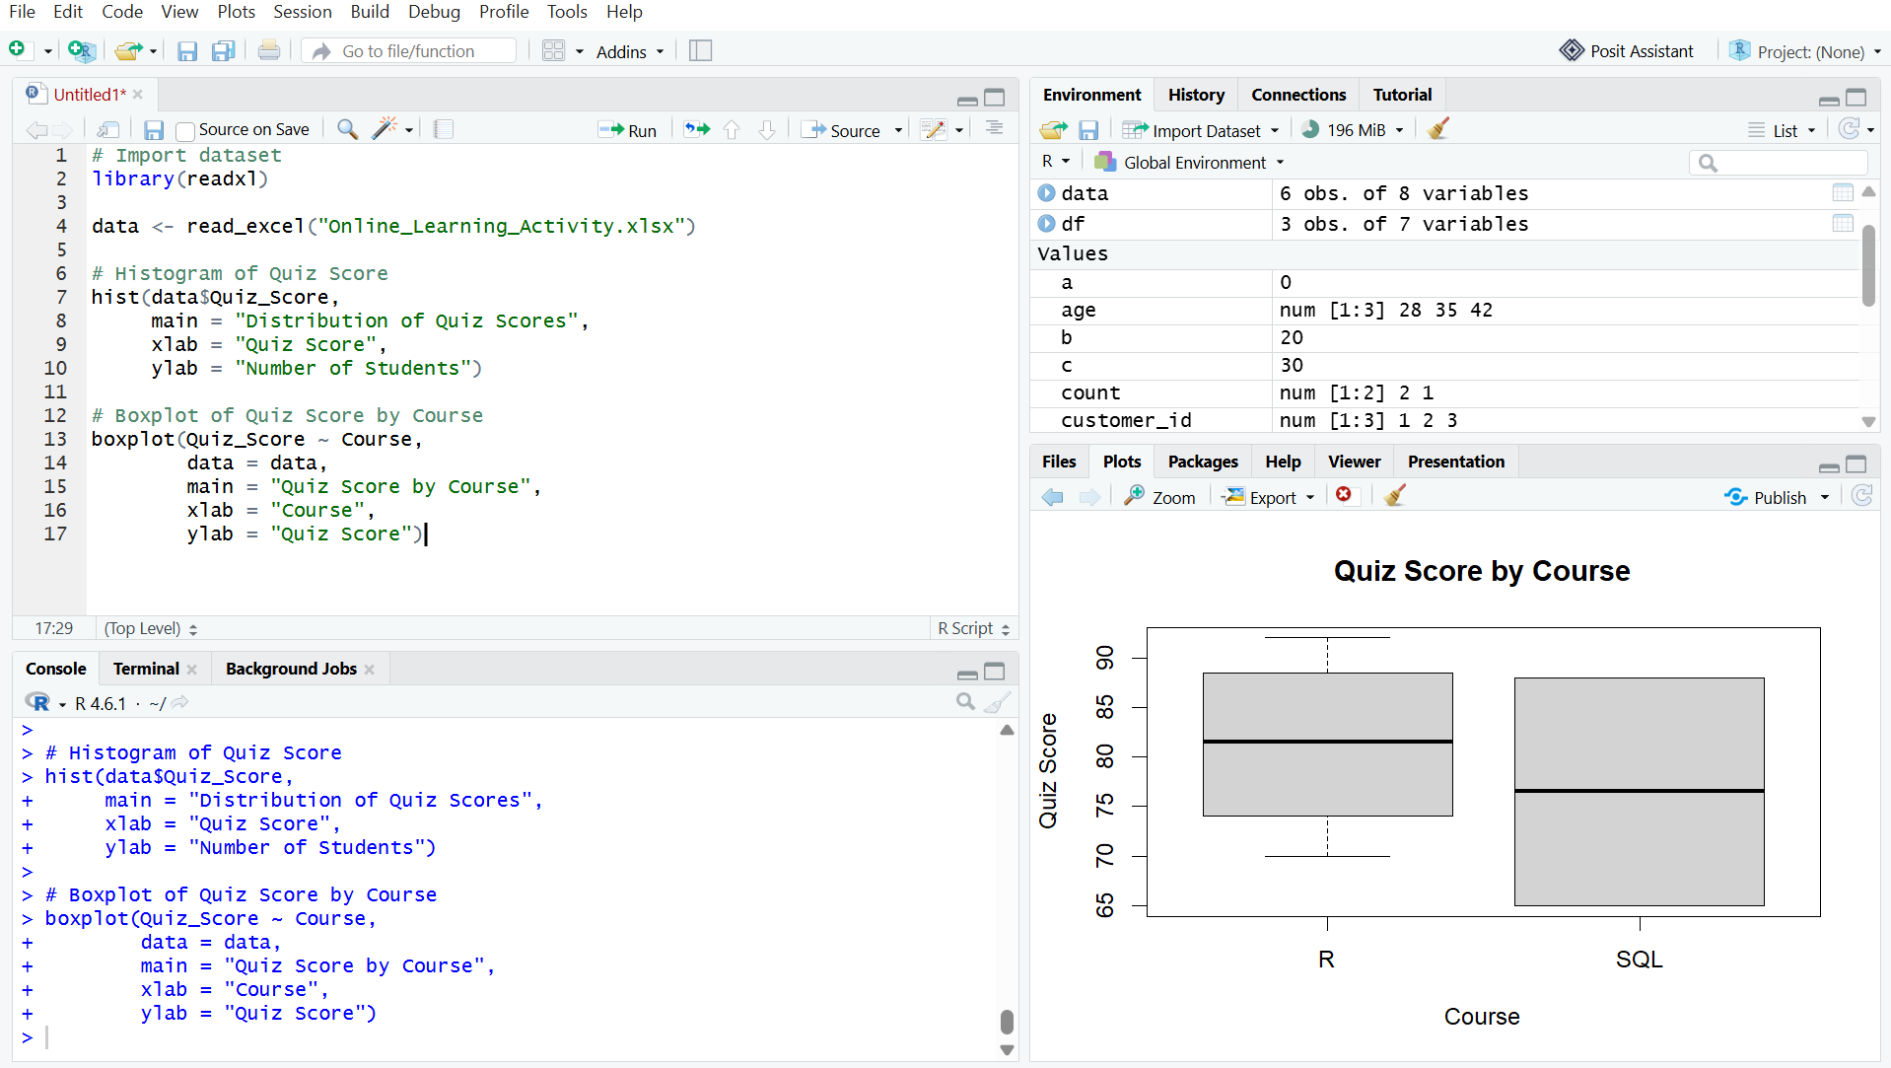
Output 1: Quiz Score Histogram and Boxplot
Observation
The histogram shows the distribution of quiz scores. The boxplot helps compare the performance of students in the R and SQL courses.
PROGRAM 2: Study Time vs Quiz Score Scatter Plot
Create a scatter plot between Study_Time and Quiz_Score. Represent Videos_Watched using bubble size and apply transparency.
Procedure:
- Select Study_Time and Quiz_Score.
- Create a scatter plot.
- Use Videos_Watched to control the bubble size.
- Apply transparency to the bubbles.
- Add title and axis labels.
- Observe the relationship between study time and quiz score.

# Load library
library(readxl)

# Import Excel file
data <- read_excel("Online_Learning_Activity.xlsx")

# Create scatter plot
plot(data$`Study_Time (hrs)`, data$Quiz_Score,
cex = data$Videos_Watched / 5,
pch = 19,
col = rgb(0, 0, 1, 0.5),
main = "Study Time vs Quiz Score",
xlab = "Study Time (hrs)",
ylab = "Quiz Score")
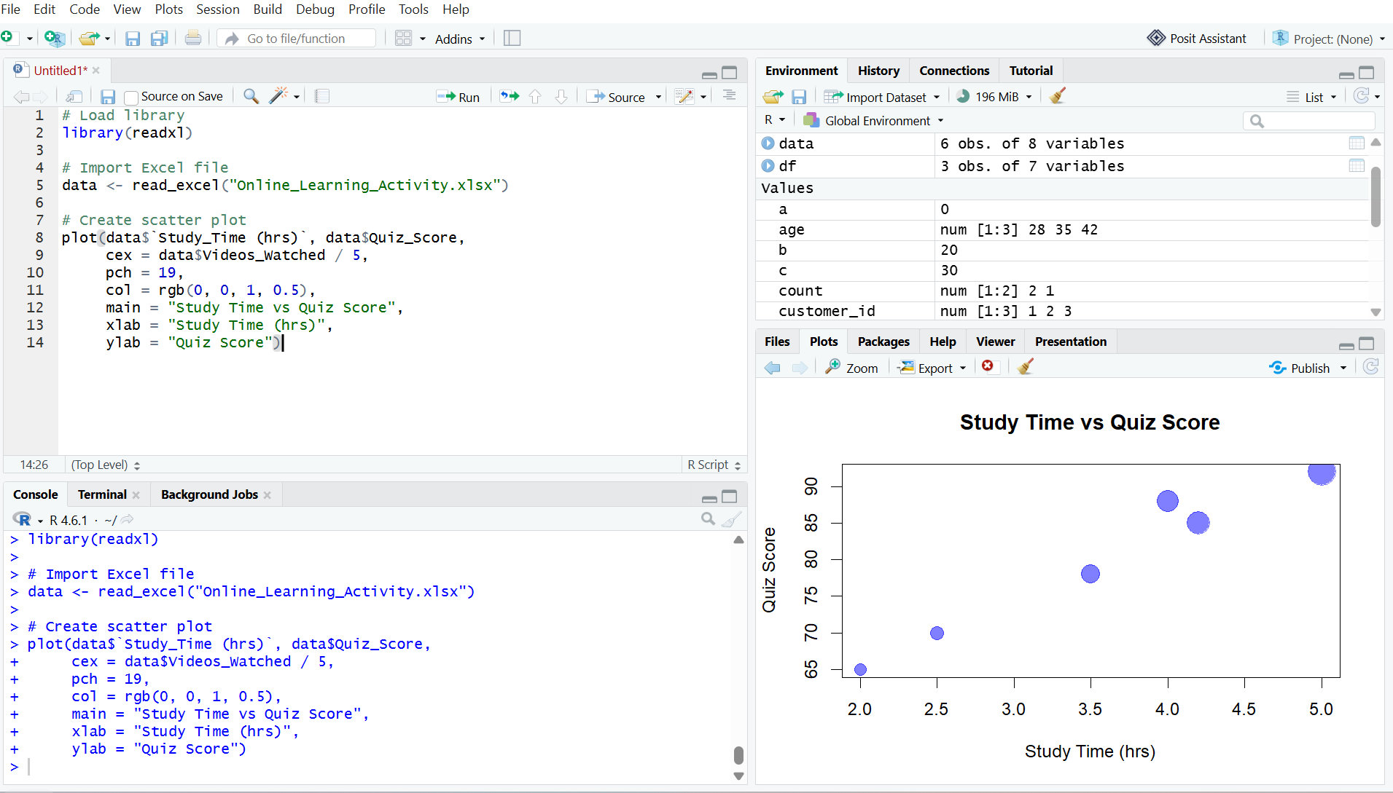
Output 2: Study Time vs Quiz Score Bubble Scatter Plot
Observation
The scatter plot shows that students who spend more time studying generally have higher quiz scores. Students who watched more videos are represented by larger bubbles.

PROGRAM 3: Monthly Average Quiz Score with Moving Average
Convert Login_Date into Date format, calculate the average quiz score per month, and create a line chart with moving average smoothing.
Procedure:
- Import the dataset into R.
- Convert Login_Date into Date format.
- Extract the month from the login date.
- Calculate the average quiz score for each month.
- Create a line chart.
- Calculate a moving average to smooth the trend.
- Add the moving average to the chart.
- Observe the monthly performance trend.
# Load library
library(readxl)

# Import Excel file
data <- read_excel("Online_Learning_Activity.xlsx")

# Convert Login_Date to Date format
data$Login_Date <- as.Date(data$Login_Date)

# Create month
data$Month <- format(data$Login_Date, "%Y-%m")

# Calculate average quiz score per month
monthly_avg <- aggregate(Quiz_Score ~ Month,
data = data,
FUN = mean)

# Print monthly average
print(monthly_avg)

# Calculate moving average
moving_avg <- c(
NA,
mean(monthly_avg$Quiz_Score[1:2]),
mean(monthly_avg$Quiz_Score[2:3])
)

# Create line chart
plot(1:nrow(monthly_avg),
monthly_avg$Quiz_Score,
type = "o",
main = "Monthly Average Quiz Score",
xlab = "Month",
ylab = "Average Quiz Score",
xaxt = "n")

# Add month names
axis(1,
at = 1:nrow(monthly_avg),
labels = monthly_avg$Month)

# Add moving average
lines(1:nrow(monthly_avg),
moving_avg,
type = "o",
lty = 2)

# Add legend
legend("bottomright",
legend = c("Average Score", "Moving Average"),
lty = c(1, 2))

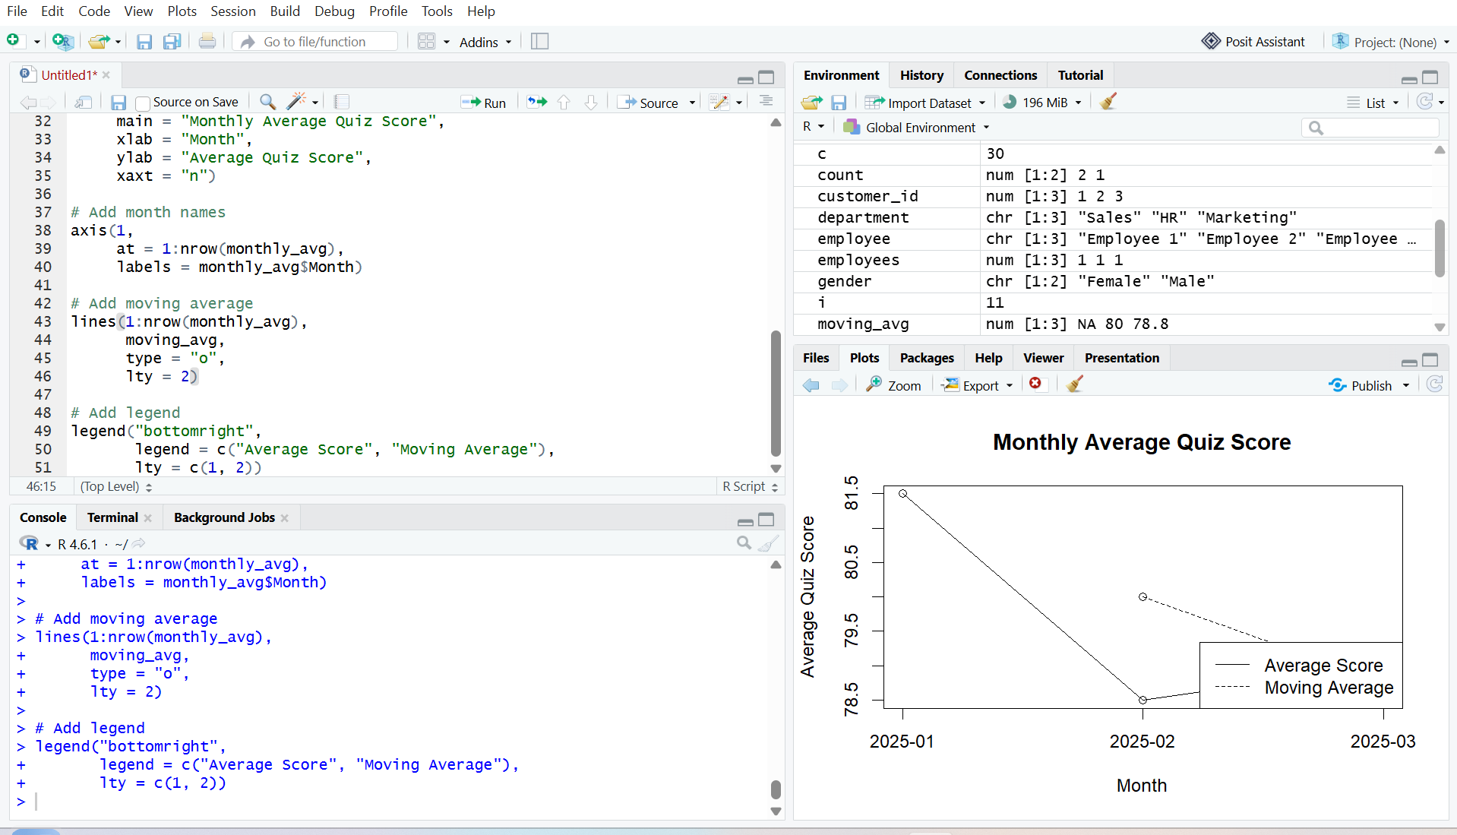
Output 3: Monthly Average Quiz Score with Moving Average
Observation
The line chart shows the monthly average quiz score. The moving average provides a smoother view of the overall student performance trend.

PROGRAM 4: Tableau Mini Interactive Dashboard
Import Online_Learning_Activity.csv into Tableau. Create a bar chart for average quiz score by course and a scatter plot for Study Time vs Quiz Score. Add Gender and Course filters.
Procedure:
- Import Online_Learning_Activity.csv into Tableau.
- Create a bar chart showing average Quiz Score by Course.
- Create a scatter plot using Study Time and Quiz Score.
- Use Videos Watched to represent the size of the bubbles.
- Add Gender and Course filters.
- Combine the charts into a mini dashboard.
- Add interactive filters.
- Save the Tableau dashboard.

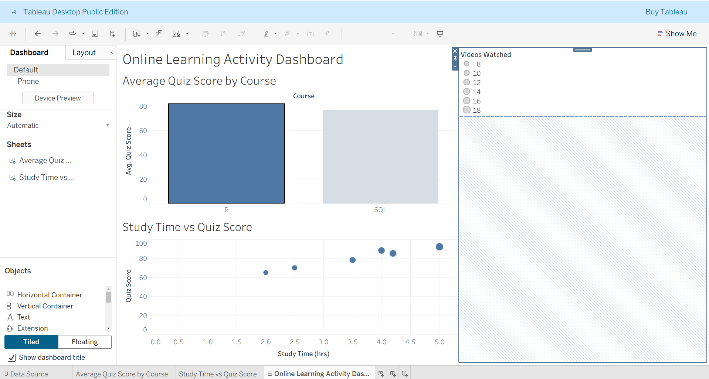
Output 4: Online Learning Activity Interactive Dashboard
Observation
The Tableau dashboard displays average quiz scores by course and the relationship between study time and quiz scores. Gender and Course filters allow interactive exploration of student learning activity.

Set 9 Procedure
- Import the Online Learning Activity dataset into R.
- Create a histogram and boxplot for Quiz Score.
- Create a bubble scatter plot between Study Time and Quiz Score.
- Convert Login Date into Date format.
- Calculate monthly average quiz scores.
- Create a line chart with moving average smoothing.
- Import the CSV dataset into Tableau.
- Create a bar chart for average quiz score by course.
- Create a scatter plot for Study Time vs Quiz Score.
- Add Gender and Course filters.
- Combine the visualizations into a mini interactive dashboard.
- Save the dashboard.
Set 9 Result
Online learning activity data was successfully analyzed using a histogram, boxplot, bubble scatter plot, and monthly line chart with moving average smoothing in R. A Tableau mini interactive dashboard was also created to analyze course-wise quiz performance and the relationship between study time and quiz scores.

