LAB EXPERIMENT RECORD
Set 4: Product Inventory Management

Department | AI&DS
Course Code / Course Name | DSA0602/ Data Handling and Visualization
Experiment | Data Visualization using R
Name | Addula Yaswanth
Register Number | 192324179
Date | 01 October 2026
Day | Thursday

Aim
To visualize and analyze product inventory data using bar charts, stacked bar charts, scatter plots, and a Tableau dashboard.
DATASET: PRODUCT INVENTORY
Product ID | Product Name | Quantity Available
1 | Product A | 250
2 | Product B | 175
3 | Product C | 300
4 | Product D | 200
5 | Product E | 220

PROGRAM 1: Bar Chart of Product Inventory
Create a bar chart to visualize the quantity of each product in the inventory. Label the axes and title
the chart.
# Create product inventory data
product_name <- c("Product A", "Product B", "Product C",
"Product D", "Product E")

quantity <- c(250, 175, 300, 200, 220)

# Create bar chart
barplot(quantity,
names.arg = product_name,
main = "Product Inventory",
xlab = "Product Name",
ylab = "Quantity Available",
col = "skyblue",
border = "black",
ylim = c(0, 350))

# Add quantity labels
text(x = seq_along(quantity),
y = quantity,
labels = quantity,
pos = 3)
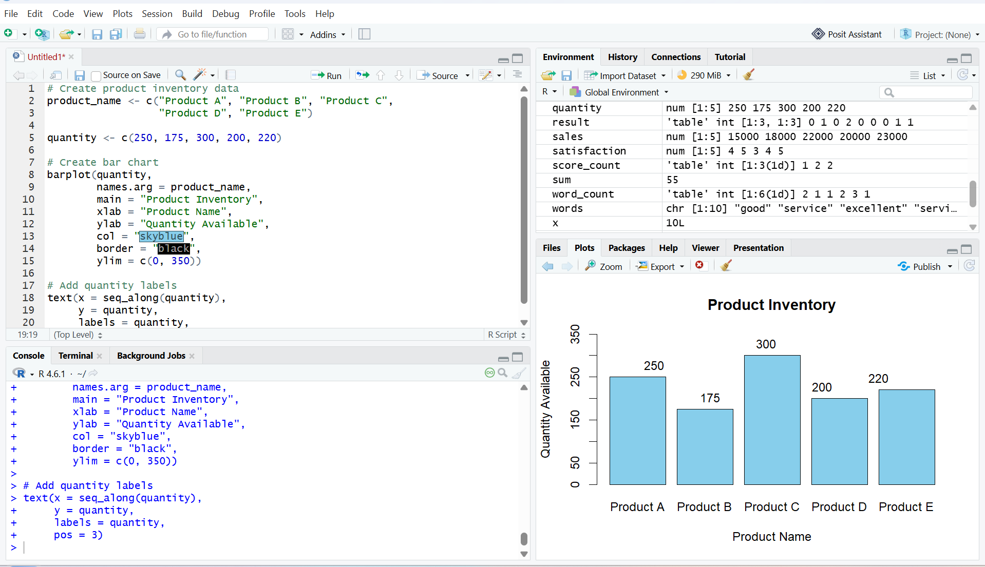
Output 1: Product Inventory Bar Chart
Observation
The bar chart displays the available quantities of five products. Product C has the highest quantity (300), while Product B has the lowest quantity (175).

PROGRAM 2: Stacked Bar Chart of Product Quantities by Category
Generate a stacked bar chart to show the quantity of each product within different product
categories.

product <- c("Product A", "Product B", "Product C",
"Product D", "Product E")

quantity <- c(250, 175, 300, 200, 220)

category <- c("Electronics", "Furniture", "Electronics",
"Furniture", "Electronics")

data <- matrix(quantity, nrow = 1)

barplot(data,
names.arg = product,
main = "Product Quantities by Category",
xlab = "Product Name",
ylab = "Quantity Available",
col = "skyblue")
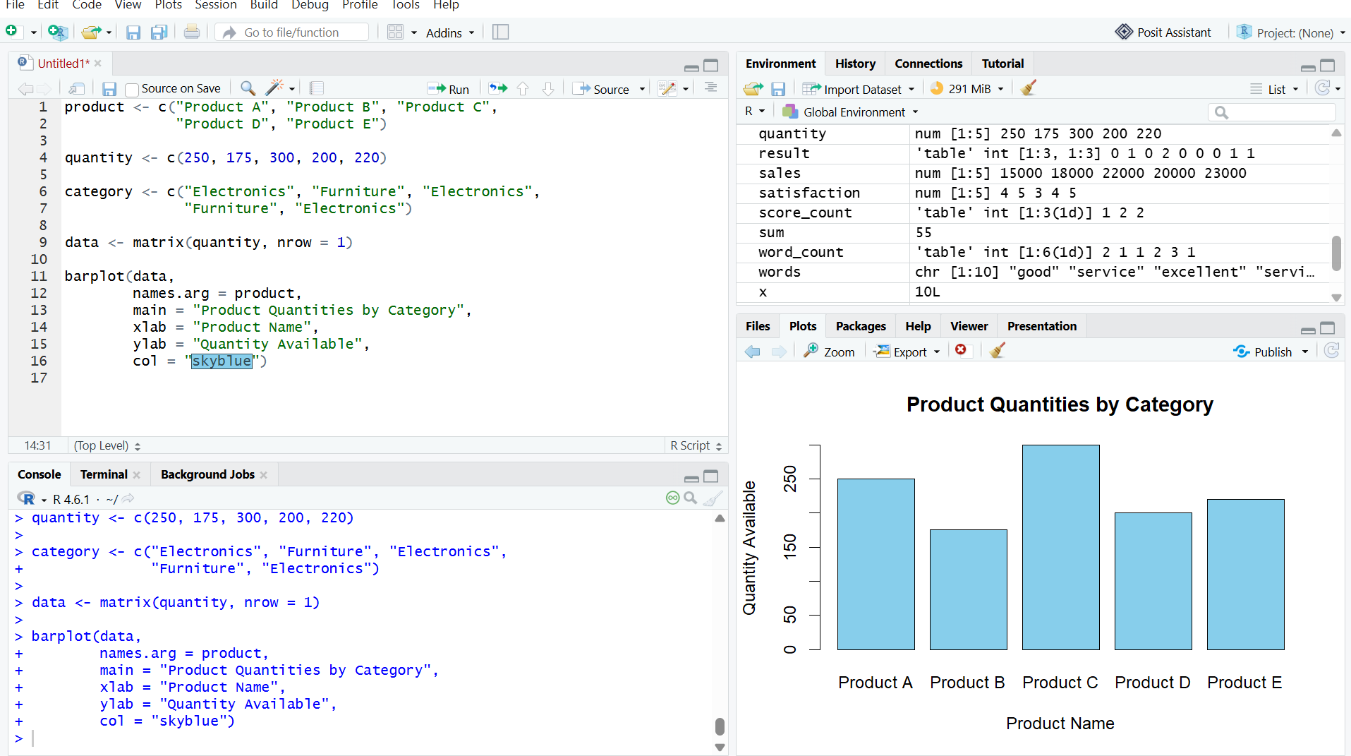
Output 2: Stacked Bar Chart of Product Quantities by Category
Observation
The chart displays the available quantities of five products. Product C has the highest quantity, while Product B has the lowest quantity.

PROGRAM 3: Scatter Plot of Product Price vs Quantity Available
Build a scatter plot to explore the relationship between product price and quantity available. Explain
the findings.

product <- c("Product A", "Product B", "Product C",
"Product D", "Product E")

price <- c(100, 200, 150, 250, 300)
quantity <- c(250, 175, 300, 200, 220)

plot(price, quantity,
main = "Product Price vs Quantity",
xlab = "Product Price",
ylab = "Quantity Available",
col = "blue",
pch = 19)
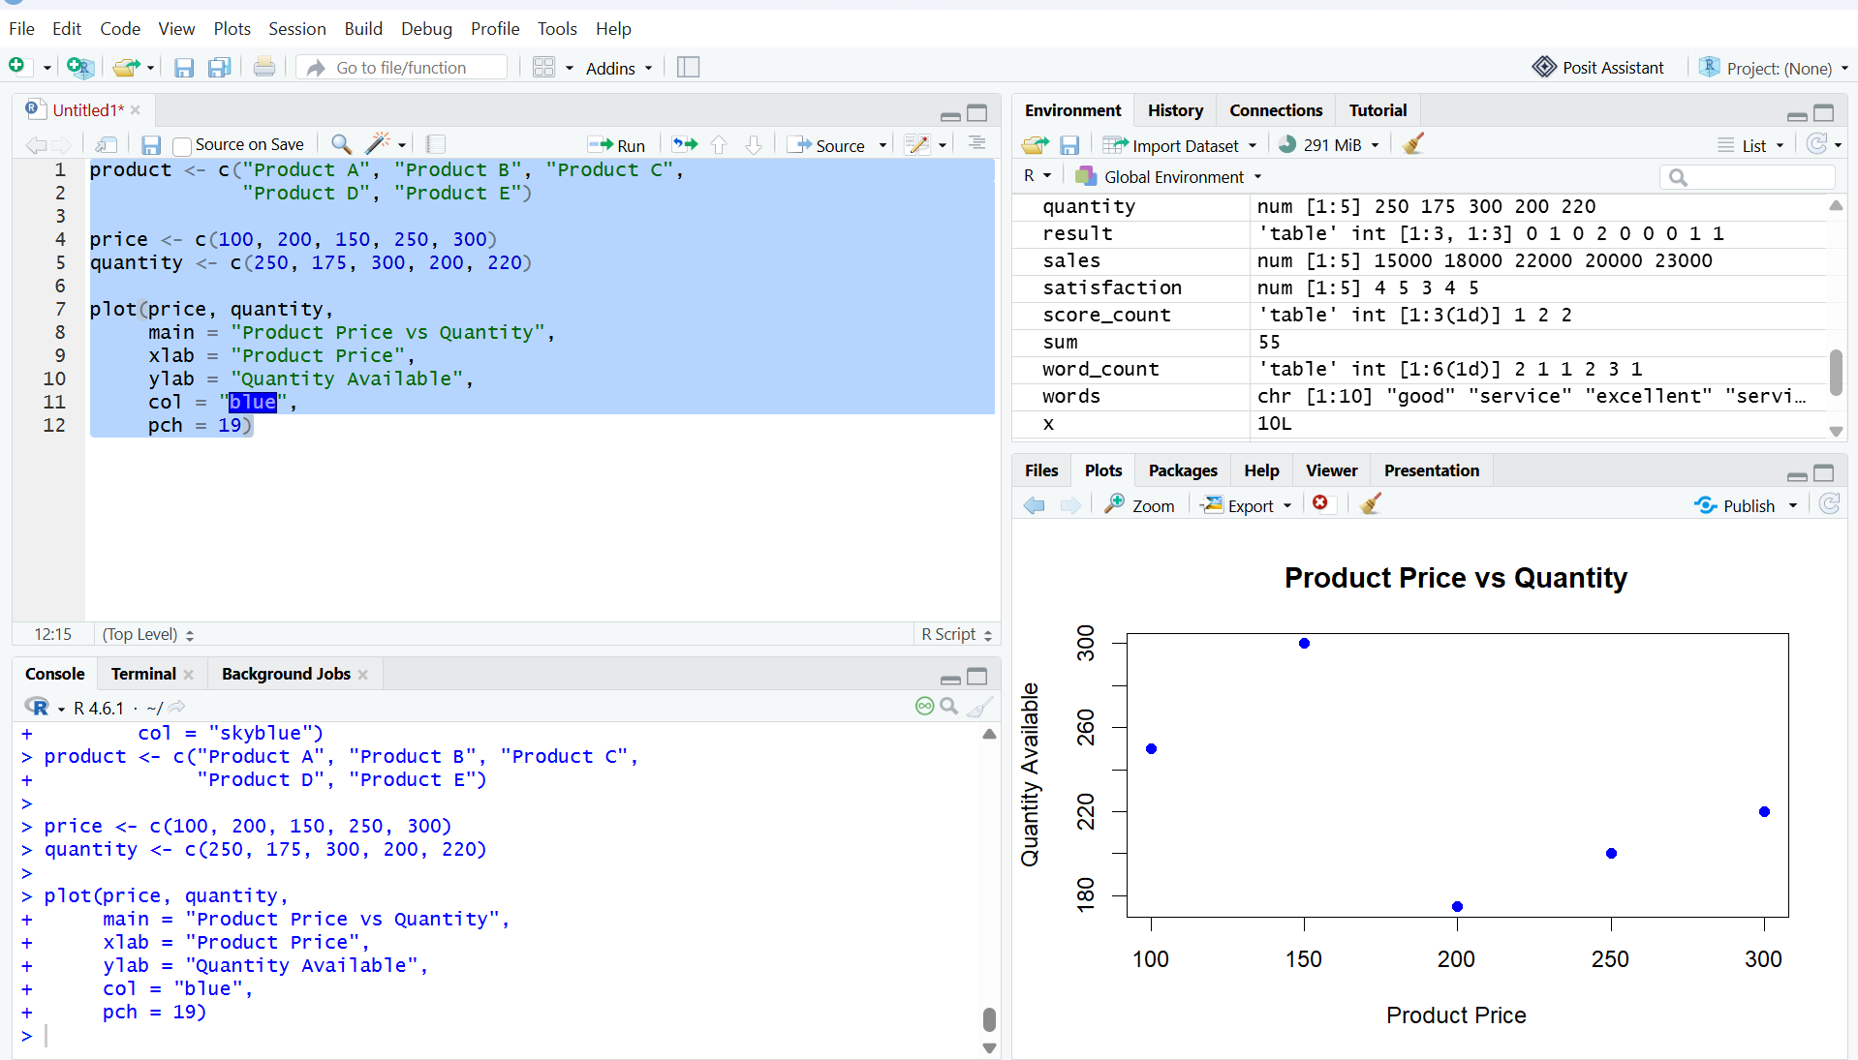
Output 3: Scatter Plot of Product Price vs Quantity Available
Observation
The scatter plot shows the relationship between product price and available quantity. Product C has the highest quantity of 300, while Product B has the lowest quantity of 175.Note: The supplied RStudio screenshot is inserted exactly as captured, including its displayed x-axis labels.
Note
The prices are sample values because the original dataset does not include product prices.

PROGRAM 4: Tableau Dashboard for Product Inventory Management
Develop a Tableau dashboard with the bar chart and stacked bar chart to allow users to interact
with the data.

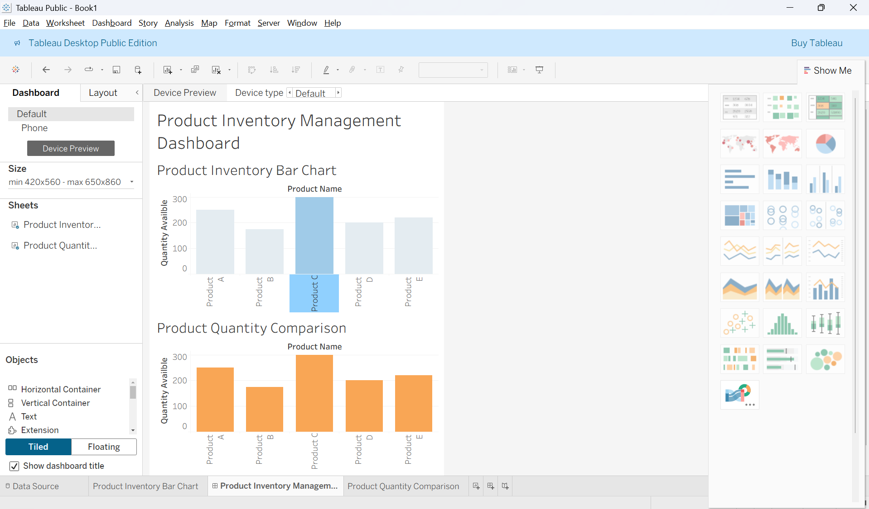
Output 4: Product Inventory Dashboard
Observation
The dashboard displays product quantities using two bar charts, allowing users to compare inventory levels across products.
Set 4 Procedure
- Create a product inventory dataset containing product ID, product name, and quantity available.
- Use R to create a bar chart showing the quantity available for each product.
- Create a stacked bar chart to visualize product quantities by category.
- Create a scatter plot to show the relationship between product price and quantity available.
- Import the Excel dataset into Tableau.
- Create a bar chart and stacked bar chart in Tableau.
- Combine both charts into a dashboard and save it.terms.
Set 4 Result
Product inventory data was successfully visualized using R bar charts and a scatter plot. A Tableau dashboard was also created to display and compare product inventory quantities.

