LAB EXPERIMENT RECORD
Set 7 Customer Demographics Analysis

Department | AI&DS
Course Code / Course Name | DSA0602/ Data Handling and Visualization
Experiment | Data Visualization using R
Name | Addula Yaswanth
Register Number | 192324179
Date | 03 October 2026
Day | Saturday

Aim
To analyze customer demographic data using bar charts, pie charts, tables, and an interactive Tableau dashboard.
Dataset: Customer Demographics
Customer ID | Age | Gender | Income ($)
1 | 28 | Female | 50000
2 | 35 | Male | 60000
3 | 42 | Female | 75000

PROGRAM 1: Customer Age Distribution Bar Chart
Create a bar chart to visualize the distribution of customer ages.
# Create customer age data
customer_id <- c(1, 2, 3)
age <- c(28, 35, 42)

# Create bar chart
barplot(age,
names.arg = customer_id,
main = "Customer Age Distribution",
xlab = "Customer ID",
ylab = "Age",
col = "skyblue",
border = "black")

# Add values on bars
text(x = seq_along(age),
y = age,
labels = age,
pos = 3)
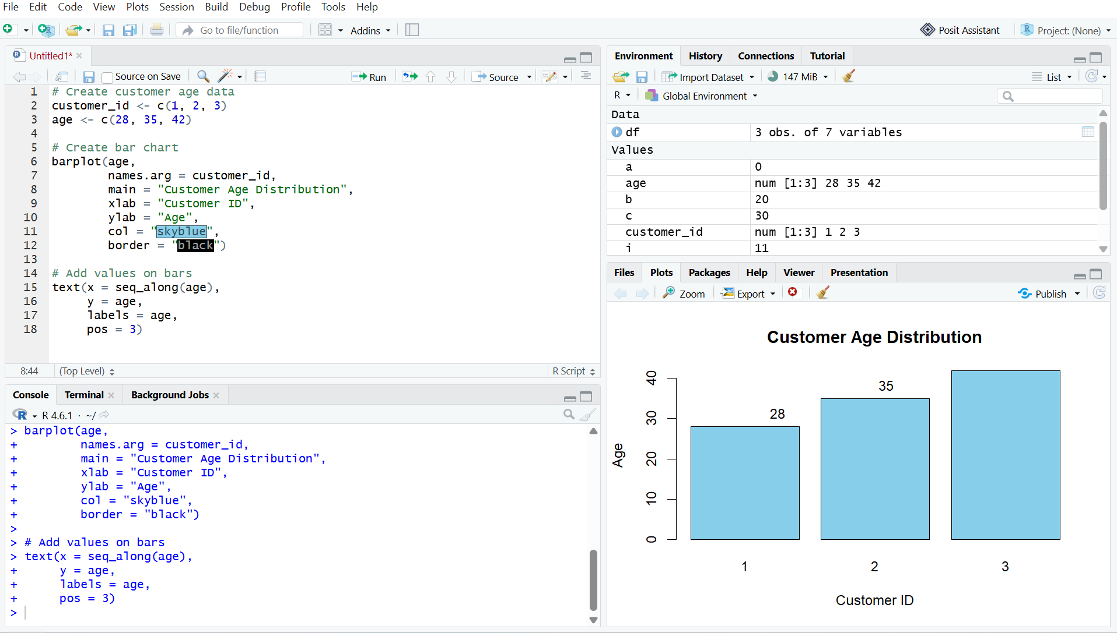
Output 1: Customer Age Distribution Bar Chart
Observation
The bar chart displays the age of each customer. Customer 3 has the highest age of 42 years, while Customer 1 has the lowest age of 28 years.

PROGRAM 2: Customer Gender Distribution Pie Chart
Generate a pie chart to represent the distribution of customers by gender.
# Create gender data
gender <- c("Female", "Male")
count <- c(2, 1)

# Create pie chart
pie(count,
labels = gender,
main = "Customer Gender Distribution",
col = c("pink", "skyblue"))

# Add percentage labels
percentage <- round(count / sum(count) * 100, 1)

legend("topright",
legend = paste(gender, percentage, "%"),
fill = c("pink", "skyblue"))

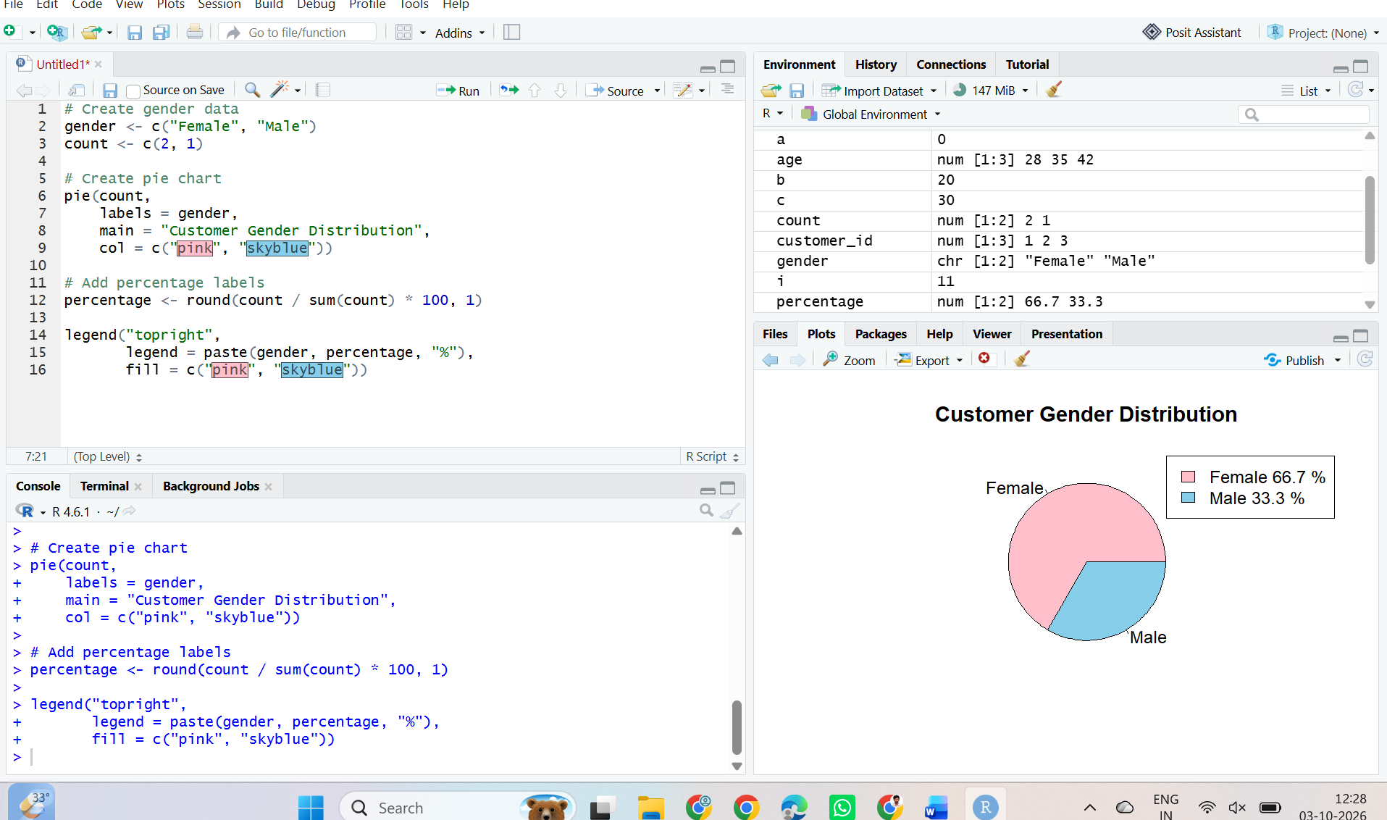

Output 2: Customer Gender Distribution Pie Chart
Observation
The pie chart shows that there are 2 female customers and 1 male customer. Female customers represent 66.7% and male customers represent 33.3% of the dataset.

PROGRAM 3: Customer Demographic Information Table
Build a table to show the demographic information for each customer.
# Create customer demographic data
customer_data <- data.frame(
Customer_ID = c(1, 2, 3),
Age = c(28, 35, 42),
Gender = c("Female", "Male", "Female"),
Income = c(50000, 60000, 75000)
)

# Display the demographic table
print(customer_data)

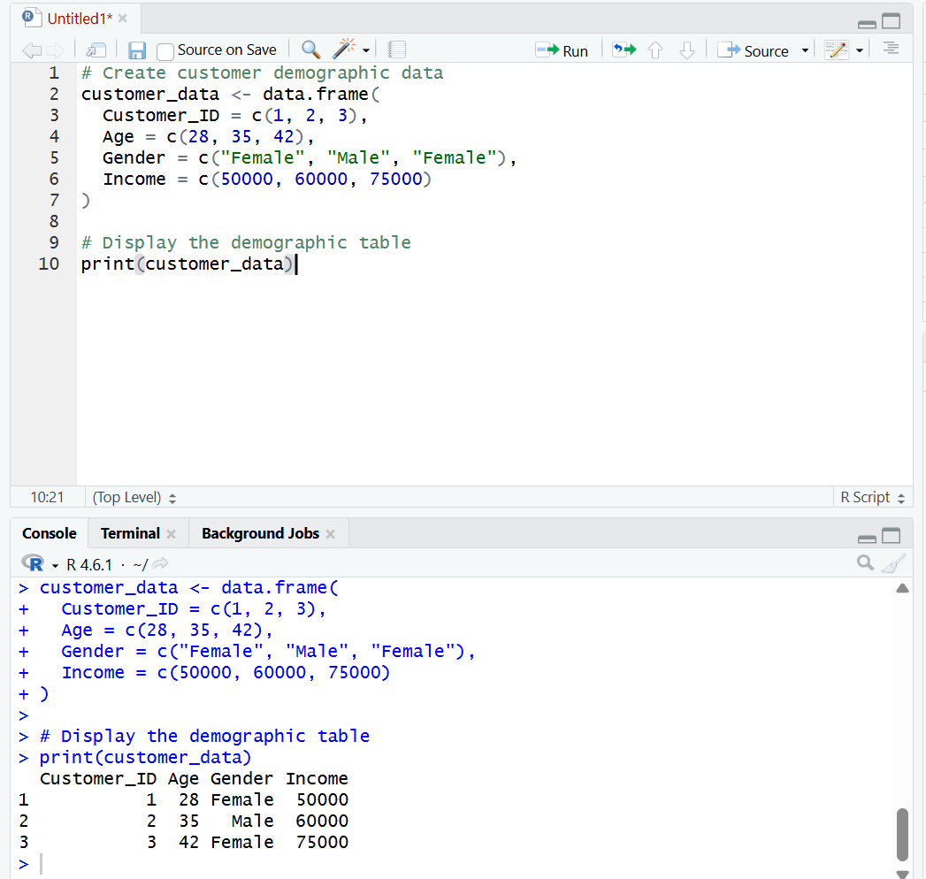
Output 3: Customer Demographic Information Table

Observation
The table displays the Customer ID, age, gender, and income of each customer clearly.
PROGRAM 4: Tableau Dashboard for Customer Demographics Analysis
Develop a Tableau dashboard with the bar chart, pie chart, and table to allow users to interactively explore customer demographic data.
Procedure:
- Create customer demographics dataset containing Customer ID, Age, Gender, and Income.
- Use R to create a bar chart showing the age of each customer.
- Create a pie chart showing the distribution of customers by gender.
- Create a table displaying Customer ID, Age, Gender, and Income.
- Import the customer demographics dataset into Tableau.
- Create a bar chart in Tableau using Customer ID and Age.
- Create a pie chart in Tableau using Gender and Customer ID/count.
- Create a table in Tableau showing Customer ID, Age, Gender, and Income.
- Combine the bar chart, pie chart, and table into a Tableau dashboard.
- Add filters/dashboard actions for interactive exploration.
- Save the dashboard.

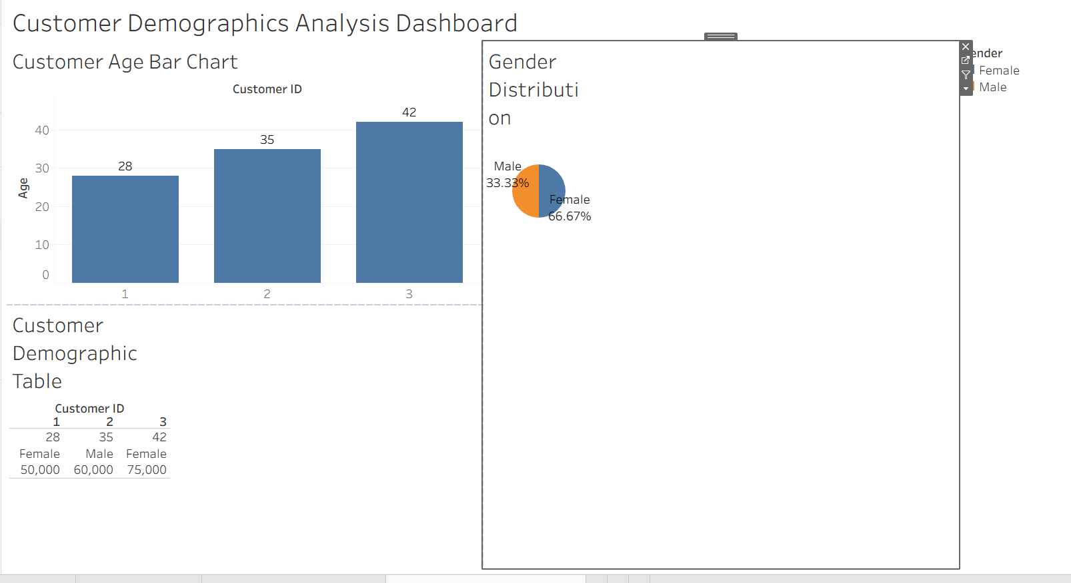

Output 4: Customer Demographics Analysis Tableau Dashboard

Observation
The dashboard displays customer demographics using a bar chart, pie chart, and table, allowing users to compare customer ages, analyze gender distribution, and view individual demographic information interactively.

Set 7 Procedure
- Create customer demographics dataset containing Customer ID, Age, Gender, and Income.
- Use R to create a bar chart showing customer age distribution.
- Create a pie chart to represent customer distribution by gender.
- Create a table to display demographic information for each customer.
- Import the customer demographics dataset into Tableau.
- Create the bar chart, pie chart, and table in Tableau.
- Apply filters and dashboard actions for interactive exploration.
- Combine all three visualizations into a dashboard and save it.
Set 7 Result
Customer demographic data was successfully visualized using an R bar chart, pie chart, and demographic information table. A Tableau dashboard was also created to display and explore customer age, gender, and income information interactively.

