Set 8 Employee Performance Analysis
Aim
To analyze employee performance data using line charts, bar charts, tables, and an interactive Tableau dashboard.
Dataset: Employee Performance
Employee ID | Department | Years of Service | Performance Score
1 | Sales | 5 | 85
2 | HR | 3 | 92
3 | Marketing | 7 | 78

PROGRAM 1: Employee Performance Trend Line Chart
Create a line chart to visualize the performance trend of employees based on years of service.
employee <- c("Employee 1", "Employee 2", "Employee 3")
years <- c(5, 3, 7)
score <- c(85, 92, 78)

plot(years, score,
type = "o",
main = "Employee Performance Trend",
xlab = "Years of Service",
ylab = "Performance Score")
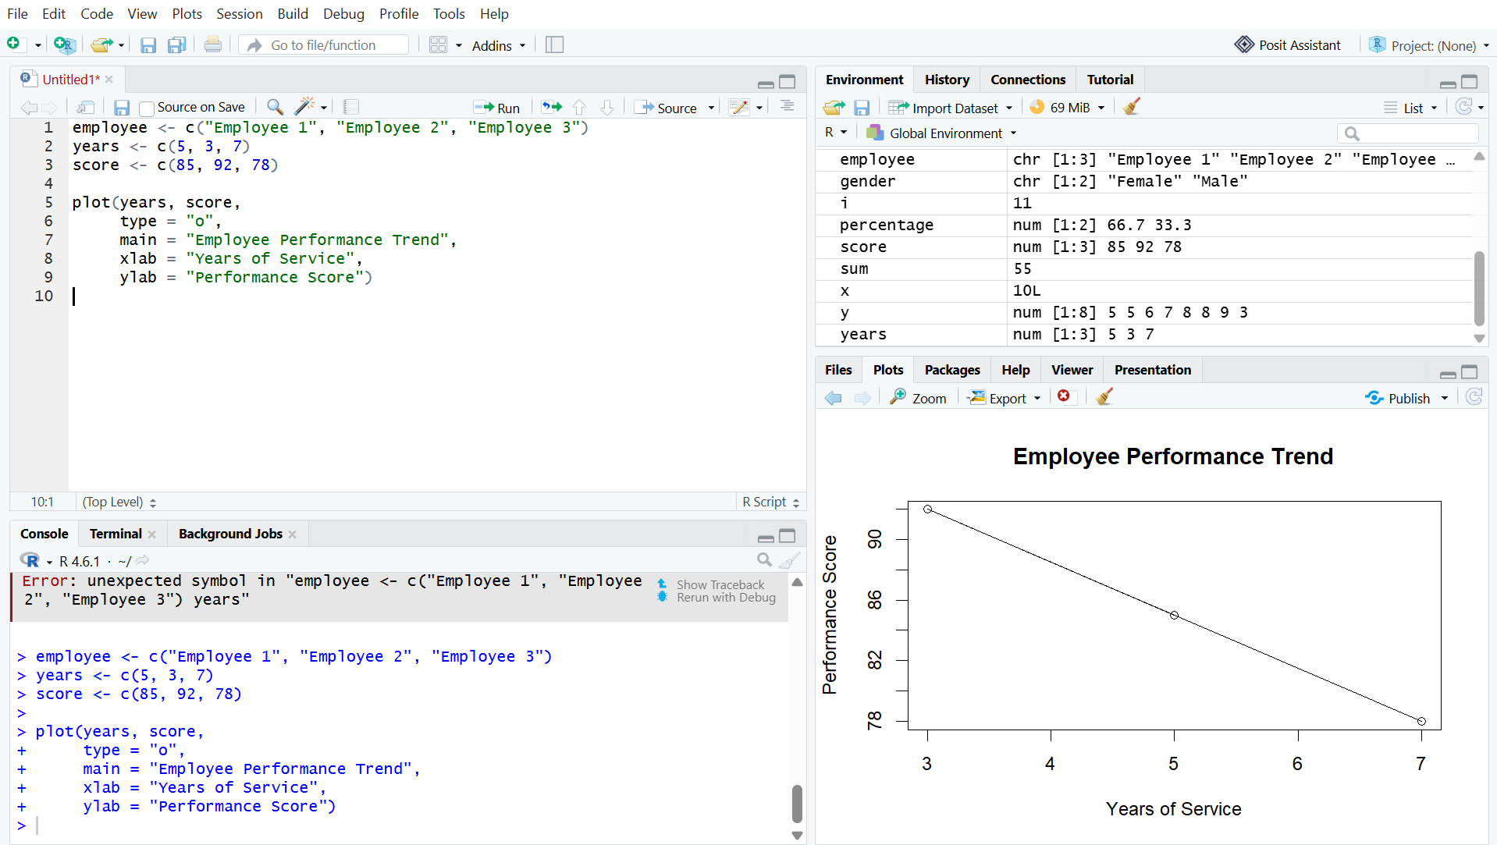
Output 1: Employee Performance Trend Line Chart
Observation
The line chart shows the performance scores of employees based on their years of service.
PROGRAM 2: Employee Distribution by Department Bar Chart
Create a bar chart showing the distribution of employees across different departments.
department <- c("Sales", "HR", "Marketing")
employees <- c(1, 1, 1)

barplot(employees,
names.arg = department,
main = "Employees by Department",
xlab = "Department",
ylab = "Number of Employees")

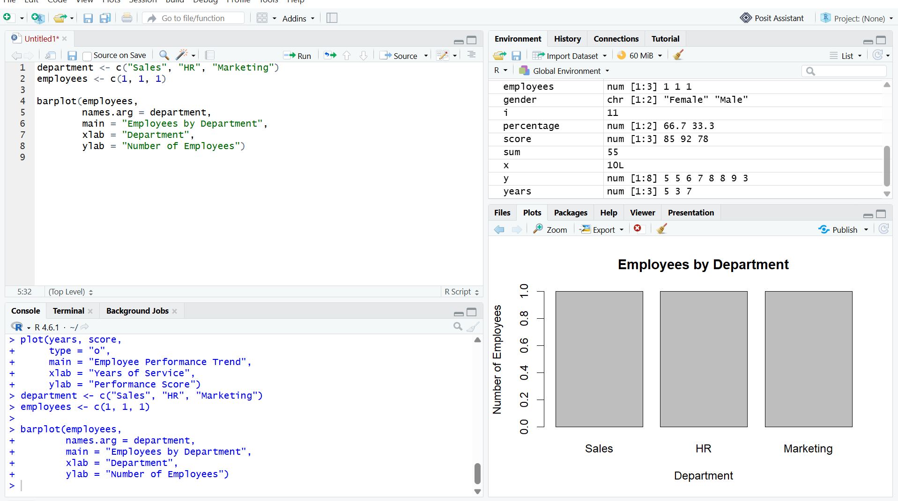
Output 2: Employee Distribution by Department Bar Chart

Observation
The bar chart shows the number of employees in the Sales, HR, and Marketing departments.

PROGRAM 3: Employee Performance Data Table
Create a table to display the performance data of each employee.
data <- data.frame(
Employee_ID = c(1, 2, 3),
Department = c("Sales", "HR", "Marketing"),
Years_of_Service = c(5, 3, 7),
Performance_Score = c(85, 92, 78)
)

print(data)

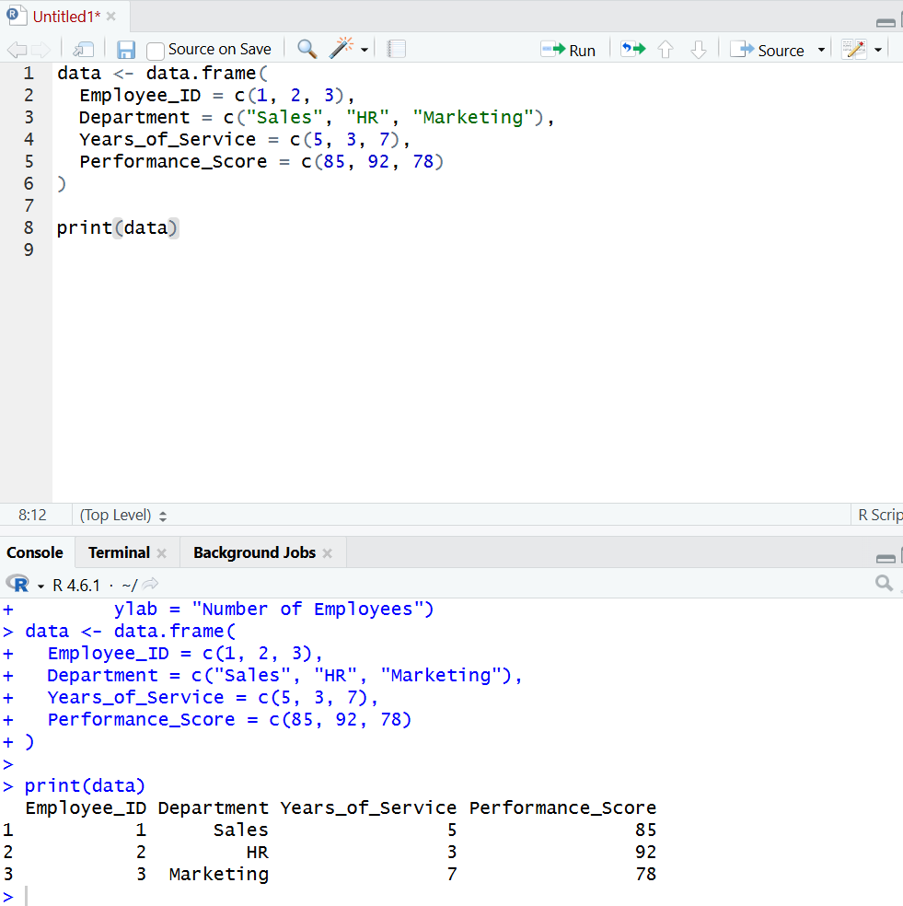
Output 3: Employee Performance Data Table

Observation
The table displays the employee ID, department, years of service, and performance score clearly.

PROGRAM 4: Tableau Dashboard for Employee Performance Analysis
Develop a Tableau dashboard with the line chart, bar chart, and table for interactive exploration of employee performance data.
Procedure:
- Create the employee performance dataset in Excel.
- Open Tableau and connect the Excel file.
- Create a line chart using Years of Service and Performance Score.
- Create a bar chart using Department and employee count.
- Create a table using Employee ID, Department, Years of Service, and Performance Score.
- Create a new dashboard.
- Drag the line chart, bar chart, and table into the dashboard.
- Add filters or dashboard actions for interactive exploration.
- Give the dashboard the title Employee Performance Analysis Dashboard.
- Save the Tableau workbook.

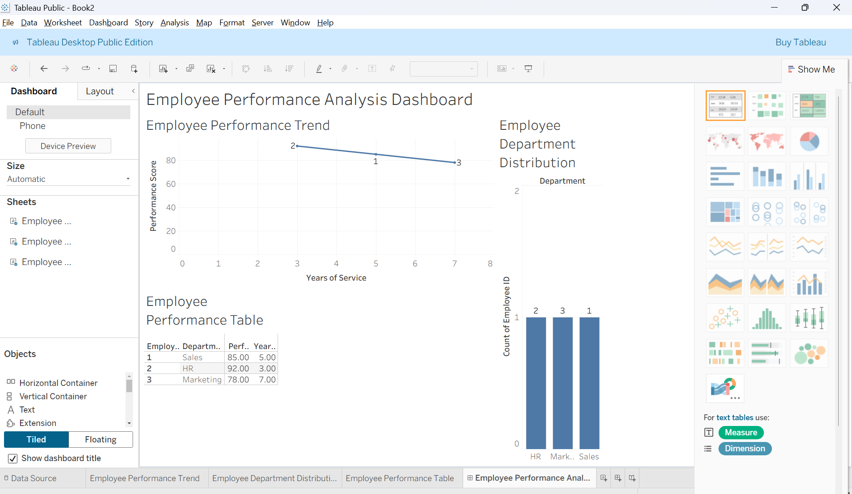
Output 4: Employee Performance Analysis Tableau Dashboard

Observation
The dashboard displays employee performance using a line chart, department bar chart, and performance table, allowing users to explore the employee performance data interactively.

Set 8 Procedure
- Create employee performance dataset containing Employee ID, Department, Years of Service, and Performance Score.
- Use R to create a line chart showing employee performance.
- Create a bar chart showing employees across departments.
- Create a table displaying employee performance data.
- Import the dataset into Tableau.
- Create the line chart, bar chart, and table in Tableau.
- Apply filters and dashboard actions.
- Combine all three visualizations into a Tableau dashboard and save it.
Set 8 Result
Employee performance data was successfully visualized using a line chart, bar chart, and data table in R. A Tableau dashboard was also created to display and explore employee performance data interactively.

