LAB EXPERIMENT RECORD
Set 10 Survey Responses Analysis

Department | AI&DS
Course Code / Course Name | DSA0602/ Data Handling and Visualization
Experiment | Data Visualization using R
Name | Addula Yaswanth
Register Number | 192324179
Date | 06 October 2026
Day | Tuesday

Aim
To analyze survey response data using bar charts, stacked bar charts, tables, and an interactive Tableau dashboard.
Dataset: Survey Responses
Survey ID | Question 1 | Question 2 | Question 3
1 | A | B | C
2 | B | A | D
3 | C | A | B

PROGRAM 1: Question 1 Response Distribution Bar Chart
Create a grouped bar chart to visualize the distribution of answers for Question 1. Label the chart elements.
R-Code:
# Create Question 1 response data
question1 <- c("A", "B", "C")

# Count responses
count <- c(1, 1, 1)

# Create bar chart
barplot(count,
names.arg = question1,
main = "Question 1 Response Distribution",
xlab = "Responses",
ylab = "Number of Responses",
col = "skyblue",
border = "black")

# Add values on bars
text(x = seq_along(count),
y = count,
labels = count,
pos = 3)

Output:
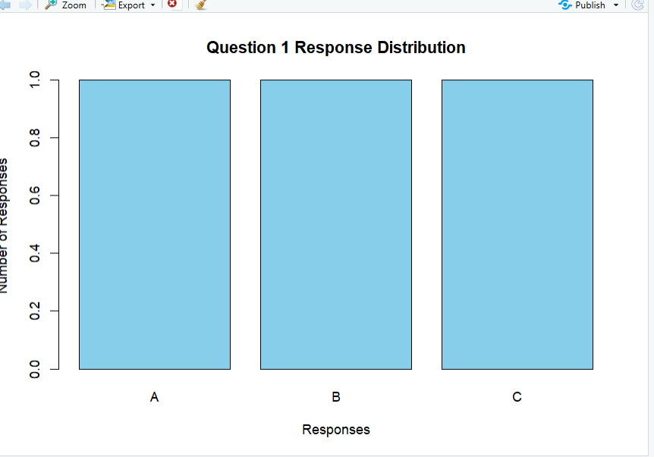
Output 1: Question 1 Response Distribution Bar Chart
Observation
The bar chart shows the distribution of survey responses. Each response occurs once, so all responses have equal frequency.

PROGRAM 2: Overall Response Distribution Stacked Bar Chart
Generate a stacked bar chart to represent the overall distribution of responses for all three questions.
R-Code:
# Create response count data
responses <- matrix(c(1, 1, 1, 2, 1, 0, 0, 1, 1, 1, 0, 0),
nrow = 3,
byrow = TRUE)

# Add row and column names
rownames(responses) <- c("Question 1", "Question 2", "Question 3")
colnames(responses) <- c("A", "B", "C", "D")

# Create stacked bar chart
barplot(responses,
beside = FALSE,
main = "Overall Survey Response Distribution",
xlab = "Questions",
ylab = "Number of Responses",
col = c("skyblue", "pink", "lightgreen", "orange"),
legend.text = TRUE)

Output:
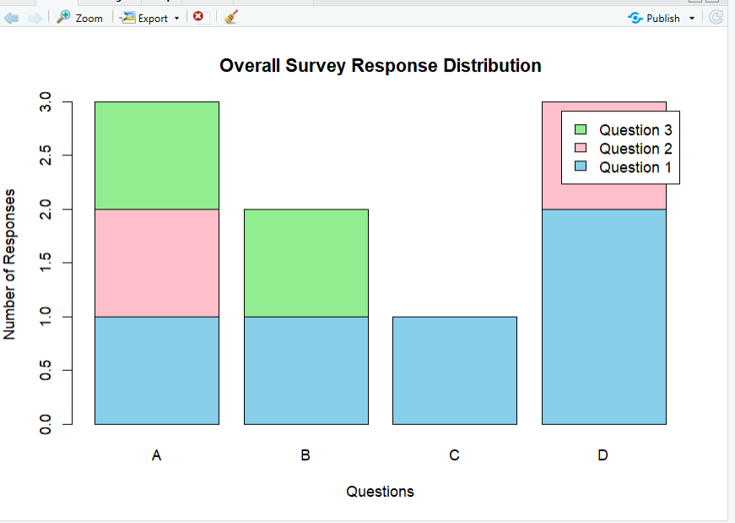

Output 2: Overall Survey Response Distribution Stacked Bar Chart
Observation
The stacked bar chart shows the overall distribution of survey responses. It helps compare the frequency of different responses across the survey.

PROGRAM 3: Survey Response Information Table
Build a table to show the survey response data for each survey. Label the table elements.
R-Code:
# Create survey response data
survey_data <- data.frame(
Survey_ID = c(1, 2, 3),
Question_1 = c("A", "B", "C"),
Question_2 = c("B", "A", "A"),
Question_3 = c("C", "D", "B")
)

# Display the survey response table
print(survey_data)

Output:
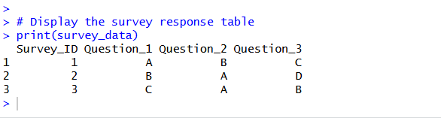

Output 3: Survey Response Information Table
Observation
The table clearly displays the Survey ID and the responses provided by each survey participant.

PROGRAM 4: Tableau Dashboard for Survey Responses Analysis
Develop a Tableau dashboard with the bar chart, stacked bar chart, and table to allow users to interactively explore survey responses.
Procedure:
- Create the survey response dataset containing Survey ID, Question 1, Question 2, and Question 3.
- Use R to create a bar chart showing the distribution of responses for Question 1.
- Create a stacked bar chart showing the overall distribution of responses for all three questions.
- Create a table displaying Survey ID and responses for all three questions.
- Import the survey response dataset into Tableau.
- Create the bar chart in Tableau using Question 1 and the count of responses.
- Create the stacked bar chart using the three questions and response counts.
- Create a table in Tableau showing Survey ID, Question 1, Question 2, and Question 3.
- Combine the bar chart, stacked bar chart, and table into a Tableau dashboard.
- Add filters or dashboard actions for interactive exploration.
- Save the dashboard.
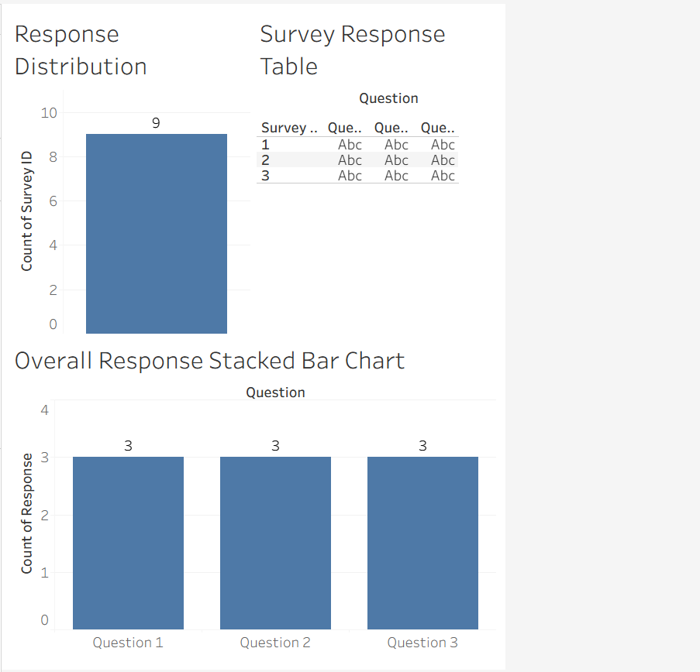
Output 4: Survey Responses Analysis Tableau Dashboard
Observation
The dashboard displays survey responses using a bar chart, stacked bar chart, and table, allowing users to compare Question 1 responses, analyze the overall response distribution, and view individual survey responses interactively.
Set 10 Procedure
- Create the survey response dataset containing Survey ID, Question 1, Question 2, and Question 3.
- Use R to create a bar chart showing the distribution of Question 1 responses.
- Create a stacked bar chart to represent the overall distribution of responses for all three questions.
- Create a table to display the response data for each survey.
- Import the survey response dataset into Tableau.
- Create the bar chart, stacked bar chart, and table in Tableau.
- Apply filters and dashboard actions for interactive exploration.
- Combine all three visualizations into a dashboard and save it.
Set 10 Result
Survey response data was successfully visualized using an R bar chart, stacked bar chart, and survey response table. A Tableau dashboard was also created to display and interactively explore the responses for all three questions.

