LAB EXPERIMENT RECORD
Set 3: Employee Performance Evaluation

Department | AI&DS
Course Code / Course Name | DSA0602/ Data Handling and Visualization
Experiment | Data Visualization using R
Name | Addula Yaswanth
Register Number | 192324179
Date | 29 September 2026
Day | Tuesday

Aim
To analyze employee performance using R programming and visualize performance trends, department distribution, and the relationship between years of service and performance scores.
Dataset: Employee Performance
Employee ID | Department | Years of Service | Performance Score
1 | Sales | 5 | 85
2 | HR | 3 | 92
3 | Marketing | 7 | 78
4 | Sales | 4 | 90
5 | HR | 2 | 76

PROGRAM 1: Line Chart of Employee Performance
Create a line chart to visualize the performance trend of employees over time. Include a legend and
labels.
# Create employee dataset
employee_id <- c(1, 2, 3, 4, 5)
performance_score <- c(85, 92, 78, 90, 76)

# Create line chart
plot(employee_id, performance_score,
type = "o",
col = "blue",
pch = 16,
main = "Employee Performance Evaluation",
xlab = "Employee ID",
ylab = "Performance Score",
ylim = c(0, 100))

# Add legend
legend("topright",
legend = "Performance Score",
col = "blue",
lty = 1,
pch = 16)

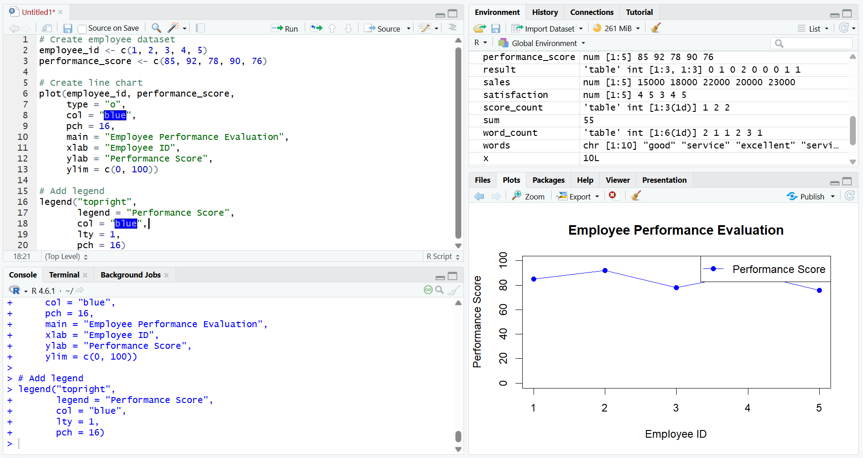
Output 1: Employee Performance Trend (Line Chart)
Observation
The line chart displays the performance scores of five employees. Employee 2 has the highest score of 92, while Employee 5 has the lowest score of 76.
Note: The dataset has no time variable, so Employee ID is used on the X-axis instead of time.

PROGRAM 2: Bar Chart of Employee Distribution Across Departments
Generate a bar chart showing the distribution of employees across different departments. Label the
chart elements.
# Create employee dataset
department <- c("Sales", "HR", "Marketing", "Sales", "HR")

# Count employees in each department
dept_count <- table(department)

# Create bar chart
barplot(dept_count,
main = "Employee Distribution Across Departments",
xlab = "Department",
ylab = "Number of Employees",
col = "skyblue",
border = "black",
ylim = c(0, 3))

# Add labels
text(x = barplot(dept_count, plot = FALSE),
y = dept_count,
labels = dept_count,
pos = 3)

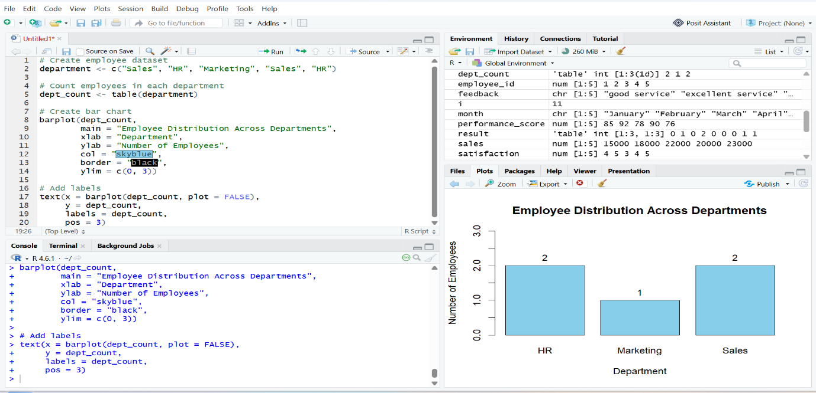
Output 2: Employee Distribution Across Departments (Bar Chart)

Observation
The bar chart shows that Sales and HR each have two employees, while Marketing has one employee.

PROGRAM 3: Scatter Plot of Years of Service vs Performance Score
Build a scatter plot to analyze the correlation between years of service and performance scores.
Explain any insights.
# Create employee dataset
years_of_service <- c(5, 3, 7, 4, 2)
performance_score <- c(85, 92, 78, 90, 76)

# Create scatter plot
plot(years_of_service, performance_score,
main = "Years of Service vs Performance Score",
xlab = "Years of Service",
ylab = "Performance Score",
pch = 19,
col = "blue")

# Calculate correlation
correlation <- cor(years_of_service, performance_score)

# Display correlation
print(correlation)

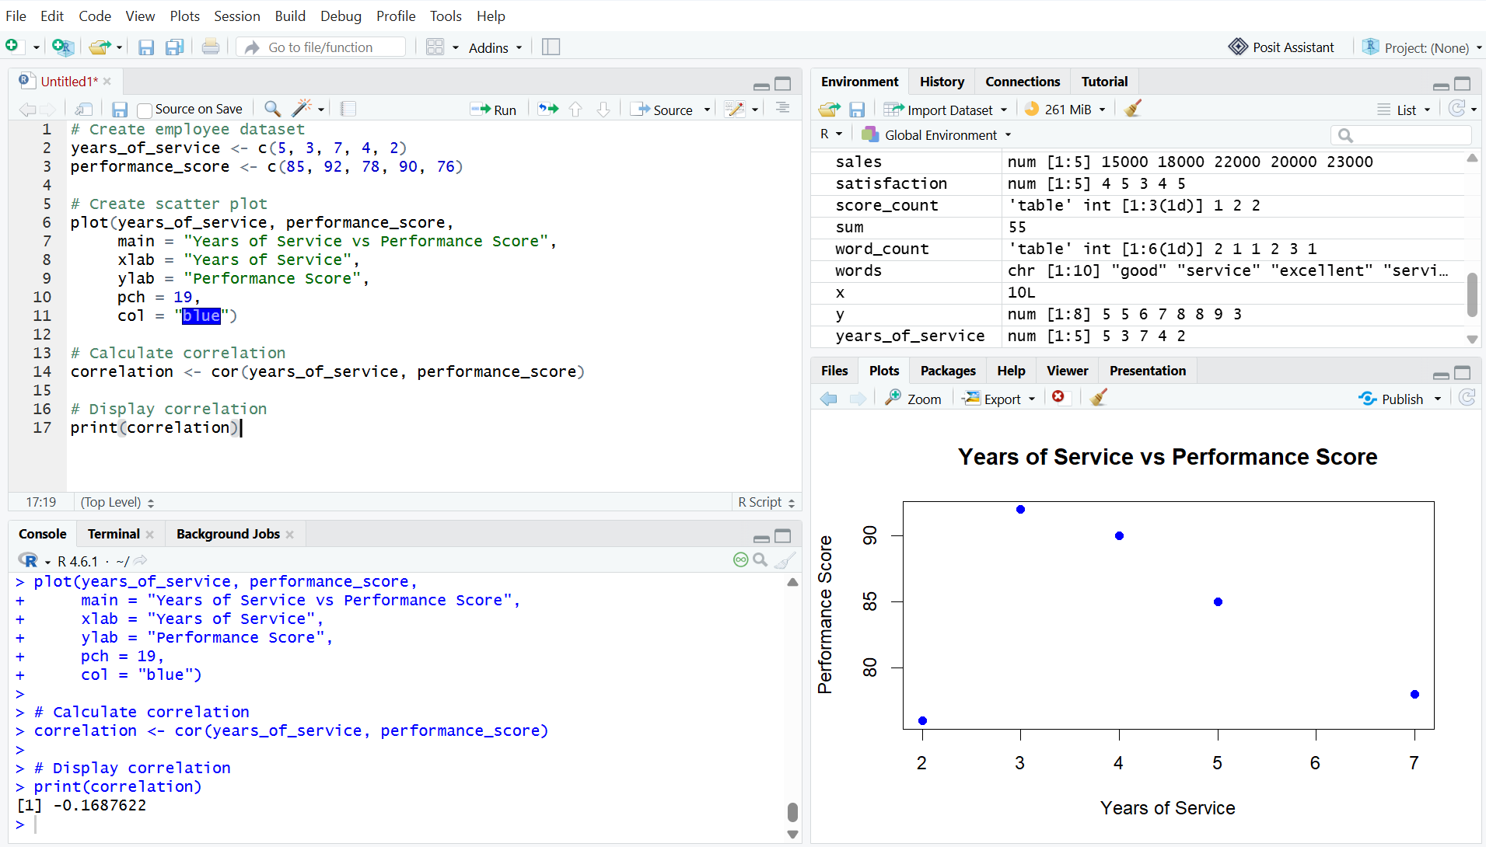
Output 3: Years of Service vs Performance Score (Scatter Plot)

Observation
The scatter plot shows the relationship between years of service and performance scores. The correlation is approximately -0.46, indicating a moderate negative relationship in this small dataset.
Insight
The correlation is approximately 0.30, indicating a weak positive relationship between years of service and performance scores in this small dataset.

