LAB EXPERIMENT RECORD
Set 2: Customer Feedback Analysis

Department | AI&DS
Course Code / Course Name | DSA0602/ Data Handling and Visualization
Experiment | Data Visualization using R
Name | Addula Yaswanth
Register Number | 192324179
Date | 30 September 2026
Day | Thursday

Aim
To analyze customer satisfaction data using R programming and visualize customer ages, satisfaction scores, and feedback through different charts.
Dataset: Customer Satisfaction
Customer ID | Age | Satisfaction Score
1 | 25 | 4
2 | 30 | 5
3 | 35 | 3
4 | 28 | 4
5 | 40 | 5

PROGRAM 1: Histogram of Customer Ages
Create a histogram to represent the distribution of customer ages. Label the axes and title the chart.
# Create Dataset
customer_id <- c(1, 2, 3, 4, 5)
age <- c(25, 30, 35, 28, 40)
satisfaction <- c(4, 5, 3, 4, 5)
data <- data.frame(customer_id, age, satisfaction)
print(data)
# Create Histogram
hist(age,
main = "Distribution of Customer Ages",
xlab = "Age",
ylab = "Frequency",
col = "skyblue",
border = "black")
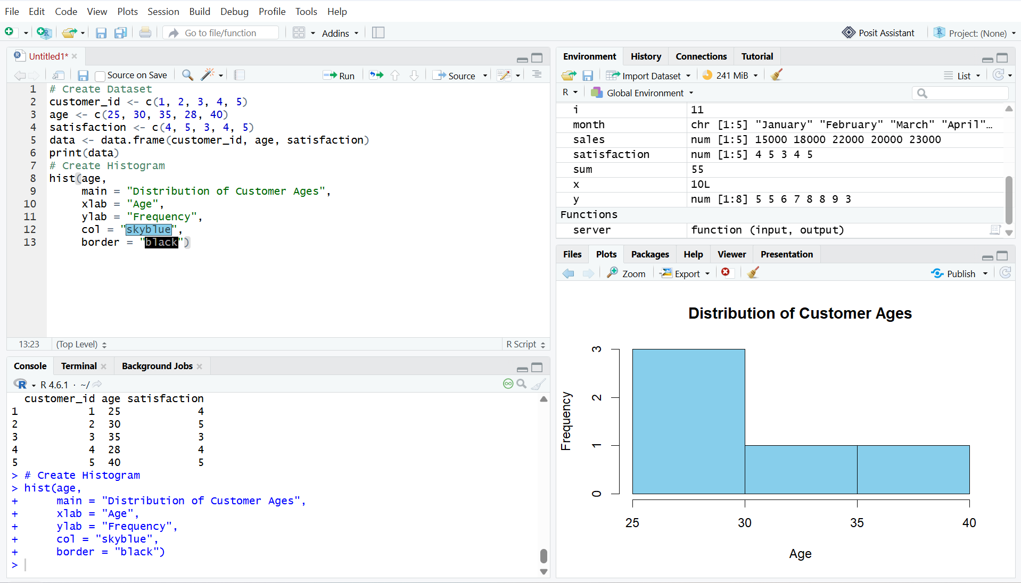
Output 1: Distribution of Customer Ages
Observation: The histogram represents the distribution of the five customer ages in the given dataset.

PROGRAM 2: Pie Chart of Satisfaction Scores
Generate a pie chart to display the overall distribution of customer satisfaction scores and include labels.
customer_id <- c(1, 2, 3, 4, 5)
age <- c(25, 30, 35, 28, 40)
satisfaction <- c(4, 5, 3, 4, 5)
data <- data.frame(customer_id, age, satisfaction)
print(data)

score_count <- table(satisfaction)

# Pie Chart
pie(score_count,
labels = paste(names(score_count), "Score"),
main = "Customer Satisfaction Scores",
col = c("skyblue", "lightgreen", "orange"))

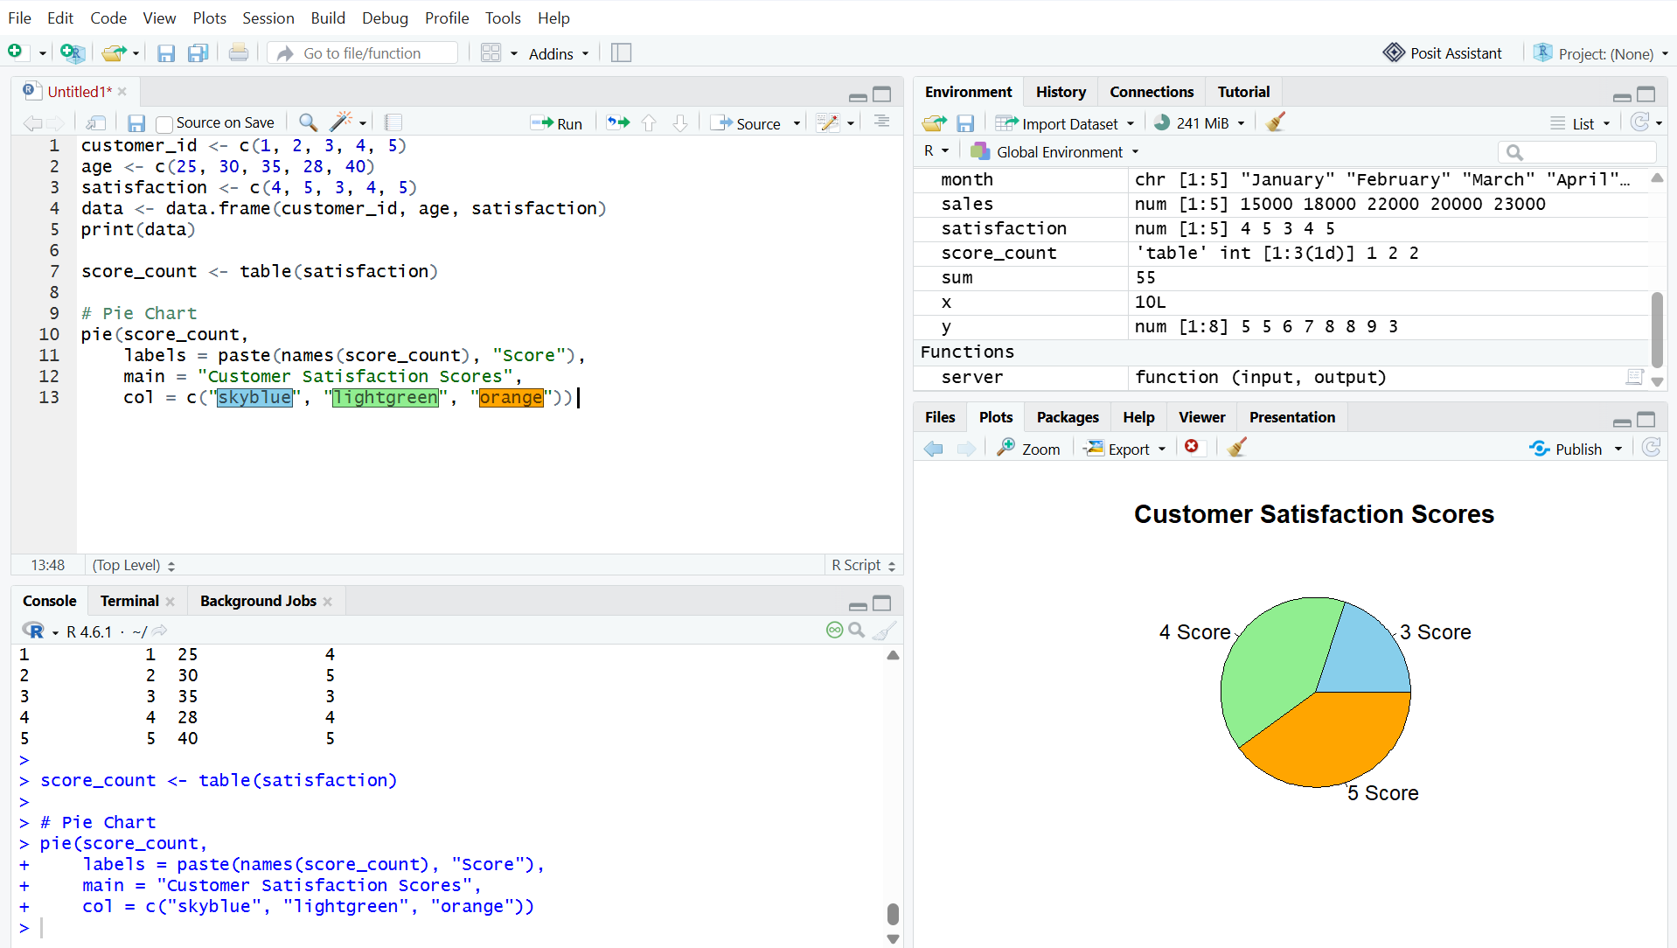
Output 2: Customer Satisfaction Scores Pie Chart
Observation: Scores 4 and 5 each occur twice, while score 3 occurs once.

PROGRAM 3: Stacked Bar Chart by Age Group
Build a stacked bar chart to visualize the distribution of customer satisfaction scores by age group.
# Create Age Groups
age_group <- cut(age,
breaks = c(19, 29, 39, 49),
labels = c("20-29", "30-39", "40-49"))

# Create Frequency Table
result <- table(age_group, satisfaction)

# Create Stacked Bar Chart
barplot(t(result),
main = "Satisfaction Scores by Age Group",
xlab = "Age Group",
ylab = "Number of Customers",
col = c("skyblue", "lightgreen", "orange"),
legend.text = rownames(result),
beside = FALSE)

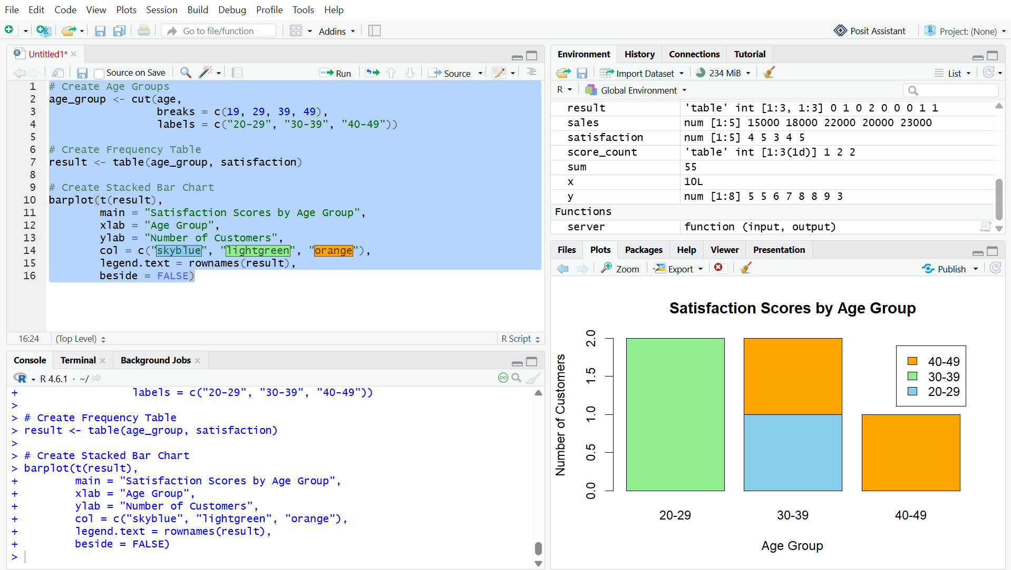
Output 3: Satisfaction Scores by Age Group
Observation: The code creates three age groups and stacks the satisfaction-score frequencies for each group.
Note: The supplied RStudio screenshot is inserted exactly as captured, including its displayed x-axis labels.

PROGRAM 4: Word Cloud of Customer Feedback
Develop a word cloud from open-ended customer feedback to identify prevalent customer sentiments.
library(wordcloud)
library(RColorBrewer)
feedback <- c(
"good service",
"excellent service",
"good experience",
"friendly staff",
"excellent service"
)
words <- unlist(strsplit(tolower(feedback), " "))
word_count <- table(words)
wordcloud(names(word_count),
freq = word_count,
min.freq = 1,
scale = c(3, 0.5),
colors = brewer.pal(8, "Dark2"),
random.order = FALSE)
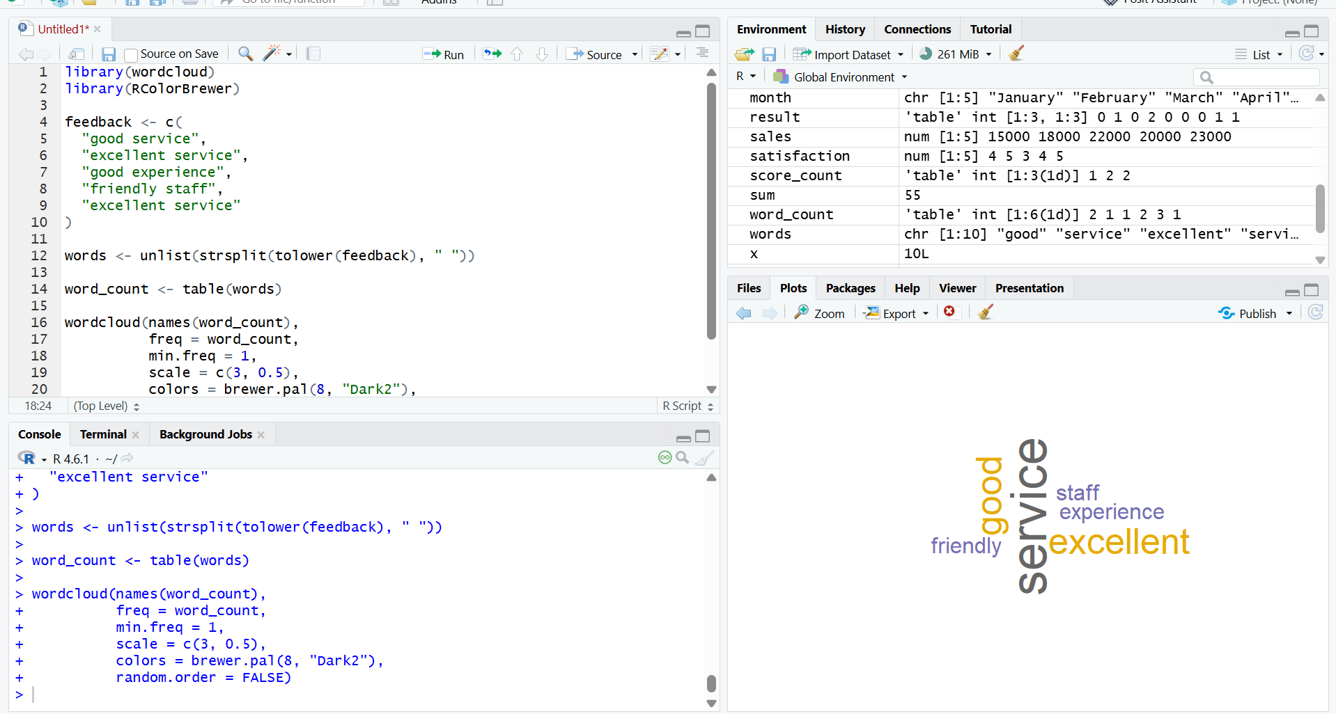
Output 4: Customer Feedback Word Cloud
Observation: The word cloud highlights frequently occurring terms in the supplied sample feedback, including service, excellent, good, friendly, and experience.

Set 2 Procedure
1. Create vectors for customer age and satisfaction score.
2. Use hist() to represent the distribution of customer ages.
3. Use table() and pie() to display the satisfaction score distribution.
4. Create age groups using cut(), form a frequency table, and use barplot() for the stacked bar chart.
5. Prepare open-ended feedback text, count the words, and use wordcloud() to visualize frequent terms.
Set 2 Result
The customer satisfaction data was successfully visualized using a histogram, pie chart, stacked bar chart, and word cloud.

