LAB EXPERIMENT RECORD
Set 10 Survey Responses Analysis

Department | AI&DS
Course Code / Course Name | DSA0602/ Data Handling and Visualization
Experiment | Data Visualization using R
Name | Addula Yaswanth
Register Number | 192324179
Date | 06 October 2026
Day | Tuesday

Aim
To analyze survey response data using bar charts, stacked bar charts, tables, and an interactive Tableau dashboard.
Dataset: Survey Responses
Survey ID | Question 1 | Question 2 | Question 3
1 | A | B | C
2 | B | A | D
3 | C | A | B

PROGRAM 1: Question 1 Response Distribution Bar Chart
Create a grouped bar chart to visualize the distribution of answers for Question 1. Label the chart elements.
R-Code:
# Create Question 1 response data
question1 <- c("A", "B", "C")

# Count responses
count <- c(1, 1, 1)

# Create bar chart
barplot(count,
names.arg = question1,
main = "Question 1 Response Distribution",
xlab = "Responses",
ylab = "Number of Responses",
col = "skyblue",
border = "black")

# Add values on bars
text(x = seq_along(count),
y = count,
labels = count,
pos = 3)

Output:
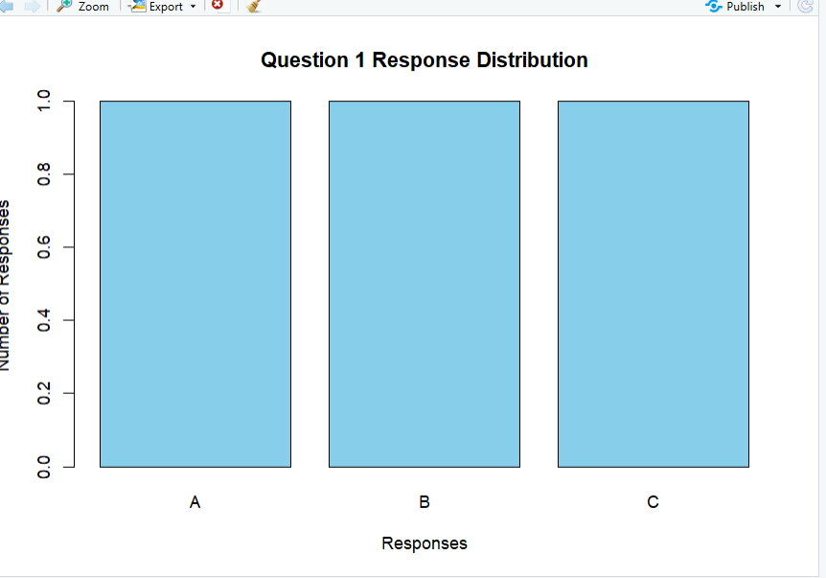
Output 1: Question 1 Response Distribution Bar Chart
Observation
The bar chart shows the distribution of survey responses. Each response occurs once, so all responses have equal frequency.

PROGRAM 2: Overall Response Distribution Stacked Bar Chart
Generate a stacked bar chart to represent the overall distribution of responses for all three questions.
R-Code:
# Create response count data
responses <- matrix(c(1, 1, 1, 2, 1, 0, 0, 1, 1, 1, 0, 0),
nrow = 3,
byrow = TRUE)

# Add row and column names
rownames(responses) <- c("Question 1", "Question 2", "Question 3")
colnames(responses) <- c("A", "B", "C", "D")

# Create stacked bar chart
barplot(responses,
beside = FALSE,
main = "Overall Survey Response Distribution",
xlab = "Questions",
ylab = "Number of Responses",
col = c("skyblue", "pink", "lightgreen", "orange"),
legend.text = TRUE)

Output:
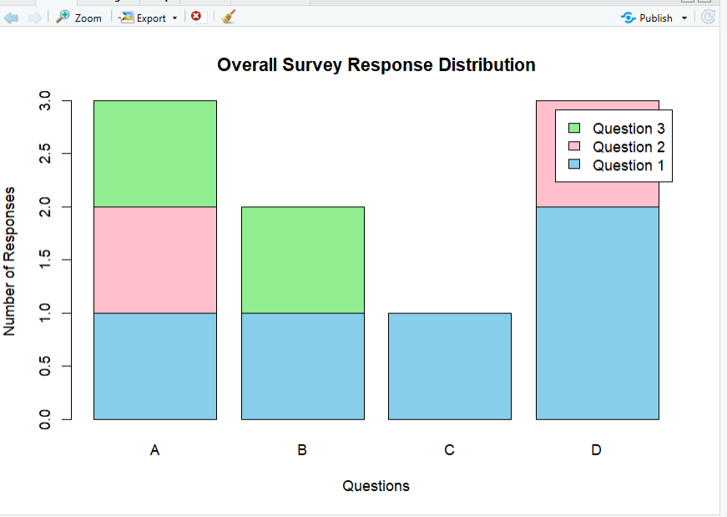

Output 2: Overall Survey Response Distribution Stacked Bar Chart
Observation
The stacked bar chart shows the overall distribution of survey responses. It helps compare the frequency of different responses across the survey.

PROGRAM 3: Survey Response Information Table
Build a table to show the survey response data for each survey. Label the table elements.
R-Code:
# Create survey response data
survey_data <- data.frame(
Survey_ID = c(1, 2, 3),
Question_1 = c("A", "B", "C"),
Question_2 = c("B", "A", "A"),
Question_3 = c("C", "D", "B")
)

# Display the survey response table
print(survey_data)

Output:
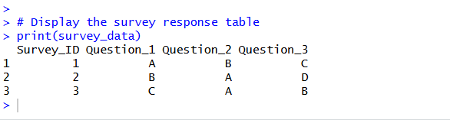

Output 3: Survey Response Information Table
Observation
The table clearly displays the Survey ID and the responses provided by each survey participant.

PROGRAM 4: Tableau Dashboard for Survey Responses Analysis
Develop a Tableau dashboard with the bar chart, stacked bar chart, and table to allow users to interactively explore survey responses.
Procedure:
- Create the survey response dataset containing Survey ID, Question 1, Question 2, and Question 3.
- Use R to create a bar chart showing the distribution of responses for Question 1.
- Create a stacked bar chart showing the overall distribution of responses for all three questions.
- Create a table displaying Survey ID and responses for all three questions.
- Import the survey response dataset into Tableau.
- Create the bar chart in Tableau using Question 1 and the count of responses.
- Create the stacked bar chart using the three questions and response counts.
- Create a table in Tableau showing Survey ID, Question 1, Question 2, and Question 3.
- Combine the bar chart, stacked bar chart, and table into a Tableau dashboard.
- Add filters or dashboard actions for interactive exploration.
- Save the dashboard.
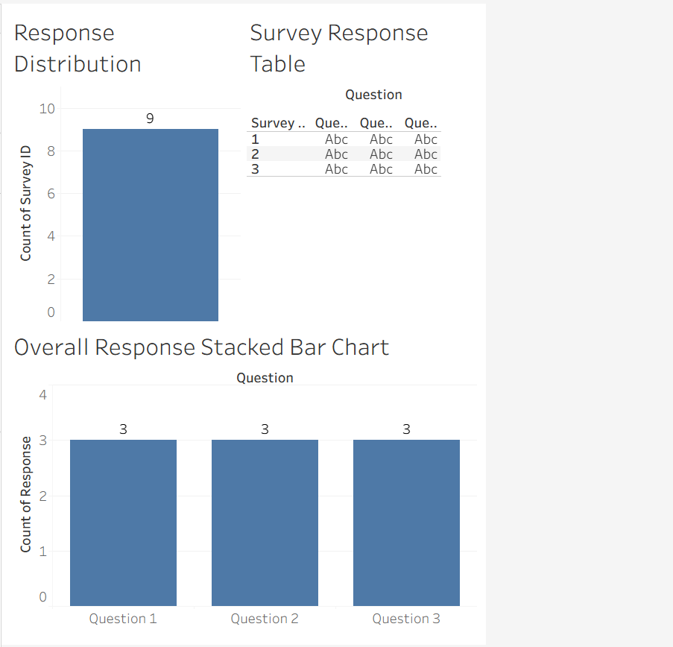
Output 4: Survey Responses Analysis Tableau Dashboard
Observation
The dashboard displays survey responses using a bar chart, stacked bar chart, and table, allowing users to compare Question 1 responses, analyze the overall response distribution, and view individual survey responses interactively.
Set 10 Procedure
- Create the survey response dataset containing Survey ID, Question 1, Question 2, and Question 3.
- Use R to create a bar chart showing the distribution of Question 1 responses.
- Create a stacked bar chart to represent the overall distribution of responses for all three questions.
- Create a table to display the response data for each survey.
- Import the survey response dataset into Tableau.
- Create the bar chart, stacked bar chart, and table in Tableau.
- Apply filters and dashboard actions for interactive exploration.
- Combine all three visualizations into a dashboard and save it.
Set 10 Result
Survey response data was successfully visualized using an R bar chart, stacked bar chart, and survey response table. A Tableau dashboard was also created to display and interactively explore the responses for all three questions.

Set 11 – Product Category Analysis
Aim
To analyze product category sales using a funnel chart, pie chart, table, and an interactive Tableau dashboard.
Dataset: Product Categories
Category | Sales ($)
Electronics | 50,000
Clothing | 35,000
Appliances | 40,000

PROGRAM 1: Product Category Sales Funnel Chart
Create a funnel chart to analyze the sales values for each product category.
R-Code:
# Create product category data
category <- c("Electronics", "Clothing", "Appliances")
sales <- c(50000, 35000, 40000)

# Sort sales in decreasing order
order_data <- order(sales, decreasing = TRUE)

category <- category[order_data]
sales <- sales[order_data]

# Create horizontal bar chart
barplot(sales,
names.arg = category,
horiz = TRUE,
main = "Product Category Sales Funnel",
xlab = "Sales ($)",
col = "skyblue",
border = "black",
las = 1)

# Add sales values
text(x = sales,
y = seq_along(sales),
labels = sales,
pos = 4)

Output:
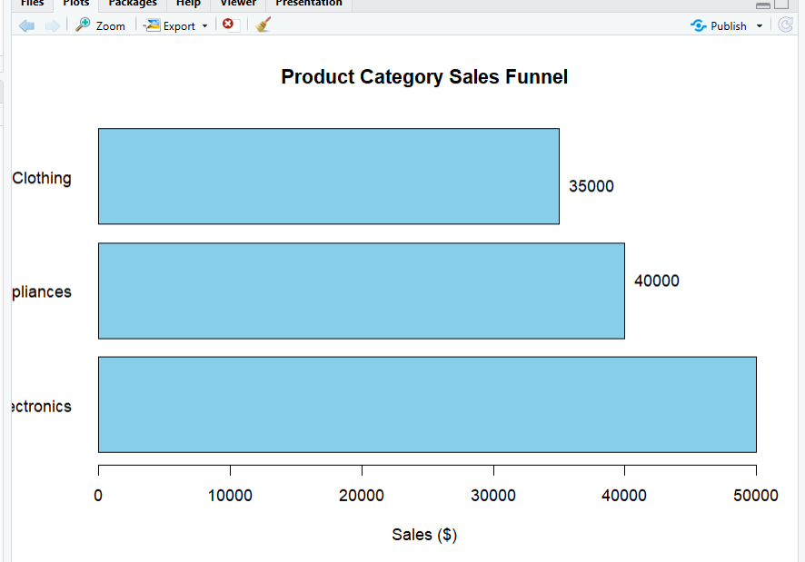
Output 1: Product Category Sales Funnel Chart
Observation
The funnel chart represents the sales values of the product categories. Electronics has the highest sales, while Clothing has the lowest sales.

PROGRAM 2: Product Category Sales Table
Build a table to display the sales data for each product category.
# Create product category data
product_data <- data.frame(
Category = c("Electronics", "Clothing", "Appliances"),
Sales = c(50000, 35000, 40000)
)

# Display the sales table
print(product_data)
Output:
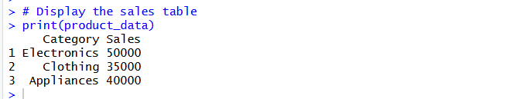
Output 2: Product Category Sales Table
Observation
The table clearly displays the product categories and their corresponding sales values.
PROGRAM 3: Tableau Dashboard for Product Category Analysis
Develop a Tableau dashboard combining the pie chart, funnel chart, and table for interactive exploration of product category data.
Procedure
- Create the product category dataset containing Category and Sales.
- Import the dataset into Tableau.
- Create a funnel-style chart using Category and Sales.
- Create a pie chart using Category and Sales.
- Create a table displaying Category and Sales.
- Create a new dashboard.
- Add the funnel chart, pie chart, and table to the dashboard.
- Add filters or dashboard actions for interactive exploration.
- Arrange the visualizations clearly.
- Add the title Product Category Sales Analysis Dashboard.
- Save the dashboard.

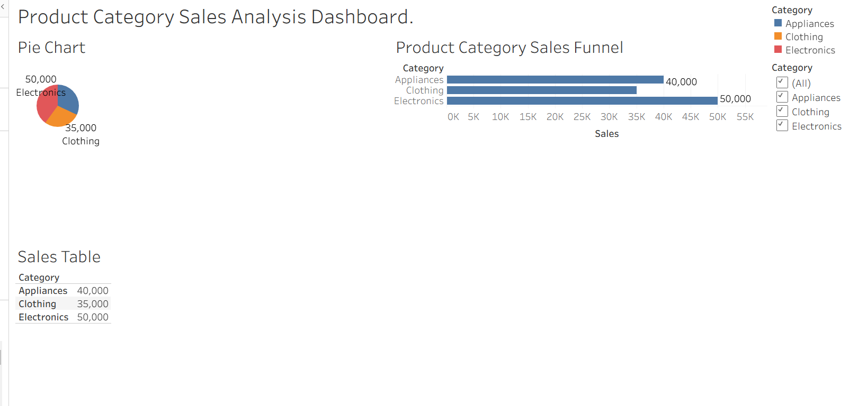
Output 3: Product Category Sales Analysis Tableau Dashboard
Observation
The dashboard displays product category sales using a funnel chart, pie chart, and table, allowing users to compare sales values and explore the product categories interactively.

PROGRAM 4: Product Category Sales Pie Chart
Create a pie chart to represent the distribution of sales across product categories.
R-code:
# Create product category data
category <- c("Electronics", "Clothing", "Appliances")
sales <- c(50000, 35000, 40000)

# Calculate percentages
percentage <- round(sales / sum(sales) * 100, 1)

# Create labels
labels <- paste(category, percentage, "%")

# Create pie chart
pie(sales,
labels = labels,
main = "Sales Distribution by Product Category",
col = c("skyblue", "pink", "lightgreen"))

# Add legend
legend("topright",
legend = category,
fill = c("skyblue", "pink", "lightgreen"))

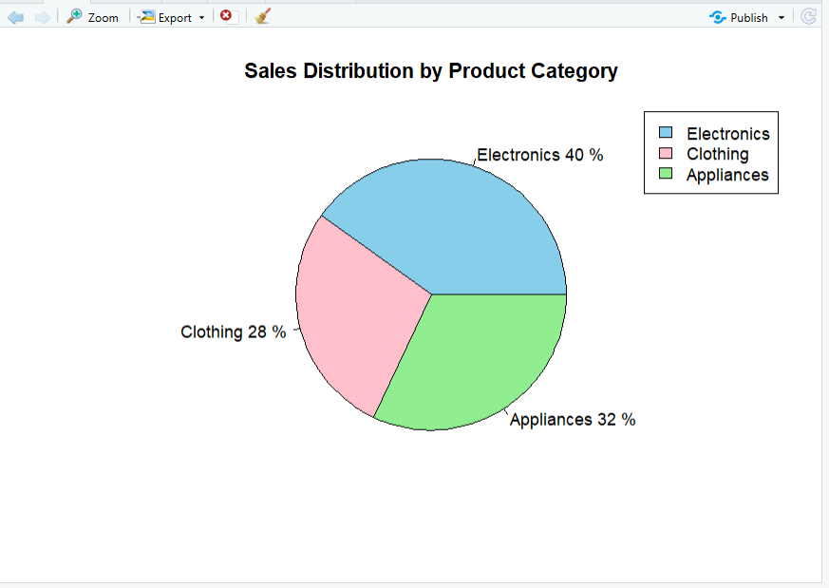
Output 4: Product Category Sales Distribution Pie Chart
Observation
The pie chart shows the distribution of total sales among the product categories. Electronics contributes the largest share of sales, while Clothing contributes the smallest share.

Set 11 Procedure
- Create the product category dataset containing Category and Sales.
- Use R to create a funnel-style chart showing sales for each category.
- Create a table to display the sales data for each category.
- Create a pie chart to represent the distribution of sales across product categories.
- Import the product category dataset into Tableau.
- Create the funnel chart, pie chart, and table in Tableau.
- Apply filters and dashboard actions for interactive exploration.
- Combine all three visualizations into a dashboard and save it.
Set 11 Result
Product category sales data was successfully visualized using a funnel chart, pie chart, and sales table. A Tableau dashboard was also created to display and interactively explore sales across different product categories.

SET 12 – Website Traffic Analysis
Aim
To analyze website traffic data using a line chart, bar chart, table, and an interactive Tableau dashboard.
Dataset: Website Traffic
Date | Page Views | Click-through Rate
2023-01-01 | 1500 | 2.3%
2023-01-02 | 1600 | 2.7%
2023-01-03 | 1400 | 2.0%

Program 1: Line Chart for Daily Page Views
Create a line chart to visualize the trend in daily page views over time. Label the axes and title the chart.
# Create website traffic data
date <- as.Date(c("2023-01-01", "2023-01-02", "2023-01-03"))
page_views <- c(1500, 1600, 1400)

# Create line chart
plot(date, page_views,
type = "o",
main = "Daily Page Views Trend",
xlab = "Date",
ylab = "Page Views",
col = "blue")

# Add values
text(date, page_views,
labels = page_views,
pos = 3)

Output:
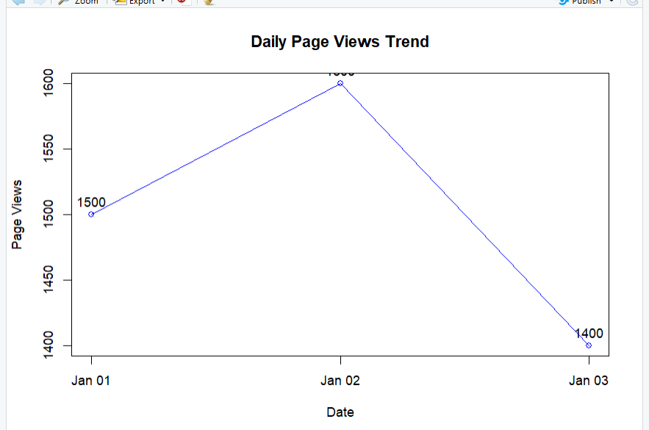
Observation:
The line chart shows the daily page views and helps identify the increase or decrease in website traffic over time.

Program 2: Bar Chart for Top N Click-through Rates
# Create website traffic data
date <- c("2023-01-01", "2023-01-02", "2023-01-03")
ctr <- c(2.3, 2.7, 2.0)

# Sort data in decreasing order
order_data <- order(ctr, decreasing = TRUE)

date <- date[order_data]
ctr <- ctr[order_data]

# Create bar chart
barplot(ctr,
names.arg = date,
main = "Top Days by Click-through Rate",
xlab = "Date",
ylab = "Click-through Rate (%)",
col = "skyblue",
border = "black")

# Add values
text(seq_along(ctr), ctr,
labels = paste0(ctr, "%"),
pos = 3)
Output:
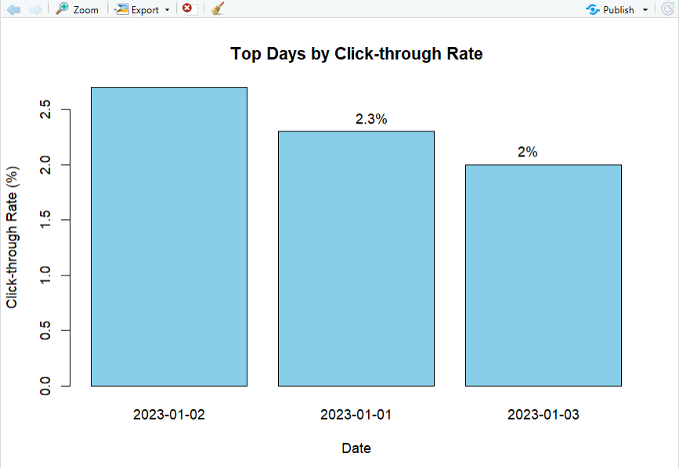
Observation:
The bar chart compares the click-through rates for different days and shows the days with higher click-through rates clearly.

Program 4: Tableau Dashboard
Develop a Tableau dashboard combining the line chart, bar chart, and the table for interactive
exploration of website traffic data.
Procedure:
- Create an Excel file containing Date, Page Views, and Click-through Rate.
- Import the Excel file into Tableau.
- Create a line chart using Date and Page Views.
- Create a bar chart using Date and Click-through Rate.
- Create a table displaying Date, Page Views, and Click-through Rate.
- Create a new Dashboard in Tableau.
- Add the line chart, bar chart, and table to the dashboard.
- Arrange the visualizations neatly.
- Add filters or dashboard actions for interactive exploration.
- Give the dashboard the title Website Traffic Analysis Dashboard.
- Save the Tableau workbook.
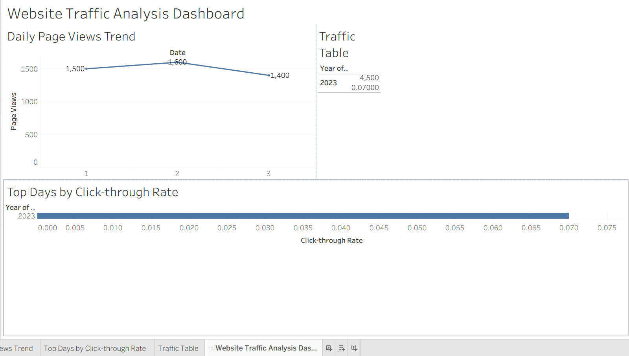
Observation:
The dashboard combines different visualizations to provide a clear view of website traffic and allows the data to be explored interactively.

Program 3: Website Traffic Table
Build a table to show the website traffic data for each day. Label the table elements.
# Create website traffic data
traffic_data <- data.frame(
Date = c("2023-01-01", "2023-01-02", "2023-01-03"),
Page_Views = c(1500, 1600, 1400),
Click_Through_Rate = c("2.3%", "2.7%", "2.0%")
)

# Display the table
print(traffic_data)
Output:
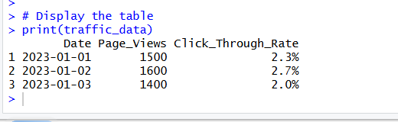
Observation:
The table clearly displays the daily website traffic information along with page views and click-through rates.

Set 12 Procedure
- Create the website traffic dataset containing Date, Page Views, and Click-through Rate.
- Use R to create a line chart for daily page views.
- Create a bar chart to compare click-through rates.
- Create a table to display the website traffic data.
- Import the dataset into Tableau.
- Create the required visualizations in Tableau.
- Combine the visualizations into an interactive dashboard.
- Apply suitable labels, titles, and filters.
- Save the completed dashboard.
Set 12 Result
Website traffic data was successfully visualized using a line chart, bar chart, and table. A Tableau dashboard was also created to provide an interactive view of website traffic and click-through rates.

