#1. Create a line chart to visualize the monthly sales. Label the axes and title the chart appropriately.

month <- c("January", "February", "March", "April", "May")
sales <- c(15000, 18000, 22000, 20000, 23000)

plot(1:5, sales,
type = "o",
col = "blue",
pch = 16,
xaxt = "n",
main = "Monthly Sales",
xlab = "Month",
ylab = "Sales (in $)")

axis(1, at = 1:5, labels = month)

OUTPUT:
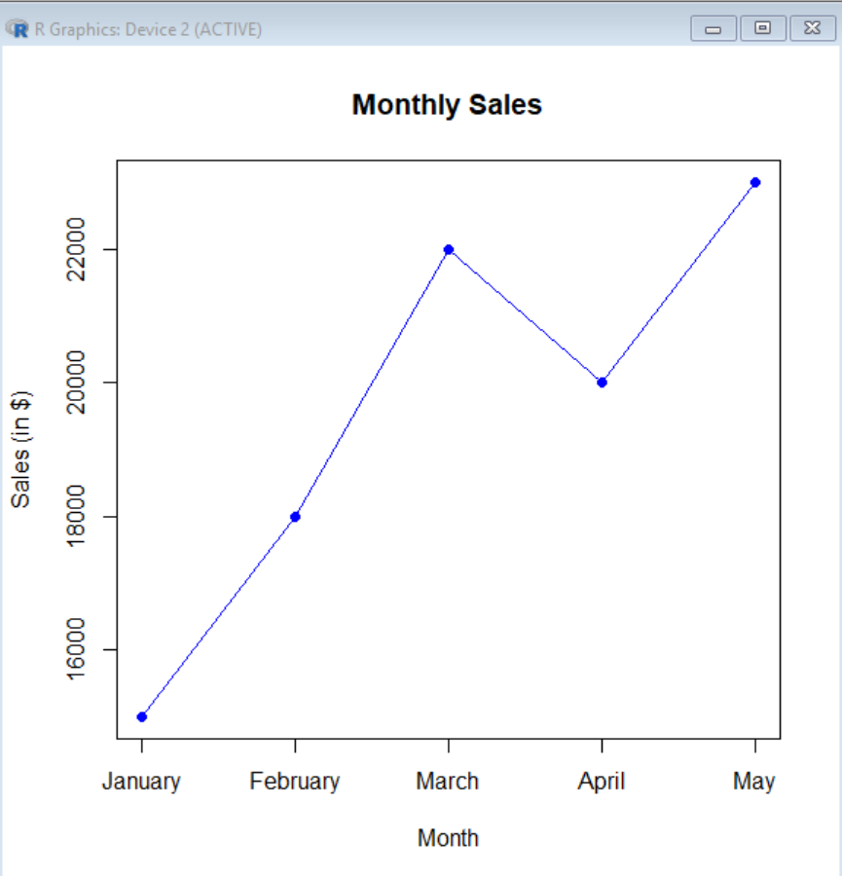

#2. Generate a bar chart to display the top-selling products for the year. Label the chart elements.
R-Code:
month <- c("January", "February", "March", "April", "May")
sales <- c(15000, 18000, 22000, 20000, 23000)

barplot(sales,
names.arg = month,
col = "skyblue",
main = "Monthly Sales",
xlab = "Month",
ylab = "Sales (in $)",
border = "black")
OUTPUT:
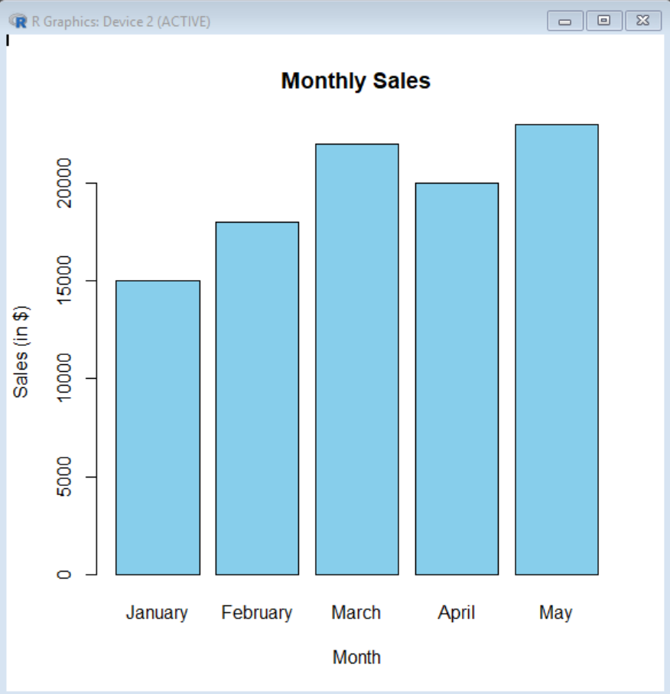

#3. Develop a scatter plot to explore the relationship between advertising budget and monthly sales.
Explain the insights drawn from the scatter plot.
R-Code:
advertising <- c(2000, 3000, 4000, 3500, 5000)
plot(advertising, sales,
main = "Advertising Budget vs Monthly Sales",
xlab = "Advertising Budget (in $)",
ylab = "Monthly Sales (in $)",
col = "red",
pch = 16)
abline(lm(sales ~ advertising), col = "blue", lwd = 2)
OUTPUT:
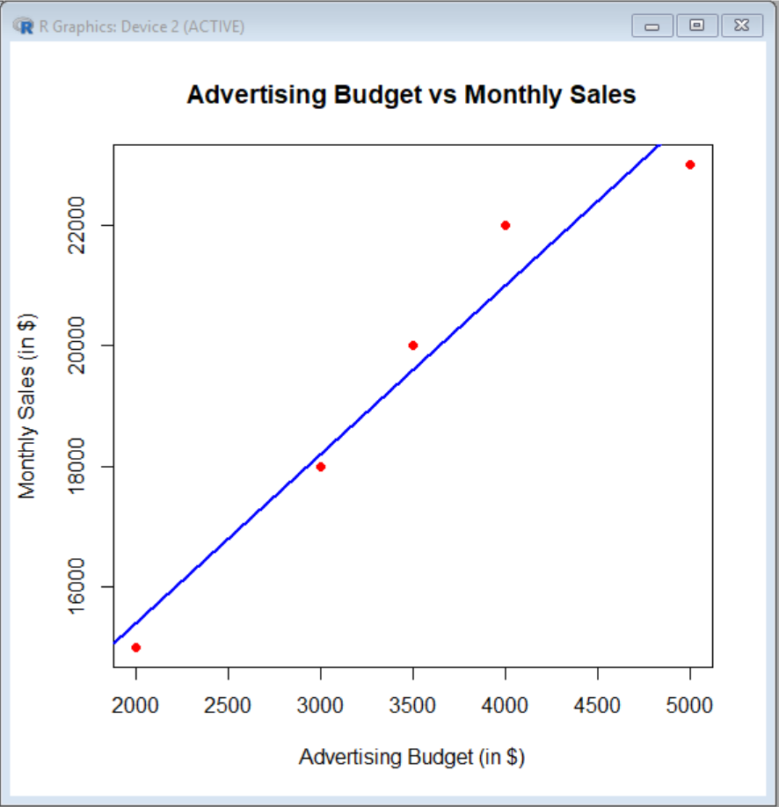

#4. Build an interactive dashboard combining the line chart and bar chart to allow users to explore sales
data interactively.
R-Code:
install.packages("shiny")
install.packages("plotly")
library(shiny)
library(plotly)

# Monthly Sales Data
month <- c("January", "February", "March", "April", "May")
sales <- c(15000, 18000, 22000, 20000, 23000)

data <- data.frame(month, sales)

# User Interface
ui <- fluidPage(
titlePanel("Monthly Sales Dashboard"),

sidebarLayout(
sidebarPanel(
selectInput("chart",
"Select Chart:",
choices = c("Line Chart", "Bar Chart"))
),

mainPanel(
plotlyOutput("salesPlot")
)
)
)

# Server
server <- function(input, output) {

output$salesPlot <- renderPlotly({

if (input$chart == "Line Chart") {
plot_ly(data,
x = ~month,
y = ~sales,
type = "scatter",
mode = "lines+markers",
line = list(color = "blue")) %>%
layout(
title = "Monthly Sales",
xaxis = list(title = "Month"),
yaxis = list(title = "Sales (in $)")
)

} else {
plot_ly(data,
x = ~month,
y = ~sales,
type = "bar",
marker = list(color = "skyblue")) %>%
layout(
title = "Monthly Sales Bar Chart",
xaxis = list(title = "Month"),
yaxis = list(title = "Sales (in $)")
)
}
})
}

# Run Dashboard
shinyApp(ui = ui, server = server)
Output:
1.
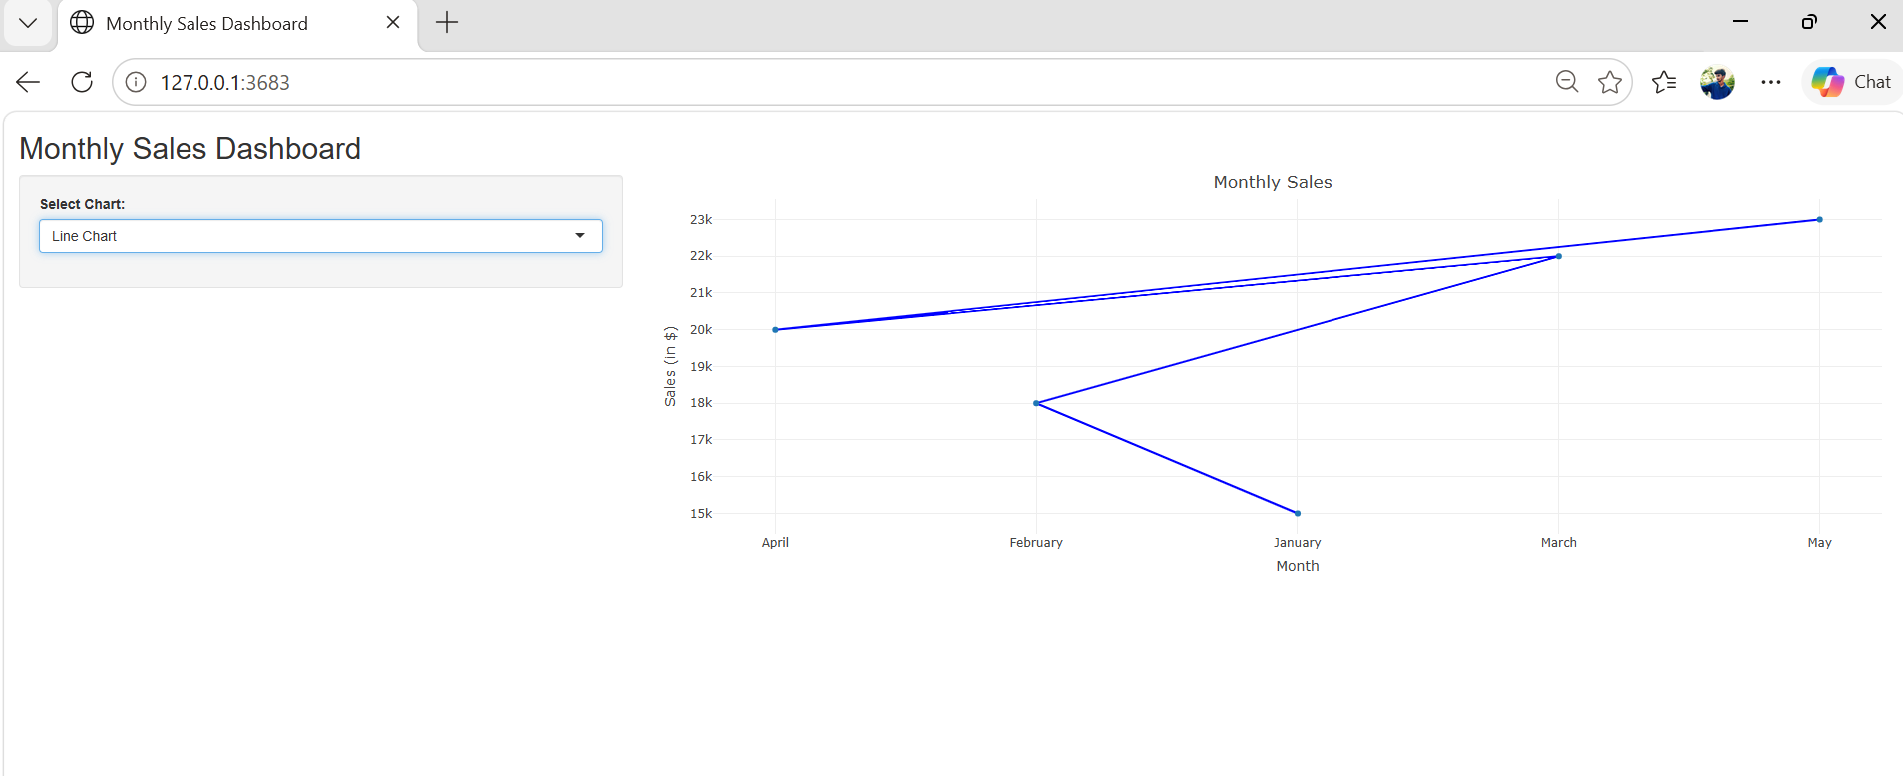
2.
